Mã đề 9.1.33
ĐỀ KIỂM TRA CUỐI KỲ INĂM HỌC: 2022-2023
MÔN: TIẾNG ANH LỚP 9
Thời gian làm bài: 45 phút
SECTION A: LISTENING (2.0 POINTS)
Task1: Listen to the dialogues and choose the best answer (1.0 point)
1.Where does her brother work?  (Nhận biết)  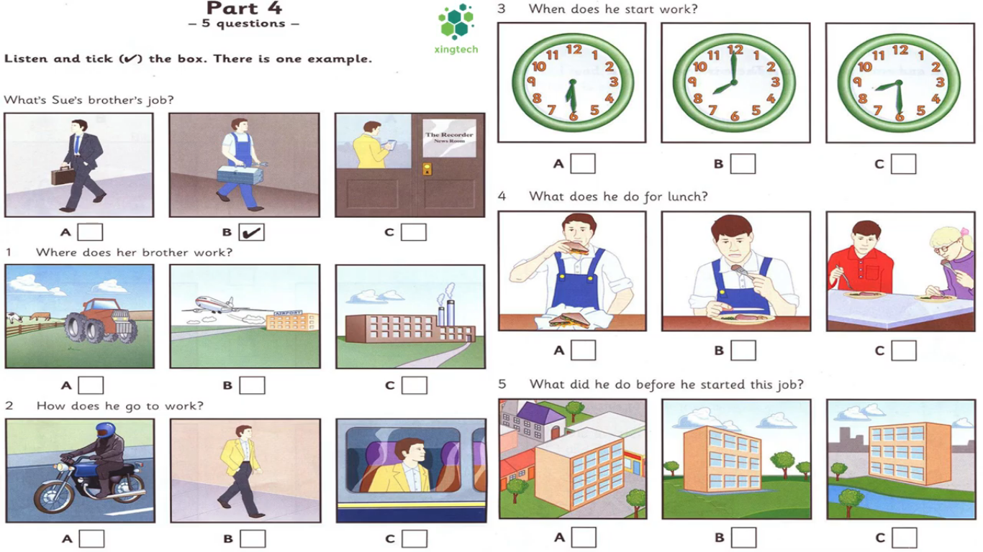 | 2.How does he go to work?  (Nhận biết)
3.When does he start work?(nhận biết) | 4.What does he do for lunch?  (Thông hiểu)
5. What did he do before he started this job? (Thông hiểu)

Task 2: Listen to a conversation and decide if the statements are true (T) or false (F).(1.0 point)
Satements | T/F
1. Sarah is a teacher. (Thông hiểu)
2. She usually arrives at work at nine o ’clock. (Nhận biết)
3. Sarah always has lunch at school.(Nhận biết)
4. She often has work to do in the evening. (Nhận biết)
5. She will stay at home this weekend. (Nhận biết)
SECTION B: LANGUAGE (2.0 POINTS)
I. Choose the best option (A, B, C or D) to complete these sentences. (2.0 points)
1. She turned _________ the new job in New York because she didn't want to leave her hometown. ( TV) (THÔNG HIỂU)
A. on | B. down | C. off | D. up

2. Minh wondered how............. social skills.(NP)NHẬN BIẾT
A. to develop | B. developing | C. develop | D. develops
3. People in the past used to…………….on the farm.(NP)NHẬN BIẾT
A. work | B. made | C. worked | D. making
4. We wish we ...............visit Ha Long Bay someday.(NP)(THÔNG HIỂU)
A. are | B. would | C. will be | D. were
5. It is ............that Ha Long Bay is one of the most unique wonders in the world. (NP)THÔNG HIỂU
A. say | B. said | C. talked | D. think
6. They suggested ................traditional games after school.(NP)(NHẬN BIẾT)
A. plays | B. playing | C. have | D. to have
7. Before going to bed, I ...................... a movie about Ho Chi Minh President.(NP) (NHẬN BIẾT)
A. see | B. saw | C. had seen | D. seen
8. It is interesting .............by flyover.(NP) (NHẬN BIẾT)
A. to travel | B. going | C. to walk | D. moved
9. Extended family has more than two.............. living together. (TV)(THÔNG HIỂU)
A. people | B. generations | C. family | D. adults
10. Recognizing and controlling your feelings are .................. skills.(TV)(THÔNG HIỂU
A. emotion control | B. self – care | C. cognitive | D. housekeeping
SECTION 3: READING (2.0 POINTS)
I. Read the passage and then choose the correct answer to each question. (1 point)
In the old days, Vietnamese roads............(1) seen with bicycles and a few trucks. Now they are full of a variety of vehicles. The Vietnamese.............(2) a huge load of a variety of goods up to over one hundred kilograms, especially during the war. Time has gone by and ..........(3) bikes are visible in the street. In big cities, many people think that bicycles belong to the inferior classes and seem...........(4). That’s why people often find it hard – psychologically and physically – to park their bikes when going to a modern café or shopping malls. Motorbikes are the main mode of transport in Viet Nam, with 24 million of them in a country of 87 million people in 2009, one of the ............(5)ratios in the world.
- A.were B. was C. is D. are (NHẬN BIẾT)
- A. hold B. carry C. produce D. import(THÔNG HIỂU)
- A. much B. fewer C. little D. less (NHẬN BIẾT)
- A. fashion B. unfashionable C. fashionable D. fashionably THÔNG HIỂU)
- A. high B.higher C. highest D. height (NHẬN BIẾT)
II. Read the passage and choose the correct answer for each question (1 point)
The combination of pressure from school, family and friends has made depression increasingly common in teenagers. According to recent study, one in eight teenagers has had some experience with pressure. Depression's symptoms like anxiety, tiredness, and lack of focus can deeply affect teenagers' social life and academic performance. Medication and therapy are two methods typically used to combat depression. These methods are proven to be effective among many teenagers. However, without the support from parents and friends, depression cannot be easily treated. Even when teens manage to get over their condition, parents need to talk to their children and create an environment where their children can talk freely to them. These steps are necessary in order to prevent teenagers from falling into depression again.
1.What is the main idea of the passage (THÔNG HIỂU)
A. The stress and pressure from school
B. The methods typically used to combat depression
C. the support from parents and friends
D. The causes and methods used to combat depression
2. What are depression's symptoms? (NHẬN BIẾT)
A. Anxiety, tiredness, angry. B. Sadness, tiredness, lack of focus.
C. Anxiety, tiredness, lack of focus. D.Sadness, lack of focus
3. What are methods proven to be effective among many teenagers? (NHẬN BIẾT)
A. Medication and entertainment. B. Relaxation and therapy.
C. Medication. D.Medication and therapy
4. Which of the following word(s) is closest in meaning to the word “support” in the passage? (VẬN DỤNG)
A. assistance B. kindness C. responsibility D. provide
5. Which sentence is not true according to the passage? (THÔNG HIỂU)
A. One in eight teenagers has had some experience with pressure
B. Parents should talk to their children and create an environment where their children can talk freely to them.
C. Medication and therapy are methods are proven to be effective among many teenagers
D. The combination of pressure from school hasn’t affected teenagers’depression.
SECTION D: WRITING (2.0 POINTS)
I. Rewrite the following sentences as directed (using the suggested words) so that the meanings stay the same. (1 point)
1. People think that our environment will be more and more polluted. (VẬN DỤNG)
It is
2. They wondered “What should we do to solve this problem”. (VẬN DỤNG)
They wondered ..........................................................................................................
3.Improving life skills is very necessary for teenagers (VẬN DỤNG)
It is…………………………………………………………………………….
4. We don’t have enough time to visit your hometown. (VẬN DỤNG)
We wish .......................................................................................
5.My grandparents often went to school on foot. (VẬN DỤNG)
My grandparents...................................................................................
III. Write a passage describing a wonder of Vietnam based on the suggested questions. (1.0 point)
- What is the name of the wonder? Where is it?(VẬN DỤNG CAO)
- What is it famous for? (VẬN DỤNG CAO)
- What activities can we do there? (VẬN DỤNG CAO)
- How do you feel about that wonder? (VẬN DỤNG CAO)
- What should you do to introduce it to all people in the world? (VẬN DỤNG CAO)
----------------The end --------------

HƯỚNG DẪNKIỂM TRA CUỐI KỲ I
NĂM HỌC: 2022-2023
MÔN: TIẾNG ANH LỚP 9
SECTION A: LISTENING (2.0 POINTS)
Task1: Listen to the dialogues and choose the best answer
(0,2 x 5 =1.0 point)
1.C 2.A 3.B 4.A 5.C
Task 2: Listen to Mira talking about her neighborhood. Tick T (True) or F (False). You will listen twice
(0,2 x 5 =1.0 point)
1. T2. F 3. T4. T 5. F
SECTION B: LANGUAGE (2.0 POINTS)
II. Choose the best option (A, B, C or D) to complete these sentences.
(0,2x 10 =2.0 points)
1. B | 3. A | 5. B | 7. C | 9.B
2. A | 4. B | 6. B | 8.A | 10.A
SECTION 3: READING (2.0 POINTS)
I. Read the passage and then choose the correct answer to each question.
(0,2 x 5 =1.0 point)
1. A 2. B 3.B 4.B 5. C
II. Read the passage and choose the correct answer for each question
(0,2 x 5 =1.0 point)
1. D 2. C 3.D 4.A 5. D
SECTION D: WRITING (2.0 POINTS)
I. Rewrite the following sentences as directed (using the suggested words) so that the meanings stay the same.
(0,2 x 5= 1.0 point)
1. People think that our environment will be more and more polluted.
It is thought that our environment will be more and more polluted.
2. They wondered “What should we do to solve this problem”.
They wondered what to do to solve that problem.
3.Improving life skills is very necessary for teenagers.
It is necessary for teenagers to improve life skills.
4. We don’t have enough time to visit your hometown.
We wish we had enough time to visit your hometown.
5.My grandparents often went to school on foot.
My grandparents used to go to school on foot.
II. Write a passage describing a wonder of Vietnam based on the suggested questions. (1.0 point)
(0,4đ)
- Trả lời đầy đủ yêu cầu của bài. Bài viết cócâu chủ đề.Các thành phần cơ bản được phát
triển kỹ, logic, cân xứng.
- Đủ ý, các ý thống nhất, cóliên quan chặt chẽ.
- Dẫn chứng hay và thuyết phục.
(0,2đ)
- Thông tin khôngbịlặp.
- Sắp xếp ý logic, mạch lạc cao. Bài viết cótổng thể hài hòa, trôi chảy, uyển chuyển, tự nhiên.
- Sử dụng đa dạng và chính xác các phương tiện kết nối.
(0,2đ)
- Từ vựng phong phú liên quan đến chủ đề, diễn đạt tự nhiên. Dùng từ phù hợp, chính xác.
- Sử dụng đa dạng các từ đồng nghĩa, trái nghĩa, kết hợp từ, thành ngữ…
- Rất ít lỗi về dạng từ, và chính tả.
(0,2đ)
- Sử dụng đa dạng, linh hoạt cấu trúc câu.
- Còn một vài lỗi nhỏ về ngữ pháp và chấm cấu, người đọc vẫn thấy dễ hiểu
( - 0,1p/ each spelling mistake; No point/ each sentence with wrong verb form)
----------The end -------------

