Date of preparing: ………………………………….
Date of teaching: ………………………………….

Period……
UNIT 2: SCHOOL
Lesson 4 - REVIEW (Page 88)

I. OBJECTIVES
By the end of the lesson, Ss will be able to…
1. Knowledge
- review school subjects and school activities.
- review famous books.
- review the use of English: connectors (and, or), preposition, possessive pronouns, like + V-ing and pronunciation.
2. Ability
- improve the listening, reading, speaking and writing skills.
3. Quality
- have positive attitude in English language learning so that they actively participate in all classroom activities.
- review the previous lessons and be well-prepared for any assessment.

II. TEACHING AIDS AND LEARNING MATERIALS
Lesson plan, PPT slides, student’s book, workbook, notebook, personal computer (if any), projector/TV, speakers, DCR &DHA on EDUHOME, handouts…
III. PROCEDURES
A. Warm up: (5’)
a) Objective: Introduce the new lesson and set the scene for Ss to review the target language; get students' attention at the beginning of the class by means of enjoyable and short activities as well as to engage them in the steps that follow.
b) Content: Revision of learnt vocabulary
c) Product: Ss are ready for the new lesson
d) Competence: Collaboration, critical thinking
e) Organization of the activity:
Teacher’s Activities | Students’ Activities
- Give greetings  - Check attendance  - Option 1: Network of words  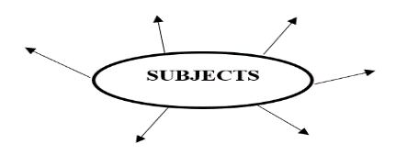  - Write the key word “subjects” and ask Ss to give subject names as many as possible  - Lead to the new lesson  - Option 2: Leave Me Out  - Give 5-7 words with an unnecessary letter in each word.  - Have Ss leave the unnecessary letter out to make a right English word  1. literrature  2. fantasty  3. authour  4. cluby  5. histoory  6. drasma  - Give feedback  → Lead to the new lesson | - Greet T  - Give answers  Possible answers  Subjects: Math, Physics, Chemistry, Literature, History, Geography, Civic Education, P.E, Technology, Music, English …  - Look and give answers  Answer Keys  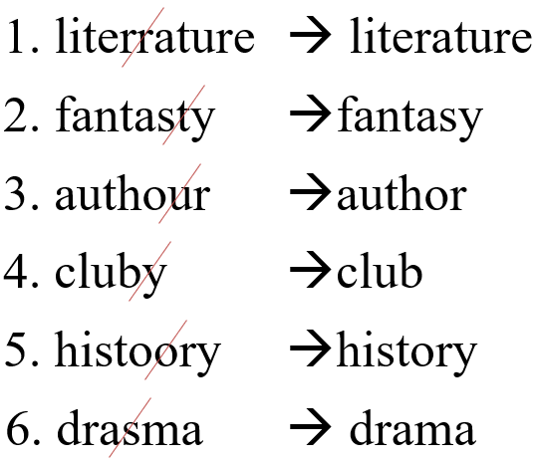

B. New lesson (35’)
- Activities 1: Listening (10’)
a) Objective: Ss improve their listening skill.
b) Content:
- Listening and choosing the correct answers
c) Products: Ss listen for details and get familiar with the listening test format
d) Competence: Collaboration, analytical and synthesizing skills.
e) Organization of the activity:
Teacher’s Activities | Students’ Activities
You will hear 5 short conversations (twice for each one). Answer each question of the conversation by choosing the correct answer (A, B or C)  - Have Ss read the questions and study the pictures  - Demonstrate the activity by using the example  - Play the audio (CD 2 – Track 64)  - Have Ss give answers  - Check answers as a whole class | - Read in silence  - Listen and then give answers  - Check and correct mistakes  Answer keys  1.B 2.A 3.A 4.B 5.A
- Activity 2: Reading (7’)
a) Objective: Ss can improve reading skill
b) Content: Reading a text and choosing the correct answer
c) Products: Ss read for comprehension and get familiar with the reading test format
d) Competence: Collaboration, analytical and synthesizing skills.
e) Organization of the activity:

Teacher’s Activities | Students’ Activities
Read the text. Choose the correct answer (A, B or C)  - Option 1:  - Demonstrate the activity by using the example  - Have Ss read the text and choose the correct answer  - Call Ss to give answers, explain  - Give feedback and evaluation  - Option 2:  - Demonstrate the activity by using the example  - Have Ss study the questions first, try to find the key words that help them find the answer quicky and correctly  - Have Ss read the text and choose the correct answer  - Call Ss to give answers, explain  - Give feedback and evaluation | - Observe and listen  - Work individually  - Give answers  Answer keys  1.A 2.B 3.B 4.C  - Listen  - Read  - Work in pairs  - Give answers
- Activity 3: Vocabulary (9’)
a) Objective: Ss can review vocabulary about school subjects, school activities and books.
b) Content: Filling in the blanks with the words from the box.
c) Products: Ss can use these vocabularies in speaking and writing as well as other skills.
d) Competence: Collaboration, analytical skills
e) Organization of the activity:

Teacher’s Activities | Students’ Activities
Fill in the blanks with the words from the box  - Have Ss look at the vocabulary box, focus on the part of speech of each word  - Ask Ss to work in pairs to fill in the blanks  - Have Ss give answers, explain for their choice  - Check answers as a whole class | - Look  - Work in pairs  - Give answers  - Listen, correct mistakes  Answer keys  1. history 2. fantasy 3. arts and crafts  4. novel 5. sign up 6. literature  7. geography 8. drama club
- Activity 4: Grammar (5’)
a) Objective: Ss can review the use of English: connectors (and, or), preposition, possessive pronouns, like + V-ing
b) Content: Circling the correct words
c) Products: Ss use the grammar point learnt actively and correctly.
d) Competence: Collaboration, communication, analytical skill
e) Organization of the activity:

Teacher’s Activities | Students’ Activities
Circle the correct words  - Ask Ss to work individually to circle the correct answer  - Have Ss work in pairs to check each other’s work  - Call Ss to give answers, explain for their choice  - Check answers as a whole class | - Work individually  - Work in pairs  - Give answers  - Listen, correct mistakes  Answer keys  1. and 2. Mine 3. playing  4. by 5. is 6. dancing  7. yours 8. drawing
- Activity 5: Pronunciation (5’)
a) Objective: Ss can review the word stress.
b) Content: Circling the word that has different stress from the rest.
c) Products: Ss can stress the words correctly when using it in speaking.
d) Competence: Collaboration, communication, analytical skill
e) Organization of the activity:
Teacher’s Activities | Students’ Activities
Circle the word that differs from the other three in the position of primary stress in each of the following questions  - Remind Ss some basic rules of putting stress on words with 2 or 3 syllables  - Ask Ss to work individually  - Have Ss work in pairs to check each other’s work  - Call Ss to give answers, pronounce the words again  - Give feedback, correct Ss’ pronunciation if necessary | - Listen  - Work individually  - Work in pairs  - Give answers  - Listen, correct mistakes  Answer keys  1. A 2. D 3. D  4. D 5. B

C. Consolidation (3’)
* Grammar of Unit 2: Connectors (and, or), preposition, possessive pronouns, like + V-ing
* Vocabulary of Unit 2: Vocabulary about school subjects, school activities and books

D. Homework (2’)
- Review vocabulary, grammar of unit 2
- Do exercises in Workbook: Review of Unit 2 (page 63)
- Prepare: Unit 3 – Vocabulary and Listening (page 22 – SB)

