Unit 3 | Global warming and Ecological systems
C. EXERCISE (BÀI TẬP)
❶ PHONETICS
I. Choose the words whose underlined part is pronounced differently from that of the others in each group.
1. A. concrete B. desert C. effect D. terrace
2. A. pond B. pocket C. stone D. modern
3. A. accept B. annoyed C. agree D. anxiuos
4. A. global B. organic C. social D. ecosystem
5. A. exctint B. landslide C. ruin D. etiquette
6. A. glassland B. hot C. pond D. worship
7. A. stopped B. turned C. stayed D. moved
8. A. school B. church C. architecture D. chemistry
9. A. played B. lived C. cooked D. happened
10. A. watched B. washed C. walked D. waited
II. Choose the word whose main stressed syllable is placed differently from that of the other in each group.
11. A. attitude B. powerless C. pagoda D. difficult
12. A. mountain B. etiquette C. modern D. accept
13. A. behaviour B. architecture C. traditional D. historical
14. A. temple B. annoyed C. narrow D. valley
15. A. confused B. palace C. tower D. crowded
❷ WORD FORMATION
Complete the sentences with the correct form of the words.
- The lighting for the production made a very effective use of shadow. (effect)
- The extinction of the dinosaurs occurred millions of years ago. (extinct)
- She would never do anything to endanger the lives of her children. (danger)
- Most electrical equipments come with a one-year guarantee. (electricity)
- They’’re here to discuss environmental issues. (environment)
- Are plastic bottles recyclable or do they go in the garbage? (recycle)
- Some think television hurts children and others regard it as harmless entertainment. (harm)
- The protection of the environment must be our first priority today. (protect)
- The farm and surrounding area were flooded. (flood)
- To conserve resources, please reuse this carrier bag. (use)
❸ FURTHER PRACTICE
UNIT OPENER
I. Write the suitable word for each picture.

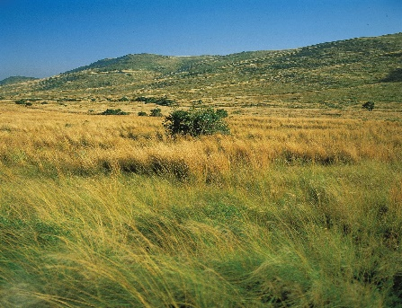 | 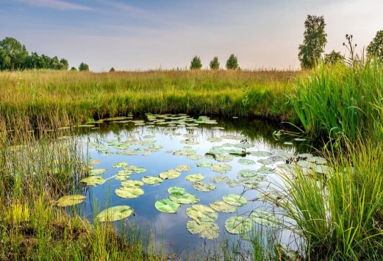 | 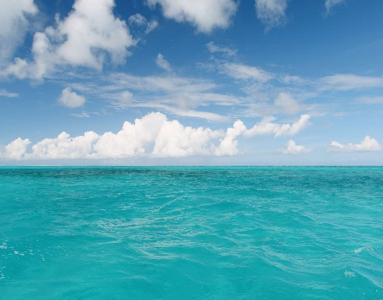
1. grassland | 2. pond | 3. ocean
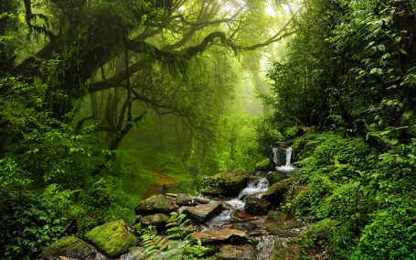 | 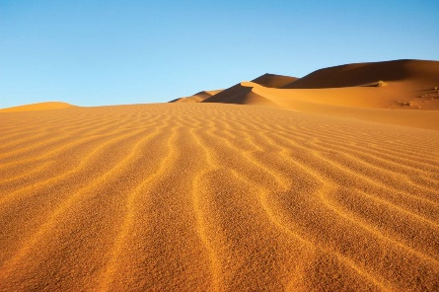 | 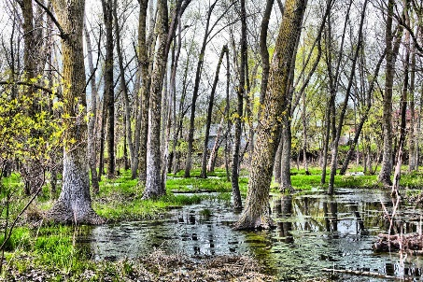
4. jungle | 5. desert | 6. swamp

II. Complete the sentences with the words in exercise I.
- The lion is often called the king of the jungle.
- They lost their way in the desert and died of thirst.
- A flock of sheep are ranging over the grassland.
- Have any fish been contaminated in the Arctic Ocean?
- This is a crocodile - infested swamp.
- She chose a bench beside the duck pond and sat down.
III. Put the words into the correct column. Then practise saying them with a partner.
worried selfish accept extinct valley career
arrange annoyed repair social jungle select
replace preserve tower palace temple terrace

Keys
  worried  selfish  valley  social  jungle  desert  tower  palace  temple  terrace | preserve  accept  extinct  career  arrange  annoyed  repair  select  replace

LESSON 3A. READING
I. Fill in the blanks using the words in the box.
effect | marine | conditions | extreme weather | extinct | temperature | emission
global warming | ecosystems | endangered | greenhouse gas | wildfires | droughts | forest

- A good night's sleep has a positive effect on your day.
- There are many wild animals in this forest.
- Heat and drought had continued for more than two weeks.
- A heatwave in southern Australia triggered wildfires that destroyed more than 100 homes.
- Carbon monoxide is also a powerful greenhouse gas.
- Mountain gorillas are an endangered species.
- The rainforest is a self-supporting ecosystem.
- Global warming could be accelerated due to the thinning of the ozone layer.
- The emission of gases such as carbon dioxide should be stabilised at their present level.
- In hot weather the temperature gets very high.
- Dinosaurs have been extinct for millions of years.
- Are recent extreme weather events due to global warming?
- The match has been cancelled due to adverse weather conditions.
- Seals and whales are marine animals.

II. Write the suitable word for each picture.

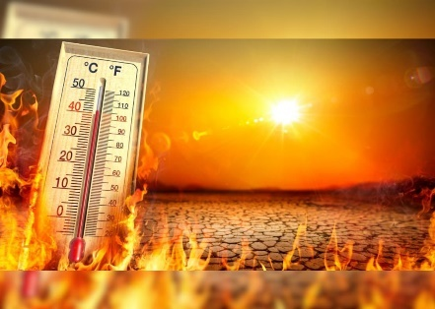 | 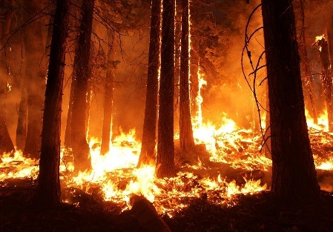 | 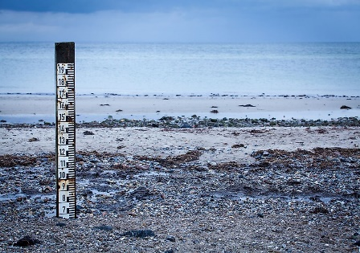
1. heatwave | 2. wildfire | 3. sea levels
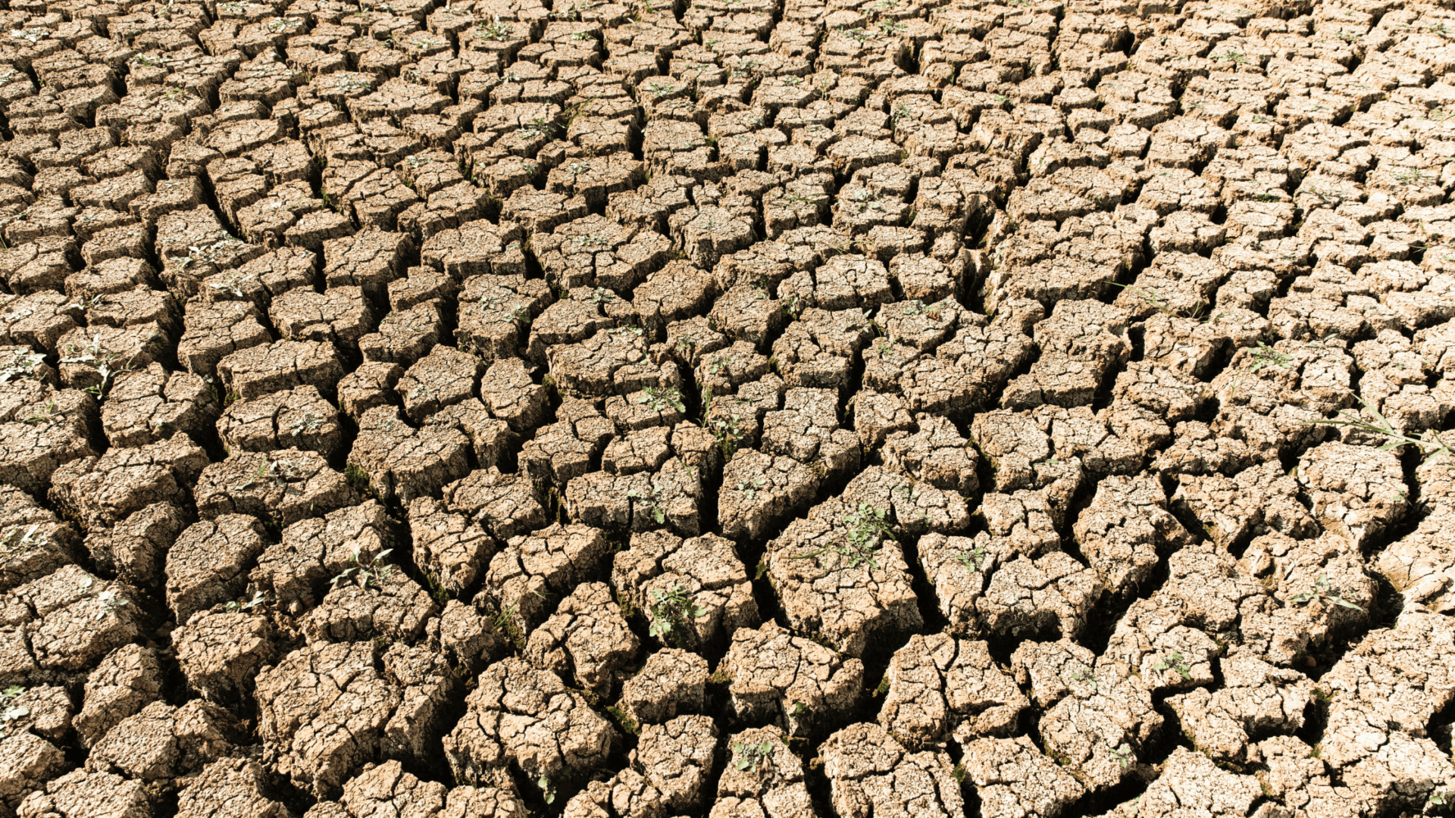 | 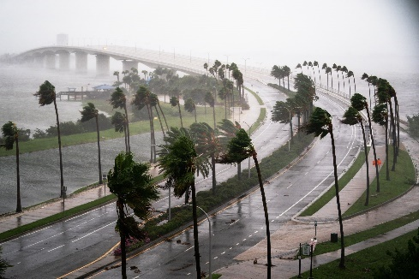 | 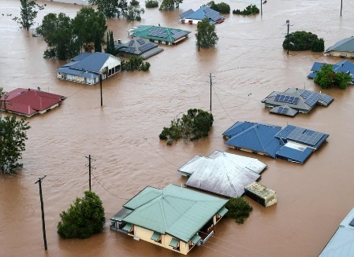
4. drought | 5. hurricane | 6. floods
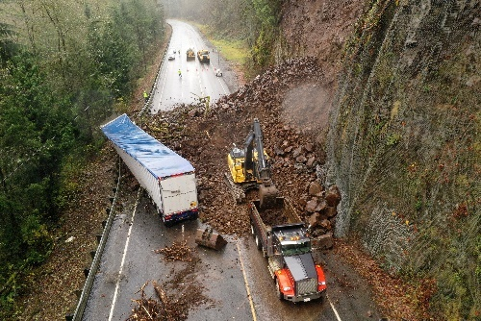 | 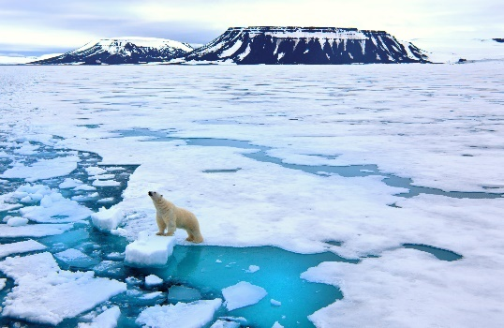 | 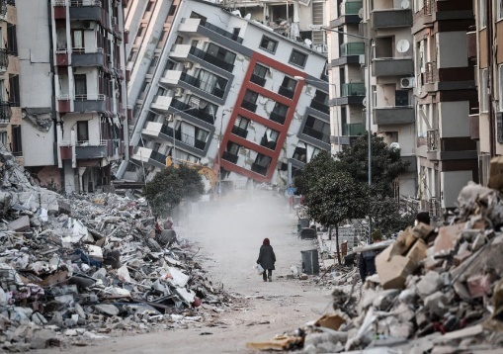
7. landslide | 8. ice caps | 9. earthquakes

III. Reading
Mega Earthquake and Tsunami
by Gillian Frost (weather correspondent)
At 14.46pm on the 11th March 2011, Japan experienced a powerful earthquake. It reached a magnitude of 9.0 and even though it lasted 6 minutes, it left parts of the country completely destroyed.
The earthquake struck close to the north coast, about 250 miles from Tokyo. It triggered a super tsunami which swept inland near the city of Sendai. Waves reached heights of up to 405 metres and travelled 6 miles inland. The Japanese National Police Agency reported that 15,883 people were killed and another 6,145 were injured during the disaster. Around 129,225 buildings were destroyed.
Jeremy Michael, an English teacher working in Japan at the time, described the whole event. ‘It was like a horrific dream,’ he recalls. He was teaching a class of primary school children when the earthquake hit. He said it had felt like it was never going to end. Crouching under their desks while it was happening, when they finally went outside, they were met with more danger. Children were panicked and many were crying. Tsunami alarm bells were also ringing, he remembers, warning the town to evacuate immediately to higher ground.
Within 10 minutes, they had all managed to reach the safety of a train station high up on a hill. He recalls looking back and seeing the wave approaching rapidly. Water had already flooded the school. The tsunami waves had destroyed most of the town and everyone was made homeless. Jeremy and his class waited for an hour on the hill until the water returned back to normal levels. It was snowing and the temperatures were freezing.
In Utatsu alone, where Jeremy was living, only 9,000 survivors from 18,000 residents had been confirmed. Millions of people suffered across Japan. It was the single worst natural disaster they had ever experienced.
A. Read the article and match the words below with their definitions. Circle the words in the text.
crouching recall horrific inland flood triggered

0 something that is the cause of a particular development, especially a bad one ___triggered
1 in a direction towards the middle of a country, away from the coast _____________________
2 extremely bad and shocking _____________________
3 bending down with your knees under you close to the ground _____________________
4 remember certain information _____________________
5 worried that something bad has happened _____________________
KEYS
1inland
2 horrific
3 crouching
4 recall
5 flood

B. Read the article again and match the information with the numbers.

0 number of people who survived F  1 height of the tsunami waves _  2 number of inhabitants in Utatsu _  3 minutes the earthquake lasted _  4 magnitude of the earthquake _  5 number of people who were injured _ | A 6  B 9.0  C 18,000  D 6,145  E 405  F 9,000
KEYS
21 E 2 C 3 A 4 B 5 D
C. Read the article again and decide if the sentences are true or false. Correct the false sentences.
0 Jeremy was teaching children in a classroom when he felt the earthquake. True
1 The emergency services warned people to evacuate to safety. ___________
2 Jeremy and his class escaped to safety by train. ___________
3 Tsunami waves covered the whole town. ___________
4 People rescued their belongings from their homes. ___________
5 Jeremy and the children waited in the freezing cold for the water levels to reduce. _______
KEYS
1.False. Tsunami alarm bells warned people to evacuate.
2 False. They reached the train station.
3 False. Waves destroyed most of the town.
4 False. No, they had to evacuate immediately.
5 True
D. Read the following article and choose the correct answer for each question.
Scientists believe that something very serious is happening to the Earth. It is becoming warmer. Scientists predict that there will be major changes in the climate during the 21st century. Coastal waters will have higher temperatures. This will have a serious effect on agriculture. Farmers will have trouble producing good crops. In warm regions, the weather will be too dry. The amount of water could decrease by 50 per cent. This would cause a large decrease in agricultural production.
World temperatures could increase from 1.5 to 5.6 degrees Celsius by the middle of the 21st century. And the increase in temperature could be even greater in the Arctic and Antarctic regions. A rise in temperature could cause the great ice sheets to melt, which, in turn would raise the level of oceans by one to two meters. Many coastal cities would be underwater. Why is all this happening?
The Earth and its atmosphere are kept warm by the Sun. The atmosphere lets most of the light from the Sun pass through to warm the Earth. The Earth is warmer by the sunlight and sends heat energy back into the atmosphere. Much of this energy escapes from the Earth’s atmosphere. However, some of it remains. Gases such as carbon dioxide, ozone and water vapor absorb this energy and create more heat. Then, this heat is sent back down to Earth, and the Earth becomes warmer.
Recently, however, an increase of carbon dioxide in the atmosphere is causing serious problems. Too much carbon dioxide in the atmosphere prevents heat energy from escaping. Too much heat is sent back down to the Earth, and the amount of carbon dioxide in the atmosphere continues to increase. When oil, gas, and coal burn, they create large amounts of carbon dioxide. The destruction of rain forests that absorb carbon dioxide also helps to increase the amount of carbon dioxide in our atmosphere. Some scientists believe that the amount of carbon dioxide in the air will double by the late 2000s.
Scientists call this warming of the Earth and its atmosphere “the greenhouse effect”. A greenhouse, made of glass and plastic, is a special place where plants are grown. The sunlight passes through the glass or plastic and warms the air inside. The heat inside escapes very slowly, so the greenhouse remains very warm. This is exactly what is happening on the Earth.
Another reason why the Earth is growing warmer is because of the amount of ozone in our atmosphere. Ozone is a form of oxygen. In the upper atmosphere, very far from the Earth, a layer of ozone helps to protect the Earth from 95 percent of the harmful light that comes from the sun. If your skin receives too much of this light, you would develop skin cancer. We need the ozone layer to protect ourselves. But the ozone layer is in trouble. Scientists have observed that the ozone layer is becoming thin, and above Antarctica there is a hole. This allows too much of the sun’s dangerous light into our atmosphere and makes the Earth warmer.
Scientists say we must start making changes and planning now. We need to continue to do research, so we can predict what will happen in the future. We must burn less coal, oil, and gas. Other scientists believe that the problem is not so serious. They think that the Earth is growing warmer naturally, that we don’t need to worry about it now, and that we should just get ready for life in the warmer climate. Most scientists agree that the causes of the world’s climate are very complicated. They say that we must continue to measure the amount of carbon dioxide and ozone in the atmosphere. Scientists also encourage people to learn about the changes that are occurring in the world and how we can all help protect our atmosphere.
(https://climate.nasa.gov/effects/)
Question 1: Which of the following will be one of the consequences of a warmer earth?
A. Crops will be poor unless they are grown in the green house.
B. The amount of water will be decreased by half.
C. Farmer will get into trouble because of the heat.
D. There will be no winter on earth.
Question 2: A rise in temperature will be more remarkable ____.
A. in the Arctic and Antarctic regions B. in the coastal cities
C. by the year 2050 D. under the great ice sheets
Question 3: The melting of the polar ice sheets will probably lead to ____.
A. a rise in global temperature B. the extinction of many polar animals
C. flooding of many coastal cities D. a serve winter all over the world
Question 4: The Earth wouldn’t become warmer if ____.
A. the heat energy didn’t escape from the Earth’s atmosphere
B. sunlight didn’t pass through the atmosphere
C. the Earth didn’t send heat energy back into the atmosphere
D. carbon dioxide, ozone and water vapor didn’t retain the heat energy
Question 5: When the rainforests are destroyed ____.
A. people have to burn coal, oil, gas instead of wood for fuel.
B. heat energy fails to escape from the atmosphere.
C. there is nothing to absorb carbon dioxide.
D. serious problems are caused for the scientists.
Question 6: How useful is the ozone layer?
A. It protects the earth from the harmful radiation from the sun.
B. It absorbs much of the carbon dioxide.
C. It sends the extra heat energy back into space and thus keeps the earth cool.
D. It helps treat skin cancer.
Question 7: The two factors that directly cause the greenhouse effects are ____.
A. the destruction of rain forests and the melting of the polar ice
B. the burning of fossil fuels and the changes of the climate
C. the increase of carbon dioxide in the atmosphere and the decrease of the ozone layer
D. the ignorance of greenhouse owners and the development of skin cancer
Question 8: Which is the best title for the passage?
A. The global warming B. The greenhouse effects
C. The heat energy D. The change of climate in the poles

KEYS
1.B | 2.A | 3.C | 4.D | 5.C | 6.A | 7.C | 8.A

LESSON 3B. GRAMMAR
I. Complete the chart below with the correct form of the verb.

Simple form | Simple past | Past participle
know | knew | known
meet | met | met
fly | flew | flown
write | wrote | written
read | read | read
fall | fell | fallen
feel | felt | felt
take | took | taken
drive | drove | driven
go | went | gone
cut | cut | cut
break | broke | broken

II. Put the verbs in the correct form of the present perfect tense.
- Our teacher________________ (be) sick since last Saturday.
- We________________ (not talk) about the problem yet.
- She________________ (play) football since she was a little girl.
- Jackson and Simon________________ (not call) us for months.
- Richard________________ (stay) with us for weeks.
- Bo _____ (drive) Rose to work today.
- They _____ (work) all day and night.
- We _____ (see) the new bridge.
- He ____ (have) breakfast this morning.
- Ann and Don ____ (wash) the car.
- Kathy ____ (want) to go to Queensland for a long time.
- Mel ____ (give) up smoking.
- I ____ (forget) that man’s name.
- They ____ (lose) their keys.
- Jack ____ (be) to England.
- They ____ (leave) London this month.
- He ____ (bring) a lot of English papers.
- She ____ (tell) me about it.
- I ____ (get) a long letter from father this week.
- She ____ (come), she will speak to you in a minute.
- I ____ (be) to Radio City.
- I think the director ____ (leave) the town.
- I ___ (paint) my office.
- We ____ (know) her since she arrived in our city.
- I ____ (forget) your name.
KEYS
  - has been
  - haven’t talked
  - has played
  - haven’t called
  - has stayed
- has driven
- have worked
- have seen
- has had
- have washed
- has wanted
- has given
- have forgotten
- have lost
- has been
- have left
- has bring
- has told
- have got
- has come
- have been
- has left
- have painted
- have known
- have forgot
III. Complete the sentences with present perfect or simple past.
  - Mr. Brown ________________ (start) teaching here many years ago.
  - We________________ (work) here since 2009.
  - She________________ (not play) football since she broke her leg.
  - Jackson and Simon________________ (stop) calling us months ago.
  - My neighbor________________ (move) here in 1967.
  - My neighbors________________ (live) in this town since 2001.
- Peter _______________( play) football yesterday.
- They ______________________(clean) the car. It looks new again.
- Last year we ___________________(go) to Italy.
- John and Peggy _____________________ (just/read ) the book. Now they can watch the film.
- I ____________________ (meet) my friend two days ago.
- We _______________________ (never/ visit) another country before.
- She _____________________ (buy) a new car in 2011.
- I'm sorry, but I _______________________ (forget) my homework.
- (you/ win) __________________the game of chess?
Keys
  - started
  - have worked
  - hasn’t played
  - stopped
  - moved
  - have lived
- played
- have cleaned
- went
- have just read
- met
- have never visited
- bought
- have forgotten
- Did you win
IV. Fill in the blanks using ever, never, just, already and yet.
  - My best friend started working there 5 years________________.
  - We haven’t talked to each other________________ we argued that day.
  - They have used that fridge________________ many years.
  - It has been a long time________________ we last met.
  - Maria started her business a few months________________ .
  - I haven’t cooked for the family________________ nearly 3 weeks.
  - Have you ______________________ been in America?
  - Do you hear the noise? The train __________________ arrived.
  - No. Your cousin hasn't come to the party _________________________.
  - Can you open the door? Oh, it is __________________ open.
  - Your daughter has ______________________returned home. You don't have to worry anymore.
  - Haven't you finished your food _____________________ ? No, I am still eating mom.
  - I am a very lucky person. I have _________________________ had nightmares.
  - Are you going to meet me at the shop? Yes, I am ____________________ there.
  - I have ____________________________ realized how beautiful you are.
Keys
    - ago
    - since
    - for
    - since
    - ago
    - for
- ever
- just
- yet
- already
- just
- yet
- never
- already
- just
V. Complete the sentences with present perfect or simple past.
- The weather around here______________________terrible in the last few weeks. (BE)
- Maria______________________her suitcase last night. (PACK)
- I__________________volleyball since I was a teenager. (NOT PLAY)
- We______________________wash the dishes. They're all clean now. (HELP)
- They_____________the factory. – Really? When________________? (CLOSE, THAT HAPPEN)
- _____________yet? (YOUR BUSINESS COURSE – START)
- How long______________________that camera? – About a month. I_____________it because it was on sale just before Christmas. (YOU HAVE, BUY)
- ________________last week's magazine? – It must be here because I _________it on Monday. (YOU SEE, BUY)
- The books you ordered____________. The delivery service ___________ them an hour ago. (ARRIVE, BRING)
- The Queen______________her two-week tour through Australia yesterday. (START)
- The plane from New York_______________. The passengers are getting out. (JUST LAND)
- We__________a party at school for ages. (NOT HAVE)
- I a cold in school a few days ago and_____________ill ever since. (CATCH, BE)
- Dinosaurs_____________around the earth millions of years ago. (WANDER)
- Prices________up last year, but they_____________by 8% already this year. (NOT GO, INCREASE)
- I'm so tired. I________________all the way to the underground station. (WALK)
- We_______________home from our holidays and getting ready to settle in. (JUST COME)
- She______________________in London for three years. However, when her mom _____________, she______________________to Leeds and______________________there ever since. (LIVE, DIE, MOVE, LIVE)
- Dusty______________________a match so far this year. He is more successful than last year, when he ______________________the first three matches. (NEVER LOSE, LOSE)
- He______________________off the ladder and______________________his ankle. That's why he ______________________in school for a while. (FALL, BREAK, NOT BE)

ANSWER KEYS
- The weather around here has been terrible in the last few weeks. (BE)
- Maria packed her suitcase last night. (PACK)
- I haven't played volleyball since I was a teenager. (NOT PLAY)
- We have helped wash the dishes. They're all clean now (HELP)
- They have closed the factory. – Really? When did that happen? (CLOSE, THAT HAPPEN)
- Has your business course started yet? (YOUR BUSINESS COURSE – START)
- How long have you had that camera? – About a month. I bought it because it was on sale just before Christmas. (YOU HAVE, BUY)
- Have you seen last week's magazine? – It must be here because I bought it on Monday.

(YOU SEE, BUY)
- The books you ordered have arrived. The delivery service brought them an hour ago.

(ARRIVE, BRING)
- The Queen started her two-week tour through Australia yesterday. (START)
- The plane from New York has just landed. The passengers are getting out. (JUST LAND)
- We haven't had a party at school for ages. (NOT HAVE)
- I caught a cold in school a few days ago and have been ill ever since. (CATCH, BE)
- Dinosaurs wandered around the earth millions of years ago. (WANDER)
- Prices didn't go up last year, but they have increased by 8% already this year. (NOT GO, INCREASE)
- I'm so tired. I have walked all the way to the underground station. (WALK)
- We have just come home from our holidays and getting ready to settle in. (JUST COME)
- She lived in London for three years. However, when her mom died, she moved to Leeds and has lived there ever since. (LIVE, DIE, MOVE, LIVE)
- Dusty has never lost a match so far this year. He is more successful than last year, when he lost the first three matches. (NEVER LOSE, LOSE)
- He fell off the ladder and broke his ankle. That's why he hasn't been in school for a while. (FALL, BREAK, NOT BE)
LESSON 3C LISTENING
A.Vocabulary
I. Match the words with their definitions.
1. tackle
2. explosion
3. blast
4. blaze
5. correspondent
6. trap
7. collapse
8. survivor
9. gas leak
10. victim

a. a person who has suffered the effects of violence or illness or bad luck
b. (of a liquid or gas) to escape from a hole or crack in a pipe or container
c. a dangerous or unpleasant situation which you have got into and from which it is difficult or impossible to escape
d. a person employed by a newspaper, a television station, etc. to report on a particular subject or send reports from a foreign country
e. a violent burst, often with a loud noise
f. to burn brightly and strongly
g. to fall down suddenly because of pressure or having no strength or support
h. a sudden very loud noise or an explosion
i. a person who continues to live, esp. after a dangerous event
j. to try to deal with something or someone

KEYS
1.
2.e
3.h
4.f
5.d
6.c
7.g
8.i
9.b
10.a

B. Listening
I. Listen to a radio news report and choose the correct answer, A, B or C.
1. The fire started … .
B. on a residential street B. in a house C. at an apartment block
2 The blast happened … .
A. before 10am B. at ten o’clock C. at night
3. Around sixty people were … .
A. killed B. rescued C. injured
4 Many people were trapped in the building’s … .
A. lower floors C corridors B upper floors
5 From the rubble, emergency teams pulled out … .
A. a young boy C. a young man B. one of the residents
6 When the explosion happened, David was … .
A. listening to the news C. fixing the gas metre B. having a bath
KEYS
1C 2 A 3 C 4 B 5 A 6 B
II. Listen again and decide if the sentences are true or false. Correct the false sentences.
1 The explosion happened in a city in Argentina. _____________________
2 Eight people were killed in the explosion. _____________________
3 The fire had burnt out when the firefighters arrived. _____________________
4 Hundreds of apartments were destroyed. _____________________
5 People from the building smelt gas before the explosion. _____________________
6 Passers-by saw the explosion. _____________________
7 People heard the explosion a long way away. _____________________
8 Alberto said they had found all the survivors. _____________________
9 The person they found in the rubble was seriously injured. _____________________
10 David’s roof in his apartment collapsed on him. _____________________
11 The explosion was caused by a faulty heating system _____________________
1 True
2True
3 False. By the time fire fighters arrived, the fire was already blazing out of control.
4 False. More the 50 apartments were destroyed.
5 True
6 False. They just saw the ceilings fall and the apartments collapse.
7 True
8 False. They are still looking.
9 False. Only minor cuts and bruising.
10 True
11True
Audioscripts
A – Announcer G – George M – María
AL – Alberto D – David

A: It’s ten o’clock. Here is the latest news, read by George Edwards.
G: Emergency teams are tackling a large fire in a residential building in the city of Santa Juana in Argentina after an explosion there this morning. The blast happened just before 10am local time and has killed at least eight people and injured more than sixty others. By the time fire fighters arrived, the fire was already blazing out of control. María Fernandez our South American correspondent reports.
M: It’s been described as one of the worst moments in the history of the city. Dozens of people were trapped in the upper floors of the apartment building in the city centre. More than fifty apartments were totally destroyed. Residents reported a strong smell of natural gas shortly before the explosion. Passers-by said they saw ceilings fall and the apartments collapse. The blast was heard several kilometres away. I spoke to the chief of the emergency team, Alberto Sánchez.
AL: We are still searching the rubble for survivors. We found one boy alive earlier under the rubble. Thankfully he only had some minor cuts and bruising to parts of his body. The whole front side of the building collapsed with the impact. There is a big risk of the whole apartment building collapsing.
M: David, who was a resident in the building, said that he was having a shower when he heard a loud explosion.
D: I was in the bathroom when the roof fell over my head. I have lost everything. A gas engineer was due to come and fix the gas metre today, so we were informed that the gas was going to be off during the day.
M: The explosion was reportedly caused by a gas leak in the heating system. Governor Lionel Benítez visited the affected area today and gave his condolences to the families of the affected victims. He said an assessment is needed to see who is responsible for this. An investigation into what happened is underway.
LESSON 3D SPEAKING
I. Look at the picture and fill in the missing words.

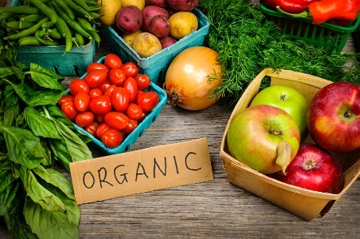 | 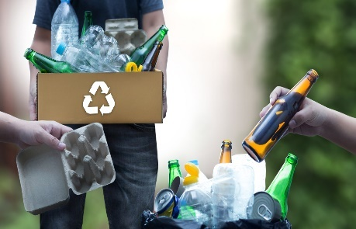 | 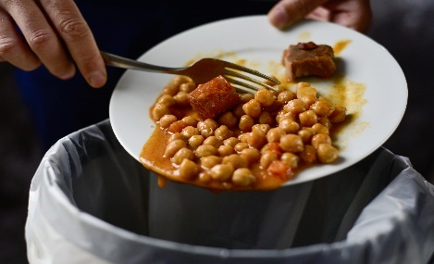
1. eat organic food | 2. recycle your rubbish | 3. get rid of your waste food
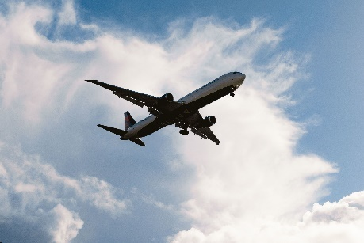 | 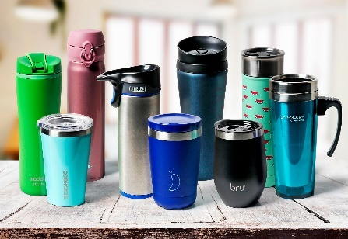 | 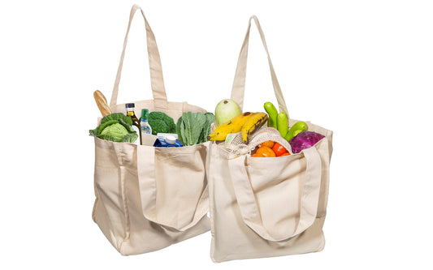
4. take few flights every year | 5. drink from usable cups | 6. shop with a cloth bag
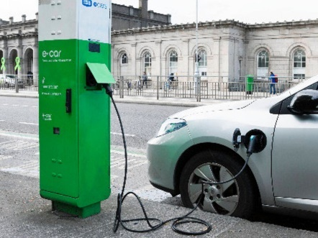 | 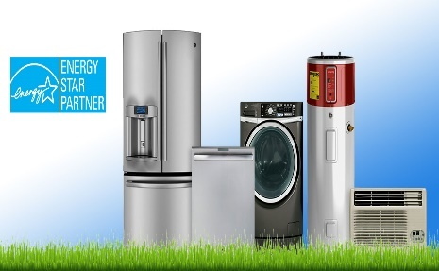 | 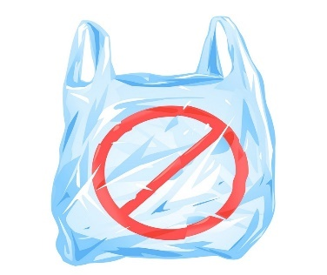
7. drive an electric car | 8. use energy-efficient devices | 9. stop using plastic bags

II. Work in groups. Make a poster about the ways to reduce carbon footprint at school. Then present to the class.

LESSON 3E WRITING

I. Rewrite the sentences using the given words.
1. warming/up/ global/ heating/ planet/is/ the/.
_________________________________________________________________________________________________________
2. ecosystems/ in/ problems/ many/ caused/ the/ rising/ have/.
_________________________________________________________________________________________________________
3. products/ try/ use/ we/ to/ energy-saving/ only/.
_________________________________________________________________________________________________________
4. gases/ we/ use/ cars/ should/ reduce/ to/ greenhouse/.
_________________________________________________________________________________________________________
5. air/ already/ in/ the/ CO2/ we/ should/ plant/ on/ down/ cut/ more/ trees/
_________________________________________________________________________________________________________

1. Global warming is heating up the planet.
2. The rising temperatures have caused many problems in ecosystems.
3. We must try to use only energy-saving products.
4. We should use electric cars to reduce greenhouse gases.
5. We should plant more trees to cut down on the CO2 already in the air.
II. Correct the mistake in each sentence.
1. They stopped contacting us for 2 weeks ago.
2. Sarah and I haven’t hung out last month.
3. I didn’t call any customers this morning. (It’s still in the morning.)
4. Jackson and Simon didn’t invite us to their parties since our argument.
5. Richard has gone to the zoo every weekend when he was a child.
Keys
1. They stopped contacting us 2 weeks ago.
2. haven’t hung → didn’t hang
3. didn’t call → haven’t called
4. didn’t invite → haven’t invited
5. has gone → went
II. Rewrite the sentences so that it has the same meaning with the provided sentences.
1. That old man has lived here for 10 years.
→ That old man moved___________________________________________________________________________.
2. She hasn’t texted me since the party.
→ She stopped_______________________________________________________________________________________.
(dùng ‘after’)
3. My sister started playing the guitar when she was 15.
→ My sister has______________________________________________________________________________________.
4. They stopped calling each other when she moved to Paris.
→ They haven’t_____________________________________________________________________________________.
5. Brian started doing yoga 6 years ago.
→ Brian has_________________________________________________________________________________________.
6. This is the first time I have seen such a beautiful house.
→ I ___________________________________________________________________________________________________.
7. I haven’t gone to school for 4 months because of covid-19.
→ The last time ______________________________________________________________________________________.
8. I have never visited Halong Bay before.
→ This is ___________________________________________________________________________________________.
9. How long have she lived in New York?
→ When ______________________________________________________________________________________________
10. He hasn’t smoked for 2 years.
→ It is _____________________________________________________________________________________________.
KEYS
1. That old man moved here 10 years ago.
2. She stopped texting me after the party.
3. My sister has played the guitar since she was 15.
4. They haven’t called each other since she moved to Paris.
5. Brian has done yoga for 6 years.
6. I have never seen such a beautiful house before.
7. The last time I went to school was 4 months ago.
8. This is the first time I have visited Halong Bay.
9. When did she start living in New York?
10. It is 2 years since he last smoked.

Tài liệu được chia sẻ bởi Website VnTeach.Com
https://www.vnteach.com

