

Tiết thứ ......
UNIT 10: ENERGY SOURCES
Lesson 5: Skills 1

Class | Date of teaching | Attendence
7... | ...../........./202....
7… | ..../......../202...
7…. | ..../......../202....
I. OBJECTIVES: By the end of this unit, students will be able to gain the following things:
1. Knowledge:
- Read for specific information about renewable and non-renewable sources of energy.
- Talk about advantages and disadvantages of different sources of energy
+ Vocabulary: - Use the vocabulary to talk about different sources of energy
+ Grammar:
2. Competence:
a) General competencies:
- Develop communication skills
- Be collaborative and supportive in pair work and team work
- Actively join in class activities
b) Specific competencies:
- Develop communication skills.
- Be cooperative and supportive in pair work and teamwork.
- Actively join in class activities.
3. Qualities:
- Be benevolent and responsible
- Develop self-study skills.
II. PREPARATIONS
- Teacher: Grade 7 text book, laptop, projector / TV/ pictures and cards.....
- Students : Text books, studying equipment….
III. PROCEDURE:
Notes: In each activity, each step will be represented as following:
* Deliver the task.
* Implement the task.
* Discuss.
* Give comments or feedback.
Activity 1. WARM UP (5’-IW, GW)
* Aim:
To introduce the topic of reading.
To lead in the lesson.
* Content: Playing a game: Hangman
* Product: Having a chance to speak English and focus on the topic of the lesson..
* Implementation: Teacher’s instructions…
Teacher’s & Student’s activities | Content
Game: Hangman  R E N E W A B L E  * Teacher divides class into 2 teams and asks them to think of the word which has 9 letters in it related the topic “ENERGY SOURCES”.  ** Ss have 1 min to think of the words related to the topic or they can discuss with their partners.  *** Each member from each team turn by turn guesses the letter in the secret word.  **** Teacher corrects their answers.  - The team which can find or guess the secret first will be the winner.  READING  - Teacher leads students into the lesson by telling what they are going to learn: “We are going to read a passage about renewable and non-renewable source of energy.” | R E N E W A B L E
Activity 2. KNOWLEDGE FORMATION (15'- PW, IW)
* Aim:
To provide students with some lexical items before reading the text
To introduce words related to skin conditions to Ss and help Ss have a general idea of what they are going to read
* Content: Teach some new words.
* Product: Knowing more new words. Understanding the conversation; topic of the lesson, grammar points…
* Implementation: Teacher’s instructions…
Teacher’s & Student’s activities | Content
* Vocabulary  - - Teacher introduces the vocabulary by:  + Providing the definition of the words and gives examples  Concept check: Rub out and Remember technique  * DISCUSSION:  * Teacher asks Ss to work in pairs to look at the Picture in Ex1 and discuss to answer the questions.  ** Ss work in pairs.  *** Teacher calls some Ss to check what they have discussed.  **** Teacher corrects | * Vocabulary  - produce (v) /prəˈdjuːs/ sản xuất  = to make things, mostly in large quantity  Examples: Companies produce many toys for children before Christmas.  - limited (a) /ˈlɪmɪtɪd/ bị hạn chế  = not very great in amount or extent  Examples: coal, oil, …  - available (a) /əˈveɪləbl/ có sẵn  = that you can get, buy or find  Examples: The coal takes a long time to be available again.  * DISCUSSION:  Suggested keys:  1. Coal, oil, hydro,…  2. Wind, solar,…  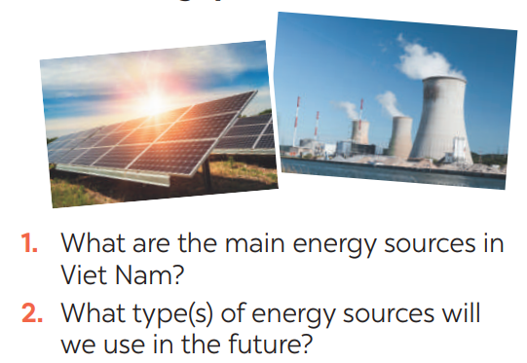
Activity 3. PRACTICE (15’-IW, PW, GW)
* Aim:
- To help Ss develop their reading skill for details and specific information (skimming and scanning)
- To help Ss further develop their reading skill for specific information (scanning).
- To check students’ reading comprehension.
- To help Ss talk about how they apply the rules in the reading to themselves.;
- To provide Ss an opportunity to ask and answer questions about the advantages and disadvantages of different types of energy sources.
* Product: Ss can learn how to do the exercises.
* Implementation: Teacher’s instructions…
Teacher’s Student’s activities | Content
Task 1: Read the text and choose the best option to complete the sentences.  * Teacher gives Ss time to: read each question, locate where the information appears in the text, read that part carefully and circle the correct answer.  ** Ss do the task independently  *** Teacher tells Ss to compare their answers in pairs before calling some of them to check.  **** Teacher confirms the correct answer and explains if needed.  1. Non-renewable sources are cheap  and ______.  A. available  B. easy to use  C. expensive  2. ______ come from the sun, wind or water.  A. Renewable sources  B. All energy sources  C. Non-renewable sources  3. When energy comes from water,  we call it ______.  A. wind energy  B. solar energy  C. hydro energy  4. Renewable energy sources are better  for ______.  A. the environment  B. our cars  C. hydro energy  Task 2: Read the text again and answer  the questions  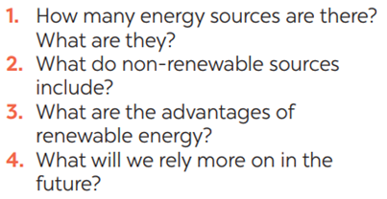*Teacher asks Ss to do the exercise carefully and individually.  ** Ss do the task independently.  *** Teachers has Ss compare their answers in pairs and call some Ss to give their ideas.  **** Teacher checks and confirms the correct answers. | 1. Read the email and match the highlighted words with their meanings. (Ex 2, p. 46)  Answer key:  1. B 2. A 3. C 3. A  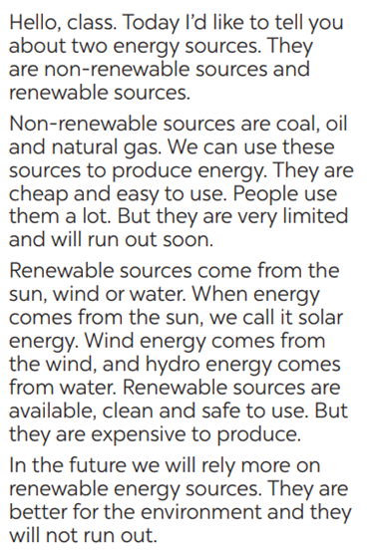  Task 2: Read the text again and  Answer key:  1. There are two energy sources. They  are non-renewable sources and renewable sources.  2. Non-renewable sources are coal, oil  and natural gas.  3. Renewable sources are available, clean and safe to use.  4. In the future, we will rely more on  renewable energy sources.
Task 3: Work in groups. Discuss and put the following words or phrases in the appropriate columns.  * Teacher asks Ss to work in groups and tells them to focus on the table.  ** Ss work in groups. Teacher goes around and listens and gives help if needed.  *** Teacher calls on some Ss to share their answers with the class. Teacher encourages  **** Teacher listens and corrects if needed  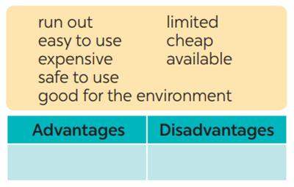 | Task 3: Work in groups. Discuss and put the following words or phrases in the appropriate columns.  Answer key:  Advantages: easy to use, safe to use, good for environment, cheap, available  Disadvantages: run out, expensive, limited, cheap
Task 4: Work in pairs. Ask and answer questions about the advantages and disadvantages of different energy sources  * Teacher has Ss work in pairs and asks them to take turns to ask and answer  ** Ss work in pairs to do the task. Teacher goes around, listens and gives help if needed.  *** Teacher calls on some pairs to share their answers with the class.  **** Teacher comments and correct | Task 4: Work in pairs. Ask and answer questions about the advantages and disadvantages of different energy sources  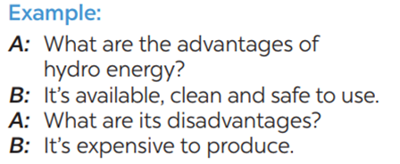
Activity 4. APPLICATION (7’-IW, PW, GW)
* Aim:
- To help students practice presenting the advantages and disadvantages of different types of energy source
- To consolidate what students have learnt in the lesson.
- To prepare for the next lesson Skills 2.
- To consolidate what students have learnt in the lesson.
* Content: Students talk about practice presenting the advantages and disadvantages of different types of energy source
* Product: Students’s dialogues.
* Implementation: Teacher’s instructions
Task 5: Give the advices on dangerous situations on the road.  * Teacher has students work in groups to prepare a presentation (poster/pictures/notes…)  *** Teacher calls on some groups to share their answers with the class.  **** Teacher comments and corrects if needed.  Consolidation  Teacher asks students to talk about what they have learnt in the lesson  * Home assignment  - Do exercises in the workbook.  - Prepare for the next lesson: Skills 2. | Task 5: Give the advices on dangerous situations on the road.  * Home assignment  - Do exercises in the workbook.  - Prepare for the next lesson: Skills 2.
V. FEEDBACK:
With 7 ……………………………………………………………………………..…
With 7…………………………...……………………………………..……………
With 7………………………………………………………………………….……

