UNIT 9: CITIES OF THE WORLD
Lesson 1: Getting Started – What nice photos!

  - I. Objectives
By the end of this lesson, students will be able to:

1. Knowledge
- Use the lexical items related to the topic Cities of the World
- Use the vocabulary and structures to describe cities and landmarks

2. Core competence
- Develop communication skills and creativity
- Be collaborative and supportive in pair work and team work
- Actively join in class activities

3. Personal qualities
- Develop self-study skills

II. Materials
- Grade 6 textbook, Unit 9, Getting started
- Computer connected to the Internet
- Projector/ TV/ pictures and cards
- hoclieu.vn

  - Language analysis
Form | Meaning | Pronunciation | Vietnamese equivalent
1. rainy (adj) | having or bringing a lot of rain | /ˈreɪni/ | trời có mưa
2. crowded (adj) | having a lot of people or too many people | /ˈkraʊdɪd/ | đông đúc
3. beautiful (adj) | having beauty; giving pleasure to the senses or to the mind | /ˈbjuːtɪfl/ | xinh đẹp
4. interesting (adj) | attracting your attention because it is/they are special, exciting or unusual | /ˈɪntrestɪŋ/ | thú vị
5. exciting (adj) | ​causing great interest or excitement | /ɪkˈsaɪtɪŋ/ | hào hứng

Anticipated difficulties | Solutions
1. Students may lack knowledge and experiences about the topic. | - Prepare some hand-outs in which key language of the key language of describing tourist attractions.
2. Students may have underdeveloped listening, speaking and co-operating skills. | - Play the recording many times if any necessary.  - Encourage students to work in pairs, in groups so that they can help each other.  - Provide feedback and help if necessary.

  - Board Plan
Date of teaching
UNIT 9: CITIES OF THE WORLD
Lesson 1: Getting started
* Warm-up
Matching game: Cities and Continents

I. Vocabulary
1. rainy (adj)
2. crowded (adj)
3. beautiful (adj)
4. interesting (adj)
5. exciting (adj)

II. Practice
Task 1: Listen and read.
Task 2: Write the names of the cities in the correct places.
Task 3: Read the conversation again and match the cities with the adjectives describing them.
Task 4: Match the cities with their landmarks.
Task 5: Game – What city is this?

* Homework

Procedure

Stage | Stage aim | Procedure | Interaction | Time
Warm-up | - To set the context for the listening and reading text.  - To introduce the topic of the unit.  - To enhance students’ skills of cooperating with team mates. | * Matching game:  - Teacher divides students into 5 groups and  delivers a set of 10 pictures about cities in 5 continents.  - Each group will be assigned the name of the 5 continents.  - Students will have to pick up the pictures and stick them to their  appropriate continent.  - The group which completes the given task the fastest and correctly will be the winner.  Answer key:  Group 1: Africa    Casablanca  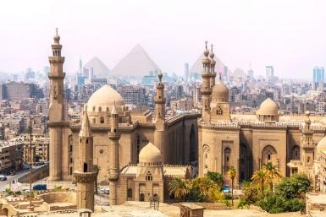  Cairo  Group 2: America    New York  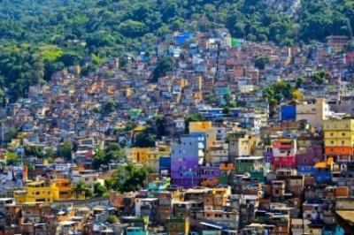  Rio De Janeiro  Group 3: Asia  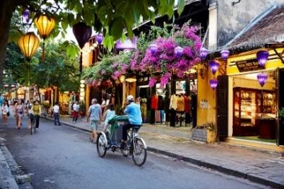  Hoi An    Singapore  Group 4: Europe  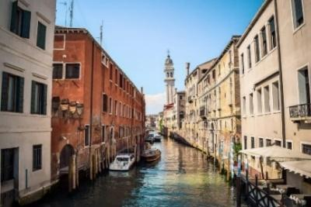  Venice    Paris  Group 5: Oceania    Sydney    Melbourne | Group work | 5 mins
Lead-in | To lead in the topic of cities and their landmarks. | - Teacher draws students’ attention to the picture in the textbook and asks them questions about the picture to introduce the land:  - What are Mai and Tom doing?  - What are they looking at?  - What is the name of the city?  - What landmark is in the picture?  Suggested answers:  - They are talking to/ discussing with each other.  - They are looking at the computer screen/ some photos/ pictures about places around the world.  - It’s Sydney in Australia.  - It’s the Opera House. | T-Ss | 2 mins
Presentation  (Vocab-  pre-teach) | - To intruduce the  vocabulary apprearing in the next.  - To help students  well-prepared for the listening and reading tasks. | VOCABULARY  - Teacher introduces the vocabulary by:  + showing the pictures illustrating the words;  + providing the synonym or antonym of the words;  + providing the definition of the words.  1. rainy (adj): [picture]  2. crowded (adj): [picture]  3. beautiful (adj): [picture]  4. interesting (adj): [synonym] 🡪 fascinating (adj)  5. exciting (adj): [antonym] 🡪 unexciting (adj)    rainy  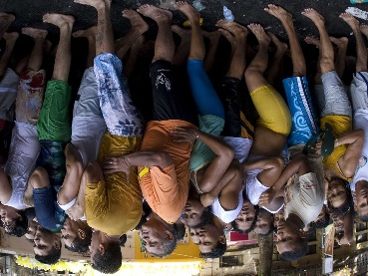  crowded    beautiful | T-Ss | 5 mins
Practice | To practice the targeted language  (adjectives) and the  background knowledge of cities in the world.  To help students identify the location of the cities mentioned in the  conversation on a map.  To help students  focus on the use of  adjectives to  describe cities.  To help students  visualize some  landmarks of the cities mentioned in the  conversation. | Task 1: Listen and read.  - Teacher sets the context for the listening and reading text:  + Teacher asks students to look at the title of the conversation and the picture.  + Teacher asks them some brainstorming questions like:  1. What do you think Mai and Tom are talking about?  2. What city can you recognize from the  photos?  3. What is it famous for? etc.  - Teacher encourages students to give their answers, but do not  confirm whether their answers are right or wrong.  - Teacher play the recording, asks students underline the words they have learn in the vocabulary part.  - Teacher can play the recording more than once.  - Students listen and read.  - Teacher invites some pairs of students to read the dialogue aloud.  - Teacher has students say the words in the text that they have underlined.  Task 2: Write the names of the cities in the correct places.  - Teacher tells students to look at the photos and the text in order to find the answers.  - Students work independently.  - Teacher allows students to share their answers before discussing as a class.  - Teacher asks students to support their answers or encourages them to provide more information about the 3 cities.  Answer key:  - London  - New York  - Sydney  Task 3: Read the conversation again and match the cities with the adjectives describing them.  - Teacher has students read the conversation again, underline the names of the cities and mark the adjectives which were previously underlined in Task 1 to find the answers.  - Students work independently.  - Teacher allows students to share their answers before discussing as a class.  - Teacher asks students to support their answers or encourages them to provide more adjectives to describe the 3 cities.  Answer key:  1. Sydney:  - c – exciting  - d – beautiful  2. London:  - a – rainy  3. New York:  - b – crowded  - e – interesting  Task 4: Match the cities with their landmarks.  - Students can work in pairs to complete this task.  - After matching the cities with their landmarks, students discuss with each other to find the names of the landmark either appearing in the pictures or in the cities.  Answer key:  1. Ha Noi – c  2. London – d  3. New York – a  4. Sydney – b | T-Ss  T-Ss  T-Ss  S  T-Ss  T-Ss  S  Ss-Ss  T-Ss  Pair work  S  T-Ss | 15 mins
Production | To give students a fun time revising what they have learnt so far in the lesson. | Task 4 (Cont.): Match the cities with their landmarks.  - After matching the cities with their landmarks, students work in groups of four discuss with each other to find the names of the landmark either appearing in the pictures or in the cities.  - Students can choose a landmark or a city to present about it.  Suggested answers:  1. Ha Noi: One Pillar Pagoda, The Old  Quarter, The Temple of Literature and Imperial Academy, Ho Chi Minh Mausoleum, Ha Noi Flag Tower, Ba Dinh Square, etc.  2. London: Houses of Parliament, Buckingham Palace, Trafalgar Square, Piccadilly Circus, The London Eye, Tower Bridge, The British Museum, St Paul’s  Cathedral, The Thames, etc.  3. New York: Statue of Liberty, Central Park, Brooklyn Bridge, Broadway, Empire State Building, Times Square, etc.  4. Sydney: Sydney Opera House, Sydney Harbour Bridge, Sydney Observatory, Museum of Contemporary Art  Australia, Art Gallery of New South Wales, Hyde Park Barracks, Sydney Tower Eye, Sydney Town Hall, Queen Victoria Building, St Mary's  Cathedral, etc.  Task 5: Game – What city is this?  - Teacher models the game by asking students to guess the picture she is holding with the whole class first.  Example:  Teacher: Can you guess the city in the picture?  A student: What’s it like?  Teacher: It has beautiful beaches.  A student: Is it in Australia?  Teacher: Yes, it is.  A student: It’s Sydney.  Teacher: Right!  - Teacher can deliver the pictures used in the Warm-up part to students so that they can have visual aids to play the game.  - Students play the game in groups of four. Every student will have to ask questions, provide information and find the answers. | Gourp work  T-Ss  Group work | 15 mins
Wrap-up | To consolidate what  students have learnt in the lesson. | Teacher asks students to talk about what they have learnt in the lesson. | T-Ss | 2 mins
Homework | To prepare vocabulary for the next lesson: A closer look 1. | Go to the Internet and search for the information on your favourite cities in the world (food, people, weather, etc.) | T-Ss | 1 min

UNIT 9: CITIES OF THE WORLD
Lesson 2: A closer look 1

  - I. Objectives
By the end of this lesson, students will be able to:

1. Knowledge
- Use the lexical items related to the topic Cities of the World
- Use the vocabulary and structures to talk cities and landmarks
- Pronounce and recognize the sounds /əʊ/ and /aʊ/

2. Core competence:
- Be collaborative and supportive in pair work and team work
- Access and consolidate information from a variety of sources
- Actively join in class activities

3. Personal qualities
- Develop self-study skills

II. Materials
- Grade 6 textbook, Unit 9, A closer look 1
- Computer connected to the Internet
- Projector/ TV/ pictures and cards
- hoclieu.vn

Language analysis

Form | Pronunciation | Meaning | Vietnamese equivalent
1. sunny (adj) | /ˈsʌni/ | with a lot of bright light from the sun | trời có nắng
2. delicious (adj) | /dɪˈlɪʃəs/ | having a very pleasant taste or smell | ngon
3. stall (n) | /stɔːl/ | a table or small shop with an open front that people sell things from, especially at a market | gian hàng, quầy hàng
4. palace (nph) | /ˈpæləs/ | the official home of a king, queen, president, etc. | cung điện, lâu đài
5. street food (nph) | /ˈstriːt fuːd/ | ​prepared or cooked food sold by vendors in a street or other public location for immediate consumption. | thức ăn đường phố
6. floating market (nph) | ˈfləʊtɪŋ mɑːrkɪt/ | an outdoor market on the rivers | chợ nổi trên sông

Anticipated difficulties | Solutions
1. Students may lack knowledge about some lexical items. | Provide students with the meaning and pronunciation of some lexical items.
2. Students may have underdeveloped listening, speaking and co-operating skills. | - Play the recording many times if any necessary.  - Encourage students to work in pairs, in groups so that they can help each other.  - Provide feedback and help if necessary.
3. Some students will excessively talk in the class. | - Define expectations in explicit detail.  - Have excessively talking students practise.  - Continue to define expectations in small chunks (before every activity).

Board Plan
Date of teaching
UNIT 9: CITIES OF THE WORLD
Lesson 2: A closer look 1
* Warm-up
Name the pictures

I. Vocabulary
1. sunny (adj)
2. delicious (adj)
3. stall (n)
4. palace (n)
5. street food (nph)
6. floating market (nph)
Task 1: Fill each box with an adjective.
Task 2: Complete the sentences with the words in Task 1.
Task 3: Write the words and phrases under the correct pictures.

II. Pronunciation
Task 4: Listen and write the words in the correct column. Then listen and repeat.
Task 5: Listen and repeat. Pay attention to the underlined words.

III. Production
Whispering game

* Homework

Procedure

Stage | Stage aim | Procedure | Interaction | Time
Warm-up | - To activate students’ prior knowledge and vocabulary related to the topic, the targeted vocabulary and its pronunciation.  - To enhance students’ skills of cooperating with team mates. | * Name the pictures  - Teacher divides students into 4 groups and delivers a set of 4 pictures about famous landmarks in the world.  - Teacher shows pictures one by one and asks students to raise hands to give the correct names and spelling of the landmarks.  - The fastest group raising their hands will get the chance to answer first.  - Teacher gives 10 points for the group that gives the correct answers.  - The group getting the highest points will be the winner.  Answer key:  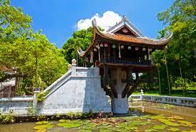  One Pillar Pagoda  /pəˈɡəʊdə/    Twin Tower  /taʊər/  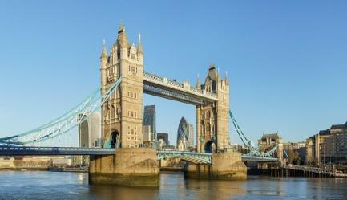  Tower Bridge  /taʊər/    Sydney Opera House  /haʊs/ | Group work | 5 mins
Lead-in | To lead in the lesson about vocabulary and pronunciation. | Teacher leads students into the lesson by telling them that “In today lesson, we are going to learn more words to describes cities and two sounds /əʊ/ and /aʊ/.” | T-Ss | 2 mins
Presentation  (Vocab-  pre-teach) | To teach students some adjectives describing a city. | VOCABULARY  - Teacher introduces the vocabulary by:  + providing the synonym or antonym of the words;  + providing the pictures of the words.  - sunny (adj): [antonym] -> rainy  - delicious (adj): [synonym] -> tasty  - stall (n): [picture]  - palace (n): [picture]  - street food (nph): [picture]  - floating market (nph): [picture]  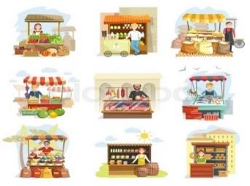  stall    palace | T-Ss | 5 mins
Practice | To teach students some adjectives describing a city.  To help students use the adjectives in Task 1 in a context.  To teach students some words/ phrases related to a city. | Task 1: Fill each box with an adjective.  - Teacher asks students to use the given words to fill in the suitable boxes in 2 minutes.  - Students do the task.  - Teacher calls some students to give their answers.  - Teacher gives feedback and corrections (if necessary).  Answer key:  - City: old, exciting  - Food: tasty, delicious  - People: friendly,  helpful  - Weather: rainy, sunny  Task 2: Complete the sentences with the words in Task 1.  - Teacher asks students to work in pairs and use the word in Task 1 to complete the sentences.  - Students work in pairs and do the task.  - Teacher calls some pairs to share their  answers with the whole class.  - Teacher gives feedback and corrections (if necessary).  Answer key:  1. sunny  2. old  3. exciting  4. friendly  5. tasty/ delicious  Task 3: Write the words and phrases under the correct pictures.  - Teacher asks students to match the given words and phrases with correct pictures.  - Students work independently.  - Teacher allows students to share their answers before discussing as a class.  - Teacher asks some students to share the answers and gives corrections (if necessary).  Answer key:  1. Palace  2. Floating market  3. Street food  4. Stall | T-Ss  S  T-Ss  Pair work  T-Ss  T-Ss  S  Ss-Ss  T-Ss | 15 mins
Presentation  (Pre-teach the sounds /əʊ/ and /aʊ/.) | To help students have concept and identify the sounds /əʊ/ and /aʊ/. | PRONUNCIATION  - Teacher introduces 2 sounds /əʊ/ and /aʊ/ to students and lets them watch a video about how to pronounce these two sounds.  - Teacher asks students to give some words they know containing these sounds  Suggested answers:  - /əʊ/: cold, close, drove, low, slow, show.  - /aʊ/: how, now, loud, cloud, sound, house. | T- Ss | 5 mins
Practice | To help students identify and practise the /əʊ/ and /aʊ/ sounds.  To help students practice the sounds /əʊ/ and /aʊ/ in sentences. | Task 4: Listen and write the words in the correct column. Then listen and repeat.  - Teacher asks students to read and write the words in correct column.  - Students work individually.  - Teacher plays the recording for students to listen, repeat and check their answers.  Answer key:  /əʊ/  boat, postcard, coast, pagoda  /aʊ/  house, town, tower, crowded  Task 5: Listen and  repeat. Pay attention to the underlined words.  - Teacher plays the recording for students to listen and asks students to repeat the sentences after they listen.  - Students listen and repeat the given  sentences. | T-Ss  S  T- Ss  T-Ss | 5 mins
Production | To give students chance to apply what they have learnt. | Game: Whispering  - Teacher divides the class into 4 big groups and asks students to stand in four lines.  - The member in the last place will make a  sentence containing at least a word and a sound they have learnt; then, whisper the sentence to the next member of the group. They will continue until the member in the first place and this member will say the sentence aloud.  - The fastest group will win the game.  Suggested sentences:  - The house is very old.  - I visited a famous floating market.  - He lives in an old house. | Group work | 5 mins
Wrap-up | To consolidate what students have learnt in the lesson. | Teacher asks students to talk about what they have learnt in the  lesson. | T-Ss | 2 mins
Homework | To revise what they have learnt. | Find 5 more words with the sound /əʊ/ and 5 more words with the sound /aʊ/. Write them down and practice  pronouncing the words. | T-Ss | 1 min

UNIT 9: CITIES OF THE WORLD

Lesson 3: A closer look 2
Possessive adjectives & Possessive pronouns

  - I. Objectives
By the end of this lesson, students will be able to:

1. Knowledge
- Use possessive adjectives and possessive pronouns correctly

2. Core competence
- Develop communication skills
- Be collaborative and supportive in pair work and team work
- Actively join in class activities

3. Personal qualities
- Develop self-study skills

II. Materials
- Grade 6 textbook, Unit 9, A closer look 2
- Computer connected to the Internet
- Projector/ TV/ pictures and cards
- hoclieu.vn

Language analysis
Form | Meaning | Example
my, your, his, her, its, our, their | a possessive adjective is used only when there is a noun following it. | News is my favourite programme.
mine, yours, his, hers, its, ours, theirs | a possessive pronoun is used alone, without a noun following it. | My favourite programme is different from yours.

Anticipated difficulties | Solutions
1. Students may lack knowledge and experiences about the topic. | Prepare some hand-outs in which key language of the key language of describing tourist attractions.
2. Some students will excessively talk in the class. | - Define expectations in explicit detail.  - Have excessively talkative students practise.  - Continue to define expectations in small chunks (before every activity).

Board Plan
Date of teaching
Unit 9: Cities of the world
Lesson 3: A closer look 2
* Warm-up
Game: Sentence puzzling

I. Grammar focus
Possessive adjectives
Task 1: Match the sentences with the pictures, paying attention to the underlined part in each sentence.
Possessive pronouns

II. Practice
Task 2: Complete the sentences with the correct possessive adjectives.
Task 3: Complete the sentences with the correct possessive pronouns.

III. Production
Task 4: Kahoot game
* Homework

Procedure

Stage | Stage aim | Procedure | Interaction | Time
Warm-up | - To activate students’ prior knowledge and vocabulary related to the targeted grammar of possessive adjectives, possessive pronouns and to increase students’ interest.  - To enhance students’ skills of cooperating with team mates. | * Game: Sentence puzzling  - Teacher divides the class into 4 groups.  - Teacher delivers a set of word cards which contains possessive adjectives and possessive pronouns to each group.  - Students will have to work in groups to create as many correct sentences from the word cards as possible.  - The group with more correct sentences will be the winner.  Suggested answers:  1. My city is very beautiful.  2. His house is very big.  3. Our school has a big garden.  4. Your school is smaller than mine.  5. My shoes are bigger than hers. | Group work | 5 mins
Lead-in | To introduce targeted grammar of possessive djectives, possessive pronouns. | - Teacher draws students’ attention to the words in the sentences created in the game “my, his, our, your, mine, hers” and asks them whether they know the types of these words.  - Teacher provides or confirms the answers and leads in the grammar  focus of the lesson:  “The words “my, his, our, your” are possessive adjectives. The words “mine, hers” are possessive pronouns.  Today we are going to learn more about possessive adjectives, possessive pronouns.” | T-Ss | 2 mins
Presentation | To help students  revise the use of  possessive adjectives.  To help  students revise the use of possessive pronouns. | 1. Possessive adjectives:  Task 1: Match the sentences with the pictures, paying attention to the underlined part in each sentence.  - Teacher has students complete the matching activity individually.  - Teacher then asks students to exchange their textbooks to check their friends’ answers.  Answer key:  1 – d  2 – e  3 – b  4 – a  5 – c  - Teacher draws students’ attention to the underlined words and to confirm the use of possessive adjectives:  “A possessive adjective is used only when there is a noun following it.”  - Teacher then asks students to work in pairs to provide all possessive adjectives except for the ones in the sentences.  Suggested answers:  my, your (singular), your (plural), his, her, its, our, their  2. Possessive pronouns:  Teacher draws students’ attention to the underlined words in the following  sentence, and encourage them to say the sentence in a different way that does not change the meaning of it.  “This book is my book, not your book.”  Suggested answer:  “This book is mine, not yours.”  - Teacher gives feedback and confirms the use of possessive pronouns:  “A possessive pronoun is used alone, without a noun following it.”  - Teacher then asks  students to work in pairs to provide all possessive pronouns except for the ones in the sentence.  Suggested answer:  mine, yours (singular), yours (plural), his, hers, its, ours, theirs  - Teacher has students work in groups of 4 to create a chart/ mind map showing all possessive  adjectives and possessive pronouns including their relation.  Suggested answers:  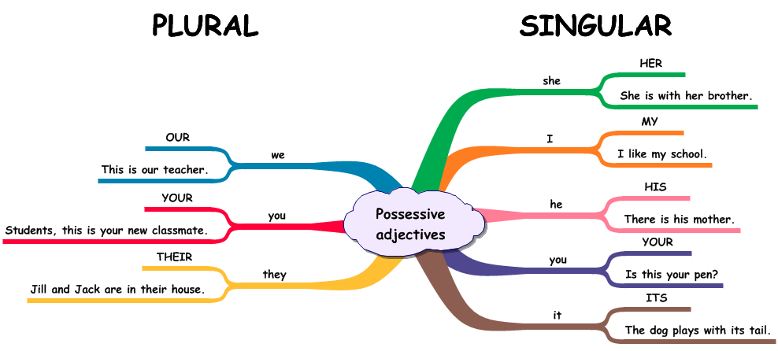  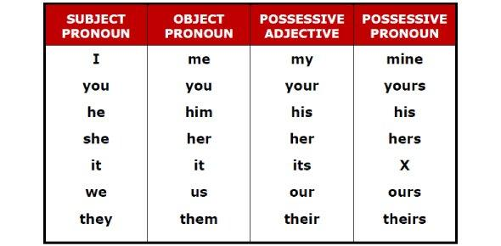 | S  Ss-Ss  T-Ss  Pair work  T-Ss  Pair work  Group work | 15 mins
Practice | To give students  opportunities to use  possessive adjectives correctly in context.  To help determine the correct possessive pronoun  representing a phrase. | Task 2: Complete the sentences with the correct possessive adjectives.  - Teacher has students work on the exercise individually before they compare answers with each other.  - Teacher gives feedback as a class discussion.  Answer key:  1. My  2. your  3. Their  4. Her  5. Our  Task 3: Complete the  sentences with the correct possessive pronouns.  - Teacher has students work on the exercise individually before they compare answers with each other.  - Teacher gives feedback as a class discussion.  Answer key:  1. mine  2. theirs  3. yours  4. his  5. ours | S  T-Ss  S  T-Ss | 10 mins
Production | To help students  distinguish and use  correctly possessive adjectives and  possessive pronouns. | Task 4: Kahoot game. Choose the best option to complete the questions in the game.  - Teacher combines Exercise 4 and Exercise 5 (p. 30) to create questions in Kahoot game.  - Teacher allows students to use their mobile devices to answer and interact with thequestions online.  - Teacher gives clear instruction for students to fully understand how to play Kahoot game online.  → Go to kahoot.it  → Enter the game PIN  → Type your nick name  → Choose the best option for each question appearing on the screen  → See who will be the winner  - Teacher provides the game PIN and allows students’ access to the game.  - Students choose the best option for each question appearing on the screen  - Teacher gives complement or good mark to the winner of the game.  * Questions in the game:  1. Australia is a strange country. All of _____ big cities are along the coast.  A. it’s B. its  C. it is D. it  2. Our city is very crowded. How about _________?  A. you B. your  C. yours D. you are  3. I love my football club. Does Phong like ______?  A. his B. him  C. he is D. he  4. ______ street is short and narrow.  A. Our B. We  C. Us D. Ours  5. They cannot find _____ city map anywhere.  A. their B. them  C. theirs D. they  6. The book is ________, but you are welcome to read it.  A. my B. mine  C. yours D. yours  7. _______ bike is dirty, and I can’t tell what colour is it.  A. Your B. Yours  C. You D. You are  8. Your country is much bigger than _________.  A. our B. their  C. ours D. yours  9. _______ dog is so friendly. It never barks.  A. They B. Them  C. Their D. Theirs  10. _______ not easy to find your way in a strange city.  A. It B. It’s  C. Its D. There  Answer key:  1. B  2. C  3. A  4. A  5. A  6. B  7. A  8. C  9. C  10. B | T-Ss | 10 mins
Wrap-up | To consolidate what  students have learnt in the lesson. | Teacher asks students to talk about what they have learnt in the lesson. | T-Ss | 2 mins
Homework | Reactivate the knowledge that students have gained in the Kahoot game. | Do Exercise 4 and Exercise 5, write the answers on the notebooks. | T-Ss | 1 min

UNIT 9: CITIES OF THE WORLD

Lesson 4: Communication

  - I. Objectives
By the end of this lesson, students will be able to:

1. Knowledge
- Make an exclamation with What to express their appreciation or surprise
- Recognise and have knowledge about some famous landmarks in big
cities

2. Core competence
- Develop creativity and communication skills
- Be collaborative and supportive in pair work and team work
- Actively join in class activities

3. Personal qualities
- Develop self-study skills

II. Materials
- Grade 6 textbook, Unit 9, Communication
- Computer connected to the Internet
- Projector/ TV/ pictures and cards
- hoclieu.vn

Language analysis

Anticipated difficulties | Solutions
1. Students may lack knowledge about some landmarks. | Provide students with information about the landmarks they do not know.
2. Students may have underdeveloped reading, speaking and co-operating skills. | - Encourage students to work in pairs, in groups so that they can help each other.  - Provide feedback and help if necessary.
3. Some students will excessively talk in the class. | - Define expectations in explicit detail.  - Have excessive talking students practise.  - Continue to define expectations in small chunks (before every activity).

Board Plan

Date of teaching
Unit 9: Cities of the world
Lesson 4: Communication
* Warm-up
Picture describing

I. Everyday English
Exclamations with What
Structure: What + (a/an) + adj + noun!
Task 1: Work in pairs. Look at the picture and say what you think by using
exclamation with What.
Game: Sentence race

II. City landmarks
Task 2: Work in pairs. Write the names of the landmarks under the correct
pictures.
Task 3: Write the names of the landmark in Task 3 for the descriptions.

Game: Lucky number
* Homework

Procedure

Stage | Stage aim | Procedure | Interaction | Time
Warm-up | To introduce the topic. | * Pictures describing:  - Teacher shows the picture of a city and asks students describe as many things in the picture as possible.    - Students give their answers.  - Teacher checks the answer.  Suggested answers:  A green city  High buildings  A beautiful city  A beautiful sky | T-Ss | 3 mins
Lead-in | To lead in the lesson about vocabulary and pronunciation. | Teacher leads students into the lesson by telling about what they are going to learn: “We are going to learn how to express exclamation with what and city land marks”. | T-Ss | 2 mins
* EVERYDAY ENGLISH
Presentation | To introduce exclamations with What. | * Expressing  exclamations with What  - Teachers write down three exclamations on the board and asks students to find the similarity/ similarities among the three  exclamations.  - Students read the exclamations and find out the similarity/ similarities among them.  - Teacher calls some students to share their opinions.  - Teacher gives more explanations and writes down the structure of an exclamation with What.  Three exclamations:  1. What a nice day!  2. What a clear sky!  3. What tall buildings!  Suggested answers:  They all begin with What followed by a noun phrase. An exclamation mark (!) is usually put at the end.  Structure: What + (a/an) + adj + noun!  *Note: use a/an with countable nouns which are singular. | T-Ss | 5 mins
Practice | To practice making  exclamations with What. | Task 1: Work in pairs. Look at the picture and say what you think by using exclamation with What.  - Teacher asks students to work in pairs and take turns to make exclamations from the picture using the suggestions.  - Students do the task in pairs.  - Teacher calls some pairs to say their  exclamations in front of the class.  - Teacher gives feedback and corrections (if  necessary).  Answer key:  1. What happy and beautiful children!  2. What a colourful and nice picture!  3. What sunny and beautiful weather!  4. What a small and cute boy!  5. What beautiful and colourful apple trees! | Pair work  T-Ss | 5 mins
Production | To apply the knowledge about exclamation with What. | Game: Sentence race  - Teacher prepares some pieces of paper with some nouns written on that.  - Teacher divides the class into 2 big groups and gives each group a piece of A3 paper.  - A representative of each group will take turns to choose a piece of paper and read aloud the word for the whole group to listen. Then, the group will have 2 minutes to write down as many exclamations with What as possible using the chosen word.  - The group with more correct answer will be the winner.  ● List of nouns:  cities  food  weather  girl | Group work | 5 mins
* CITY LANDMARKS
Presentation | To help students get used to some famous  landmarks in big cities. | Task 2: Work in pairs. Write the names of the landmarks under the correct pictures.  - Teacher shows the photos of the four landmarks of different cities and asks  students what they are. If students do not know their name in English, allow them to use Vietnamese.  - 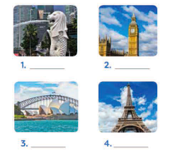  - Teacher asks students to work in pairs, read the names in the boxes (make sure that they pronounce the names correctly) and write the correct name under the pictures of the landmarks.  - Students share the answer with the whole class.  - Teacher checks and elicits from students any information they know about the l  andmarks.  Answer key:  - Merlion  - Big Ben  - Sydney Opera House  - Eiffel Tower | T- Ss  Pair work  Ss-Ss  T-Ss | 5 mins
Practice | To help students recognise each landmark through its description. | Task 3: Write the names of the landmark in Task 2 for the descriptions.  - Teacher asks students to read the  descriptions about the four landmarks and sets the time limit for reading task.  - Students work individually and write the names of the landmarks under the correct descriptions.  - Teacher calls some students to give their answers and checks.  Answer key:  - Big Ben  - Sydney Opera House  - Eiffel Tower  - Merlion | T-Ss  S  T-Ss | 5 mins
Production | To check how much students know about different cities and their landmarks. | Game: Lucky number  - Teacher divides the class into 2 big groups.  - Each group will take turns to choose a number and answer the question in each number. There will be 4 questions in Exercise 5 page 31.  - If the answer is correct the group will receive 10 points. If no, the other group will have chance to answer the question and get 5 points.  - There will be one lucky number that gives the group 10 points without answering the  question.  - The group with higher scores will win the game.  Answer key:  1. B  2. A  3. C  4. A | Group work | 7 mins
Wrap-up | To consolidate what students have learnt in the lesson. | Teacher asks students to talk about what they have learnt in the lesson. | T-Ss | 2 mins
Homework | To prepare for the next lesson Skills 1. | Choose a city (Berlin, Bangkok,…) and find out the information about the city (the weather, the food, landmarks,…). | T-Ss | 1 min

UNIT 9: CITIES OF THE WORLD

Lesson 5: Skills 1

  - I. Objectives
By the end of this lesson, students will be able to:

1. Knowledge
- Develop reading skill for general and specific information
- Identify different features of a place
- Use what they have learnt to talk about a city

2. Core competence
- Develop communication skills and creativity
- Be collaborative and supportive in pair work and team work
- Develop presentation skill
- Actively join in class activities

3. Personal qualities
- Develop self-study skills

II. Materials
- Grade 6 textbook, Unit 9, Skills 1
- Computer connected to the Internet
- Projector/ TV/ pictures and cards
- hoclieu.vn

  - III. Language analysis
Form | Meaning | Pronunciation | Vietnamese equivalent
1. postcard (n) | a card used for sending messages by post without an envelope, especially one that has a picture on one side | /ˈpəʊstkɑːrd/ | bưu thiếp
2. fantastic (adj) | extremely good; excellent | /fænˈtæstɪk/ | phi thường, vô cùng to lớn, tuyệt vời
3. perfect (adj) | having everything that is necessary; complete and without faults or weaknesses | /ˈpɜːrfɪkt/ | hoàn hảo
4. rent (v) | to regularly pay money to somebody so that you can use something that they own | /rent/ | thuê, mướn
5. helmet (n) | a type of hard hat that protects the head | /ˈhelmɪt/ | mũ bảo hiểm
6. traditional (adj) | ​being part of the beliefs, customs or way of life of a particular group of people, that have not changed for a long time | /trəˈdɪʃənl/ | thuộc về truyền thống
7. landscape (n) | everything you can see when you look across a large area of land, especially in the country | /ˈlændskeɪp/ | phong cảnh

Anticipated difficulties | Solutions
1. Students may lack knowledge about some lexical items. | Provide students with the meaning and pronunciation of words.
2. Students may have underdeveloped reading, speaking and co-operating skills. | - Let students read the text a gain (if needed).  - Create a comfortable and encouraging environment for students to speak.  - Encourage students to work in pairs, in groups so that they can help each other.  -Provide feedback and help if necessary.
3. Some students will excessively talk in the class. | - Define expectations in explicit detail.  - Have excessive talking students practise.  - Continue to define expectations in small chunks (before every activity).

Board Plan

Date of teaching
Unit 9: Cities of the world
Lesson 5: Skills 1
* Warm-up
Discussion
I. Reading
Vocabulary
1. fantastic (adj)
2. perfect (adj)
3. rent (v)
4. helmet (n)
5. traditional (adj)
6. landscape (n)
Task 1: Look at the postcard and discuss.
Task 2: Read the postcard and answer the questions.
Task 3: Read the text and match the places with the things they have.
II. Speaking
Task 4: Work in groups. Choose a city you know. Discuss and answer the questions.
Task 5: Share the information with the whole class.
* Homework

Procedure
Stage | Stage aim | Procedure | Interaction | Time
Warm-up | - To introduce the topic of reading.  - To lead in the topic of the reading text.  - To enhance students’ skills of cooperating with team mates. | * Discussing  Task 1: Look at the postcard and discuss.  - Teacher shows the picture of a postcard and asks students to work in group of 4 and discuss 2 questions:  1. When do people write a postcard?  2. What do they often write on a postcard?  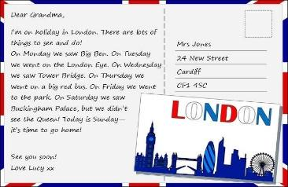  - Teacher invites some students to share their discussion and accepts reasonable answers.  Suggested answers:  1. When they are away from home, often on holiday or business. They want to tell their family or friends what they see and do, and how they feel about their time here.  2. The sender often writes about his/her stay in a city or country. | Group work  T-Ss | 5 mins
Lead-in | To lead in the lesson about Skills 1. | - Teacher leads students into the lesson by asking students some questions:  1. Have you ever written a postcard?  2. If yes, who did you write to? If no, do you intend to write a postcard in the future?  Suggested answers:  - Yes, I have. / No, I haven’t.  - I wrote to my best friend. / Yes, if I travel, I will write and tell my best friend about my trip. | T-Ss | 2 mins
Pre-Reading (Pre-teach vocabulary) | To provide students with some lexical items before reading the text. | * VOCABULARY  - Teacher introduces the vocabulary by:  + providing the synonym or antonym of the words;  + providing the pictures of the words;  + providing the definition of the words.  - fantastic (adj) [synonym] -> great  - perfect (adj) [synonym] -> ideal  - rent (v) [definition]: pay money to use something  - helmet (n) [picture]  - traditional (adj)  [synonym] -> modern (adj)  - landscape (n) [picture]  -   helmet  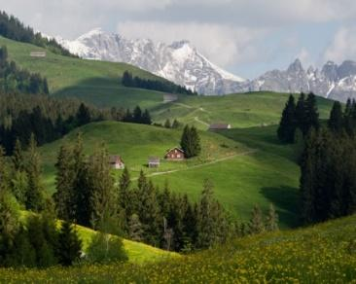  landscape | T-Ss | 5 mins
While-  Reading | To develop reading skill for general and specific  information.  To identify different features of a place | Task 2: Read the postcard and answer the questions.  * Key words in multiple choice questions:  - Teacher asks students to go through the questions (1 – 4) to make sure that they understand them and know what information is being asked.  - Students underline the key word(s) in each question to locate the answer in the reading text.  - Teacher introduces the strategy for multiple choice questions:    Answer key:  1. B 2. A 3. B 4. C  Task 3: Read the text and match the places with the things they have.  - Teacher asks students to read the text again and do the matching  - Teacher sets the time.  - Teacher checks students answers as a class.  Answer key:  1. b,c  2. a,d,e | T- Ss  S  T-Ss  T- Ss | 10 mins
Post-Reading | To check students’  reading comprehension. | * Kahoot game. Choose the best option to complete the questions in the game.  - Teacher can modify questions in Exercise 2 (p. 32) or use the  original one to create questions in Kahoot game.  - Teacher allows students to use their mobile devices to answer and interact with the questions online.  - Teacher gives clear instruction for students to fully understand how to play Kahoot game online.  → Go to kahoot.it  → Enter the game PIN  → Type your nick name  → Choose the best option for each question appearing on the screen  - See who will be the winner  - Teacher provides the game PIN and allow students’ access to the game.  - Students choose the best option for each question appearing on the screen  - Teacher gives complement or good mark to the winner of the game.  * Questions in the game:  1. This postcard is about ____________ in Stockholm.  A. the weather  B. a holiday  C. landscape  2. Guests can ____________ in the  hotel.  A. exercise  B. cycle  C. see Swedish art  3. Mai and her parents rented bikes to _____________.  A. cycle around the hotel  B. visit the Old Town  C. go shopping  4. “Fika” is a _____________________.  A. traditional café  B. palace  C. coffee break  Answer key:  1. B 2. A 3. B 4. C | T-Ss | 5 mins
Pre-Speaking | To help students form the ideas for their speaking. | Task 4: Work in groups. Choose a city you know. Discuss and answer the questions.  - Teacher asks students to work in groups and allows each group some time to choose one city they have learnt about in this unit, or the one they all know/like.  - Teacher asks students to discuss and makes notes of the information they want to share with the class.  - Teacher asks students to refer to the questions as suggestions for their notes or they can do it in their own way.  ○ What city is it?  ○ What is it like? (the weather, the food ...)  ○ What can you see and do there?  ○ How do you feel about it?  - Teacher goes around and offers help if needed. | Group work | 5 mins
While-Speaking | To help student use what they have learnt so far to talk about a city. | Task 5: Share the information with the whole class.  - Teacher invites some students to share their preparation and makes sure they speak in full sentences.  - Students share their ideas with the whole class. | T- Ss  Ss-Ss | 7 mins
Post-Speaking | To help students improve next time. | - Teacher allows students to give comments for their friends and vote for the most interesting and informative  presentation.  - Teacher gives feedback and comments. | T-Ss | 3 mins
Wrap-up | To consolidate what students have learnt in the lesson. | Teacher asks students to talk about what they have learnt in the lesson. | T-Ss | 2 mins
Homework | To prepare for the next lesson Skills 2. | Teacher asks students to search for information about Bangkok (the weather, the people, the food, landmarks,…). | T-Ss | 1 min

UNIT 9: CITIES OF THE WORLD

Lesson 6: Skills 2

  - I. Objectives
By the end of this lesson, students will be able to:

1. Knowledge
- Listen for specific information about a description of a city
- Write a holiday postcard

2. Core competence
- Develop communication skills and creativity
- Be collaborative and supportive in pair work and team work
- Actively join in class activities

3. Personal qualities
- Develop self-study skills

II. Materials
- Grade 6 textbook, Unit 9, Skills 2
- Computer connected to the Internet
- Projector/ TV/ pictures and cards
- hoclieu.vn

Language analysis

Anticipated difficulties | Solutions
1. Students may lack knowledge and experiences about the topic. | Prepare some hand-outs in which key language of the key language of describing tourist attractions.
2. Students may have underdeveloped listening, writing and co-operating skills. | - Play the recording many times if any necessary.  - Encourage students to work in pairs, in groups so that they can help each other.  - Provide feedback and help if necessary.
3. Some students will excessively talk in the class. | - Define expectations in explicit detail.  - Have excessive talking students practise.  - Continue to define expectations in small chunks (before every activity).

Board Plan

Date of teaching
Unit 9: Cities of the world
Lesson 6: Skills 2
* Warm-up
Game: Relay-race to capital cities of ASEAN countries.

I. Listening
Task 1: Work in groups. Discuss and answer the questions.
Task 2: Listen and tick True or False.
Task 3: Listen again and fill in each gap with one word/ number.
* Talk about Bangkok, the capital city of Thailand.

II. Writing
Task 4: Work in groups. Talk about a city in our country, using the questions below as a guide.
Task 5: Write a postcard about 50 words about your holiday in a city. Use the information in Task 4.

* Homework

Procedure

Stage | Stage aim | Procedure | Interaction | Time
Warm-up | - To introduce the topic of the listening tasks.  - To enhance students’ skills of cooperating with team mates. | * Game: Relay-race to  capital cities of ASEAN countries.  - Teacher sticks the map of ASEAN countries on the board.  - Teacher divides the class into 2 teams. Each team will have to take turns to run in a relay-race to write the correct names of the capital cities of ASEAN countries.  - Each team will write on the board with different colour of chalk so that the teacher can count the correct answers easily.  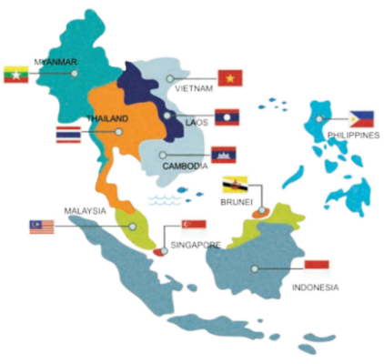  Suggested answers:  1. Ha Noi of Viet Nam  2. Phnom Penh of Cambodia  3. Jakarta of Indonesia  4. Manila of Philippines  5. Naypyitaw of Myanmar  6. Kuala Lumpur of Malaysia  7. Singapore of Singapore  8. Vientiane of Laos  9. Bangkok or Krung Thep of Thailand  10. Banda Seri Begawan of Brunei Darussalam | Team work | 5 mins
Lead-in | To lead in the listening task. | Teacher draws students’ attention to the capital city of Thailand.  “Today we are going to listen to interesting facts and figures about one of the capital cities of ASEAN countries. It’s Bangkok.” | T-Ss | 1 min
Pre-Listening | - To help students brainstorm about  Bangkok.  - To set the context for the listening part. | Task 1: Work in groups. Discuss and answer the questions.  - Teacher tells students that they will listen to a talk about Bangkok, the capital of Thailand.  - Teacher asks students to work in groups of four to answer the 2 questions and discuss with them to see what they know about Bangkok or Thailand.  1. Where is Bangkok?  2. What is Bangkok famous for?      - Teacher allows students to talk in Vietnamese (sometimes) if they do not have enough vocabulary in English.  - Teacher asks students to look at the photos and say what they see, and if it’s similar to Viet Nam.  Suggested answers:  1. Bangkok is in Thailand.  – It is the capital and the biggest city.  – It has the population of about 8 million.  2. It’s famous for pagodas, temples, open/ night/ ﬂoating markets and shopping centres, silk, street food, friendly  people, and entertainments. | T-Ss  Group work | 3 mins
While-  Listening | To help students  develop listening skill for specific information (T/F).  To help students  develop listening skill for specific information (gap-filling). | Task 2: Listen and tick True or False.  * True – False prediction:  - Teacher asks students to go through the  statements (1 – 4) to make sure that they  understand them and know what information they have to catch for the answers.  - Students underline the key word(s) in each statement and guess whether they are True or False  individually.  * Listen and decide True or False:  - Teacher plays the recording.  - Teacher asks students to listen and tick the answers.  - Teacher asks students to compare their answers with the prediction made previously.  - Teacher calls on some students to read aloud their answers and correct the false one(s).  - Teacher checks students’ answers as a class.  Answer key:  1. F (markets and street food)  2. F (cheap)  3. F (on the river)  4. T  Task 3: Listen again and fill in each gap with one word/ number.  - Teacher asks students to read the questions carefully and determine what information they need to fill the gaps  (numbers, words).  - Teacher plays the recording for students to fill the gaps.  - Teacher asks them to swap their answers in pairs before checking their answers as a class.  Answer key:  1. 15,000  2. 5  3. life  4. delicious  Audio script:  Bangkok is famous for its markets and street food. Visit the Chatuchak, the largest weekend market in the world. There are over 15,000 stalls selling nearly everything, at cheap prices. It’s only five minutes’ walk from the station. When you visit this market, you can see part of Thai people’s life.  Another interesting type of market is the ﬂoating market on the river. Don’t forget to try street food in Bangkok. It’s easy to find food stalls all around Bangkok, serving diﬀerent Thai dishes. They are really delicious. | T-Ss  S  T-Ss  Ss-Ss  T-Ss  T-Ss  Ss-Ss | 10 mins
Post-Listening | To develop student’s speaking skill, using the available information and their background knowledge. | * Summarize the information and talk about Bangkok:  - Students work in groups of four.  - Teacher asks students to summarize the  information in the 2 listening tasks and talk about it.  - Students can add more information based on their background knowledge.  - Teacher goes round and help if needed. | Group work | 5 mins
Pre-Writing | To help students talk about a holiday city and collect information for their later writing. | Task 4: Work in groups. Talk about a city in our country, using the questions below as a guide.  - Teacher models the task by showing the picture of Hanoi, ask a student questions about it.  Example:  Teacher: What city is it?  Student: It’s Ha Noi, the capital of Viet Nam.  Teacher: What is it like? Can you tell me more about its weather, people and food?  Student: There are 4 seasons in Ha Noi. It’s warm in spring and hot in summer. It’s not so cold in winter. Autumn is the best time of a year when it’s always cool. The people in Ha Noi are very friendly. They also helpful and hospitable. Ha Noi is famous for many delicious dishes, especially Phở or beef noodles soup.  Teacher: What can you see and do in Ha Noi?  Student: I can see many interesting places such as Old Quarter, One Pillar Pagoda, the Temple of Literature and Imperial Academy, etc. I can go to the night market or the walking street at weekends.  - Teacher asks students to work in groups. Choose a city they know and discuss as guided by the questions.  - Teacher asks students to take short notes of the answers for later use.  - Teacher goes round and help if needed. | T-Ss  Group work | 5 mins
While-Writing | To teach students how to write a holiday postcard. | Task 5: Write a postcard about 50 words about your holiday in a city. Use the  information in Task 4.  - Teacher shows the postcard in Task 2 – Skills 1 to help students identify the main parts of a postcard for students.  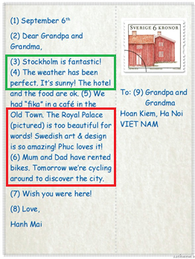  - Teacher asks students to use their ideas in Task 4 to write a postcard to their family.  - Teacher asks students to refer to Reading 2 if needed.  - If there is time, teacher pairs students and asks them to write postcards to each other.  - Teacher has them swap and give feedback on each other’s writing once they have finished.  - Teacher explains to students that the space for writing on postcards is not big so people often write short sentences which contain the most important information.  - Teacher tells students that contraction is often used in writing postcards to make them short and informal. | T-Ss  What can you see and do there?  What is it like? (the weather, the people, the food)  S  Ss-Ss  T-Ss  T-Ss | 10 mins
Post-Writing | To peer check, cross check and final check students’ writing. | - Teacher asks students to exchange their textbooks to check their friends’ writing.  - Teacher then gives feedback as a class  discussion. | Ss-Ss  T-Ss | 2 mins
Wrap-up | To consolidate what  students have learnt in the lesson. | Teacher asks students to talk about what they have learnt in the lesson. | T-Ss | 2 mins
Homework | To allow students  finalize their postcards after being checked by friends and the teacher. | Rewrite the postcard on the notebook. | T-Ss | 1 min

UNIT 9: CITIES OF THE WORLD

Lesson 7: Looking back & Project

  - I. Objectives
By the end of this lesson, students will be able to:

1. Knowledge
- Review the vocabulary and grammar of Unit 9
- Apply what they have learnt (vocabulary and grammar) into practice through a project

2. Core competence
- Develop communication skills and creativity
- Develop presentation skill
- Develop critical thinking skill
- Be collaborative and supportive in pair work and team work
- Actively join in class activities

3. Personal qualities
- Be more creative when doing the project
- Develop self-study skills

II. Materials
- Grade 6 textbook, Unit 9, Looking back & Project
- Computer connected to the Internet
- Pictures, A0 paper
- Projector/ TV
- hoclieu.vn

Language analysis

Anticipated difficulties | Solutions
1. Students may have underdeveloped speaking, writing and co-operating skills when doing project. | - Encourage students to work in pairs, in groups so that they can help each other.  - Provide feedback and help if necessary.
2. Some students will excessively talk in the class. | - Define expectations in explicit detail.  - Have excessive talking students practise.  - Continue to define expectations in small chunks (before every activity).

  - Board Plan

Date of teaching
Unit 9: Cities of the world
Lesson 7: Looking back & Project
* Warm-up
Brainstorming: adjectives to describe city, weather, people, food and building.

I. Looking back
Task 1: Choose the best two options to complete the sentences.
Task 2: Write the words in the box under the pictures.
Task 3: Complete the sentences with the correct possessive pronouns in the box.
Task 4: Read the sentences and correct the underlined words.

II. Project
World Travel Market (WTM 2021)

* Homework

Procedure

Stage | Stage aim | Procedure | Interaction | Time
Warm-up | - To revise the vocabulary related to the topic and lead in the next part of the lesson.  - To enhance students’ skills of cooperating with team mates. | * Brainstorming:  - Teacher sticks 5 icons on the board, and divides the class into 5 big groups.    city    weather    people    food  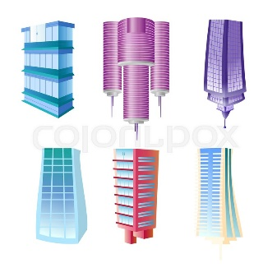  building  - Each group will be assigned a name of the following categories: city, weather, people, food.  - Teacher asks students to brainstorm all adjectives related to city, weather, people, food.  - The group having the most suitable answers is the winner.  Suggested answers:  - City: peaceful, lively, busy, industrial, cosmopolitan, green, historic, modern, etc.  - Weather: rainy, wet, humid, dry, arid, frigid, foggy, windy, stormy, breezy, windless, calm, etc.  - People: reliable, passionate, generous, kind, ambitious, etc.  - Food: delicious, salty, bitter, creamy, awful, etc. | Group work | 5 mins
Looking back | To help students  revise the adjectives describing cities and landmarks.  To help students  revise the nouns showing landmarks in a city.  To help students  revise the possessive pronouns in context.  To help students revise the possessive adjectives and possessive pronouns in context. | Task 1: Choose the best two options to complete the sentences.  - Teacher encourages students to complete the task individually.  - Student exchange their textbook to discuss the reasons why they are choosing the appropriate adjectives.  - Teacher gives feedback as a class discussion.  Answer key:  1. A, B  2. A, C  3. A, C  4. A, B  5. B, C  - Teacher encourages students to provide more adjective for each questions in the Warm-up part and according to their background knowledge.  Suggested answers:  1. peaceful, lively, busy, industrial, cosmopolitan, green, historic, modern, etc.  2. rainy, wet, humid, dry, arid, frigid, foggy, windy, stormy, breezy, windless, calm, etc.  3. reliable, passionate, generous, kind, ambitious, etc.  4. tall, high, modern, etc.  5. delicious, salty, bitter, creamy, awful, etc.  Task 2: Write the words in the box under the pictures.  - Teacher asks students to read the words in the box first and make sure they remember their meanings.  - Teacher then allows students some time to write the words under the correct pictures.  - Teacher encourages students to complete the task individually.  - Student exchange their textbook to discuss the reasons about their choices.  - Teacher gives feedback as a class discussion.  Answer key:  1. towers  2. river bank  3. beach  4. night market  5. palace  6. postcard  Task 3: Complete the sentences with the correct possessive pronouns in the box.  - Teacher has students complete the task  individually.  - Student exchange their textbook to discuss the reasons about their choices.  - Students should record their original answers to guide their self-assessment later.  - Teacher gives feedback as a class discussion.  Answer key:  1. yours  2. theirs  3. mine  4. Ours  5. hers  Task 4: Read the sentences and correct the underlined words.  - Students work in pairs.  - Teacher ask students to read the sentences carefully and correct the underlined words.  - Students complete the task and discuss about the answers.  - Teacher gives feedback as a class discussion.  Answer key:  1. its  2. our  3. their  4. its  5. ours | S  Ss-Ss  T-Ss  T-Ss  T-Ss  S  Ss-Ss  T-Ss  S  Ss-Ss  T-Ss  Pair work  T-Ss | 16 mins
Project | To allow students to apply what they have learnt (vocabulary and grammar) into practice through  a project. | * World Travel Market (WTM 2021):    - Teacher sets the context of a World Travel Market (WTM 21) that will be  occurred right now in the classroom.  - Teacher divides students into 4 big groups. Each group will act as a travel agency.  - Teacher asks “the travel agencies” to discuss and choose a city they would like to attract visitors to come.  - Teacher asks them to look for necessary information for the visit, basically by discussing the suggested questions.  1. What city is it?  2. Where is it?  3. How can you go there?  4. What’s the weather like there?  5. What would you like to see and to do there?  - Students summarise the information and design A0 size posters about the cities they would like to promote.  - Teacher asks the class to listen to the reports and ask questions if they would like to.  - Students will critically evaluate all the posters, then give 1 vote for the most attractive poster/ city.  - Teacher gives comments and feedback to all 4 posters and awards special prize the group which has the most votes. | T-Ss  Group work  T-Ss | 20 mins
Wrap-up | To consolidate what students have learnt in the  lesson. | Teacher asks students to talk about what they have learnt in the lesson. | T-Ss | 3 mins
Homework | To prepare for the next lesson. | Prepare for the next lesson: Review 3. | T-Ss | 1 min
*Pictures' source: From Internet

