UNIT 6. A VISIT TO A SCHOOL
PART 1. THEORY
I. VOCABULARY
No. | English | Type | Pronunciation | Vietnamese
1 | Mathematics  (Maths) | n | /.mæθə'mætɪks (mæθs)/ | môn Toán
2 | Physics | n | /'fɪzɪks/ | môn Lý
3 | Chemistry | n | /'keməstrɪ/ | môn Hóa
4 | Biology | n | /baɪ’ɒlədʒɪ/ | môn Sinh
5 | Geography | n | /dʒɪ’ɒgrəfɪ/ | môn Địa ỉý
6 | Information  Technology (IT) | n | /ɪnfə'meɪʃn  tek’nɒlədʒɪ/ | môn Công nghệ Thông tin
7 | Art | n | /ɑːt/ | môn Mỹ thuật
8 | Literature | n | /'lɪtrətʃə(r)/ | môn Văn học
9 | History | n | /'hɪstərɪ/ | môn Lịch sử
10 | Music | n | /'mjuzɪk/ | môn Âm nhạc
11 | Craft | n | /kræft/ | môn Thủ công
12 | Economics | n | /i:kə'nɒmɪks/ | môn Kinh tế
13 | Social Science | n | /'səʊʃəl 'saɪəns/ | môn Khoa học xã hội
14 | Physical Education (PE) | n | /fɪzɪkl edʒu'keɪʃn / | môn Thể dục
15 | computer room | n | /kəm'pju:tə(r) ru:m/ | phòng máy tính
16 | library | n | /'laɪbrərɪ/ | thư viện
17 | schoolyard | n | /'sku:ljɑːd/ | sân trường
18 | playground | n | /'pleɪ.graʊnd/ | săn chơi
19 | gym | n | /dʒɪm/ | phòng thể dục
20 | Science lab | n | /'saɪəns læb/ | phòng thí nghiệm
21 | classroom | n | /'klɑːsru:m/ | phòng học
22 | examination | n | /ɪg.zæmɪ'neɪfn/ | kỳ thi
23 | test | n | /test/ | bài kiểm tra
24 | midterm | n | /'mɪdtɜ:m/ | giữa kì
25 | gifted student | n | /'gɪftəd 'studənt/ | học sinh giỏi
26 | school facilities | n | /skul fə'sɪlətɪz/ | Cơ sở vật chất của trường
27 | teacher | n | /'tɪtʃər/ | giáo viên
28 | head teacher | n | /hed 'tɪtʃər/ | giáo viên chủ nhiệm
29 | president | n | /'prezɪdənt/ | hiệu trưởng

II. GRAMMAR
Giới từ chỉ thài gian và địa điểm: in, on, at
1. Cách sử dụng giới từ chỉ thời gian: at, in và on
AT | IN | ON
Thời gian  chính xác | Tháng, năm, mùa, thế kỷ & những thời kỳ dài | Thứ, ngày
at 3 o’clock | in May | on Sunday
at 10.30 a.m | in summer | on Tuesdays
at noon | in the summer | on the 6th of March
at dinnertime | in 1990 | on the 21st of December, 2010
at bedtime | in the 1990s | on Christmas Day
at sunrise | in the next century | on Independence Day
at sunset | in the Ice Age | on my birthday
at the moment | in the past/future | on New Year’s Eve
Ex: I will go to the cinema at 9 a.m.
My brother was born in 2000.
Her birthday is on the 20th of November.
2. Cách sử dụng giới từ chỉ nơi chốn: at, in và on
GIỚI TỪ | Ý NGHĨA | CÁCH SỬ DỤNG
AT | “At” mang nghĩa là ở, tại.  Nó thường được dùng khi muốn nói đến một nơi chốn, một địa điểm cụ thể | Giới từ at dùng để chỉ:  - Vị trí tại 1 điểm  Ex: at home, at the station/ airport/ door/ office Ex: at the top/ bottom of, at the beginning/ end of  - Dùng để chỉ nơi làm việc, học tập Ex: at work/ school/ university/ college  Dùng để chỉ địa chỉ cụ thể Ex: at 55 Tran Phu Street
IN | “In” mang nghĩa là ở bên trong.  Nó thường được dùng khi bạn muốn nói đến một không gian rộng và chung nhất. | Giới từ in dùng để chỉ:  - Vị trí bên trong, không gian (bao quanh vật)  Ex: in the room/ building/ restaurant/ park  Ex: in the sea/ in the world/ in the sky  Ex: in the line/ queue/ row  Ex: in a book/ newspaper/ photo  - Đứng trước tên làng, thị trấn, thành phố, quốc gia Ex: in France, in Ha Noi, in Viet Nam  - Dùng với phương tiện đi lại bằng taxi hoặc xe hơi Ex: in a car/ taxi  - Dùng để chỉ phương hướng hoặc một số cụm từ chỉ nơi chốn  Ex: in the south/ east/ west/ north  Ex: in the middle/ in the back/ in front of
ON | “On” mang nghĩa là ở bên trên. | Giới từ on dùng để chỉ:  - Chỉ số tầng (nhà), nơi chốn  Ex: on the ground, on the 1st/ 2nd floor,  Ex: on the platform/ railway  - Chỉ bề mặt  Ex: on the table/ carpet/ wall/ ceiling/ board/ screen/ map/ page
 | Nó thường được dùng để chỉ một bề mặt phẳng hoặc tầng/ lầu của một tòa nhà. “On” cũng được dùng trong một số trường hợp khác nữa. | - Dùng trước tên đường  Ex: on the street, on Wall Street  - Dùng với phương tiện đi lại công cộng hoặc cá nhân (trừ car & taxi)  Ex: on a bus/ train/ plane/ ship/ bike/ motorbike/ horse  - Dùng trong 1 số trường hợp sau:  Ex: on the left/ right, on the front/ back of...

iii. PHONETICS

Cách phát âm âm /tʃ/ và /dʒ/
1. Cách phát âm âm /tʃ/
- Âm /tʃ/ là một phụ âm vô thanh. Để phát âm này, bạn đưa môi về phía trước và căng ra để tạo âm, khép hai răng, nâng đầu lưỡi lên chạm phía sau hàm răng trên. Nó phát âm gần như âm “ch” của tiếng việt nhưng mạnh hơn một chút.  - Vì /tʃ/ là một phụ âm vô thanh, khi bật hơi thì cổ sẽ không rung, ta có thể kiểm tra bằng cách đặt bàn tay phía trước miệng và thử phát âm, sẽ có hơi bật vào tay bạn. | 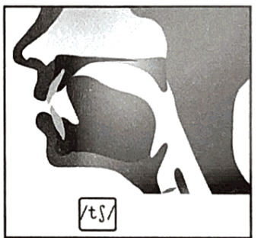
2. Cách phát âm âm /dʒ/
- Âm /dʒ/ là phụ âm hữu thanh. Các bước phát âm của /dʒ/ tương tự như cách phát âm /tʃ/, điểm khác là khi bật hơi thì cổ chúng ta rung lên. Khi đó, nếu để bàn tay phía trước miệng, sẽ không có hơi bật vào bàn tay. | 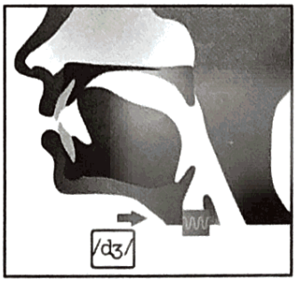
Listen and repeat these words. Track 016
/tʃ/ | teach | question | choose | culture
 | /ti:tʃ/ | /'kwestʃn/ | /tʃu:z/ | /'kʌtʃ(rJ/
/dʒ/ | ịob | engineer | just | heritage
 | /dʒob/ | /,endʒɪ'niə(r)/ | /dʒʌst/ | /'herɪtɪdʒ/
PART 2. LANGUAGE
I. VOCABULARY
Exercise 1. Find the odd one out among A, B, C or D.
1. A. teacher B. maths C. physics D. geography
2. A. literature B. craft C. economics D. test
3. A. student B. teacher C. classmate D. blackboard
4. A. learn B. project C. listen D. speak
5. A. gym B. library C. classroom D. exam
Exercise 2. Look at the photos and write the names of subjects.
1. _______________   | 2. _______________   | 3. _______________  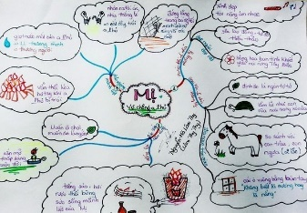 | 4. _______________  
5. _______________   | 6. _______________  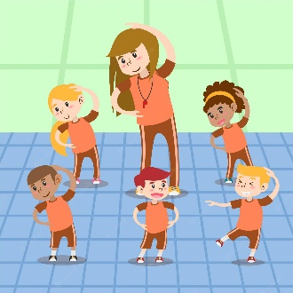 | 7. _______________   | 8. _______________  
Exercise 3. Look at the photo and put the correct word under each photo.
gym |  | classroom |  | library |  | globe
playground |  | president |  | teacher |  | school yard
1. _______________  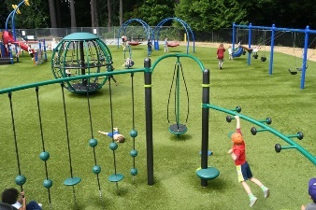 | 2. _______________   |  | 3. _______________   |  | 4. _______________  
5. _______________   | 6. _______________  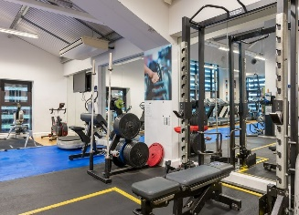 |  | 7. _______________  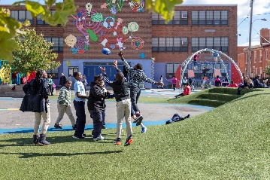 |  | 8. _______________  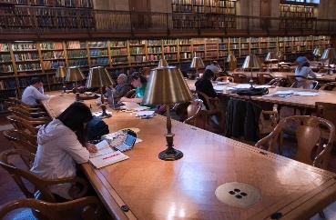
Exercise 4. Match the words in column A with the suitable words in column B to correct phrases.
No | Column A | Opt | Column B | Your answer
1. | school | A. | facilities | 1. ___________________
2. | secondary | B. | examination | 2. ___________________
3. | entrance | C. | test | 3. ___________________
4. | gifted | D. | school | 4. ___________________
5. | ourdoor | E. | activities | 5. ___________________
6. | midterm | F. | students | 6. ___________________
II. GRAMMAR
Exercise 1. Fill in the blanks with: at / in / on.
1. We always go on holiday _________ summer.
2. My mother usually goes shopping _________ Friday morning.
3. I always do my homework _________ the evening.
4. The circus usually comes to our town _________ spring.
5. Sophia’s birthday is _________ May 16th.
6. I usually get up _________ seven o’clock.
7. My favorite television programme begins _________ 6:30 _________ the evening.
8. Sometimes it snows _________ winter.
9. My friend’s birthday is _________ June.
10. Some birds and animals come out _________ night.
11. Auroras birthday is _________ May, but I don’t know which date.
12. She hasn’t seen Kate for a few days. She said that she had last seen her _________ Tuesday.
13. Steve is 65. He’ll be retiring from his job _________ two years.
14. Same isn’t here _________ the moment, but he’ll be there this afternoon.
15. I don’t like dark. I try to avoid going out _________ night.
16. It rained very hard _________ the night. Did you hear it?
17. My car is being repaired at the garage. It will be ready _________ two hours.
18. The bus station was busy. A lot of buses were leaving _________ the same time.
19. Helen and David always go out for dinner _________ their wedding anniversary.
20. It was a short book and easy to read. I read it _________ a day.
Exercise 2. Choose the best preposition to complete the sentence.
1. My lesson starts _________ five o'clock.
A. on B. at C. in
2. My father usually buys a newspaper _________ the morning.
A. on B. at C. in
3. We wear warm clothes _________ winter.
A. on B. at C. in
4. We get presents _________ Christmas.
A. on B. at C. in
5. I usually visit my grandparents _________ Sunday afternoon.
A. on B. at C. in
6. John's birthday is _________ August 16th.
A. on B. at C. in
7. The film finishes _________ 9:30.
A. on B. at C. in
8. The supermarket is closed _________ Sunday.
A. on B. at C. in
Exercise 3. Fill in the text with at / in / on.
My birthday is (1) _________ the 30th of July. Last year, I had a great day. I got up (2) _________ 8 o'clock (3) _________ the morning and tidied the house. Then (4) _________ the afternoon I went into town with my friend to buy food for the party. The party started (5) _________ 7 o'clock (6) _________ the evening and didn't stop until very late (7) _________ night! (8) _________ the 31st of July I was very tired, so I went to bed early (9) _________ the evening.
Exercise 4. Complete the sentences with at / in / on.
1. There was a long queue of people _________ the bus stop.
2. Nicola was wearing a silver ring _________ her little finger.
3. There was a security guard standing _________ the entrance to the building.
4. I wasn’t sure whether I had come to the right office. There was no name _________ the door.
5. There are plenty of shops and restaurants _________ the town centre.
6. You’ll find the weather forecast _________ the back page of the newspaper.
7. The headquarters of the company are _________ California.
8. I wouldn’t like an office job. I couldn’t spend the whole day sitting _________ a desk.
9. The man the police are looking for has a scar _________ his right cheek.
10. Have you ever been camping? Have you ever slept _________ a tent?
11. Sign your name _________ the top of the page.
12. Is your brother _________ this photo? I don’t recognise him.
13. They live in a small house _________ the bottom of the hill.
14. We had to wait _________ a queue for an hour to check in at the airport.
15. There was a list of names, but my name wasn’t _________ the list.
16. Is there anything interesting _________ today’s newspaper?
17. I love to look up at the stars _________ the sky at night.
18. When I’m a passenger in a car, I prefer to sit _________ the front.
19. I live in a very small village. You probably won’t find it _________ your map.
20. Joe works _________ the furniture department of a large store.
Exercise 5. Choose the best preposition to complete the sentence.
1. _________ time _________ time I will examine you on the work you have done.
A. From – to B. At – to C. In – to D. With – to
2. Lan will stay there _________ the beginning in September _________ November.
A. from - to B. till - to C. from - in D. till – of
3. I would like to apply _________ the position of sales clerk that you advised in the Sunday newspaper.
A. to B. for C. with D. in
4. Make a comment _________ this sentence!
A. to B. in C. on D. about
5. He’s a very wealthy man; a few hundred pounds is nothing _________ him.
A. for B. with C. to D. about
6. Mum is always busy _________ her work in the laboratory.
A. with B. at C. in D. of
7. The clerk _________ that counter said those purses were _________ sale.
A. in/ for B. at/ on C. at/ in D. on/on
8. Don’t believe her! She just makes _________ the story.
A. of B. up C. out D. off
9. Old people like to descant _________ past memories.
A. in B. with C. on D. for
10. You should comply _________ the school rules.
A. to B. about C. with D. in
Exercise 6. Fill in the blanks with a correct preposition.
1. The price of electricity is going up _________ August.
2. They came to visit us _________ my birthday.
3. Did you have a good time _________ Christmas?
4. The children are really excited _________ their summer vacation.
5. We were very disappointed _________ the organization of the festival.
6. John missed a lot of lessons. He was ill _________ January to March.
7. Helen had said goodbye to everybody in the class _________ she left for the hometown.
8. My cat is very fond _________ fish.
9. I waited _________ 10 o’clock and then went home.
10. I can’t remember exactly when the accident happened. I think it was _________ nine and half past nine.
III. PHONETICS
Listen and circle the words you hear. TRACK 17
1. choice/ joy | 11. natural/ soldier
2. charge/ judge | 12. nurture/schedule
3. chat/ age | 13. check/cage
4. charm/ jam | 14. cherish/village
5. cheap/jeep | 15. picture/ geology
6. choke/ joke | 16. chin/ginger
7. watch/ large | 17. chocolate/ cottage
8. chest/ hedge | 18. chimney/gymnastic
9. change/ danger | 19. lecture/ stage
10. church/ June | 20. much/lunge

PART 3. COMMUNICATION SKILLS
I. LISTENING
Listen and do the tasks followed. Track 18
Exercise 1. Listen and complete the sentences.
1. Van Mieu Quoc Tu Giam is also called “the Temple of _____________”
2. Van Mieu Quoc Tu Giam is the first _____________ of Hanoi.
3. Visiting Van Mieu Quoc Tu Giam can help you explore the _____________ and architecture of this monument.
4. Van Mieu Quoc Tu Giam was built in the _____________ of King Ly Thanh Tong.
5. King Ly Nhan Tong established Quoc Tu Giam by _____________.
Exercise 2. Listen again and decide if each statement is True (T) or False (F).
1. The Temple of Literature is still training students now. ________
2. The Temple of Literature never trained anyone but princes. ________
3. The Temple of Literature was operating for about 700 years. ________
4. People are allowed to take pictures in Temple of Literature. ________
5. The Temple of Literature opens for nearly 10 hours every day. ________
II. SPEAKING
Exercise 1. Match the questions in column A with the answers in column B.
No | A | Opt | B
1. | What school do you want to visit? | A. | On Sunday.
2. | When do you want to go? | B. | Take part in some outdoor activities.
3. | How do you want to go there? | C. | Thang Long Lower Secondary School.
4. | Who do you want to meet? | D. | My classmates and friends.
5. | What do you want to see? | E. | By bus.
6. | What do you want to do? | E | The school facilities.
Exercise 2. Make questions for the underlined parts.
Mai: (1) ___________________________________________________________________________.
Huan: I last went to the Temple of Literature in 2017.
Mai: (2) ___________________________________________________________________________.
Huan: The Temple of Literature is located on Van Mieu Street.
Mai: (3) ___________________________________________________________________________.
Huan: The Temple was founded by Emperor Ly Thanh Tong.
Mai: (4) ___________________________________________________________________________.
Huan: It was built in 1070.
Mai: (5) ___________________________________________________________________________.
Huan: The Imperial Academy was established in 1076.
Mai: (6) ___________________________________________________________________________.
Huan: Chu Van An was the first principal of the Imperial Academy.
III. READING
Exercise 1. Put a word from the box in each gap to complete the following passage.
state | find | go | start | leave
stay | private | take | study | choose
Secondary education in the USA
In the USA, students (1) ____________ their secondary education at the age of 11. First they (2) ____________ to Middle School for three years. Then they go for High School for four years, from the age of 14 to 18. Some students (3) ____________ school when they are 16 and (4) ____________ jobs. But most students (5) ____________ at High School still they are 18. Then they (6) ____________ exams and they get “High School Diploma”. There aren't any national exams.
All students at secondary school in the USA (7) ____________ English, Maths, Science, and P.E, but students (8) ____________ other subjects, so they don't all study the same subjects.
About 90% of students in the USA go to (9) ____________ schools. About 10% go to (10) ____________ schools. Most of the private schools are religious schools.
Exercise 2. Read the letter and decide which statements are true (T) or false (F).
Thanks for your letter. It's very interesting to know about schools in the USA. I think schools in Viet Nam are a little different. Vietnamese students usually wear uniform. Classes start at 7.00 each morning and end at 11.15 in the afternoon. Students have a 30-minute break after three periods. At break time, many students play games. Some go to the canteen and buy something to eat or drink. Others talk together. Our school year lasts for 9 months, from September to May. Then we have a 3-month summer vacation. We feel too much long to come back to school to meet friends. I hope to know more about schools in your country.
Your friend,
Hoa
No. | Statements | True (T) or False (F)
1. | Hoa thinks schools in Viet Nam are different from schools in the USA.
2. | Vietnamese students do not usually wear school uniform.
3. | Classes start from seven to a quarter past eleven.
4. | Students have a 30-minute break after two periods.
5. | Most students go to the canteen at break time.
6. | The school year begins in September.
7. | The summer vacation lasts for two months.
8. | Vietnamese students like a long holiday vacation.
Exercise 3. Read the following passage and choose the best option.
Chu Van An was born in 1292 and died in 1370. From his childhood, he was (1) ____________ for his intelligence. He did not have the dream of (2) ____________ part in exams to become mandarins (3) ____________ other students. Chu Van An stayed at (4) ____________ and taught himself by reading books, and opened schools. His school quickly became famous in the region and many students from other places went there to (5) ____________.
Emperor Tran Minh Tong (6) ____________ Chu Van An to be the principal of the Imperial Academy to teach his crown prince and other students to become (7) ____________ people for the country. In 1359, Emperor Tran Minh Tong gave his crown (8) ____________ his son, Tran Hien Tong, who was also a student of Chu Van An. Under the regime of Emperor Tran Hien Tong, the court and the country were peaceful. (9) ____________, this period lasted only for 12 years. Then Emperor Tran Hien Tong died, and Tran Du Tong inherited the crown. The social situation became complicated, the people were very poor and many good people were killed.
Chu Van An bravely submitted a petition which requested the Emperor to behead 7 perfidious mandarins, so it was (10) ____________ “Seven Beheaded Petition” (That Tram So). “Seven Beheaded Petition” became the symbol of the courageous attitude of the real intellectuals, and of Chu Van Ans spirit.
1. A. like B. famous C. Such as D. Similar
2. A. approximately B. expressively C. taking D. progressively
3. A. like B. pioneering C. pioneering D. pioneers
4. A. custom B. waiter C. service D. home
5. A. tourists B. study C. pilot D. guess
6. A. invited B. orbition C. orbital D. orbiting
7. A. constructed B. designed C. talented D. painted
8. A. equipment B. to C. equivalent D. furniture
9. A. invitation B. ticket C. space D. However
10. A. called B. departures C. islands D. destinations
IV. WRITING
Exercise 1. Rewrite each sentence so that the meaning stays the same. (Use the preposition in the brackets.)
1. My house is behind the hotel. (in front of)
The hotel
2. The drug store is to the right of the bakery. (to the left of)
The bakery
3. The supermarket is behind the bank. (in front of)
The bank
4. The garden is to the left of Nams classroom. (to the right of)
Nam’s classroom
5. The bookstore is in front of the restaurant. (behind)
The restaurant
6. He walks to school. (on)
He goes
7. He goes to work at six forty-five. (to)
He
8. Mai gets up at 6.30. (past)
Mai gets
9. Tom drives to work every morning. (by)
Tom travels
10. Does your father ride the bike to work? (by)
Does
Exercise 2. Rewrite each sentence so that the meaning stays the same.
1. It is not easy to learn English well.
Learning
2. What is the matter with you?
What
3. How high is the Big Ben Clock Tower?
What
4. What is your sons weight?
How
5. What is the price of this face mask?
How much
6. How long is the Mekong River?
What
7. How wide is the West Lake?
What
8. He lives too far away from the school.
He doesn’t
9. Long is a good swimmer.
Long swims
10. My brother cycles slowly.
My brother is

