PHÒNG GDĐT TP. HẢI DƯƠNG | ĐỀ THI SINH GIỎI LỚP 8  MÔN: TIẾNG ANH  Thời gian làm bài: 150 phút  (Đề thi này gồm có 08 trang)
Học sinh lưu ý:
+ Làm bài vào tờ giấy thi (Không làm bài vào đề thi này)
+ Phần trắc nghiệm: Chỉ cần ghi phần (A, B ...), câu (I, II…), ý (1, 2…) và đáp án.
+ Phần tự luận: Viết đầy đủ theo yêu cầu của từng bài.
A. LISTENING: 20 points
Part I (5points)
0. How many people were at the meeting?
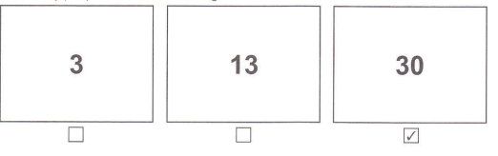
1. What must the man turn off?

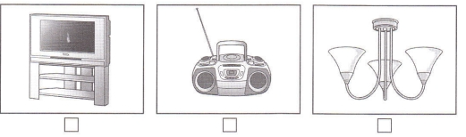

2. Where’s the girl’s pen?

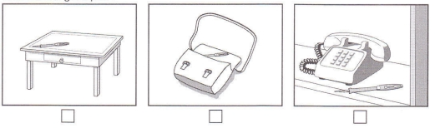

3. What will the boy do this evening?
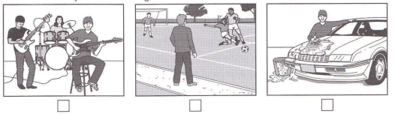

4. What animals did they see on their holiday?

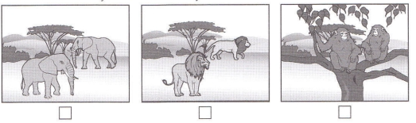

5. What does the man want to buy?
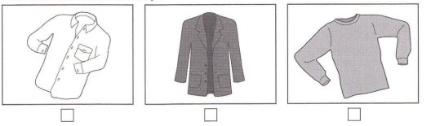

Part II. (5points): You will hear a girl asking for information about going to Kendal by bus. Listen and complete questions from 6-10. You will hear the conversation twice.

Bus to Kendal
First bus leaves at:  Cost of single ticket:  Buy ticket from:  Address of bus station:  next to :  At bus station, you can buy: | 6.45am  (6) £ __________  (7) _____________  (8) ______________Street  (9) ______________  (10) ______________

Part III. You will hear some information about a film-making competition.
For each question, fill in the missing information in the numbered space.
FILM-MAKING COMPETITION

Maximum length of film: (11) .........................
Type of film: (12) ........................
Subject this year: The (13) .........................
JUDGES:
Martha Fernando, presenter of the programme called ‘Film (14) .........................’
Mark Matthews, director
PRIZES:
First prize: visit to a film school
Other prizes: books and modern (15) .........................
Where the best films will be shown: a town hall

Part IV. Listen to Eric talking to Mary about the weekend. Their friend, Carlos, is coming to visit them. Listen and write the letter of the correct answer in your test paper. (5 points)
16. When is the football match?
A. Saturday morning. B. Saturday afternoon.
C. Sunday afternoon. D. Sunday morning.
17. Where are they going to eat on Saturday evening?
A. at home. B. in an Italian restaurant.
C. in a Chinese restaurant. D. in a Vietnamese restaurant.
18. What are they going to do on Sunday morning?
A. go for a drive. B. get up late.
C. go to the cinema. D. watch DVD.
19. Where are they going to have lunch on Sunday?
A. in a café. B. in a pub.
C. at home. D. in the park.
20. They can’t go the cinema on Sunday afternoon because:
- Carlos doesn’t like films. B. Eric doesn’t like films
- They don’t have time D. Carlos and Eric don’t like films

B. GRAMMAR- VOCABULARY-LANGUAGE FUNCTIONS
I. Choose the word, phrase or expression which best completes each sentence (10 points).
21. This car _________ in Japan seven years ago.
A. is made B. made C. has been made D. was made
22. “Your performance was excellent, Lily! You danced very _________,” said the instructor.
A. beautiful B. beauty C. beautifully D. beautify
23. Mike: “Why don’t we spend the weekend on the beach?” Susan: “_________.”
A. Yes, that’s a good idea B. I’m glad you like it
C. Yes, it’s very informative D. Twenty five kilometers at least
24. If I were you, I _________for the job.
A. will apply B. can apply C. applied D. would apply
25. Vietnam became an independent nation _________September 2nd, 1945.
A. on B. in C. at D. of
26. Your uncle lives in London, _________?
A. isn’t he B. doesn’t your uncle C. didn’t he D. doesn’t he
27. Teacher: “May I introduce myself to you. My name’s John Smith.” Student: “_________. I’m Anne Hathaway.”
A. I am fine, thank you B. Oh, that’s good
C. Pleased to meet you. D. Hope to see you again
27. _________it was extremely cold and wet, Peter’s grandfather went fishing in the sea.
A. However B. Because C. Although D. Therefore
28. The children will stay at home if it _________tomorrow.
A. snow B. snows C. will snow D. snowed
29. Volcanoes, earthquakes and tidal waves are natural_________.
A. materials B. gifts C. disasters D. resources
30. The smaller the room, furniture it needs.
A. a little B. the little C. the fewer D. the less
31. Boy: “Ms. Thomson, thank you very much for taking me to school.”
Ms. Thomson: “_________.”
A. Good idea B. You’re welcome C. Well-done D. You’re right
32. New York and Tokyo are two of the most _______-populated cities in the world.
A. greatly B. densely C. variously D. closely
33. “. of the victims in the Tsunami remain missing.
A. Two third C. Third twos B. Two thirds D. Two of thirds
34. Nora: “Would you mind turning down the music, Tom? I am writing my essay.” Tom: “_________.”
A. No, of course not B. Yes, I would
C. Yes, let’s D. You can say that again
35. A: “I don’t like playing soccer” – B: “______”
A. So do I B. I do, either C. Neither do I D. Neither am I
36. When you arrive, I …………..……. firework displays by Han River.
A. will be watching B. was watching C. watched D. will have watched
37. Neither Linh nor her classmates ______ the National Museum so far.
A. visit B. visited C. have visited D. has visited
38. Could you do me a favor, Madam? - …………………………………
A. Yes. How can I help you? B. No, thanks.
39. She bought ………………..jacket when she was in Paris last year.
A. a brown leather expensive B. a leather brown expensive
C. an expensive brown leather D. an expensive leather brown
40. Their washing machine was out of …………..., so they couldn’t wash any clothes.
A. activity B. work C. order D. condition

II. Give the correct form of the words in brackets (5 points).
41. Gas and oil …………………….. always increases in cold weather. (consume)
42. He has great ………………………….as a writer. (CAPABLE)
43. A. right amount of calcium added to our food will help to……………….our weak bones. (SOLID)
44. We always have a bed ready in the spare room in case visitors arrive…………… (EXPECT)
45. I am not saying he is …………………, but he is not very good with money. (HONEST)
III. Choose the underlined word or phrase in each sentence that needs correcting (5 points).
46. There (A) are more (B) opportunities to (C) find jobs in Hong Kong (D) as in Bangkok.
47. (A) Cattle (B) is fed every day (C) by (D) the farmers.
48. (A) Sometimes it takes (B) me about three (C) hours (D) finishing my round.
49. (A) These are your old (B) cassettes which Sarah (C) wants to borrow, aren’t (D) these?
50. This will have a serious effect about agriculture.
A B C D

C. READING
Part I. Look at the text in each question. What does it say? Mark the correct letter A, B or C on your answer sheet. (5 points)
51.  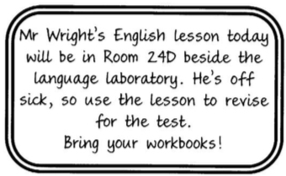 | 51.  A. The English class must take their workbooks to the language laboratory.  B. The room for English lessons is changing because of the test.  C. The usual English teacher cannot attend today's lesson.
52.  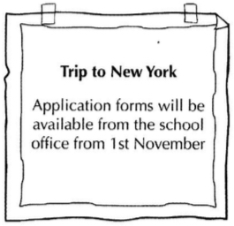 | 52.  A. Application forms are unavailable after 1st November.  B. The earliest that students can pick up their application forms is 1st November.  C. Students should give in their application forms on 1st November.
53.  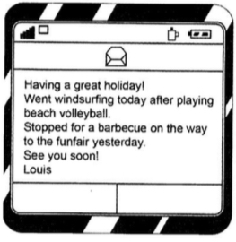 | 53.  A. Louis went windsurfing after he went to the funfair yesterday.  B. Louis played beach volleyball before he went windsurfing.  C. Louis went to the funfair before he had lunch.
54.  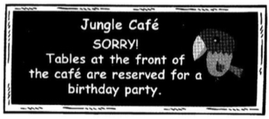 | 54.  A. Don't sit at the front of the café unless you're attending the party.  B. Only people invited to the party can come into the café.  C. If you're coming to the party you shouldn't use the tables at the front.
55.  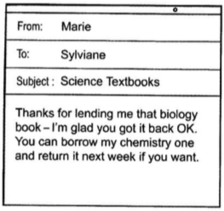 | 55.  A. Marie is offering to lend Sylviane a book.  B. Marie wants to return one of Sylviane's books to her.  C. Marie is asking Sylviane to give back a book she has borrowed.

II. Read the passage below and decide which option A, B, C or D best fits each space. (10 points)

Personal space is a term that refers (1) ………. the distance we like to keep between ourselves and other people. When (2) …………. we do not know well gets too close we usually begin to feel uncomfortable. If a business colleague comes closer than 1.2 meters, the (3)…………… common response is to move (4) ………. Some interesting (5) ……….. have been done in libraries. If strangers come too close, many people get up and leave the building; others use different methods such as turning their back on the intruder. Living in cities has (6)…………… people develop new skills for dealing with situations (7)………….. they are very close to strangers. (8)…………… people on crowded trains try not to look at strangers; they avoid skin contact, and apologize if hands touch by mistake. People use newspapers (9) …….. a barrier between themselves and other people, and if they do not have one, they stare into the distance, (10)………………..sure they are not looking into anyone’s eyes.
1. A. about B. from C. to D. for
2. A. nobody B. anyone C. someone D. people
3. A. more B. most C. best D. first
4. A. way B. up C. on D. in
5. A. studies B. questionnaires C. research D. survey
6. A. caused B. allowed C. made D. done
7. A. that B. where C. how D. which
8. A. Almost B. The most C. Most D. Mot of
9. A. alike B. like C. as D. such as
10. A. making B. made C. make D. be
III. Read the following passage and choose the correct answer. (10 points)
The Hollywood sign in the hills that line the northern border of Los Angeles is a famous landmark recognized the world over. The white – painted, 50 – foot – high, sheet mental letters can be seen from great distances across the Los Angeles basin.
The sign was not constructed, as one might suppose, by the movie business as a means of celebrating the importance of Hollywood to this industry; instead, it was first constructed in 1923 as means of advertising homes for sale in a 500 – acre-housing subdivision in a part of Los Angeles called “Hollywood land”. The sign that was constructed at time, of course, said “Hollywood land”. Over the years, people began referring to the area by the shorten version “Hollywood” and after the sign and its site were donated to the city in 1945, the last four letters were removed.
The sign suffered for years of disrepair, and in 1973, it needed to be completely replaced, at a cost of $ 27,700 per letter. Various celebrities were instrumental in helping to raise needed funds. Rock star Alice Cooper, for example, bought an O in memory of Groucho Marx, and Hugh Hefner of Playboy fame held a benefit party to raise the money for the Y. The construction of the new sign was finally completed in 1978.
66. What is the topic of this passage?
A. A famous sign B. a famous city
C. World landmarks D. Hollywood versus Hollywood land
67. The expression “The world over” in line 2 could best be replaced by _________.
A. in the northern parts of the world B. on top of the world
C. in the entire world D. in the skies
68. It can be inferred from the passage that most people think that the Hollywood sign was first constructed by _______.
A. an advertising company B. the movie industry
C. a construction company D. the city of Los Angeles
69. The pronoun “it” in line 5 refers to _______.
A. the sign B. the movie business
C. the importance of Hollywood D. this industry
70. According to the passage, the Hollywood sign was first built in ________.
A. 1923 B. 1949 C. 1973 D. 1978
71. Which of the following is NOT mentioned about Hollywood land?
A. It used to be the name of an area of Los Angeles.
B. It was formerly the name of the sign in the hills.
C. There were houses for sale there.
D. It was the most expensive area of Los Angeles.
72. The passage indicates that the sign suffered for years of _________.
A. being damaged B. not being fixed
C. the bad weather D. being poorly constructed
73. How old was the Hollywood sign when it was necessary to replace it completely?
A. Ten years old B. Twenty – six years old
C. Fifty years old D. Fifty – five years old
74. The word “replaced” is closest in meaning to which of the following?
A. Moved to a new location B. Destroyed
C. Found again D. Exchanged for a newer one
75. According to the passage, how did celebrities help with new sign?
A. They played instruments.
B. They raised the sign.
C. They helped get the money.
D. They took part in work parties to build the sign.

IV. Read the passage carefully. Then decide whether each of the statements below is TRUE (T), or FALSE (F). (5 points)
Many years ago, people used to buy what they needed from stores and markets. Now where would you go if you wanted to buy all these goods at one time? Ask anybody, and he would probably say "you'd better go to the supermarket". A supermarket is a special kind of market. It is usually much larger than an ordinary store. In a supermarket, you can buy all kinds of food, household, products and daily necessities. In a store, a customer is served by a storekeeper but in a supermarket, the goods are arranged on rows of shelves along the aisles. The prices are printed on small labels on the goods. A customer gets goods he needs from the shelves. This is known as self-service. Of course, you can always ask for help from the supermarket shop assistants.
When you enter a supermarket, you take a basket to carry the goods you will buy. If you want to buy a lot of things, you will need a trolley. A trolley is like a large basket on wheels. You can push it along the aisles, choose what you want from the shelves and put it into your trolley. A supermarket often provides a more comfortable environment for shopping than a market that is usually wet and dirty. As a result, many people usually buy more goods than they need when they visit a supermarket.
Many years ago, people used to buy what they need from supermarkets.
76. ……………. Many years ago, people used to buy what they need from supermarkets.
77. ……………. We can go to a supermarket if you want to buy different kinds of goods at one time.
78. ……………. The prices of the goods are written on small labels all over the shelves.
79. ……………. You will need a basket if you want to buy a lot of things
80. …………….. Customers get the goods they need from the shelves.

D. WRITING
I. Rewrite each of the following sentences using the words provided. (5 points)
81. France presented the Statue of Liberty to the United States in 1876.
 The Statue................................................................................................................................
82. Let’s meet inside the center, at the cafe corner?
 How........................................................................................................................................
83. Please don’t interrupt me while I am speaking.
 I’d rather................................................................................................................................
84. They arrived late because the traffic was terrible.
 Because of...........................................................................................................................
85. I don’t intend to apologize to either of them.
 I have no...................................................................................................................................
II. This is part of a letter you receive from your penfriend. (10points)
In your next letter, could you give me some advice? Tell me how you keep fit and healthy!
Now write a letter, answering your penfriend’s questions.
Now write in about 60-80 words on your answer sheet.
Dear Ann,
......................................................................................................................................................………………………………………………………………………………………………………………………………………………………………………………………………………………………………………………………………………………………………………………………………………………………………………………………………………………………………………………………………………………………………………………………………………………………………………………………………………………………………………………………………………………………………………………………………………………………………………………………………………………………………………………………………………………………………………………………………………………………………………………………………………………………………………………………………………………………………
II. Imagine that you have recently visited a place of interest. In about 100 – 120 words, write a paragraph about your trip (15pts). Your paragraph may include:
⬧ When and where you went
⬧ How you got there
⬧ Who you went with
⬧ What the place was like
⬧ What you did there
……………………
……………………
⬧ Your impression of the place
...…………………………………………………………………………………………………………………………………………………………………………………………………………………………………………………………………………………………………………………………………………………………………………………………………………………………………………………………………………………………………………………………………………………………………………………………………………………………………………………………………………………………………………………………………………………………………………………………………………………………………………………………………………………………………………………………………………………………………………………………….....................................
----------------- Hết-----------------

PHÒNG GDĐT TP. HẢI DƯƠNG | HƯỚNG DẪN CHẤM VÀ BIỂU ĐIỂM  ĐỀ THI SINH GIỎI LỚP 8  MÔN: TIẾNG ANH  Thời gian làm bài: 150 phút  (Hướng dẫn chấm gồm có 02 trang)
A. LISTENING
I. Listen and write the letter of the correct answer in your test paper. (5points)
(1 point for each correct answer)
1. A 2. C 3. B 4. C 5. C
Part II(5points): You will hear someone talking on the radio about the Willingham Museum. For each question, fill in the missing information in the numbered space
6. (£) 18.25 / eight (pounds) twenty-five
7. (the) (bus) driver
8. Gately (Street)
9. (the) museum
10. (a/some) drink(s)
Part III. You will hear some information about a travel agency. Listen and complete questions. (6 points)
(1 point for each correct answer)
11. 12 minutes 12. drama 13. weather 14. world 15. cameras
Part IV. Listen to Eric talking to Mary about the weekend. Their friend, Carlos, is coming to visit them. Listen and write the letter of the correct answer in your test paper. (4 points)
(1 point for each correct answer)
17. B 18. C 19. A 20. C
B. GRAMMAR - VOCABULARY – LANGUAGE FOCUS.
I. Choose the best option to complete the sentence. (10 points)
(0.5 point for each correct answer)
21. D 22. C 23. A 2 4. D 25. A 26. D 27. C 28. C 29. C 30. D 31. B 32. B 33. B 34. A 35. C 36. A 37. C 38. A 39. C 40. C
II. Give the correct form of the words in brackets (10 points).( 5 points for each correct answer)
41. consumption 42. capability 43. solidify 44. unexpectedly 45. dishonest
III. (5 points). Each of the following sentences has one mistake. Identify the mistakes and correct:
46. D 47. B 48. D 49. D 50.C

C. READING (30 points)
I. 5 points (one point for each corect answer)
51.C | 52.B | 53.B | 54.A | 55.A

II. 10 points (one point for each corect answer)

56.C | 57.C | 58.B | 59.A | 60.A
61.C | 62.B | 63.C | 64.C | 65.A

III. 10 points (one point for each corect answer)

66.A | 67.C | 68.B | 69.A | 70.A
71.D | 72.B | 73.C | 74.D | 75.C
IV. Read the passage carefully. Then decide whether each of the statements below is TRUE (T), or FALSE (F). (5 points)
(1 point for each correct answer)
76. F 77. T 78. F 79. F 80. T

D. WRITING
I. Finish each of the following sentences in such a way that it means exactly the same as the sentence printed before it (5 points).
81. The Statue of Liberty was presented to the United State by the France in 1876.
82. How about meeting inside the center, at the cafe corner.
83. I’d rather you didn’t interrupt me while I am speaking.
84. Because of the terrible traffic, they arrived late.
85. I have no intention of apologizing to either of them.
II. Write a letter. (10 points)

Điểm thành phần của bài viết theo những điểm đề nghị sau:  - Organization: (Bố cục bài viết rõ ràng, đầy đủ 3 phần: mở bài, thân bài, kết luận)  - Discourse: (Thể hiện khả năng viết mạch lạc, chặt chẽ, nối kết câu, chuyển mạch tốt)  - Sentence structure (morphology, vocabulary, spelling): Cấu trúc câu, ngữ pháp, từ vựng, câu linh hoạt (đơn, phức..)  - Ideas: (Ý hay, phong phú, biểu đạt nội dung liên quan chặt chẽ với chủ đề của đề thi)  - Length: (Đảm bảo đủ số lượng từ qui định: không quá dài hoặc quá ngắn.) | 1.5  2.5  2.5  2.0  1.5

III. Imagine that you have recently visited a place of interest. In about 100 – 120 words, write a paragraph about your trip (15pts).
Điểm thành phần của bài viết theo những điểm đề nghị sau:  - Organization: (Bố cục bài viết rõ ràng, đầy đủ 3 phần: mở bài, thân bài, kết luận)  - Discourse: (Thể hiện khả năng viết mạch lạc, chặt chẽ, nối kết câu, chuyển mạch tốt)  - Sentence structure (morphology, vocabulary, spelling): Cấu trúc câu, ngữ pháp, từ vựng, câu linh hoạt (đơn, phức..)  - Ideas: (Ý hay, phong phú, biểu đạt nội dung liên quan chặt chẽ với chủ đề của đề thi)  - Length: (Đảm bảo đủ số lượng từ qui định: không quá dài hoặc quá ngắn.) | 3.0  3.0  3.0  3.5  2.5

