Họ tên thí sinh: .................................................................
Số báo danh: ......................................................................
Mã Đề: 025.
Câu 1. Look at the signs. Choose the best answer for the question.
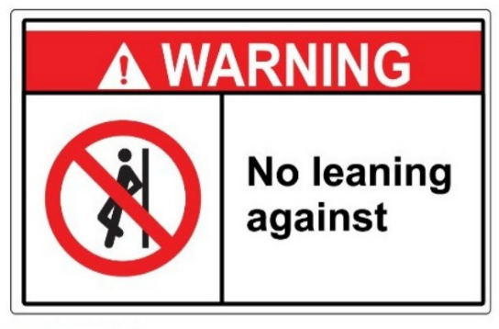
A. Leaning against the wall is possible. B. This is not a leaning wall.
C. Do not lean against the wall. D. Don’t stand near the wall because it’s leaning.
Câu 2. What is the current promotion at the clothes store?

A. Buy one get one free on summer dresses B. 10% discount on all clothes
C. Free T-shirt with every purchase D. 20% discount on all clothes
Câu 3. Look at the signs. Choose the best answer for the question.
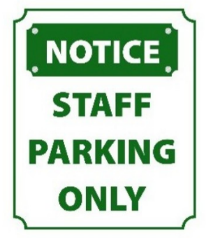
A. This parking area is for everyone.
B. You have to contact the staff if you want to park in this area.
C. No one is allowed to park in this area.
D. Only people who work here can park in this area.
Câu 4. Look at the signs. Choose the best answer for the question.
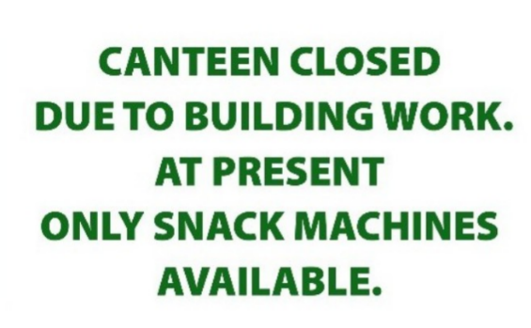
A. Students can’t buy food until the snack machines are fixed.
B. Students can’t buy snacks because the machines are closed.
C. Students can only buy food from the snack machines.
D. Students have to stop buying food till the canteen is opened.
Câu 5. How long will the cooking course run?
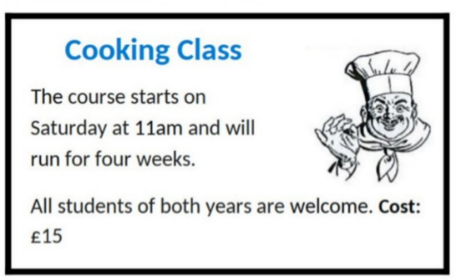
A. Two weeks B. Four weeks C. Three weeks D. Five weeks
Câu 6. Look at the signs. Choose the best answer for the question.
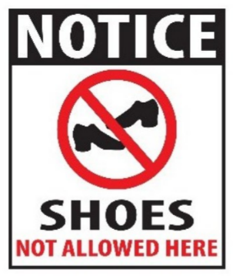
A. Please put on your shoes when entering this place.
B. You can’t buy any shoes in this place.
C. Please take off your shoes when entering this place.
D. You don’t have to wear shoes in this place.
Câu 7. Who is Andrew planning to go to the cinema with?

A. His brother B. James C. His parents D. Alone
Câu 8. How long does the reading competition last?
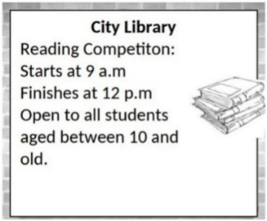
A. 3 hours B. 4 hours C. 5 hours D. 2 hours
Câu 9. Look at the signs. Choose the best answer for the question.
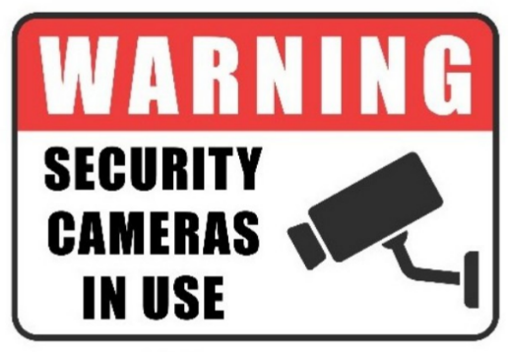
A. This area is supervised by camera. B. Cameras can only be used for security purposes.
C. You must look after your cameras in this area. D. Cameras can be used in this area.
Câu 10. Look at the signs. Choose the best answer for the question.
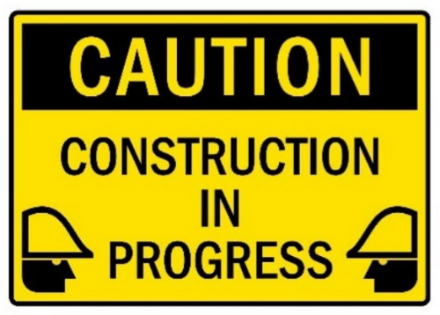
A. You have to construct buildings with caution. B. Be careful because building work is happening.
C. Construction must be carefully done in progress. D. There is careful construction.
----HẾT---

