|  |  |
| --- | --- |
|  | *Thời gian làm bài: 40 phút (Không kể thời gian giao đề)*  *-------------------------* |

**Họ tên thí sinh: .................................................................**

**Số báo danh: ......................................................................**

**Mã Đề: 005.**

**Câu 1.** What is true about the Iceland advertisement?

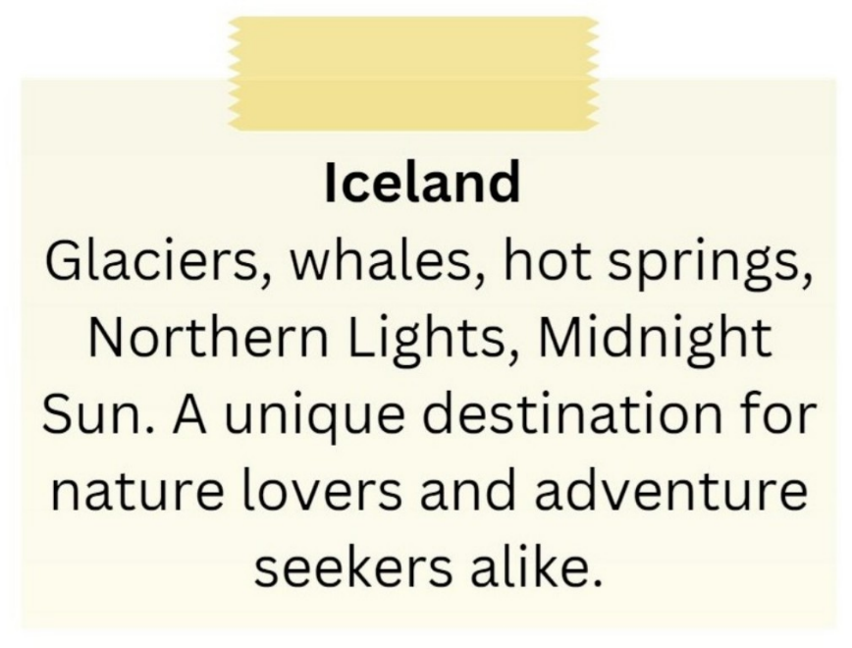

**A.** It emphasizes tropical beaches and sunbathing.

**B.** It is exclusively for adventure seekers.

**C.** It showcases skyscrapers and bustling city life.

**D.** It includes attractions such as glaciers, whales, hot springs, and the Northern Lights.

**Câu 2.** **Look at the signs. Choose the best answer for the question.**



**A.** You don’t have to run in this area.  **B.** You don’t need to run in this area.

**C.** Running is not good for you to do.  **D.** You are not allowed to run in this area.

**Câu 3.** When can students receive a 20% discount at Sam's Café?

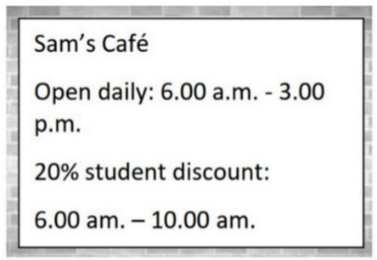

**A.** After 10:00 a.m.  **B.** From 6:00 a.m. to 3:00 p.m.

**C.** All day  **D.** From 6:00 a.m. to 10:00 a.m.

**Câu 4.** What is the main issue mentioned in the notice?

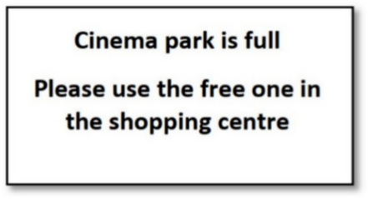

**A.** There are no free parking spaces  **B.** The shopping centre is closed

**C.** The cinema park is full  **D.** The cinema is closed

**Câu 5.** What can customers expect at the new store opening?



**A.** Exclusive deals and entertainment  **B.** Expensive prices on everything

**C.** Only fashion items  **D.** No entertainment, only shopping

**Câu 6.** Which of the following is NOT mentioned as available at the Indoor Market?

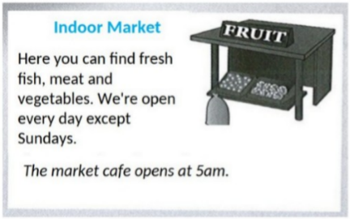

**A.** Dairy products  **B.** Meat  **C.** Vegetables  **D.** Fresh fish

**Câu 7.** "What does the person sending the message want to do?"

Hi there! I hope you're doing well. I wanted to see if you're interested in going to a show this weekend. There's a new play that just opened at the local theatre, and I've heard great things about it. Let me know if you're free and we can get tickets together.

**A.** Go to a show  **B.** Watch a movie  **C.** Visit a museum  **D.** Attend a concert

**Câu 8.** How long is the flight to France?

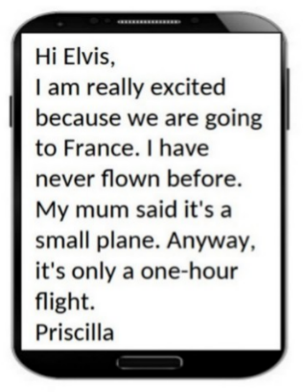

**A.** 30 minutes  **B.** Three hours  **C.** One hour  **D.** Two hours

**Câu 9.** Who can participate in this cycle ride?

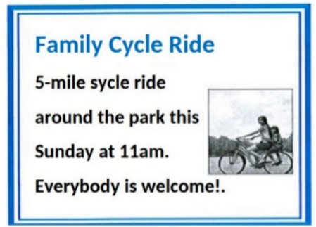

**A.** Anyone who wants to join  **B.** Only families with children

**C.** Only park members  **D.** Only experienced cyclists

**Câu 10.** Where does Rafa suggest meeting Mark instead of the café?

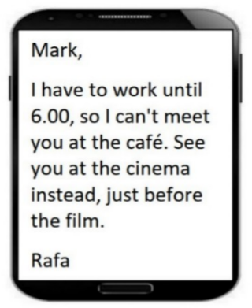

**A.** At a restaurant  **B.** At work  **C.** At the cinema  **D.** At home

**----HẾT---**