**LỚP HỌC THẦY (CÔ) ___________________________** **ĐỀ ÔN TẬP: READING SIGNS/ NOTICES – A2**

**Test 17**

*Thời gian làm bài: [Time]*

Họ và tên: ________________________________________________ Lớp: 9/___

Question 1: What does this sign mean?

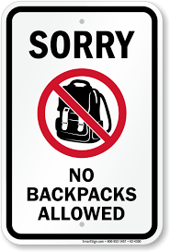A. You shouldn't carry a backpack when you're in this area.

B. You cannot bring your backpacks into this area.

C. You must pay attention when you bring a backpack.

D. Backpacks are not allowed in this area without your attention.

**Question 2:** Which statement is true according to the notice?

**Notice**  
Restaurant has new rules for reservations.

* You need to pay a deposit for reservations.

**A.** You do not need to pay a deposit.

**B.** You can walk in anytime.

**C.** You need to pay a deposit for reservations.

**D.** You can only make reservations for today.

Question 3: What does this sign indicate?

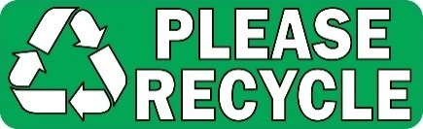

A. You must recycle if there is trash.

B. You should recycle and you should do so when you can.

C. Recycling is not allowed in this area.

D. Recycling is only allowed in certain areas.

**Question 4:** Which statement is true according to the notice?

Notice:

Our glass store is closed for Quốc Khánh for 2 days from September 2 - September 3. Please come back on September 4. Thank.

**A.** The store will be open on September 2nd.

**B.** The store will be closed from September 2nd to September 3rd.

**C.** The store will be closed on September 4th.

**D.** The store will open on September 3rd.

Question 5: What does this sign indicate?

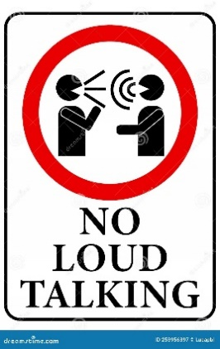

A. You must keep quiet when other people are around.

B. You are not allowed to talk here.

C. You should talk loudly in this area with your friends.

D. You should not talk loudly in this area.

**Question 6:** Which statement is true according to the notice?

**Notice**  
Students will have a break today to participate in the local "Green Week" event.

* **Time:** 3 PM
* **Location:** The vacant area in the local community

**A.** The event will start at 3 PM.

**B.** The event will take place in the school gym.

**C.** Students will have a break to attend a "Green Week" event tomorrow.

**D.** The event will start at 4 PM.

Question 7: What does this sign indicate?

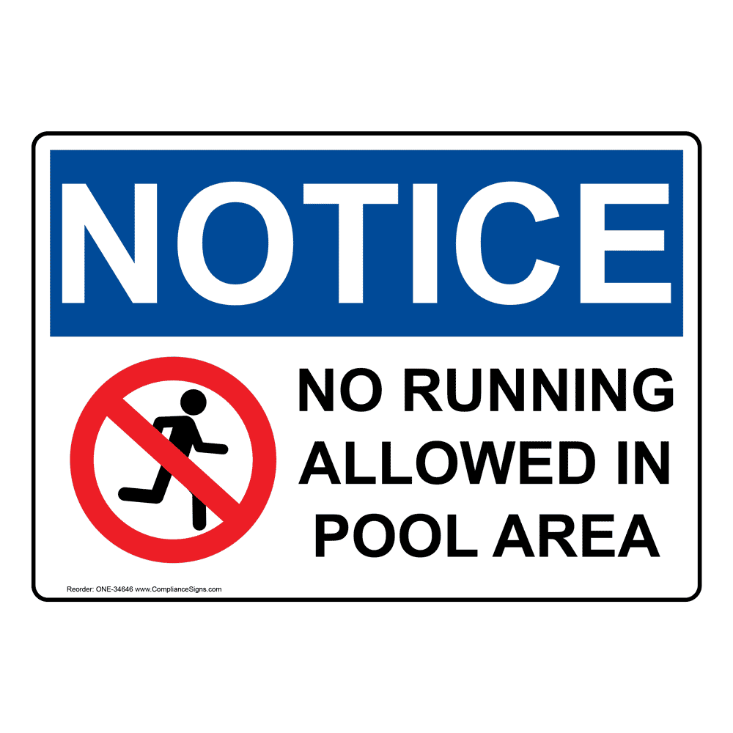A. Children are not allowed to run in the pool area.

B. Swimming is not allowed in this pool.

C. Do not approach this area.

D. This pool area is slippery so walk slowly.

**Question 8:** What does the notice tell you?

**Please turn off your mobile phones before the meeting begins. This helps prevent interruptions.**

A. Keep your cell phone turned off during the meeting.

B. Turn off your cell phone after the meeting.

C. Use your cell phone during the meeting.

D. Charge your cell phone before the meeting.

Question 9: What does this sign indicate?

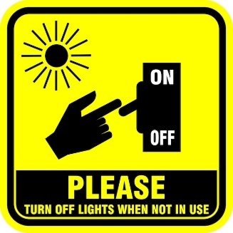 A. You should turn off the light when there are few people in the room.

B. Turn off the light when you are not using it.  
C. You are not allowed to turn off the night light.  
D. Always keep the light on when you go out.

**Question 10:** What does the notice tell you?

**Please come 10 minutes early for your appointment. This helps us be on time.**

A. Arrive 10 minutes late for your appointment.

B. You should arrive for that meeting 10 minutes in advance.

C. You should be there 10 minutes before the meeting starts.

D. Cancel your appointment 10 minutes in advance.

**[HẾT]**