Thời gian làm bài: 40 phút (Không kể thời gian giao đề)
-------------------------
Họ tên thí sinh: .................................................................
Số báo danh: ......................................................................
Mã Đề: 035.
Câu 1. Look at the signs. Choose the best answer for the question.
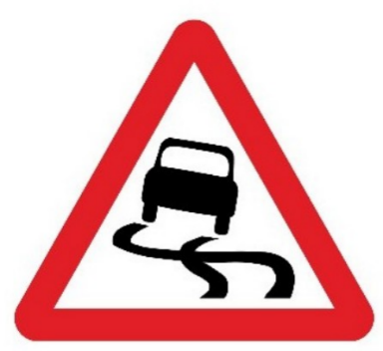
A. Be careful when driving as the road is bumpy. B. Be careful as the road is narrow ahead.
C. Be careful when driving as the road is slippery. D. Be careful as there is ice on the street.
Câu 2. Look at the signs. Choose the best answer for the question.

A. Dogs cannot be taken into this place as it is a children’s play area.
B. Don’t let your children play here because of the dogs.
C. Dogs are not allowed to play with children in this area.
D. Dogs are not safe for children in this play area.
Câu 3. When can students receive a 20% discount at Sam's Café?
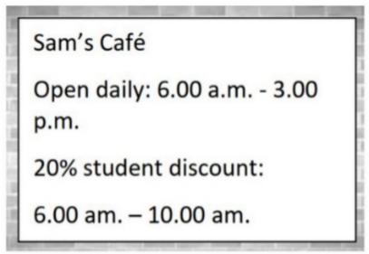
A. From 6:00 a.m. to 3:00 p.m. B. From 6:00 a.m. to 10:00 a.m.
C. All day D. After 10:00 a.m.
Câu 4. Look at the signs. Choose the best answer for the question.
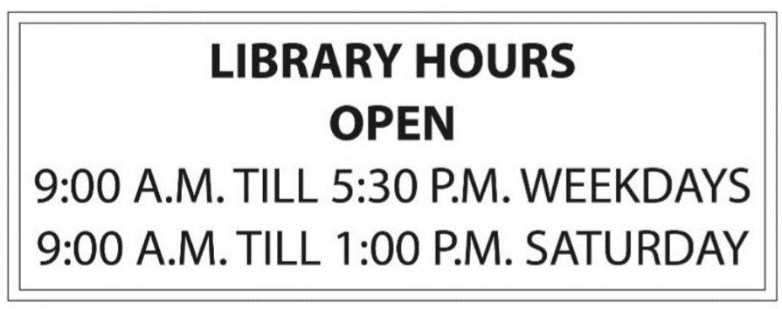
A. The library closes after 1 o’clock on Saturday afternoons.
B. People can come to the library from 9 a.m. to 5.30 p.m. every day.
C. People cannot come to the library on the weekends.
D. The library is not open at noon.
Câu 5. Look at the signs. Choose the best answer for the question.
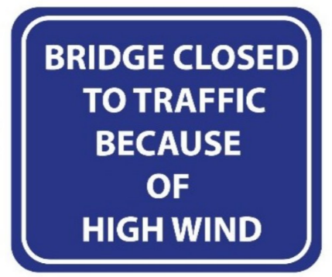
A. Be careful when using the bridge on windy days.
B. High wind prevented the bridge to be finished.
C. You cannot cross the bridge because the wind is so strong.
D. High traffic stopped people from using the bridge.
Câu 6. Look at the signs. Choose the best answer for the question.
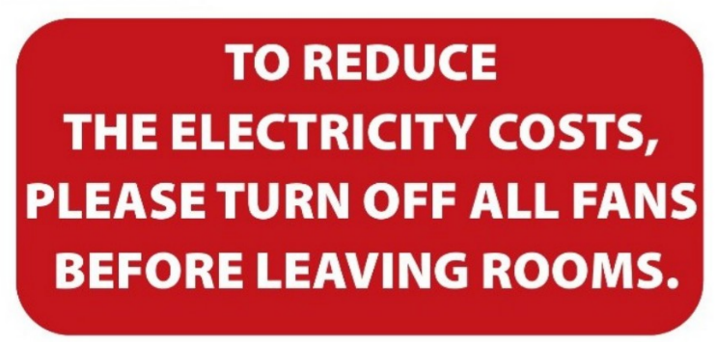
A. Please reduce the costs of electricity by leaving the room.
B. Please switch off fans when you finish using a room to save electricity.
C. Please leave the fans in the room after you go out.
D. When you leave, please reduce the number of fans in your room.
Câu 7. What is the colour of the bin for composting according to the notice?
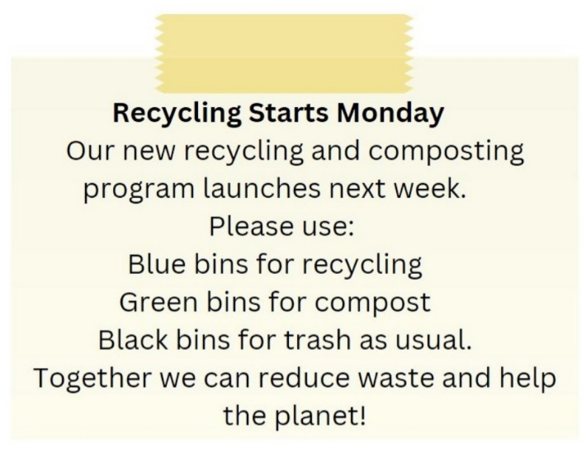
A. Green B. Red C. Blue D. Black
Câu 8. What can you see at the circus?

A. Only acrobats B. Only funny clowns
C. Wild animals and funny clowns D. Only wild animals
Câu 9. What is the current promotion at the clothes store?
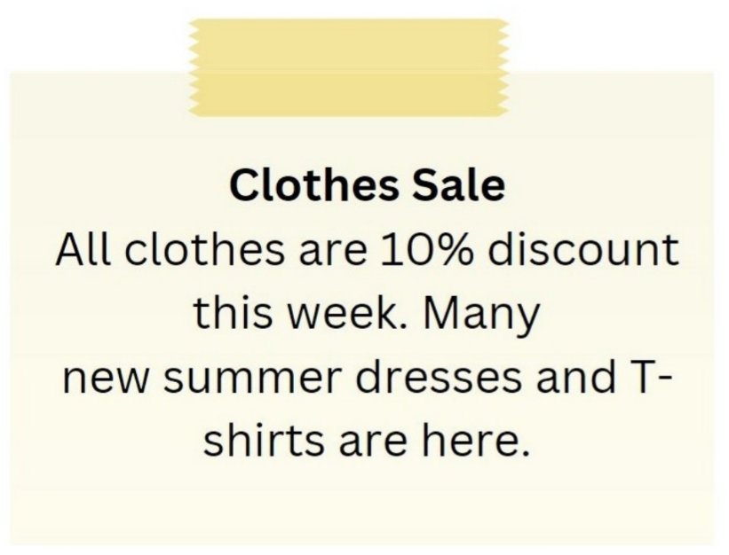
A. 10% discount on all clothes B. Buy one get one free on summer dresses
C. 20% discount on all clothes D. Free T-shirt with every purchase
Câu 10. Which of the following services is NOT offered by the Village Shop?
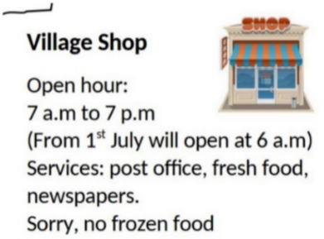
A. Fresh food B. Frozen food C. Post office D. Newspapers
----HẾT---

