School: ……………………………………….. | Date: ………………………………..
Class: ……………………………..................... | Period: ………………………..........

UNIT 6: EDUCATION
Lesson 4 – Review (pages 100, 101)

I. OBJECTIVES
By the end of the lesson, Ss will be able to:
1.1. Language knowledge and skills
- review words about feelings and school tasks (disappointed, excited, delighted, annoyed, surprised, test, presentation, book report, project, homework, fail, pass, …) and talk about them.
- review grammar: “however” and “although” to show contrast, “because” to show causes /reasons, and intensifiers “so”, “really”.
- review: talk about school life.
- pronoun the ending sounds correctly: “ed” endings.
- put stress on nouns and adjectives with two and three syllables.
1.2. Competences
- improve speaking, listening, reading and writing skills.
- improve the use of English.
1.3. Attributes
- have positive attitude in English language learning so that they actively participate in all classroom activities.
- review the old lesson and have good preparation for any test.

II. TEACHING AIDS AND LEARNING MATERIALS
1. Teacher’s aids: Student book and Teacher’s book, class CDs, Digital Book (DCR phần mềm tương tác SB, DHA (từ vựng/ cấu trúc) phần mềm trò chơi tương tác), projector/interactive whiteboard / TV (if any), PowerPoint slides, handouts.
2. Students’ aids: Student’s book, workbook, notebook.

III. ASSESSMENT EVIDENCE
Performance Tasks | Performance Products | Assessment Tools
- Listening: You will hear five short conversations. You will hear each conversation twice. There is one question for each conversation. For each question, choose the correct answer (A, B or C). | - Ss’ answers. | - T’s feedback/Peers’ feedback.
- Reading: Read the article about Anna's school year. Choose the correct answer (A, B, or C). | - Ss’ answers. | - T’s feedback/Peers’ feedback.
- Vocabulary: Circle the correct words. | - Ss’ answers. | - T’s feedback/Peers’ feedback.
- Grammar: Underline the mistakes and write the correct answers on the lines. | - Ss’ answers. | - T’s feedback/Peers’ feedback.
-Pronunciation: Circle the word that has the underlined part pronounced differently from the others.  + Circle the word that differs from the other three in the position of primary stress in each of the following questions. | - Ss’ answers/ presentation. | - T’s observation, T’s feedback/Peers’ feedback.

IV. PROCEDURES
A. Warm up: (5’)
a) Objective: Introduce the new lesson and set the scene for Ss to acquire new language; get students' attention at the beginning of the class by enjoyable and short activities as well as to engage them in the follow-up steps.
b) Content: Review vocabulary about school subjects / names of some countries Vietnamese students often apply for higher education.
c) Expected outcomes: Ss are ready for the new lesson.
d) Organization of the activity:
TEACHER’S ACTIVITIES | STUDENTS’ ACTIVITIES
- Option 1: Review: School subjects  - Have Ss look at the pictures and give names of school subjects.  - Call Ss to give answers, then pronounce the words and give meaning.  - Correct Ss’ pronunciation if necessary.  - Lead to the new lesson.  *Illustration:  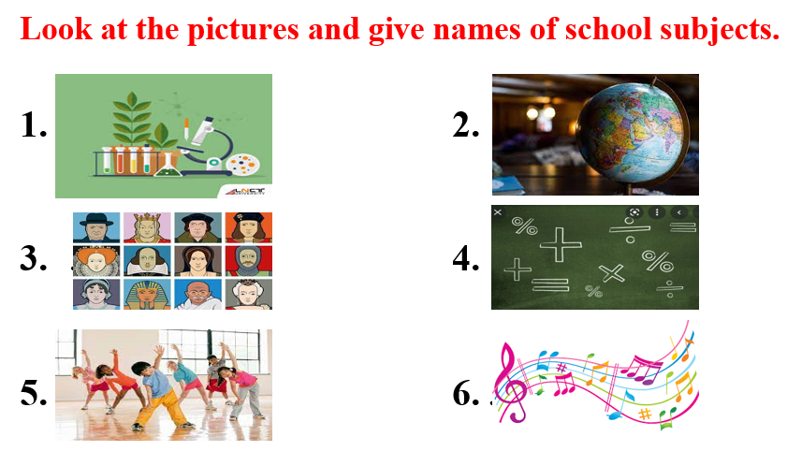  - Option 2: Review: Ideal countries for studying abroad.  - Have Ss look at the flags and give names of some countries that Vietnamese students often choose for their studying.  - Call Ss to give answers, then pronounce the words and give meaning.  - Correct Ss’ pronunciation if necessary.  - Lead to the new lesson.  *Illustration:  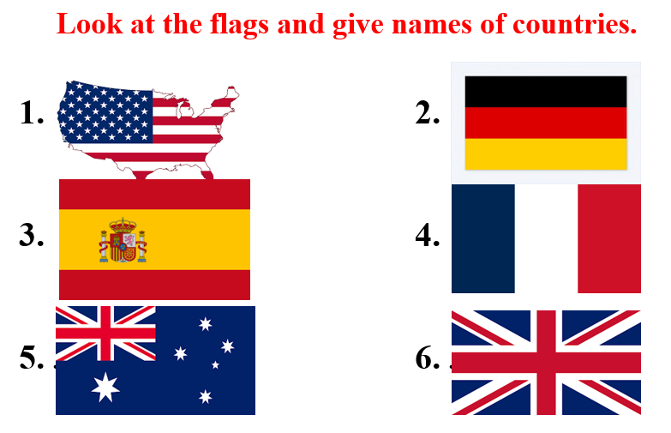 | - Look at the pictures and give names of school subjects.  - Give answers, pronounce the words.  - Listen.  Answer keys  1. Biology  2. Geography  3. History  4. Math  5. Physical Education  6. Music  - Look at the pictures and give names of the countries.  - Give answers, pronounce the words.  - Listen  Answer keys  1. The USA  2. Spain  3. Australia  4. Germany  5. France  6. The UK

B. New lesson (35’)
- Activity 1: Listening (7’)
a) Objective: Help Ss improve their listening skill.
b) Content:
- You will hear five short conversations. You will hear each conversation twice. There is one question for each conversation. For each question, choose the correct answer (A, B or C).
c) Expected outcomes: Ss listen in details and get familiar with the listening test format.
d) Organization of the activity:
TEACHER’S ACTIVITIES | STUDENTS’ ACTIVITIES
You will hear five short conversations. You will hear each conversation twice. There is one question for each conversation. For each question, choose the correct answer (A, B or C).  - Have Ss read through the listening part.  - Demonstrate the activity by using the example.  - Play the audio (CD 2 – Track 40). Have Ss listen and choose the correct answer.  - Have Ss check answers with pairs, then read answers  - Check answers as a whole class using DCR. | - Read in silence.  - Listen and read answers.  Answer keys  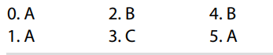
- Activity 2: Reading (7’)
a) Objective: Students can improve their reading skill.
b) Content:
- Read the article about Anna's school year. Choose the correct answer (A, B, or C).
c) Expected outcomes: Ss read for comprehension and get familiar with the reading test format.
d) Organization of the activity:
TEACHER’S ACTIVITIES | STUDENTS’ ACTIVITIES
Read the article about Anna's school year. Choose the correct answer (A, B, or C).  - Demonstrate the activity on DCR by using the example.  - Have Ss look and read, then choose the correct answer, underline the supporting ideas for their answers.  - Call Ss to give answers, explain.  - Give feedback and evaluation. | - Observe and listen.  - Work individually.  - Give answers, explain.  Answer keys  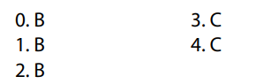

- Activity 3: Vocabulary (7’)
a) Objective: Ss can review vocabulary about feelings and school tasks.
b) Content: Circle the correct words.
c) Expected outcomes: Ss produce the new language successfully, and they can use these words in speaking and writing.
d) Organization of the activity:
TEACHER’S ACTIVITIES | STUDENTS’ ACTIVITIES
Circle the correct words.  - Have Ss read the sentences.  - Ask Ss to work in pairs to circle the correct words.  - Have Ss give answers, tell the meaning of the words /phrase again.  - Check answers as a whole class using DCR. | - Read the sentences.  - Work in pairs to match.  - Give answers.  Answer keys  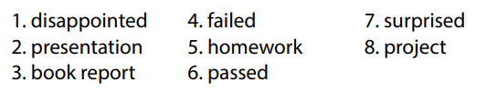
- Activity 4: Grammar (10’)
a) Objective: Ss can review the use of English: “however” and “although” to show contrast, “because” to show causes /reasons, and intensifiers “so”, “really”.
b) Content:
- Underline the mistakes and write the correct answers on the lines.
c) Expected outcomes: Ss produce the new language successfully, and they can use the grammar points in speaking and writing.
d) Organization of the activity:
TEACHER’S ACTIVITIES | STUDENTS’ ACTIVITIES
Underline the mistakes and write the correct answers on the lines.  - Ask Ss to work individually to underline the mistakes and write the correct answers on the lines.  - Have Ss work in pairs to check each other’s work.  - Call Ss to give answers, explain for their choice.  - Check answers as a whole class using DCR. | - Work individually.  - Work in pairs.  - Give answers.  Answer keys  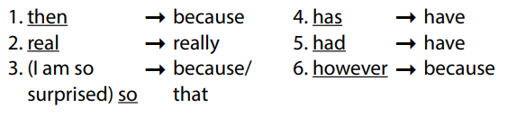
- Activity 5: Pronunciation (4’)
a) Objective: Ss can review the stress of nouns and adjectives with 2 and 3 syllables, last consonant of “ed” endings.
b) Content:
- Circle the word that has the underlined part pronounces differently from the others.
- Circle the word that differs from the other three in the position of primary stress in each of the following questions.
c) Expected outcomes: Ss produce the new language successfully.
d) Organization of the activity:
TEACHER’S ACTIVITIES | STUDENTS’ ACTIVITIES
Task a. Circle the word that has the underlined part pronounced differently from the others.  - Have Ss distinguish 3 ways to pronoun “ed” endings (review).  - Ask Ss to work individually to circle the answer  - Have Ss work in pairs to check each other’s work.  - Call Ss to give answers, pronounce the words again.  - Give feedback, correct Ss’ pronunciation if necessary.  Task b. Circle the word that differs from the other three in the position of primary stress in each of the following questions.  - Remind Ss some basic rules of putting stress on nouns and adjectives with 2 or 3 syllables.  - Ask Ss to work individually.  - Have Ss work in pairs to check each other’s work.  - Call Ss to give answers, pronounce the words again.  - Give feedback, correct Ss’ pronunciation if necessary. | - Review.  - Work individually.  - Work in pairs.  - Give answers.  Answer keys  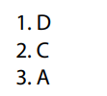  - Listen.  - Work individually.  - Work in pairs.  - Give answers.  Answer keys  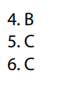

C. Consolidation and homework assignments (5’)
* Consolidation:
* Grammar of Unit 6: “however” and “although” to show contrast, “because” to show causes /reasons, and intensifiers “so”, “really”.
* Vocabulary of Unit 6: Words about feelings and school tasks (disappointed, excited, delighted, annoyed, surprised, test, presentation, book report, project, homework, fail, pass, …).

* Homework:
- Review vocabulary, grammar of unit 6.
- Do the exercises in WB: Review of Unit 6 (page 67).
- Prepare: Unit 7 – New words and Listening (page 52 – SB).

D. Reflection
a. What I liked most about this lesson today:
…………………………………………………………………………………………
- What I learned from this lesson today:
…………………………………………………………………………………………
c. What I should improve for this lesson next time:
…………………………………………………………………………………………

