Date of preparing: ………………………………….
Date of teaching: ………………………………….

Period……
UNIT 10: CITIES AROUND THE WORLD
Review Lesson - (Pages 104, 105)

I. OBJECTIVES
By the end of the lesson, Ss will be able to…
1. Knowledge
- review all vocabularies relating to landmarks in cities around the world;
- review all new language, grammar and pronunciation;
- improve the four-English skills;
2. Ability
- improve their four-English skills (main skills: Listening and Speaking; sub-skills: Reading and Writing);
- develop communication, collaboration, self-study, and problem-solving skills;
3. Quality
- have positive attitude in learning and actively participate in all classroom activities;
- improve the four-English skills and enlarge their vocabularies relating to the topic.
II. TEACHING AIDS AND LEARNING MATERIALS.
Lesson plan, PPT slides, Student’s book, workbook, notebook, personal computer (if any), projector/ TV, speakers, DCR & DHA on Eduhome, CD player, handouts…
III. PROCEDURES
A. Warm up: (3’)
a) Objectives: To review all vocabularies, new language;
To improve and develop Ss’ collaboration and communication.
b) Contents: practicing the four-English skills on the topic “Cities around the world”
c) Product: Students can improve the four-English skills and enlarge their vocabularies relating to the topic.
d) Competence: Collaboration, critical thinking, problem-solving, and communication skills
e) Organization of the activity:
Teacher’s activities | Students’ activities
- Ask Ss to retell what they have learnt in Unit 10.  - Get them to do the task individually.  - Have Ss to say out loud in front the class.  - Support Ss to do learning tasks.  - Lead to new Lesson. | - Retell what they have learnt in Unit 10.  + Vocabulary  + Grammar  + Pronunciation  + Skills  - Say out loud in front the class.

B. New lesson (39’)
- Activity 1: Listening Skill (7’)
a) Objectives: To improve their listening skill through choosing the correct answers to develop a conversation and to develop their critical thinking skills (guessing/ reasoning) and communication.
b) Content: discussing and performing well with the questions.
c) Products: Students can produce the new language successfully and then can finish the listening exercise.
d) Competence: Collaboration, guessing, communication, and critical thinking skills
e) Organization of the activity:
Teacher's activities | Students' activities
Listen to 5 short conversations. And choose the best answers.  - Have Ss read the questions and guess the information they will hear.  - Play the audio once.  - Check answers as a whole class.  - Ask Ss to give the cues for their answers.  - Play the audio again for Ss to check their answers. | Listen to 5 short conversations. And choose the best answers.  - Read the questions and guess the information they will hear.  - Listen and answer the questions.  - Share their answers with partners.  - Give the cues for their answers.  Expected answers:  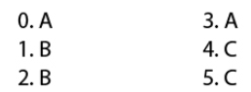

- Activity 2: Reading Skill (8’)
a) Objectives: To improve their reading skills with the kind of questions - filling in the blanks;
To develop critical thinking skills (guessing/ reasoning) and communication.
b) Content: discussing and performing well with the questions, filling-gap
c) Products: Students can improve their reading skills with filling-gap.
d) Competence: Collaboration, communication, guessing, and critical thinking skills
e) Organization of the activity:
Teacher's activities | Students' activities
Read the email and write one word for each blank.  - Exploit some vocabularies and ask Ss to give Vietnamese equivalent meaning if necessary.  - Get them to read the email individually and do the task.  - Have Ss share their answers with partners.  - Check answers as a whole class.  - Ask Ss to give reasons for their answers and give them feedback. | - Give the meaning of the words if necessary.  - Read the email individually and answer the questions.  - Share their answers with the partners.  - Present their answers in front of the class.  Expected answers:  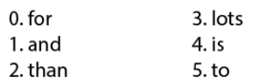

- Activity 3: Vocabulary (8’)
a) Objectives: To enrich and practice their vocabulary through filling in the blanks;
To develop critical thinking skills (guessing/ reasoning) and communication.
b) Content: discussing and performing well with the questions, filling-gap
c) Products: Students can review and enrich their vocabulary they have learnt from the previous lessons.
d) Competence: Communication, collaboration, presentation, and imagination
e) Organization of the activity:
Teacher's activities | Students' activities
Fill in the blanks with words from the unit.  - Ask Ss exploit some vocabularies relating to the Unit.  - Get them to do the task individually.  - Have Ss share their answers with partners.  - Check answers as a whole class.  - Ask Ss to give reasons for their answers and give feedback. | Fill in the blanks with words from the unit.  - Exploit some vocabularies relating to the Unit.  - Do the task individually.  - Share their answers with the partners.  - Present their answers with the whole class.  Expected answers:  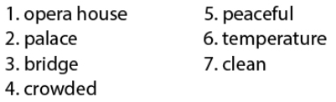

- Activity 4: Grammar (11’)
a) Objectives: To review all new grammatical points;
To develop critical thinking skills (guessing/ reasoning) and communication.
b) Contents: reviewing all new grammatical points
c) Products: Students can review and produce the new language successfully in their speaking.
d) Competence: Communication, collaboration, presentation, and imagination
e) Organization of the activity:
Teacher's activities | Students' activities
Unscramble the sentences.  - Ask Ss to exploit the Grammatical point in the Unit 10.  - Ask Ss to do the task individually.  - Have Ss share their answers with partners.  - Check answers as a whole class.  - Ask Ss to give reasons for their answers and give feedback. | Unscramble the sentences.  - Exploit Grammatical point in the Unit 10.  - Do the task individually.  - Share their answers with the partners.  - Present their answers with the whole class.  Expected answers:  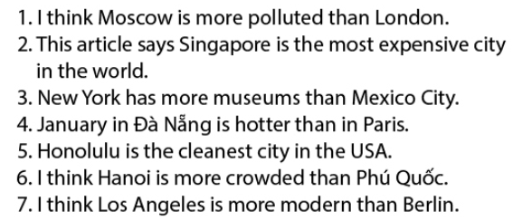

- Activity 5: Pronunciation (5’)
a) Objectives: To review the phonetic items;
To critical thinking skills (guessing/ reasoning) and communication.
b) Contents: reviewing all new phonetic item
c) Products: Students can review and produce the new language successfully in their speaking.
d) Competence: Communication, collaboration, and listening skills
e) Organization of the activity:
Teacher's activities | Students' activities
Circle the word which has the underlined part pronounced differently from the others.  - Ask Ss to exploit the phonetic item in the Unit 10.  - Ask them to do the task individually.  - Have Ss share their answers with partners.  - Check answers as a whole class.  - Ask Ss to give reasons for their answers and give feedback. | Circle the word which has the underlined part pronounced differently from the others.  - Exploit phonetic item in the Unit 10.  - Do the task individually.  - Share their answers with the partners.  - Present their answers in front of the class.  Expected answers:  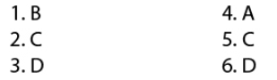

D. Homework (3’)
- Learn new words and practice with the learnt language of Unit 10.
- Do the exercises on page 71 (WB).
- Prepare the new lesson.

