School: ……………………………………….. | Date: …………………………………..
Class: ……………………………..................... | Period: ………………………….........

UNIT 6: EDUCATION
Lesson 2.1 – New words and Reading (page 47)

I. OBJECTIVES
By the end of the lesson, Ss will be able to:
1.1. Language knowledge and skills
- know some words about feelings (pleased, disappointed, surprised, delighted, annoyed, upset, frustrated).
- talk about how they feel at school.
- read a letter from James to his aunt about his studying to understand general and specific information.
1.2. Competences
- improve communication, collaboration, analytical and critical thinking skills.
1.3. Attributes
- overcome studying pressure and negative feelings.
- have a balance between studying and relaxing.

II. TEACHING AIDS AND LEARNING MATERIALS
1. Teacher’s aids: Student book and Teacher’s book, class CDs, Digital Book (DCR phần mềm tương tác SB, DHA (từ vựng/ cấu trúc) phần mềm trò chơi tương tác), projector/interactive whiteboard / TV (if any), PowerPoint slides.
2. Students’ aids: Student’s book, workbook, notebook.

III. ASSESSMENT EVIDENCE
Performance Tasks | Performance Products | Assessment Tools
- Number the pictures. | - Ss’ answers. | - T’s feedback/Peers’ feedback.
- Listen and repeat. | - Ss’ answers/ presentation. | - T’s observation / feedback.
- When did you feel like the people in the pictures? | - Ss’ answers. | - T’s feedback/Peers’ feedback.
- Read the letter from James to his aunt. Is James doing well in school? | - Ss’ answers. | - T’s feedback/Peers’ feedback.
- Read and circle the correct answer. | - Ss’ answers. | - T’s feedback/Peers’ feedback.
- What subjects do you find the easiest? What do you find the most difficult? | - Ss’ answers/ presentation. | - T’s feedback/Peers’ feedback.

IV. PROCEDURES
A. Warm up: (5’)
a) Objective: Introduce the new lesson and set the scene for Ss to acquire new language; get students' attention at the beginning of the class by enjoyable and short activities as well as to engage them in the follow-up steps.
b) Content: Introduce some words about feelings (pleased, disappointed, surprised, delighted, annoyed, upset, frustrated).
c) Expected outcomes: Ss have general ideas about the topic of the new lesson: feelings at school.
d) Organization of the activity:
TEACHER’S ACTIVITIES | STUDENTS’ ACTIVITIES
- Option 1:  - Use the “New words” part a – page 47 for the warm-up activity.  - Show pictures and words using DCR, have Ss number the pictures (in pairs).  - Call Ss to give answers.  - Give feedback and show correct answers using DCR.  - Lead to the new lesson.  - Play the audio (CD1 – Track 64), have Ss listen and repeat.  - Correct Ss’ pronunciation if necessary.  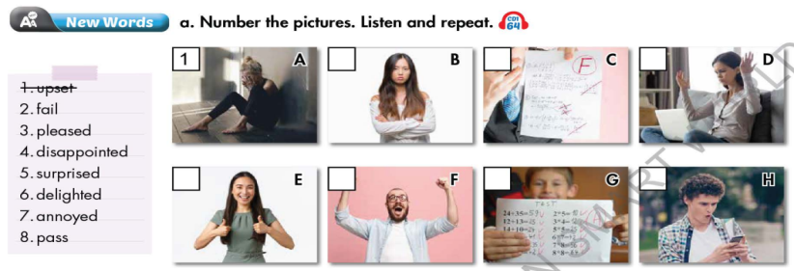  - Option 2: Chatting  - Ask Ss some questions:  How do you feel when …  1. … you get bad marks  2 … you win a competition?  3. … you meet a new nice classmate?  4. … you fail the exam?  5. … you pass an exam with flying colors?  6. … you cheat in an exam?  7. … you have too much homework to do?  8 … your parents misunderstand you?  9. … a friend asks you to lend him / her some money?  - Call Ss to give answers.  - Give feedback.  - Introduce the new lesson: feeling about school and other school activities. | - Work in pairs to number the pictures.  - Give answers.  - Listen.  Answer keys  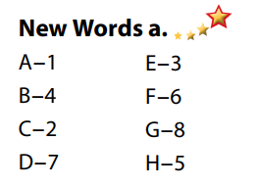  - Listen and give answers.

B. New lesson (35’)
- Activity 1: Pre-Reading (Vocabulary) (12’)
a) Objective: Ss know some words about feelings about school.
b) Content:
- Vocabulary study: Number the pictures (pleased, disappointed, surprised, delighted, annoyed, upset, frustrated, fail, pass).
- Listen and repeat.
- Speaking: When did you feel like the people in the pictures?
c) Expected outcomes: Ss know how to pronounce the new words correctly and use them in appropriate situations.
d) Organization of the activity:
TEACHER’S ACTIVITIES | STUDENTS’ ACTIVITIES
Task a. Number the pictures. Listen and repeat.  - Option 1 (If the teacher hasn’t used this part for the Warm-up activity.)  - Demonstrate the activity on DCR, using the example.  - Have Ss look at the pictures and phrases, then number the pictures.  - Divide class into pairs and have them check their answers with their partners.  - Call Ss to give answers (read or write).  - Check answers as a whole class using DCR.  - Play audio (CD1 – Track 64). Have Ss listen and repeat.  - Correct Ss’ pronunciation.  - Option 2: (If the teacher has used part a. for the Warm-up activity.)  - Have Ss review the words they have known in the warm-up activity by labeling the pictures. (T uses different pictures from those in the textbook and add more icons.)  - Call Ss to give answers (read or write).  - Check answers as a whole class.  - Call some Ss to read the words again.  - Correct Ss’ pronunciation if necessary.  *Illustration:  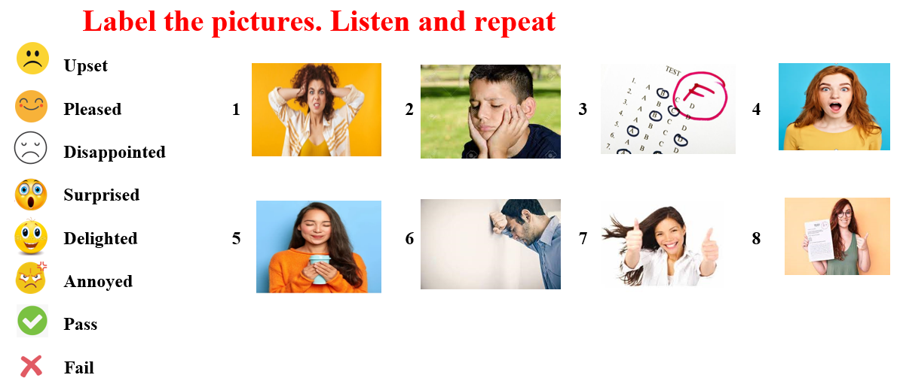  Task b. When did you feel like the people in the pictures?  - Have students tell when they felt like the people in the pictures.  - Have Ss share their stories in front of the class.  - Give feedback and evaluation. | - Look and listen.  - Work individually.  - Work in pairs.  - Give answers.  - Listen and repeat.  Answer keys  - Work in pairs.  - Give answers.  - Read.  Answer keys  - Work in pairs.  - Present.  Sample answers  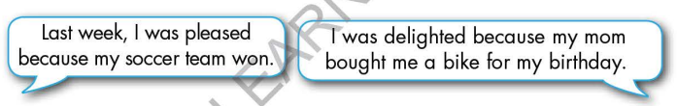
- Activity 2: While - Reading (17’)
a) Objective: Students can develop their reading skill.
b) Content:
- Read the letter from James to his aunt. Is James doing well in school?
- Read and circle the correct answer.
c) Expected outcomes: Students can read a paragraph and understand more about the studying of a student.
d) Organization of the activity:

TEACHER’S ACTIVITIES | STUDENTS’ ACTIVITIES
Task a. Read the letter from James to his aunt. Is James doing well in school?  - Ask Ss to scan the paragraph, then choose the best answer.  - Remind Ss to underline or highlight the keywords or supporting ideas for their answers.  - Have some Ss share their answers with the class (read), explain for their answers.  - Give feedback.  - Give feedback and correct Ss’ answers if necessary.  Task b. Now, read the paragraph and circle the correct answer.  - Have Ss look at sentences and underline the key words.  - Have Ss work in pairs to circle the best answer.  - Elicit answers from different pairs.  - Give feedback and evaluation. | - Work individually.  - Read answers, explain.  - Check answers.  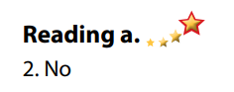  Answer keys  - Work in pairs to circle the best answer.  - Read answers.  Answer keys  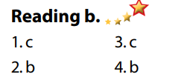

- Activity 3: Post - Reading (6’)
a) Objective: Students can use the vocabulary and ideas from the reading text to develop their speaking skill.
b) Content: Speaking: What subjects do you find the easiest? What do you find the most difficult?
c) Expected outcomes: Students can talk about their easiest and most difficult subjects at school.
d) Organization of the activity:
TEACHER’S ACTIVITIES | STUDENTS’ ACTIVITIES
Task c. In pairs: What subjects do you find the easiest? What do you find the most difficult?  - Have Students work in pairs to answer the questions.  - Go round and give help if necessary.  - Call some Ss to share their ideas with the whole class.  - Give feedback and evaluation. | - Discuss in pairs.  - Present.  - Listen.

C. Consolidation and homework assignments (5’)
* Consolidation:
- Words about feelings (pleased, disappointed, surprised, delighted, annoyed, upset, frustrated) and verbs (pass, fail).

* Homework:
- Learn the new words by heart.
- Practice talking about favorite subject at school.
- Do the exercises in WB: New words + Reading (pages 34, 35).
- Complete the grammar notes in Tiếng Anh 7 i-Learn Smart World Notebook (page 38).
- Play consolation games in Tiếng Anh 7 i-Learn Smart World DHA App on www.eduhome.com.vn
- Prepare: Unit 6 - Lesson 2.2 – Grammar (page 48 – SB).

D. Reflection
a. What I liked most about this lesson today:
…………………………………………………………………………………………
- What I learned from this lesson today:
…………………………………………………………………………………………
c. What I should improve for this lesson next time:
…………………………………………………………………………………………

