**ĐỀ SỐ 7**

**Mark the letter A, B, C, or D on your answer sheet to indicate the word whose underlined part differs from the other three in pronunciation in each of the following questions.**

Question 1. A. child B. fill C. milk D. pink

**Question 2.** A. technique B. chemist C. children D. headache

Mark the letter A, B, C, or D on your answer sheet to indicate the word that differs from the other three in the position of primary stress in each of the following questions.

Question 3. A. enjoy B. consist C. beauty D. succeed

Question 4. A. capable B. different C. difficult D. delightful

Mark the letter A, B, C, or D on your answer sheet to indicate the correct answer to each of the following questions.

**Question 5.** Hurricane Andrew swept through southern Florida ______ 1992.

A. for B. on C. at D. in

**Question 6.** I ______ from her since she left school.

A. don’t hear B. haven’t heard C. didn’t hear D. hasn’t heard

**Question 7.** Of all the shoes that I have tried on, these ones are ______.

A. comfortable B. less comfortable

C. more comfortable D. the most comfortable

Question 8. If more chemicals are released into the environment, many species ______ extinct.

A. will become B. are becoming

C. becomes D. became

Question 9. This shopping mall, which ______ two years ago, attracts a lot of shoppers.

A. built B. was built C. will be built D. was building

Question 10. Giving lucky money to the young at Tet is a common ______ in many Asian countries.

A. practice B. behaviour C. tradition D. habit

Question 11. This restaurant is ______ for its excellent dishes and service.

A. proud B. certain C. famous D. different

Question 12. Mary: “That’s a very nice skirt you’re wearing.” - Jolie: “______”

A. You’re welcome. B. That’s all right.

C. Don’t mention it. D. Thank you.

Read the following announcement and mark the letter A, B, C, or D on your answer sheet to indicate the correct option that best fits each of the numbered blanks from 13 to 16.

8 TIPS TO STAY SAFETY ONLINE

1. Be nice (**13**) ______ people online

2. Take care with what you share

3. (**14**) ______ personal information private

4. Check your privacy settings

5. Know how (**15**) ______ posts

6. Keep your password (**16**) ______

7. Never meet anyone in person you have only met online

8. If you see anything online that you don't like or you find upsetting, tell someone you trust

**Question 13.** A.to B. with C. of D. for

**Question 14.** A. Make B. Keep C. Remain D. Sustain

**Question 15.** A. reporting B. report C. to report D. reported

**Question 16.** A. safe B. safeless C. safeness D. unsafe

**Question 17.** ***Put the sentences (a-c) in the correct order, then fill in the blank to make a logical text.***

I had a hard 10-day course in an army camp in Son Tay last summer. Everything was different from my life at home. ______

A. We had to wake up at 5 a.m. and attend classes which were like training courses for soldiers.

B. In the evening, we read books or worked in teams with many exciting activities.

C. We also joined a performance that had the theme: environmental protection.

A. b-c-a B. c-b-a C.a-b-c D. a-c-b

Question 18. Choose the sentence that can end the text (in Question 17) most appropriately.

A. After that, I attended such a strict but exciting course like this.

B. Finally, I can attend an exciting course.

C. I also felt disappointed about it.

D. I have never attended such a strict but exciting course like this.

Read the following passage and mark the letter A, B, C, or D on your answer sheet to indicate the correct word or phrase that best fits each of the numbered blanks from 19 to 24.

Owning a pet can be a great (**19**) ______. It is a chance to love and care for a living creature. By watching and looking at its growth and behavior, you will discover that having a pet can be exciting and (**20**).

It is also said that owning a pet reaps benefits to your health. You will have lower blood pressure and lower cholesterol levels. Owning a pet gives you a greater sense of well-being and (**21**) ______ your stress level.

Different types of pets need different kinds of care. Some pets are easy to look (**22**) ______ while others are difficult. Pets are not toys and a certain amount of work is needed if you want to take care of (**23**) ______ properly. You must be willing to spend a part of each day to meet your pet's needs.

(**24**) ______ pets, big or small, depend on their owners for food, housing and protection. Although love is very important, it alone is not enough.

**Question 19.** A. activities B. way C. task D. pleasure

**Question 20.** A.amusing B. amuse C. amused D. amusingly

**Question 21.** A.decreases B. make C. increase D. cause

**Question 22.** A.at B. for C. after D. into

**Question 23.** A.it B. them C. they D. their

**Question 24.** A. AB. Much C. All D. Any

Mark the letter A, B, C or D on your answer sheet to indicate the sentence that is closest in meaning to the original sentence in each of the following questions.

**Question 25.** “What time did you go to bed last night, Mike?” his mother asked.

A. Mike’s mother asked him what time he had gone to bed last night.

B. Mike’s mother asked him what time he has gone to bed the previous night.

C. Mike’s mother asked him what time he had gone to bed the previous night.

D. Mike’s mother asked him what time he went to bed last night.

**Question 26.** The house belongs to my grandparents. It was built in 1975.

A. The house which it belongs to my grandparents was built in 1975.

B. The house who belongs to my grandparents was built in 1975.

C. The house which belongs to my grandparents was built in 1975.

D. The house what belongs to my grandparents was built in 1975.

Mark the letter A, B, C, or D on your answer sheet to indicate the sentence that is made from the given cues in each of the following questions.

**Question 27.** Linda / go / cooking class / every Wednesday evening.

A. Linda went to the cooking class every Wednesday evening.

B. Linda goes the cooking class every Wednesday evening.

C. Linda will go to the cooking class every Wednesday evening.

D. Linda goes to the cooking class every Wednesday evening.

**Question 28.** She / tell / me / quiet / because / baby / sleep.

A. She tells me to be quiet because the baby was sleeping.

B. She told me be quiet because the baby was sleeping.

C. She told me to be quiet because the baby is sleeping.

D. She told me to be quiet because the baby was sleeping.

**Read the following sign or notice and mark the letter A, B, C, or D on your answer sheet to indicate the correct answer to each of the following questions.**

**Question 29.** What does the sign say?

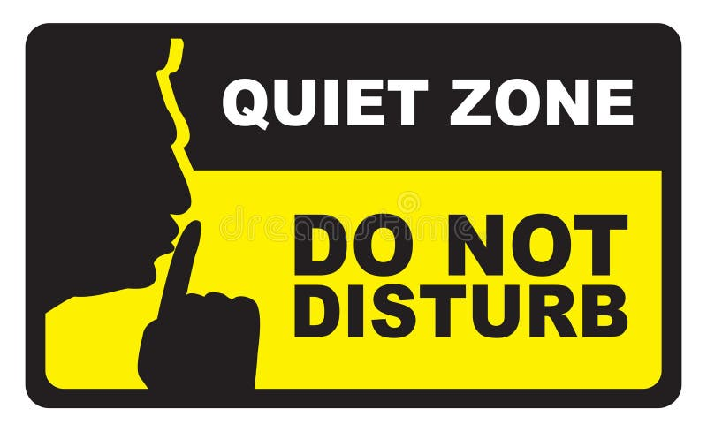

A. You can make noise and talk loudly in this area.

B. This area is for quiet and no loud noises are allowed.

C.Making noise is encouraged and allowed in this area.

D. The area is not watched, so noise is not controlled.

**Question 30.** What does the notice say?

**Seavista Restaurant  
Opening this weekend.  
Free food for children.**

A. The restaurant is old.

B. The restaurant has great food.

C. Guests don’t have to pay for children’s meals.

D. The restaurant is only open at the weekend.

Read the following passage and mark the letter A, B, C, or D on your answer sheet to indicate the correct answer to each of the following questions from 31 to 36.

Ke Ga Cape, which is about twenty-five kilometres from the city of Phan Thiet, is often overlooked by the majority of travellers coming to Viet Nam. Therefore, the peacefulness of this coastal area has been preserved. If you want to experience the 'real', unspoiled side of Viet Nam, we highly recommend that you add Ke Ga Cape to your 'places' to visit' list.

Once you've arrived at Ke Ga Cape, its attractions are immediately obvious. Most j travellers are attracted by the sight of its untouched cliffs spreading out along the coast J and the sound of the casuarina trees rustling in the breeze. On sunny days, you will be enthralled by the harmonious tones of the sea and sky, and the sight of clouds embracing the mountain peaks. You can also admire the splendid sunrise, and later go for a walk to enjoy the mesmerizing sunset. The red-yellow rays of the sun reflected in the waves paint an **enchanting** picture of the pristine Ke Ga Cape. Sometimes, it may be hard for you to distinguish where the sky ends and the sea begins.

If you want to get to Ke Ga Lighthouse, taking a canoe is highly recommended because it is quick, convenient, and safe. Ke Ga Lighthouse is worth a visit during your Viet Nam tour, if you want to experience daily life in a fishing village. The locals are very friendly, **warm-hearted,** and sincere. Not surprisingly, they will often invite you to join them for a meal of their freshly caught seafood, which will definitely awaken your taste buds.

**Question 31.** What is the main idea of the passage?

A. Ke Ga Cape - a travel destination in Vietnam.

B. The ways to preserve Ke Ga Cape.

C.How Ke Ga Cape attract tourists from all over the world.

D. Some interesting activities in Ke Ga Cape.

**Question 32.** What attracts most travellers to Ke Ga Cape?

A. the harmonious tones of the sea and sky.

B. the sight of clouds embracing the mountain peaks.

C.cliffs spreading out along the coast.

D. The red-yellow rays of the sun reflected in the waves.

**Question 33.** If you want to get to Ke Ga Lighthouse, you are highly recommended to take ______.

A. a bus B. a train C. a plane D. a canoe

**Question 34.** What are the locals in Ke Ga Lighthouse like?

A. loyal and funny B. warm-hearted and quick

**C.** friendly and sincere D.safe and convenient

**Question 35.** The word **“enchanting”** is CLOSEST in meaning to ______.

A. attractive B. ugly C.special D. exciting

**Question 36.** The word **“warm-hearted”** is **OPPOSITE** in meaning to ______.

A. kind B. useful C. gentle D. unfriendly

Four phrases/ sentences have been removed from the text below. For each question, mark the letter A, B, C, or D on your answer sheet to indicate the correct option that best fits each of the numbered blanks from 37 to 40.

Braj Kachru was a Professor of Linguistics **(37**) ______. The term refers to the fact that English has become a global means of communication with a lot of varieties.

In 1985, Kachru proposed a model of the different uses of English around the world. (**38**) ______. The first of these circles is the Inner Circle, which consists of the traditional English- speaking countries, (**39**) ______. In these regions, English is the first language, and their speakers provide the standards of English.

The next circle is the Outer Circle where English is not the first language but the second or official language. The countries in this circle include India, Singapore, the Philippines, Pakistan, Malaysia, etc. The speakers of these places follow the standards which the countries in the Inner Circle provide.

The last circle is the Expanding Circle. (**40**) ______. Some of the countries in the Expanding Circle are Brazil, Japan, Russia, and Viet Nam. Speakers of English in these places follow the rules which the people in the Inner Circle have established.

A. who invented the term 'World Englishes'

B. People in this circle speak English as a foreign language

C. such as the UK, the USA, Australia, New Zealand, and Canada

D. There are three concentric circles in the model

**Question 37.** __________ **Question 38.** __________

**Question 39.** __________ **Question 40.** __________