Mã đề 9.1.25
ĐỀ KIỂM TRA CUỐI KỲ I NĂM HỌC: 2022-2023
MÔN: TIẾNG ANH LỚP 9
Thời gian làm bài: 60 phút
SECTION A: LISTENING (2 point)

I. Listen and choose the correct answer A, B or C for each question. (1 point)
1. What's the matter with Daisy? | 4. What can Jane and Jim do?
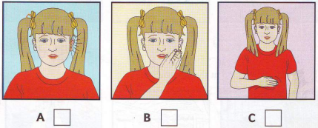 | 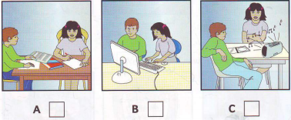
2. Which child is Ben? | 5. What did Nick do at the weekend?
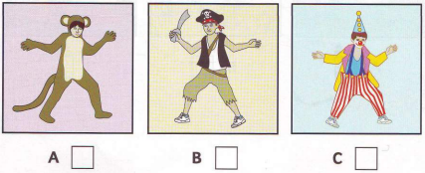 | 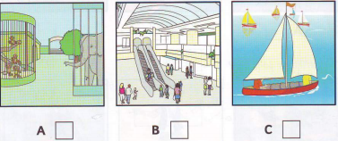
3. What does John want for lunch?
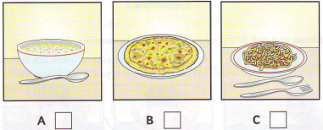
II. Listen to the passage and write the correct word/ number in the blank. (1 point)

SOUTH SEAS TRAVEL AGENCY
1. New phone number: ………………….
2. New address: 98………………….Road
3. Opposite: ………………….
4. Opens on: ………………….of May
5. Book a holiday for: £…………………
SECTION B: LANGUAGE (2 POINTS)
I. Choose the word that has the different stress from others by circling A, B, C or D (0.4 point)
1. A. contribute B. confident C. fabulous D. negative
2. A. factor B. conflict C. remind D. bamboo
II. Choose the best option (A, B, C or D) to complete these sentences. (1.6 point)
1. Physical changes are different for everyone, so you don’t need to feel embarrassed or __
A. frustrated B. calm C. confident D. delighted
2. Today's cities are _____than cities in the previous time.
A. lots larger B. much larger C. as large D. the largest
3. She presented me with a new blanket on which she _____ some beautiful flowers.
A. knitted B. embroidered C. moulded D. carved
4. Jane said that she _________ come and look after the children the following day.
A. would B. was C. has to D. is going to
5. “Thank you very much for your help.” “______”
A. It’s quite OK. B. That’s right. C. I’d love to. D. You’re welcome.
6. The children in my village used to go ______, even in winter. Now they all have shoes.
A. on foot B. bare-footed C. playing around D. played around
7. Your body will change in shape and______
A. height B. high C. tall D. taller
8. They can’t decide where _____ first
A. go B. to go C. went D. going
SECTION 3: READING (2 POINTS)
I. Read the passage and then choose the correct answer to each question. (1 point)
Teenagers today live in a very competitive world. It is (1) ______important than ever to succeed at school if you hope to (2 ) ______a chance in the job market afterwards. It’s no wonder that many young people worry (3) ______letting down their parents, their peers and themselves. To try to please everyone, they take on too (4) ______tasks until it becomes harder and harder to balance homework assignments, parties, sports activities and friends. The result is that young people (5) ______from stress.
1. A. more B. much C. little D. very
2. A. gain B. achieve C. have D. retain
3. A. with B. about C. of D. on
4. A. few B. many C. much D. a few
5. A. suffer B. have C. get D. catch
II. Read the passage and choose the correct answer for each question (1 point)
ROOTED IN THE PAST
Good manners are a treasure to the people who possess them, as well as to the community they live in. Manners are taught, learnt, and passed from generation to generation. Even hundreds of years ago, children were taught to behave responsibly. They learnt to respect seniority. When they passed an object to another person, they had to use both hands. When they entered a room, they had to bow and greet the oldest person first. Boys learnt to work hard to support their families. Girls learnt to do housework, and to take care of others. Loyalty and honesty were highly appreciated. When they made a mistake, they would not let another person be punished for it. That would be cowardly and mean. They were taught that families were b, and everybody should stick together in adversity. Fortunately, many of these values have been well preserved. They have contributed to making the unique Vietnamese culture, and strengthening our society.
1. Good manners are ________.
A. value B. a treasure C. a measure D. a leisure
2. What did boys learn to do?
A.to respect seniority B. to do housework
C. to support his family D. to share good things
3. ‘When they made a mistake, they would not let another person be punished for it,’ means they would ____.
A. deny their mistake B. admit their mistake C. keep it a secret D. punish others
4. The underlined word ‘they’ refers to _____.
A. tradition B. generations C. children D. seniority
5. The phrase ‘cowardly and mean’ is used to describe a(n)____________ behaviour.
A. acceptable B. good C. proper D. unacceptable
SECTION D: WRITING (2 POINTS)
I. Arnage words to make meaningful sentences. (0.4 point)
1. wish / I / had / lots of / I / money.
………………………………………………..
2. They / to / used / go / Ha Long Bay / on holiday / to /.
………………………………………………..
II. Rewrite the following sentences as directed ( using the suggested words) so that the meanings stay the same. (0.6 point)
1. Hanoi capital is generally not as exciting as Ho Chi Minh city. (more)
⇒ Ho Chi Minh city.................................................................................................
2. The boys said, “We have to try our best to win the match,”
⇒ The boys said that..............................................................................
3. People say that children are not afraid of ghosts.
⇒ It ..............................................................................
III. Your pen pal is visiting Viet Nam this summer. He/She asks you for some recommendations. Now write an email (100-120 words) to suggest where he/she should go to. (1 point)
You should write about:
- What it is
- How it looks
- What he/she can do there
- What he/she should prepare for the trip
Hi Adam,

KEY
SECTION A: LISTENING (2 point)
Task1: Listen and choose the correct answer A, B or C for each question (1 point)
1.A 2.C 3.B 4.C 5.A
Task 2: Listen to the passage and write the correct word/ number in the blank. (1 point)
1. 8472296 2. Warnock 3. (the) bank 4. 21st 5. 350
SECTION B: LANGUAGE (2 POINTS)
I. Choose the word whose underlined part pronounced differently from that of the others by circling A, B, C or D (0.4 point)
1.A 2.A
II. Choose the best option (A, B, C or D) to complete these sentences. (1.6 point)
1.A 2.B 3.B 4.A 5.D 6.B 7.A 8.B
SECTION 3: READING (2 POINTS)
I. Read the passage and then choose the correct answer to each question. (1 point)
1.A 2.C 3.C 4.B 5.A
II. Read the passage and choose the correct answer for each question (1 point)
1. B 2.C 3.B 4.C 5.D
SECTION D: WRITING (2 POINTS)
I. Arange words to make meaningful sentences. (0.4 point)
1. I wish I had lots of money.
2. They used to go to Ha Long Bay on holiday.
II. Rewrite the following sentences as directed ( using the suggested words) so that the meanings stay the same. (0.6 pt)
1. Ho Chi Minh city is more exciting than Ha Noi capital.
2. The boys said that they had to try their best to win the match.
3. It is said that children are not afraid of ghosts.
III. Your pen pal is visiting Viet Nam this summer. He/She asks you for some recommendations. Now write an email (100-120 words) to suggest where he/she should go to. (1 pts)
- Ss’ writing
- 2 mistakes or lack of one preposition: -0,1p/1sentence
* Form: (0.2 point)
- correct form of an e-mail
* Task fulfillment: (0.5 point)
- complete the paragraph with all relevant information
- well-organized.
* Language: (0.3 points)
- accurate grammar
- appropriate vocabulary

