
A question:
The Carmichael theorem states that in the Fibonacci sequence, for all n>12, each term has a prime factor that isn't factor of any of the previous terms.
How can we prove that? Please help me.





Trail Map
Bookmark This Page
Return to Bookmark
Sign Up For a Bookmark
Comments

π is Irrational
A rational number is one that can be expressed as the fraction of two integers. Rational numbers converted into decimal notation always repeat themselves somewhere in their digits. For example, 3 is a rational number as it can be written as 3/1 and in decimal notation it is expressed with an infinite amount of zeros to the right of the decimal point. 1/7 is also a rational number. Its decimal notation is 0.142857142857…, a repetition of six digits. However, the square root of 2 cannot be written as the fraction of two integers and is therefore irrational.
For many centuries prior to the actual proof, mathematicians had thought that pi was an irrational number. The first attempt at a proof was by Johaan Heinrich Lambert in 1761. Through a complex method he proved that if x is rational, tan(x) must be irrational. It follows that if tan(x) is rational, x must be irrational. Since tan(pi/4)=1, pi/4 must be irrational; therefore, pi must be irrational.
Many people saw Lambert's proof as too simplified an answer for such a complex and long-lived problem. In 1794, however, A. M. Legendre found another proof which backed Lambert up. This new proof also went as far as to prove that π^2 was also irrational.

A Proof that e is Irrational
A Math Forum Project
  Table of Contents:  Famous Problems Home  The Bridges of Konigsberg  · Euler's Solution  · Solution, problem 1  · Solution, problem 2  · Solution, problem 4  · Solution, problem 5  The Value of Pi  · A Chronological Table of Values  · Squaring the Circle  Prime Numbers  · Finding Prime Numbers  Famous Paradoxes  · Zeno's Paradox  · Cantor's Infinities  · Cantor's Infinities, Page 2  The Problem of Points  · Pascal's Generalization  · Summary and Problems  · Solution, Problem 1  · Solution, Problem 2  Proof of the Pythagorean Theorem  Proof that e is Irrational  Book Reviews  References  Links | e is one of those special numbers in mathematics, like pi, that keeps showing up in all kinds of important places. For example, in Calculus, the function f(x) = c(e^{x}) for any constant c is the one function (aside from the zero function) that is its own derivative. It is the base of the natural logarithm, ln, and it is equal to the limit of (1 + 1/n)^{n} as n goes to infinity. In the proof below, we use the fact that e is the sum of the series of inverted factorials.  Like Pi, e is an irrational number. It is interesting that these two constants that have been so vital to the development of mathematics cannot be expressed easily in our number system. For, if we define an irrational number as a number that cannot be represented in the form p/q, where p and q are relatively prime integers, we can prove fairly easily that e is irrational.  The following is a well known proof, due to Joseph Fourier, that e is irrational.  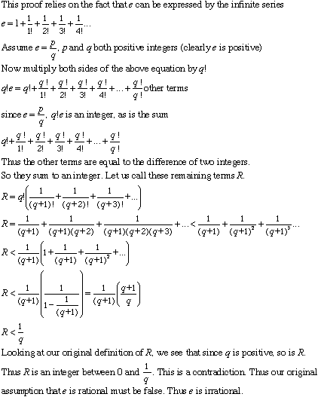

IRRATIONALITY OF π

Index
Site Map
Photos
Washington
London
N Carolina
Videos
Science
England
Cars
Dogs
Albania
Diary
Fun Stuff
9-11
Author
Links
Guestbook

See also ...
( Home → Science → Proof → π )
Perhaps the best known of the irrational numbers is π (=3.14159 ...). A simple and well-known definition of π is as the ratio of the circumference to the diameter of a circle. However, π occurs frequently in the mathematical descriptions of systems with spherical or cylindrical symmetry or geometry. π can also be expressed in terms of a number of infinite series.
Previous: Irrationality of e
Our aim is to prove that π is irrational. The proof presented here is due to a mathematician named Ivan Niven, and was developed and reported in 1947.
In this case, the statement we need to prove is:
S = The number π is irrational.
The converse of the statement S is
T = The number π is rational.
If statement T is true, then our original assertion in statement S is false. So, let us assume that statement T is true, and see if we can find a contradiction. If π is rational, then we can define integers a and b such that
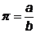
where a and b are integers with no common factors. Now, let us define a function f(x) as follows:
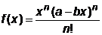
In this expression, n is another integer that we won’t specify at the present time – we’ll choose it later on. Now, if we make the variable transformation
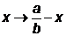
we can see that our function f(x) has the following property:
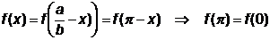 (1)
Now let us define another function in terms of the derivatives of f(x):
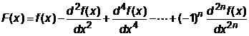
Differentiating this function twice and adding, we can see that.
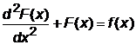
since derivatives of f(x) of order higher than 2n are zero. In order to proceed, we want to prove an important property about the function f(x) and its derivatives. Let’s begin by noting that we can write the function f(x) as follows:
where the c coefficients take integral values. Therefore, any derivative of f(x) lower than the n^{th} derivative is zero at x = 0. The (n+J) derivative (J ≤ n), at x = 0, is simply equal to
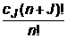
We therefore conclude that the derivatives of f(x), evaluated at x = 0, are either zero or take integral values. Further, from (1), we have that
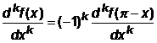
We can therefore further conclude that the derivatives of f(x) evaluated at x = π are also either zero or take integral values.
With all this in mind, we deduce that
take integral values.
Now by using very simple differential calculus, it is easy to show that
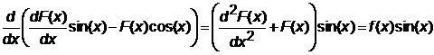
and hence by integrating both sides of this expression, and noting that
we find that
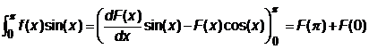 (A)
This has an integral value, as we have just shown that the two terms on the right-hand side of the above expression take integral values.
But, let us go back to our original definition of f(x). By inspection of the definition of f(x), it can be seen that
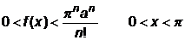
and hence
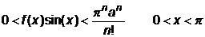 (B)
This provides us with the contradiction that we seek. Look back at the integral (A). We’ve just shown that it takes an integral value. And yet, result (B) shows that the integrand can be made as small as we like, by choosing a sufficiently large value of n. Therefore, on the basis of (B), we can make the integral (A) as small as we like.
The point is that we cannot have both situations at once, namely that the integral (A) is both an integer and arbitrarily small. This is an impossibility, and so the statement T is false.
Hence, statement S is true, and π is an irrational number.
Carmichael's theorem, named after the American mathematician R.D. Carmichael, states that for n greater than 12, the nth Fibonacci number F(n) has at least one prime factor that is not a factor of any earlier Fibonacci number. The only exceptions for n up to 12 are:
F(1)=1 and F(2)=1, which have no prime factors
F(6)=8 whose only prime factor is 2 (which is F(3))
F(12)=144 whose only prime factors are 2 (which is F(3)) and 3 (which is F(4))
If a prime p is a factor of F(n) and not a factor of any F(m) with m < n then p is called a characteristic factor or a primitive divisor of F(n). Carmichael's theorem says that every Fibonacci number, apart from the exceptions listed above, has at least one characteristic factor.

