SPEAKING TEST QUESTIONS
i-LEARN SMART WORLD 7
UNIT 1: FREE TIME
Target language:
• Ask and answer about hobbies
• Make future plans
• Present Simple for habits
• Present Continuous for future plans and prepositions of place
• Give opinions about different extreme sports
- What do you like to do in your free time?
- Do you like building models/collecting soccer stickers/baking cakes…?
- How often do you build models/collect soccer stickers/bake cakes…?
- What is the most popular hobby in your class?
- Where do you like to meet your friends? What do you do there?
- What are you doing tomorrow/tonight/this weekend…?
- Are you going to the bowling alley/buying a book/meeting your friend… tonight?
- Which extreme sport would you like to try? Why?
- Do you like rock climbing/skateboarding/surfing/zorbing…?
- Talk about an activity that you like:
- When you are doing it
- Where it is
- Who is going with you
- What it is like
- How much it costs
- Why you like it

UNIT 2: HEALTH
Target language:
• Talk about what makes a healthy lifestyle
• Give advice and persuade someone to have a healthy lifestyle
• Indefinite quantifiers
• "should" and "shouldn't"
• Talk about healthy food
- What do you think makes a healthy lifestyle?
- Do you eat fruits and vegetables/get enough sleep/eat fast food…?
- How much water do you drink/fruit do you eat/exercise do you do… every day?
- Who has the healthiest lifestyle in your class/family? What does he/she do?
- What should you do when you have a fever/sore throat/stomachache...? What shouldn’t you do when you’re sick?
- Do you keep warm/get some rest/take medicine… when you’re sick?
- Should you eat too much junk food/drink a lot of soda/ watch too much TV…?
- How are you feeling today?
- Do you eat in the school cafeteria? Do you think it has healthy food?
- Talk about a healthy food:
- What it is
- How often do you like it
- Why it is good for your health
- Why you like it

UNIT 3: MUSIC AND ARTS
Target language:
• Talk about music that you like
• Make plans to go to a music event
• Present Simple for facts
• Prepositions of time and possessive adjectives
• Talk about your favorite movie
- What types of music do you like/dislike?
- Do you like listening to rock/hip hop/classical music…? Why?
- Does your friend/brother/sister… like listening to rock/hip hop/classical music…?
- What is the most popular kind of music in your class?
- Do you like going to music festivals? Why?
- What types of movies do you like to watch?
- How often do you watch a movie?
- Do you like going to the cinema? Why
- Talk about your favorite movie:
- What kind of movie it is
- Where and when it is set
- What happens in the movie
- Why you like this movie
- Talk about a music festival you would like to go to:
- When it is
- Where it is
- Who you would like to see there
- Why you like the show(s)

UNIT 4: COMMUNITY SERVICES
Target language:
• Suggest and plan a charity event
• Talk about things we did to help our community
• "should," "Let's," and "How about"
• Past Simple with regular verbs
• Talk about how to help the environment
- Would you like to join a charity event: a craft fair/fun run/bake sale…?
- Would you like to volunteer at your school? What would you like to do?
- Do you think the school should organize a fun run or an art show? Why?
- How can you help your school/community/the environment?
- Would you like to take part in a beach clean-up? Why (not)?
- What did you do to help your school/community/the environment last week?
- Did you clean up the park/donate used clothes/plant trees… last week?
- What should we do to help poor children?
- Talk about a time you helped the environment:
- What did you do?
- Where did you go?
- When did it happen?
- How many people took part?
- How long did you work for?
- Will you do that again?
- Talk about a charity event you would like to organize at school:
- What kind of charity event it is
- How many volunteers you will need
- How you will call it
- Who/what the event will help
- Where and when it will be

UNIT 5: FOOD AND DRINKS
Target language:
• Talk about what food you need to buy
• Talk about containers and quantities of food and drinks
• Quantities and amounts
• Indefinite and definite articles
• Talk about unusual foods
- What foods do you like/dislike?
- What is your favorite food?
- How often do you go shopping to get groceries? What do you usually buy?
- What did your mom buy from the supermarket last week?
- What do you have in your kitchen?
- Does your kitchen have milk/bananas/butter…? How much/many of each kind is there?
- Would you like to try unusual food?
- What is the strangest dish that you know?
- Talk about an unusual dish:
- Where is the dish from?
• What is the name of the dish?
• What is in the dish? How do people cook it?
• What do you eat with it?
• What does it taste like?
- Look at this picture and answer the questions:
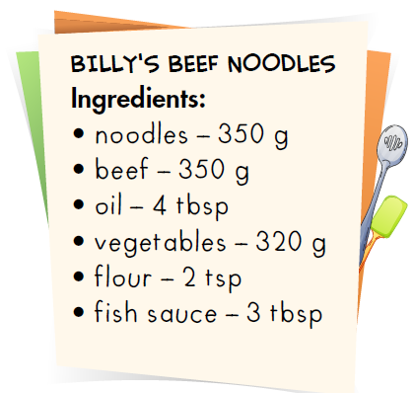 | - What do we need to make beef noodles?  - How much beef/oil/flour… do we need?  - How many grams of flour/noodles/vegetables… do we need?

UNIT 6: EDUCATION
Target language:
• Decline invitations and express obligations
• Talk about how you feel about school
• Present Simple and "have to"
• Intensifiers and "because"
• Talk about studying abroad experience
- Do you have a lot of homework/presentations/projects… at school?
- Do you have to finish a book report/give a presentation/study for a test… tonight?
- What things do/don't you have to do at home?
- How are you feeling now?
- How do you feel when you fail a test/when your mom buys you a gift/when your soccer team loses…?
- Is it good or bad to study abroad?
7-8. Do you plan to study abroad? What problems do you think you would have?
9. Do you think it is easy to make friends/learn a new language/take care of yourself… abroad?
10. Talk about your study abroad plan:
- Where you are going
- When you are going
- What positive experiences you think you would have
- What problems you think you would have
- How you think you would feel

UNIT 7: TRANSPORTATION
Target language:
• Describe and identify personal belongings
• Compare different types of transportation
• Possessive pronouns and adjectives in order
• "(not) as...as..."
• Talk about kinds of transportation
- Do you like traveling?
- What do you usually bring when you go traveling?
- Do you bring your passport/backpack/luggage?
- What color is your/your sister’s/your brother’s… suitcase?
- How do you usually go to school?
- Do you usually use public transport?
- What kinds of public transport do you like?
- What types of transportation are there in your neighborhood?
- What do you prefer: buses or trains, planes or taxis…? Why?
- What kinds of transport do you think people will use in the future?

UNIT 8: FESTIVALS AROUND THE WORLD
Target language:
• Talk about festivals around the world
• Compare how different countries celebrate festivals
• Future Simple
• "like" and "different from"
• Talk about your favorite festival
- Are there many festivals in your country?
- What are some famous festivals in your country?
- What do people usually do in those festivals?
- Do people have a bonfire/have an eating competition/see a hot-air balloon…?
- Do you know any festivals around the world?
- What do people usually do to celebrate Lunar New Year/Mid-Autumn Festival/Christmas?
- What are some other traditions to celebrate Lunar New Year and Mid-Autumn Festival in your family?
- Do you know any unusual festival in your country?
- Look at the picture and answer the following questions:
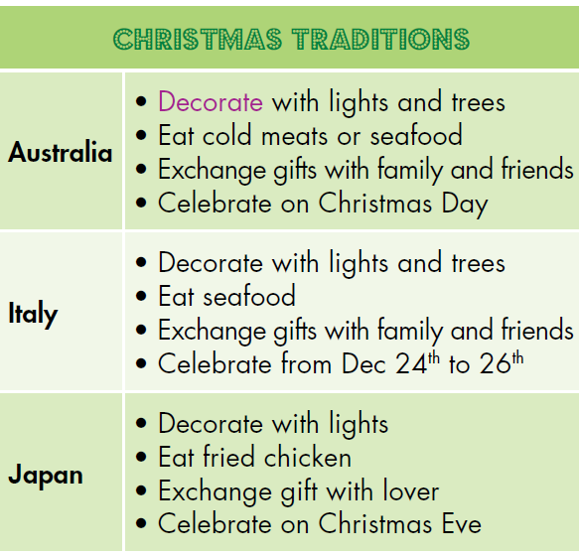 | - What are the similarities in the way people celebrate Christmas in Australia and Italy/Australia and Japan/Italy and Japan?  - What are the differences in the way people celebrate Christmas in Australia and Italy/Australia and Japan/Italy and Japan?

- Talk about your favorite festival:
• What the name of the festival is
• Where it happens
• When it takes place
• How it started
• Why it happens
• What people do in the festival
• Why you like it

UNIT 9: ENGLISH IN THE WORLD
Target language:
• Talk about tourist attractions and cultures of English-speaking countries
• Talk about holidays in English-speaking countries
• Articles
• Past Simple with irregular verbs
- Do you like learning English?
- Do you have any problem learning English?
- What are some ways speaking English can help you?
- Have you ever traveled abroad? Did you use English there?
- What do you know about the United States? Would you like to visit it?
- Do you know any historic places?
- What do you like doing on your holiday?
- What did you do on your last holiday? How was it?
- Which city would you like to visit? Why?
- Talk about an amazing trip you had:
- Where you went
- When you went there
- Who you went there with
- What you did
- Why you liked it

UNIT 10: ENERGY SOURCES
Target language:
• Talk about types and sources of energy
• Talk about the advantages and disadvantages of energy sources
• "more…than..." and "less...than..."
• "and" and "but"
• Talk about the best energy sources for a town
- Which energy source could we use in our town?
- What are the advantages of solar power/wind power/nuclear power…?
- What are the disadvantages of solar power/wind power/nuclear power…?
- Which of the energy sources is the best choice for the future of your country?
- Which one is greener, natural gas or coal?
6-7-8. Is your town polluted? What are the causes? What should your town do to improve it?
9. Look at the picture and answer the following questions:
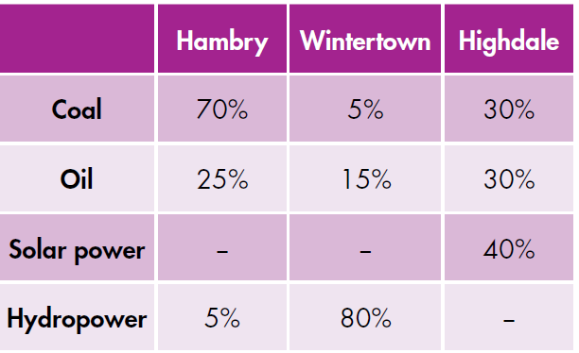 | - Which city uses less coal, Hambry or Wintertown?  - Which city uses more energy from hydropower, Wintertown or Highdale?  - Which city is greener, Hambry or Highdale?

10. Talk about an energy source.
- What it is
- What advantages/disadvantages it has
- Why we should (not) continue to use it

