Date of preparing: ………………………………….
Date of teaching: ………………………………….

Period …
UNIT 5: AROUND TOWN
Lesson 2 - Part 1 (Page 41) - Vocabulary and Reading

I. OBJECTIVES
By the end of the lesson, Ss will be able to…
1. Knowledge
- know more vocabularies about food and drinks.
- order food and drinks in a restaurant.
2. Ability
- improve the use of English and Reading skills.
3. Quality
- have positive attitude in English language learning so that they actively participate in all classroom activities.
- order food and drinks in a restaurant politely.

II. TEACHING AIDS AND LEARNING MATERIALS
Lesson plan, PPT slides, student’s book, workbook, notebook, personal computer (if any), projector/TV, speakers, DCR & DHA on Eduhome, handouts…
III. PROCEDURES
A. Warm up: (5’)
a) Objective: Introduce the new lesson and set the scene for Ss to acquire new language; get students' attention at the beginning of the class by means of enjoyable and short activities as well as to engage them in the steps that follow.
b) Content: Introduction of food and drinks
c) Product: Ss have general ideas about the topic they are going to study in the lesson
d) Competence: collaboration, guessing, communication.
e) Organization of the activity:
Teacher’s Activities | Students’ Activities
- Give greetings  - Check attendance  - Option 1: Food and drinks  - Show pictures of some food and drinks  - Have Ss give names of the food and drinks  - Call Ss to give answers  - Give feedback  - Lead to the new lesson  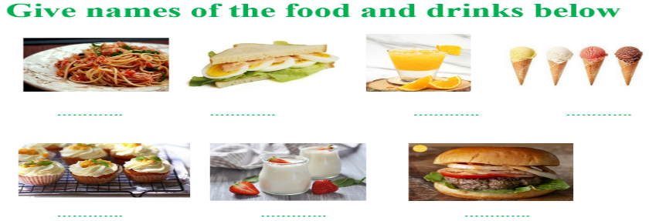  - Option 2: Design Menu  - Have Ss close all books  - Divide class into 4 groups  - Give out a piece of paper to each group and show some food, drinks and desserts on the board / screen  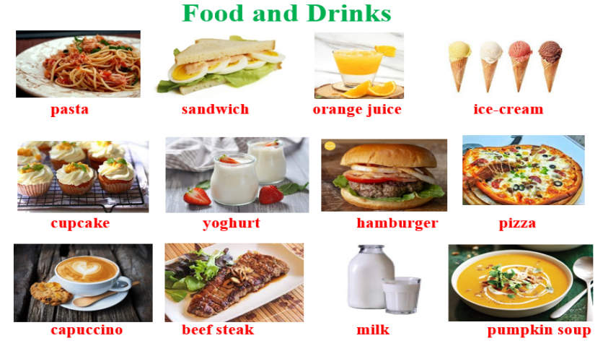  - Have Ss work in groups to put the words in right category and design their menu  - Have Ss hang their menus on the board  - Check Ss’ work and have class vote for the best menu  - Give a small gift to the winner  → Lead to the new lesson | - Greet T  - Work in groups and give names of the food and drinks  - Give answers  - Listen  Answer keys  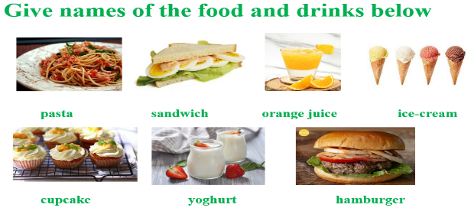  - Close books  - Work in groups to put the food and drinks into right category (Food / Drinks / Desserts), then design a menu

B. New lesson (35’)
- Activities 1: Vocabulary (18’)
a) Objective: Ss know some vocabularies about ordering food and drinks in a restaurant
b) Content:
- matching the words with the pictures, then listening and repeating
- talking about food and drinks
c) Products: Ss can get to know some food ans drinks and talk about them.
d) Competence: communication, collaboration, presentation, creativity.
e) Organization of the activity:
Teacher’s Activities | Students’ Activities
a. Match the words with the pictures. Listen and repeat.  - Option 1:  - Demonstrate the activity, using the example in the book.  - Have Ss look, read and match the words with the pictures, using the words in the box  - Ask Ss to work in pairs to check their answers with their partners.  - Check answers as a whole class.  - Play the audio (CD1 – Track 60) for Ss to listen and repeat.  - Call some Ss to read the words again, correct their pronunciation and stress.  - Option 2:  - Follow same steps as option 1  - Give Ss an extra activity (Vocabulary checking)  - Have Ss close all books  - Use other pictures (different pictures from those in the book) to help Ss remember the new words they have learnt.  - Have Ss look at the pictures, then use the vocabularies in New Words to match with the right pictures  - Ask Ss to give answers  - Check answers as a whole class  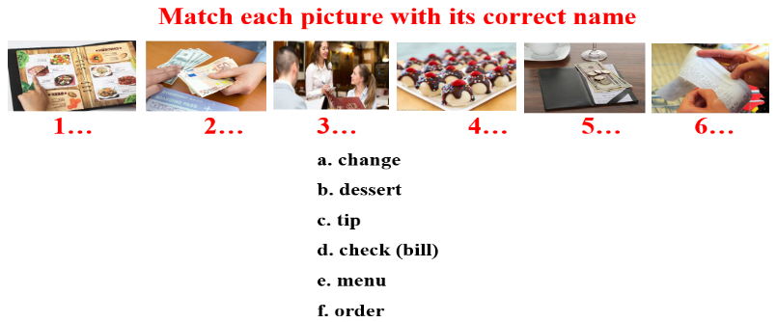  b. Ask and answer (about things you order in a restaurant)  - Option 1:  - Have Ss work with a partner to say what food and dessert they often order in a restaurant  - Encourage Ss to use more food and drinks (besides those in the textbook)  - Have some Ss share their ideas with the class  - Give feedback and evaluation  - Option 2: (for class with better student)  - Have Ss work n groups to ask and answer about ordering food and drinks in a restaurant  - Encourage Ss to be creative and use their own ideas to make the conversation more interesting and natural  - Call some Ss to demonstrate the activity in front of the class  - Give feedback and evaluation | - Look and listen  - Work in pairs  - Listen and repeat  - Read  Answer keys  1C 2D 3F 4B 5E 6A  - Close books  - Look and give answers  - Give answers (Say or write on the board)  Answer keys  1e 2a 3f 4b 5c 6d  - Work in pairs  - Work in pairs (Ss can use words in the Warm up activity for reference)  - Listen  - Work in groups  - Work in pairs  Suggested conversation  A: How often do you have meal in a restaurant?  B: Not very often. I usually eat out in a restaurant with my family once every two months.  A: What food do you often order in a restaurant?  B: I often order pizza. Sometimes we order beef steak, and my brother orders hamburger  A: Sounds great! What do you often have for dessert?  B: My mom and I love yogurt; my dad and brother like cakes.  A: How about drinks?  B: I love cokes but it’s not good for our health, so I order mineral water.  …
- Activity 2: Reading (17’)
a) Objective: Ss can develop their reading skills
b) Content: Reading a menu and answering questions
c) Products: Ss can read for main ideas and details.
d) Competence: collaboration, communication, analytical and synthesizing skills.
e) Organization of the activity:

Teacher’s Activities | Students’ Activities
a. Ben and Jane are at a new restaurant. Do they enjoy their meal?  - Explicit the structure:  (What) would you like + to infinitive  I’d like (I would like) + to infinitive  - Have Ss read the dialogue  - Have Ss circle the correct answer  - Have Ss give answer, explain for their answer  - Check answers as a whole class  b. Tick (✓)the things they ordered on the menu  - Option 1:  - Demonstrate the activity.  - Have Ss read the dialogue again and tick the things they ordered on the menu  - Check answers as a whole class  - Option 2:  - Have Ss read the dialogue and answer the questions:  1. What food and drink does Ben order?  2. What food and drink does Jane order?  3. How much do they have to pay for the meal?  4. Do they enjoy the meal? How do you know?  - Have Ss give answers (write on the board or read)  - Check answers as a whole class | - Listen and take notes  - Read  - Circle the correct answers  - Give answer and explain  - Check  Answer key: Yes  - Listen  - Read and do the task  Answer keys  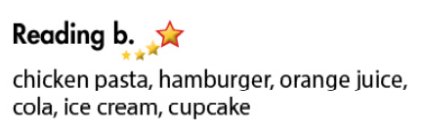  - Work in pairs  - Give answers  Answer keys  1. Ben orders some chicken pasta, orange juice and some ice cream.  2. Jane orders a hamburger, a cola and a cupcake.  3. They have to pay $45.5 for the meal.  4. Yes, they do. They say: “That was a great meal” and “We should come here again.”

C. Consolidation (3’)
* Vocabulary:
About ordering: order, check, tips, change, menu, desert, starter, …
About food and drinks: pizza, pasta, hamburger, sandwich, fries, orange juice, coke, ice-cream, cupcake, yogurt, …
* Structures: (What) would you like + to infinitive
I’d like (I would like) + to infinitive

D. Homework (2’)
- Learn by heart the new words.
- Do exercises in Workbook: Lesson 2 - New words – Part a, b, c (page 28) and Listening (page 29).
- Prepare: Lesson 2 – Grammar (page 42 – SB).

