ĐỀ VIP 9+ - ĐỀ SỐ 11
Read the following leaflet and mark the letter A, B, C, or D to indicate the correct option that best fits each of the numbered blanks from 1 to 6.

CELEBRATE EARTH HOUR DAY WITH US!
Earth Hour Day is a global movement encouraging individuals and communities to take action for the planet by turning off non-essential lights and appliances for one hour. This annual (1) to conserving energy and raising climate awareness invites everyone to (2) time to reflect on our environmental impact. From 8:30 PM to 9:30 PM, join millions around the world as we switch off lights, TVs, and (3) gadgets, standing together in the fight against climate change.
Remember (4) in this simple but powerful act - an hour without lights makes a statement that echoes across the globe. As lights are dimmed, we inspire meaningful change, (5) how small actions can lead to a brighter future. Take part in this effort, uniting with others in a worldwide moment of awareness and action, making Earth Hour a tradition that brings us all closer to a (6) future.

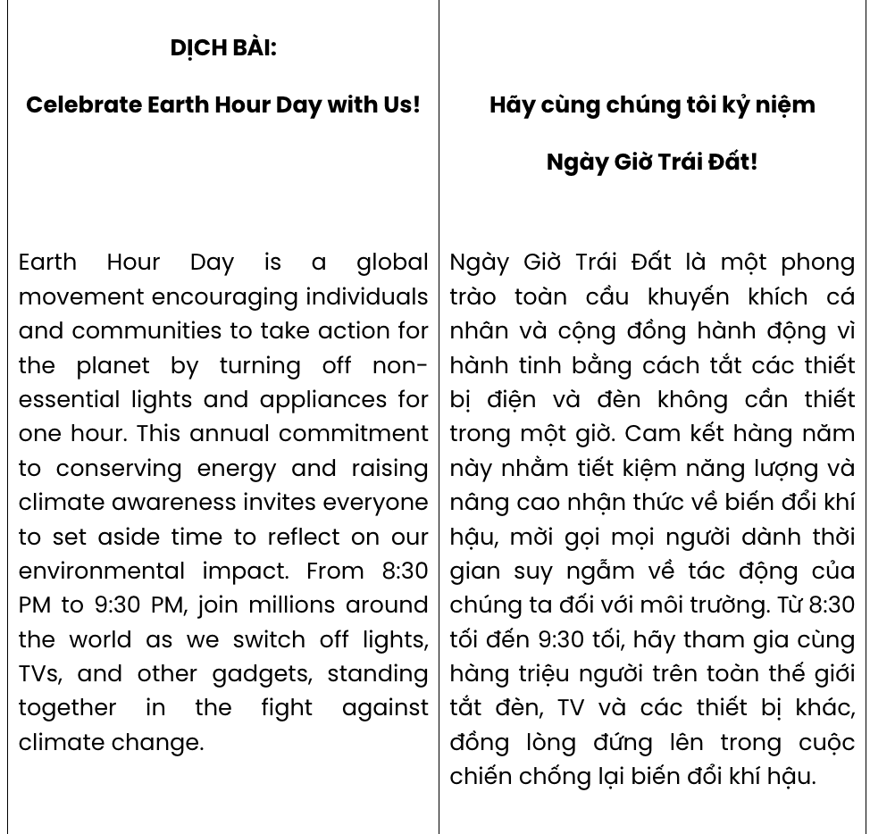
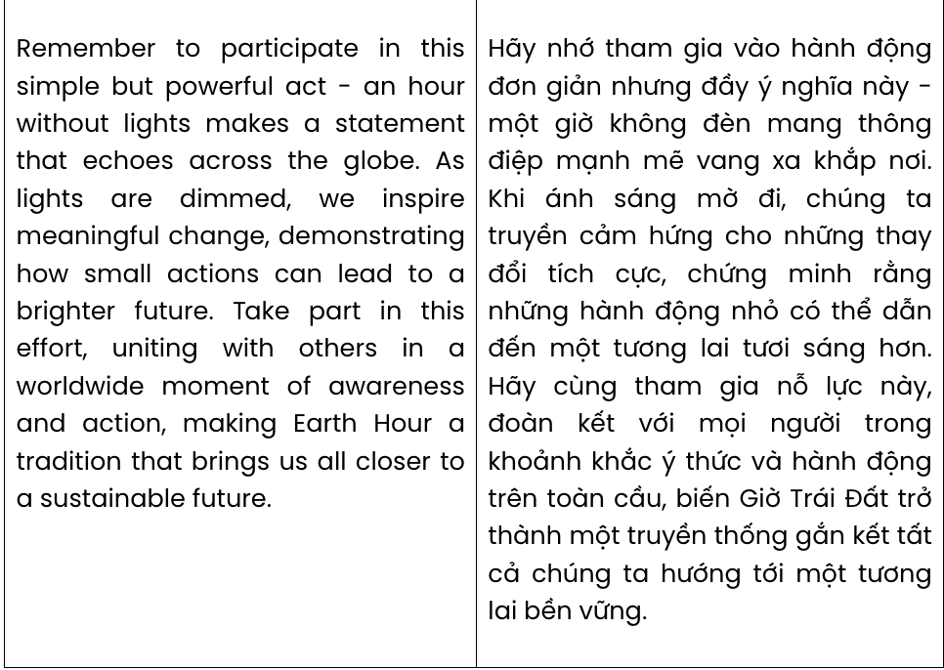
Question 1. A. attainment B. preference C. commitment D. adherence
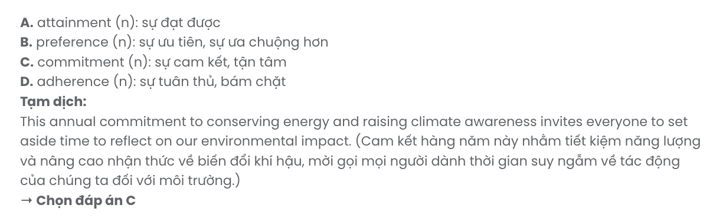
Question 2. A. turn out B. set aside C. make out D. keep up
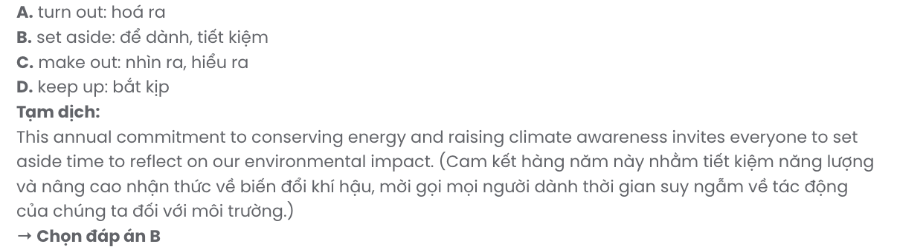
Question 3. A. another B. the others C. every D. other
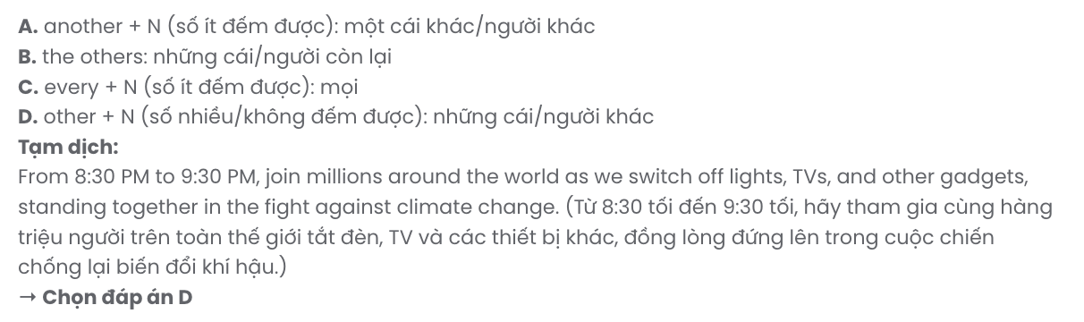
Question 4. A. to participating B. participating C. participate D. to participate
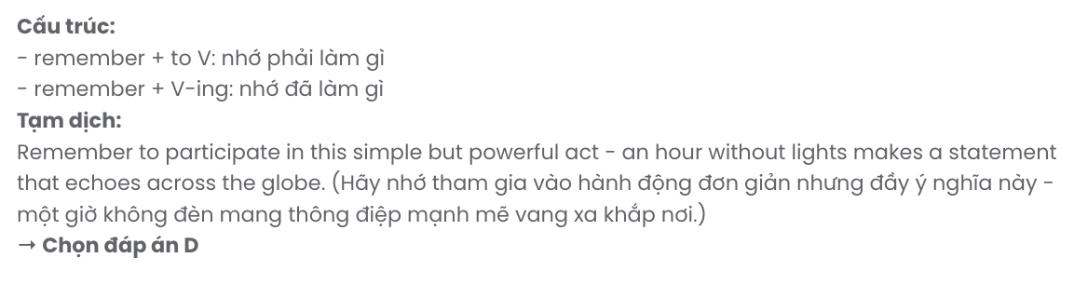
Question 5. A. demonstrates B. demonstrating C. demonstrated D. demonstrate
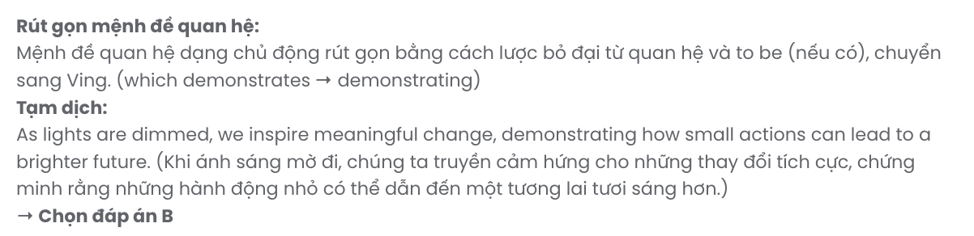
Question 6. A. inclusive B. sustainable C. renewable D. responsible
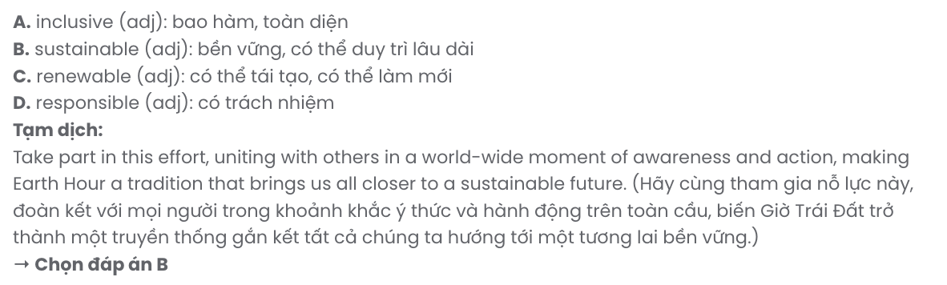

Read the following school announcement and mark the letter A, B, C, or D to indicate the correct option that best fits each of the numbered blanks from 7 to 12.
Are you a passionate reader? Join the Reading Cultural Ambassador Contest to showcase your unique journey and inspire others! This contest provides a (7) experience for students who wish to engage in (8) . You’ll also have the opportunity to share your reading passion (9) others and encourage a love of books within our school.
(10) prizes, winners will have the chance to lead school reading events throughout the year. A large (11) of enthusiasm is encouraged as we seek students who can make a real impact. (12)
in mind that participants will be judged on their ability to connect with and motivate others through their love of reading. Don’t miss this chance - sign up today at the library!

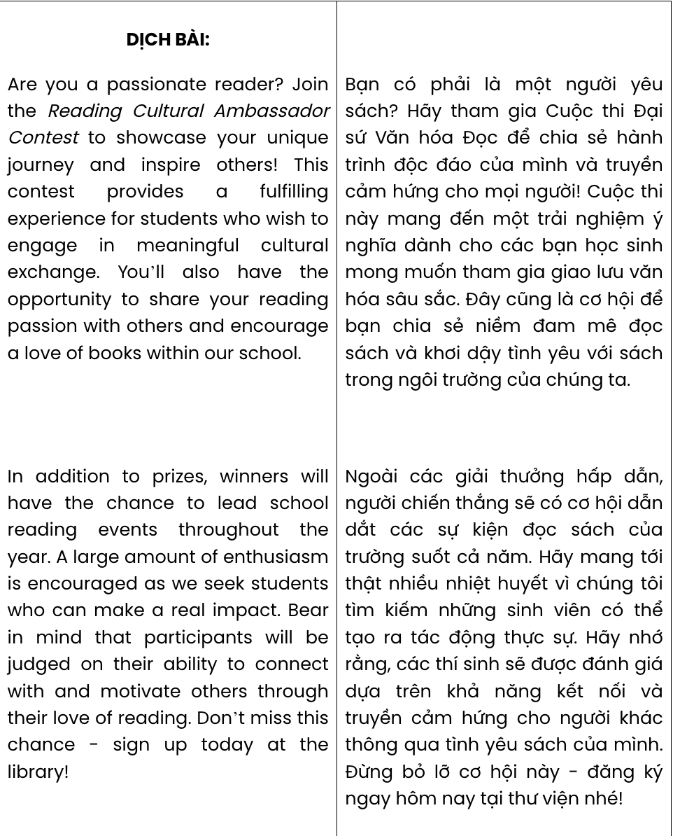

Question 7. A. fulfilment B. fulfilling C. fulfilled D. fulfil
GIA SƯ TẠI HUẾ (079.3833.272)

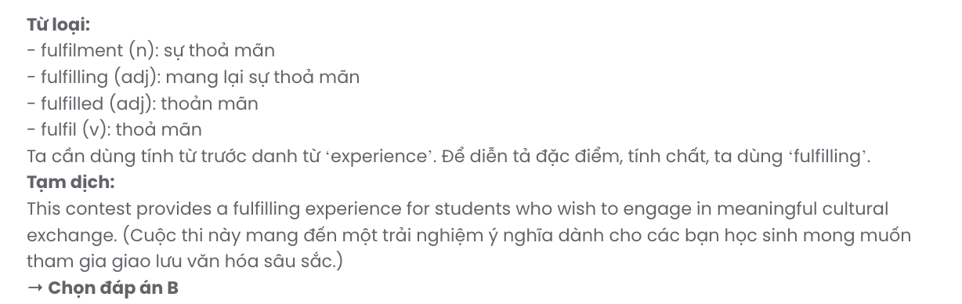
Question 8. A. cultural meaningful exchange B. meaningful cultural exchange
C. meaningful exchange cultural D. cultural exchange meaningful

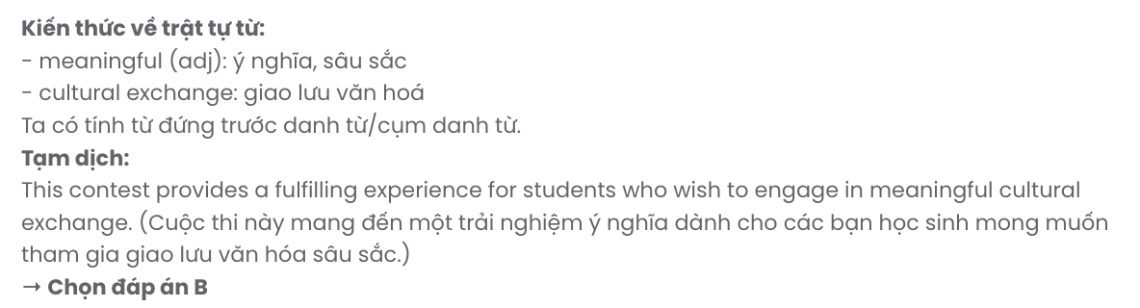
Question 9. A. in B. for C. with D. by
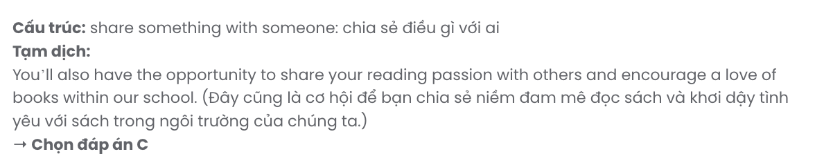
Question 10. A. In contrast to B. In addition to C. By virtue of D. In place of

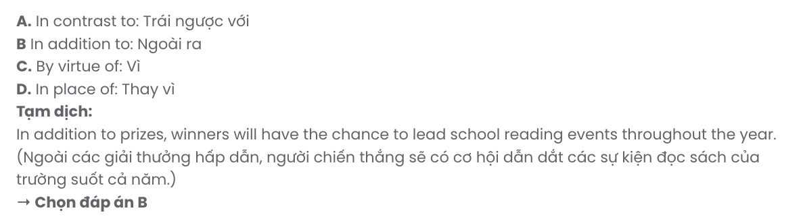
Question 11. A. variety B. range C. amount D. number

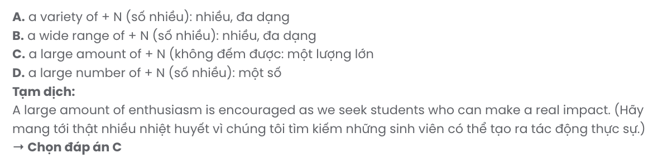
Question 12. A. Make B. Take C. Put D. Bear

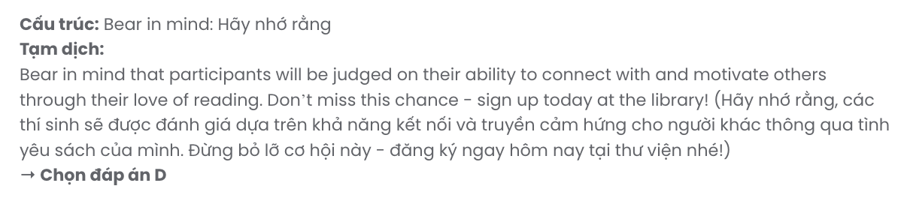
Mark the letter A, B, C or D to indicate the best arrangement of utterances or sentences to make a meaningful exchange or text in each of the following questions from 13 to 17.

Question 13.

Dear Susan,
- This position really helped me develop confidence through interactions with customers and co-workers, which I hadn't expected.
- I’m grateful for this opportunity, as it made my college years more fulfilling and prepared me well for future roles.
- Working at a local café near campus turned out to be a surprisingly valuable experience.
- The busy mornings at the café, often filled with multiple orders and impatient customers, were initially a challenge, but I soon adjusted to the fast-paced environment.
- Looking back, I realise just how much this part-time job taught me about time management and teamwork.
Best, Michael
A. d – e – a – b – c B. c – d – a – b – e C. e – d – b – a – c D. a – d – b – c – e

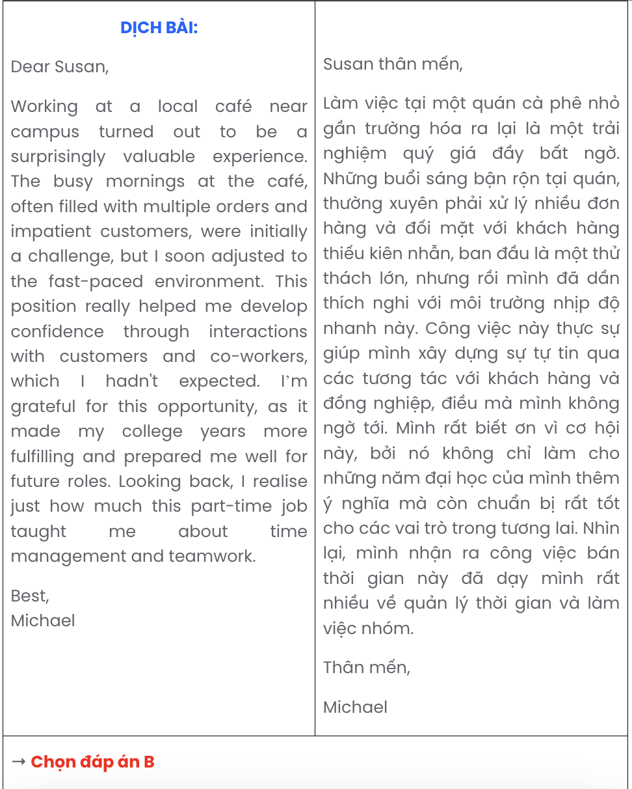

Question 14.
- Such visible improvements send a clear message that residents care deeply about their neighbourhood’s appearance and safety.
- This simple effort has brought the community together, with residents working side by side to beautify neglected areas.
- As a result, once-overlooked spaces now look vibrant and inviting, attracting more foot traffic and reducing places for potential criminal activity.
- The impact of this initiative has been encouraging, as it fosters both pride and security within the town.
- Planting flowers has shown unexpected benefits in deterring crime in our small town.
A. e – a – c – d – b B. e – d – c – b – a C. e – b – c – a – d D. e – c – b – d – a

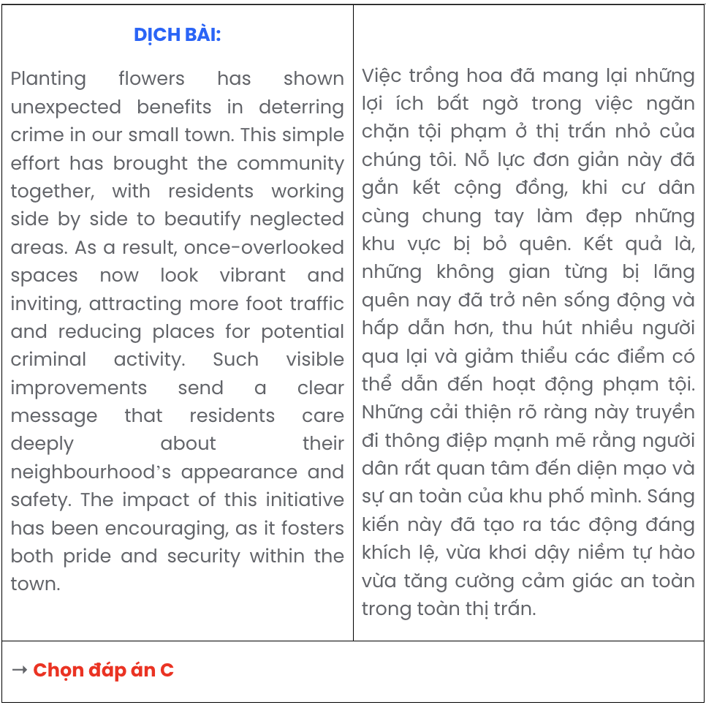

Question 15.
- Mr. Lee: I make sure to walk every morning and eat plenty of vegetables.
- Mia: How do you stay healthy, Grandpa?
- Mia: I’ll try to do that too! Maybe we can go for a walk together.
A. b – a – c B. a – c – b C. b – c – a D. c – a – b
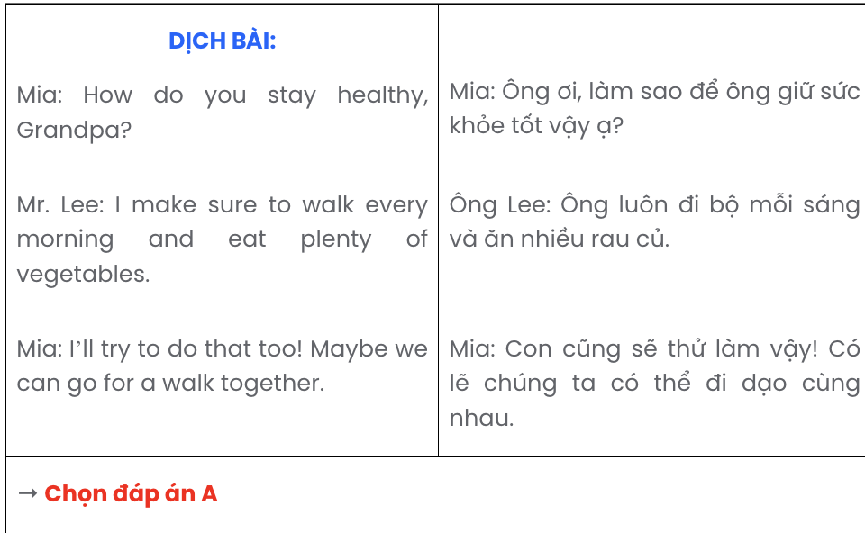

Question 16.
- The first sign of trouble was the weather; a sudden storm swept through, turning these once-clear skies into a dark, relentless downpour.
- My summer holiday, which I had eagerly anticipated, quickly turned into a disaster.
- These setbacks transformed what was meant to be a relaxing getaway into a frustrating ordeal that we were eager to leave behind.
- This unexpected shift forced us to stay indoors, cancelling all the outdoor activities we had planned.
- Adding to the misery, the hotel we had booked was far from the charming place it appeared online, with broken amenities and noisy surroundings.
A. a – d – e – c – b B. b – a – d – e – c C. b – d – e – a – c D. a – e – d – c – b

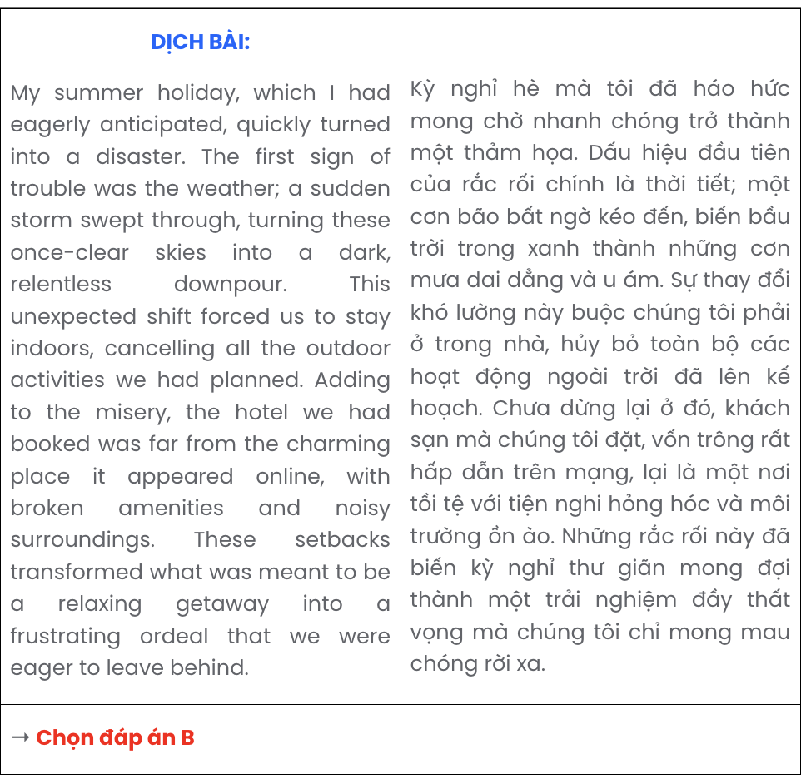

Question 17.
- Mr. Smith: Do you think breaks are really that important for students, Mrs. Lee?
- Mrs. Lee: Exactly! And these moments also give us time to prepare for the next lesson.
- Mrs. Lee: Absolutely. Without these short breaks, students can’t recharge and stay focused on learning.
- Mr. Smith: True, those few minutes make a big difference for both the students and us.
- Mr. Smith: I’ve noticed that after a quick break, students become more engaged in class.
A. a – b – d – c – e B. e – b – d – c – a C. e – c – d – b – a D. a – c – e – b – d

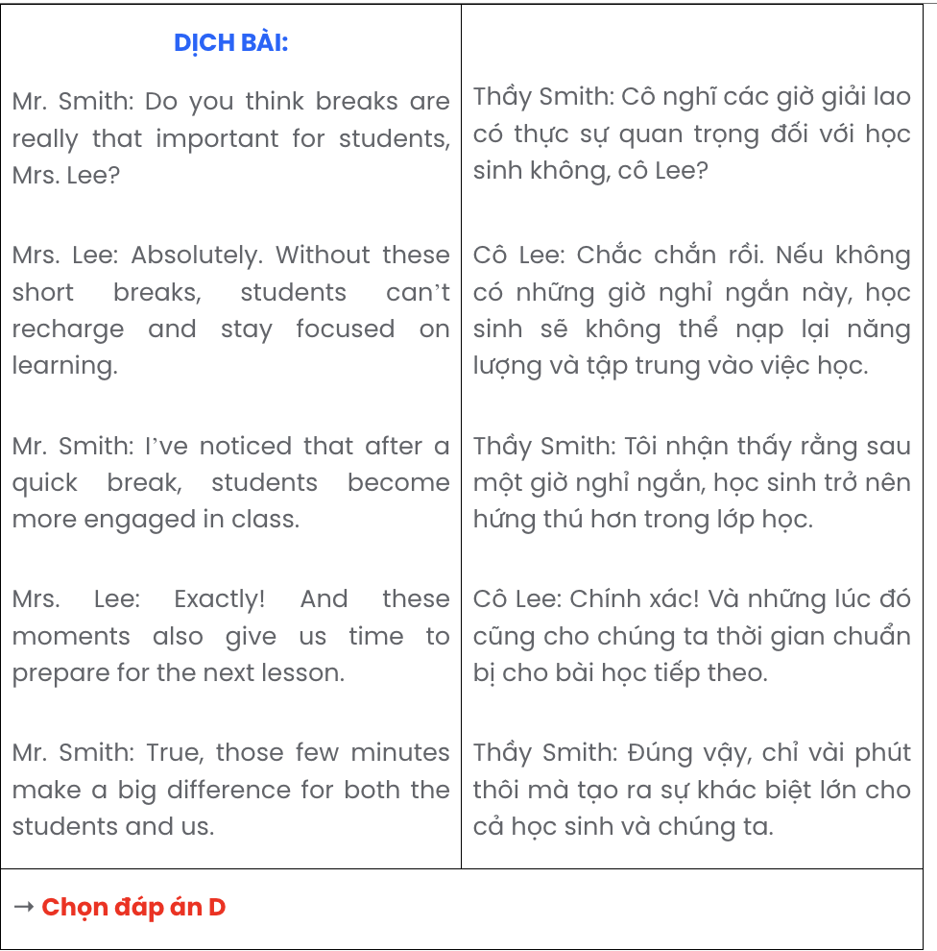

Read the following passage about food waste and the spread of contagious diseases and mark the letter A, B, C, or D to indicate the correct option that best fits each of the numbered blanks from 18 to 22.
Global food waste has become one of the most pressing issues, affecting both the environment and global economies. Millions of tons of food are wasted annually, a phenomenon fuelled by consumer habits and inefficient supply chains. Food waste, (18) , contributes to nearly 8-10% of global greenhouse gas emissions, which makes it a significant factor in climate change. Produced in excessive quantities, (19) where it releases methane, a potent greenhouse gas. In addition to the environmental cost, food waste has economic consequences, with billions of dollars lost every year due to food that is grown, transported, and prepared but never consumed.
(20) . Reducing waste at the consumer level, for example, (21) . Raised awareness among consumers is essential, as people often do not realise the scale and consequences of food waste. Campaigns encouraging people to plan meals, store food correctly, and repurpose leftovers are being implemented in various regions. (22) , ensuring that food reaches those in need before it spoils. By taking these steps, countries worldwide can begin to tackle the global food waste crisis and work toward a more sustainable future. GIA SƯ TẠI HUẾ (079.3833.272)

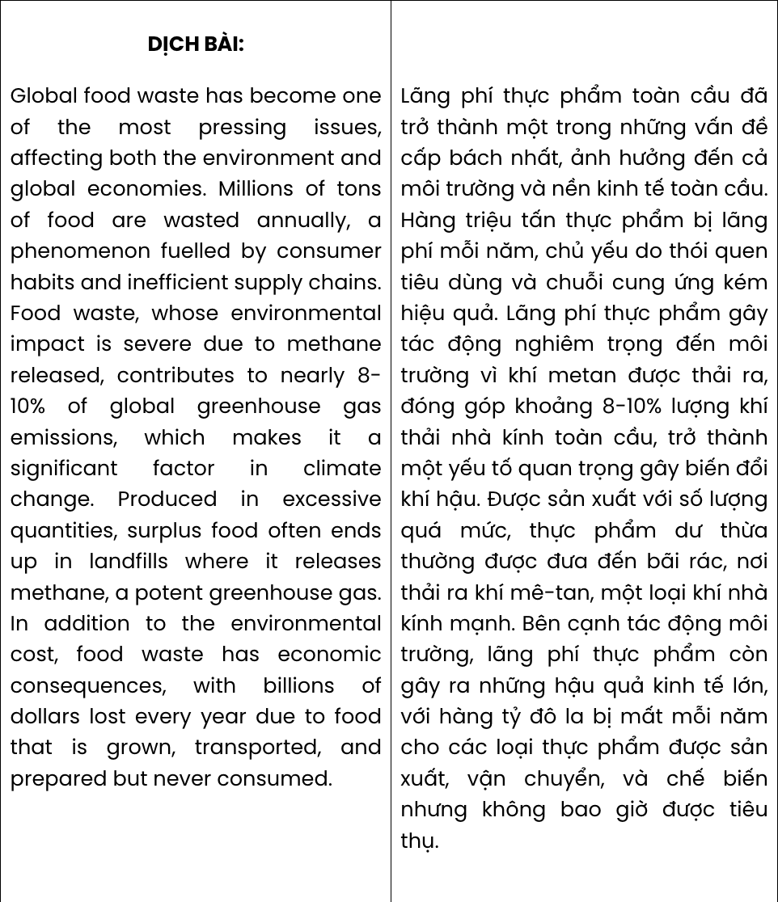
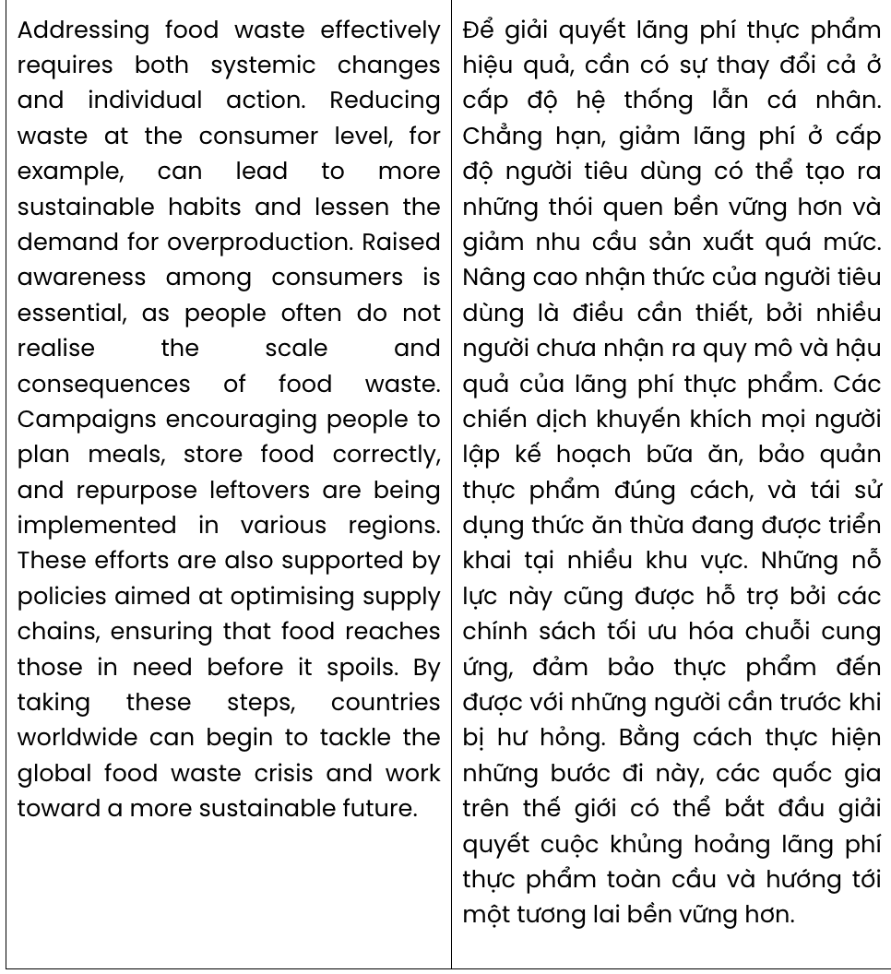

Question 18.
A. of which the severity of environmental impact due to methane released
B. severely impacted the environment due to methane released
C. whose environmental impact is severe due to methane released
D. had a severe impact on the environment due to methane released
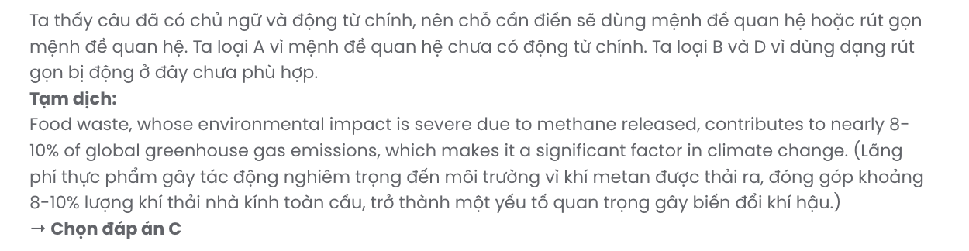

Question 19.
A. landfills struggle to accommodate surplus food
B. they tend to throw away surplus food in landfills
C. surplus food often ends up in landfills
D. surplus food’s final destination is in landfills
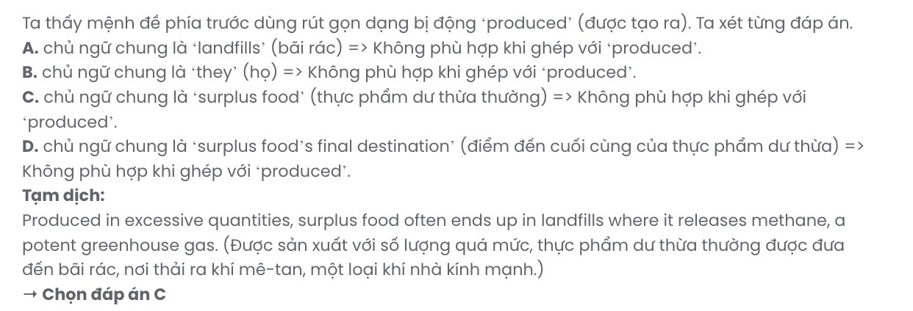

Question 20.
A. Needing both systemic changes and individual action, food waste is addressed effectively
B. Addressing food waste effectively requires both systemic changes and individual action
C. The requirement of systemic changes and individual action solves food waste effectively
D. Both systemic changes and individual action are ineffective in solving food waste
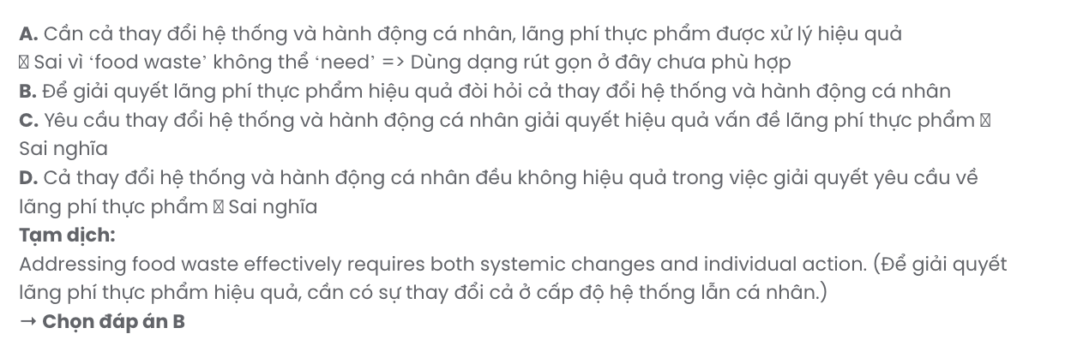

Question 21.
A. can lead to more sustainable habits and lessen the demand for overproduction
B. resulting in more sustainable habits and a decline in overproduction demand
C. which brings about more sustainable habits and a decline in overproduction demand
D. more sustainable habits and a drop in the demand for overproduction are the final result
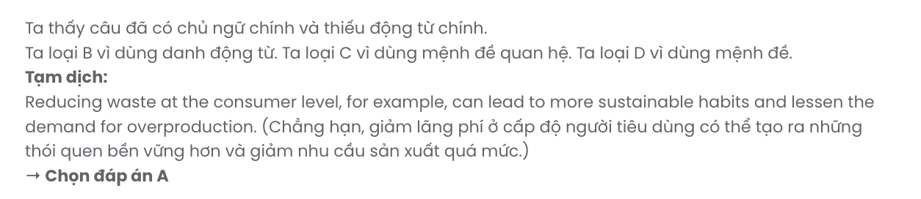

Question 22.
A. Supply chains are optimised so that policies aimed at these efforts are also supported
B. Thanks to policies aimed at supporting supply chains, these efforts are also optimised
C. Policies aimed at optimising supply chains are also supported by these efforts
D. These efforts are also supported by policies aimed at optimising supply chains
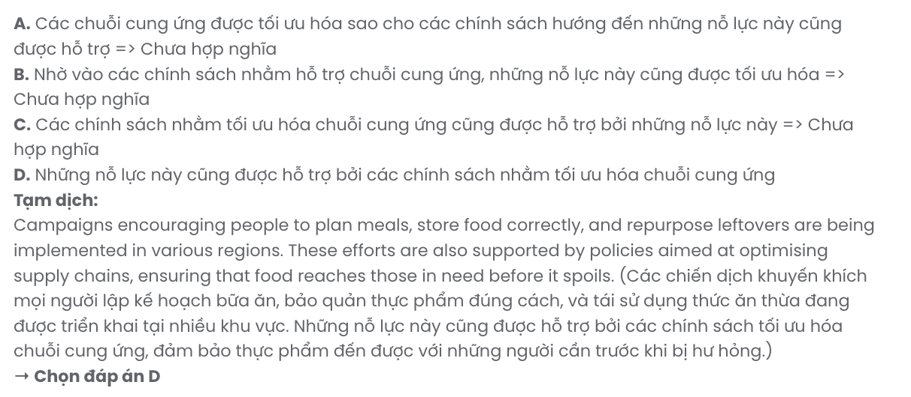

Read the following passage about when losing means winning and mark the letter A, B, C, or D to indicate the correct answer to each of the questions from 23 to 30.
In sports, we expect that athletes and teams will play to win. In some unusual cases, however, trying to lose may be better. In the 2018 FIFA World Cup, England played Belgium. The winners would play great teams like Brazil or France in future games. The losing team would still advance but would play less famous teams like Denmark or Sweden and therefore, would have easier games and more chances to win the whole competition. In the end, Belgium won the game. But for England, losing did not feel like a failure. The team easily reached the semi-final, the country's best result in almost 30 years.
In some North American sports leagues, losing can also mean winning. However, a team must lose many games in some years in order to win in future years. The reason is something called a draft. Each year, every team gets a chance to add the best young players from around the country. Teams with very bad records get the first chances to pick players. So, losing a lot gives a team a good chance to draft a great young player.
With drafting, a team can add several top players to improve very quickly, or even to become good enough to win a championship. In baseball, for example, the Chicago Cubs lost game after game for years. However, the drafted players afterwards were so good that the Cubs won the baseball World Series in 2016.
When a team tries to lose often in order to draft great players, it is called "tanking." This is sometimes unpopular with fans, but it is not against the rules. To do this, trading players is a common way. A tanking team can trade its best players to other teams. In return, it can get extra draft picks.
(Adapted from Explore New Worlds)
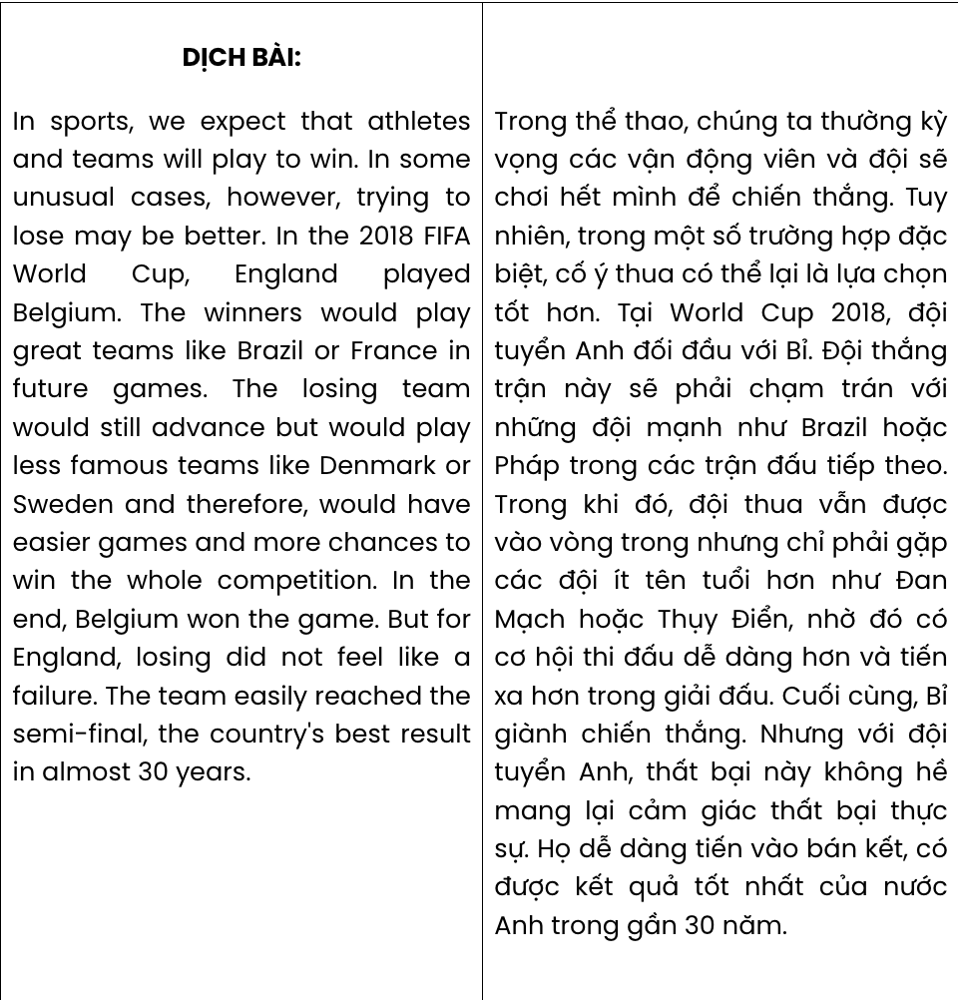
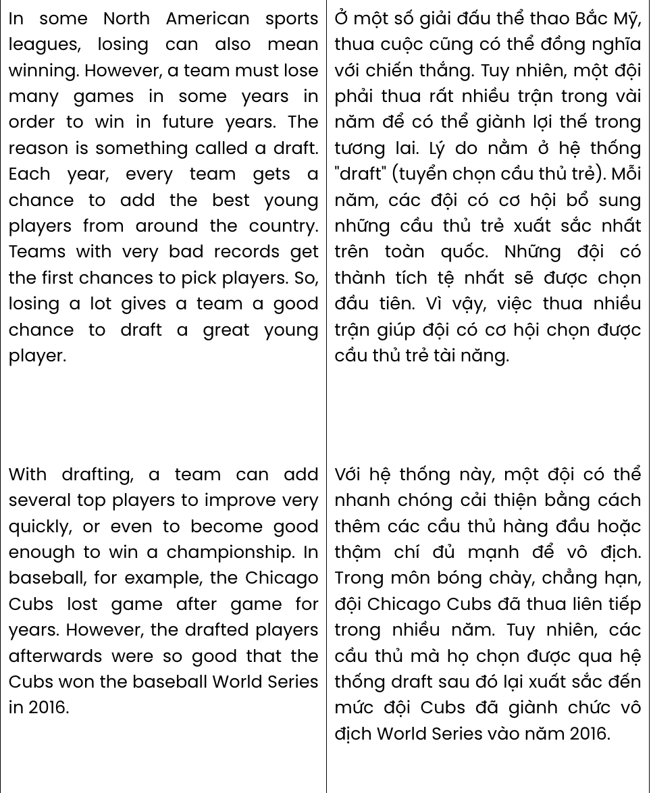
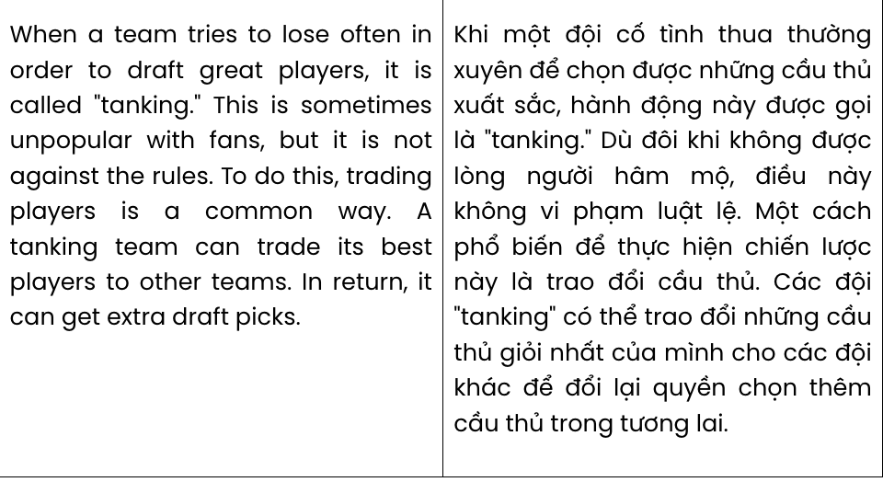
Question 23. The word unusual in paragraph 1 is OPPOSITE in meaning to .
A. common B. abnormal C. risky D. secure
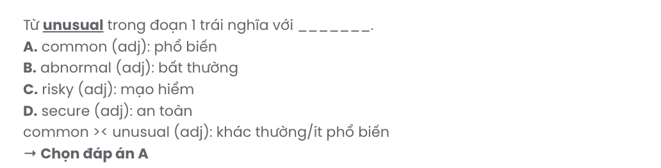
Question 24. According to paragraph 1, what is indicated about the 2018 FIFA World Cup?
A. Denmark and Sweden managed to get into the final.
B. Brazil and France didn’t compete for the gold trophy.
C. The losing team possibly had an advantage over the winning team.
D. Belgium’s victory was overshadowed by the failure of England.
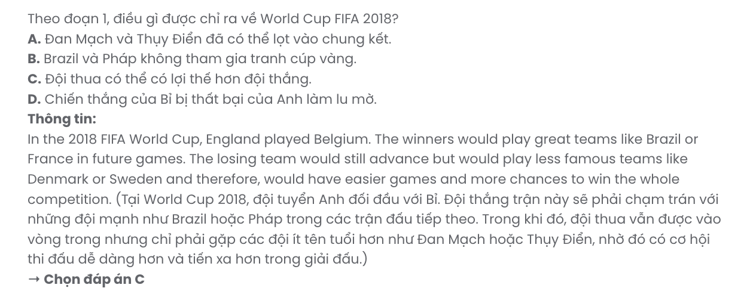
Question 25. The phrase The team in paragraph 1 refers to .
A. England B. Belgium C. Brazil D. France
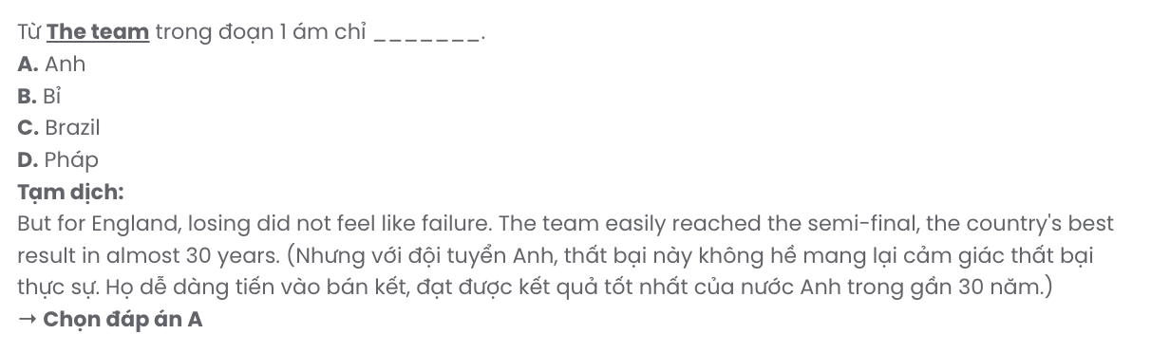
Question 26. The word draft in paragraph 2 can be best replaced by .
A. avoid B. select C. nominate D. honour
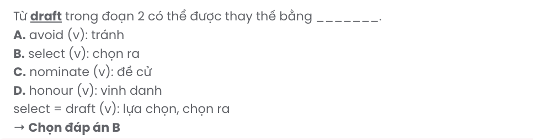
Question 27. Which of the following best paraphrases the underlined sentence in paragraph 4?

This is sometimes unpopular with fans, but it is not against the rules.
A. Although this may upset some fans, it does not break any rules.
B. This can be a controversial move with some fans, but it does follow standard practices.
C. Fans are never supportive of this, though it aligns with common regulations.
D. Despite being disliked by every fan, this action is still within the rules.

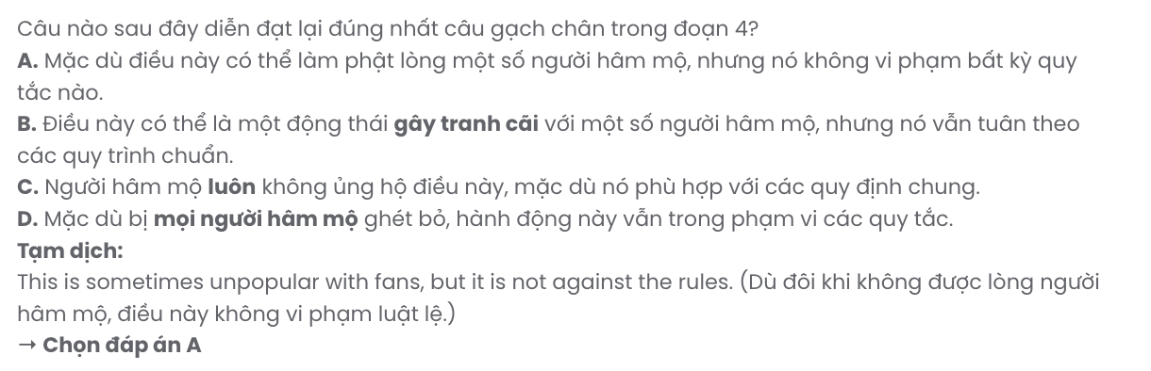
Question 28. Which of the following is TRUE according to the passage?
A. Losing in some North American sports leagues is always more meaningful and appreciated than winning.
B. The Chicago Cubs’s victory in the baseball World Series in 2016 was thanks to the drafted players.
C. A tanking team can receive additional drafted players who are even more skilled than their best players.
D. The worst team in the previous sports league is the first to pick the most talented drafted players across the country.

Question 29. In which paragraph does the writer mention an activity that sports fans frown upon?
A. Paragraph 1 B. Paragraph 2 C. Paragraph 3 D. Paragraph 4
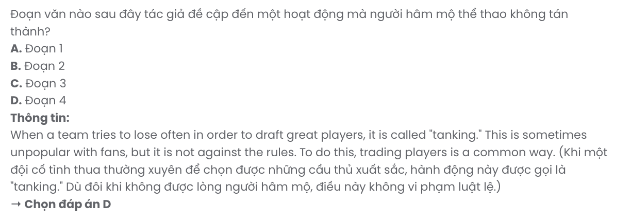
Question 30. In which paragraph does the writer explain how ‘draft’ works?
A. Paragraph 1 B. Paragraph 2 C. Paragraph 3 D. Paragraph 4

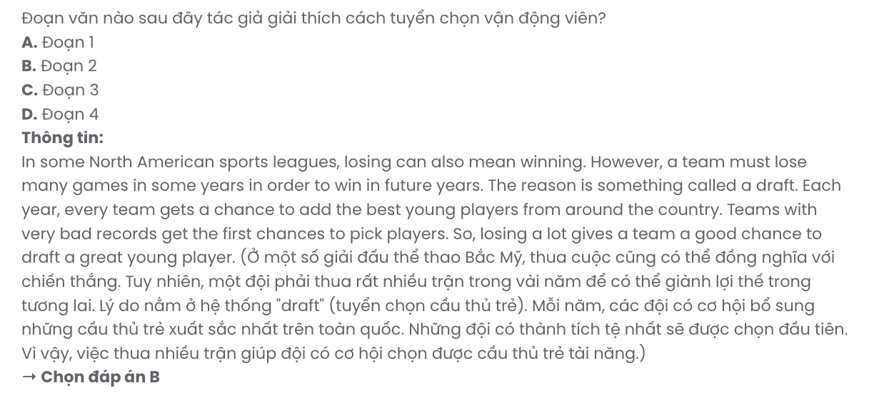

Read the following passage about concerns about AI and mark the letter A, B, C, or D to indicate the correct answer to each of the questions from 31 to 40.
AI (artificial intelligence) has been on the rise since the 1990s, but people started to notice its power when humanoid robots were first introduced in 2016. Since then, the potential of AI has been extremely promising, but it has raised significant concerns about the control over AI abilities.
Phone scams involved in AI-generated voice have been reported in the USA and some European nations. [I] Scammers, equipped with advanced knowledge and skills, collected some data and recorded some victim's voices before they faked the victims' voices to borrow some money from their friends and relatives. [II] In these situations, some parents received a phone call from an unknown number and heard their child's voice crying, "I've been kidnapped. Help me!" while the child was actually safe at school or a friend's house. [III] Consequently, the parents were terrified and transferred large sums of money to the scammers. [IV]
Deepfake, a combination of "deep learning" and "fake," is a sort of technology that can replicate photos and voices of a person to create convincing videos of individuals saying things they never did. Then, the scammers upload these videos online to deceive other people into various actions, such as transferring money or spreading wrong information to create confusion for their benefit. As a result, lots of people, especially celebrities or politicians, have become victims of deepfake technology as their images have been illegally used. Moreover, detecting those deepfake videos is extremely difficult for people without expertise, which creates a huge concern about the credibility of multimedia content.
AI is generally created to assist humans, but if it is misused, it will pose unimaginable threats. Therefore, there must be strict regulations on AI use and development to eliminate AI risks and ensure a safe and stable society.
(Adapted from Bright)
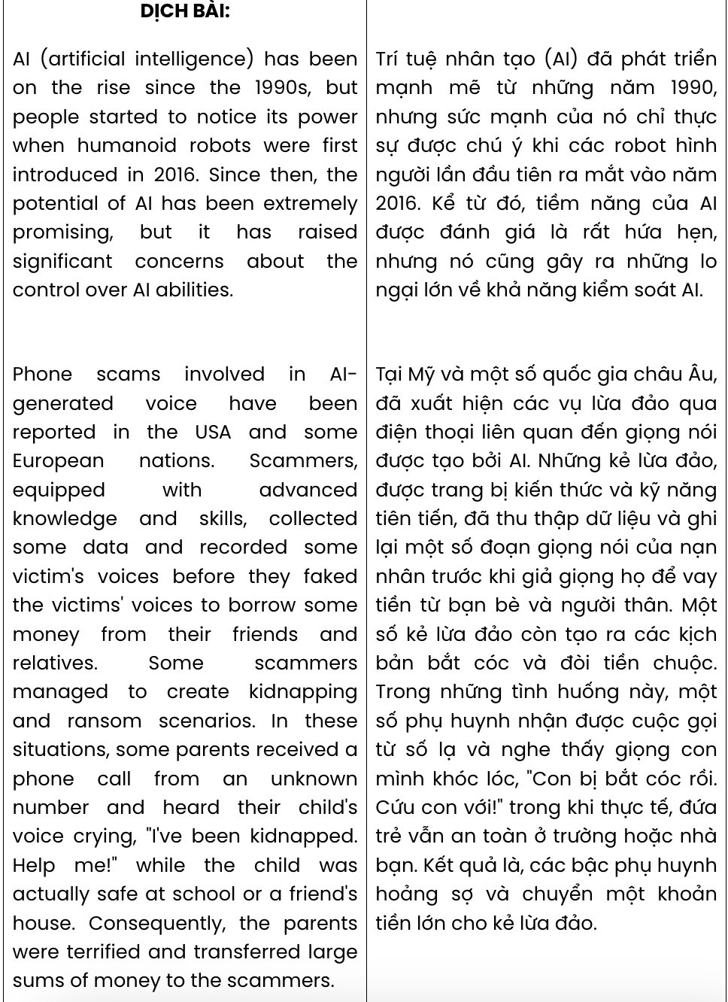
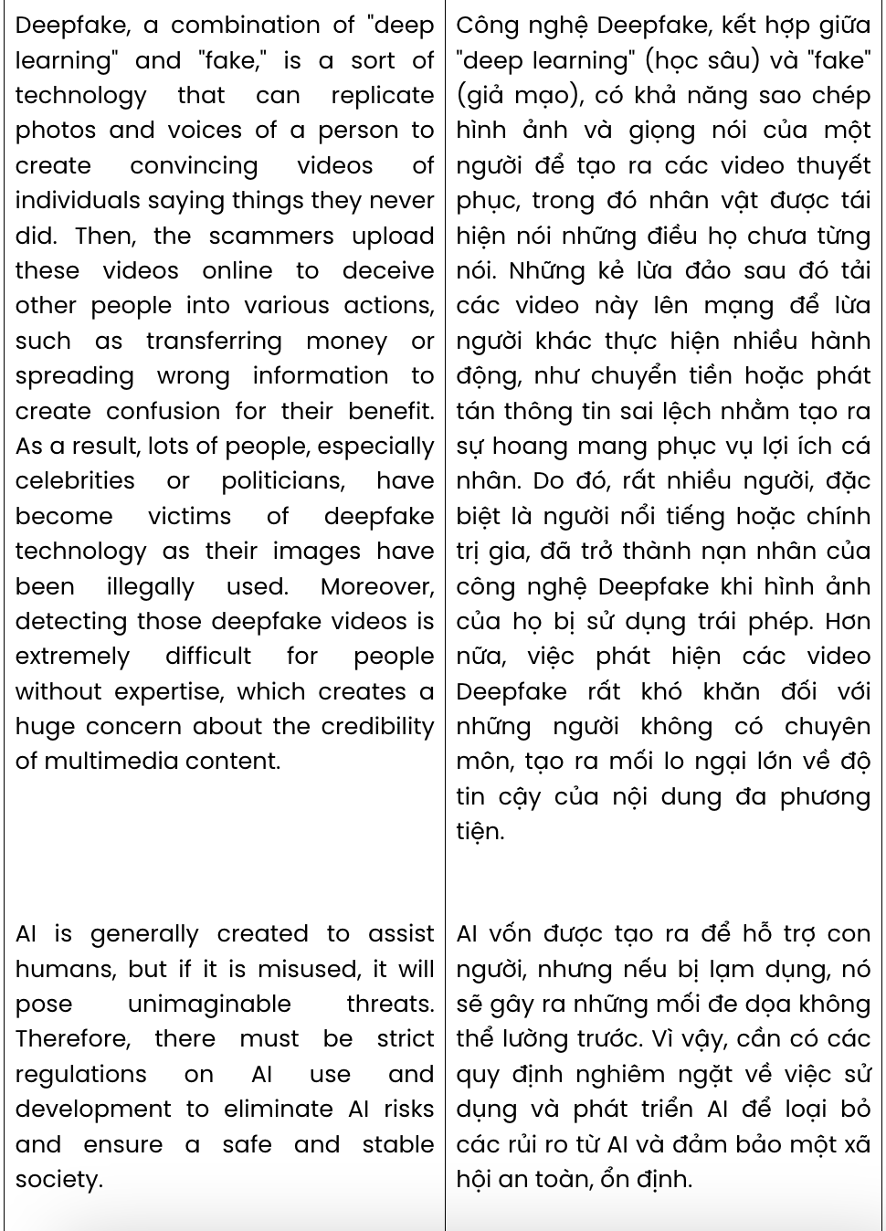
Question 31. According to paragraph 1, which of the following is NOT indicated about AI?
A. It has been advancing steadily since the 1990s.
B. Its potential was in the public eye in 2016.
C. It has sparked some ethical concerns.
D. Its potential has shown great promise.
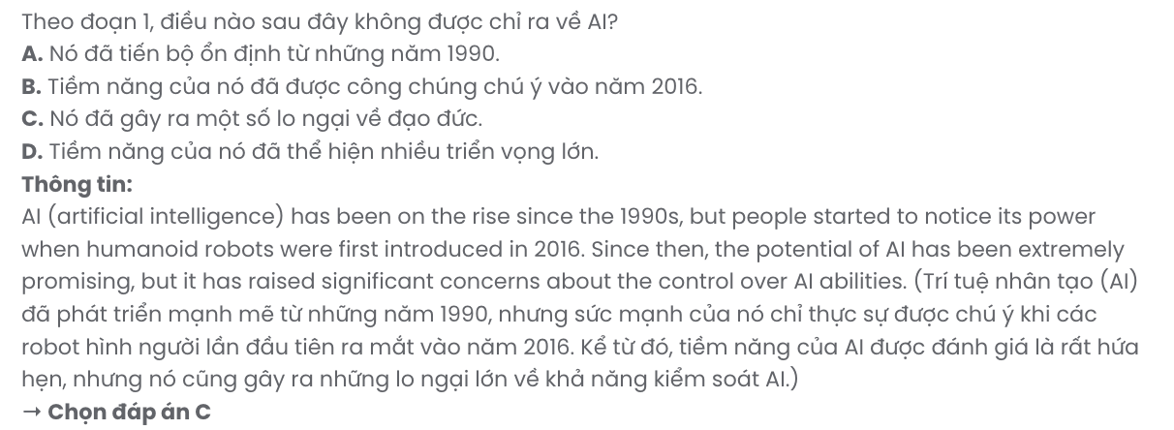
Question 32. The word they in paragraph 2 refers to . GIA SƯ TẠI HUẾ (079.3833.272)
A. victims B. scammers C. voices D. phone scams
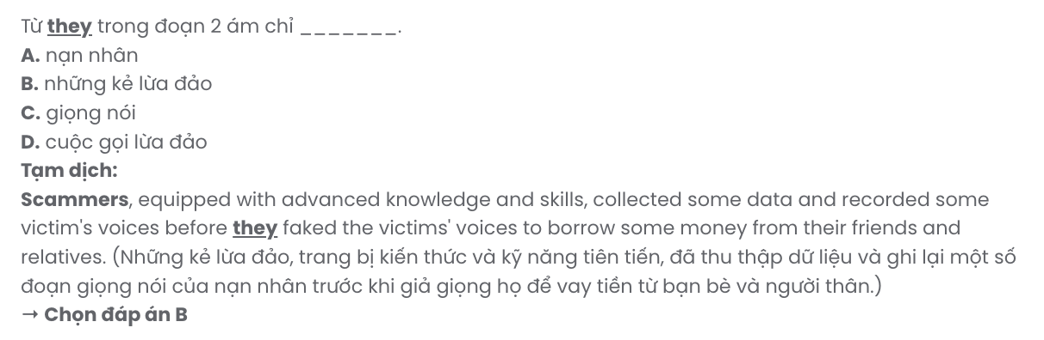
Question 33. Where in paragraph 2 does the following sentence best fit?

Some scammers managed to create kidnapping and ransom scenarios.
A. [I] B. [II] C. [III] D. [IV]

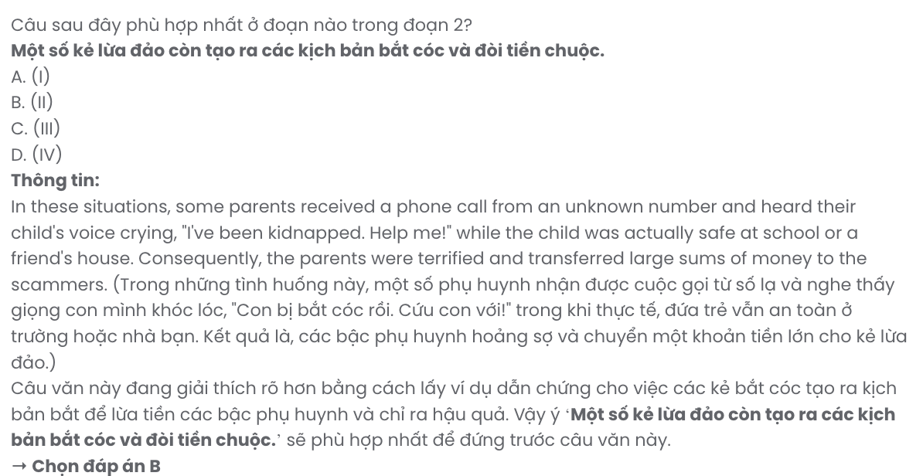
Question 34. Which of the following best summarises paragraph 2?
A. AI-powered phone scams are the most popular in the USA and Europe as scammers mimic victims' voices, leading to fraudulent money transfers.
B. Scammers use AI-generated voices to trick victims, sometimes staging fake kidnapping calls for ransom payments.
C. AI phone scams trick parents into paying ransoms after receiving false calls from unknown numbers.
D. Scammers, posing as relatives, use victims' voices for phone scams, causing fear and financial loss.
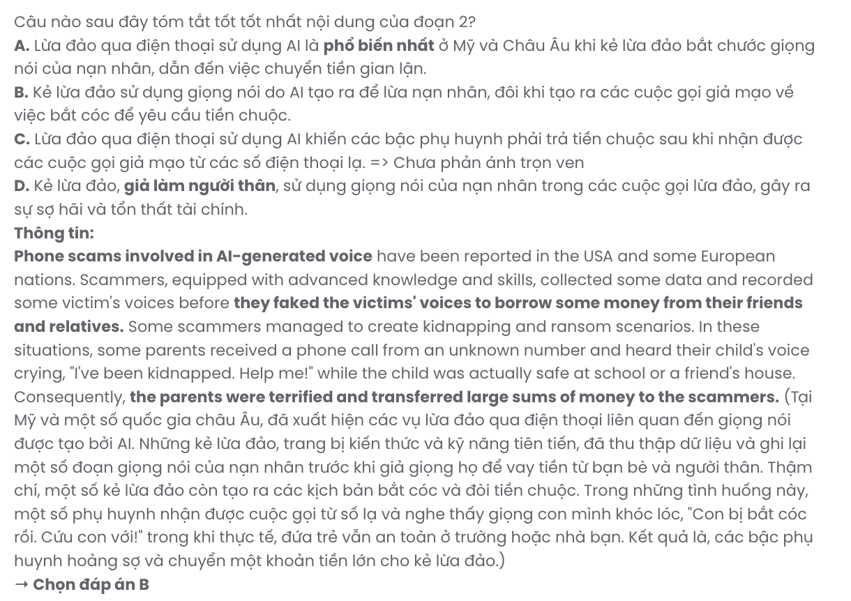
Question 35. The word deceive in paragraph 3 is closest in meaning to .
A. mislead B. discourage C. pursue D. respect
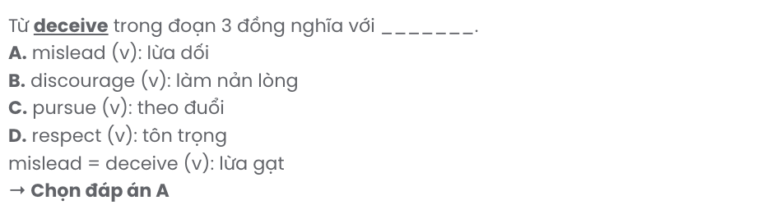
Question 36. The word expertise in paragraph 3 is OPPOSITE in meaning to .
A. hands-on experience B. expert knowledge
C. diplomatic skills D. inadequate training
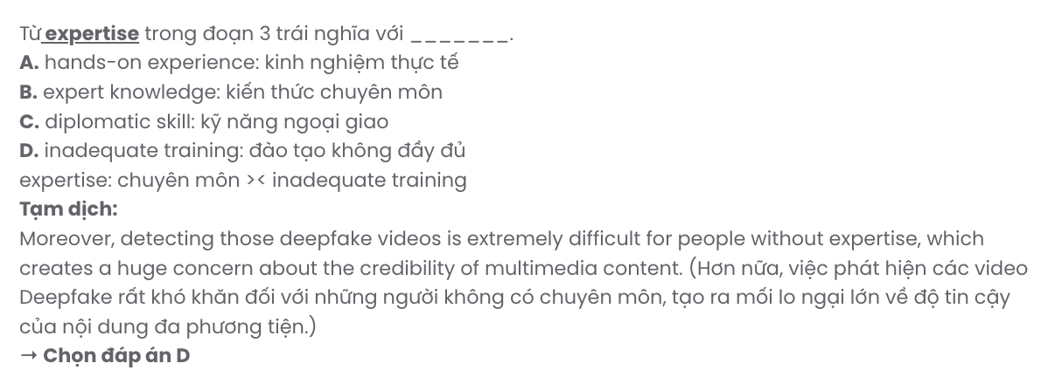
Question 37. Which of the following best paraphrases the underlined sentence in paragraph 4?

AI is generally created to assist humans, but if it is misused, it will pose unimaginable threats.
A. AI is created to improve life for humans, ensuring safety under all circumstances.
B. Misuse of AI will create unimaginable risks, though it is the best companion of humans in modern society.
C. AI technology always benefits humans, though its misuse may cause minor issues.
D. AI is primarily developed to help people, though improper use could result in serious dangers.
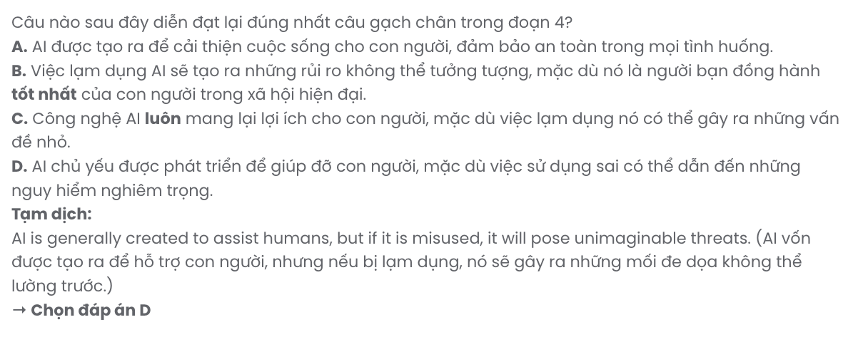
Question 38. Which of the following is TRUE according to the passage?
A. AI-generated voice is particularly used in phone scams, tricking people into familiar situations.
B. Deepfake allows creating persuasive videos that encourage Internet users to spread wrong information on social media.
C. Phone scammers particularly aim at parents with small children because they are more vulnerable.
D. People, regardless of social status, can fall victim to deepfake technology, with their images unlawfully exploited.
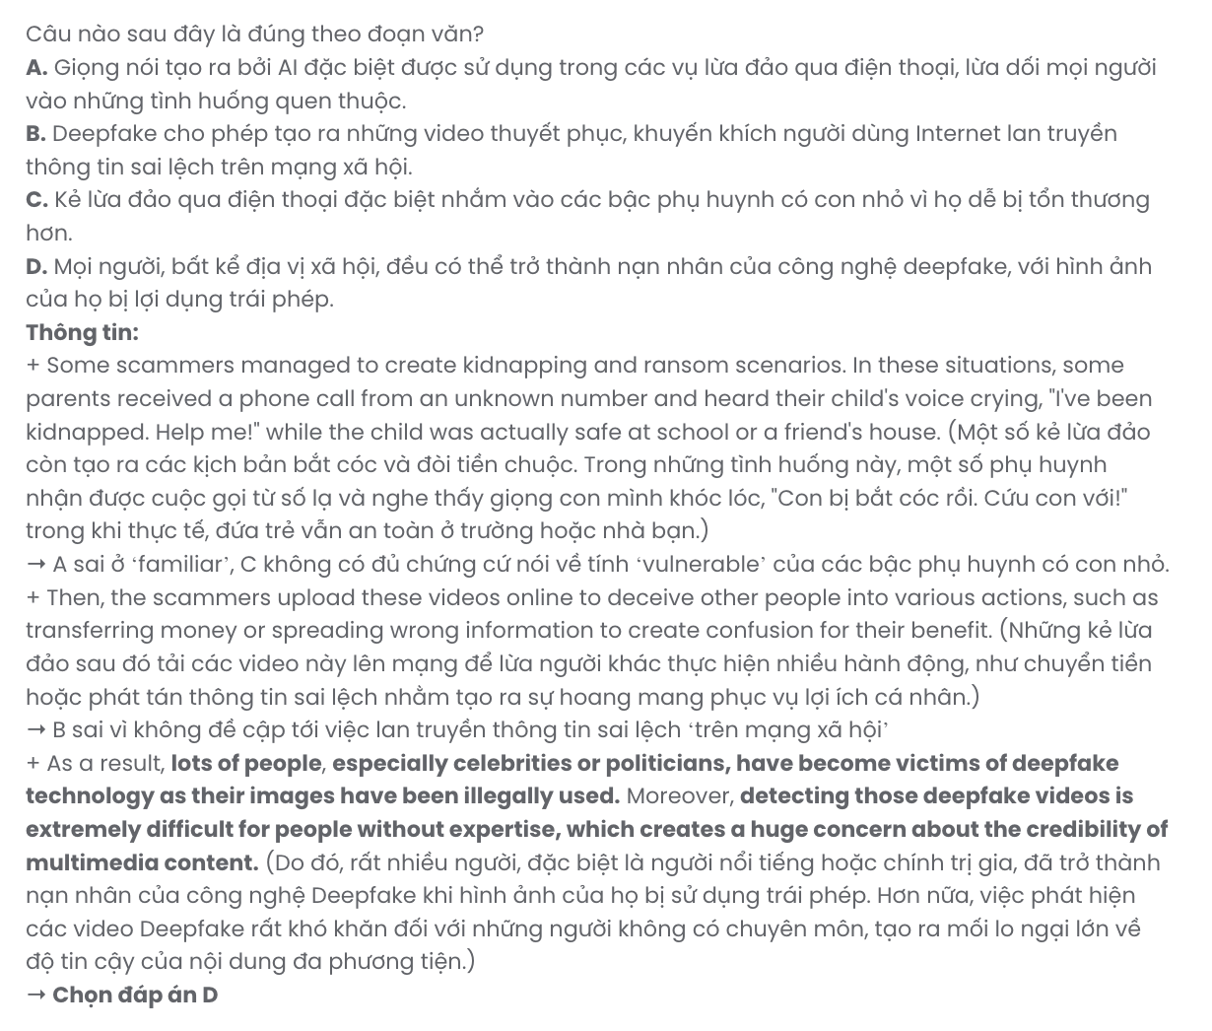
Question 39. It can be inferred from the passage that .
A. current regulations on AI use may lack strict enforcement to fully mitigate the risks associated with AI
B. deepfake poses a greater risk than phone scams because it is challenging to detect deepfake videos
C. most scammers are tech-savvy and use their knowledge and skills inappropriately to trick people
D. it is impossible to completely eradicate AI risks to ensure a safe and ethical digital environment for everyone
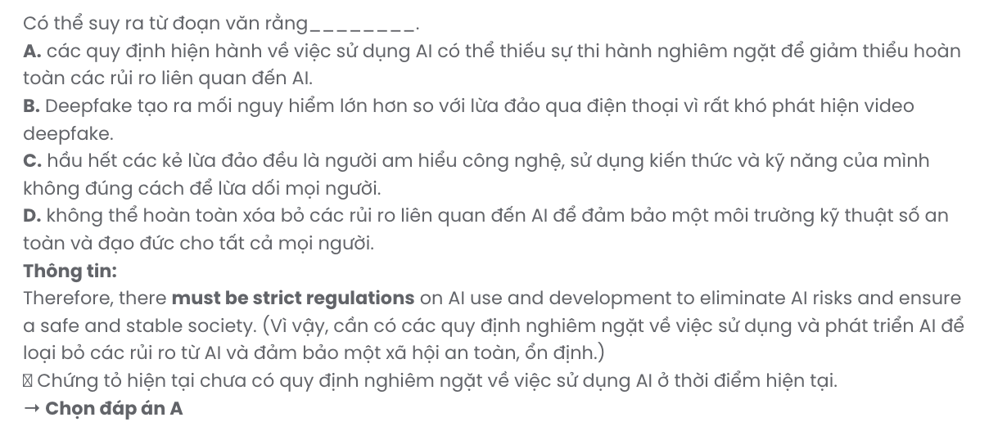
Question 40. Which of the following best summarises the passage?
A. AI advancements offer significant potential but also serious threats, such as phone fraud, leading to calls for strict regulations to protect people and ensure societal safety.
B. AI misuse, especially in phone scams and deepfake videos, has harmed individuals and undermined multimedia credibility.
C. Although AI supports humans, its misuse, as seen in deepfake and phone scams, raises concerns over controlling AI’s power and enforces the necessity of strict guidelines for safety.
D. AI developments, including deepfake, have affected celebrities and politicians, requiring strict laws to manage media authenticity and limit the impact of widespread misinformation.

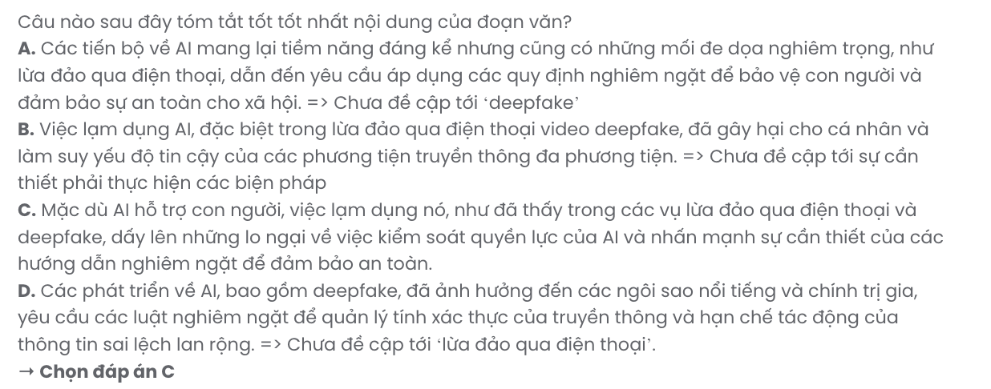
BẢNG TỪ VỰNG
STT | Từ vựng | Từ loại | Phiên âm | Nghĩa
1. | unite | v | /juːˈnaɪt/ | hợp nhất, đoàn kết
2. | demonstrate | v | /ˈdemənstreɪt/ | chứng minh, thể hiện
3. | dim | v | /dɪm/ | làm mờ
4. | participate | v | /pɑːˈtɪsɪpeɪt/ | tham gia
5. | gadget | n | /ˈɡædʒɪt/ | thiết bị
6. | reflect | v | /rɪˈflekt/ | phản ánh, phản chiếu
7. | awareness | n | /əˈweənəs/ | nhận thức
8. | conserve | v | /kənˈsɜːv/ | bảo tồn
9. | commitment | n | /kəˈmɪtmənt/ | cam kết
10. | annual | adj | /ˈænjuəl/ | hàng năm
11. | non-essential | adj | /ˌnɒn ɪˈsenʃəl/ | không cần thiết
12. | individual | n, adj | /ˌɪndɪˈvɪdʒʊəl/ | cá nhân
13. | encouraging | adj | /ɪnˈkʌrɪdʒɪŋ/ | mang tính khuyến khích, động viên
14. | movement | n | /ˈmuːvmənt/ | phong trào
15. | motivate | v | /ˈmoʊtɪˌveɪt/ | thúc đẩy, động viên
16. | enthusiasm | n | /ɪnˈθjuːziæzəm/ | nhiệt huyết, sự hăng hái
17. | throughout | prep | /θruːˈaʊt/ | xuyên suốt
18. | engage | v | /ɪnˈɡeɪdʒ/ | tham gia, thu hút
19. | provide | v | /prəˈvaɪd/ | cung cấp
20. | contest | n | /ˈkɒntest/ | cuộc thi, tranh tài
21. | ambassador | n | /æmˈbæsədər/ | đại sứ
22. | passionate | adj | /ˈpæʃənət/ | đầy đam mê
23. | grateful | adj | /ˈɡreɪtfl/ | biết ơn
24. | interaction | n | /ˌɪntərˈækʃən/ | tương tác, giao tiếp
25. | develop | v | /dɪˈveləp/ | phát triển, xây dựng
26. | fast-paced | adj | /ˈfæstˌpeɪst/ | nhịp độ nhanh
27. | adjust | v | /əˈdʒʌst/ | điều chỉnh, thích nghi
28. | initially | adv | /ɪˈnɪʃəli/ | ban đầu

29. | impatient | adj | /ɪmˈpeɪʃnt/ | thiếu kiên nhẫn
30. | multiple | adj | /ˈmʌltɪpl/ | nhiều, đa dạng
31. | surprisingly | adv | /səˈpraɪzɪŋli/ | một cách đáng ngạc nhiên
32. | valuable | adj | /ˈvæljuəbəl/ | có giá trị, quý báu
33. | security | n | /sɪˈkjʊə.rɪ.ti/ | sự an ninh
34. | pride | n | /praɪd/ | sự tự hào
35. | foster | v | /ˈfɒstər/ | nuôi dưỡng, khuyến khích
36. | initiative | n | /ɪˈnɪʃətɪv/ | sáng kiến
37. | appearance | n | /əˈpɪərəns/ | ngoại hình, sự xuất hiện
38. | improvement | n | /ɪmˈpruːvmənt/ | sự cải tiến, sự tiến bộ
39. | visible | adj | /ˈvɪzɪbəl/ | có thể nhìn thấy
40. | potential | n | /pəˈtenʃəl/ | tiềm năng
41. | attract | v | /əˈtrækt/ | thu hút
42. | vibrant | adj | /ˈvaɪbrənt/ | sôi động, tươi sáng
43. | neglect | v | /nɪˈɡlekt/ | bỏ mặc, sao lãng
44. | resident | n | /ˈrezɪdənt/ | cư dân
45. | unexpected | adj | /ˌʌnɪkˈspektɪd/ | bất ngờ
46. | crime | n | /kraɪm/ | tội phạm
47. | deter | v | /dɪˈtɜː(r)/ | ngăn chặn
48. | ordeal | n | /ɔːˈdiːəl/ | thử thách, khó khăn
49. | frustrating | adj | /ˈfrʌstreɪtɪŋ/ | làm nản lòng, bực bội
50. | setback | n | /ˈsetbæk/ | trở ngại, thất bại
51. | amenity | n | /əˈmiːnɪti/ | tiện nghi
52. | charming | adj | /ˈʧɑːmɪŋ/ | quyến rũ, duyên dáng
53. | downpour | n | /ˈdaʊnpɔːr/ | mưa lớn, cơn mưa xối xả
54. | relentless | adj | /rɪˈlentləs/ | không ngừng, liên tục
55. | sudden | adj | /ˈsʌdn/ | đột ngột
56. | storm | n | /stɔːm/ | bão
57. | trouble | n | /ˈtrʌbl/ | rắc rối, khó khăn
58. | sign | n | /saɪn/ | dấu hiệu, biển báo

59. | eager | adj | /ˈiːɡər/ | háo hức, nhiệt tình
60. | recharge | v | /ˌriːˈtʃɑːdʒ/ | nạp lại năng lượng
61. | crisis | n | /ˈkraɪsɪs/ | khủng hoảng, tình trạng khẩn cấp
62. | tackle | v | /ˈtækəl/ | giải quyết, xử lý
63. | optimise/ optimize | v | /ˈɒptɪmaɪz/ | tối ưu hóa
64. | repurpose | v | /ˌriːˈpɜːpəs/ | tái sử dụng
65. | overproduction | n | /ˌəʊvərprəˈdʌkʃən/ | sản xuất dư thừa
66. | lessen | v | /ˈlesən/ | giảm bớt
67. | consequence | n | /ˈkɒnsɪkwəns/ | hậu quả
68. | potent | adj | /ˈpəʊtənt/ | mạnh mẽ, có sức mạnh
69. | surplus | n | /ˈsɜːpləs/ | thặng dư
70. | quantity | n | /ˈkwɒntɪti/ | số lượng
71. | excessive | adj | /ɪkˈsesɪv/ | quá mức, thừa thãi
72. | severe | adj | /sɪˈvɪə(r)/ | nghiêm trọng, khắc nghiệt
73. | supply chains | n | /səˈplaɪ ˌʧeɪnz/ | chuỗi cung ứng
74. | pressing | adj | /ˈpresɪŋ/ | cấp bách, khẩn thiết
75. | phenomenon | n | /fɪˈnɒmɪnən/ | hiện tượng
76. | inefficient | adj | /ɪnɪˈfɪʃənt/ | không hiệu quả, kém hiệu quả
77. | unpopular | adj | /ʌnˈpɒpjʊlər/ | không được yêu thích
78. | championship | n | /ˈʧæmpɪənʃɪp/ | giải vô địch
79. | draft | v | /dræft/ | chọn ra
80. | league | n | /liːɡ/ | giải đấu, liên đoàn
81. | unusual | adj | /ʌnˈjuːʒʊəl/ | bất thường, lạ thường
82. | athlete | n | /ˈæθliːt/ | vận động viên
83. | ensure | v | /ɪnˈʃʊr/ | đảm bảo, cam đoan
84. | stable | adj | /ˈsteɪbəl/ | ổn định, vững chắc
85. | eliminate | v | /ɪˈlɪmɪˌneɪt/ | loại bỏ, loại trừ
86. | regulation | n | /ˌreɡjʊˈleɪʃən/ | quy định, điều lệ
87. | strict | adj | /strɪkt/ | nghiêm ngặt, chặt chẽ

88. | assist | v | /əˈsɪst/ | hỗ trợ, giúp đỡ
89. | credibility | n | /ˌkredɪˈbɪləti/ | tính uy tín, độ tin cậy
90. | confusion | n | /kənˈfjuːʒən/ | sự nhầm lẫn, sự bối rối
91. | convince | v | /kənˈvɪns/ | thuyết phục
92. | terrified | adj | /ˈterəfaɪd/ | sợ hãi, hoảng sợ
93. | unknown | adj | /ʌnˈnəʊn/ | không biết, không rõ
94. | scenario | n | /sɪˈnɑːrɪəʊ/ | kịch bản, tình huống
95. | ransom | n | /ˈrænsəm/ | tiền chuộc
96. | kidnap | v | /ˈkɪdnæp/ | bắt cóc, bắt giữ
97. | relative | n | /ˈrelətɪv/ | người thân
98. | victim | n | /ˈvɪktɪm/ | nạn nhân, người bị hại
99. | scammer | n | /ˈskæmər/ | kẻ lừa đảo
100. | humanoid | adj | /ˈhjuːməˌnɔɪd/ | giống người

STT | Cấu trúc | Nghĩa
1. | encourage somebody to do something | khuyến khích ai làm gì
2. | give someone time to do something | cho ai đó thời gian để làm gì
3. | be grateful for something | biết ơn vì điều gì đó

