School:
Teacher’s name:
Class:

LESSON PLAN
(Based on Official Letter No. 5512/BGDĐT-GDTrH dated December 18, 2020 of the MOET)

UNIT 8: SPORTS AND GAMES
Lesson 1: Getting started – At the gym

I. OBJECTIVES
By the end of this lesson, Ss will be able to:
1. Knowledge
- Have an overview about the topic Sports and games
- Use the vocabulary and talk about sports and games
2. Competences
- Develop communication skills and creativity
- Be collaborative and supportive in pair work and teamwork
- Actively join in class activities
3. Personal qualities
- Develop good habits playing sports and games
- Be responsible in exercising to improve health
- Develop self-study skills

II. MATERIALS
- Grade 6 textbook, Unit 8, Getting started
- Computer connected to the Internet
- Projector / TV
- hoclieu.vn

Language analysis

Form | Pronunciation | Meaning | Vietnamese equivalent
1. gym (n) | /dʒɪm/ | a place or club where you can go to exercise using machines, weights or other equipment | phòng tập thể dục
2. equipment (n) | /ɪˈkwɪpmənt/ | a set of necessary tools, clothing… for a particular purpose | thiết bị, dụng cụ
3. karate (n) | /kəˈrɑːti/ | A sport, originally from Japan, in which people fight using their arms, legs, hands, and feet | võ ka-ra-te

Assumption
Anticipated difficulties | Solutions
Students may have underdeveloped speaking and co-operating skills. | - Play the recording many times if necessary.  - Encourage students to work in groups so that they can help each other.  - Give short, clear instructions and help if necessary.

III. PROCEDURES
1. WARM-UP (5 mins)
a. Objectives:
- To activate students’ knowledge on the topic of the unit.
- To set the context for the listening and reading part.
b. Content:
- Spider web completion
c. Expected outcomes:
- Students can complete the word web related to the topic Television
d. Organisation:

TEACHER’S ACTIVITIES | STUDENTS’ ACTIVITIES | CONTENTS
Spider web completion  Teacher writes the words SPORTS AND GAMES on the board and asks students to give any words relating to the topic.  - Teacher may allow students to give a Vietnamese word and ask other students in the class if they know the equivalent in English.  - Teacher writes on the board a list of the words which students cannot translate into English and asks them to keep a record for later reference when the unit finishes.  - Teacher lets students open their books and starts the lesson. | - Students listen to the instruction and give their answers. | Suggested answer:  chess, cycling, basketball, football, running, hiking, swimming, badminton, tennis,...
e. Assessment
- T checks ss’ answers and gives feedback.

2. ACTIVITY 1: PRESENTATION (5 mins)
a. Objectives:
- To provide students with vocabulary.
- To help students be well-prepared for the task.
b. Content:
- Vocabulary pre-teaching
c. Expected outcomes:
- Students can identify some new words related to the topic: sports and games.
d. Organisation

TEACHER’S ACTIVITIES | STUDENTS’ ACTIVITIES | CONTENTS
Vocabulary pre-teaching  - Teacher introduces the vocabulary by:  + providing definitions of the words.  + showing the pictures illustrating the words. | - Students guess the meaning of words. | New words:  1. gym (n)  2. equipment (n)  3. karate (n)
e. Assessment
- Teacher checks students’ pronunciation and gives feedback.

3. ACTIVITY 2: PRACTICE (20 mins)
a. Objectives:
- To help Ss read for specific information about the text.
- To help Ss practise using words related to the topic Sports and Games
- To help Ss revise / learn names of some sports and games through pictures.
b. Content:
- Task 1: Listen and read.
- Task 2: Put a word from the conversation in each gap.
- Task 3: Name these sports and games, using the words from the box.
c. Expected outcomes:
- Students understand the conversation and topic of the lesson and can complete the tasks successfully.
d. Organisation

TEACHER’S ACTIVITIES | STUDENTS’ ACTIVITIES | CONTENTS
Task 1: Listen and read. (6 mins)
- Teacher ask students some questions before listening.  - Teacher plays the recording, and asks students to underline the words they have learned in the vocabulary part.  - Teacher can play the recording more than once.  - Teacher invites some pairs of students to read the dialogue aloud. | - Students answer the questions.  - Students underline the words related to the topic.  - Students listen and read.  - Some pairs read aloud the dialogue. | Questions:  1. Where are the two kids?  2. What sports are they going to play?  Suggested answers:  1. They are in the gym/ school gym.  2. They are going to run.
Task 2: Put a word from the conversation in each gap. (4 mins)
- Teacher asks students to do this task independently, and reminds them of the ways to do the activity if needed.  - Teacher allows students to share their answers before discussing as a class.  - Teacher writes the correct answers on the board.  - Teacher explains the meanings of some words if necessary. | - Students to the task without reading the conversation again.  - Students share and discuss the answers before discussing as a class.  - Students correct the answers. | Answer key:  1. fit  2. gym  3. table tennis  4. Club  5. cycle
Task 3: Name these sports and games, using the words from the box. (5 mins)
- Ask Ss to label the pictures with the correct words given. Ss can work in pairs. Elicit Ss’ answers. Then provide the correct words.  - Ask them for the meanings of the words. Provide them with the meanings of the words they don’t  know. T may also ask them if they play these sports and games or if people in Viet Nam play them.  - Teacher divides the class into groups of fours, prepares each group with 2 sets of cards, one includes pictures of sports and games and the other includes their names.  - Students work in groups and label the pictures with the  correct words given. The group matches faster and  correctly is the winner.  - Teacher checks with the whole class, and asks them for the meanings of the words. Provide them with the meanings of the words they don’t know. Teacher may also ask them if they play these sports and games or if people in Viet Nam play them. | - Students do the task individually.  - Share answers before discussing as a class.  - Students correct the answers. | Answer key:  1. cycling  2. aerobics  3. table tennis  4. swimming  5. chess  6. volleyball
e. Assessment
- Teacher checks students’ exercises individually and gives feedback.

4. ACTIVITY 3: FURTHER PRACTICE (10 mins)
a. Objectives:
- To help Ss talk about what TV programme(s) they like.
- To check students’ vocabulary and improve group work skills.
b. Content:
- Task 4: Work in pairs. Ask your partners these questions to find out how sporty they are.
c. Expected outcomes:
- Ss can talk about what TV programme(s) they like.
d. Organisation

TEACHER’S ACTIVITIES | STUDENTS’ ACTIVITIES | CONTENTS
Task 4: Work in pairs. Ask your partners these questions to find out how sporty they are.
- Teacher lets students work in pairs (or in groups) to ask and answer the questions. Some pairs (or groups) may report their results to the class. (In their groups, how many students answer “A”, how many students with answer “B” and who is the sportiest in their groups.)  - Teacher may want to find out how sporty the class is by writing the results on the board. | - Students work in groups of 4 to do the task.  - One student from each group reports the answer to the class. | Suggested answers:
e. Assessment
- T and other Ss listen to the answers and comment.

5. CONSOLIDATION (5 mins)
a. Wrap-up
- Teacher asks students to talk about what they have learnt in the lesson.
b. Homework
- Do exercises in the workbook.
- Name some sports and games that you know.
- Start preparing for the Project of the unit:
Teacher randomly puts Ss in groups of 4 or 5 and asks them to read the information about a traditional game on page 25, then choose a game in task 2 and give a presentation about it to the class in Lesson 7 – Looking back and Project. (Teacher should check the progress of students’ preparation after each lesson.)

Board plan
Date of teaching
Unit 8: Sports and games
Lesson 1: Getting started
* Warm-up

* Vocabulary
1. gym (n)
2. equipment (n)
3. karate (n)

Task 1: Listen and read.
Task 2: Put a word from the conversation in each gap.
Task 3: Name these sports and games.
Task 4: Ask questions.

*Homework

UNIT 8: SPORTS AND GAMES
Lesson 2: A closer look 1

I. OBJECTIVES
By the end of this lesson, Ss will be able to:
1. Knowledge
- Use the lexical items related to the topic Sports and games;
- Pronounce correctly and recognise the sounds /e/ and /æ/.
2. Competences
- Be collaborative and supportive in pair work and teamwork
- Access and consolidate information from a variety of sources
- Actively join in class activities
3. Personal qualities
- Be ready to make and share ideas among classmates.
- Develop good habits playing sports and games
- Be responsible in exercising to improve health
- Develop self-study skills

II. MATERIALS
- Grade 6 textbook, Unit 8, A closer look 1
- Computer connected to the Internet
- Projector / TV
- hoclieu.vn

Language analysis

Form | Pronunciation | Meaning | Vietnamese equivalent
1. racket (n) | /ˈrækɪt/ | an object used for hitting the balls in some sports | vợt (cầu lông/ tennis…)
2. goggles (n) | /ˈɡɒɡəlz/ | special glasses used to protect the eyes from chemicals, wind, water… | kính bảo hộ
3. competition (n) | /ˌkɒmpəˈtɪʃən/ | a situation in which someone tries to win something or be more successful than someone else | cuộc thi
4. champion (n) | /ˈtʃæmpiən/ | someone or something has beaten all other  competitors in a competition | nhà vô địch
5. marathon (n) | /ˈmærəθən/ | a running race of slightly over 26 miles (~42 km) | chạy đua ma-ra-tông/ chạy đường dài

Assumption
Anticipated difficulties | Solutions
Students may have difficulties in distinguishing two sounds /e/ and /æ/. | Provide students some tips by identifying the letters that may include each sound.
Students may lack knowledge about some lexical items. | Provide students with the meaning and pronunciation of some lexical items.
Some students will excessively talk in the class. | - Define expectations in explicit detail.  - Have excessively talkative students practise.  - Continue to define expectations in small chunks (before every activity).

III. PROCEDURES
1. WARM-UP (5 mins)
a. Objectives:
- To activate students’ prior knowledge and vocabulary related to the topic.
b. Content:
- Brainstorming
c. Expected outcomes:
- Students can recognise some kind of sports and games.
d. Organisation:

TEACHER’S ACTIVITIES | STUDENTS’ ACTIVITIES | CONTENTS
Brainstorming
- Teacher divides the class into two teams. One member from each team, in turns, comes to the board and lists all the sports and games they have learnt.  - The team with more correct answers in two minutes is the winner. | - Students work in two teams to do the task. | Suggested answer:  ball, shoes, net, bicycle, racket,...
e. Assessment
- Teacher’s feedback.

2. ACTIVITY 1: VOCABULARY (20 mins)
a. Objectives:
- To revise / teach the names of some sports / games and the equipment to be used in the sports/ games.
b. Content:
- Vocabulary pre-teaching
- Task 1: Write the right words / phrase under the pictures.
- Task 2: What sports are these things for? Match each thing in column A with a sport in column B.
- Task 3: Fill each blank with one of the words from the box.
c. Expected outcomes:
- Students can identify some words about sports / games and the equipment.
d. Organisation

TEACHER’S ACTIVITIES | STUDENTS’ ACTIVITIES | CONTENTS
Vocabulary pre-teaching (6 mins)
- Teacher introduces the vocabulary by:  + providing explanations of the words;  + showing pictures illustrating the words. | - Students guess the meaning of the words through pictures, synonyms or antonyms. | New words:  1. racket (n)  2. goggles (n)  3. competition (n)  4. champion (n)  5. marathon (n)
Task 1: Write the words/ phrases in the box next to the definition. (4 mins)
- Teacher asks students to look at the pictures and see if they can write the words under the pictures.  - Teacher lets students work individually, and tells them to put the words and phrases given under the right pictures.  - Teacher calls a student to come and write their answer on the board. The rest of the class may compare.  - Teacher checks the answer with the whole class and explains the meanings to them if necessary. If there is enough time, let students give examples. | - Students work individually to do the task.  - Write the answer on the board. Correct the answer.  - Give examples if there is enough time. | Answer key:  1. ball  2. sports shoes  3. boat  4. racket  5. goggles
Task 2: Complete the sentences with the words / phrases in the box. (5 mins)
- Teacher tells students to do the task independently first, then calls on some students to write their answers on the board, then checks their answers as a class.  - Teacher checks with the whole class, asks students to give more names of sports and equipment to be used with them.  For example:  - table tennis – bats  - running – sports shoes  - chess – chess board + chess pieces... | - Students work in pairs to do the task.  - Some pairs share their answers with the class.  - Student correct the answer if need | Answer key:  1. c  2. d  3. a  4. b  5. e
Task 3: Complete the sentences with the adjectives in the box. (5 mins)
- Teacher has students read the sentences and fill in the blanks with the words given, then read the sentences carefully and look for clues so that they can choose the right words to complete the sentences.  - Teacher calls one student to write the words on the board, then gives corrections.  - For more able students, teacher asks them to make sentences with the words. Other students and teacher give comments. | - Students do the task individually.  - Students share their answers with their partners before discussing as a class. | Answer key:  1. competition  2. champion  3. congratulations  4. sporty  5. marathon
e. Assessment
- Teacher’s observation and feedback

3. ACTIVITY 2: PRONUNCIATION (15 mins)
a. Objectives:
- To help students identify how to pronounce the sounds /θ/ and /ð/.
- To help students practise pronouncing these sounds correctly in words and in sentences.
b. Content:
- Task 4: Listen and repeat the words.
- Task 5: Tongue Twister. Take turns to read the sentences quickly and correctly.
c. Expected outcomes:
- Students can pronounce the /θ/ and /ð/ sounds in words in sentences correctly
d. Organisation

TEACHER’S ACTIVITIES | STUDENTS’ ACTIVITIES | CONTENTS
Task 4: Listen and repeat the words. (8 mins)
- Teacher introduces 2 sounds /θ/ and /ð/ to students and lets them watch a video about how to pronounce these two sounds.  Video link: HƯỚNG DẪN PHÁT ÂM LỚP 6 - Unit 7: Television /θ/ - /ð/  - Teacher asks students to read the words first as they are familiar with students.  - Teacher plays the recording and asks students to listen carefully and check if they have pronounced them correctly.  - Teacher calls some students to read the words individually.  - Teacher asks students to give some words they know containing these sounds. | - Students watch a video about how to pronounce the two sounds.  - Students listen to the recording and repeat.  - Students give more words containing the sounds /θ/ and /ð/. | 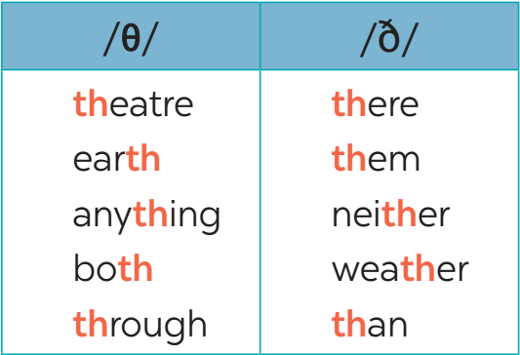  Suggested answers:  /θ/: think, thank, throw, theatre, third.  /ð/: this, that, these, those, there, father.
Task 5: Tongue Twister. Take turns to read the sentences quickly and correctly. (7 mins)
- Teacher allows students to work in pairs and practice reading the tongue twister: slowly at first, then faster and faster.  - Teacher asks some students to read the Tongue Twister aloud. | - Students work in pairs to practise reading the sentences.  - Some students read the sentences aloud. | Tongue Twister challenge:  1. They are thinking about the weather there.  2. The new theatre opens on Thursday the third.
e. Assessment
- Teacher’s observation and feedback on student’s pronunciation.

4. CONSOLIDATION (5 mins)
a. Wrap-up
- Teacher asks students to talk about what they have learnt in the lesson.
b. Homework
- Do exercises in the workbook.
- Find 5 more words with the sound /θ/ and 5 more words with the sound /ð/. Write them down and practice pronouncing the words.

Board Plan

Date of teaching …
Unit 8: Sports and games
Lesson 2: A closer look 1

*Warm-up
Matching

* Vocabulary
1. comedy (n)
2. viewer (n)
3. performer (n)
4. popular (adj)
5. live (adj)
6. boring (adj)

Task 1: Write the words / phrases.
Task 2: Complete the sentences.
Task 3: Complete the sentences.

* Pronunciation
Task 4: Listen and repeat the words.
Task 5: Tongue Twister.

*Homework

UNIT 8: SPORTS AND GAMES
Lesson 3: A closer look 2

I. OBJECTIVES
By the end of this lesson, Ss will be able to:
1. Knowledge
- use the Wh-question words and conjunctions in compound sentences: and, but, so correctly
2. Competences
- Develop communication skills
- Be collaborative and supportive in pair work and teamwork
- Actively join in class activities
3. Personal qualities
- Be ready to make and share ideas among classmates.
- Develop good habits playing sports and games
- Be responsible in exercising to improve health
- Develop self-study skills

II. MATERIALS
- Grade 6 textbook, Unit 8, A closer look 2
- Computer connected to the Internet
- Projector / TV
- hoclieu.vn

Language analysis
Past simple tense
 | Form | Example
to be | S + was/ were + … . | They were friends.
 | S + wasn’t/ weren’t + … . | She wasn’t at home last night.
 | Was/ Were + S + … ? | Were you good at French?
 | W/H + was/ were + S + … ? | Who was with you at the party?
to verb | S + Ved + … . | She played tennis yesterday  morning.
 | S + didn’t + Vinf + … . | He didn’t work yesterday.
 | Did + S + Vinf + … ? | Did they go to school last Monday?
 | W/H + did + S + Vinf + … ? | When did you go to the  supermarket?
Imperatives
Positive | V | Open the door.
Negative | Don’t + V | Don’t play outside.

Assumption
Anticipated difficulties | Solutions
1. Students may be confused about when to use regular or irregular verbs in past simple tense. | Give students a set of common irregular verbs and ask them to look the words up when they need.
2. Students may be confused when making imperative sentences with be. | Give more examples.
3. Students may have underdeveloped speaking and co-operating skills. | - Give clear instruction, give examples before letting students work in groups.  - Provide feedback and help if necessary.

III. PROCEDURES
1. WARM-UP (5 mins)
a. Objectives:
- To activate students’ prior knowledge related to the targeted grammar of past simple tense and to increase students’ interest.
- To enhance students’ skills of cooperating with team mates.
b. Content:
- Game: Pelmanism
c. Expected outcomes:
- Students can play the game using the past simple tense
d. Organisation

TEACHER’S ACTIVITIES | STUDENTS’ ACTIVITIES | CONTENTS
Word cloud  - Teacher divides the class into groups of fours, prepares each group with 2 sets of cards, one includes activities in infinitive forms and the other includes those of past simple form.  - Students work in groups and match the card with infinitive form with its correct past simple form. The group matches faster and correctly is the winner. | - Students follow the teacher's instructions to play the game. | watch TV watched TV  play computer games played computer games  have lunch had lunch  drink water drank water  teach English taught English  learn French learnt French  go to school went to school  do homework did homework  be at home was/ were at home
e. Assessment
- Teacher corrects students’ answers (if needed).

2. ACTIVITY 1: THE PAST SIMPLE (20 mins)
a. Objectives:
- To help Ss practise using the past simple in context.
- To help Ss practise using the past simple in real situations.
b. Content:
- Task 1: Choose the correct answer A, B or C.
- Task 2: Write the correct form of the verbs to complete the conversation.
- Task 3: Work in groups. Ask and answer questions about your last weekend.
c. Expected outcomes:
- Students understand how to use the targeted grammar.
d. Organisation

TEACHER’S ACTIVITIES | STUDENTS’ ACTIVITIES | CONTENTS
The past simple tense: Elicit past simple tense (5 mins)
- Teacher draws students’ attention to the form of the verbs in the game and asks them whether they know the target tense.  - Teacher provides or confirms the answers and leads in the grammar focus of the lesson.  - Teacher asks students to give the rules and lets them study the grammar box. | - Students read the words in the Warm-up part and answer the teacher’s question.  - Students read the Remember box. | To verb To be  Positive S + Ved + … . S + was/ were + … .  Negative S + didn’t + Vinf + … . S + wasn’t/ weren’t + … .  Interrogative Did + S + Vinf + … ? Was/ Were + S + … ?  Answer Yes, S + did. No, S + didn’t. Yes, S + was/ were. No, S + wasn’t/ weren’t.  W/H questions W/H + did + S + Vinf + … ? W/H + was/were + S + ...?  Notes  There are regular and irregular verbs in past simple tense.
Task 1: Choose the correct answer A, B or C. (3 mins)
- Teacher lets students do the task individually and then compares their answers in pairs.  - Teacher tells students that when they do the multiple choice questions, they should first read the sentences (stems) and the options carefully. After that they should choose the answer that they think is correct by eliminating each clearly wrong answer.  - Teacher checks and confirms students’ answers. | - Students do the task individually and then check the answers with a partner before checking as a class. | Answer key:  1. C  2. B  3. C  4. A  5. B
Task 2: Write the correct form of the verbs to complete the conversation. (5 mins)
- Teacher lets students do the task individually, and asks them to read the conversation first, so that they understand the context to use the verbs given in the correct form.  - Teacher may call on some students separately to read out their answers and correct their answers if they’re wrong, and give explanation if necessary.  - Teacher then calls some pairs to read the conversation with the correct verb form, and corrects their pronunciation and intonation if necessary. | - Students do the task individually.  - Some students read out their answers.  - Correct the answer. | Answer key:  1. went  2. had  3. did you do  4. visited  5. ate  6. scored
Task 3: Work in groups. Ask and answer questions about your last weekend. (7 mins)
- Teacher divides the class into groups of 4, then lets students take turns to ask and answer questions about their last weekend.  - Teacher encourages them to give as many sentences as possible, tell them to use all the three forms (affirmative, negative, and question).  - Some more able students can report to the class about one of their friends’ last weekend. | - Students do the task in groups of four.  - Report to the class about one of their friends’ last weekend. | 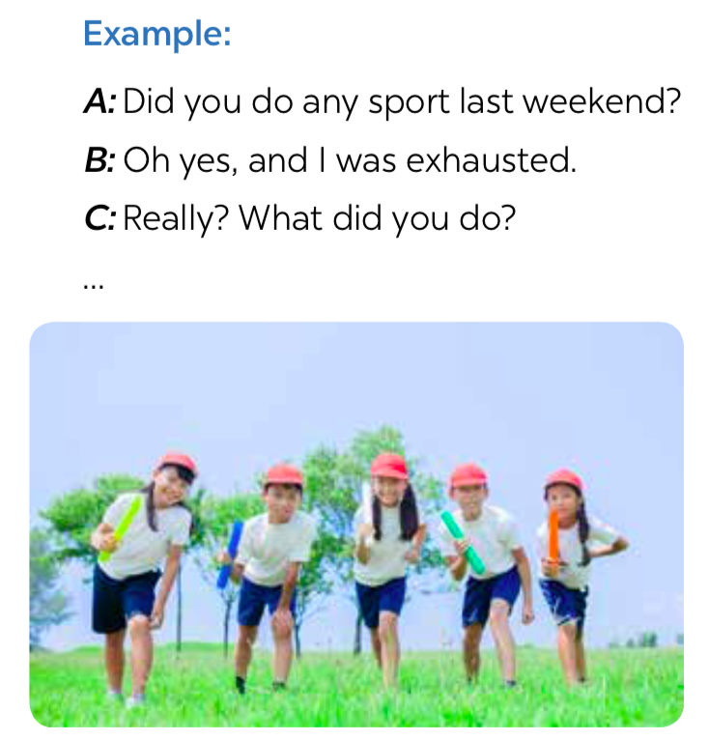
e. Assessment
- Teacher corrects the students as a whole class.

3. ACTIVITY 2: IMPERATIVES (15 mins)
a. Objectives:
- To help Ss use the correct form of imperatives in different situations.
- To help Ss practise using imperatives to tell someone to do something in a real context.
b. Content:
- Task 4: Look at each picture and choose the correct answer.
- Task 5: Tell your friends what to do and what not to do at the gym.
c. Expected outcomes:
- Students understand how to use the targeted grammar.
d. Organisation

TEACHER’S ACTIVITIES | STUDENTS’ ACTIVITIES | CONTENTS
Imperatives (5 mins)
- Teacher sets context to lead in the lesson: There is an obese kid, let’s tell the kids what to do/ what not to do to stay fit and healthy by using imperatives.  Do more exercise. Don’t spend much time on computer games.  - Teacher asks students to give the rules and when to use imperatives: use imperatives to tell someone to do something or to give direct order.  - Teacher asks students to read the Remember box. | - Students listen to the teacher., answer the questions and then read the Remember box. | 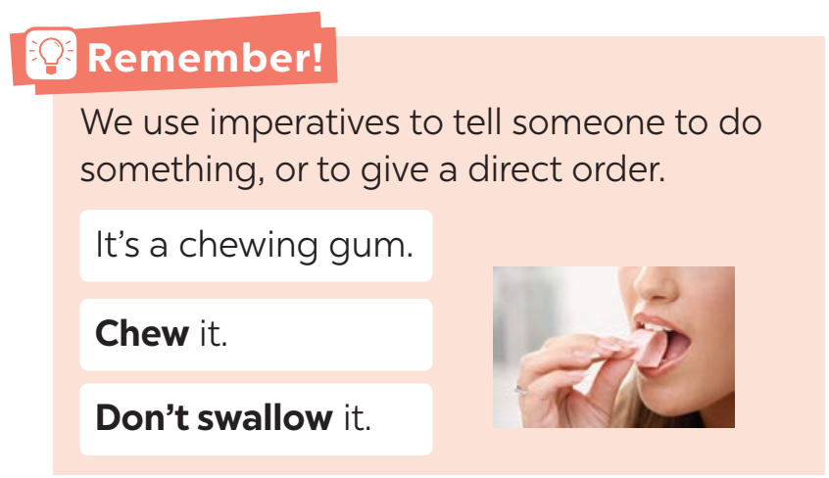  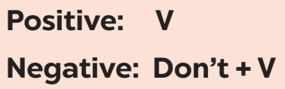
Task 4: Look at each picture and choose the correct answer. (5 mins)
- Teacher tells students to work in pairs, and gives them about 2 – 3 minutes to do the task.  - Teacher goes round, observes the class and gives help if necessary.  - Teacher calls on some students to read their answers, then checks their answers as a class. | - Students work in pairs to do the task.  - Some students read out loud the complete sentences.  - Check the answers as a class. | Answer key:  1. Don’t park  2. Close  3. Tidy up  4. Don’t use  5. Try
Task 5: Tell your friends what to do and what not to do at the gym. (5 mins)
- Teacher lets students work in groups of four, gives each group a piece of paper, asks them to take turns to tell their friends what to do and what not to do at the gym and write down the answer in the paper in 3 minutes.  - Teacher gives help and lets them give as many sentences as possible.  - Teacher calls some groups to read aloud their answers and check with the whole class.  - If there is still time, teacher may ask students to draw a picture illustrating one of the gym rules in the blank space at the bottom of their notebook page. Make sure that students write the rules somewhere in the picture. (This may be done as homework.) | - Students work in groups of four to do the task.  - Some students read their group’s answers aloud.  - Do as the teacher’s instructions if there is still time. | Some possible sentences:  + Pay your fee first.  + Put on your trainers/ sports shoes.  + Listen to the instructor carefully.  + Don’t litter.  + Don’t eat or drink at the gym.
e. Assessment
- Teacher corrects the students as a whole class.

4. CONSOLIDATION (5 mins)
a. Wrap-up
- Summarise the main points of the lesson.
b. Homework
- Make 3 sentences about yourself, using the past simple.
- Give 3 orders or tell your friends to do an activity/ everyday routine.
- Do exercises in the workbook.

Board Plan

Date of teaching
Unit 8: Sports and games
Lesson 3: A closer look 2
* Warm-up
Game: Pelmanism

I. Grammar
The past simple
Task 1: Choose A, B or C.
Task 2: Complete the conversation.
Task 3: Ask and answer.
Imperatives
Task 4: Choose the correct answer.
Task 5: Tell your friends.

* Homework

UNIT 8: SPORTS AND GAMES
Lesson 4: Communication

I. OBJECTIVES
By the end of this lesson, Ss will be able to:
1. Knowledge
- Use the lexical items related to the topic Sports and games
- Express and respond to congratulations
- Talk about sports and games that they like
2. Competences
- Develop communication skills and creativity
- Be collaborative and supportive in pair work and teamwork
- Actively join in class activities
3. Personal qualities
- Be ready to make and share ideas among classmates.
- Develop good habits playing sports and games
- Be responsible in exercising to improve health
- Develop self-study skills

II. MATERIALS
- Grade 6 textbook, Unit 8, Communication
- Computer connected to the Internet
- Projector / TV
- hoclieu.vn

Assumption
Anticipated difficulties | Solutions
1. Students may have underdeveloped speaking and co-operating skills. | - Encourage students to work in pairs, in groups so that they can help each other.  - Provide feedback and help if necessary.
2. Some students will excessively talk in the class. | - Define expectations in explicit detail.  - Have excessively talkative students practise.  - Continue to define expectations in small chunks (before every activity).

III. PROCEDURES
1. WARM-UP (5 mins)
a. Objectives:
- To activate students’ prior knowledge and to increase students’ interest.
b. Content:
- Game: Lucky numbers
c. Expected outcomes:
- Students can make questions to ask about a TV programme.
d. Organisation
TEACHER’S ACTIVITIES | STUDENTS’ ACTIVITIES | CONTENTS
Lucky numbers  - Class is divided into 2 teams.  - Teacher prepares 7 numbers which includes 5 questions about their school, and 2 lucky numbers.  - Each team takes turns, chooses a number and answers the question behind the number. If the team answers the question correctly, they will get 1 point. If the team chooses the lucky number, they get 1 point without answering the question and get another turn. | - Students play the game in 2 teams. | Suggested question:  1. Lucky number  2. Complete the following imperative:  ... watch TV more than 3 hours a day. It’s bad for your eyes.  -> Don’t  3. Complete the question:  ... you have dinner with your parents yesterday?  -> Did  4. Look at the picture and complete the sentence:  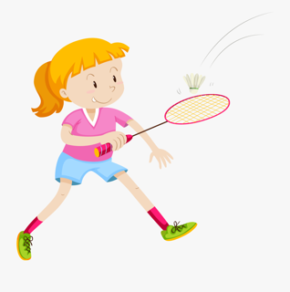  Jane ... with her brother last weekend.  -> played badminton  5. Lucky number  6. Look at the picture and complete the sentence:    … to the instructor at the gym.  -> Listen  7. Translate the following sentence into English:  Tôi chiến thắng trong cuộc thi đánh vần Thứ Hai tuần trước.  -> I won the spelling contest last Monday.
e. Assessment
- Teacher corrects students’ answers (if needed).

2. ACTIVITY 1: EVERYDAY ENGLISH (15 mins)
a. Objectives:
- To introduce the way of expressing and responding to congra tulations
- To help Ss practise expressing and responding to congratulations
b. Content:
- Task 1: Listen and read the short conversation below, paying attention to the highlighted parts.
- Task 2: Work in pairs.
c. Expected outcomes:
- Students can use the structures to express and respond to congratulations.
d. Organisation
TEACHER’S ACTIVITIES | STUDENTS’ ACTIVITIES | CONTENTS
Task 1: Listen and read the short conversation below, paying attention to the highlighted parts. (7 mins)
- Teacher leads students into the lesson by repeating the answer in question 7 of the game (I won in the spelling contest last Monday.) and asks students how they will respond in such situations.  - Teacher lets students listen and read the dialogue, and asks them what the characters say when they hear good news from other people.  - Teacher calls some students to share their opinions.  - Teacher gives more explanations and writes down the structure of expressing and responding to congratulations. | - Students respond to the situation in the warm-up part.  - Students listen to the recording and pay attention to the highlighted words.  - Students practise the dialogue in pairs. | 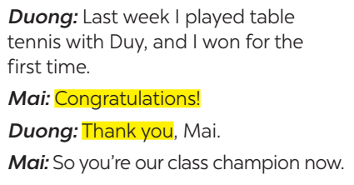
Task 2: Work in pairs. Student A has won a prize in the school’s singing contest / sports competition. Student B congratulates him / her. Make a similar dialogue. Remember to use the highlighted parts in 1. Then change roles. (8 mins)
- Teacher allows students to work in pairs, practise the situation, using structures above.  - Teacher calls some pairs to present their answers.  - Teacher gives feedback and corrections (if necessary). | - Students do the task in pairs.  - Some pairs act out their conversation in front of the class. | Suggested conversation:  A: Yesterday, I played chess with my dad and I won for the first time.  B: Wow, really? Congratulations!  A: Thank you.
e. Assessment
- Teacher checks students’ understanding by asking some checking-questions.

3. ACTIVITY 2: ﻿TV THE SPORTS/ GAMES YOU LIKE (25 mins)
a. Objectives:
- To have Ss revise / learn some knowledge of sports / games.
- To help Ss communicate through a quiz about sports / games.
- To help Ss ask and answer questions about themselves concerning the field of sports / games.
b. Content:
- Task 3: Work in groups. Discuss and complete the facts with the countries in the box.
- Task 4: Work in groups. Interview your partners using the following questions. You may ask for more information.
c. Expected outcomes:
- Students know about different types of house.
- Students can ask and answer questions about houses.
d. Organisation
TEACHER’S ACTIVITIES | STUDENTS’ ACTIVITIES | CONTENTS
Task 3: Work in pairs. Do the quiz.
- Teacher asks students to work in pairs and find the answers to the quiz.  - Teacher checks and gives the correct answers. | - Students work in pairs to do the task.  - Some students stand up to give the answers.  - Students correct their answers if needed. | Answer key:  1. There are usually 22 players (11 on each side).  2. It normally lasts 90 minutes (divided into two halves).  3. They take place every four years.  4. A marathon is 42.195 kilometres long (26 miles and 385 yards).  5. They took place in Olympia (in Ancient Greece) (in 776 BC).
Task 4: Work in groups. Interview your partners using the following questions. You may ask for more information.
- Teacher divides the class into groups of 5 or 6.  - Teacher appoints one student to be the interviewer, others to be the interviewees, then gives students plenty of time to ask and answer questions. Encourage them to talk and raise as many questions as possible.  - Teacher goes round the class and gives support if  necessary.  - After a fixed amount of time, choose the interviewer of some groups to present to the class. Teacher and other students listen and make comments. | - Students do the task individually.  - Some students stand up to give the answers.  - Students correct their answers if needed. | Suggested questions:  1. What sports / games do you play in your free time? Do you play them well? When and how often do you play them?  2. Which sport / game do you like watching on TV?  3. Did you join any clubs?  4. If you don’t play sport, what do you often do in your spare time?
e. Assessment
- Teacher corrects students’ answers by going around while they’re practising.
- Teacher gives corrections and feedback

4. CONSOLIDATION (3 mins)
a. Wrap-up
- Have Ss say what they have learnt in the lesson.
b. Homework
- Write down the results and feedback of the previous
interviews.
- Do exercises in the workbook.
- Prepare for the next lesson: Skills 1

Board Plan

Date of teaching
Unit 8: Sports and games
Lesson 4: Communication
*Warm-up
Lucky numbers

* Everyday English
Expressing and responding to congratulations.
Task 1: Listen and read.
Task 2: Role play.

* The sports/ games you like
Task 3: Work in pairs. Do the quiz.
Task 4: Work in groups. Interview.

*Homework

UNIT 8: SPORTS AND GAMES
Lesson 5: Skills 1

I. OBJECTIVES
By the end of this lesson, Ss will be able to:
1. Knowledge
- read for general and specific information about a TV guide
- talk about a favourite TV programme and the reason for that
2. Competences
- Develop communication skills and creativity
- Be collaborative and supportive in pair work and teamwork
- Develop presentation skill
3. Personal qualities
- Be ready to make and share ideas among classmates.
- Develop good habits playing sports and games
- Be responsible in exercising to improve health
- Develop self-study skills

II. MATERIALS
- Grade 6 textbook, Unit 7, Skills 1
- Computer connected to the Internet
- Projector / TV
- hoclieu.vn

Language analysis
Form | Pronunciation | Meaning | Vietnamese equivalent
1. career (n) | /kəˈrɪə(r)/ | the job or series of jobs that you do during your working life | sự nghiệp
2. goal (n) | /ɡəʊl/ | a point score in some sports, such as football, when a player get the ball into this area | bàn thắng
3. score (v) | /skɔːr/ | to win or get a point | ghi bàn

Assumption
Anticipated difficulties | Solutions
1. Students may lack knowledge about some lexical items. | Provide students with the meaning and  pronunciation of words.
2. Students may have underdeveloped reading, speaking and co-operating skills. | - Let students read the text again (if needed).  - Create a comfortable and encouraging environment for students to speak.  - Encourage students to work in pairs, in groups so that they can help each other.  - Provide feedback and help if necessary.
3. Some students will excessively talk in the class. | - Define expectation in explicit detail.  - Have excessively talkative students practise.  - Continue to define expectations in small chunks (before every activity).

III. PROCEDURES
1. WARM-UP (5 mins)
a. Objectives:
- To introduce the topic of reading and also revise the previous lesson.
b. Content:
- Game: Hidden picture
c. Expected outcomes:
- Students can guess the TV channels
d. Organisation
TEACHER’S ACTIVITIES | STUDENTS’ ACTIVITIES | CONTENTS
Game: Hidden picture  - Class is divided into 2 teams.  - Teacher prepares 6 cards numbered from 1 to 6.  - Each team takes turns to choose a number and answer the question behind the number. If the team answers the question correctly, they will get 1 point.  - There is a hidden picture under the 6 cards, the team that finds the hidden picture first will be the winner. | - Students play the game in two teams. | Suggested questions:  1. How many players are there in a football match? - 22.  2. How long does a football match last? - 90 minutes.  3. Is football in America the same sport as football in other countries? - No, it isn’t.  4. Who is this man? - Quang Hải – a Vietnamese footballer.    5. Which sport happens in a ring? - Boxing.  6. Who is this girl? - Ánh Viên – a Vietnamese swimmer.    -> The hidden picture is Pelé.
e. Assessment
- Teacher corrects students’ answers (if needed).

2. ACTIVITY 1: READING (20 mins)
a. Objectives:
- To help Ss develop their reading skill for general and specific information.
- To help Ss broaden and deepen their knowledge of Pelé.
b. Content:
- Vocabulary pre-teaching
- Task 1: Work in pairs. Discuss the questions.
- Task 2: Read the dialogue quickly to check your ideas in 1.
- Task 3: Read the text again and answer the questions.
c. Expected outcomes:
- Students understand the text and do the tasks successfully.
d. Organisation
TEACHER’S ACTIVITIES | STUDENTS’ ACTIVITIES | CONTENTS
Vocabulary pre-teaching
- Teacher introduces the vocabulary by:  + providing the pictures of the words  + providing the definition of the words | - Students write down the new words. | New words:  1. career (n)  2. goal (n)  3. score (v)
Task 1: Work in pairs. Discuss the questions.
- T may begin by asking Ss to name some famous football players in Viet Nam.  - Tell them to work in pairs to discuss the questions in this activity. Encourage them to give their ideas  (as many ideas as possible) in front of the class.  - Have Ss work in pairs and discuss the questions about Pelé. It is not important whether they know  much or little information about Pelé as long as they talk with each other. | - Students answer the teacher’s questions.  - Students work in pairs to discuss the question. | Questions:  1. What do you know about Pelé?  2. What is special about him?
Task 2: Read the dialogue quickly to check your ideas in 1.
- Tell Ss to read the text quickly and check their ideas in 1.  - Set a strict time limit to ensure that Ss read quickly for information. Encourage Ss to give any piece of  information they can remember (and it is not so important what they say as long as they speak English). | - Students read the text quickly and check their ideas again.
Task 3: Read the text again and answer the questions.
- Give Ss some time to practise reading the dialogue. Ss listen to T (or other Ss) read aloud while tracking the dialogue with their fingers.  - Ask Ss to read in chorus the new and difficult words / phrases in the dialogue.  - Check with Ss the meanings of the new words. Explain to them if necessary.  - Ask Ss to find the key words in each question. Then find the information in the dialogue to answer the questions.  - Confirm the correct answers to the class. | - Students read aloud the dialogue.  - Find the key words in each question.  - Find the information and answer the questions.  - Correct the answers if needed. | Answer key:  1. Pelé was born in 1940.  2. His father did. / His father taught him.  3. He scored 1,281 goals in total.  4. (He became Football Player of the Century) in 1999.  5. They call him “The King of Football”.
e. Assessment
- Teacher checks students’ understanding with follow up questions.

3. ACTIVITY 2: SPEAKING (15 mins)
a. Objectives:
- To help Ss practise reading and understand fact files of famous sportspeople.
- To help Ss practise speaking about a famous sportsperson in 4.
b. Content:
- Task 4: Read the following facts about two famous sportspeople.
- Task 5: Choose one sportsperson in 4. Talk about him / her. Use the following cues.
c. Expected outcomes:
- Students can talk about a sportsperson.
d. Organisation
TEACHER’S ACTIVITIES | STUDENTS’ ACTIVITIES | CONTENTS
Task 4: Read the following facts about two famous sportspeople.
- Ss work by themselves and read the fact files of two famous sportspeople. T may ask them whether they know these sportspeople, and what else they know about them.  - Explain any new words to Ss if necessary. Make sure Ss understand everything and they can use these  facts to prepare for the next speaking activity. | - Students read the fact files individually.  - Ask the teacher the meaning of the new words if necessary. | 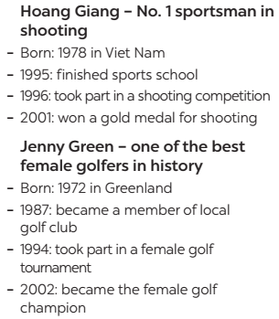
Task 5: Choose one sportsperson in 4. Talk about him / her. Use the following cues.
- Have Ss work in pairs or groups. Have them take turns to talk about their chosen sportsperson.  - Let them have freedom to choose what information to mention. (They can skip some points, or add some of their own.)  - While Ss are talking, T goes round the class and monitors. Remember not to stop them in order to correct their mistakes.  - When the talking time is over, T collects common errors and discusses them with the whole class. | - Students work in pairs or groups to talk about their chosen sportsperson. | Suggested cues:  – His / Her name  – The sport he / she plays  – Why he / she is famous  – You like him / her or not  Explain why
e. Assessment
- Teacher gives corrections and feedback.

4. CONSOLIDATION (5 mins)
a. Wrap-up
- Summarise the main points of the lesson.
b. Homework
- Write down their opinion about a famous sportsperson.
- Do exercises in the workbook
- Prepare for the next lesson: Skills 2.

Board Plan

Date of teaching
Unit 8: Sports and games
Lesson 5: Skills 1
*Warm-up
Game: Hidden picture
* Reading
Vocabulary
1. career (n)
2. goal (n)
3. score (v)
Task 1: Discuss the questions.
Task 2: Read and quickly check your ideas.
Task 3: Read and answer the questions.
* Speaking
Task 4: Read about two famous sportspeople.
Task 5: Talk about one sportsperson in Task 4.
*Homework

UNIT 8: SPORTS AND GAMES
Lesson 6: Skills 2

I. OBJECTIVES
By the end of this lesson, Ss will be able to:
1. Knowledge
- Use the lexical items related to the topic Sports and games
- Listen for general and specific information about people’s favourite sports
- Write a passage about your favourite sport
2. Competences
- Develop communication skills and creativity
- Be collaborative and supportive in pair work and team work
- Actively join in class activities
3. Personal qualities
- Be ready to make and share ideas among classmates.
- Develop good habits playing sports and games
- Be responsible in exercising to improve health
- Develop self-study skills

II. MATERIALS
- Grade 6 textbook, Unit 8, Skills 2
- Computer connected to the Internet
- Projector / TV
- hoclieu.vn

Assumption
Anticipated difficulties | Solutions
1. Students may have  underdeveloped listening skills. | - Play the recording many times if necessary.  - Encourage students to work in pairs, in groups so that they can help each other.  - Provide feedback and help if necessary.
2. Some students will excessively talk in the class. | - Define expectation in explicit detail.  - Have excessively talkative students practise.  - Continue to define expectations in small chunks (before every activity).

III. PROCEDURES
1. WARM-UP (5 mins)
a. Objectives:
- To create an active atmosphere in the class before the lesson;
- To lead in the topic of the listening tasks.
- To set the context for the listening part.
b. Content:
- Game: Choose the numbers
c. Expected outcomes:
- Students can answer the questions related to rooms and houses.
d. Organisation
TEACHER’S ACTIVITIES | STUDENTS’ ACTIVITIES | CONTENTS
Game: Choose the numbers  - Teacher divides the class into 2 teams.  - Each team takes turns to spin the wheel. Under each number is a picture of a famous sportsperson. If the team gives the correct name of the sport which the person plays, they’ll get one point.  - The team with more points is the winner. | - Students play the game in two teams. | Answers key:  1. Football (David Beckham)  2. Tennis (Roger Federer)  3. Badminton (Phạm Hồng Nam)  4. Ice skating (Yuzuru Hanyu)  5. Boxing (George Foreman)
e. Assessment
- Teacher corrects for students (if needed)

2. ACTIVITY 1: LISTENING (20 mins)
a. Objectives:
- To activate Ss’ knowledge of the topic of the listening text
- To help Ss develop the skill of listening for general and specific information.
b. Content:
- Task 1: Listen to the passages. Who are they about?
- Task 2: Listen to the passages again. Then tick T (True) or F (False) for each sentence.
- Task 3: Listen again and fill each blank with a word to complete each sentence.
c. Expected outcomes:
- Students can understand the listening task to check their answers.
d. Organisation
TEACHER’S ACTIVITIES | STUDENTS’ ACTIVITIES | CONTENTS
Task 1: Listen to the passages. Who are they about?
- Play the recording once only. Ask Ss to listen and say who are mentioned in the passages.  - Confirm the correct answer as a class. | - Students listen to the recording and do the task.  - Students correct their answers if needed. | Answer key:  The listening passages are about Hai and Alice.
Task 2: Listen to the passages again. Then tick T (True) or F (False) for each sentence.
- Ask Ss to read the sentences carefully and find the key words.  - Play the recording again. Tell Ss that while they listen, they have to tick T or F for each sentence.  - Call on some Ss to read the answers and explain their choice.  - Confirm the correct answers as a class. | - Students read through the statements and find the key words.  - Students listen to the recording to do the task.  - Students correct their answers if needed. | Answer key:  1. F  2. T  3. T  4. T  5. F
Task 3: Listen again and fill each blank with a word to complete each sentence.
- Ask Ss to read the sentences and find the key words.  - Play the recording a third time (or more if needed). Tell Ss that they have to identify the exact words in  the listening passages to fill the blanks, and that the words must be spelled correctly. | - Students read the sentences and find the key words.  - Students listen to the recording again and do the task.  - Ss can share their answers in pairs before listening to the recording a final time to check the answers as a class. | Answer key:  1. volleyball  2. three  3. Alice  4. chess
e. Assessment
- Teacher checks students’ answers as a whole class.

3. ACTIVITY 2: WRITING (18 mins)
a. Objectives:
- To help Ss practise writing a paragraph ﻿about the sport / game they like.
b. Content:
- Task 4: ﻿Work in pairs. Talk about the sport / game you like. Use the following questions as cues.
- Task 5: Write a paragraph of 40-50 words about the sport / game you talked about in 4. You can also refer to the listening passages.
c. Expected outcomes:
- Students can use learned vocabulary and grammar to write a paragraph about TV-viewing habits.
d. Organisation
TEACHER’S ACTIVITIES | STUDENTS’ ACTIVITIES | CONTENTS
Task 4: ﻿Work in pairs. Talk about the sport / game you like. Use the following questions as cues.
- Have Ss work in pairs and talk about the sport / game they like. They can use the cues given or their  own ideas.  - Ask them to note down the important and interesting things in their notebooks.  - Go around and give help if necessary.  - Call on some Ss to read their notes in front of the class. T and other Ss listen and make comments. | - Students work in pairs to do the task.  - Note down important and interesting things.  - Share their notes in front of the class. | Suggested cue:  – What is the name of the sport / game?  – How many players are there?  – How often do you play it?  – What equipment does it need?  – Why do you like it?
Task 5: Write a paragraph of 40-50 words about the sport / game you talked about in 4. You can also refer to the listening passages.
- Ask Ss to write a paragraph about the sport / game they talk about in 4. Allow Ss to refer to the listening passages and other sections for useful language for writing. Note interesting expressions and language on the board.  - Tell Ss to write a draft first, based on the ideas they have talked about in 4. Then Ss actually write a  paragraph of 40 – 50 words (or more if they can), covering as many ideas as possible. Tell them to pay  special attention to punctuation, structural elements, linking words, etc.  - T may collect some Ss’ writings and mark them, then give comments to the class. Remember to tell them how to improve their writings. | - Students refer to their note and write the paragraph individually.  - Students can ask the teacher to help them with vocabulary if needed.
e. Assessment
- Teacher gives corrections and feedback.

4. CONSOLIDATION (2 mins)
a. Wrap-up
- Summarise the main points of the lesson.
b. Homework
- Rewrite the paragraph in the notebook.
- Do exercises in the workbook.

Board Plan

Date of teaching
Unit 8: Sports and games
Lesson 6: Skills 2
*Warm-up
Game: Spin the wheel
*Listening
Task 1: Listen to the passages. Who are they about?
Task 2: ﻿Listen and tick T or F.
Task 3: Listen and fill each blank.
﻿*Writing
Task 4: Talk about the sport/ game you like.
Task 5: Write a paragraph.
*Homework

UNIT 8: SPORTS AND GAMES
Lesson 7: Looking back and Project

I. OBJECTIVES
By the end of this lesson, Ss will be able to:
1. Knowledge
- review the vocabulary and grammar of Unit 8
- apply what they have learnt (vocabulary and grammar) into practice through a project.
2. Competences
- Develop communication skills and creativity
- Develop presentation skill
- Be collaborative and supportive in pair work and teamwork
3. Personal qualities
- Be ready to make and share ideas among classmates.
- Develop good habits playing sports and games
- Be responsible in exercising to improve health
- Develop self-study skills

II. MATERIALS
- Grade 6 textbook, Unit 8, Looking back and Project
- Computer connected to the Internet
- Projector / TV
- hoclieu.vn

Assumption
Anticipated difficulties | Solutions
1. Students may have underdeveloped speaking, writing and co-operating skills when doing the project. | - Encourage students to work in pairs, in groups so that they can help each other.  - Provide feedback and help if necessary.
2. Some students will excessively talk in the class. | - Define expectation in explicit detail.  - Have excessively talkative students practise.  - Continue to define expectations in small chunks (before every activity).

III. PROCEDURES
1. WARM-UP (6 mins)
a. Objectives:
- To create an active atmosphere in the class before the lesson
- To revise what students have learnt in Unit 8 and lead in the next part of the lesson.
b. Content:
- Mind map
c. Expected outcomes:
- Students can use the knowledge they have learnt in this unit to have a talk.
d. Organisation

TEACHER’S ACTIVITIES | STUDENTS’ ACTIVITIES | CONTENTS
Mind map  - Teacher divides the class into groups of four, gives each group a mind map, and asks them to fill in the missing words in the map.  - The fastest group giving out the correct answer is the winner. | - Students work in groups of four to do the task. | 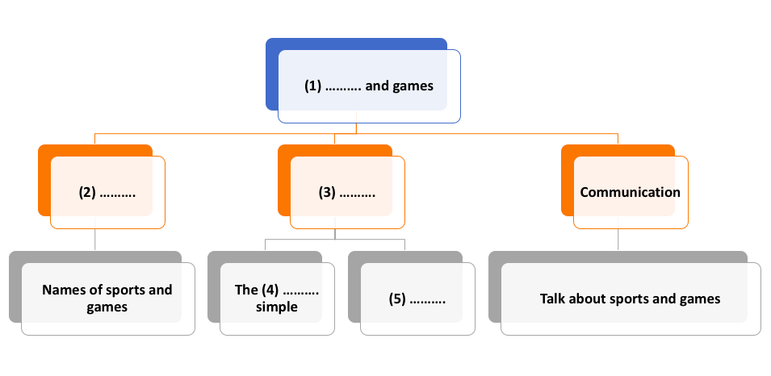  Answer key:  1. Sports  2. Vocabulary  3. Grammar  4. past  5. Imperatives
e. Assessment
- Teacher corrects for students (if needed)

2. ACTIVITY 1: LOOKING BACK (16 mins)
a. Objectives:
- To help Ss revise the vocabulary items they have learnt in the unit.
- To help Ss revise the use of the past simple tense and the use of imperatives in different situations.
b. Content:
- Task 1: Find one odd word / phrase in each question.
- Task 2: Put the correct form of the verbs play, do or go in the blanks.
- Task 3: Put the verbs in brackets in the correct form.
- Task 4: What do you say in these situations?
- Task 5: Fill each blank with ONE word to complete the passage.
c. Expected outcomes:
- Recall the vocabulary and grammar points that have been learned in the Unit.
d. Organisation
TEACHER’S ACTIVITIES | STUDENTS’ ACTIVITIES | CONTENTS
Task 1: Find one odd word / phrase in each question.
- Ss do this task individually.  - Call on some Ss to read the answers aloud.  - Confirm the correct answers as a class. Have the whole class read the words / phrases correctly. | - Students do the task individually.  - Some students read aloud their answers.  - Students correct their answers if needed. | Answer key:  1. C  2. A  3. C  4. B  5. B
Task 2: Put the correct form of the verbs play, do or go in the blanks.
- Tell Ss that in English sports and games may go after one of three verbs: play, do and go. Ss have to  remember these combinations.  - Allow Ss time to do the task individually.  - Call on some Ss to write the answers on the board. Then have the class comment, and give them the  correct answers.  - T may call on some Ss to read the sentences. | - Students do the task individually.  - Exchange the answers with a partner to check.  - Some students write their answers on the board.  - Students correct their answers if needed. | Answer key:  1. do  2. is playing  3. goes  4. went  5. played  6. are doing
Task 3: Put the verbs in brackets in the correct form.
- Have Ss work in pairs and put the verbs in brackets in the correct form of the past simple.  - Tell Ss to pay attention to the point of time given in the sentences.  - Check their answers as a class. | - Students do the task in pairs.  - Students correct their answers if needed. | Answer key:  1. took  2. started  3. didn’t like  4. did you do; cycled; watched
Task 4: What do you say in these situations?
- Give Ss some time to work by themselves. Ask them to revise how to use imperatives (positive and  negative) in these situations.  - Call on some Ss to read their sentences.  - Have other Ss give comments. T confirms the correct sentences. | - Students do the task individually.  - Some students read aloud their answers.  - Students correct their answers if needed. | Answer key:  1. Please stop making noise.  2. Go out to play with your friends.  3. Don’t feed the animals.  4. Stand in line, boys!  5. Don’t touch the dog.
Task 5: Fill each blank with ONE word to complete the passage.
- Ask Ss to do the task individually first. Then they can check their answers with a partner before  discussing as a class. T gives corrections.  - Have some Ss read the whole passage aloud (maybe sentence by sentence). The rest of the class should track the text with their fingers as the other Ss read. | - Students do the task individually.  - Exchange the answers with a partner to check.  - Some students read aloud their answers.  - Students correct their answers if needed. | Answer key:  1. play  2. hear  3. favourite  4. sports  5. famous
e. Assessment
- Teacher corrects students’ answers as a whole class.

3. ACTIVITY 3: PROJECT (17 mins)
a. Objectives:
- To introduce to Ss the traditional team game Blind man’s buff.
- To improve their speaking and presentation skills
b. Content:
- Present the chosen game to the class.
c. Expected outcomes:
- Students can talk about a traditional game.
d. Organisation
TEACHER’S ACTIVITIES | STUDENTS’ ACTIVITIES | CONTENTS
- Have students sit in groups as divided in Lesson 1.  - Teachers allow students some time to prepare their presentation.  - Give feedback to students’ presentations. | - Students prepare the presentation and talk about a traditional game. | Student’s presentations.
e. Assessment
- Teacher gives corrections and feedback.

4. CONSOLIDATION (4 mins)
a. Wrap-up
- Summarise the main points of the lesson.
b. Homework
- Prepare for the next lesson.
Board Plan

Date of teaching
Unit 8: Sports and games
Lesson 7: Looking back and Project
*Warm-up
Mind map

*Looking back
﻿﻿Task 1: Find one odd word/ phrase.
Task 2: Put the correct form of the verbs.
Task 3: Put the correct form of the verbs.
Task 4: What do you say in these situations?
Task 5: Fill each blank.
*Project

* Homework

