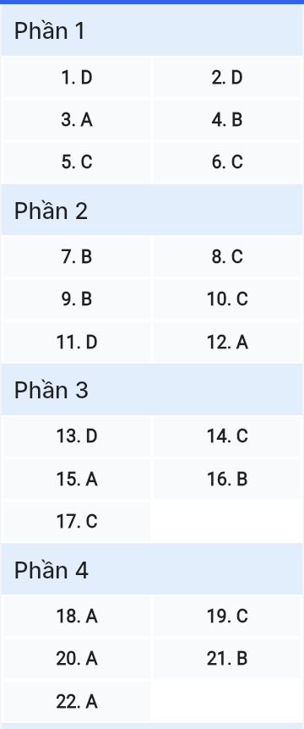
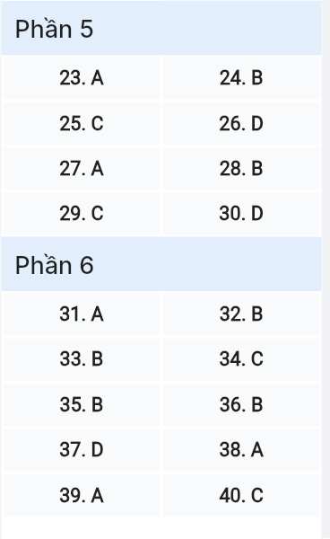
ĐỀ MINH HỌA SỐ 14
KỲ THI TỐT NGHIỆP TRUNG HỌC PHỔ THÔNG NĂM 2025
(Đề thi có 08 trang)
Môn thi: TIẾNG ANH
Thời gian làm bài: 50 phút, không kể thời gian phát đề
Read the following advertisement and mark the letter A, B, C or D on your answer sheet to indicate the option that best fits each of the numbered blanks from 1 to 6.
Discover the Exciting World of Adventure Travel!
Are you ready to explore breathtaking landscapes and experience (1) ____ activities? Our (2) ____ are crafted to give you an unforgettable journey around the world.
Discover spectacular landscapes and indulge in world-class cuisine while connecting (3) ____ diverse cultures. Whether you're interested in hiking the majestic mountains, diving into crystal-clear waters, or simply relaxing on stunning beaches, we have something for everyone. Our goal is to help you (4) ____ full advantage of every moment during your trip.
Our tours, (5) ____ to provide memorable experiences, will leave you with memories that last a lifetime! Book your adventure today and get ready (6) ____ your dreams come true!
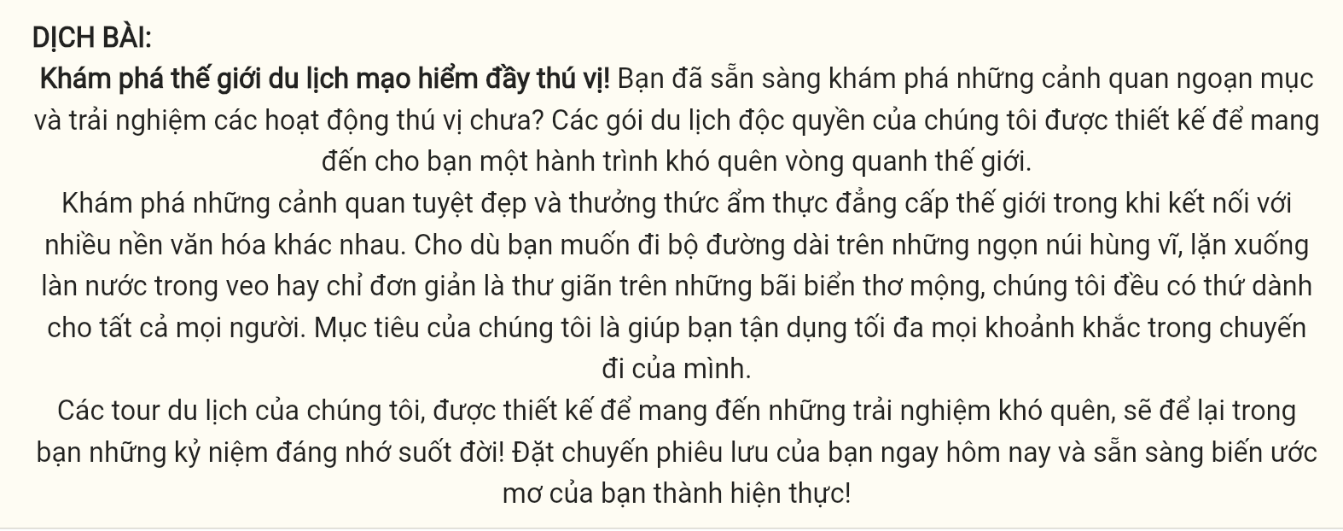
Questions 1 [697736]: A. thrilled B. thrills C. thrillingly D. thrilling
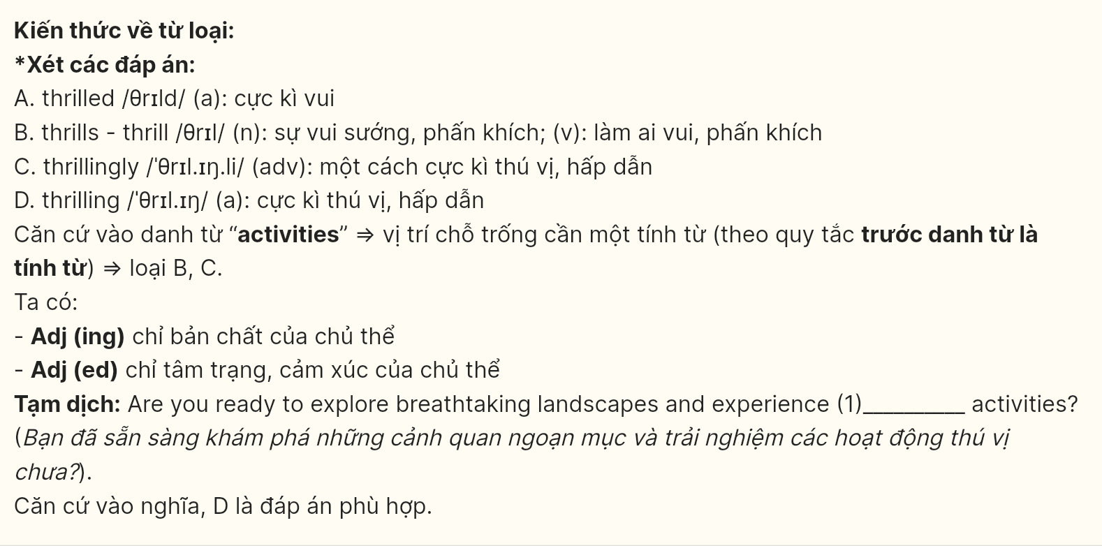
Question 2 [697737]: A. exclusive packages travel B. travel packages exclusive
C. travel exclusive packages D. exclusive travel packages
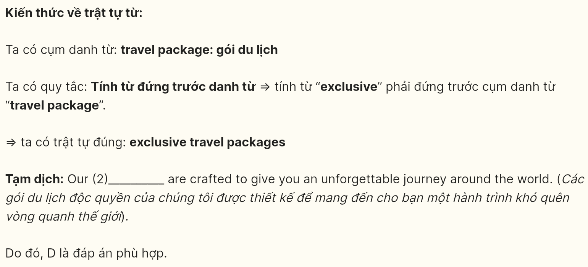
Question 3 [697738]: A. with B. from C. for D. of
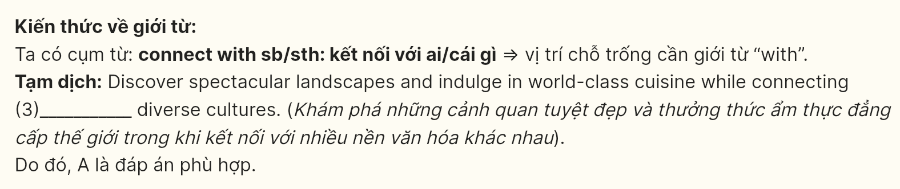
Question 4 [697739]: A. make B. take C. do D. book
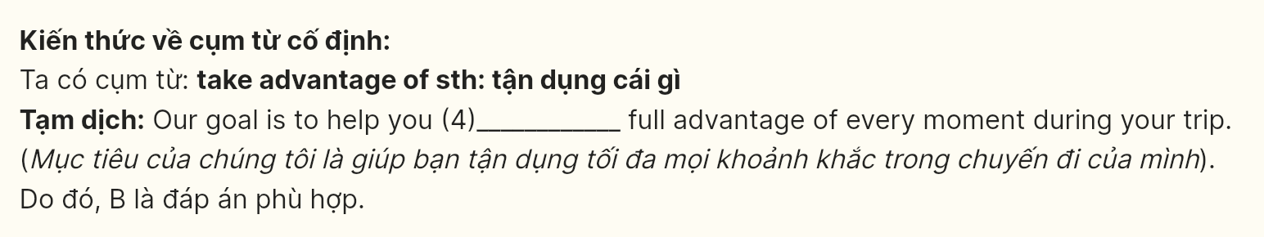
Question 5 [697740]: A. which designs B. to design C. designed D. designing

Question 6 [697741]: A. making B. to making C. to make D. make

Read the following leaflet and mark the letter A, B, C or D on your answer sheet to indicate the correct option that best fits each of the numbered blanks from 7 to 12.
KEEP YOUR LUNG HEALTHIER: LIMIT SMOKE CONSUMPTION
Why it matters
Smoking not only affects the smoker but also poses several risks to (7) ____ resulting in a wide range of health complications. Therefore, reducing smoke consumption is vital for improving public health. Smoking can lead to severe long-term health problems, including lung cancer, heart diseases, and chronic respiratory disorders. The (8) ____ of smoking-related illnesses continues to rise globally, placing a heavy burden on healthcare systems and claiming many lives. It is essential to adopt measures to (9) ____ smoking for the sake of both well-being and society at large.
How to cut down on smoke consumption
- Use nicotine replacement therapies (NRTs): Products such as nicotine gum, patches, and inhalers help alleviate cravings while reducing (10) ____ on cigarettes over time.
- Stay physically active: With regular exercise every morning, it becomes easier to (11) ____ smoking.
- Follow guidelines: (12) ____ the strategies above can significantly reduce the likelihood of cravings. Everyone aiming to cut down on smoking should follow expert recommendations to minimize harm and promote a smoke-free lifestyle.
(Adapted from Toutreenews)
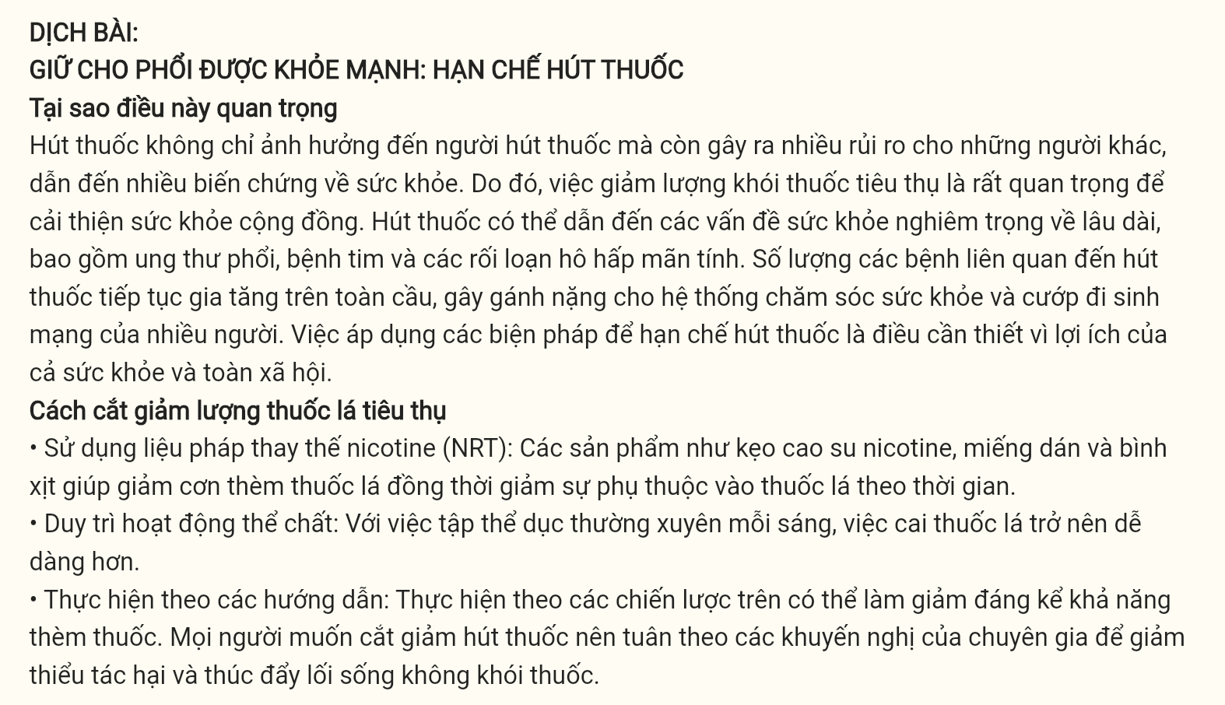
Question 7 [697742]: A. another B. others C. the other D. other
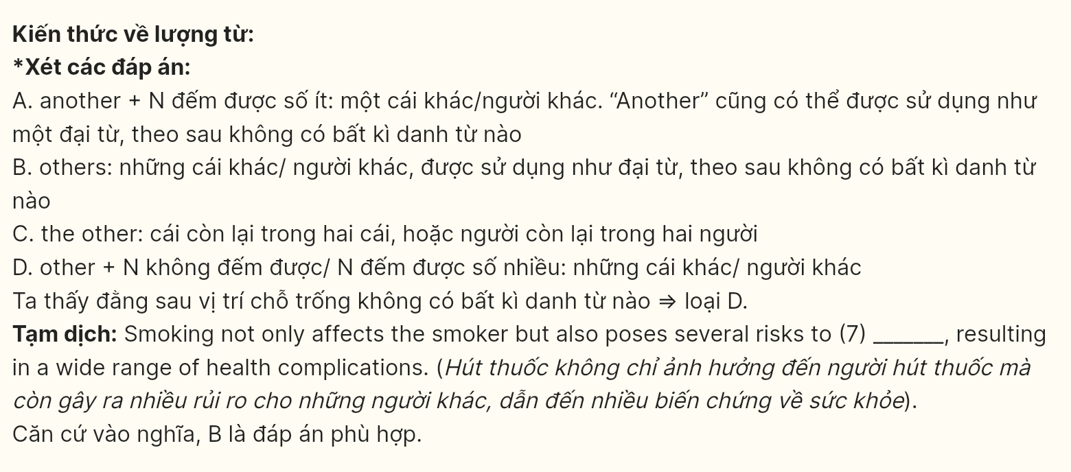
Question 8 [697743]: A. level B. amount C. number D. quality
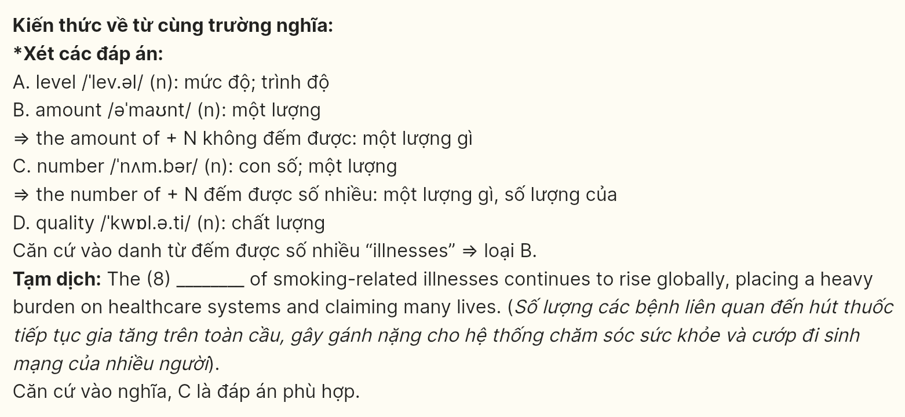
Question 9 [697744]: A. entail B. curb C. overcome D. shrink
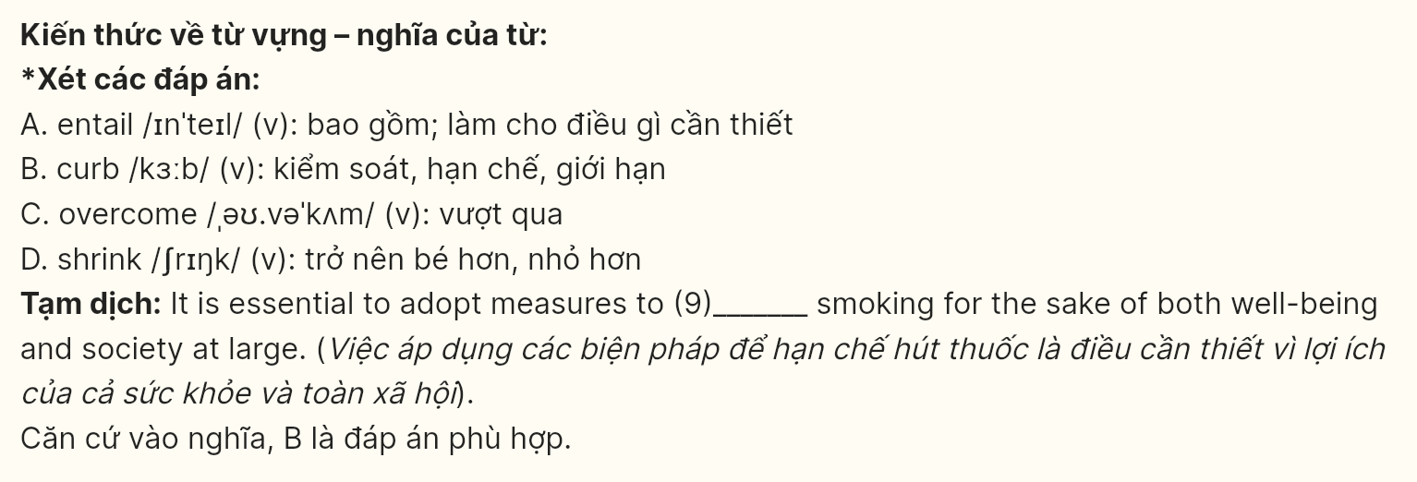
Question 10 [697745]: A. attachment B. compulsion C. dependence D. addiction
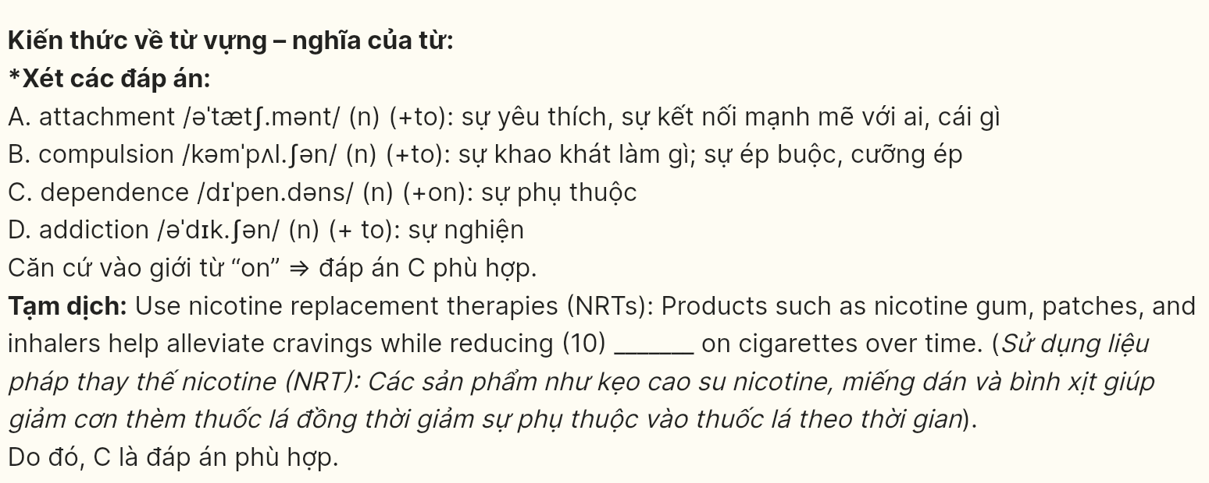
Question 11 [697746]: A. make out B. concur with C. give in D. refrain from
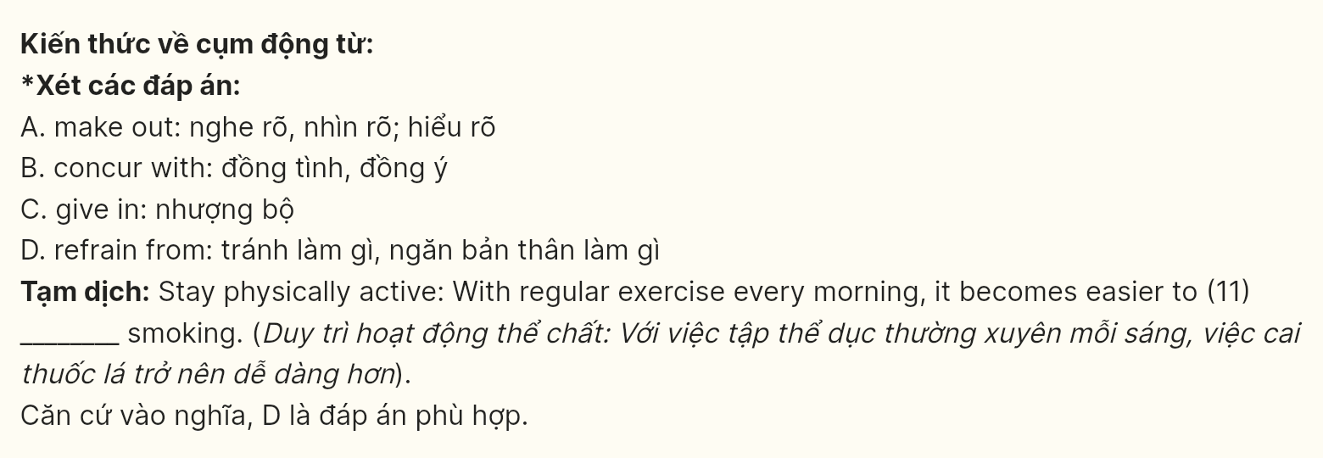
Question 12 [697747]: A. In accordance with B. Regardless of C. In light of D. Rather than
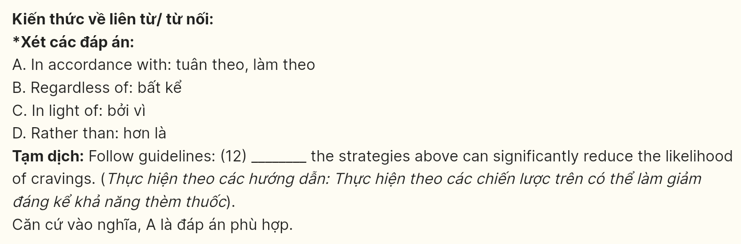
Mark the letter A, B, C or D on your answer sheet to indicate the best arrangement of utterances or sentences to make a meaningful exchange or text in each of the following questions from 13 to 17.
Question 13 [697748]:
A. John: I heard your school is implementing project-based learning. How's that working out?
B. John: That's remarkable. Our school should definitely consider adopting this innovative approach too.
C. Mary: It's fantastic! Students are more engaged and they're developing real-world problem-solving skills.
A. b-a-c B. a-b-c C. c-b-a D. a-c-b
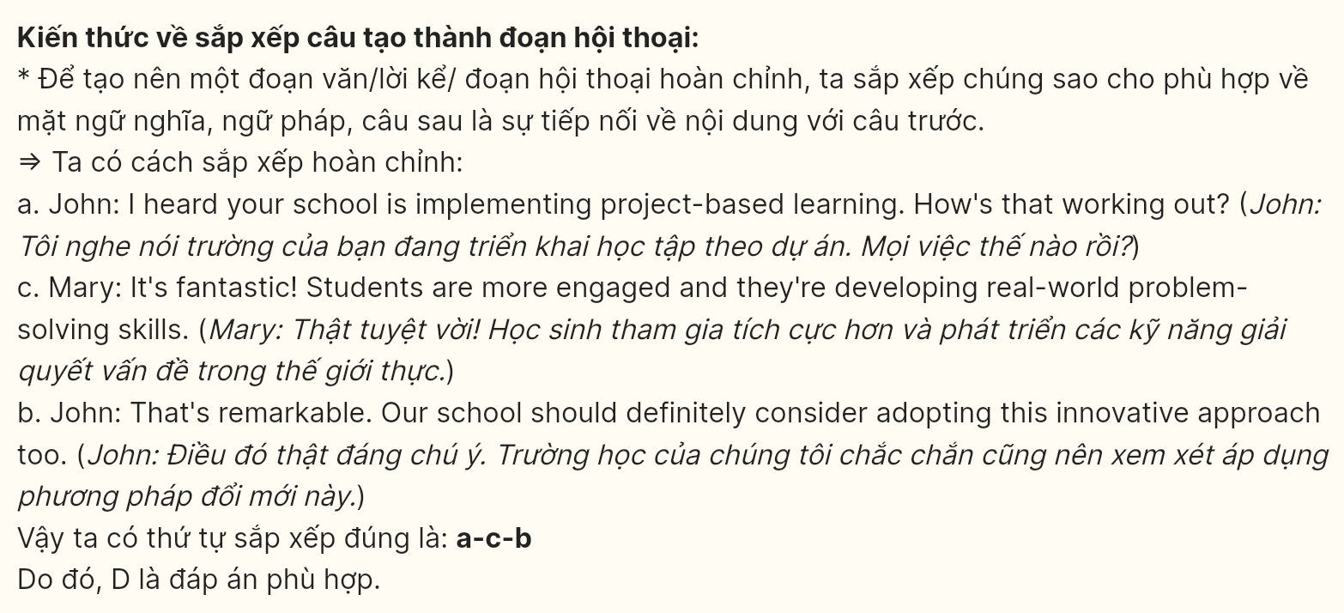
Question 14 [697749]:
A. Emma: Does this affect the diversity of your talent pool?
B. Emma: I noticed many companies are shifting to AI-powered recruitment processes nowadays.
C. Tom: Actually, we've seen improved diversity as AI helps eliminate unconscious biases.
D. Tom: True, we've implemented AI screening, but we still value human interaction in final decisions.
E. Emma: That's fascinating how technology is making hiring both efficient and more inclusive.
A. B-a-c-d-e B. b-c-a-e-d C. b-d-a-c-e D. b-d-c-a-e
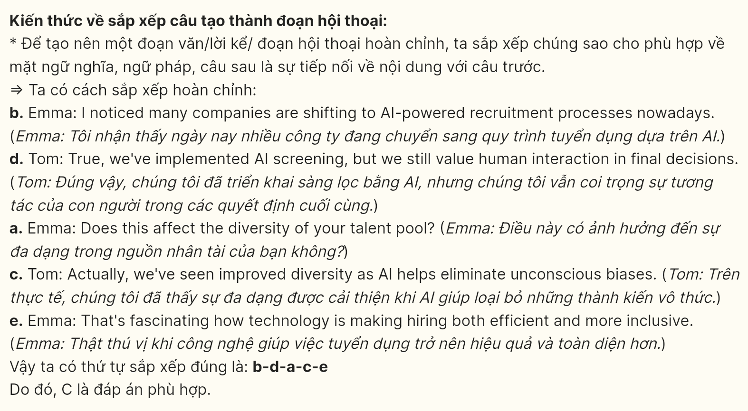
Question 15 [697750]:
Dear Amy,
a. The way you described their sustainable practices and communal values was eye-opening.
b. Your recent presentation about your year living with indigenous communities really moved me.
c. I particularly appreciated how you connected their traditions to modern environmental challenges.
d. Your experience has inspired me to learn more about indigenous wisdom and cultural preservation.
e. Perhaps we could collaborate on a cultural awareness workshop for our community.
Warm regards, Jack
A. b-a-c-d-e B. B-c-a-d-e C. B-a-c-e-d D. b-d-a-c-e
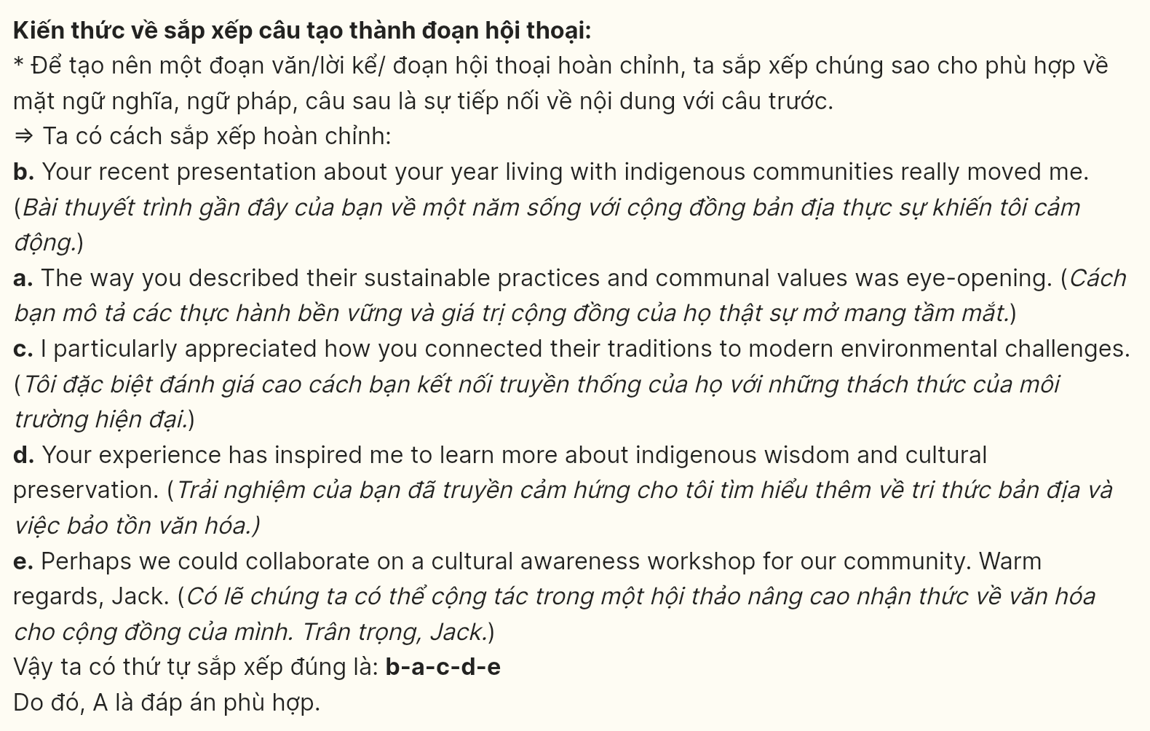
Question 16 [697751]:
a. Traditional media professionals argue that human insight and emotional depth cannot be replicated.
b. The rise of artificial intelligence in digital content creation has sparked intense debate in media circles.
c. While AI can generate articles and videos quickly, questions about authenticity and creativity emerge.
d. This hybrid approach might define the future landscape of digital media production.
e. Yet, some platforms have successfully integrated AI tools with human oversight.
A. b-a-e-d-c B. b-c-a-e-d C. b-a-c-d-e D. b-d-c-e-a
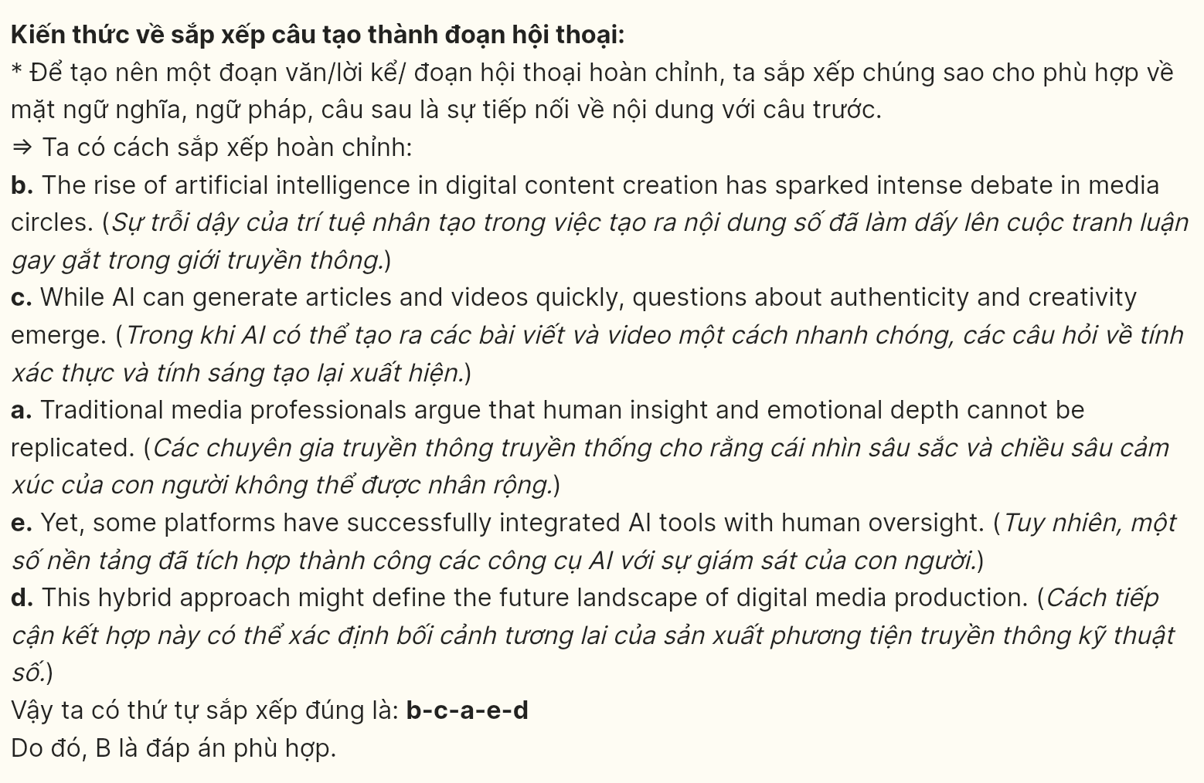
Question 17 [697864]:
a. Through skilled volunteering, companies can create a sustainable impact while developing their workforce.
b. These initiatives now focus on leveraging employees' professional skills to support nonprofit organizations.
c. Corporate volunteer programs have evolved from simple charity events to strategic community partnerships.
d. This transformation represents a new era in corporate social responsibility and community engagement.
e. Data shows that such programs improve employee satisfaction and community relations simultaneously.
A. b-a-c-d-e B. c-b-a-d-e C. c-b-a-e-d D. b-d-c-e-a
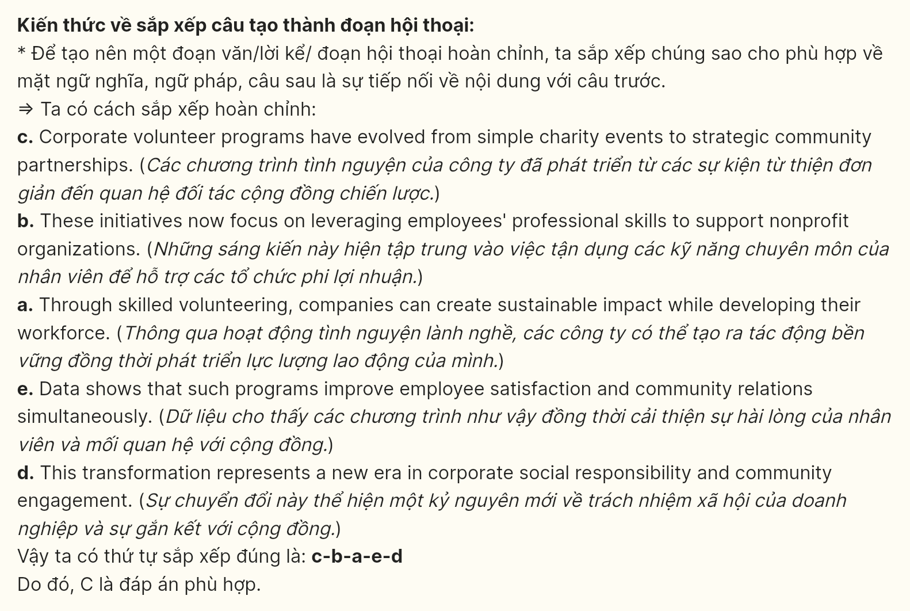
Read the following passage and mark the letter A, B, C or D on your answer sheet to indicate the option that best fits each of the numbered blanks from 18 to 22.
Urbanization, among one of the most alarming issues worldwide, (18) ____. This shift is not merely a change of scenery; it reflects a profound shift in lifestyles, opportunities, and challenges. As more people flock to urban centers in search of better employment prospects and improved living conditions, cities around the world are experiencing rapid growth.
While urbanization can bring numerous benefits, such as economic development and cultural exchange, it also poses significant challenges that need to be addressed. One of the most pressing issues is the strain on infrastructure. (19) ____. As cities expand, the demand for housing, transportation, and public services frequently exceeds supply, leading to overcrowded living conditions and increased traffic congestion. Many major cities, which are grappling with inadequate public transportation systems, force residents to rely on cars, contributing to pollution and exacerbating greenhouse gas emissions.
Moreover, urbanization can exacerbate social inequalities. Low-income families have been pushed into informal settlements or slums, and access to basic services is limited. (20) ____.
To navigate the challenges posed by urbanization, effective urban planning and policy-making are essential. (21) ____. Furthermore, engaging communities in the planning process can foster a sense of ownership and responsibility. Addressing these challenges head-on, (22) ____.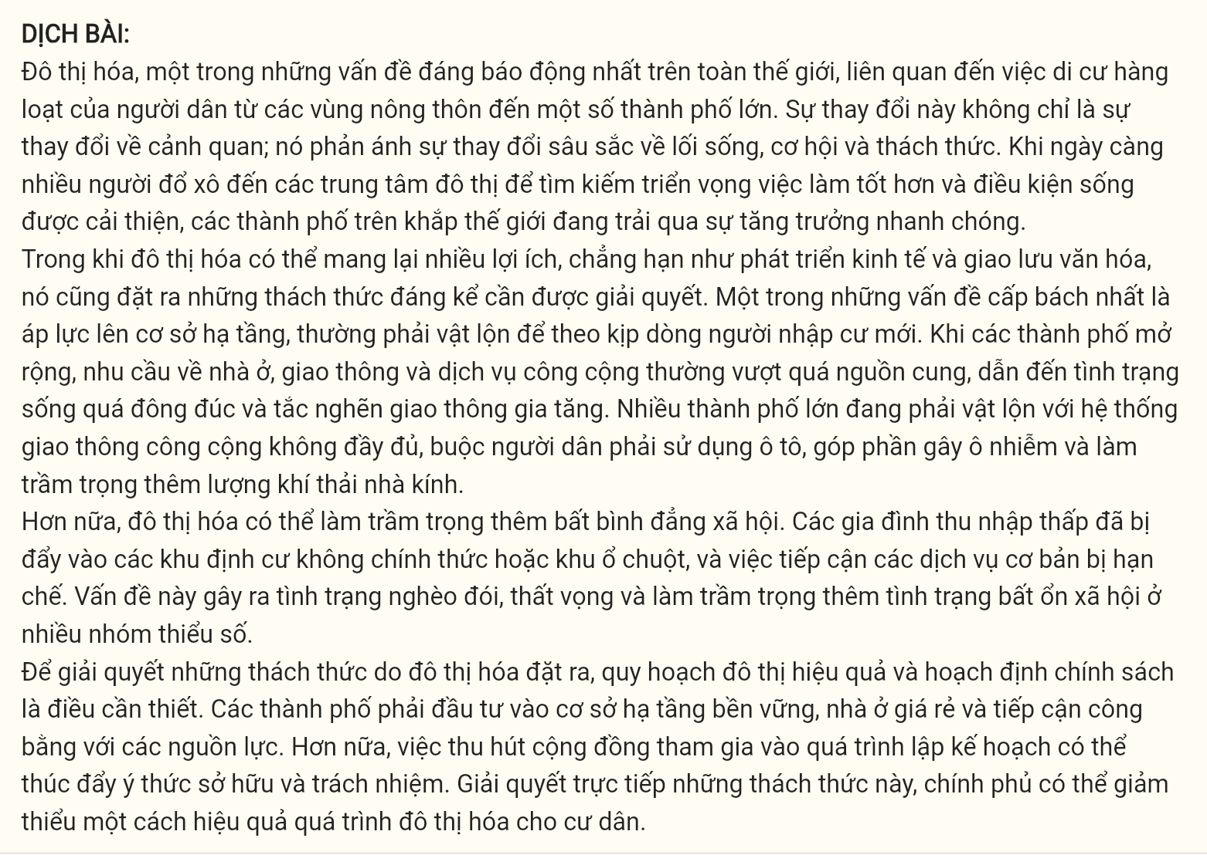
Question 18 [697865]:
A. involves the mass migration of people from rural areas to some big cities
B. involving the fact that people from rural areas rapidly migrate to some big cities
C. that involves some big cities have a great number of people from rural areas migrate to
D. on which a large number of migrants from rural areas move to some big cities
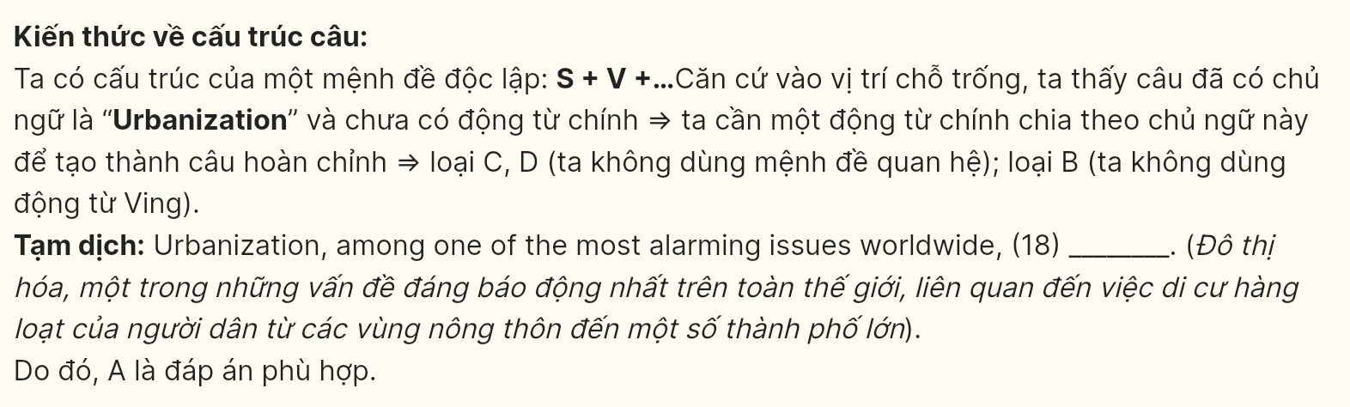
Question 19 [697866]:
A. often managing the influx of residents that is rapidly expanding
B. figure out how to prevent it from the incredibly large population's influx
C. which often struggles to keep pace with the influx of new residents
D. struggling to make the influx of residential scale not beyond control
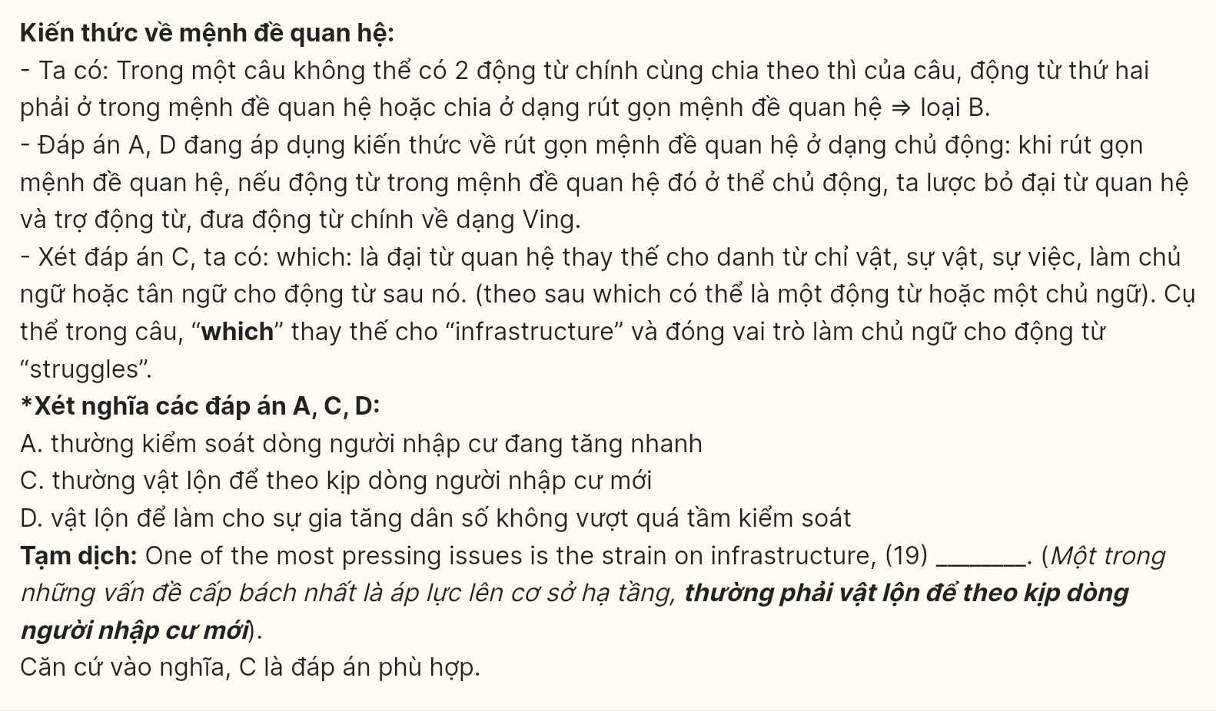
Question 20 [697867]:
A. The issue adversely gives rise to poverty, frustration, and aggravates social unrest in many marginalized groups
B. Creating a cycle of poverty, frustration, and social unrest among marginalized groups, people are negatively affected
C. These factors somehow worsen marginalized groups, leading to disparity in escaping poverty in frustrating society
D. Residents who live in more slums in marginalized groups due to poverty and social frustration
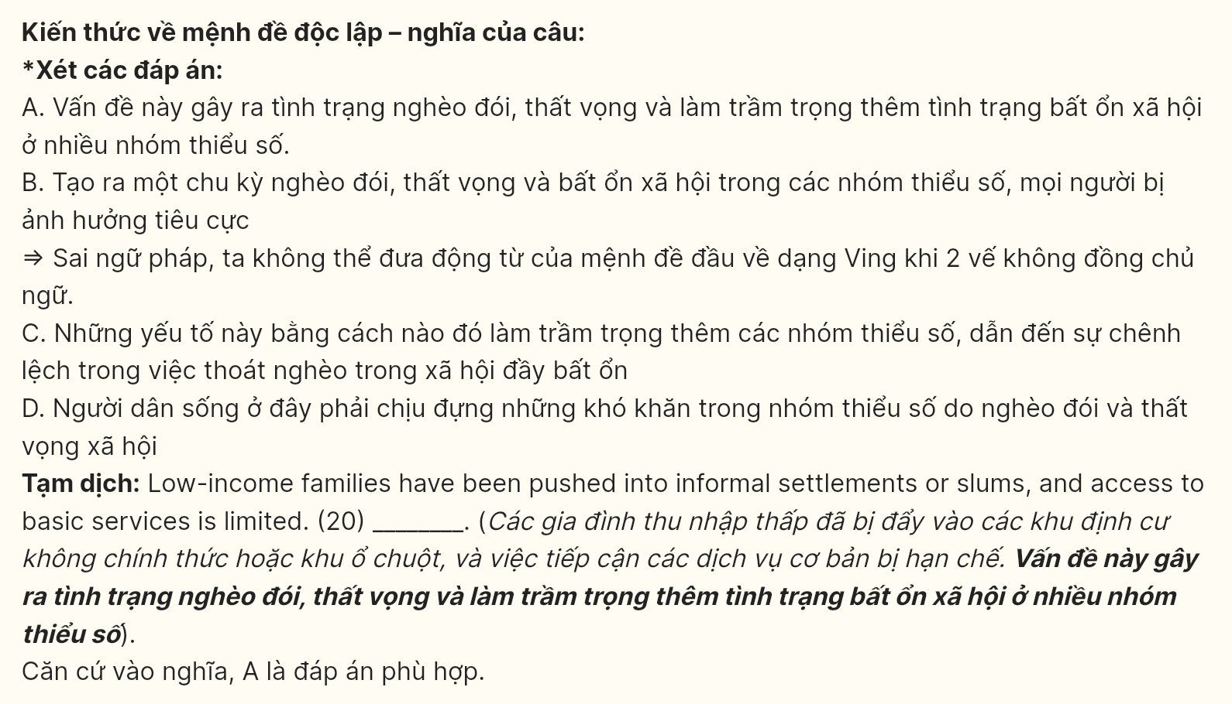
Question 21 [697868]:
A. Sustainable infrastructure and affordable housing can allow cities to have equitable access to resources
B. Cities must prioritize sustainable infrastructure, affordable housing, and equitable access to resources
C. Having equitable access to resources, cities will have sustainable infrastructure and affordable housing
D. Equitable access to resources can help cities invest in sustainable infrastructure and affordable housing
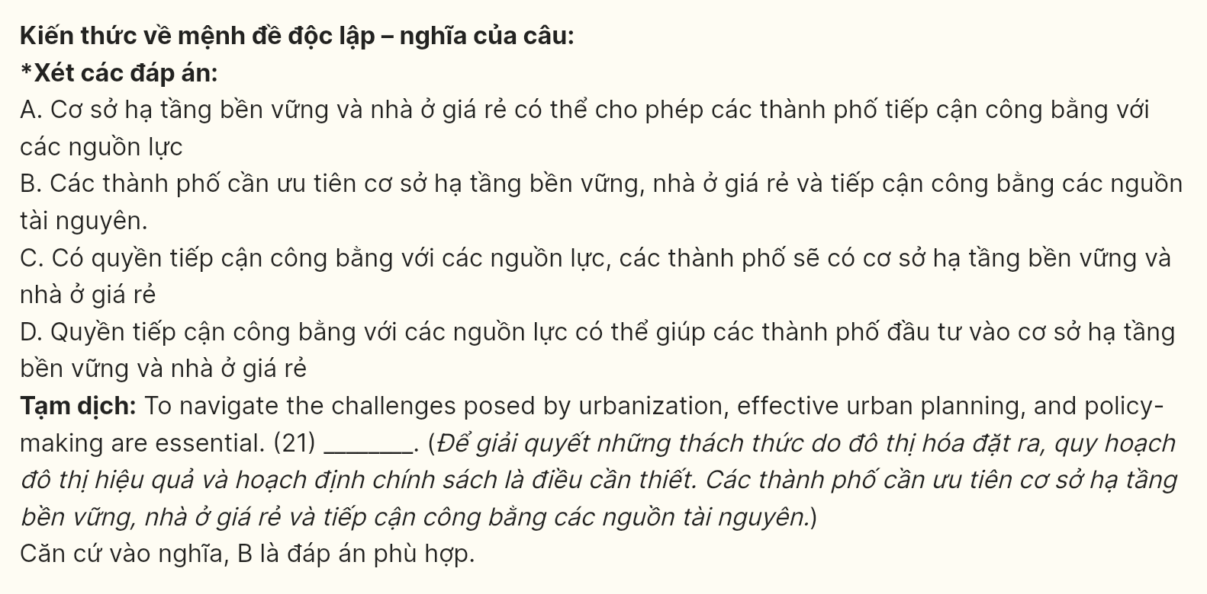
Question 22 [697869]:
A. governments can effectively mitigate the urbanization for their residents
B. urbanization has its mitigation to benefit people living in some big cities
C. residents achieve a major reduction in the scale of urbanization in many cities
D. these methods can prevent cities from expanding urbanization
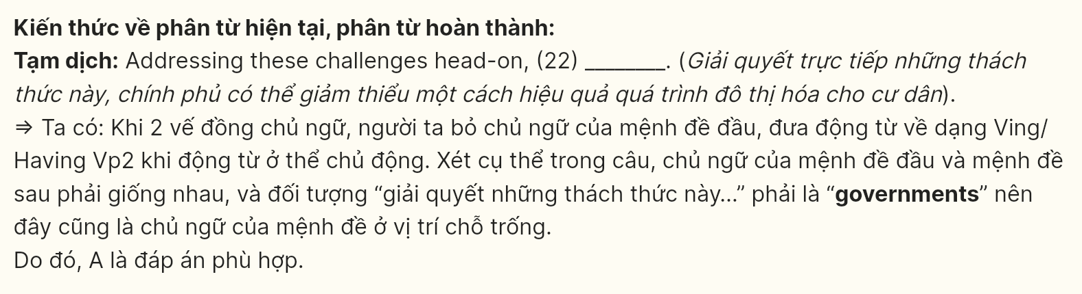
Read the following passage about the Rio Grande and mark the letter A, B, C or D on your answer sheet to indicate the best answer to each of the following questions from 23 to 30.
Although not the longest river in America, the Rio Grande is one of the most important. But, unlike other significant rivers, it is not used for shipping. In fact, oceangoing ships cannot navigate the waters. No, what makes the Rio Grande so important is its location. Since 1846, it has been the official border of Texas and Mexico.
Rio Grande Geography
The Rio Grande is either the fourth or fifth longest river system in North America. It all depends on how it is measured. Because the river twists so much, it occasionally changes course. And these course shifts can cause it to be longer or shorter. At its last official measure, the Rio Grande clocked in at 1,896 miles. The river starts in Colorado and extends downward to the Gulf of Mexico. Downward is the best way of describing it too. Not only does the river extend south, but it also starts in the mountains and gets lower and lower in elevation as it extends to the Gulf.
Its name is Spanish for the “Big River”, but the Rio Grande is actually known as Rio Bravo in Mexico. “Bravo” translates as “furious”, so the name makes sense. Because of its twists and turns, it certainly does seem to be angrier than most rivers!
Rio Grande Today
The Rio Grande today is mostly used as a source of drinking water. Sadly, much of the water has been drained from the river. Parts of the river are almost dry! This is because people use more water from the river than the river can get back from rain and other sources. Experts are working to correct this, with hopes of restoring the river to its past strength. Today, the river is important as a source of water for Texans and Mexicans. More important, it is a symbol of cooperation between two nations. Though borders like the Rio Grande separate nations, they are also shared spaces. The Rio Grande is therefore a symbol of friendship and peace between two nations.
(Adapted from ReadTheory)
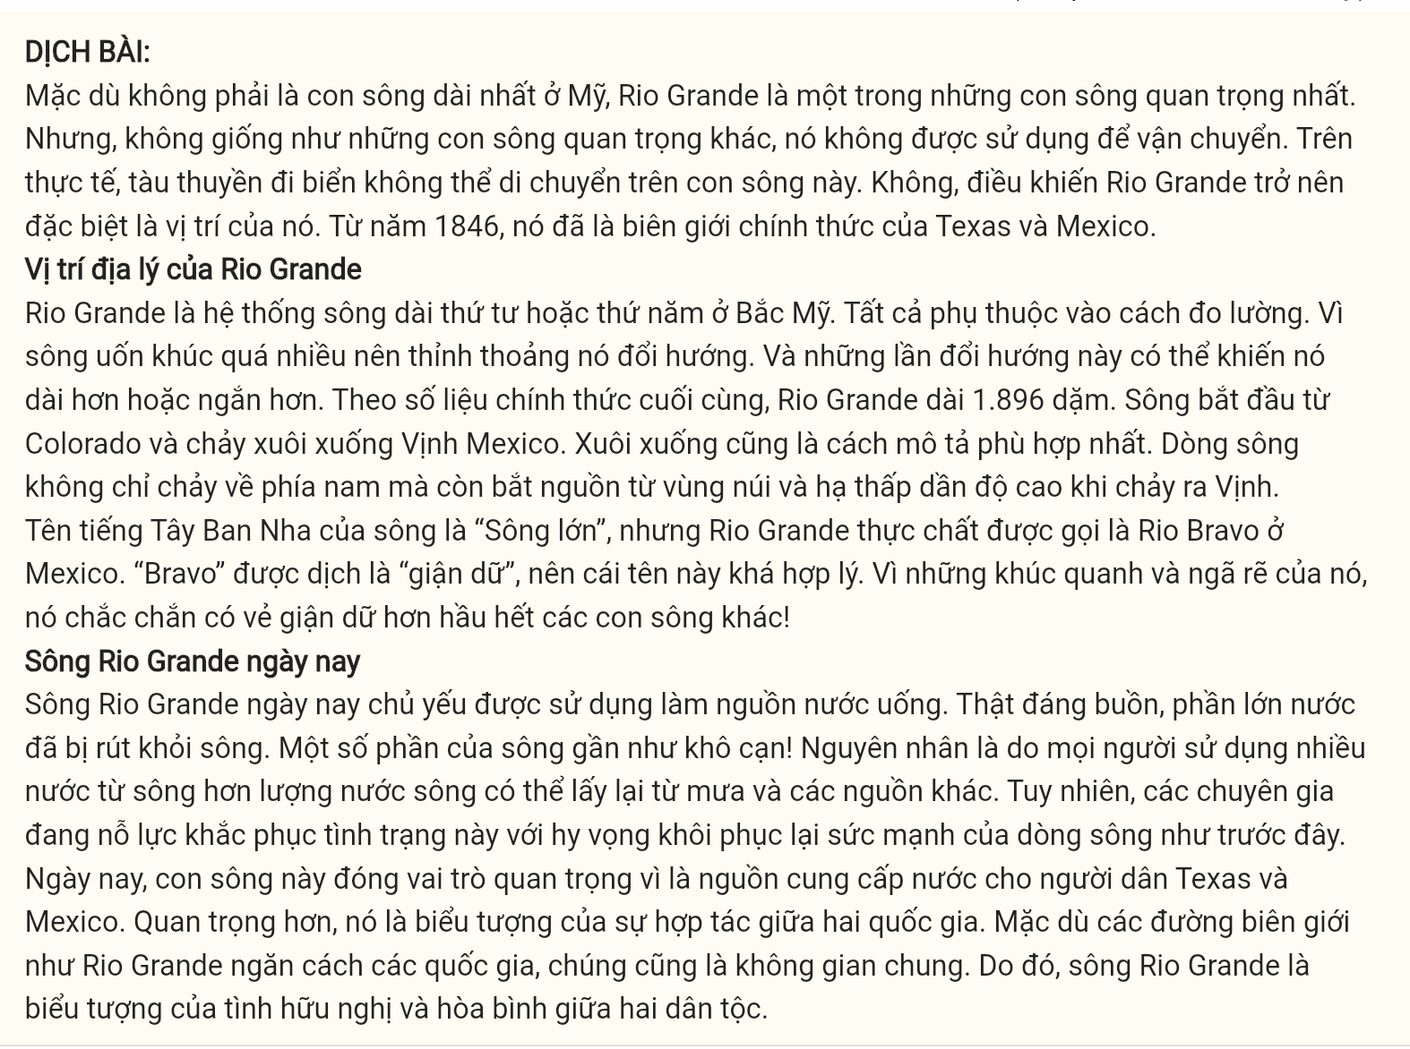
Question 23 [697870]: Which of the following best paraphrases the underlined sentence?
A. The Rio Grande doesn’t cater to shipping activities like other important rivers do.
B. Shipping is available on every river, including the Rio Grande.
C. The Rio Grande is an exception when it comes to shipping commodities.
D. The Rio Grande is not a significant river in shipping.
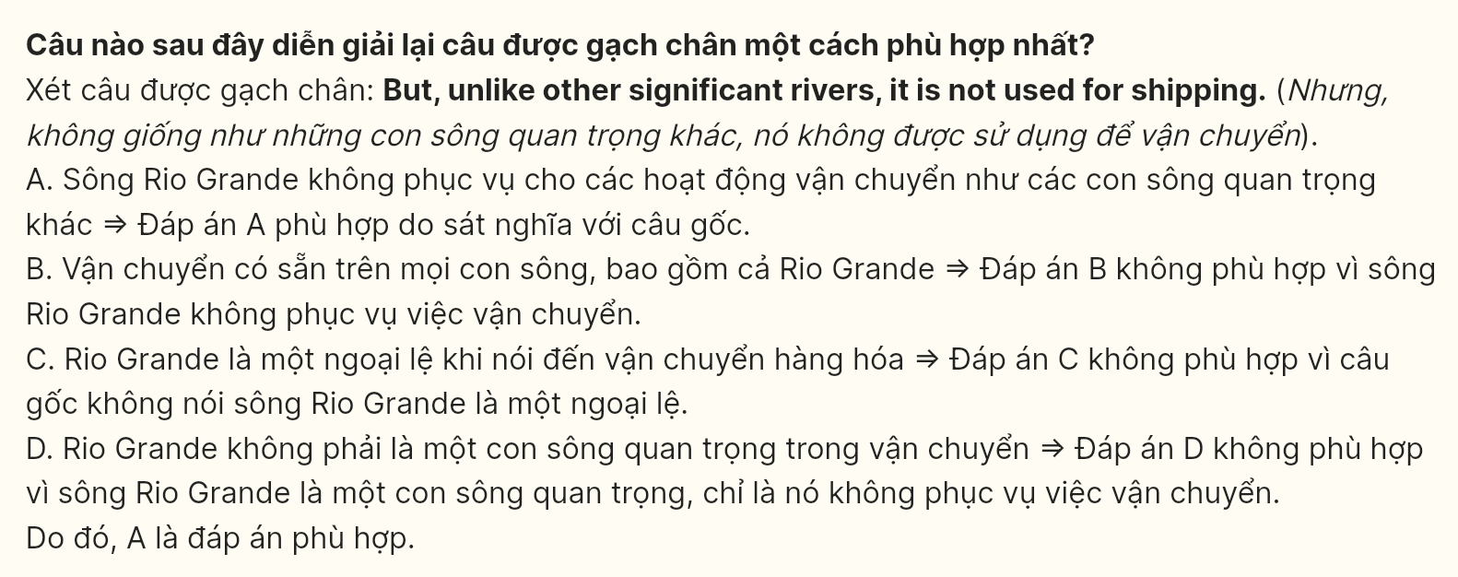
Question 24 [697871]: The word “furious” in the passage can be replaced by _______
A. satisfied B. angry C. strong D. dangerous
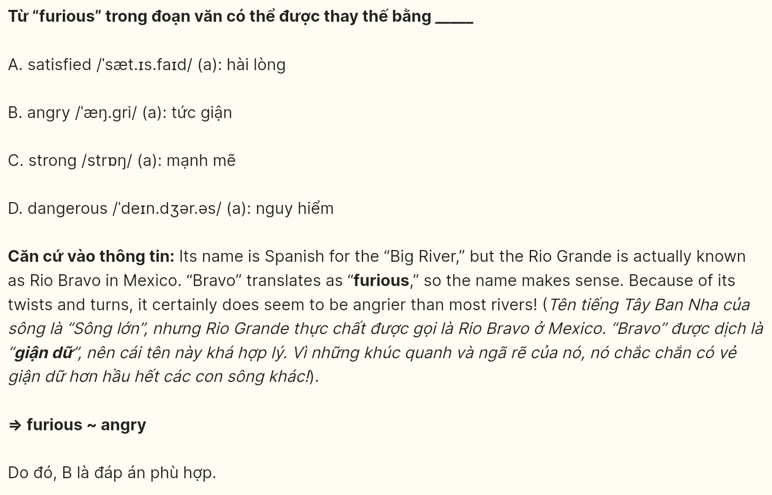
Question 25 [697872]: Which of the following is TRUE according to the passage?
A. The Rio Grande is the longest river between Texas and Mexico.
B. The Rio Grande is primarily used for shipping and transportation.
C. The name “Rio Bravo” was named by Mexicans due to its twists.
D. The Rio Grande has never been used as a source of drinking water.
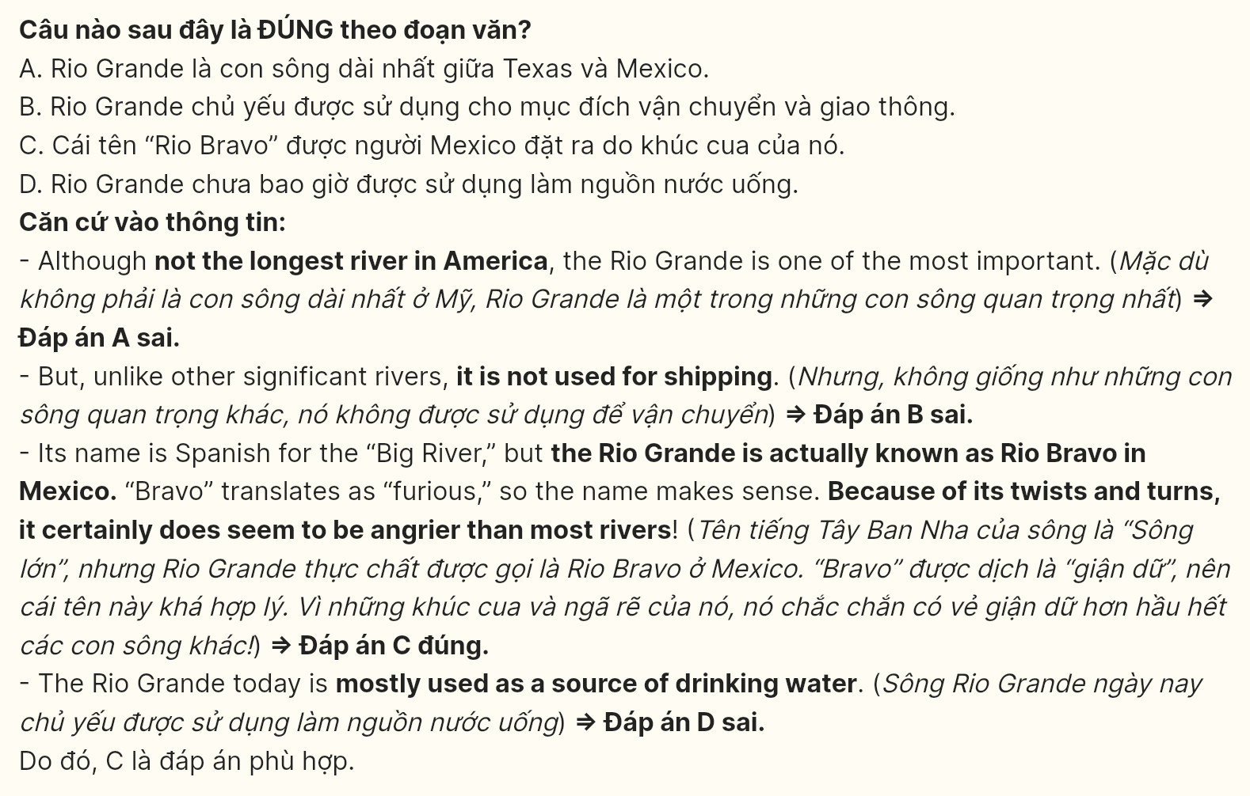
Question 26 [697873]: The word “restoring” in the last paragraph is OPPOSITE in meaning to _______
A. constructing B. assembling C. erecting D. damaging
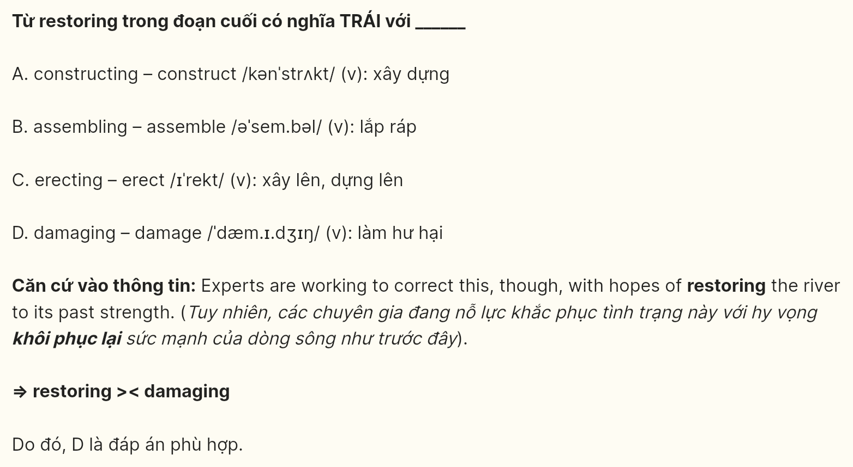
Question 27 [697874]: The word its in the last paragraph refers to _______
A. the river B. rain C. source D. symbol
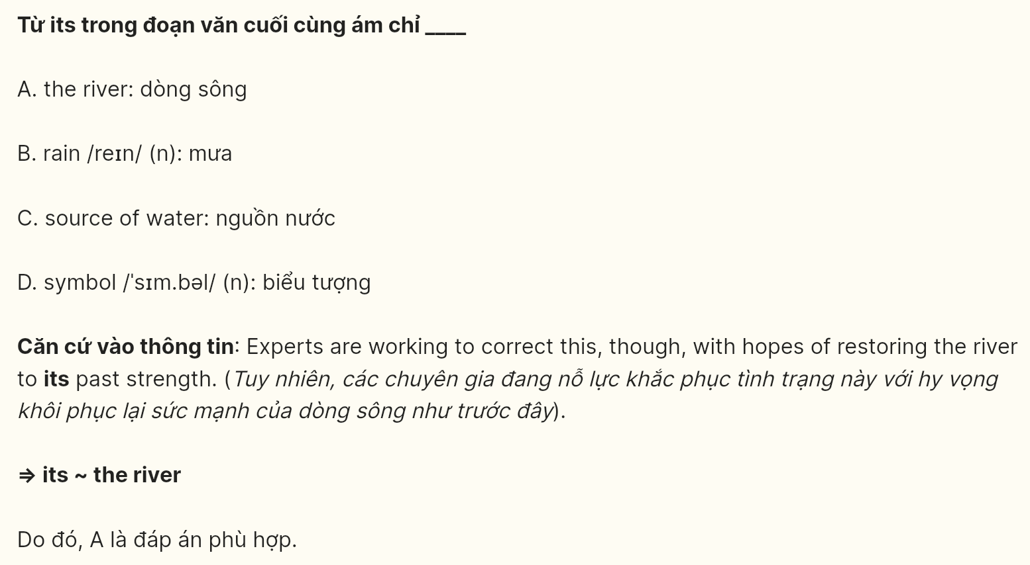
Question 28 [697875]: Which of the following is NOT mentioned as a symbol associated with Rio Grande?
A. friendship B. luxury C. peace D. cooperation
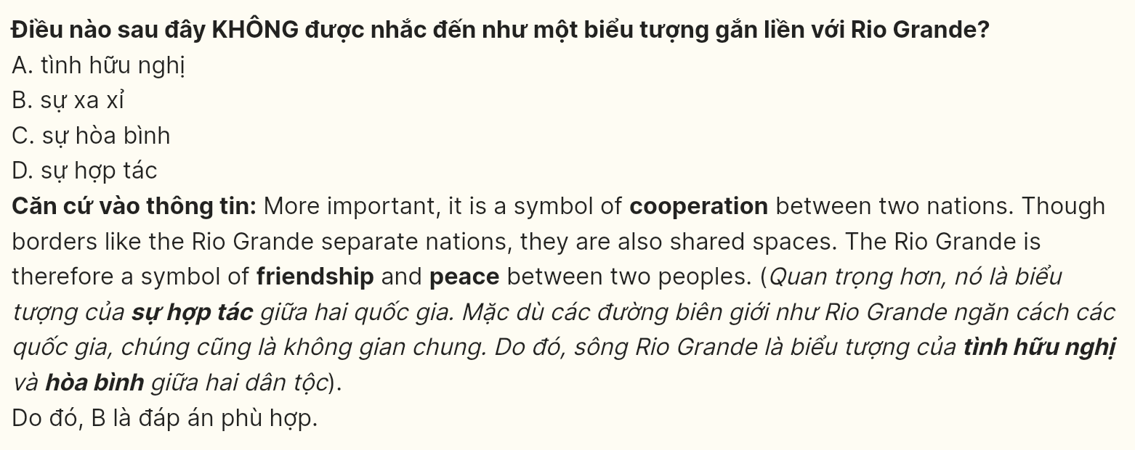
Question 29 [697876]: In which paragraph does the writer explain the meanings of Rio Grande’s names in two different nations?
A. Paragraph 1 B. Paragraph 2 C. Paragraph 3 D. Paragraph 4
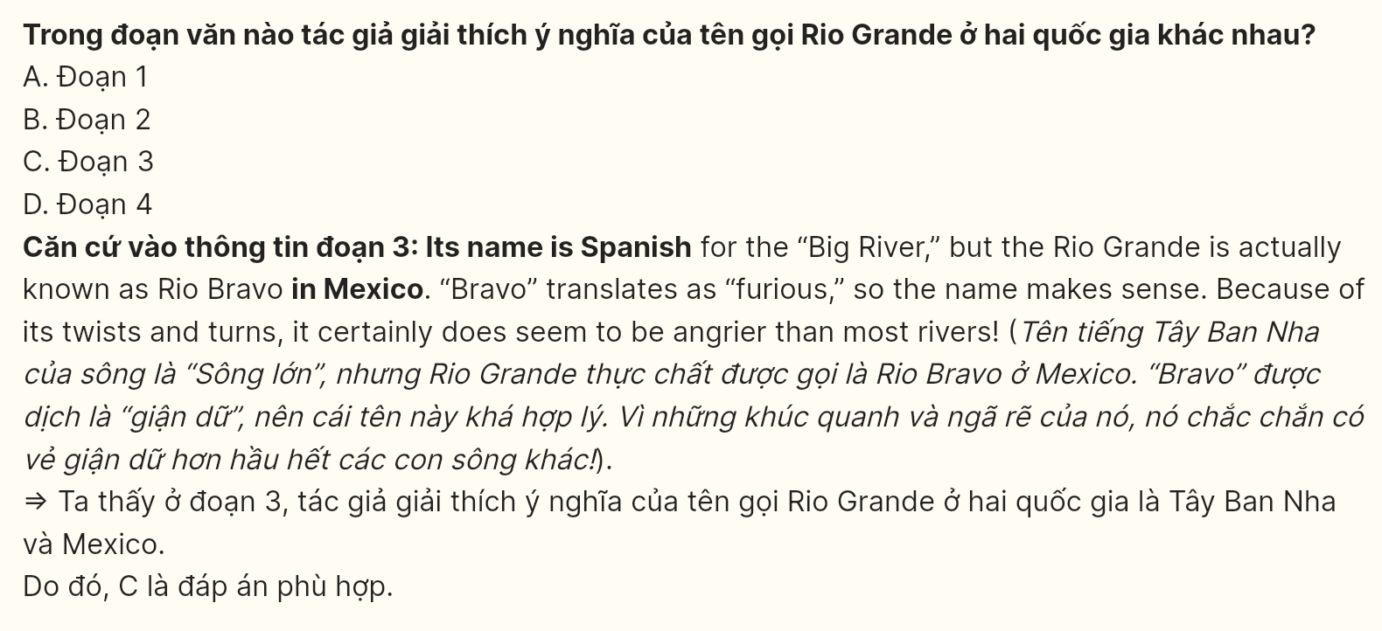
Question 30 [697877]: In which paragraph does the writer mention a problem related to the water level of Rio Grande?
A. Paragraph 1 B. Paragraph 2 C. Paragraph 3 D. Paragraph 4
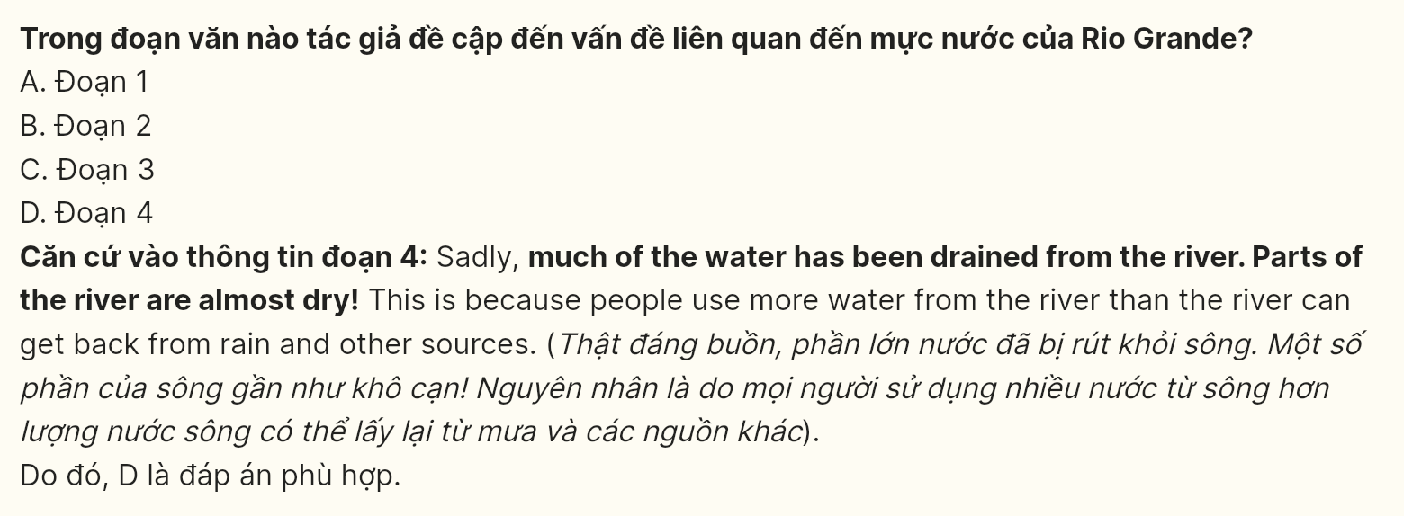
Read the following passage about volunteer tourism and mark the letter A, B, C or D on your answer sheet to indicate the option that best fits each of the numbered blanks from 31 to 40.
The pristine beaches of Koh Rong have long drawn tourists seeking an authentic glimpse of Cambodia’s coastal life. Yet beneath the surface of this seeming paradise, a complex dynamic unfolds. Local businesses, who thrive on traditional tourism, now navigate the rising tide of volunteerism — a phenomenon reshaped by demand for more meaningful experiences.
In the narrow streets of the fishing village, 'volunteer houses' have proliferated at an unprecedented rate. [I] These establishments, charging participants substantial fees for the privilege of teaching English or conducting marine conservation work, generate revenue streams that bypass traditional community structures. [II] Market vendors, whose daily income previously averaged $75, now report earnings below $45 as volunteers, housed in all-inclusive compounds, rarely venture into local establishments. [III] Local restaurants have adapted by offering international menus, though many struggle to attract volunteer residents who receive meals within their compounds. [IV]
The marine conservation sector particularly exemplifies this shifting landscape. Professional dive operators previously employed 45 local guides, paying certification fees exceeding $2,000 per person. Currently, they maintain only 15 positions as volunteer programs offer free diving services. These programs contribute valuable reef monitoring data, collecting over 1,000 marine species records annually. Local dive masters, having invested years in certification and training, find their expertise commanding lower wages - dropping from $60 to $35 per dive session in areas with high volunteer presence.
Cultural preservation initiatives face similar patterns. Traditional craft workshops, which once hosted 200 weekly visitors at $25 per session, now average 80 participants despite reducing fees to $15. While volunteer programs record 300 weekly participants in craft activities, their standardized sessions run 30 minutes compared to traditional three-hour workshops. Master craftsmen, whose techniques typically require two years to master, observe volunteers teaching simplified versions learned in two-week orientations.
The education sector presents perhaps the most nuanced picture. Local schools receiving volunteer teachers report improved English test scores, rising 25% on average. However, student performance fluctuates by up to 40% with each teaching transition. Established language centers have reduced staff from twenty to twelve instructors, as enrollment declined by 35% following the introduction of free volunteer-taught classes. "We’re seeing repeated adjustments in teaching methods," notes headmaster Chan, highlighting monthly changes in classroom approaches.
Local authorities aim to turn the tide through regulatory frameworks, requiring volunteer organizations to demonstrate measurable community benefits. Economic data shows $2 million invested in volunteer facilities in 2023, while traditional business revenue dropped 28%. Community surveys indicate 60% of local enterprises have modified their business models, with 45% reporting reduced profitability despite these adaptations. Local leaders fear the shift may cause irrevocable damage to the traditional economy and cultural practices on the island.
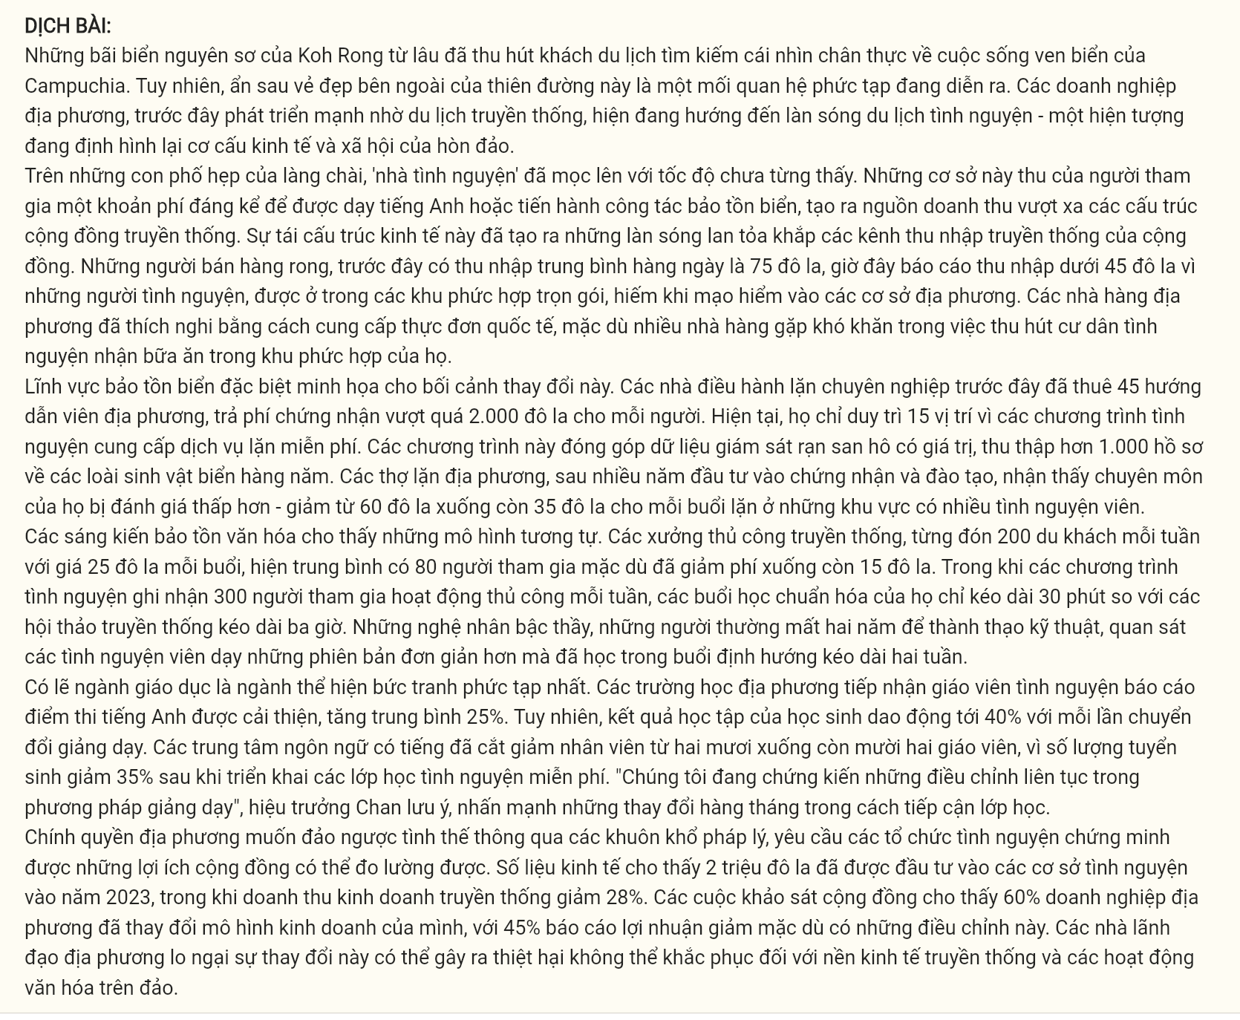
Question 31 [697878]: Which of the following best paraphrases the underlined sentence in paragraph 1?
A. Behind the attractive destination lies a complicated dynamic affecting the local communities.
B. Beneath the welcoming atmosphere exists a deepening divide between old and new systems.
C. Within the harmonious environment emerges a shifting pattern of community structures.
D. Beyond the picturesque surroundings develops an intricate web of cultural transitions.
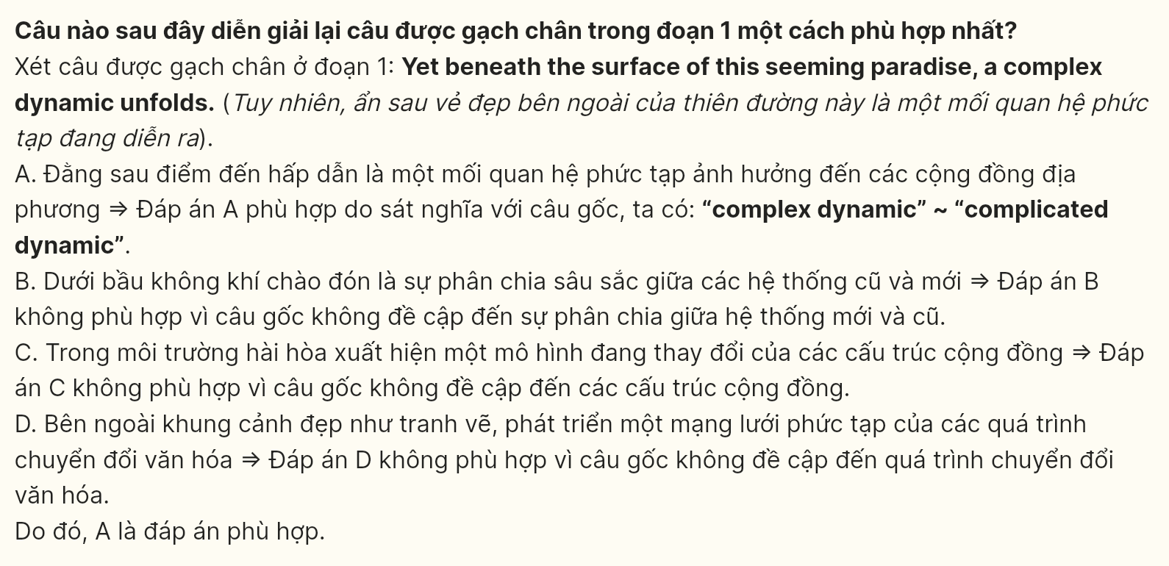
Question 32 [697879]: Where in paragraph 2 does the following sentence best fit?
"This economic restructuring has created ripples through the community’s traditional income channels."
A. [I] B. [II] C. [III] D. [IV]
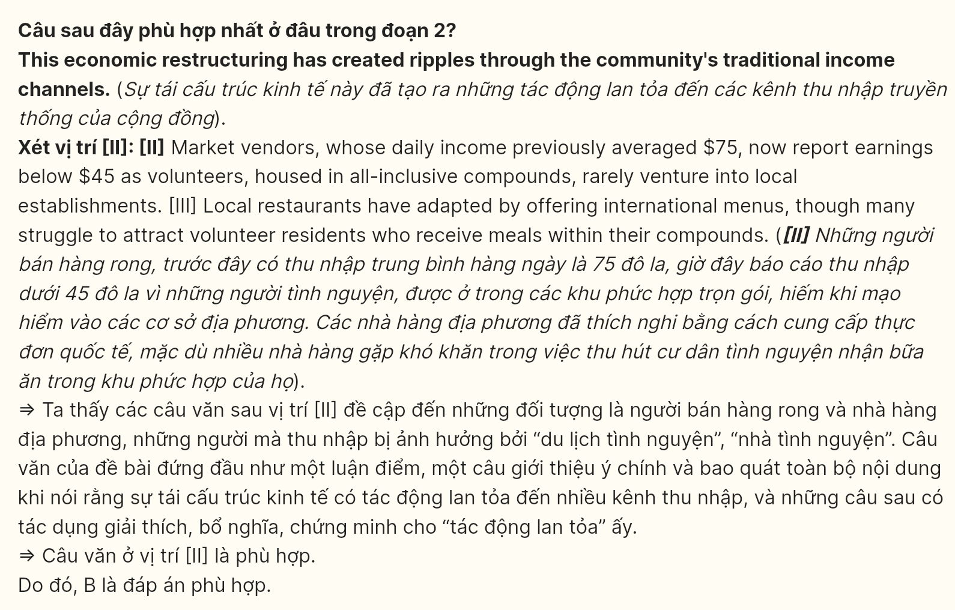
Question 33 [697880]: The word "they" in paragraph 3 refers to ______.
A. programs B. operators C. guides D. positions
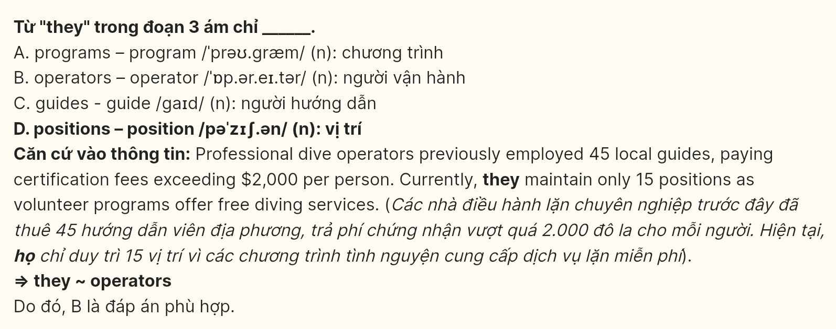
Question 34 [697881]: According to paragraph 3, which of the following is NOT mentioned regarding marine conservation programs?
A. number of marine species recorded
B. changes in guide employment
C. tourist satisfaction levels
D. diving service fees
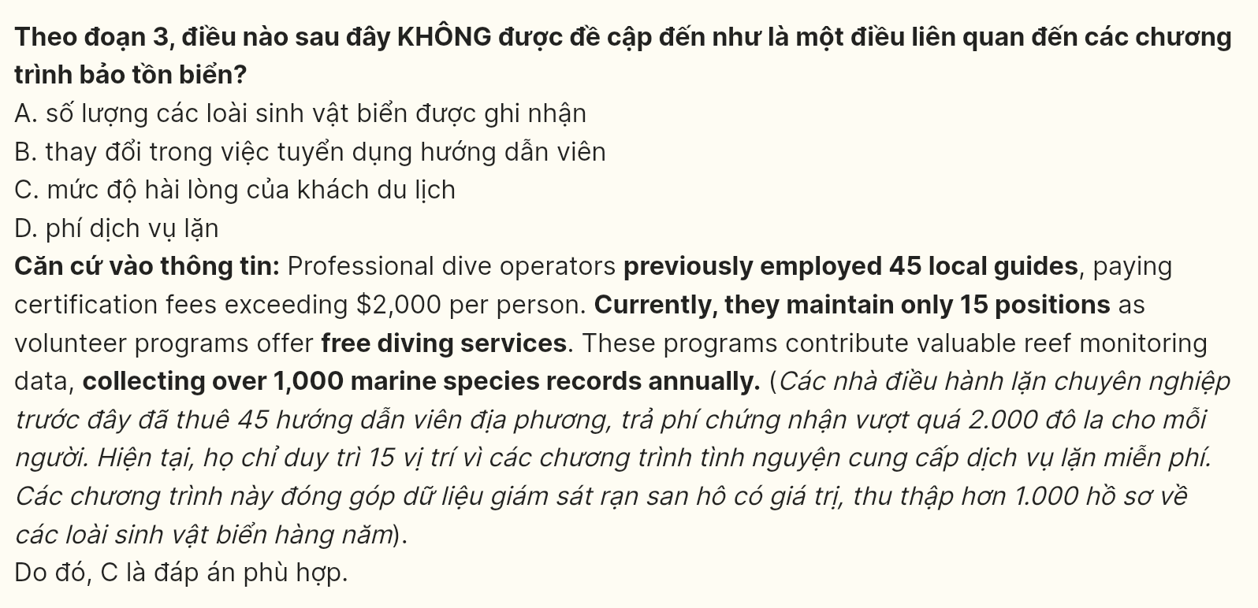
Question 35 [697882]: Which of the following best summarizes paragraph 4?
A. Rising volunteer participation has disrupted traditional teaching models
B. Simplified craft sessions affect both workshop income and skill preservation
C. Workshop formats have evolved to match changing participant demands
D. Cultural preservation balances between volume and teaching quality
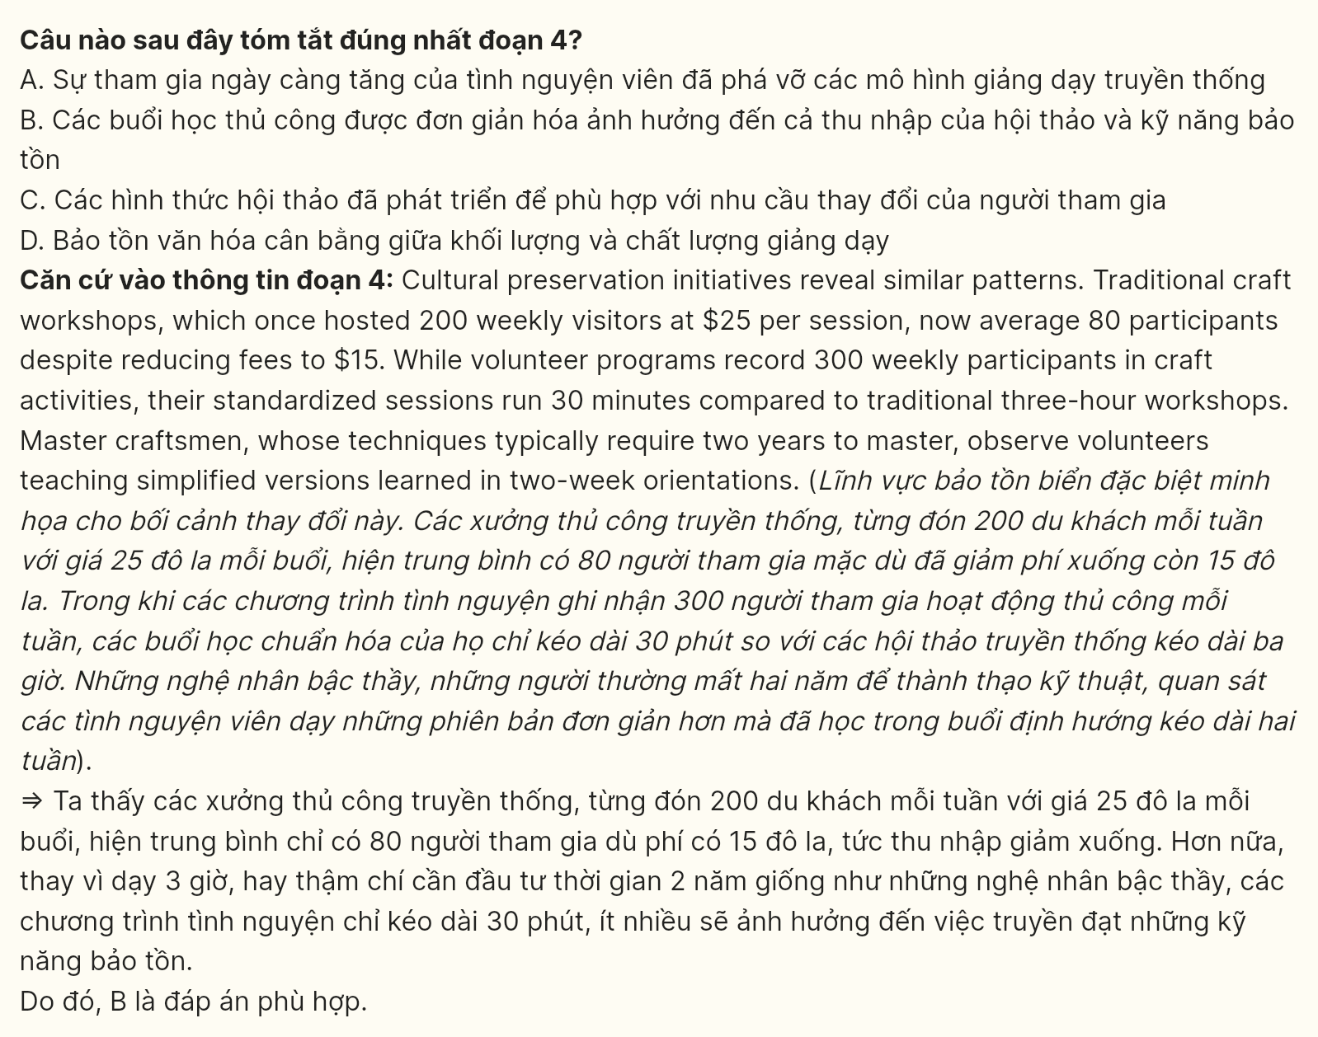
Question 36 [697883]: According to the passage, which of the following is TRUE?
A. Local restaurants maintain traditional menus despite changing tourist preferences
B. Volunteer houses provide comprehensive meals with their accommodation sites
C. Professional dive operators hire exclusively from the surrounding communities
D. Traditional craft workshops preserve their original participation fee structures
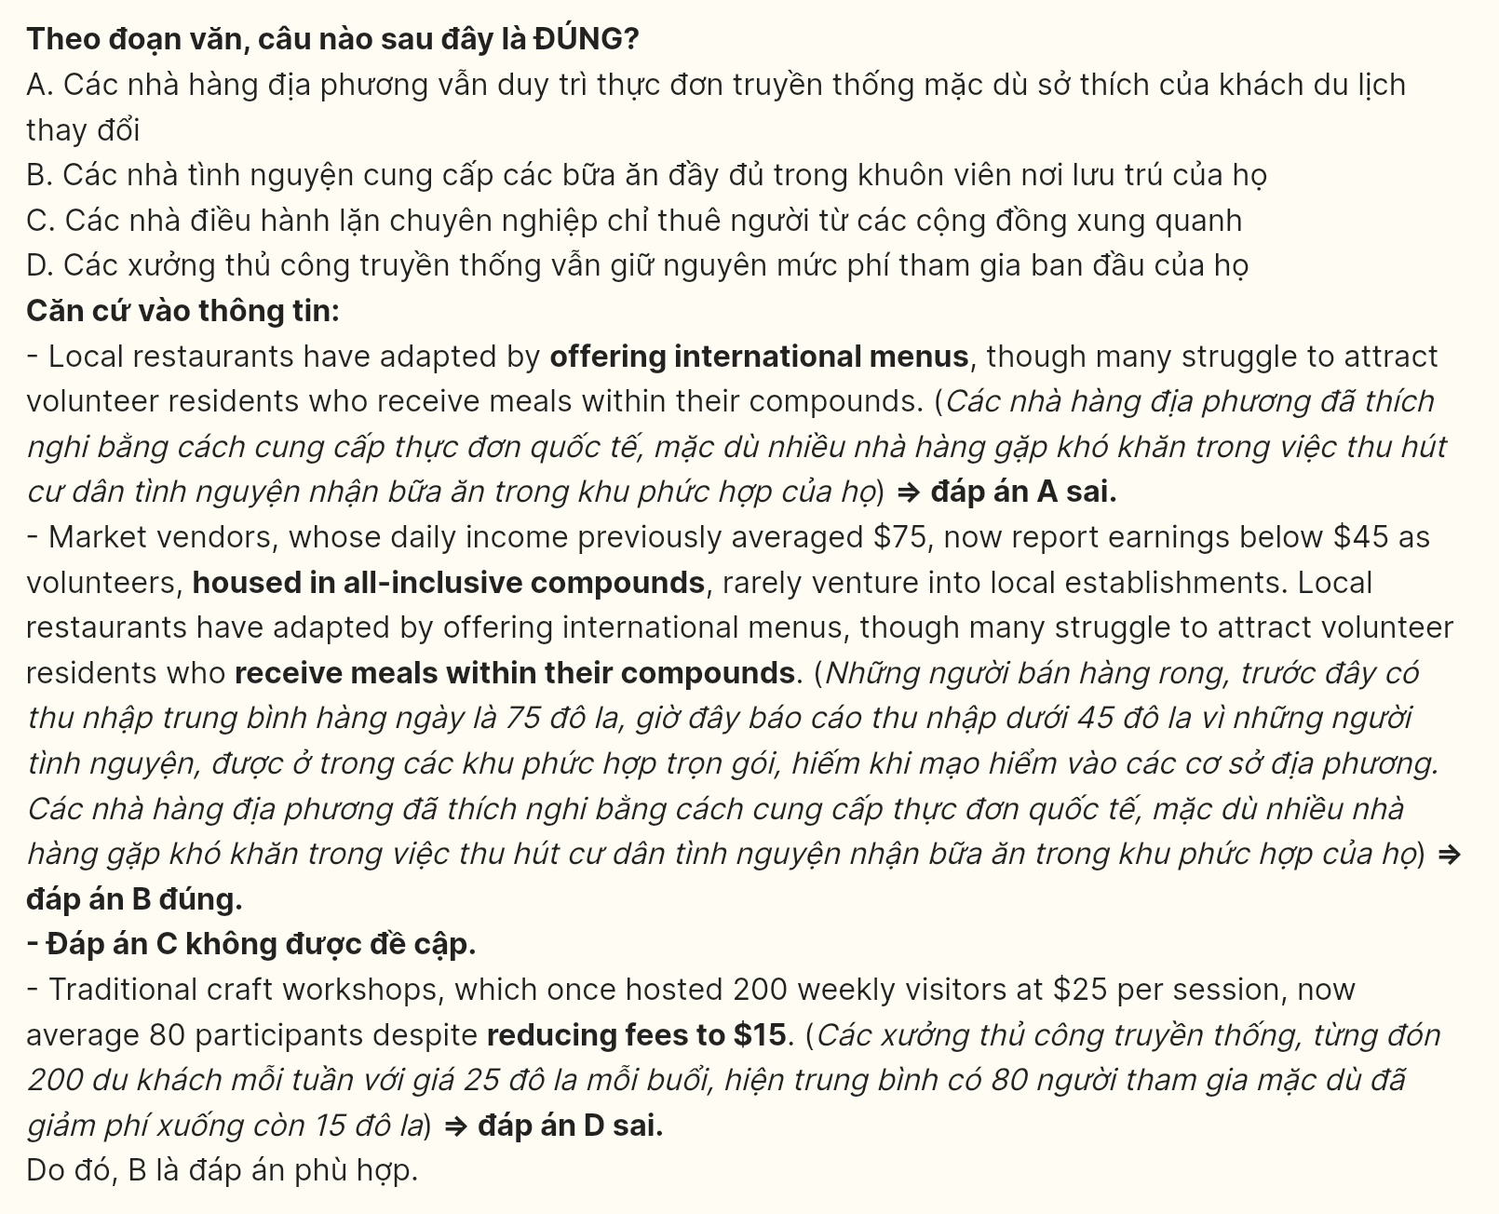
Question 37 [697884]: The phrase "turn the tide" in paragraph 6 could be replaced by ______.
A. change direction B. solve problems
C. improve conditions D. reverse trends
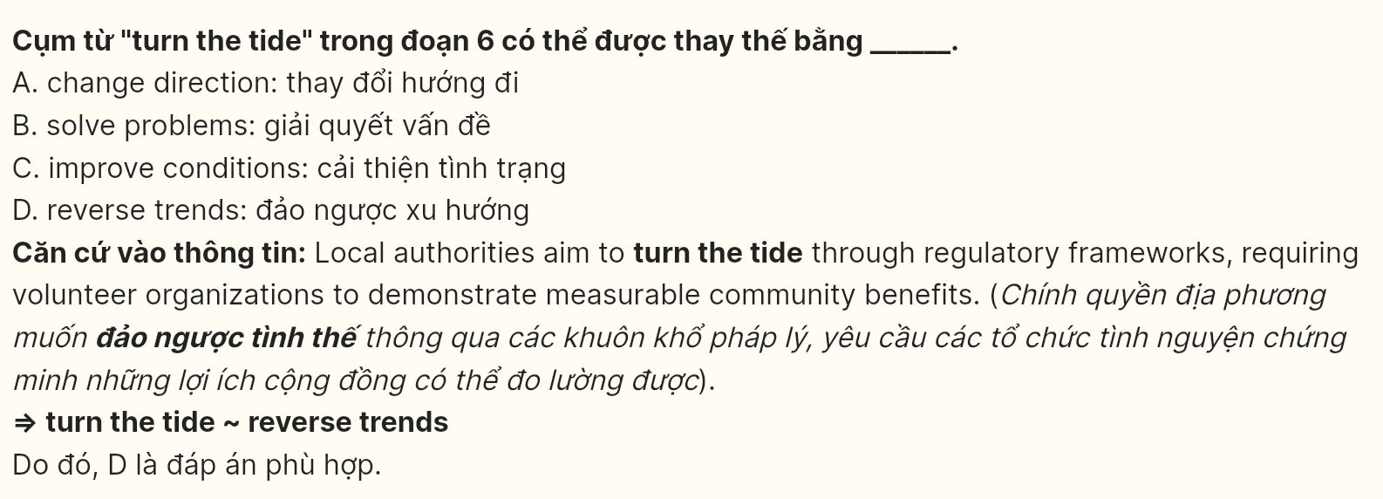
Question 38 [697885]: The word "irrevocable" in paragraph 6 is closest in meaning to ______.
A. permanent B. detrimental C. undeniable D. inevitable
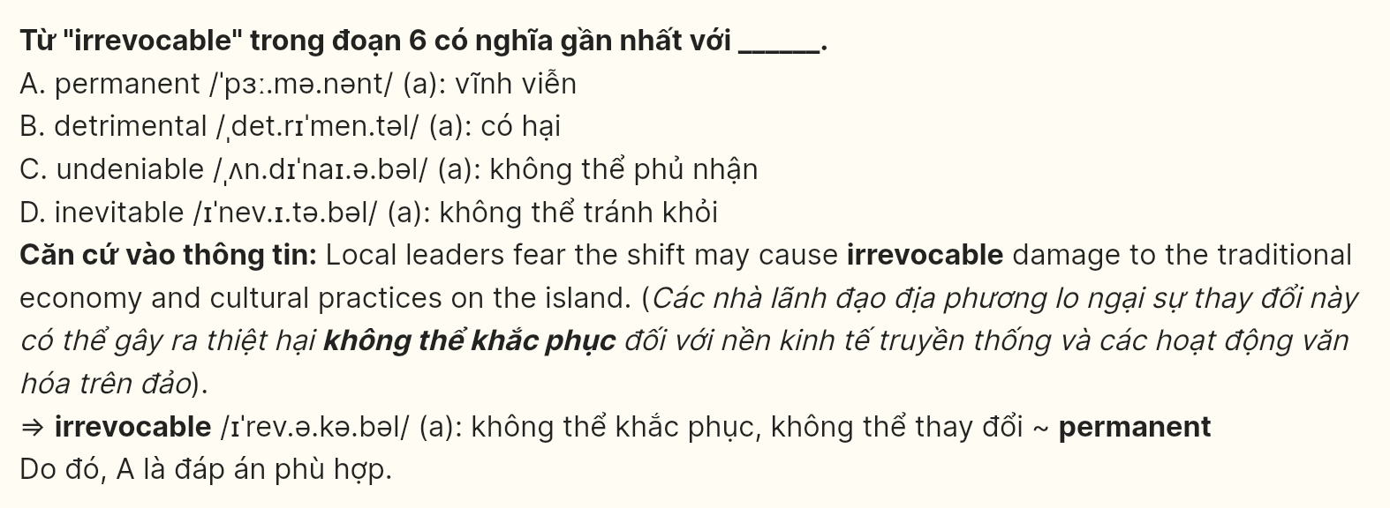
Question 39 [697886]: Which of the following can be inferred from the passage?
A. Volunteer programs inadvertently undermine established professional certification standards
B. Traditional businesses systematically alter their services to accommodate new demands
C. Local instructors gradually lose authority as temporary teaching methods predominate
D. Cultural preservation initiatives unconsciously compromise longstanding traditions
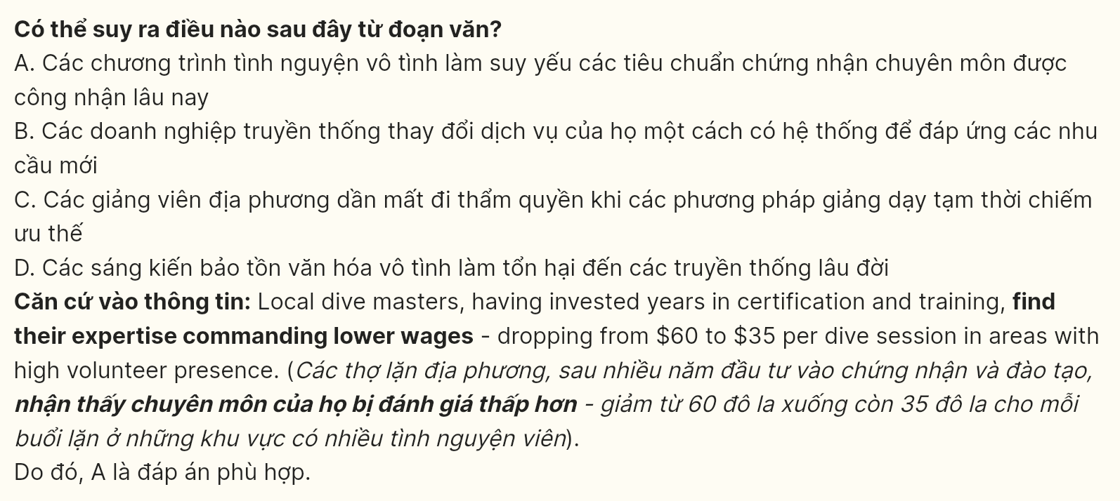
Question 40 [697887]: Which of the following best summarizes the passage?
A. The emergence of volunteer tourism in Koh Rong demonstrates how traditional economies adapt to new market forces while maintaining cultural authenticity through regulatory oversight
B. The transformation of local business landscapes through volunteer tourism illustrates the complex interplay between economic opportunities and community preservation efforts
C. The implementation of volunteer tourism programs creates multifaceted impacts on traditional economies, requiring communities to balance potential benefits against established practices
D. The evolution of tourism patterns in coastal communities reveals how volunteer initiatives can both enhance and challenge existing social and economic structures
