SPEAKING
1. Introduction:
Introduce yourself with basic information (name, class, age, hobby, family, etc.)(0.5 point)
2. Each of you will now receive a card. On the card there is a picture and clues for five questions. You should use the words to make questions and ask your friend. Your friend will answer the questions based on the picture he/she has (0.5 point)
Wonders of Viet Nam  1. What / name?  2. Where?  3. Name some attractions there  4. How about the people / food … there? | 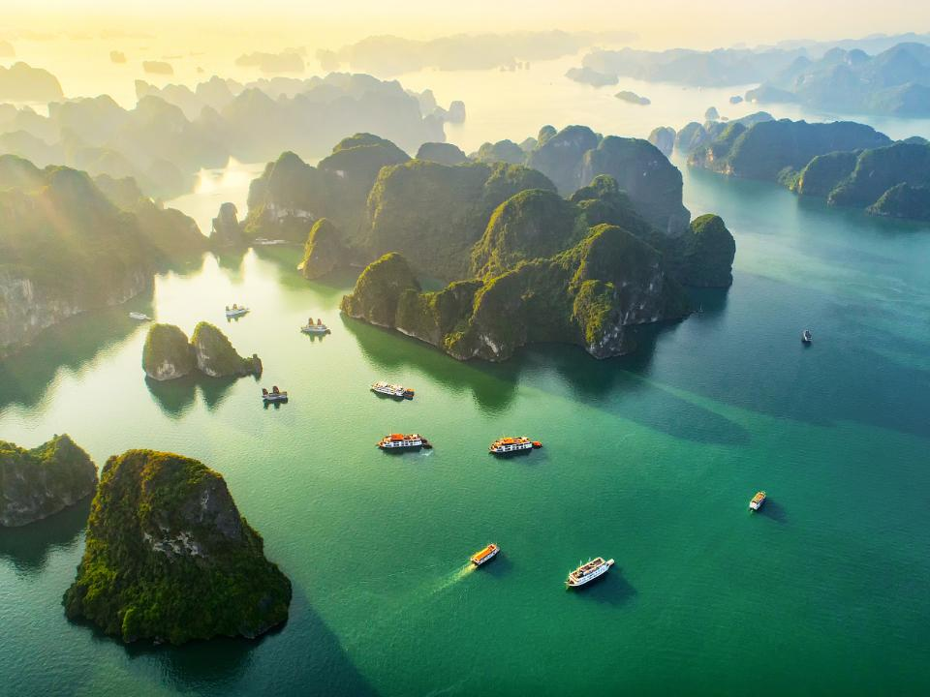
1. What / name?  2. Where / located?  3. What / the complex include?  4. When / built?  5. what / people do there? | 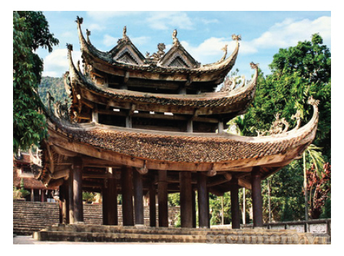
3. Answer further questions (1 point)
- How often do you go there?
- What do you like most about that wonder?
- What is the most attractive there?
- When is the ideal time to visit it?
- How should we go there?

