Full name: …………………………………………………………  Class: ………………………………………..………………………  School: …………………………………………………………….. | Mark:

SPEAKING TEST 5 (UNITS 9 & 10)

TASK 1 |  |  | Let’s talk about an ecotourism destination you would like to visit. The following questions may help you.
 | 1. | What is the name of the ecotourism destination? Where is it?
 | 2. | Why is it an ecotourism destination?
 | 3. | What should tourists do/ not do during this tour?
 | 4. | If you have a chance to go there, what items will you bring?
 | 5. | If you visited it now, what activities would you join?

TASK 2 | Work in pairs. Each of you receives a card. Use the clues on your card to make questions about your friend’s picture. Use the picture on your card to answer your friend’s questions.

CARD A
Ask your friends about his/ her picture. Listen to his/ her answers. |  | 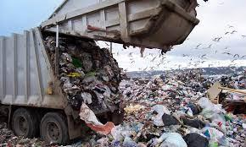
1. | What/ environmental problem?
2. | What/ reasons/ for this?
3. | What/ its/ negative effects?
4. | What/ solution(s)/ to this problem?
5. | What/ students/ help/ solutions?
 |  | Answer your friend’s questions about this picture.

CARD B
Ask your friends about his/ her picture. Listen to his/ her answers.

1. | What/ environmental problem?
2. | What/ reasons/ for this?
3. | What/ its/ negative effects?
4. | What/ solution(s)/ to this problem? | 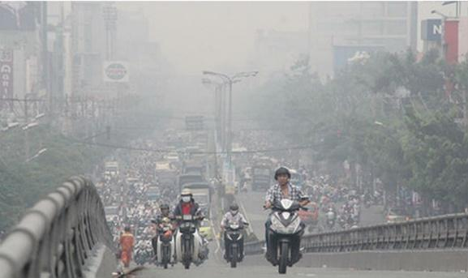
5. | What/ students/ help/ solutions?
 |  | Answer your friend’s questions about this picture.

