Date of preparing: ………………………………….
Date of teaching: ………………………………….

Period……
UNIT 4: FESTIVALS and FREE TIME
Lesson 2 - Part 3 (Page 35) – Pronunciation and Speaking

I. OBJECTIVES
By the end of the lesson, Ss will be able to…
1. Knowledge
- use sound changes in the question: “What time …?”.
- talk about festival activities.
2. Ability
- improve speaking skills.
3. Quality
- have positive attitude in English language learning so that they actively participate in all classroom activities.
- take part in some useful activities with friends to relax after school time.

II. TEACHING AIDS AND LEARNING MATERIALS
Lesson plan, PPT slides, student’s book, workbook, notebook, personal computer (if any), projector/TV, speakers, DCR & DHA on Eduhome, handouts…

III. PROCEDURES
A. Warm up: (5’)
a) Objective: to introduce the new lesson and set the scene for Ss to acquire new language; to get students' attention at the beginning of the class by means of enjoyable and short activities as well as to engage them in the steps that follow.
b) Content: revision of how to say the time in English /vocabulary.
c) Product: Ss review knowledge in the previous lessons and they are ready for the new lesson.
d) Competence: collaboration, observation, synthesizing skill.
e) Organization of the activity:
Teacher’s Activities | Students’ Activities
- Give greetings  - Check attendance  - Option 1: Telling the Time  - Have Ss close all books  - Show some clocks with different time markers, have Ss read the time  - Call Ss to give answers  - Give feedback, correct Ss’ answers if necessary  Lead to the new lesson  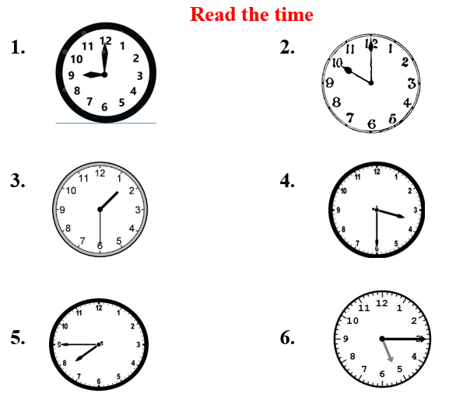  - Option 2: FIND THE OPPOSITE  - Have Ss close all books  - Give some words, have Ss find their opposites  1. start  2. open  3. begin  4. boring  5. wrong  6. false  - Call Ss to give answers  - Give feedback, check answers as a whole class  Lead to the new lesson | - Greet T  - Close books  - Look, read the time  - Give answers  Answers keys  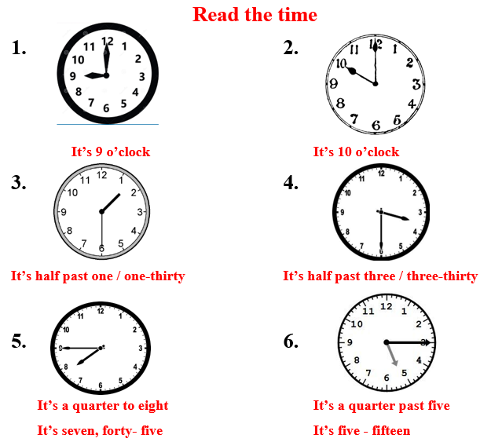  - Close books  - Find the opposites  - Read answers  - Check answers with the teacher  Answers keys  1. start >< end  2. open >< close  3. begin >< finish / end  4. boring >< interesting  5. wrong >< right  6. false >< true

B. New lesson (35’)
- Activities 1: Pronunciation (10’)
a) Objective: Ss know how to use sound changes in the question: “What time …?”
b) Content:
- recognizing the sound changes in the question: “What time …?”.
- listening and focusing pronunciation feature, finding and correcting mistakes.
- practice saying the target pronunciation point.
c) Products: Ss can apply the sound changes to their speaking skill.
d) Competence: communication, collaboration, presentation.
e) Organization of the activity:
Teacher’s Activities | Students’ Activities
a + b. Listen. Notice the sound changes of the underlined words  - Play the recording (CD1, track 49)  - Ask Ss to listen and pay attention to the sound changes  - Call Ss to make their comments on the sound changes of the questions: “What time …?”  - Give feedback, explain the pronunciation feature: “What time …?” often sounds like /wʌˈtaɪm/  - Play the recording again, have Ss listen and repeat with a focus on the pronunciation feature  c + d. Listen and cross out the one with the wrong sound changes, then read the sentences with the correct sound changes to a partner.  - Play the recording, have Ss listen and cross out the option that doesn’t use the correct sound changes  - Call Ss to give answers  - Play the recording again and check answers as a whole class.  - Then have Ss practice saying the sentences with a partner, using the correct sound changes, then encourage Ss to use their own sentences  - Call some Ss to read their sentences in front of the class  -Check and correct Ss’ pronunciation | - Listen  - Comment  - Listen  - Listen again and repeat  - Listen and cross out  - Give answers  - Listen again and check  - Work in pairs  - Present
- Activity 2: Practice (10’)
a) Objective: Ss can ask and answer questions about events and time.
b) Content: practicing a conversation and using pictures on the right as a cue.
c) Products: Ss can apply what they have learnt into practice and into producing the language successfully.
d) Competence: collaboration, communication, creativity.
e) Organization of the activity:
Teacher’s Activities | Students’ Activities
a. Practice the conversation. Swap the roles and repeat. (Controlled practice)  - Option 1:  - Demonstrate the activity by practicing role-play with a student  - Emphasize the structures to ask about time:  What time does it begin / end?  What time does it / do they open / close?  What time + do / does / + S + V…?  - Have pairs practice the conversation  - Call some pairs to read in front of the class  - Have pairs swap roles and repeat-using the pictures on the right  - Have some pairs demonstrate the activity in front of the class  - Check Ss’ pronunciation  - Option 2: (for class with better students)  - Follow the same steps as option 1  - Then give Ss an extra activity: Practice the conversation in the textbook; however, they try to remember the conversation content  - Have some pairs demonstrate the activity in front of the class, not looking at the textbook; encourage Ss to present as naturally as possible  - Give feedback and evaluation  b. Practice with your own ideas. (Free - practice)  - Have pairs practice the conversation with their own ideas, then swap roles  - Go round, observe Ss’ work and give help if necessary  - Call some pairs to demonstrate the activity in front of the class  - Give feedback and evaluation | - Listen  - Work in pairs  - Act out the conversation  - Listen to the instruction and work in pairs. Ss can practice the new conversation with the information in the pictures.  - Act out the conversation  - Listen  - Work in pairs  - Present
- Activity 3: Speaking (15’)
a) Objective: Ss can discuss things to do when they go to a festival.
b) Content: asking and answering questions about activities.
c) Products: Ss produce the language naturally, confidently and successfully.
d) Competence: collaboration, communication, creativity.
e) Organization of the activity:
Teacher’s Activities | Students’ Activities
a. You are going to a festival. Student B goes to page 120, file 2. Look at the schedule for the festival. Take turns asking about the activities. Choose at least 3 things to do.  - Demonstrate the activity by practicing role-play with a student  - Remind Ss to use the Present Simple tense and some structures of asking time  - Have student A stay on page 35 and student B turn to page 120, file 2  - Have Ss ask and answer and choose at least 3 things to do.  - Have some Ss share their ideas with the class  - Give feedback and evaluation  b. Join another pair. Did you choose the same activities?  - Have Ss join another pair, discuss which activities they choose to do  - Have some Ss share their ideas with the class  - Give feedback and evaluation | - 1 S practices role-play with the teacher  - Listen  - Work in pairs  - Role play  - Work in pairs

C. Consolidation (3’)
* Pronunciation: “What time …?” often sounds like /wʌˈtaɪm/
* Asking about the time of the activities
What time does it begin / end?
What time does it / do they open / close?

D. Homework (2’)
- Practice using sound changes in the question: “What time …?”.
- Practice asking and answering about festival activities.
- Prepare: Lesson 3: Social Studies – New Words and Listening (page 36 – SB).

