UNIT 10: COMMUNICATION IN THE FUTURE
Lesson 1: Getting started – At the technology club

I. OBJECTIVES
By the end of this lesson, Ss will be able to:
1. Knowledge
- Gain an overview about the topic Communication
- Gain vocabulary to talk about Communication
2. Competences
- Develop communication skills and creativity
- Be collaborative and supportive in pair work and teamwork
3. Personal qualities
- Be aware of the importance of technology in communication
- Be interested in learning more about technology and apply it in daily life
- Actively join in class activities

II. MATERIALS
- Grade 8 textbook, Unit 10, Getting started
- Computer connected to the Internet
- Projector / TV
- hoclieu.vn

Language analysis
New words | Pronunciation | Meaning | Vietnamese equivalent
1. video conference (n) | /ˈvɪdiəʊ ˌkɒnfərəns/ | a meeting or gathering between people who are in different locations and using video and audio technology to communicate with each other | họp trực tuyến
2. webcam (n) | /ˈwebkæm/ | a camera that is connected to a computer or the internet and is used for video communication or for broadcasting live video footage | thiết bị ghi hình kĩ thuật số
3. zoom in (v) | /zuːm ɪn/ | to make an image or a part of an image larger or closer in a digital image or on a computer screen | phóng to
4. tablet (n) | /ˈtæblət/ | a small portable computer that has a touch screen and can be used as a mobile device or as a substitute for a laptop. | máy tính bảng
5. internet connection (n) | /ˈɪntənet kəˈnekʃn/ | a connection to the internet, typically through a modem or a local area network | kết nối mạng

Assumption
Anticipated difficulties | Solutions
Ss may lack experience of group / teamwork. | - Encourage Ss to work in groups so that they can help one another.  - Give short, clear instructions, and help if necessary.

III. PROCEDURES
1. WARM-UP (5 mins)
a. Objectives:
- To set the context for the introductory dialogue;
- To introduce the topic of the unit.
b. Content:
- Game: Who knows more?
c. Expected outcomes:
- Students identify the topic of the unit and be ready for the conversation.
d. Organisation

TEACHER’S AND STUDENTS’ ACTIVITIES | CONTENTS
Who knows more?  - Teacher asks ss to work in groups and list as many social networks as possible.  - The group with the most correct answers is the winner.  - Ask students what they use social network for  - Asks students to guess the topic of the unit/ lesson. | Suggested answers:  Instagram, YouTube, Facebook, TikTok, Pinterest, Twitter, Snapchat,...
e. Assessment
- Teacher calls the group with the most activities to answer.

2. ACTIVITY 1: PRESENTATION (7 mins)
a. Objectives:
- To prepare vocabulary for students to understand the conversation.
b. Content:
- Vocabulary pre-teaching
c. Expected outcomes:
- Ss know how to pronounce the new words correctly and identify their meanings
d. Organisation

TEACHER’S AND STUDENTS’ ACTIVITIES | CONTENTS
Vocabulary pre-teaching  - Teacher introduces the vocabulary.  - Teacher explains the meaning of the new vocabulary by pictures.  - Teacher checks the students' understanding.  - Teacher gives feedback and asks students to open their textbook to discover further. | New words:  1. video conference (n)  2. webcam (n)  3. zoom in (v)  4. tablet (n)  5. internet connection (n)
e. Assessment
- Teacher checks students’ pronunciation and gives feedback.

3. ACTIVITY 2: PRACTICE (20 mins)
a. Objectives:
- To help Ss use words and phrases related to communication
- To help Ss further understand the text.
- To introduce some more vocabulary items related to communication.
b. Content:
- Task 1: Listen and read.
- Task 2: Read the conversation again and circle the correct answer A, B, or C.
- Task 3: Match the words and phrases in the conversation with their pictures.
- Task 4: Circle the words / phrases which are CLOSEST in meaning to the underlined words / phrases.
c. Expected outcomes:
- Students are able to understand the conversation and identify the vocabulary related to the topic.
d. Organisation

TEACHER’S AND STUDENTS’ ACTIVITIES | CONTENTS
Task 1: Listen and read. (7 mins)
- Teacher asks Ss to look at the pictures in the book and answer the questions.  - Ss answer the questions in pairs.  - Teacher plays the recording twice. Ss listen and read.  - Teacher checks Ss’ prediction. T calls 4 Ss to read the conversation aloud in pairs. | Questions:  - Who are the people?  - What might they be doing?  Suggested answers:  - They are students: Trang and Mark.  - They are preparing for an online meeting.
Task 2: Read the conversation again and circle the correct answer A, B, or C. (6 mins)
- Ask Ss to read the questions and choose the correct answers from what they remember after their listening and reading.  - Elicit the answers from Ss. Write their answers on the board.  - Now have them read the conversation again to check their answers.  - Ask Ss for their answers again, referring to the answers that have been written on the board before.  - Confirm the correct answers. | Answer key:  1. A  2. C  3. A
Task 3: Match the words and phrases in the conversation with their pictures. (6 mins)
- Ask Ss to name items or activities they can see in each picture (a-e).  - Have Ss work individually to match the words and phrases with the appropriate pictures.  - Have them compare their answers with a partner.  - Invite some Ss to go to the board and write their answers.  - Confirm the correct answers.  - Have some Ss practise saying the words and phrases again. | Answer key:  1. d  2. a  3. b  4. e  5. c
Task 4: Circle the words / phrases which are CLOSEST in meaning to the underlined words / phrases. (6 mins)
- Have Ss work in pairs and find the underlined words / phrases of Activity 4 in the GETTING STARTED conversation, then guess the meaning of these words / phrases using the clues in the conversation.  - Have Ss share their guesses and confirm the correct ones.  - Have Ss complete Activity 4. Check and confirm the answers.  - For a more able class, have Ss work in groups to make sentences with the underlined words / phrases. | Answer key:  1. A  2. B  3. A  4. A  5. B
e. Assessment
- Teacher checks students’ answers as a whole class and gives feedback.

4. ACTIVITY 3: FURTHER PRACTICE (7 mins)
a. Objectives:
- To help Ss practise using the vocabulary items related to communication.
b. Content:
- Task 5: Quiz
c. Expected outcomes:
- Students can gain more knowledge about the history of communication technology.
d. Organisation

TEACHER’S AND STUDENTS’ ACTIVITIES | CONTENTS
Task 5: Work in groups. Complete the diagram of the history of communication technology with the words and phrases from the box.
- Set time (3-5 minutes) for Ss to do this activity in groups. Tell them that they can use the diagram to help them.  - Have Ss read the answers aloud. Confirm the answers.  - For a more able class, ask Ss to work in their groups again and prepare a short talk about the history of communication technology. | Answer key:  1. carrier pigeon  2. telephone  3. mobile phone  4. social network
e. Assessment
- Teacher gives corrections and feedback.

5. CONSOLIDATION (5 mins)
a. Wrap-up
- Ask one or two Ss to tell the class what they have learnt.
- Ask Ss to say aloud some words and phrases they remember from the lesson
b. Homework
- Students’ workbook
- Start preparing for the Project of the unit:
Teacher randomly puts Ss in groups of 4 or 5 and asks them to brainstorm about a means of communication in 2050 and make a poster or create a model for the presentation. Students will show and present in Lesson 7 – Looking back and Project. (Teacher should check the progress of students’ preparation after each lesson.)

Board Plan

Date of teaching
Unit 10: Communication in the future
Lesson 1: Getting started - At the technology club
*Warm-up

* Vocabulary
1. video conference (n)
2. webcam (n)
3. zoom in (v)
4. tablet (n)
5. internet connection (n)
Task 1: Listen and read.
Task 2: Read and circle.
Task 3: Match.
Task 4: Circle the words / phrases.
Task 5: Complete the diagram.

*Homework

UNIT 10: COMMUNICATION IN THE FUTURE
Lesson 2: A closer look 1

I. OBJECTIVES
By the end of this lesson, Ss will be able to:
1. Knowledge
- Vocabulary: The lexical items related to Communication
- Pronunciation: Correctly stress words that ending with -ese and -ee
2. Competences
- Develop communication skills and creativity
- Be collaborative and supportive in pair work and teamwork
3. Personal qualities
- Be aware of the importance of technology in communication
- Be interested in learning more about technology and apply it in daily life
- Actively join in class activities

II. MATERIALS
- Grade 8 textbook, Unit 10, A closer look 1
- Computer connected to the Internet
- Projector / TV
- hoclieu.vn

Language analysis
Words | Pronunciation | Meaning | Vietnamese equivalent
1. social network | /ˌsəʊʃl ˈnetwɜːk/ | a platform or website where people can create a public profile, connect with others, and share information and content, such as photos and messages | mạng xã hội
2. voice message | /ˈvɔɪs mesɪdʒ/ | a recorded message that is sent or received using voice technology | tin nhắn thoại
3. group call | /ɡruːp kɔːl/ | a telephone call or video call that involves multiple participants, typically used for group discussions or meetings | cuộc gọi nhóm
4. smartphone | /ˈsmɑːtfəʊn/ | a mobile phone that combines the features of a computer, including the ability to run software applications and access the internet | điện thoại thông minh
5. emoji | /ɪˈməʊdʒi/ | a small digital image or icon used to express emotions, ideas, or concepts in electronic communication | biểu tượng cảm xúc
6. holography | /hɒlˈɒɡrəfi/ | three-dimensional images created by the interference of light beams from a laser or other light source | hình chiếu 3 chiều

Assumption
Anticipated difficulties | Solutions
Ss may lack vocabulary related to technology communication so they may have difficulty completing the tasks | T is willing to provide them with enough vocabulary related to the topic

III. PROCEDURES
1. WARM-UP (5 mins)
a. Objectives:
- To create an active atmosphere in the class before the lesson.
- To lead into the new lesson.
b. Content:
- Jumbled words
c. Expected outcomes:
- Students get some vocabulary from the lesson and be ready for the lesson.
d. Organisation

TEACHER’S AND STUDENTS’ ACTIVITIES | CONTENTS
Jumbled words:  - Teacher asks students to work in groups of four.  - Teacher shows the words with the letters mixed in a wrong order  - Ss rearrange the words.  - Teacher elicits answers from students and announces the winning group.  - T sets the context for the lesson. | Answer key:  1. video conference  2. tablet  3. internet connection  4. zoom in  5. webcam
e. Assessment
- Teacher shows students the answer on the screen and announces the winning group.

2. ACTIVITY 1: VOCABULARY (25 mins)
a. Objectives:
- To present and help students practise using words and phrases related to communication technology.
- To give Ss further practice with fixed phrases related to communication technology.
b. Content:
- Vocabulary pre-teaching
- Task 1: Write the correct word or phrase from the box under each picture.
- Task 2: Choose the correct answer A, B, or C.
- Task 3: Complete the sentences with the words from the box.
c. Expected outcomes:
- Students are able to identify meanings of some new words related to the topic and use them in meaningful contexts.
d. Organisation

TEACHER’S AND STUDENTS’ ACTIVITIES | CONTENTS
Vocabulary pre-teaching (7 mins)
- Teacher asks ss to complete the word search.  - Teacher introduces the vocabulary.  - Teacher checks students’ understanding by the follow-up tasks in the student's book. | New words:  1. social network (n)  2. voice message (n)  3. group call (n)  4. smartphone (n)  5. emojis (n)  6. holography (n)
Task 1: Write the correct word or phrase from the box under each picture. (5 mins)
- Have Ss look at the pictures and name what they see in the pictures.  - Have Ss read the words / phrases in the box and match them with the appropriate pictures.  - Let Ss work in pairs to compare their answers before giving T the answers.  - Check and confirm the correct answers. Elicit from Ss the clue(s) that help(s) them to complete the matching task.  - Note: some words are familiar to them such as social network, smartphone, group call. Spend more  time explaining unfamiliar words like holography and emojis.  - Have the whole class read aloud the words / phrases. | Answer key:  1. smartphone  2. emojis  3. voice message  4. holography  5. social network  6. group call
Task 2: Choose the correct answer A, B, or C. (6 mins)
- Have Ss do this exercise individually. Tell them to read all the sentences carefully to make sure they understand the sentences and choose the correct option.  - Let them share their answers in pairs.  - Invite some Ss to give the answers and confirm the correct ones. Explain the options that might be challenging to Ss.  - With a more able class, have Ss make true sentences about themselves with the learnt words/ phrases. | Answer key:  1. A  2. C  3. B  4. B  5. A
Task 3: Complete the sentences with the words from the box. (6 mins)
- Have Ss read the sentences in pairs and choose the appropriate words to complete the sentences.  - Invite Ss to share their sentences orally or in writing.  - Confirm the correct answers. Draw Ss’ attention to the phrases “private messages”; “language barrier”, “in real time”, “translation machine”, “reply to messages instantly”. Make sure they understand the meaning of these phrases.  - Have Ss to choose one or two phrases and make sentences with them. | Answer key:  1. private  2. language  3. real  4. translation  5. instantly
e. Assessment
- Teacher checks students’ pronunciation and gives feedback.
- Teacher checks students’ answers as a whole class.

3. ACTIVITY 2: PRONUNCIATION (10 mins)
a. Objectives:
- To help Ss identify how to stress the words ending in -ese and -ee
- To help Ss practise pronouncing these sounds in words.
b. Content:
- Task 4: Listen and repeat the words. Pay attention to the word stress.
- Task 5: Mark the stress in the underlined words. Then listen and repeat the sentences.
c. Expected outcomes:
- Students are able to pronounce words ending in -ese and -ee with the correct stress.
d. Organisation

TEACHER’S AND STUDENTS’ ACTIVITIES | CONTENTS
Task 4: Listen and repeat the words. Pay attention to the word stress. (5 mins)
- Have some Ss read out the words first. Then play the recording for them to listen and repeat the words they hear. Play the recording as many times as necessary.  - Explain to Ss that these words end with -ese and -ee. Say the words again slowly and elicit from them the stress of these words.  - Ask Ss to look at the Remember! box. Confirm the rule for stressing these words.  - Have the class say the words again in chorus, and then invite some Ss to say them.  - Invite some Ss to say some words they know that end in -ese or -ee. | 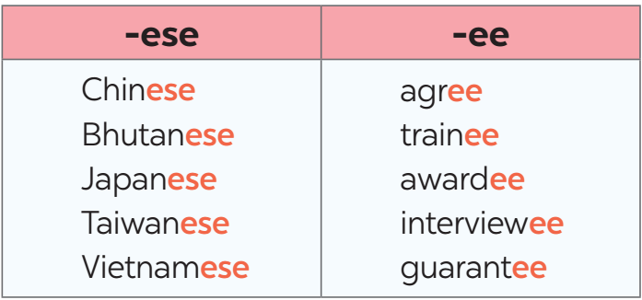
Task 5: Mark the stress in the underlined words. Then listen and repeat the sentences. (5 mins)
- Have Ss quickly read the sentences. Ask them to pay attention to the underlined words.  - Elicit from Ss the syllables that they should stress on in each word. Confirm the correct ones.  - Have some Ss read aloud the sentences with correct stress.  - Play the recording for Ss to repeat the sentences.  - Have Ss practise the sentences in pairs. Invite some pairs to read the sentences aloud. Comment on their pronunciation. | Answer key:  1. The interview'ees said that they were Taiwa'nese.  2. Joe a'grees with me that learning Chi'nese is difficult.  3. She obtained a bachelor’s de'gree in Japa'nese.  4. The Taiwa'nese company gave each awar'dee a smartphone.  5. The Japa'nese teacher sent a video to the absen'tees on Monday.
e. Assessment
- Teacher gives corrections and feedback to students’ pronunciation.

5. CONSOLIDATION (5 mins)
a. Wrap-up
- Ask one or two Ss to tell the class what they have learnt.
- Ask Ss to make some sentences with words and phrases they remember from the lesson
b. Homework
- Students’ workbook

Board Plan

Date of teaching
Unit 10: Communication in the future
Lesson 2: A closer look 1
*Warm-up

* Vocabulary
1. social network (n)
2. voice message (n)
3. group call (n)
4. smartphone (n)
5. emoji (n)
6. holography (n)

Task 1: Write the correct word or phrase.
Task 2: Choose the correct answer.
Task 3: Complete the sentences.

* Pronunciation:
Task 4: Listen and repeat the words.
Task 5: Mark the stress.
*Homework

UNIT 10: COMMUNICATION IN THE FUTURE
Lesson 3: A closer look 2

I. OBJECTIVES
By the end of this lesson, Ss will be able to:
1. Knowledge
- use the prepositions of time and place, possessive pronouns correctly
2. Competences
- Develop communication skills and creativity
- Be collaborative and supportive in pair work and teamwork
3. Personal qualities
- Be aware of the importance of technology in communication
- Love to learn more about technology and apply it in daily life
- Actively join in class activities

II. MATERIALS
- Grade 8 textbook, Unit 10, A closer look 2
- Computer connected to the Internet
- Projector / TV
- hoclieu.vn

Language analysis
Grammar | Usage
Preposition of place | in: bên trong  on: bên trên  under: bên dưới  opposite: đối diện  in front of: phía trước  at: ở
Preposition of time | - “in + a length of time” can express future meaning.  Example: Robots will replace human shop assistants in ten years.  - “for + a length of time” says how long something goes on for.  Example: It rained for three hours yesterday.  - “by + a specific time” means “not later than that time”.  Example: We’ll be there by 6 p.m.
Possessive pronouns | We can use possessive pronouns after of

Assumption
Anticipated difficulties | Solutions
Ss may lack experience of group / teamwork. | - Encourage Ss to work in groups so that they can help one another.  - Give short, clear instructions, and help if necessary.

III. PROCEDURES
1. WARM-UP (5 mins)
a. Objectives:
- To review vocabulary related to communication technology
- To introduce prepositions of time and place, possessive pronouns.
b. Content:
- Game: Where is it?
c. Expected outcomes:
- Ss recall some prepositions of time and place learnt in the previous lesson.
d. Organisation

TEACHER’S AND STUDENTS’ ACTIVITIES | CONTENTS
Where is it?  - Show Ss your mobile phone. Then put it on the table. Say: Look. This is my mobile phone. Where is it?  - Have Ss answer the question. Quickly move your phone to different places while asking Where’s it now? to elicit Ss’ answers with prepositions of places (on, in, under, opposite, etc.). Write one or two sentences of their answers on the board. Underline the prepositions in Ss’ answers.  - Write a question on the board: “What will mobile phones be like in 2030?” Elicit Ss’ answers.  - Tell Ss that today they are learning more prepositions of place and time, and possessive pronouns.  - Lead to the lesson.  - Introduce the objectives of the lesson. Write the objectives in the left corner of the board. | Answer the questions:  1. Where is the teacher's smartphone?  2. What will smartphones be like at the end of 2023?  3. What will smartphones be like in 10 years?
e. Assessment
- Teacher corrects students’ answers (if needed).

2. ACTIVITY 1: PRESENTATION (10 mins)
a. Objectives:
- To review Ss’ knowledge of prepositions of place and time & possessive pronouns
b. Content:
- Prepositions of place and time
- Possessive pronouns
c. Expected outcomes:
- Students are able to identify when and how to use the prepositions of place and time & possessive pronouns.
d. Organisation

TEACHER’S AND STUDENTS’ ACTIVITIES | CONTENTS
Prepositions of place
- Show the pictures of prepositions of places and ask ss to guess the meaning based on the pictures. | In: bên trong  On: bên trên  Under: bên dưới  Opposite: đối diện  In front of: phía trước  At: ở
Prepositions of time
- Remind Ss of some common phrases with prepositions of time: at, in, on.  - Write the sentence “Robots will replace human shop assistants in ten years.” on the board. Point to  “will” and “in ten years” and elicit from Ss that this sentence talks about the future.  - Explain that “in + a length of time” can express future meaning. Give Ss one or two more examples.  - Go through a similar process to explain “for + a length of time” and “by + specific time”. Use the examples in the Remember! box. | 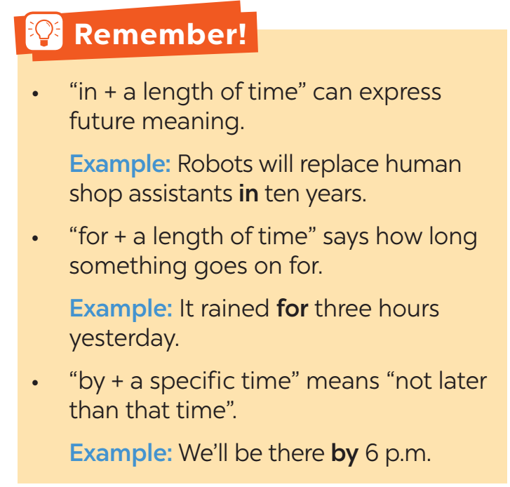
Possessive pronouns
- Write the example sentences in the Remember! box on the board. Underline “one of my friends” and “a friend of mine”.  - Draw Ss’ attention to “mine” and “my” and explain the two structures.  - Have Ss work individually to complete this exercise. Invite some early-finishers Ss to the board to write their answers.  - Check their answers with the class and confirm the correct ones. | 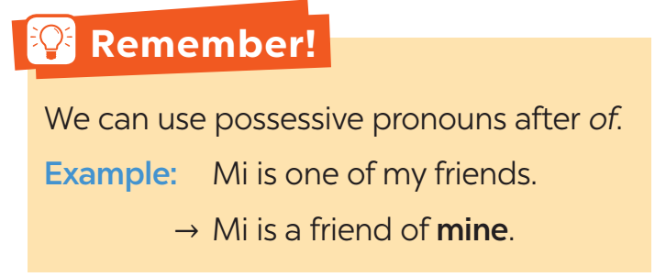
e. Assessment
- Teacher checks students’ understanding by asking some checking-questions.

3. ACTIVITY 2: PRACTICE (18 mins)
a. Objectives:
- To help Ss practise using prepositions of time and place, possessive pronouns.
b. Content:
- Task 1: Complete the sentences with at, in, in front of, on, opposite, or under.
- Task 2: Circle the correct preposition in each sentence.
- Task 3: Complete the text with the prepositions from the box. Use each preposition only ONCE.
- Task 5: Complete the second sentence so that it has the same meaning as the first sentence.
c. Expected outcomes:
- Students are able to use the target grammar in different contexts.
d. Organisation

TEACHER’S AND STUDENTS’ ACTIVITIES | CONTENTS
Task 1: Complete the sentences with at, in, in front of, on, opposite, or under. (4 mins)
- Have Ss do these exercises individually and then compare their answers with a partner.  - Ask some Ss to write their answers on the board.  - Check the answers with the whole class. | Answer key:  1. at 2. opposite  3. under 4. in; on  5. in front of
Task 2: Circle the correct preposition in each sentence. (3 mins)
- Have Ss do these exercises individually and then compare their answers with a partner.  - Ask some Ss to write their answers on the board.  - Check the answers with the whole class. | Answer key:  1. by 2. in  3. for 4. on  5. in
Task 3: Complete the text with the prepositions from the box. Use each preposition only ONCE. (5 mins)
- Have Ss do the exercise individually and then compare the  answers with another classmate.  - Invite some Ss to write their answers on the board.  - Check the answers with the whole class. Confirm the correct  answers | Answer key:  1. in 2. By  3. at 4. on  5. for
Task 5: Complete the second sentence so that it has the same meaning as the first sentence. (6 mins)
- Have Ss do these exercises individually and then compare their answers with a partner.  - Ask some Ss to write their answers on the board.  - Check the answers with the whole class. Accept different sentences provided that they are correct. | Answer key:  1. Jack is a cousin of hers.  2. Is this a tablet of his?  3. Can I borrow one of your pencils?  4. You look like Nick and Peter. Are you a relative of theirs?  5. Last year, two classmates of ours won scholarships to the US.
e. Assessment
- Teacher checks the students' answers as a whole class.

4. ACTIVITY 3: PRODUCTION (7 mins)
a. Objectives:
- To help Ss practise using prepositions of time and place, possessive pronouns
b. Content:
- Task 4: Work in pairs. Tell each other whether you agree or disagree with the following ideas.
c. Expected outcomes:
- Students are able to use prepositions of time and place, possessive pronouns to discuss some ideas.
d. Organisation

TEACHER’S AND STUDENTS’ ACTIVITIES | CONTENTS
Task 4: Work in pairs. Tell each other whether you agree or disagree with the following ideas. (7 mins)
- Have Ss work in pairs and say whether they agree or disagree with the given ideas. They can take notes if they wish to. With a less able class, T can ask further questions to help them (e.g. What are some bad points of using smartphones too much? In the future, will people meet each other face to face like now? etc.)  - Invite some pairs to stand up and give their opinions.  - Comment on their answers. | Ideas to discuss:  1. We should not use our smartphones for more than a few hours every day.  2. By 2050, the way people communicate with each other will be different from now
e. Assessment
- Teacher gives corrections and feedbacks

5. CONSOLIDATION (5 mins)
a. Wrap-up
- Summarise the main points of the lesson.
- Ask Ss to make sentences about themselves, using comparative adverbs.
b. Homework
- Students’ workbook

Board Plan

Date of teaching
Unit 10: Communication in the future
Lesson 3: A closer look 2
*Warm-up

* Grammar:
+) Prepositions of place: in, on, under, opposite, in front of, at
+) Prepositions of time:
in + length of time
for + length of time
by + a specific time
+) Possessive pronouns

Task 1: Complete the sentences.
Task 2: Circle the correct preposition.
Task 3. Complete the text.
Task 5: Complete the second sentence.
Task 4: Discuss the ideas.
*Homework
UNIT 10: COMMUNICATION IN THE FUTURE
Lesson 4: Communication

I. OBJECTIVES
By the end of this lesson, Ss will be able to:
1. Knowledge
- Know how to interrupt politely
- Know some means of communication may appear in the near future
2. Competences
- Develop communication skills and creativity
- Be collaborative and supportive in pair work and teamwork
3. Personal qualities
- Be aware of the importance of technology in communication
- Be interested in learning more about technology and apply it in daily life
- Actively join in class activities

II. MATERIALS
- Grade 8 textbook, Unit 10, Communication
- Computer connected to the Internet
- Projector / TV
- hoclieu.vn

Language analysis
Language function | Examples
How to interrupt politely | Hold on.  Sorry for interrupting, but…

Assumption
Anticipated difficulties | Solutions
Ss may lack experience of group / team work. | - Encourage Ss to work in groups so that they can help one another.  - Give short, clear instructions, and help if necessary.

III. PROCEDURES
1. WARM-UP (5 mins)
a. Objectives:
- To create an active atmosphere in the class before the lesson;
- To lead into the new lesson.
b. Content:
- Ask and answer.
c. Expected outcomes:
- Students can understand and answer the questions with their own ideas.
d. Organisation

TEACHER’S AND STUDENTS’ ACTIVITIES | CONTENTS
- Teacher asks students the question.  - Write on the board “I will _____ in 10 years.” Have Ss complete the sentence with their own ideas. Encourage them to provide more detail by adding one more sentence.  - Invite some Ss to share their sentences. Listen attentively and try interrupting one student by saying “Hold on. Can you repeat that, please?”.  - Have students repeat the information. Thank him/ her.  - Write “Hold on. Can you repeat that, please?” on the board. Explain to Ss that this structure is for interrupting the other speaker politely.  - Lead into the lesson. Introduce the objectives of the lesson. Write the objectives in the left corner of the board. | Suggested question:  1. “How do you see yourself in 10 years?”  Suggested answers:  1. I will be working as a teacher.
e. Assessment
- Teacher corrects students’ answers (if needed).

2. ACTIVITY 1: EVERYDAY ENGLISH (15 mins)
a. Objectives:
- To introduce ways to interrupt politely
- To help Ss practise interrupting politely
b. Content:
- Task 1: Listen and read the conversations below. Pay attention to the highlighted parts.
- Task 2: Work in pairs. Make similar conversations with the following situations.
c. Expected outcomes:
- Students are able to use the structures to interrupt politely.
d. Organisation

TEACHER’S AND STUDENTS’ ACTIVITIES | CONTENTS
Task 1: Listen and read the conversations below. Pay attention to the highlighted parts. (6 mins)
- Play the recording for Ss to listen and read the conversations between Mark and Trang, and between Nick and Lan. Ask Ss to pay attention to the highlighted language. Tell them that these are two ways to interrupt the other speaker politely.  - Have Ss practise the conversations in pairs. Call on some pairs to practise the dialogues in front of the class. | 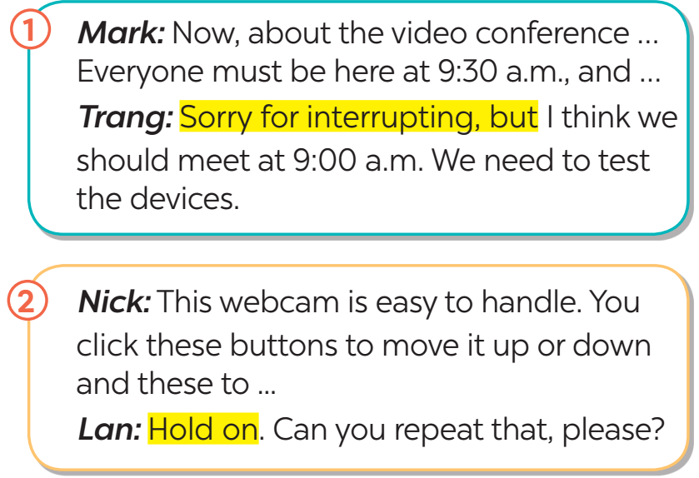
Task 2: Work in pairs. Make similar conversations with the following situations. (9 mins)
- Ask Ss to work in pairs to make similar dialogues, using the language they have learnt.  - Move around to observe and provide help. Call on some pairs to practise in front of the class.  - Comment on their performance. | 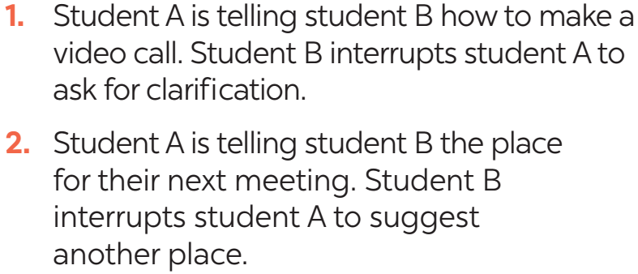
e. Assessment
- Teacher gives comments on students' conversations and corrects them if needed.

3. ACTIVITY 2: THE FUTURE OF LANGUAGE (25 mins)
a. Objectives:
- To help Ss learn about the prediction about the future of communication.
- To provide Ss with practice in giving a presentation about their friends’ answers.
b. Content:
- Task 3,4 in Student book
c. Expected outcomes:
- Students are able to make questions and answers about popular means of communication.
- Students are able to make a talk to report their pairs’ conversation to the class.
d. Organisation

TEACHER’S AND STUDENTS’ ACTIVITIES | CONTENTS
Task 3: Work in pairs. Read Mark’s prediction about a popular means of communication in the near future. Then ask and answer the questions. (7 mins)
- Draw or show pictures of some emojis on the board. Have Ss call out the word “emoji”. Ask them if they use emojis a lot when chatting.  - Have Ss work in pairs, read Mark’s prediction about emojis and answer the questions that follow.  - Invite some pairs to share their answers. Confirm the correct answers. Accept all answers that are  logical and reasonable.  - Ask Ss if they think one day, they will receive an email or message that contains only emojis. | Suggested answers:  1. Jack is a cousin of hers.  2. Is this a tablet of his?  3. Can I borrow one of your pencils?  4. You look like Nick and Peter. Are you a relative of theirs?  5. Last year, two classmates of ours won scholarships to the US.
Task 4: Work in pairs. Choose one means of communication below. Ask and answer questions about it. (8 mins)
- Have Ss work in groups to ask and answer the two questions in the book. Have Ss in each group note down their friends’ answers.  - Ask some Ss to report their group’s answers to the class.  - Call on some Ss to give the presentation to the whole class. After each student finishes his or her presentation, invite comments on his or her clarity, language, and fluency from other Ss. | 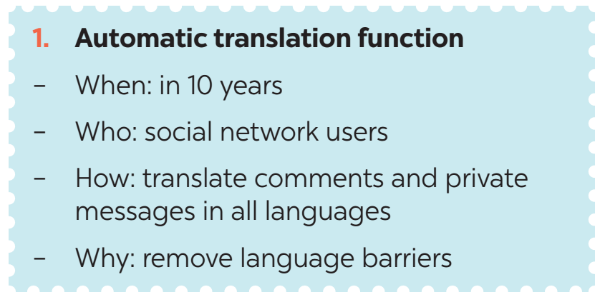  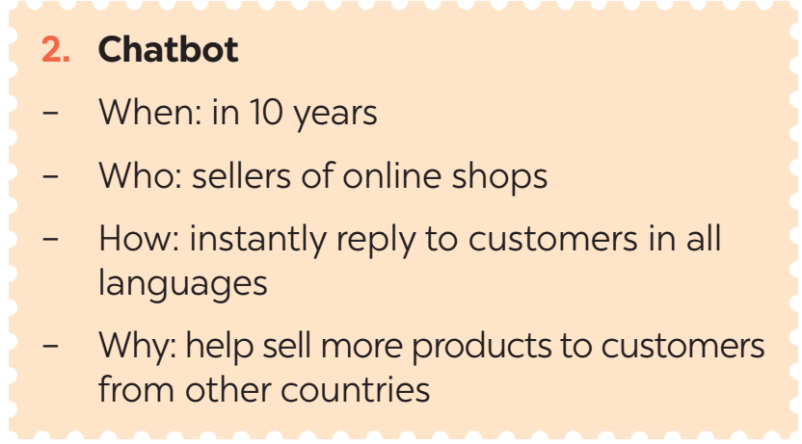
Task 5: Report your pair’s conversation to the class by making a similar talk to Mark’s prediction in 3. (10 mins)
- Have Ss work in groups to ask and answer the two questions in the book. Have Ss in each group note down their friends’ answers.
- Ask some Ss to report their group’s answers to the class.
- Call on some Ss to give the presentation to the whole class. After each student finishes his or her presentation, invite comments on his or her clarity, language, and fluency from other Ss.
e. Assessment
- Teacher corrects students’ pronunciation by going around while they’re practising.

5. CONSOLIDATION (5 mins)
a. Wrap-up
- Have Ss tell about what they have learnt in the lesson.
b. Homework
- Students’ workbook

Board Plan

Date of teaching
Unit 10: Communication in the future
Lesson 4: Communication
*Warm-up

* Everyday English
Language function | Examples
How to interrupt politely | Hold on.  Sorry for interrupting, but…

Task 1: Listen and read.
Task 2: Make similar conversations.

* The future of language
Task 3: Read and answer the questions.
Task 4: Ask and answer about 1 means of communication.
Task 5: Report by making a similar talk to Mark’s prediction.

*Homework

UNIT 10: COMMUNICATION IN THE FUTURE
Lesson 5: Skills 1

I. OBJECTIVES
By the end of this lesson, Ss will be able to:
1. Knowledge
- read about telepathy;
- talk about advantages and disadvantages of a way of communication;
2. Competences
- Develop communication skills and creativity
- Be collaborative and supportive in pair work and teamwork
3. Personal qualities
- Be aware of the importance of technology in communication
- Be interested in learning more about technology and apply it in daily life
- Actively join in class activities

II. MATERIALS
- Grade 8 textbook, Unit 10, Skills 1
- Computer connected to the Internet
- Projector / TV
- hoclieu.vn

Language analysis
New words | Pronunciation | Meaning | Meaning
1. telepathy (n) | /təˈlepəθi/ | the supposed ability to communicate mentally with another person without using the usual senses | thần giao cách cảm
2. keep in contact (v) | /kiːp ɪn kənˈtækt/ | to maintain communication or a relationship with someone | giữ liên lạc
3. thought (n) | /θɔːt/ | an idea, opinion, or belief, especially one that is considered to be formed as a result of mental activity | suy nghĩ
4. tiny (a) | /ˈtaɪni/ | very small in size or amount; little | nhỏ bé

Assumption

Anticipated difficulties | Solutions
1. Students may lack lexical items. | - Provide students with the meaning and pronunciation of words.
2. Students may not have sufficient reading, speaking and co-operating skills. | - Let students read the text again (if necessary).  - Create a comfortable and encouraging environment for students to speak.  - Encourage students to work in pairs, in groups so that they can help each other.  - Provide feedback and help if necessary.
3. Some students may excessively talk in the class. | - Define expectation in explicit detail.  - Have excessively talkative students practise.  - Continue to define expectations in small chunks (before every activity).

III. PROCEDURES
1. WARM-UP (5 mins)
a. Objectives:
- To help Ss understand and activate their knowledge of the topic;
- To help Ss remember some words related to telepathy
b. Content:
- Task 1: Work in pairs. List as many ways of communication as you can.
c. Expected outcomes:
- Students can list some ways of communication.
d. Organisation

TEACHER’S AND STUDENTS’ ACTIVITIES | CONTENTS
Task 1: Work in pairs. List as many ways of communication as you can. (5 mins)
- Have Ss work in pairs and list as many ways of communication as they can.  - Invite some Ss to share their lists. Write their ideas on a corner of the board and keep them there until the end of the lesson. | Suggested ideas: meeting face-to-face, sending letters, sending emails, texting, chatting online, sending voice messages, making phone calls, making group calls, having video calls, etc.
e. Assessment
- Teacher corrects for students (if needed)

2. ACTIVITY 1: READING (20 mins)
a. Objectives:
- To improve Ss’ vocabulary on communication, including telepathy
- To improve Ss’ skill of reading for general and specific information
b. Content:
- Vocabulary pre-teaching
- Task 2: Read an interview with two students, Minh and Tom. Then tick the speaker of each sentence.
- Task 3: Read the interview again. Choose the correct answer A, B, or C.
c. Expected outcomes:
- Ss are able to identify the meaning and use of some new words related to communication.
- Students can understand the text and choose the correct answers.
d. Organisation

TEACHER’S AND STUDENTS’ ACTIVITIES | CONTENTS
Vocabulary pre-teaching
- Teacher explains the meaning of the new vocabulary with pictures.  - Teacher reveals that these new words will appear in the reading text and asks students to open their textbook to find the words  - Teacher checks students’ understanding with follow-up questions. | New words:  1. telepathy (n)  2. keep in contact (v)  3. thought (n)  4. tiny (a)
Task 2: Read an interview with two students, Minh and Tom. Then tick the speaker of each sentence. (5 mins)
- Draw Ss’ attention to the word “telepathy”. Tell them that this is a way of communication. Challenge Ss to quickly find the word telepathy in the conversation and guess its meaning. Confirm their answer.  - Ask Ss who are in the interview (the MC, Minh and Tom). Tell them that in this exercise, they need to find out what Tom is saying and what Minh is saying, so they should focus on Tom and Minh’s lines in the conversation.  - Briefly tell Ss the steps to complete the exercise: Read the statements, underline the keywords in each statement, locate the keywords in the text, find the information and decide if Minh or Tom is saying that information.  - Ask Ss to do the exercise individually and then check their answers in pairs.  - Invite some Ss to share their answers. Confirm the correct answers. | Answers key:  1. Minh  2. Tom  3. Minh  4. Minh  5. Tom
Task 3: Read the interview again. Choose the correct answer A, B, or C. (10 mins)
- Ask Ss what they are going to do.  - Have Ss share how to do this exercise.  - Briefly tell them the steps: Read the questions, underline the key words in each question, locate the key words in the text and find the information to answer the question.  - Ask Ss to repeat the steps if necessary.  - Ask Ss to do the exercise individually and then check their answers in pairs.  - Invite some Ss to share their answers. Have them explain their answers. Confirm the correct answers.  - To connect the reading and the speaking parts, T can draw a table and ask Ss to fill in the table about the advantages and disadvantages of telepathy. | Answer key:  1. A  2. B  3. C  4. B  5. C  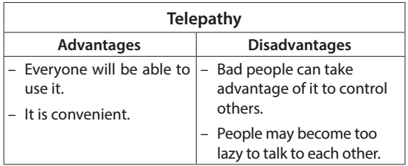
e. Assessment
- Teacher checks students’ answers as a whole class.

3. ACTIVITY 2: SPEAKING (15 mins)
a. Objectives:
- To help Ss prepare ideas about a way of communication.
- To provide an opportunity for Ss to practise talking about advantages and disadvantages of a way of communication
b. Content:
- Task 4: Work in pairs. Read the following ideas about online calls. Put the ideas in the correct column.
- Task 5: Work in groups. Choose a way of communication and discuss its advantages and disadvantages. Then report your answers to the class.
c. Expected outcomes:
- Students can use the learnt vocabulary and grammar points to discuss a way of communication and then report to the class.
d. Organisation

TEACHER’S AND STUDENTS’ ACTIVITIES | CONTENTS
Task 4: Work in pairs. Read the following ideas about online calls. Put the ideas in the correct column. (5 mins)
- Ask Ss to work in pairs and complete the table about the advantages and disadvantages of online calls.  - Have Ss share their answers. Confirm the correct answers. | Answer key:  Advantages: a, c, e  Disadvantages: b, d, f
Task 5: Work in groups. Choose a way of communication and discuss its advantages and disadvantages. Then report your answers to the class. (10 mins)
- Elicit from Ss some useful structures to start a talk, and to introduce the advantages and disadvantages.  - Encourage Ss to try using the structures to make sentences about online calls.  - Have Ss work in groups. Tell them that they will choose from the list of ways of communication in the Warm up and discuss its advantages and disadvantages. They should make a table like the one in Activity 4 first, and then talk.  - Set a time limit for group work. Go around, monitor and support when necessary. Invite some Ss to share their group’s discussion to the class.  - Ask other groups to listen and give comments.  - Comment on Ss’ answers. | - To start a talk about advantages and disadvantages:  + I think there are both advantages and disadvantages of online calls.  - To introduce the advantages:  + In terms of the advantages / good points, ...  +... can be beneficial in many ways. First, ...  - To introduce the disadvantages:  + However, ... has some drawbacks. For example, ...
e. Assessment
- Teacher listens to students’ answers and corrects their pronunciation if needed.
- Teacher gives corrections and feedback.

4. CONSOLIDATION (5 mins)
a. Wrap-up
- Summarise the main points of the lesson.
b. Homework
- Do exercises in the workbook.

Board Plan

Date of teaching
Unit 10: Communication in the future
Lesson 5: Skills 1
*Warm-up
Task 1: Listing: ways of communication.

* Reading
Vocabulary:
1. telepathy (n)
2. keep in contact (v)
3. thought (n)
4. tiny (a)
Task 2: Read and tick.
Task 3: Read and choose the correct answer.

* Speaking
Task 4: Read and put the ideas in the correct column.
Task 5: Discuss then report.

*Homework

UNIT 10: COMMUNICATION IN THE FUTURE
Lesson 6: Skills 2

I. OBJECTIVES
By the end of this lesson, Ss will be able to:
1. Knowledge
- Listening to someone making an announcement of art exhibition
- Writing a paragraph about modern ways of communication
2. Competences
- Develop communication skills and creativity
- Be collaborative and supportive in pair work and teamwork
3. Personal qualities
- Be aware of the importance of technology in communication
- Be interested in learning more about technology and apply it in daily life
- Actively join in class activities

II. MATERIALS
- Grade 8 textbook, Unit 10, Skills 2
- Computer connected to the Internet
- Projector / TV
- hoclieu.vn

Assumption
Anticipated difficulties | Solutions
1. Students may not have sufficient listening, writing and co-operating skills. | - Play the recording, replay depends on students’ needs.  - Encourage students to work in pairs, in groups so that they can help each other.  - Provide feedback and help if necessary.
2. Some students will excessively talk in the class. | - Define expectation in explicit detail.  - Have excessively talkative students practise.

III. PROCEDURES
1. WARM-UP (5 mins)
a. Objectives:
- To create an active atmosphere in the class before the lesson;
- To lead into the new lesson.
b. Content:
- Game: Hot seat
c. Expected outcomes:
- Students can use the words they know to describe the given words.
d. Organisation

TEACHER’S AND STUDENTS’ ACTIVITIES | CONTENTS
Hot seat  - Invite some Ss to go to the board. Give him/ her one way of communication that they learnt in the previous lesson. Ask them to describe the words without saying anything. The rest of the class guess the words.  - Lead to the new lesson: Listening and Writing about ways of communication.  - Introduce the objectives of the lesson. | Suggested words/phrases:  - voice message  - video call  - face-to-face talk  - telephone
e. Assessment
- Teacher corrects for students (if needed)

2. ACTIVITY 1: LISTENING (15 mins)
a. Objectives:
- To help Ss develop the skill of listening for general and specific information about an exhibition agenda.
b. Content:
- Task 1: Look at the pictures. Complete the word/ phrase for each picture.
- Task 2: Listen to an announcement about an exhibition. Complete each gap in the agenda with ONE word or a number.
- Task 3: Listen again. Circle the correct answer A, B, or C.
c. Expected outcomes:
- Ss can listen for general and specific information to do the learning tasks.
d. Organisation

TEACHER’S AND STUDENTS’ ACTIVITIES | CONTENTS
Task 1: Look at the pictures. Complete the word / phrase for each picture. (5 mins)
- Have Ss look at the pictures and complete the words.  - Invite answers from Ss. Confirm the correct answers.  - Have some Ss read the answers aloud again. Tell them that these words will appear in the listening task, so they should pay attention to them.. | Answer key:  1. carrier pigeon  2. smartwatch  3. translation machine  4. holography
Task 2: Listen to an announcement about an exhibition. Complete each gap in the agenda with ONE word or a number. (6 mins)
- Tell Ss that they are going to listen to an announcement about an exhibition.  - Have Ss look at the agenda. Elicit from them the type of information they need to fill in each blank.  - Play the recording and ask Ss to listen and complete each gap with one word or a number.  - Ask one or two Ss to go to the board and write their answers. Have other Ss work in pairs to compare their answers.  - Confirm the correct answers. Play part of the recording again when needed. | Answer key:  1. 8:20  2. First  3. Modern  4. 10:15  5. Cinema
Task 3: Listen again. Circle the correct answer A, B, or C. (5 mins)
- Tell Ss that they are going to listen to the announcement again and choose the correct answers.  - Have Ss read the questions and underline the keywords in each question.  - Play the recording and ask Ss to listen again and choose the correct answers. Then ask Ss to work in pairs to compare their answers with each other.  - Check the answers to Activity 3 with the whole class. Ask Ss to explain their choices. Confirm the correct answers. | Answer key:  1. A  2. C  3. A  4. B  5. C
e. Assessment
- Teacher checks students’ answers as a whole class.

3. ACTIVITY 2: WRITING (20 mins)
a. Objectives:
- To help Ss brainstorm ideas and make an outline for the writing.
- To help Ss practise writing an email about ways of communication.
b. Content:
- Task 4: Work in pairs. Match the ideas (a - h) with parts of an outline (1 - 4) for a paragraph about a video call.
- Task 5: Write a paragraph (80 – 100 words) to describe a way of modern communication. You can use the ideas in 4 or your own ideas.
c. Expected outcomes:
- Students can write a paragraph about a way of modern communication.
d. Organisation

TEACHER’S AND STUDENTS’ ACTIVITIES | CONTENTS
Task 4: Work in pairs. Match the ideas (a - h) with parts of an outline (1 - 4) for a paragraph about a video call. (7 mins)
- Have Ss work in pairs to match the ideas to their appropriate parts of a paragraph outline.  - Have some Ss present their answers or write their answers on the board.  - Confirm the correct answers. | Answer key:  1 – a, d  2 – c, f, h  3 – b, e  4 – g
Task 5: Write a paragraph (80 – 100 words) to describe a way of modern communication. You can use the ideas in 4 or your own ideas. (13 mins)
- Review the outline in Activity 4 with Ss. Tell them that their paragraph should start by introducing the name of the way of communication, then describe one or two advantages and disadvantages of it and conclude by making a prediction about its future.  - Ask Ss to write their paragraphs individually. Remind them that they do not need to use all suggested ideas, and that they can add ideas of their own.  - For a more able class, Ss can choose to write about other ways of modern communication. | Suggested answer:  Making a video call is a modern way of communication. A video call is a phone call via the Internet. It transmits live images of the speakers with a webcam or camera on smart devices. Video calls are time-saving because people do not need to travel to meet and still see and hear each other in real time. They help both family members and business partners keep contact with each other regardless of geographic distances. However, video calls require high-speed Internet access, so not all the time people can make one. I believe that when the Internet becomes better in the future, video calls will be an even more common tool of communication.
e. Assessment
- Teacher gives corrections about spelling and grammar if needed.

4. CONSOLIDATION (5 mins)
a. Wrap-up
- Summarise the main points of the lesson.
b. Homework
- Rewrite the email on the notebook.
- Prepare for Lesson 7 – Looking back & Project.

Board Plan

Date of teaching
Unit 10: Communication in the future
Lesson 6: Skills 2
*Warm-up
Hot seat

* Listening
Task 1: Complete the word / phrase.
Task 2: Listen and complete.
Task 3: Listen and circle the correct answer.

* Writing
Task 4: Match.
Task 5: Write a paragraph.

*Homework
UNIT 10: COMMUNICATION IN THE FUTURE
Lesson 7: Looking back and Project

I. OBJECTIVES
By the end of this lesson, Ss will be able to:
1. Knowledge
- review the vocabulary and grammar of Unit 10
- apply what they have learnt (vocabulary and grammar) into practice through a project.
2. Competences
- Develop communication skills and creativity
- Be collaborative and supportive in pair work and teamwork
3. Personal qualities
- Be aware of the importance of technology in communication
- Be interested in learning more about technology and apply it in daily life
- Actively join in class activities

II. MATERIALS
- Grade 8 textbook, Unit 10, Looking back and Project
- Computer connected to the Internet
- Projector / TV
- hoclieu.vn

Assumption
Anticipated difficulties | Solutions
1. Students may not have sufficient speaking, writing and co-operating skills when doing the project. | - Encourage students to work in pairs, in groups so that they can help each other.  - Provide feedback and help if necessary.
2. Some students may excessively talk in the class. | - Define expectation in explicit detail.  - Have excessively talkative students practise.  - Continue to define expectations in small chunks (before every activity).

III. PROCEDURES
1. WARM-UP (5 mins)
a. Objectives:
- To create an active atmosphere in the class before the lesson;
- To lead into the revision.
b. Content:
- Revision
c. Expected outcomes:
- Ss can recall what they have learnt in the unit.
d. Organisation

TEACHER’S AND STUDENTS’ ACTIVITIES | CONTENTS
Revision  - Teacher asks Ss to think of what they have learnt already in Unit 10.  - Ss work in pairs to do the task. Teacher calls some students to retell.  - Teacher confirms and leads them to do all the exercises in books. | Questions:  - What have we learnt in Unit 10?  Suggested answers:  - use the words related to communication technology;  - pronounce the words ending in -ese and -ee with the correct stress;  - recognise and use prepositions of place and time, and possessive pronouns;  - interrupt politely;  - read an interview about a way of communicating in the future;  - talk about the advantages and disadvantages of a way of communicating;  - listen to an announcement about a communication exhibition;  - write a paragraph to describe a way of modern communication.
e. Assessment
- Teacher discusses the learnt points in Unit 10 as a whole class.

2. ACTIVITY 1: VOCABULARY (8 mins)
a. Objectives:
- To help Ss review the vocabulary of Unit 10
b. Content:
- Task 1: Circle the correct option to complete each sentence below.
- Task 2: Fill in each gap with a word from the box to complete the passage.
c. Expected outcomes:
- Ss can recall vocabulary items related to the topic of the unit.
d. Organisation

TEACHER’S AND STUDENTS’ ACTIVITIES | CONTENTS
Task 1: Circle the correct option to complete each sentence below. (3 mins)
- Have Ss do this activity individually, then compare their answers  with their partners.  - Ask for Ss’ answers or ask one student to write his / her answers on the board.  - Confirm the correct answers. | Answer key:  1. social network  2. Telepathy  3. voice messages  4. translation machine  5. making a group call
Task 2: Fill in each gap with a word from the box to complete the passage. (5 mins)
- Have Ss do this activity individually then compare their answers with their partners.  - Ask for Ss’ answers or ask some Ss to read out their answers in front of the class.  - Confirm the correct answers. | Answer key:  1. text  2. social  3. real  4. language  5. instantly
e. Assessment
- Teacher asks Ss some follow up questions.

3. ACTIVITY 2: GRAMMAR (10 mins)
a. Objectives:
To help Ss revise the forms and uses of prepositions of place and time, possessive pronouns
b. Content:
- Task 3: Complete the sentences with the prepositions from the box. Tick the sentences which have prepositions of time.
- Task 4: Which of the underlined parts in each question is incorrect? Find and correct it.
c. Expected outcomes:
- Students can use the learnt grammar points to do the tasks.
d. Organisation

TEACHER’S AND STUDENTS’ ACTIVITIES | CONTENTS
Task 3: Complete the sentences with the prepositions from the box. Tick the sentences which have prepositions of time. (5 mins)
- Ask Ss to list some phrases with prepositions of place and time they have learnt in the unit.  -Have Ss do this exercise individually, then compare their answers with a partner. Call on some Ss to give the answers. Confirm the correct answers and write them on the board | Answer key:  1. on  2. in  3. for  4. opposite  5. by  Sentences with prepositions of time: 2, 3, 5
Task 4: Which of the underlined parts in each question is incorrect? Find and correct it.
- Tell them that they need to identify the incorrect part in each sentence and correct it.  - Have Ss do this exercise individually then compare their answers with a partner.  - Invite some Ss to read their answers aloud. Confirm the correct answers.  - Remind Ss to keep a record of their original answers so that they can use that information in the Now I can … section. | Answer key:  1. B (my → mine)  2. A (at → on)  3. A (ours → our)  4. C (on → in)  5. C (in → by / on)
e. Assessment
- Teacher checks students’ answers as a whole class.

4. ACTIVITY 3: PROJECT (15 mins)
a. Objectives:
- To help Ss improve their creativity and teamwork
- To improve their speaking and presentation skills
b. Content:
- Poster presentation
c. Expected outcomes:
- Students can use the learned grammar and vocabulary to present their posters.
d. Organisation

TEACHER’S AND STUDENTS’ ACTIVITIES | CONTENTS
Communication in the future  - Ask Ss to read the instructions again (T has already assigned the project since the first lesson of the Unit and checked their progress after each lesson). Let students have some time to check their posters for the final time and make any adjustments if necessary.  - T has groups show their posters and present them to the class.  - T gives feedback for each presentation. | Suggested outcome:  Students’ posters & presentations
e. Assessment
- Teacher checks students’ grammatical and spelling mistakes on their poster, listens to their presentation, and gives feedback.

5. CONSOLIDATION (5 mins)
a. Wrap-up
- Summarise the main points of the lesson.
b. Homework
- Do exercises in the workbook.
- Prepare for Unit 11 – Getting started.

Board Plan

Date of teaching
Unit 10: Communication in the future
Lesson 7: Looking back and Project
*Warm-up
Revision

* Vocabulary
Task 1: Circle the correct option.
Task 2: Fill in each gap.
* Grammar
Task 3: Complete the sentences.
Task 4: Find and correct the mistake.

*Project

* Wrap up & Homework

