

**UNIT 1: LIFE STORIES WE ADMIRE**

**PART I. VOCABULARY**

**a. Vocabulary**

|  |  |  |  |
| --- | --- | --- | --- |
| **Word** | **Part of speech** | **Pronunciation** | **Meaning** |
| 1. admire | v | /ədˈmaɪə(r)/ | ngưỡng mộ |
| 1. volunteer | v | /ˌvɒlənˈtɪə(r)/ | tình nguyện |
| 1. army | n | /ˈɑːmi/ | quân đội |
| 1. surgeon | n | /ˈsɜːdʒən/ | bác sĩ phẫu thuật |
| 1. resistance war | n | /rɪˈzɪstəns wɔː(r)/ | cuộc kháng chiến |
| 1. diary | n | /ˈdaɪəri/ | nhật ký |
| 1. field hospital | n | /ˈfiːld hɒspɪtl/ | bệnh viện tạm thời gần chiến trường |
| 1. account | n | /əˈkaʊnt/ | câu chuyện |
| 1. experience | n | /ɪkˈspɪəriəns/ | trải nghiệm |
| 1. enemy | n | /ˈenəmi/ | kẻ thù |
| 1. duty | n | /ˈdjuːti/ | nghĩa vụ, nhiệm vụ |
| 1. hero | n | /ˈhɪərəʊ/ | anh hùng |
| 1. devote | v | /dɪˈvəʊt/ | cống hiến |
| 1. youth | n | /juːθ/ | tuổi trẻ |
| 1. death | n | /deθ/ | cái chết |
| 1. attend | v | /əˈtend/ | đi học, tham dự |
| 1. childhood | n | /ˈtʃaɪldhʊd/ | tuổi thơ ấu |
| 1. marriage | n | /ˈmærɪdʒ/ | cuộc hôn nhân |
| 1. impressive | adj | /ɪmˈpresɪv/ | đầy ấn tượng |
| 1. achievement | n | /əˈtʃiːvmənt/ | thành tựu |
| 1. biological | adj | /ˌbaɪəˈlɒdʒɪkl/ | (quan hệ) ruột thịt |
| 1. adopt | v | /əˈdɒpt/ | nhận con nuôi |
| 1. bond | v | /bɒnd/ | kết thân, kết nối |
| 1. accessible | adj | /əkˈsesəbl/ | dễ tiếp cận |
| 1. touchscreen | n | /ˈtʌtʃskriːn/ | màn hình chạm |
| 1. cutting-edge | adj | /ˌkʌtɪŋ ˈedʒ/ | hiện đại |
| 1. stylish | adj | /ˈstaɪlɪʃ/ | kiểu cách |
| 1. animated | adj | /ˈænɪmeɪtɪd/ | hoạt hình |
| 1. blockbuster | n | /ˈblɒkbʌstə(r)/ | phim bom tấn |
| 1. diagnose | v | /ˌdaɪəɡˈnəʊz/ | chẩn đoán |
| 1. rare | adj | /reə(r)/ | hiếm |
| 1. cancer | n | /ˈkænsə(r)/ | ung thư |
| 1. visionary | adj | /ˈvɪʒənri/ | có tầm nhìn |
| 1. creative | adj | /kriˈeɪtɪv/ | sáng tạo |
| 1. genius | n | /ˈdʒiːniəs/ | thiên tài |
| 1. military | n | /ˈmɪlətri/ | quân sự |
| 1. the Communist Party | n | /ðə ˈkɒmjənɪst pɑːti/ | Đảng Cộng sản |
| 1. battle | n | /ˈbætl/ | trận chiến |
| 1. biography | n | /baɪˈɒɡrəfi/ | tiểu sử |
| 1. rule | v/n | /ruːl/ | trị vì, cai trị |
| 1. determination | n | /dɪˌtɜːmɪˈneɪʃn/ | lòng quyết tâm |
| 1. defeat | v | /dɪˈfiːt/ | đánh bại |
| 1. ambitious | adj | /æmˈbɪʃəs/ | tham vọng |

**b. Collocations/ phrases**

|  |  |
| --- | --- |
| **Collocations/ phrases** | **Meaning** |
| 1. devote something to (doing) something | cống hiến thứ gì cho thứ gì/ việc gì |
| 1. attend school/ college | đi học (trường đại học, cao đẳng) |
| 1. be admired for something | được ngưỡng mộ vì điều gì |
| 1. drop out | bỏ học |
| 1. be diagnosed with something | được chẩn đoán mắc bệnh gì |
| 1. pass away | qua đời |
| 1. be dedicated to something | cống hiến cho thứ gì |

**PART II. GRAMMAR**

**a. Past simple and past continuous**

|  |  |  |
| --- | --- | --- |
| **Past Simple** (Quá khứ đơn) | | **Past Continuous** (Quá khứ tiếp diễn) |
| **Công thức**   |  |  | | --- | --- | | **(+)** | S + V(-ed/ cột 2) | | **(-)** | S + didn't + V nguyên | | **(?)** | Did + S + V nguyên? | | | **Công thức**   |  |  | | --- | --- | | **(+)** | S + was/ were + V-ing | | **(-)** | S + was/ were + not + V-ing | | **(?)** | Was/ Were + S + V-ing? | |
| **Cách dùng**  - Diễn tả một hành động xảy ra và chấm dứt hoàn toàn trong quá khứ.  **E.g:** My mother left this city 2 years ago.  - Diễn đạt các hành động xảy ra liên tiếp trong quá khứ  **E.g:** She came home, switched on the computer and checked her e-mails. | | **Cách dùng**  - Hành động diễn ra tại thời điểm xác định trong quá khứ  **E.g:** I was watching TV at 9 o'clock last night.  Created by: Mr Thanh (0369904425) |
| **Dấu hiệu**  - last night/ year/month, yesterday, ago (2 years ago), in + năm trong quá khứ (in 1999) | | **Dấu hiệu**  - at this time last night, at this moment last year, at 8 p.m last night, while,... |
| **Past simple and past continuous with “When” and “While”** | | |
| Dùng **“while”** hoặc **“when”** để chỉ mối liên hệ giữa 2 hành động xảy ra trong quá khứ. | - Hành động đang xảy ra thì có hành động khác xen vào   |  | | --- | | **S1 + QKTD + when + S2 + QKÐ** |   **E.g:** I was watching TV when she came home.   |  | | --- | | **When + S1 + QKÐ, S2 + QKTD** |   **E.g:** When she came home, I was watching television. | |
| - Những hành động xảy ra song song   |  | | --- | | **S1 + QKTD + while + S2 + QKTD** |   **E.g:** She was doing her homework while I was preparing dinner.   |  | | --- | | **While + S1 + QKTD, S2 + QKTD** |   **E.g:** While they were running, we were walking. | |
| - Thói quen xấu với trạng từ **“always”**  **E.g:** He was constantly talking. He annoyed everyone. | |

**PART III. PRACTICE**

**Exercise 1: Mark the letter A, B, C, or D to indicate the word whose underlined part differs from the other three in pronunciation in each of the following questions.**

1. A. childhood B. biography C. marriage D. biological
2. A. admire B. achievement C. adopt D. army
3. A. campaign B. diary C. biography D. military
4. A. stylish B. contribution C. achievement D. communist
5. A. diagnosed B. distinguished C. passed D. launched

**Exercise 2: Mark the letter A, B, C, or D to indicate the word that differs from the other three in the position of primary stress in each of the following questions.**

1. A. campaign B. duty C. genius D. knowledge
2. A. cancer B. army C. battle D. account
3. A. impact B. inspire C. decide D. prefer
4. A. considerate B. priority C. influential D. experience
5. A. ambitious B. visionary C. creative D. impressive

**Exercise 3: Mark the letter A, B, C, or D to indicate the correct answer to each of the following questions.**

1. Despite growing up in an orphanage, she always felt a strong connection to her _______ family, hoping to reunite with them someday.

A. biological B. ambitious C. cutting-edge D. creative

1. After being _______ with a rare genetic disorder, he channeled his energy into raising awareness and funds for research.

A. dedicated B. admired C. volunteered D. diagnosed

1. The soldiers who fought together in the war formed a tight-knit brotherhood, forever _______ by their shared experiences.

A. adopted B. devoted C. bonded D. investigated

1. During the Vietnam War, brave soldiers in the Vietnamese _______ fought valiantly to defend their homeland.

A. army B. operation C. college D. marriage

1. The successful defense of Dien Bien Phu marked a significant _______ for Vietnam in its struggle for independence.

A. account B. impression C. achievement D. opinion

1. The strong bond between _______ who fought side by side created lifelong friendships.

A. soldiers B. biographies C. accounts D. experiences

1. Even in challenging conditions, Vietnamese women maintained their _______ traditional clothing and cultural identity.

A. diary B. stylish C. resign D. biography

1. Daniel inherited the whole legacy of his grandma when she _______ last week.

A. brought up B. passed out C. passed away D. brought around

1. Nguyen Hue, with his _______ leadership, created a people's army, no matter small or large.

A. genius B. duty C. achievement D. itinerary

1. Mother Teresa was a Roman Catholic nun who _______ her life to serving the poor and destitute around the world.

A. cutting- edge B. pancreatic C. visionary D. dedicated

1. He didn’t get married and _______ a child from the orphanage.

A. adopted B. adapted C. advertised D. admitted

1. While he was doing his _______, he was killed by the enemy.

A. visionary B. animated C. duty D. stylish

1. The website gives brief _______ of some famous historical figures in Vietnam.

A. determinations B. biographies C. cancers D. rules

1. A _______ and creative leader will navigate his business through the most difficult period.

A. visionary B. biography C. discovery D. encouragement

1. One of her _______ achievements is the discovery of radium and polonium.

A. impress B. impressive C. impression D. impressively

1. The company’s sales have doubled since the introduction of new _______ technology.

A. full-length B. traditional C. cutting-edge D. standard

1. It was their determination that helped them _______ the enemy.

A. contain B. publish C. remain D. defeat

1. Nelson Mandela is one of the most _______ political leaders of the Twentieth and Twenty-First Century.

A. admired B. perfect C. talent  D. skilled

1. When we were on a voluntary tour, we ____ to public places to collect rubbish every day.

A. were going B. went C. have gone D. had gone

1. I _______ about him when suddenly he came in.

A. talk B. talked C. am talking D. was talking

1. I was revising for my civics class when my dad ____________ me about the volunteer job.

A. tell B. was telling C. told D. had told

1. When Tien _______ some photos of the wildlife reserve, it started to rain heavily.

A. has taken B. was taking C. would take D. is taking

1. I ____ Maria for the first time at the Heart-to-Heart Charity Office.

A. saw B. was seeing C. was seen D. has seen

1. We _______ our quality time when the unexpected guess _______.

A. had – came B. were having - came

C. had been having – came D. have had – would have come

1. When I went to get the tickets, 1 realised I ____ any money.

A. wasn’t having B. didn’t have C. haven’t had D. hadn’t had

1. I _______ an online class in Advanced Maths when the Wi-Fi got disconnected.

A. attends B. have attended C. was attending D. had attended

1. When I first saw Miriam, I ____ her to come in for tea and we talked for nearly two hours.

A. invited B. invite C. have invited D. was inviting

1. While he _______ some plants in the garden, his wife was preparing dinner.

A. waters B. is watering C. would water D. was watering

1. The girls were chatting ____ the boys were playing games.

A. when B. while C. during D. at the same time

1. The boys broke a window when they _______ football.

A. played B. were playing C. half played D. are playing

1. Last night, we _______ for you for ages but you never _______ up.

A. waited – showed B. would wait - showed

C. were waiting - were showing D. waited – was showing

1. Last night at this time, they _______ the same thing. She _______ and he _______ the newspaper.

A. are doing/ is cooking/ is reading B. were doing/ was cooking/ was reading

C. was doing/ has cooked/ is reading D. had done/ was cooking/ read

1. We _______ to the hospital to visit Mike when he _______ to say that he was fine.

A. were driving - was calling B. drove - called

C. were driving – called D. drove - was calling

1. While Phong _______ a presentation, his laptop suddenly crashed.

A. has given B. was giving C. is giving D. gives

1. What _______ to you on Sunday night?

A. happen B. happened C. was happening D. would happen

1. He was talking to his mother about his first day at school when his phone _______.

A. rings B. was ringing C. rang D. has rung

1. I first met her four years ago when we _______ at a middle school.

A. had been studying B. are studying C. have been studying D. were studying

**Exercise 4: Put the verb in the past simple tense or the past continuous.**

1. When I (arrive) **_________________** at this house, he still (sleep) **_________________** .
2. The light (go) **_________________** out while we (have) **_________________** dinner.
3. Bill (have) **_________________** breakfast when I (stop) **_________________** at this house this morning.
4. She (wash) **_________________** up when Tam (arrive) **_________________** at this house.
5. As we (cross) **_________________** the Street, we (see) **_________________** an accident.
6. Tom (see) **_________________** a serious accident while he (stand) **_________________** at the bus stop.
7. The children (play) **_________________** football when their mother (come) **_________________** back home.
8. The bell (ring) **_________________** while Tom (take) **_________________** a bath.
9. He (sit) **_________________** in a car when I (see) **_________________** him.
10. We (clean) **_________________** the house when she (come) **_________________** yesterday.

**Exercise 5: Read the following advertisement / announcement and mark the letter A, B, C or D to indicate the correct option that best fits each of the numbered blanks**

**➀**

|  |
| --- |
| **My Tam Live Concert in Ho Tram!**  📅 **Date**: May 11, 2024  🕒 **Time**: 7:00 PM  📍 **Venue**: My Soul 1981, Hồ Tràm, Bà Rịa Vũng Tàu  Get ready for an (1) ______ night with the sensational Vietnamese singer, My Tam! She'll be performing her greatest hits, captivating the audience with her soulful voice and mesmerizing stage presence.  Tickets (2) ______ fast, so grab yours now! Don't miss this chance to experience the magic of My Tam live in concert. (3) ______ ticket information and reservations, visit My Tam's official website (https://www.mytam.info) or call our hotline at +84 123 456 789. See you there! |

1. A. unforgettable B. boring C. animated D. creative
2. A. sold B. was selling C. have sold D. are selling
3. A. For B. And C. Yet D. Nor

**➁**

|  |
| --- |
| **Meeting with General Secretary Nguyen Phu Trong**  We are pleased to announce a significant bilateral meeting between General Secretary Nguyen Phu Trong of (4) ______ Communist Party of Vietnam and President Joseph R. Biden Jr. of the United States. This historic occasion marks the 10th anniversary of the Vietnam-U.S. Comprehensive Partnership. The leaders will discuss bilateral ties, (5) ______ issues, and further strengthen the bonds of friendship between our nations. The meeting will take place in Hanoi, Vietnam, and underscores the importance of cooperation and (6) ______ development in the region and the world. |

1. A. the B. an C. a D. no article
2. A. internationally B. nationality C. international D. nation
3. A. sustainable B. rare C. accessible D. cutting-edge

**Exercise 6: Mark the letter A, B, C or D to indicate the correct arrangement of the sentences to make a meaningful paragraph/letter in each of the following questions.**

1.

**a.** She joined the Viet Minh and became a guerrilla fighter at a very young age.

**b.** Take care, and I look forward to catching up soon! Warm regards, Thanh

**c.** Unfortunately, she was apprehended by the French authorities and executed by firing squad when she was only 19 years old.

**d.** Her grave, located in Hang Duong Cemetery, stands as a symbol of her courage and the revolutionary spirit. It's a place of great historical significance, and I felt honored to pay my respects there.

**e.** Dear Ann, I hope this letter finds you well. I recently had the opportunity to visit Vo Thi Sau's grave in Con Dao, Vietnam.

**f.** Vo Thi Sau was a remarkable Vietnamese schoolgirl who became involved in revolutionary activities.

A. e – d – a – b – f – c B. d – f – b – a – c – e

C. e – f – a – c – d – b D. b – f – c – e – a – d

2.

**a.** Despite health challenges, he authored over 30 works, including poems, stories, and memoirs. His life exemplified perseverance and lifelong learning, inspiring students to overcome difficulties.

**b.** Teacher Nguyen Ngoc Ky, who wrote with his feet, inspired generations of Vietnamese students.

**c.** His determination led him to participate in the national math contest in 1963, where he placed fifth and received recognition from President Ho Chi Minh. Ky later majored in Literature at Hanoi University and became a teacher.

**d.** In 2005, he was recognized as "Vietnam’s first teacher to write with his feet." Teacher Nguyen Ngoc Ky's legacy reminds us that "nothing is impossible".

**e.** Born in 1947 in the northern province of Nam Dinh, Ky faced a severe illness that left him without the use of his arms at the age of four.

**f.** However, he refused to surrender to despair. Using his feet, he accomplished tasks that others do with their hands.

A. d – f – b – a – c – e B. e – d – a – b – f – c

C. b – f – c – e – a – d D. b – e – f – c – a – d

**Exercise 7: Read the following passage and mark the letter A, B, C, or D to choose the word or phrase that best fits each of the numbered blanks from 1 to 5.**

**➀** Gia Long was the first emperor of the Nguyen dynasty as well as the founding father of the modern nation of Vietnam. Born as Nguyen Phuc Anh, he was the nephew of the last Nguyen lord who ruled over southern Vietnam. (1) ______ being born into a royal family, he had to (2) ______ many difficulties in his early life as he became the target of rival groups who attempted to wipe out the Nguyen clan completely. After the deaths of his father and uncle at the hands of the rival leaders, Nguyen Phuc Anh fled to the southern coastal tip of Vietnam where by chance he met a French priest, Pigneau de Behaine, who would (3) ______ become his trusted adviser and play a major role in his rise to power. He escaped with the help of the priest and later on sought aid from the French in his struggle against his rivals. (4) ________ the help of the French, and equipped with advanced European armaments, he was (5) _______ in securing victories over his rivals.

1. A. Because of B. In view of C. Despite of D. In spite of
2. A. encounter B. adopt C. manage D. bond
3. A. at last B. especially C. specially D. eventually
4. A. With B. Without C. But for D. Thanks
5. A. engaged B. involved C. successful D. attended

**➁**

**THE PRICE OF FAME**

Charlotte Church looks like a normal teenager, but she is far from average. She has an amazing voice. Her fan stands in queues for hours to get tickets for her concerts, and she is often on television. Charlotte's singing (1) ______ began when she performed on a TV show at the age of 11. The head of a record company was so impressed by her voice that he signed her up on the spot. Her first album rose to number one in the charts.

Charlotte still attends school in her home town when she can. However, she is often away on tour for weeks at a time. She doesn't miss out on lessons, though, because she takes her own tutor with her! She (2) _____ three hours every morning with him. Her exam results in all the subjects she studies are impressive.

But how does she (3) _____ with this unusual way of life? She insists that she has the same friends as before. That may be true, but she can no longer go into town with them because everybody stops her in the street to ask for her (4) _____. It seems that, like most stars, she must learn to (5) _____ these restrictions and the lack of privacy. It's the price of fame.

1. A. profession B. marriage C. career D. blockbuster
2. A. admires B. spends C. takes D. devotes
3. A. cope B. adjust C. bear D. tolerate
4. A. letter B. autograph C. signs D. writing
5. A. look down on B. make do with C. run out of D. put up with

**Exercise 8: Mark the letter A, B, C, or D on your answer sheet to indicate the correct option that best fits each of the numbered blanks from 1 to 5.**

**➀** The school field trip last year had a big impact on my life. (1) ________ the forest, a sudden rainstorm caught us off guard. As the rain poured down, I found myself helping others, (2) _______, and laughing together. The experience was (3) _______ a turning point, not just in the trip, but in my life. It felt (4) ______ bonds were forming, and friendships were growing stronger. The shared laughter and struggles created a connection as we faced the unexpected together. This event left (5) ______and the friendships I appreciate.

1. A. When we explore B. While we were exploring

C. While we are exploring D. When we have explored

1. A. sharing umbrellas B. I shared umbrellas

C. to share umbrellas D. umbrellas were shared

1. A. if B. though C. like D. as
2. A. as if B. as like C. though as D. though
3. A. a lasting perspective on my impact B. an impact on my lasting perspective

C. a perspective on my lasting impact D. a lasting impact on my perspective

**➁**  Donald John Trump is the 45th President of the United States, in office since January 20, 2017. In addition to being a politician, he is a successful business magnate and television personality as well. The son of a wealthy real estate developer, Trump attended the Wharton School of the University of Pennsylvania (1) _______. He owned several beauty pageants and ventured into reality television as well. (2) ______, he entered national politics in the early 2000s and set his eyes on the presidential office. As a politician, his career was marred by allegations of sexual misconduct and he also earned much 3) ____ for his extravagant lifestyle and controversial comments on immigrants from Islamic nations. (4) _______ Trump ran for the 2016 presidential election as a Republican and defeated Democratic candidate Hillary Clinton in a surprise victory. Donald Trump is the first person to assume presidency without prior military or government service and at 70, (5) _______.

1. A. before taking charge of his family's business B. Between taking charge of his family's business

C. after taking charge of his family's business D. Without taking charge of his family's business

1. A. Expanding the horizons of his ambitions B. Reducing the horizons of his ambitions

C. Admiring the horizons of his ambitions D. Diagnosing the horizons of his ambitions

1. A. criticism B. accusation C. blame D. conviction
2. A. Thanks to the controversies surrounding him, B. Despite the controversies surrounding him,

C. With the controversies surrounding him, D. Other than the controversies surrounding him,

1. A. she is also the oldest one to assume the office B. he is also the oldest one to invest the office

C. she is also the oldest one to participate the office D. he is also the oldest one to assume the office

**Exercise 9: Read the following passage and mark the letter A, B, C, or D to indicate the correct answer to each of the questions from 1 to 5.**

**➀** Steve Jobs, a genius in the world of technology, was born in 1955 and adopted by a working-class family. He dropped out of college, taking a leap into the unknown, where he found his passion for technology and creativity.

In 1976, Jobs met Steve Wozniak, and together **they** founded Apple, a company that would revolutionise the computer industry with cutting-edge innovations. Apple's Macintosh computer and the iconic iPhone are testaments to Jobs' commitment to cutting-edge design and user-friendly technology.

Apart from his work at Apple, Jobs also played a significant role in the success of Pixar Animation Studios, where he contributed to the creation of the first computer-animated film, Toy Story. Despite facing **setbacks**, such as being diagnosed with cancer, Jobs continued to lead Apple until his passing away in 2011.

His legacy lives on through the products and innovations that have shaped the way people live and work in the digital age.

1. What does the passage mainly discuss?

A. Steve Jobs’ academic achievements B. Steve Jobs’ life and achievements

C. Steve Jobs’ rare disease D. Steve Jobs’ first company

1. According to paragraph 1, which of the following is NOT stated about Steve Jobs?

A. He was adopted by a working-class family. B. He found a passion for technology from childhood.

C. He didn’t finish his college education. D. He’s a genius in the world of technology.

1. The word **they** in paragraph 2 refers to .

A. cutting-edge innovations B. Apple's Macintosh computer and iPhone

C. Jobs and Steve Wozniak D. design and technology

1. The word **setbacks** in paragraph 3 is opposite in meaning to .

A. difficulties B. advantages C. results D. influences

1. Which of the following is true about Steve Jobs?

A. He contributed to the success of Pixar Animation Studios.

B. He established Apple without the help of Steve Wozniak.

C. He didn’t lead Apple when he was diagnosed with cancer.

D. His ambition was to shape the way people lived and worked

**➁** David Beckham is an English footballer who has played for Manchester United and Real Madrid, as well as representing his country 100 times. He moved to the Los Angeles Galaxy in 2007 to increase the profile of football in America. He married *Spice Girl* Victoria Beckham and has become a worldwide celebrity, an advertising brand and a fashion icon.

Beckham was born in London in 1975. His parents were **fanatical** Manchester United supporters. His talent was obvious from an early age and he signed with Manchester United on his fourteenth birthday. He helped the youth team win several trophies and made his first team debut in 1995. He helped his team achieve considerable success in his eleven seasons with them.

Beckham has been runner-up twice as world football's best player. He won many trophies with Manchester United, including the Champions League, and won a league title with Real Madrid. He also captained his club and country. He was famously sent off in a match against Argentina in the 1998 World Cup. In 2003, Beckham received an honour for services to football from Britain's Queen.

Beckham has many interests off the soccer pitch and is rarely out of the headlines, especially concerning his marriage and children. He has established football academies in Los Angeles and London. In 2006 he was named a judge for the British Book Awards. He lives near Tom Cruise and the two are best buddies. Beckham is also a United Nations Goodwill Ambassador.

1. What is the main idea of the reading passage?

A. The life and career of David Beckham B. Beckham's family background

C. Beckham's life before and after getting married D. Beckham's marriage with a Spice Girl's member

1. According to the passage, Beckham has played 100 times for ____.

A. Real Madrid B. Manchester United

C. the national team of America D. The national team of England

1. The word "**fanatical**" is closest in meaning to ____.

A. inspired B. enthusiastic C. realistic D. idealistic

1. When did Beckham receive the royal award for his contribution to football?

A. In 1995 B. In 1998 C. In 2003 D. In 2006

1. Which of the following is NOT mentioned about Beckham?

A. He contributed to the success of the youth team of the Manchester United.

B. He made England lose the match against Argentina in the 1998 World Cup.

C. He was voted one of the best football players of the world more than once.

D. Some of Beckham's interests are not related to football.

**Exercise 10: Read the following passage and mark the letter A, B, C, or D to indicate the correct answer to each of the questions from 1 to 7.**

**➀** A large number of inventions require years of **arduous** research and development before they are perfected. For instance, Thomas Edison had to make more than 1,000 attempts to invent the incandescent light bulb before he finally succeeded. History is replete with numerous other examples of people trying, yet failing to make inventions before they eventually succeeded. Yet some inventions have come about not through hard work but simply by accident in most cases, when someone unintentionally invented something, the inventor was attempting to create something else. For example, in the 1930s, chemist Roy Plunkett was attempting to make a new substance that could be used to refrigerate items. He mixed some chemicals together. Then, he put them into a pressurized container and cooled the mixture. By the time his experiment was complete, he had a new invention. It was not a new substance that could be used for refrigeration though. Instead, he had invented Teflon, which is today most commonly used to make nonstick pots and pans. Similarly, decades earlier, John Pemberton was a pharmacist in Atlanta, Georgia. He was attempting to create a tonic that people could use whenever they had headaches. While he was not successful in that **endeavor**, he managed to invent Coca-Cola, the world - famous carbonated soft drink.

Scientists have also made crucial discoveries by accident when they were conducting experiments. In 1928, Alexander Fleming discovered penicillin, an antibiotic in this manner. He discovered some mold growing in a dish with some bacteria. He noticed that the bacteria seemed to be avoiding the mold. When he investigated further, he determined some of the many useful properties of penicillin, which has saved millions of lives over the past few decades. Likewise, in 1946, scientist Percy Spencer was conducting an experiment with microwaves. He had a candy bar in his pocket, and he noticed that it suddenly melted. He investigated and learned the reason why that had happened. Soon afterward, he built a device that could utilize microwaves to heat food, the microwave oven.

1. Which title best summarizes the main idea of the passage ____.

A. History's Most Important Inventions B. Accidental Inventions and Discoveries

C. How to Become a Great Inventor D. You Don't Always Get What You Want

1. In paragraph 1, the word "**arduous**" is closest in meaning to ____.

A. detailed B. tough C. specific D. constant

1. In paragraph 2, the word "**endeavor**" is closest in meaning to ____.

A. research B. dream C. request D. attempt

1. What does the author say about Teflon?

A. People first used it as a refrigeration device. B. It was created many years before Coca-Cola.

C. The man who made it was a pharmacist. D. It is used for kitchenware nowadays.

1. Who was John Pemberton?

A. The person who made Teflon B. The creator of Coca-Cola

C. The man who discovered penicillin D. The inventor of the microwave

1. The author uses Alexander Fleming as an example of ____.

A. one of the most famous inventors in history

B. a person who made an accidental scientific discovery

C. someone who became a millionaire from his invention

D. a man who dedicated his life to medical science

1. What does the author imply about penicillin?

A. Doctors seldom use it nowadays. B. Some people are not affected by it.

C. It is an invaluable medical supply. D. Mold combines with bacteria to make it.

**➁** Joyce Carol Oates published her first collection of short stories, **By The North Gate**, in 1963, two years after she had received her master's degree from the University of Wisconsin and become an instructor of English at the University of Detroit. Her productivity since then has been prodigious, accumulating in less than two decades to nearly thirty titles, including novels, collections of short stories and verse, play and literary criticism. In the meantime, she has continued to teach, moving in 1967 from the University of Detroit to the University of Windsor, in Ontario, and, in 1978, to Princeton University Reviewers have admired her enormous energy, but find a productivity of such magnitude difficult to assess.

In a period characterized by the abandonment of so much of the realistic tradition by authors such as John Barth, Donald Barthelme, and Thomas Pynchon, Joyce Carol Oates has seemed at times determinedly old-fashioned in her insistence on the essentially mimetic quality other fiction. Hers is a world of violence, insanity, Fractured love, and hopeless loneliness. Although some of it appears to come from her own direct observations, her dreams, and her fears, much more is clearly from the experiences of others. Her first novel **With Shuddering Fall** (1964), dealt with stock car racing, though she had never seen a race. In Them (1969) she focused on Detroit from the Depression through the riots of 1967, drawing much of her material from the deep impression made on her by the problems of one of her students. Whatever the source and however shocking the events or the motivations, however, her **fictive** world remains strikingly akin to that real one reflected in the daily newspapers, the television news and talk shows, and popular magazines of our day.

1. What is the main purpose of the passage?

A. To review Oates' By the North Gate B. To compare some modern writers

C. To outline Oates career D. To describe Oates' childhood

1. Which of the following does the passage indicate about Joyce Carol Oates' first publication?

A. It was not successful B. It was a volume of short fiction

C. It was part of her master's thesis. D. It was about an English instructor in Detroit

1. Which of the following does the passage suggest about Joyce Carol Oates in terms of her writing career?

A. Most of her work is based on personal experience.

B. Her style is imitative of other contemporary authors.

C. She has produced a surprising amount of fictions in a relative short time.

D. She has experienced long nonproductive periods in her writing.

1. The word "**fictive**" in the passage is closest in meaning to ____.

A. imaginary B. attractive C. helpful D. impressive

1. What was the subject of Joyce Carol Oates' first novel?

A. Loneliness B. Racing C. Teaching D. Insanity

1. Why does the author mention Oates' book Them?

A. It is her best piece of nonfiction

B. It is an autobiography

C. It is a typical novel of the 1960's.

D. It is a fictional work based on another person's experiences.

1. Which of the following would Joyce Carol Oates be most likely to write?

A. A romance novel set in the nineteenth century B. A story with an unhappy ending

C. A dialogue for a talk show D. A science fiction novel

--- THE END ---

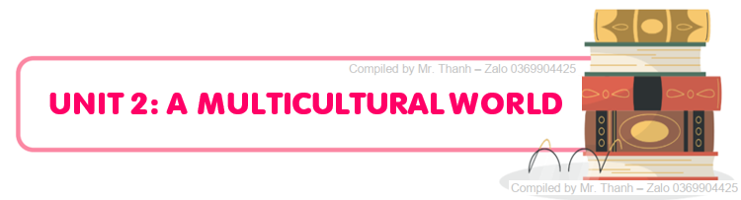

**PART I. VOCABULARY**

**a. Vocabulary**

|  |  |  |  |
| --- | --- | --- | --- |
| **Word** | **Part of speech** | **Pronunciation** | **Meaning** |
| 1. multicultural | adj | /ˌmʌltiˈkʌltʃərəl/ | đa văn hoá |
| 1. cultural diversity | n.p | /ˈkʌltʃərəl daɪˈvɜːsəti/ | đa dạng văn hoá |
| 1. cuisine | n | /kwɪˈziːn/ | ẩm thực |
| 1. booth | n | /buːð/ | gian hàng |
| 1. spicy | adj | /ˈspaɪsi/ | cay |
| 1. autograph | n | /ˈɔːtəɡrɑːf/ | chữ ký của người nổi tiếng |
| 1. souvenir | n | /ˌsuːvəˈnɪə(r)/ | đồ lưu niệm |
| 1. tug of war | n | /ˌtʌɡ əv ˈwɔː(r)/ | trò chơi kéo co |
| 1. bamboo dancing | n | /ˌbæmˈbuː ˈdɑːnsɪŋ/ | nhảy sạp |
| 1. delicious = tasty | adj | /dɪˈlɪʃəs/ = /ˈteɪsti/ | ngon miệng |
| 1. identity | n | /aɪˈdentəti/ | bản sắc, đặc điểm nhận dạng |
| 1. origin | n | /ˈɒrɪdʒɪn/ | nguồn gốc |
| 1. popularity | n | /ˌpɒpjuˈlærəti/ | sự phổ biến |
| 1. festivity | n | /feˈstɪvəti/ | ngày hội |
| 1. trend | n | /trend/ | xu hướng |
| 1. custom | n | /ˈkʌstəm/ | phong tục |
| 1. mystery | n | /ˈmɪstri/ | điều bí ẩn |
| 1. globalisation | n | /ˌɡləʊbəlaɪˈzeɪʃn/ | toàn cầu hoà |
| 1. connected | adj | /kəˈnektɪd/ | kết nối |
| 1. respect | n | /rɪˈspekt/ | khía cạnh |
| 1. dish | n | /dɪʃ/ | món ăn |
| 1. ingredient | n | /ɪnˈɡriːdiənt/ | nguyên liệu, thành phần |
| 1. unique | adj | /juˈniːk/ | độc đáo |
| 1. specialty | n | /ˈspeʃəlti/ | đặc sản |
| 1. captivate | v | /ˈkæptɪveɪt/ | thu hút, lôi cuốn |
| 1. cross-cultural | adj | /ˌkrɒs ˈkʌltʃərəl/ | giao thoa văn hoá |
| 1. blend | v | /blend/ | pha trộn |
| 1. reflect | v | /rɪˈflekt/ | phản ánh |
| 1. richness | n | /ˈrɪtʃnəs/ | sự phong phú |
| 1. appreciate | v | /əˈpriːʃieɪt/ | thưởng thức, trân trọng |
| 1. lifestyle | n | /ˈlaɪfstaɪl/ | lối sống |
| 1. celebrate | v | /ˈselɪbreɪt/ | tổ chức, ăn mừng |
| 1. extracurricular | adj | /ˌekstrəkəˈrɪkjələ(r)/ | ngoại khoá |
| 1. culture shock | n | /ˈkʌltʃə ʃɒk/ | sốc văn hoá |
| 1. language barrier | n | /ˈlæŋɡwɪdʒ ˈbæriə(r)/ | rào cản ngôn ngữ |
| 1. unfamiliar | adj | /ˌʌnfəˈmɪliə(r)/ | không quen thuộc |
| 1. insulting | adj | /ɪnˈsʌltɪŋ/ | xúc phạm |
| 1. overcome | v | /ˌəʊvəˈkʌm/ | vượt qua |
| 1. staple | adj | /ˈsteɪpl/ | cơ bản, thiết yếu |
| 1. costume | n | /ˈkɒstjuːm/ | trang phục |
| 1. admire | v | /ədˈmaɪə(r)/ | ngắm nhìn, chiêm ngưỡng |
| 1. confusion | n | /kənˈfjuːʒn/ | sự bối rối |
| 1. anxiety | n | /æŋˈzaɪəti/ | sự lo lắng |

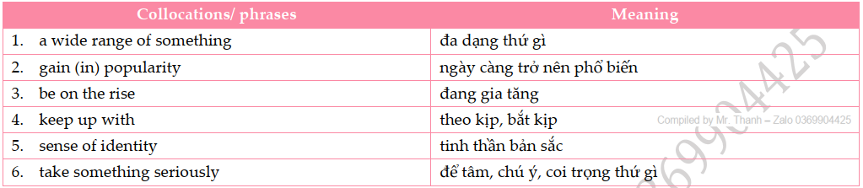**b. Collocations/ phrases**

**PART II. GRAMMAR**

**a. Article**

* **Indefinite articles (Mạo từ bất định): A/ An**

- Dùng “an” trước nguyên âm (u, e, o, a, i) hoặc phụ âm “h” không đọc rõ

E.g: an hour, an honest person….

- Dùng “a” trước danh từ/ tính từ bắt đầu bằng 1 phụ âm.

E.g: a book, a unit ……

**\*\*\* A/ an thường dùng trong các trường hợp sau**

+ Dùng trước danh từ (số ít đếm được) chưa xác định / mới đề cập lần đầu.

+ với danh từ chỉ nghề nghiệp. E.g: a doctor, an engineer

+ các từ chỉ số, số lượng. E.g: a hundred, a million, a pair of shoes, a few, a little, …

Không dùng **a/ an** trước danh từ không đếm được: E.g: sugar, milk, information, water, ....

* **Definite Article (Mạo từ xác định): The**

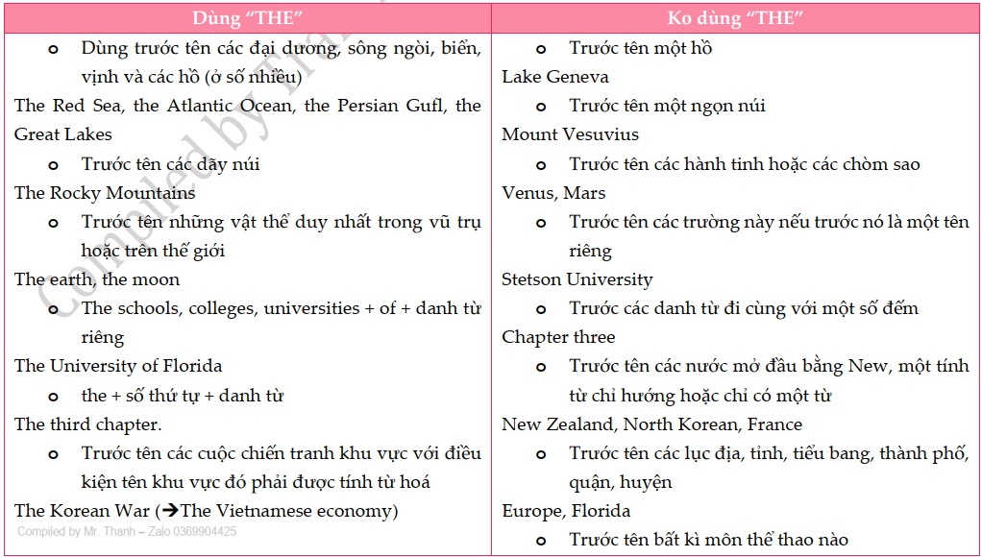

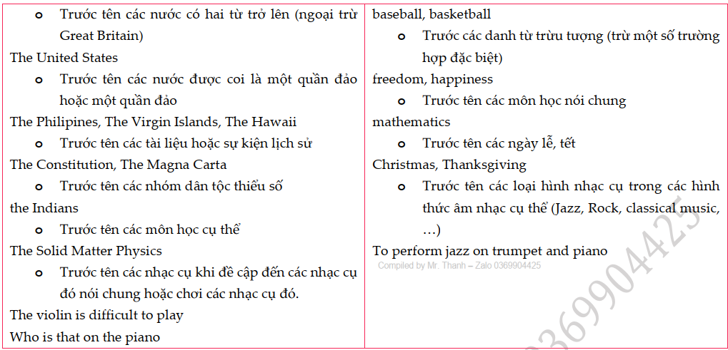

**PART III. PRACTICE**

**Exercise 1: Mark the letter A, B, C, or D to indicate the word whose underlined part differs from the other three in pronunciation in each of the following questions.**

1. A. cuisine B. spicy C. custom D. overcome
2. A. anxiety B. staple C. admire D. captivate
3. A. custom B. unique C. cultural D. cut
4. A. captivated B. blended C. appreciated D. admired
5. A. popularity B. festivity C. identity D. diversity

**Exercise 2: Mark the letter A, B, C, or D to indicate the word that differs from the other three in the position of primary stress in each of the following questions.**

1. A. lifestyle B. richness C. respect D. custom
2. A. origin B. confusion C. autograph D. specialty

# A. multicultural B. unfamiliar C. continental D. considerate

1. A. reflect B. admire C. damage  D. connect
2. A. anxiety B. ingredient C. festivity D. celebration

**Exercise 3: Mark the letter A, B, C, or D to indicate the correct answer to each of the following questions.**

1. Many festivals celebrate the _______ of their community's ancestors, showcasing traditional dances and music.

A. origin B. confusion C. lifestyle D. identity

1. The _______ of international travel has made understanding different cultures more important than ever.

A. trend B. popularity C. festivity D. origin

1. The _______ of a multicultural society is evident in the arts, where multiple influences create unique styles.

A. origin B. language barrier C. richness D. costume

1. In cities around the globe, multicultural education is on the _____, fostering understanding and respect among young minds.

A. hit B. raise C. defeat D. rise

1. Rice is a _______ food in many cultures, but each has its own distinct way of preparing it.

A. unique B. staple C. connected D. multicultural

1. What is considered a _______ in one culture may be a normal practice in another, highlighting the need for cultural sensitivity.

A. taboo B. trend C. festivity D. costume

1. _______ can mean different things in different cultures; some view it as a sign of respect, while others have a more relaxed approach to time.

A. Specialty B. Blend C. Ingredient D. Punctuality

1. Using certain gestures can be _______ in some cultures, even if they are seen as harmless in others.

A. unique B. fascinating C. insulting D. cultural

1. Cultural changes in _____ can be stressful and result in confidence and mental health.

A. specialty B. anxiety C. identity D. cuisine

1. A multicultural world celebrates a wide range _____ traditions, cuisines, and languages, enriching our global community.

A. of B. for C. to D. with

1. Festivals from different cultures gain ______ every year, as people become more curious and appreciative of diverse celebrations.

A. mystery B. specialty C. popularity D. lifestyle

1. Governments and organizations must ______ seriously the challenges and opportunities that come with a multicultural society to ensure harmony and progress.

A. take B. do C. make D. sweep

1. Moving to a new country can often lead to _______ as one encounters different customs and ways of life.

A. lifestyle B. bamboo dancing C. tug of war D. culture shock

1. In our _______ world, we can experience traditions and ideas from across the globe without leaving our homes.

A. staple B. extracurricular C. delicious D. connected

1. The variety of _______ available in any major city is a testament to the diversity of its population.

A. cuisines B. trends C. mysteries D. origins

1. Each region has its own _______, from handcrafted goods to unique culinary dishes.

A. manners B. occasions C. specialties D. norm

1. With the world changing rapidly, it's important to ______ the various cultural dynamics to remain globally connected.

A. keep on B. keep up with C. keep in with D. keep away

1. Despite the blending of cultures, individuals still maintain a strong sense of ______, often rooted in their heritage and family history.

A. origin B. identity C. festivity D. trend

1. Embracing a multicultural world enriches our lives, breaking down the _______ and fostering mutual understanding.

A. norm B. language barrier C. cuisine D. anxiety

1. What is considered the _______ in one society might be unusual or even frowned upon in another.

A. specialty B. confusion C. festivity D. norm

1. ***Bun cha*** and ***banh my*** are the two most famous street foods in Vietnam because they are ______.

A. cross-cultural B. unfamiliar C. insulting D. tasty

1. The _______ dish in Vietnam is rice; we consume it on a daily basis.

A. multicultural B. staple C. connected D. multicultural

1. My hobby is reading ______ books. It’s relaxing.

A. Ø (no article) B. an C. the D. a

1. Her favourite pastime is playing ______ piano.

A. an B. the C. a D. Ø (no article)

1. He spends at least 3 hours per day surfing ______ Internet.

A. Ø (no article) B. a C. an D. the

1. It’s undeniable that ______ Japanese is a difficult language to master.

A. an B. the C. a D. Ø (no article)

1. I had ______ terrible headache yesterday and I had to see a doctor.

A. an B. a C. Ø (no article) D. the

1. Nhung travels by ______ train to the workplace every day.

A. a B. an C. Ø (no article) D. the

1. Here’s ______ novel you want to borrow.

A. an B. the C. a D. Ø (no article)

1. Elephants can be found in ______ Africa.

A. Ø (no article) B. a C. the D. an

1. Anna is dedicated to helping ______ disabled in her neighbourhood.

A. an B. Ø (no article) C. the D. a

1. We spent nearly 1 day climbing the Mountain Everest in ______ Himalayas.

A. a B. an C. Ø (no article) D. the

1. Who was ______ last person to leave the office yesterday?

A. an B. the C. a D. Ø (no article)

1. The pace of ______ life in the countryside is much slower than that in the city.

A. Ø (no article) B. an C. the D. a

1. This school has recently adopted a new regulation to meet the demands of ______ students with disabilities.

A. an B. the C. Ø (no article) D. a

1. There’s ______ good chance that he will be offered the job.

A. a B. an C. the D. Ø (no article)

1. The weather is lovely. Let’s go for ______ picnic.

A. the B. Ø (no article) C. an D. a

1. Don’t believe in what he says. He isn’t ______ honest man.

A. Ø (no article) B. an C. the D. a

1. I stayed in ______ bed all day because I felt tired.

A. the B. Ø (no article) C. an D. a

1. Before opening this restaurant, my sister had worked as ______ interpreter.

A. an B. the C. Ø (no article) D. a

1. The article provides some interesting insights into ______ climate change.

A. a B. an C. the D. Ø (no article)

1. It was such ______ tricky question that no one in my class could answer it.

A. a B. an C. Ø (no article) D. the

1. What ______ nice shoe! I wish I had enough money to buy it.

A. the B. Ø (no article) C. a D. an

1. A lot of teachers argue that ______ history should be a compulsory subject.

A. the B. Ø (no article) C. an D. a

1. Linda was absent from school this morning because she had ______ fever.

A. an B. the C. a D. Ø (no article)

1. The trip to Hai Phong last year was ______ most memorable experience in my life.

A. a B. Ø (no article) C. the D. an

1. It’s quite ______ small hotel, but its service was top-notch.

A. a B. the C. an D. Ø (no article)

1. We had ______ enjoyable weekend in Da Nang last week.

A. an B. Ø (no article) C. a D. the

1. She enjoys watching ______ films directed by Mark Chou.

A. an B. the C. a D. Ø (no article)

1. ______ Japanese are thought to have the highest life expectancy in the world.

A. The B. an C. Ø (no article) D. a

1. Hung used to play ______ badminton with other children every afternoon.

A. the B. Ø (no article) C. a D. an

1. I found a wallet when I went back ______ home yesterday.

A. the B. an C. Ø (no article) D. a

**Exercise 4: Add "A/ AN/ THE/ X" to each of the following sentences.**

1. He made his first attempt to engage in sporting activities four years ago with **____________** support of his family.

2. He was **____________** most talented football player that our school had produced in years. His talent for **____________** football was great.

3. He did **____________** Black Mountain hike with his friends, but had to check his blood glucose levels every four hours.

4. Do you know Professor Phan Huy Le whose great achievement was his books on **____________** history of Viet Nam in **____________** 19th century?

5. **____________** following year, he took part in **____________** Melbourne Sunset run to raise funds for **____________** orphanage.

6. He wishes to straighten up and lead **____________** respectable life. He would like to be socially acceptable due to his good behavior.

7. He had to brake hard to avoid hitting **____________** truck in front.

8. Doing things with generosity will give us **____________** true happiness. **____________** more we give away, **____________** happier we are.

9. His career as **____________** journalist was full of distinguished achievements. He was **____________** respected and admired journalist.

10. Five years ago, when Edward was 35 years old, he was diagnosed with **____________** diabetes.

**Exercise 5: Read the following advertisement / announcement and mark the letter A, B, C or D to indicate the correct option that best fits each of the numbered blanks**

**➀**

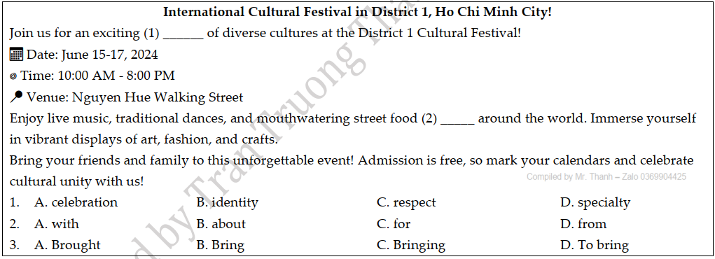

**➁**

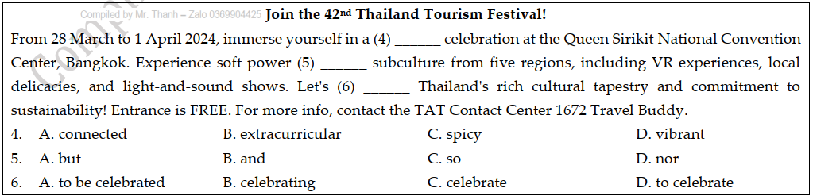

**Exercise 6: Mark the letter A, B, C or D to indicate the correct arrangement of the sentences to make a meaningful paragraph/letter in each of the following questions.**

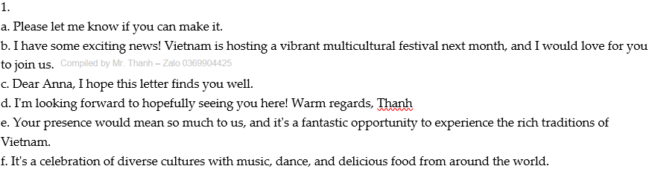

A. c – b – f – e – a – d B. c – e – a – d – b - f

C. b – f – c – a – d – e D. b – a – e – f – d – c

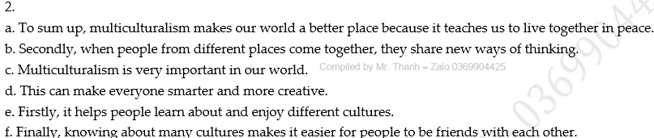

A. c – a – d – e – a B. c – e – b – d – f – a

C. b – e – d – a – c D. b – e – c – a – d

**Exercise 7: Read the following passage and mark the letter A, B, C, or D to choose the word or phrase that best fits each of the numbered blanks from 1 to 5.**

**➀** Together with the festive atmosphere Tet brings to Vietnam every year, the event is also the best time of the year for Vietnamese people to spend time on their (1) _______ life and pay respect to religious institutions. Visiting pagodas on the first days of the year has long been a (2) _______ tradition.

It has been a long-lasted custom of the people in this country each time a New Year arrival to visit pagoda. In Vietnam, the custom is described as "Lễ Chùa" - (3) _______ "lễ" means not only visiting but also showing respects in all sincerity to Buddha and Gods of the pagodas or temples. No matter how busy the Vietnamese are during the hilarious atmosphere of Tet, everyone attempts (4) _______ an incense to wish for best wishes for the New Year like healthiness, happiness and wealth. (5) _______ praying at pagodas and temples is among the best ways to go out and enjoy the spring. Mixing ones' soul with the spiritual spaces, breathing in the aroma of burning incense and flowers and enjoying relaxing glimpse in the garden of the pagodas help demolish all the stresses and worries of the previous year.

(Source: [*https://www.vietnamonline.com*](https://www.vietnamonline.com))

1. A. spirit B. spiritual C. spiritless D. spirited
2. A. deep-seated B. deep-rooted C. deep-pocketed D. deep-fried
3. A. which B. that C. in which D. when
4. A. to burn B. burning C. to burning D. burn
5. A. Beside B. Moreover C. In addition to D. Thus

**➁**  In Korea, in former days the marriage between a man and woman represented the joining of two families, rather (1) ______ the joining of two individuals. The event was often called Tae rye (Great Ritual), and people from all over the village or neighborhood participated. The ceremonies and events surrounding the actual marriage were long and (2) ______. Professional matchmakers paired up likely candidates for marriage, with the new couple often meeting for the first time at their wedding! The families considered many factors in the decision, consulting with fortune tellers for predictions about the couple's future life together. During the Chosun period, people married (3) ______ their early teens, with the girl often being several years older than the boy.

The groom usually traveled to the house of the bride for the ceremony, then stayed there for three days before taking his new bride to his family's home. The actual ceremony involved many small rituals, with many bows and symbolic gestures. The (4) ______ were expected to control their emotions and remain somber.

(5) ______ Koreans have kept several aspects of the traditional ceremony, most modern ceremonies resemble Western marriage ceremonies more than traditional Korean ones. However, many folk villages and museums across the country regularly perform ceremonies to keep the traditions alive.

1. A. as B. more C. than D. more than
2. A. elaborate B. elaboration C. eleborately D. elaborateness
3. A. for B. in C. on D.from
4. A. examiners B. competitors C. contests D. participants
5. A. As B. Although C. As though D. If only

**Exercise 8: Mark the letter A, B, C, or D on your answer sheet to indicate the correct option that best fits each of the numbered blanks from 1 to 5.**

**➀** Why is culture important and how does it answer the question " *What is cultural identity*?"? (1) ______ and beliefs that help a person relate to the world around them. It is the basis for any superstitions (2) ______. It is the aversion to specific types of meat, or which days you can work on. Culture gives us a definite starting point (3) ______. Knowing where (4) _____ from will help to define how they look at their family obligations as well as how they celebrate important milestones in life.

As a person has given up their cultural identity, they no longer can identify themselves with the things that were once the most important things in their lives. They lose direction. (5) ______ about their past and their natural traditions, their identity becomes less and less pronounced.

1. A. Culture is the underlying foundation of globalizations

B. Culture is the underlying foundation of trends

C. Culture is the underlying foundation of specialties

D. Culture is the underlying foundation of traditions

1. A. they may have B. it may have C. them may have D. their may have
2. A. when finishing to search for our roots. B. when blending to search for our roots.

C. when beginning to search for our roots. D. when overcoming to search for our roots.

1. A. a person gives up B. a person comes from

C. a person closes down D. a person looks after

1. A. As time goes by and they continue to be forget about their past

B. As time goes by and they continue forgetting about their past

C. As time goes by and they continue being forgot about their past

D. As time goes by and they continue to forget about their past

**➁** Experiencing cultural shocks involves encountering a language barrier, (1) _____, and grappling with confusion and anxiety. The language barrier (2) ______, while unfamiliar traditions and behaviours can cause confusion.

Overcoming cultural shocks requires patience, openness, and (3) ______. Initially, the experience may cause anxiety, but with time and effort, (4) ______ can gradually adjust and integrate into the new cultural environment. By embracing differences and seeking understanding, individuals can navigate cultural shocks more effectively, (5) ______ and enriched cross-cultural experiences.

1. A. when we face unfamiliar customs B. facing unfamiliar customs

C. face unfamiliar customs D. if we face unfamiliar customs

1. A. making challenging communication B. makes communication challenged

C. to make communication challenged D. makes communication challenging

1. A. a willingness to adapt B. willing to adapt

C. a willing adaptation D. adapt willingly

1. A. their B. it C. one D. mine
2. A. a leading personal growth B. lead to personal growth

C. leading to personal growth D. led to personal growth

**Exercise 9: Read the following passage and mark the letter A, B, C, or D to indicate the correct answer to each of the questions from 1 to 5.**

**➀** Culture is a strong part of people’s lives. *It influences their views, their values, their humor, their hopes, their loyalties, and their worries and fears.* If you are from New Mexico or Montana, if your parents are Cambodian, French Canadian, or Native American, if you are German Catholic or African-American, if you are Jewish or Mormon, if you are a boy or a girl, if you are a mixture of cultures your culture has affected you. So when you are working with people and building relationships with them, it helps to have some perspective and understanding of their cultures.

*But as we explore culture, it’s also important to remember how much we have in common*. A person who grew up in Tibet, will probably see the world very differently than someone who grew up in Manhattan - but both people know what it *is like to wake up in the morning and look forward to the adventures that of the day. We are all human beings*. We all love deeply, want to learn, have hopes and dreams, and have experienced pain and fear.

At the same time, we can’t pretend that our cultures and differences don’t matter. We can’t gloss over differences and pretend they don’t exist, wishing that we could be alike. And we can’t pretend that people that discrimination doesn’t exist.

People have very different views of what a multicultural society or community should be like or could be like. In the past few decades there has been a lot of discussion about what it means to live and work together in a society that is diverse as ours. People struggle with different visions of a fair, ***equitable***, moral, and harmonious society.

36. Culture has effect on the followings EXCEPT _______.

A. anxieties B. desires C. opinions D. gestures

37. If we learn about the differences among many cultures, _______.

A. we are always afraid and react to everything with fear.

B. we will look on the bright side of life and think that the future can be positive.

C. we want to love someone who experience foreign cultures with unprecedented ease.

D. we should know that the similarities between us and others who have different cultures

38. Why do we all expect something interesting when a new day come although having different cultures?

A. We know who we are B. We need love, money and health

C. We are all human beings D. We share many things in common

39. According to the passage, which of the following statements is **NOT TRUE**?

A. Culture has become an important part of our daily lives.

B. When we get acquaintance with someone, we shouldn’t know about their cultures.

C. Discrimination is still a problem in modern society.

D. People have very different attitudes towards cultural diversity.

40. The word *“****equitable****”* in the passage is **OPPOSITE** in meaning to _______.

A. one-sided B. even-handed C. touch-oriented D. impartial

**➁**

**INTERNATIONAL GIFT – GIVING CUSTOMS**

The tradition of gift giving is a worldwide practice that is said to have been around since the beginning of human beings. Over time different cultures have developed their own gift giving customs and traditions.

In France the gift of wine for the hostess of a dinner party is not an appropriate gift as the hostess would prefer to choose the vintage for the night. In Sweden, a bottle of wine or flowers are an appropriate gift for the hostess. In Vietnam, a gift of whisky is appropriate for the host, and some fruit or small gifts for the hostess, children or elders of the home. Besides, gifts should never be wrapped in black paper because this color is unlucky and **associated with** funerals in this country. Gifts that symbolize cutting such as scissors, knives and other sharp objects should be avoided because they mean the cutting of the relationship. Also, in some countries you should not open the gift in front of the giver and in others it would be an insult if you did not open the gift.

Beyond the gift itself, give careful consideration to the manner in which **it** is presented. Different culture have different customs regarding how a gift should be offered – using only your right hand or using both hand, for example. Others have strong traditions related to the appropriate way to accept a gift. In Singapore, for instance, it is the standard to graciously refuse a gift several times before finally accepting it. The recipient would never unwrap a gift in front of the giver for fear of appearing greedy.

Understanding these traditions and customs, as well as taking time to choose an appropriate gift, will help you to avoid any awkwardness or embarrassment as you seek to build a better cross – cultural relationship.

(Adapted from: [*http://www.giftypedia.com/International_gift-customs*)](http://www.giftypedia.com/International_gift-customs))

1. When did the tradition of gift-giving become popular all over the world?

A. A long time ago B. Thousands of years ago

C. Since the beginning of humans D. Since the beginning of industrialization

1. Which of the following is NOT true about gift-giving customs?

A. In France, wine is not considered a suitable gift for the hostess of a dinner party.

B. In Sweden, it is not customary to bring some wine or flowers when you are invited to a dinner party.

C. In Vietnam, such things as scissors, knives and other sharp objects shouldn’t be used as a gift.

D. In Singapore, it is unacceptable to open the gift right in front of the giver.

1. The phrase “**associated with**” is closet in meaning to ______.

A. connected with B. familiar with C. informed of D. similar to

1. The word “**it**” in paragraph 3 refer to ______.

A. consideration B. manner C. gift D. culture

1. Which of the following is the main idea of paragraph?

A. The people who are presented with gifts B. The traditions of giving and receiving gifts

C. The occasions of giving and receiving gifts D. The manners of giving and receiving gifts

**Exercise 10: Read the following passage and mark the letter A, B, C, or D to indicate the correct answer to each of the questions from 1 to 7.**

**➀** In Viet Nam festivals often take place during the three months in spring and in autumn when people have a lot of leisure time. In addition, the climate in spring and autumn is especially suitable for holding festivals and for festivals goers to enjoy.

Traditional festivals constitute a form of cultural activities, a spiritual product which the people have created and developed during the **course** of history. From generation to generation, the Vietnamese people preserve the fine tradition of “**remembering the source while drinking water**.” Festivals are events which represent this tradition of the community as well as honor the holy figures named as “gods”

the real persons in national history or legendary persons. The images of gods converge the noble characteristics of mankind. They are national heroes who fought against foreign invaders, reclaimed new lands, treated people, fought against natural calamities, or those legendary characters who affect the earthly life.

Accordingly, first and foremost, festivals are events when people pay tribute to divinities that rendered merits to the community and the nation. These are occasions when people come back to either their natural or national roots, which form a sacred part in their mind. Furthermore, festivals represent the strength of the commune or village, the local region or even the whole nation. Worshipping the same god, the people unite in solidarity to overcome difficulties, striving for a happy and wealthy life.

Moreover, festivals display the demand for creativity and enjoyment of spiritual and material cultural values of all social strata. Festivals become a form of education under which fine traditional moral values can be handed from one generation to the next in a unique way of combining spiritual characters with competition and entertainment games.

Festivals are also the time people can express their sadness and worries in a wish that gods might bestow favor on them to help them strive for a better life.

(Adapted from: *Overview of Traditional Festival – Vietnam, Country and People*)

1. What affects the time to hold festivals in Vietnam?

A. Festival holders’ timetable and festival goers’ preference.

B. The abundance of fruits and flowers and people’s health.

C. Weather conditions and people’s working pattern.

D. People’s preference of leisure time and climate.

1. Which of the followings best replace the word “course” in the second paragraph?

A. lesson B. road C. creation D. development

1. What does the author mean by saying “**remembering the source while drinking water**?”

A. Appreciating the contributing of national heroes

B. Only drinking water of clear production sources

C. Forgetting the outlet as the source is more important

D. Comparing the number of gods to the amount of water

1. What does the word “**they**” in the second paragraph refer to?

A. Images B. Gods C. Characteristics D. Invaders

1. Which of the following is NOT mentioned as a value of festivals?

A. Remembering national heroes B. Educating young generations

C. Showing community’s union D. Questioning personal bad lucks

1. According to the passage, which of the following is NOT found as a common activity in festivals?

A. Entertaining B. Fortune- telling C. Praying D. Worshipping

1. What is the best title of the passages?

A. Time, formation and meaning of traditional Vietnamese festivals

B. Social, educational and historical values of Vietnamese festivals

C. Similarities, differences and changes in Vietnamese festivals

D. When, how and why festivals in Vietnam keep their traditions

**➁** In China, New Year's Day is on the first day of the first month of the lunar calendar. The date may differ each year. It is at the end of January or in early February. People return home to China from all over the world to celebrate the day. In other countries, people who live in big cities in areas called Chinatown also celebrate.

The Chinese New Year is also called the Spring Festival. It is from the ancient tradition which marks the end of winter and the beginning of spring with a celebration. It is the start of a new growing cycle on the Earth. Family and friends get together. The event is full of colorful decorations and traditions. Chinese New Year is over 4,000 years old.

Their celebration starts on New Year's Eve. A big party is held on the next day. The entire event lasts 15 days. After the 15 days, the Lantern Festival occurs at the time of the first full moon. The families start getting ready for the event two weeks ahead of time. They clean their houses to **get rid of** all the bad luck which has accumulated in the previous year. After the celebration, a person cannot clean a room for several days or he might sweep out the good luck which has come in. Cleaning up also means apologizing to friends and paying off bills.

Red and gold are the Chinese colors. Banners in these colors are hung everywhere as decorations with wishes for good luck written on them. For the Chinese, red and gold are lucky colors. Red symbolizes life and happiness. Gold symbolizes riches. Food must be prepared ahead of time because it is unlucky to use a knife during the New Year's festival. A knife may cut off all the good luck for the New Year People decorate their houses with some of the lucky plants. Orange trees, pussy willows and mandarin trees are several which are bought.

A celebration can only begin after the family pays respect to their dead relatives. On New Year's Eve, the families go to the temple to pray for good luck in the coming year. They carry food or incense to try to please the spirits of the dead. Chinese red and gold lanterns are hung all around the towns. Firecrackers are also a big part of the celebration. They are lit outside businesses and houses to scare away bad spirits. They are also a part of the big parades.

A lion performance is acted out by two people. One holds the head and one the body of the lion. The performers put on acrobatic stunts. The lion actors run along the streets accompanied by drums, gongs and cymbals. Their purpose is to bring goodwill to all. A 'laughing Buddha' goes along with the lion actors. He teases the lion and makes him fall down and roll around. People standing along the road place red envelopes into the lion's mouth. They contain money which is a donation for whatever martial arts school is putting on the show. Sometimes a business hangs a head of lettuce from the ceiling. The actor in the lion outfit has to reach up and pick off the red envelope from inside the lettuce. Then the lion spits out the leaves to spread good luck. At the end of the performance, a scroll pops out of the lion's mouth carrying a message of good luck. The usual colors for the lion outfit are red, green and gold.

1. What topic does the passage mainly discuss?

A. Chinese New Year. B. The Preparations for New Year in China.

C. The celebration of New Year's Day in China. D. Activities in Chinese New Year.

1. What sentence is NOT true?

A. the New Year date in China may not be the same every year.

B. the Chinese New Year marks the start of winter and the end of spring.

C. The celebration is decorated with colors and traditions.

D. the Chinese New Year began to be celebrated more than 4 thousand years ago.

1. The phrase "**get rid of**" in paragraph 3 is closest in meaning to ______.

A. keep away B. clean C. remove D. welcome

1. Why don't the Chinese clean their rooms for some days after the celebration?

A. Because they spend two weeks getting ready for the event.

B. Because they want to apologize their friends.

C. As they don't want to accumulate bad lucks.

D. Because they don't want to sweep out the good luck coming in their houses.

1. The following items are used at the Chinese New Year, EXCEPT ______.

A. a knife B. lanterns C. colorful banners D. orange trees

1. According to the passage, which sentence is TRUE?

A. the Chinese go to the temple to pray for good luck on the first New Year Day.

B. Red and gold are rarely used at New Year celebration.

C. the Chinese lit firecrackers outside their houses to keep away bad spirits.

D. A pig party is celebrated on New Year's Eve.

1. According to the last paragraph, what does the lion spit out the lettuce's leaves for?

A. To bring goodwill. B. In order to spread good luck.

C. So as to carry a message of good luck. D. To run along the streets

--- THE END ---

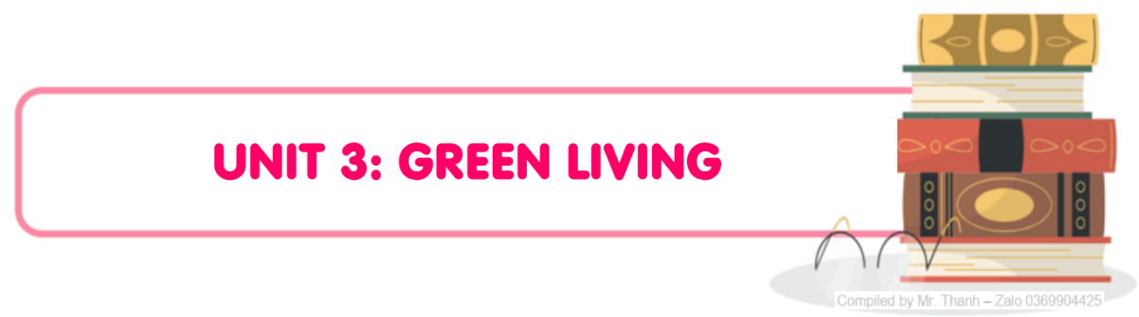

**PART I. VOCABULARY**

**a. Vocabulary**

|  |  |  |  |
| --- | --- | --- | --- |
| **Word** | **Part of speech** | **Pronunciation** | **Meaning** |
| 1. awareness | n | /əˈweənəs/ | sự nhận thức |
| 1. carbon footprint | n | /ˌkɑːbən ˈfʊtprɪnt/ | tổng lượng phát thải khí nhà kính |
| 1. resource | n | /rɪˈsɔːs/ | nguồn tài nguyên |
| 1. efficiently | adv | /ɪˈfɪʃntli/ | một cách hiệu quả |
| 1. eco-friendly | adj | /ˌiːkəʊ ˈfrendli/ | thân thiện/ tốt cho hệ sinh thái |
| 1. decompose | v | /ˌdiːkəmˈpəʊz/ | phân huỷ |
| 1. reusable | adj | /ˌriːˈjuːzəbl/ | có thể tái sử dụng |
| 1. single-use | adj | /ˌsɪŋɡl ˈjuːs/ | dùng một lần |
| 1. ecotourism | n | /ˈiːkəʊtʊərɪzəm/ | du lịch sinh thái |
| 1. waste | n | /weɪst/ | rác thải |
| 1. landfill | n | /ˈlændfɪl/ | bãi rác |
| 1. reuse | v | /ˌriːˈjuːz/ | tái sử dụng |
| 1. packaging | n | /ˈpækɪdʒɪŋ/ | bao bì |
| 1. container | n | /kənˈteɪnə(r)/ | thùng, hộp, gói |
| 1. recyclable | adj | /ˌriːˈsaɪkləbl/ | có thể tái chế |
| 1. cardboard | n/adj | /ˈkɑːdbɔːd/ | bìa cứng, làm bằng bìa cứng |
| 1. leftover | n | /ˈleftəʊvə(r)/ | thức ăn thừa |
| 1. contaminated | adj | /kənˈtæmɪneɪtɪd/ | nhiễm độc, nhiễm khuẩn |
| 1. compost | n | /ˈkɒmpɒst/ | phân hữu cơ |
| 1. sort | v | /sɔːt/ | phân loại |
| 1. layer | n | /ˈleɪə(r)/ | tầng, lớp |
| 1. household waste | n | /ˌhaʊshəʊld weɪst/ | rác thải sinh hoạt |
| 1. fruit peel | n | /ˈfruːt piːl/ | vỏ hoa quả |
| 1. pile | n | /paɪl/ | đống |
| 1. recycle | v | /ˌriːˈsaɪkl/ | tái chế |
| 1. sustainable | adj | /səˈsteɪnəbl/ | bền vững, thân thiện với môi trường |
| 1. release | v | /rɪˈliːs/ | thải ra |

**b. Collocations/ phrases**

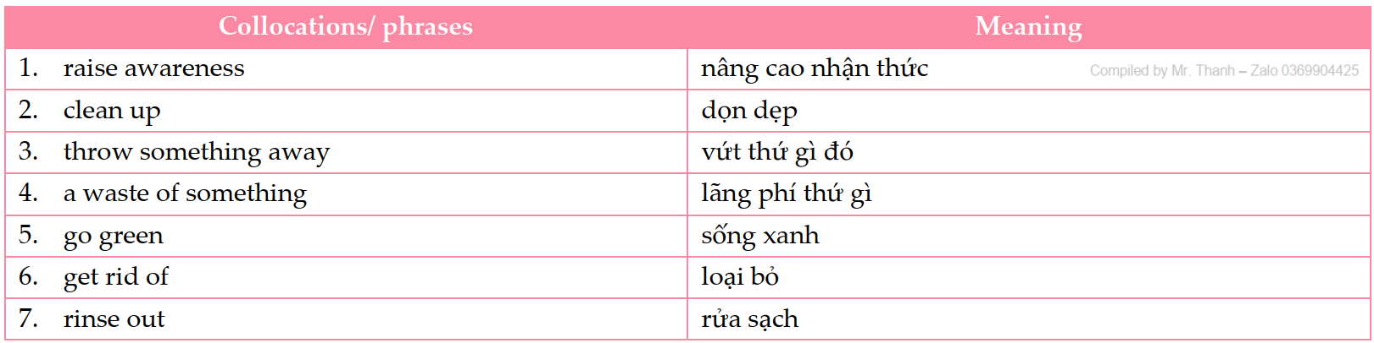



**PART II. GRAMMAR**

**a. Prepositions after certain verbs** (giới từ theo sau một số động từ)

Một số động từ thường có các giới từ đi kèm theo sau.

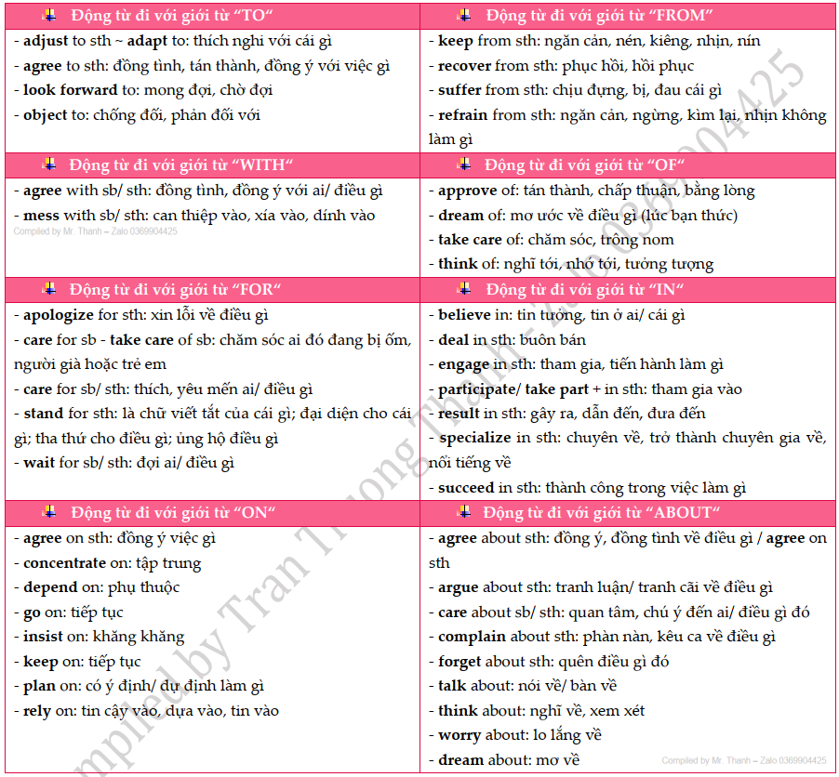

**b. Relative clauses referring to a whole sentence**



**PART III. PRACTICE**

**Exercise 1: Mark the letter A, B, C, or D to indicate the word whose underlined part differs from the other three in pronunciation in each of the following questions.**

1. A. illegal B. climatic C. benefit D. efficiently
2. A. researcher B. energy  C. number D. death
3. A. reusable B. packaging C. contaminated D. landfill
4. A. carbon B. container C. compost D. recycle
5. A. decompose B. eco-friendly C. leftover D. compost

**Exercise 2: Mark the letter A, B, C, or D to indicate the word that differs from the other three in the position of primary stress in each of the following questions.**

1. A. awareness B. container C. packaging D. recycle
2. A. release B. resource C. compost D. reuse
3. A. interview B. essential C. comfortable D. industry
4. A. compost B. footprint C. landfill D. resource
5. A. difficult B. simplicity C. discovery D. commodity

**Exercise 3: Mark the letter A, B, C, or D to indicate the correct answer to each of the following questions.**

1. Leaves and grass clippings _______quickly, making them perfect for starting a new compost pile.

A. release B. reuse C. decompose D. recycle

1. Nuclear ______ can cause serious damage to the environment if not disposed of properly.

A. packaging B. waste C. container D. leftover

1. _______sites are overflowing with waste, highlighting the urgent need for better recycling programs.

A. Landfill B. Leftover C. Resource D. Footprint

1. Community efforts to _______local parks can significantly improve the health of our environment.

A. get rid of B. go green C. rinse out D. clean up

1. Reducing our _______is essential for combating climate change and protecting future generations.

A. cardboard B. leftover C. fruit peel D. carbon footprint

1. Everyday, the world produces carbon dioxide that is ____ to the earth's atmosphere and which will still be there in one hundred years time.

A. decompose B. reuse C. recycle D. released

1. In the ____ agriculture, farmers try to limit the use of chemicals and fertilizers.

A. sustainable B. conserving C. preserving D. supporting

1. Leaving the water running while brushing your teeth is a waste _______water, a precious resource we need to conserve.

A. to B. about C. of D. for

1. Many companies are making an effort to _______ by reducing their carbon footprint and using sustainable resources.

A. get rid of B. go green C. rinse out D. clean up

1. Always _______your recyclables, like jars and bottles, to prevent contamination in the recycling process.

A. give back B. run out C. go back D. rinse out

1. Investing in renewable energy may seem costly at first, but in the long _______, it will save money and protect the environment.

A. go B. move C. take D. run

1. Organic materials can _______naturally, providing nutrients back to the earth when managed properly.

A. release B. reuse C. decompose D. recycle

1. Adopting _______practices in agriculture can lead to healthier food and less environmental degradation.

A. sustainable B. reusable C. single-use D. recyclable

1. Creating a _______bin at home is an easy way to turn kitchen scraps into valuable fertilizer for your garden.

A. waste B. container C. compost D. layer

1. Drinking water can become _______by industrial waste, so it's crucial to support clean water initiatives.

A. sorted B. decomposed C. recycled D. contaminated

1. Choosing _______materials for building projects can help conserve natural resources and reduce waste.

A. sustainable B. reusable C. single-use D. recyclable

1. What were they arguing _______?

A. at B. about C. of D. in

1. The IT specialists apologised _______ being late because of the heavy traffic.

A. for B. in C. of D. about

1. I talked _______ her about this matter.

A. for B. of C. about D. to

1. My husband specializes _______ computer software.

A. for B. about C. in D.of

1. The course in this school appeals _______ me the most.

A. by B. on C. to D. of

1. He's always boasting _______ the one time he was on TV!

A. about B. on C. at D. for

1. Poor Linda! She suffers _______ migraine headaches.

A. to B. at C. for D. from

1. How are you feeling? Have you recovered _______ your operation yet?

A. from B. to C. on D. at

1. A columnist ____ in writing a newspaper or a magazine.

A. believes B. concentrates C. responds D. specializes

1. A lot of residents had to ____ from the unexpected hurricane last month.

A. protect B. recover C. suffer D. save

1. The society tries to deal ____ young offenders ____ a variety of ways.

A. with - in B. about - to C. to - by D. around - from

1. You can never rely ____ Anna to provide you ____ information.

A. of - with B. for - to C. on - with D. on - by

1. Many people are turning to cycling, _______ is a habit that reduces carbon emissions significantly.

  A. which  B. what               C. whom                    D. who

1. Solar panels are becoming more popular, _______ is a trend that helps decrease reliance on fossil fuels.

A. that                  B. whom             C. whose              D. which

1. Using reusable bags is a small change, _______ is an action that can have a big impact on plastic pollution.

A. which                B. whose             C. who              D. whom

1. Conserving water is crucial, _______ is something we should all be mindful of in our daily routines.

A. whom B. which C. where D. that

1. Composting kitchen scraps is a practice that enriches the soil, _______ is something that also reduces landfill waste.

    A. where                B. whom             C. which                D. whose

1. Carpooling is gaining traction, _______ is a movement that can lessen traffic congestion and air pollution.

A. of which            B. whom C. whose                  D. which

1. Avoiding single-use plastics is a step towards a cleaner planet, _______ is a goal that we all need to work towards.

A. which                B. whose             C. who              D. whom

**Exercise 4: Fill each gap with an appropriate preposition.**

1. Don't worry ____________ your exam! Everything will be OK.

2. I've waited ____________ him for 30 minutes. I'm going home.

3. Stop talking and concentrate ____________ your work.

4. Don't forget to pay ____________ the meal.

5. He explained the answer ____________ me.

6. I don't know what I will do at the weekend. It depends ____________ the weather.

7. She will arrive ____________ New York at 2 p.m.

8. I like to listen ____________ music when I have free time.

9. He borrowed this book ____________ his brother.

10. Who does this car belong ____________?

**Exercise 5: Read the following advertisement / announcement and mark the letter A, B, C or D to indicate the correct option that best fits each of the numbered blanks**

**➀**

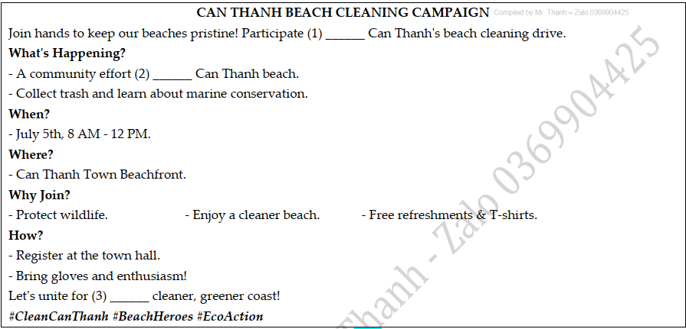

1. A. on B. with C. in D. for
2. A. to clean B. cleaning C. clean D. cleaned
3. A. an B. a C. the D. $∅$ (no article)

**➁**

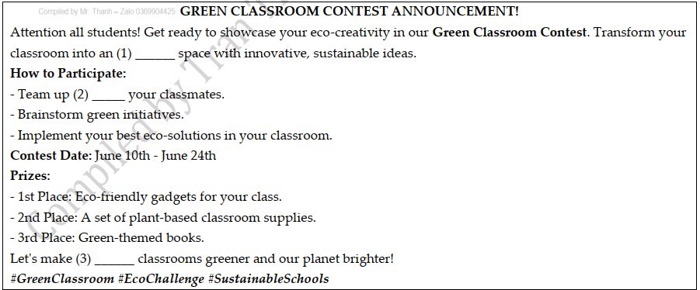

1. A. eco-friendly B. friendly C. friendship D. friendliness
2. A. to B. with C. for D. without
3. A. it B. their C. us D. our

**Exercise 6: Mark the letter A, B, C or D to indicate the correct arrangement of the sentences to make a meaningful paragraph/letter in each of the following questions.**

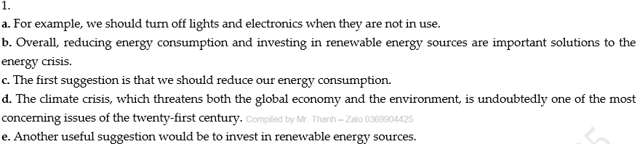

A. d-b-a-c-e B. d-c-a-e-b C. e-a-c-d-b D. c-b-d-e-a

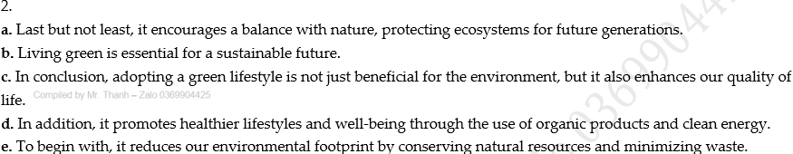

A. d-b-a-c-e B. a-c-b-d-e C. b-e-d-a-c D. b-e-a-c-d

**Exercise 7: Read the following passage and mark the letter A, B, C, or D to choose the word or phrase that best fits each of the numbered blanks from 1 to 5.**

**➀**

**GREEN ENERGY**

Fossil fuels are used to generate the majority of the world's energy, and they come in different forms. For example, coal may be burned in a power (1) ____ to generate electricity, but gasoline is burned in a car's engine to make it run. Neither of these two sources is considered green energy because they produce a lot of pollution when they are burned. In addition, they come from a source that is inevitably going to (2) ____.

Green energy can be defined as any energy source that is to some degree non-polluting. When it is called (3) ____, this means that a person can replace the same amount of energy that was consumed by that person (4) ____ that person's lifetime. Since it took millions and millions of years to create the fossil fuels that we now burn, we know that they cannot be replaced by us.

Wind power and solar power, (5) ____ harnessed properly, are two excellent sources of green energy. Once the necessary parts such as wind turbines to generate wind power and solar panels to create solar power have been produced, only the pollution from the production is left.

1. A. point B. outlet  C. factory D. plant

2. A. run out of B. run out C. burn out D. cut out

3. A. durable B. sustainable C. harmful D. effective

4. A. along B. about  C. within  D. during

5. A. where B. when  C. which  D. what

**➁**

**INTERFERING WITH NATURE**

Climate change is caused by the (1) ____ high levels of dangerous chemicals in the atmosphere, particularly carbon dioxide. It is estimated that average global temperatures will rise (2) ____ between two and six degrees by the end of this century. We all know the effects could be catastrophic, but are we (3) ____ of the possible solutions?

Crazy as it sounds, a group of academics from British universities is making a plan to build a 12-mile pipe, held up by a huge balloon, that would pump (4) ____ quantities of toxic chemicals, such as Sulphur dioxide, into the atmosphere. Surprisingly, there is good science behind the idea. The chemicals would form a (5) ____ layer around the Earth that would reflect sunlight and so cool the earth, much like the effects of a volcanic eruption.

1. A. absolutely B. extremely C. interestingly D. repeatedly

2. A. by B. with C. for D. in

3. A. able B. capable C. aware D. fond

4. A. great B. enormous C. extreme D. absolute

5. A. protecting B. protected C. protective D. protection

**Exercise 8: Mark the letter A, B, C, or D on your answer sheet to indicate the correct option that best fits each of the numbered blanks from 1 to 5.**

**➀** From the seeds themselves to the machinery, fertilizers and pesticides - The Green Revolution regimen depend heavily on technology. (1) _____. Many organic farmers use machinery, but not chemical fertilizers or pesticides. Instead of chemical soil enrichers, (2) ______, organic fertilizers that are clearly (3) _____. Organic farmers also use alternatives for pesticides, for example, they may rely on natural predators of certain insect pests. If the need arises, (4) ______ and larvae of these natural predators and introduce them into their crop fields. They use other techniques to control pests as well, like planting certain crops together because one crop repels the other's pests. Organic farmers do not need a lot of land, (5) ______ and is relatively inexpensive. Finally, many organic farmers' average yields compare favorably with other farmers' yields.

1. One alternative, however, depends much less on technology - organic farming.

B. One alternative, therefore, depends much less on technology - organic farming.

C. One alternative, however, depends much less of technology - organic farming.

D. One alternative, therefore, depends much less of technology - organic farming.

1. A., they used animal manure and plant parts not used as food - natural

B., they use animal manure and plant parts not used as food - natural

C., they using animal manure and plant parts not used as food - natural

D., they are used animal manure and plant parts not used as food - natural

1. a renewable substance  B. a renewable matter  C. a renewable resource  D. a renewable source
2. they would buy the eggs B. they can buy the eggs

C. they have bought the eggs D. they ought to buy the eggs

1. in fact, organic farming is perfectly suited to small farms

B. in fact, organic farming isn’t perfectly suited to small farms

C. but, organic farming is perfectly suited to small farms

D. and, organic farming isn’t perfectly suited to small farms

**➁**

**GREEN WITH PLASTICS!**

Plastic has become very common in our daily lives; however, most plastic items take up to 1,000 years to decompose in landfills. Can we enjoy the convenience of plastics and a greener world at the same time? (1) _____________ have sent us many emails with useful tips this week.

(Hai, 18) I try to use fewer plastic bags when shopping. The supermarket near my house even provides cardboard boxes, so I can pack my groceries and (2) _____________! When I must use plastic bags, I try to reuse them again and again instead of throwing them away after a single use.

(Ha, 16) I have learnt that most plastic containers have numbers at the bottom to show the type of plastic they're made of. So when you recycle a bottle, for instance, remove the cap because a bottle often has the number 1 on it while (3) _____________. Numbers 1 and 2 are the most widely accepted plastics for recycling.

(Phuong, 16) I know how convenient it is to buy a bottle of water from a vending machine or a supermarket; however, I always bring my reusable water bottle. All 1 have to remember is to fill my bottle before going to school, and then use the water filling stations or (4) _____________.

(Hoang, 15) I always reuse plastic takeaway containers. I use them to store portions of cooked food and keep leftovers in the fridge. This is also better for the environment.

(Binh, 17) (5) _____________, I made the mistake of putting some plastic takeaway containers container with some leftover food into the recycling bin. The next day, the whole bin was contaminated, so all the recyclables were taken to the landfill instead. So now I always rinse out containers before recycling them.

1. A. Your readers B. Their readers C. My readers D. Our readers
2. A. gets rid of plastic packaging B. get rid of plastic packaging

C. to get rid of plastic packaging D. getting rid of plastic packaging

1. A. the cap will often have number 5 B. the cap is often having number 5

C. the cap often had number 5 D. the cap often has number 5

1. A. to drink fountains at school B. having drunk fountains at school

C. fountains are drunk at school D. drinking fountains at school

1. A. When I started recycling B. Having started recycling

C. To start recycling D. Starting recycling

**Exercise 9: Read the following passage and mark the letter A, B, C, or D to indicate the correct answer to each of the questions from 1 to 5.**

**➀**

**HOW GREEN ARE OUR FESTIVAL TRADITIONS?**

Festivals come with many traditions that bring happiness and joy. However, some of these customs may

not be environmentally friendly and may need to be changed for a sustainable future. Below are three of

them.

Balloons and sky lanterns: In countries such as China, India, and Japan, releasing balloons or sky lanterns provides a spectacular sight. They are also flown to bring good luck and send wishes to the sky. However, the litter left behind by the balloons and lanterns is hard to **decompose**. The frames of the lanterns can harm wild animals, and many animals mistake the balloons for food. Lanterns also caused wildfires in the past.

Fireworks: In Australia, the US, and many other countries, there are fascinating fireworks displays that people won't want to miss. However, fireworks actually release a lot of harmful chemicals into the air. Like sky lanterns, they can also cause fires.

Christmas trees: Real or fake Christmas trees are often displayed in almost every house, office, and shop during the festive season. When Christmas is over and the real trees go to landfills, they produce methane and carbon dioxide, which are two harmful greenhouse gases. Fake trees can be reused for many years, but during their production, harmful pollutants are released into the air. And when **they** end up in landfills, they will take hundreds of years to decompose.

1. What is the passage mainly about?

A. The history and cultural significance of festivals.

B. The joy and happiness brought by different festivals

C. The environmental impact of festivals and their traditions.

D. The impact of festivals and traditions on global temperature.

1. What does the word “**decompose**” in paragraph 2 mostly mean?

A. remain intact B. be recycled and reused

C. break down naturally D. become poisonous

1. According to the passage, what potential risk do balloons and sky lanterns pose to wildlife?

A. They contribute to soil erosion. B. They block sunlight, hindering plant growth.

C. They can be mistaken for food. D. They release harmful chemicals into the water.

1. What does the word “**they**” in paragraph 4 refer to?

A. real Christmas trees B. fake Christmas trees

C. harmful pollutants D. Christmas trees' production

1. Which of the following is NOT supported by the passage?

A. Fireworks release harmful chemicals into the air but can pose a fire risk.

B. Sky lanterns and balloons are difficult to decompose and can harm wild animals.

C. Real Christmas trees release harmful pollutants during their production.

D. Artificial Christmas trees release harmful pollutants during production and decomposition

**➁** Many people go through life only thinking about their own well-being and that of those around them. In reality, the well-being of the environment is just as important in certain ways. Without a healthy and sustainable environment, their own health and ability to leave behind a sustainable planet to those who live after them is negatively affected. Therefore, two main environmental benefits can be realised with greener living.

Firstly, people can conserve natural resources. The natural resources that man has been enjoying are beginning to disappear. Due to population growth, it is estimated that the use of natural resources has more than tripled since 1970. At that rate, it is not difficult to see how these same resources will eventually become **depleted**. It is important to conserve those precious resources so that others after this generation can enjoy the same quality of living on this planet.

Secondly, people can reduce the harmful effects of climate change. Primarily due to human’s reliance on fossil fuels over the years, climate change is a real concern. People continue to release carbon dioxide into the atmosphere, further polluting the air. **This** is leading to dramatic changes in temperatures that need to be stopped. Greener living aims to do exactly that. For every person who makes an effort to reduce his or her carbon footprint in the world, climate change can begin to become less of a concern over time.

*Adapted from: https://planetrenewed.com/why-is-green-living-so-important-we-find-out*

1. Which of the following can be the best title for the passage?

A. Natural Resources B. The Benefits of Green Living

C. The Effects of Climate Change D. A Healthy Environment

1. The word “**depleted**” in paragraph 2 is CLOSEST in meaning to ________.

A. run out B. picked up C. filled in D. searched for

1. The word “**This**” in paragraph 3 refers to________.

A. the activity of releasing carbon dioxide and causing air pollution

B. the harmful effect of climate change

C. the reliance on fossil fuels

D. green living

1. According to paragraph 2, natural resources ________.

A. are not precious to human on Earth B. are hard to be conserved

C. has been used more and more since 1970s D. can not disappear

1. Which of the following is NOT TRUE according to the passage?

A. The well-being of the environment is as important as that of each person

B. Climate change is a problem because of the reliance on fossil fuels

C. Carbon dioxide contributes to air pollution

D. Climate change can only be stopped by actions of governments

**Exercise 10: Read the following passage and mark the letter A, B, C, or D to indicate the correct answer to each of the questions from 1 to 7.**

**➀** In a statistical report released by WHO, around 13 million deaths happen each year due to environmental issues. To make it worse, multiple diseases are a result of surviving in a low-quality environment. Lung diseases, asthma, stroke, issues in the heart are some of the examples. Green living such as making environment-friendly and sustainable food choices, energy conservation can help reduce pollution to some extent.

Firstly, the consumption of healthier foods can contribute to reducing pollution. People can start by consuming eco-friendly foods by buying from local farmers, buying organic and seasonal foods, etc. **They** are made of fewer pesticides that go into human bodies. Too much exposure to pesticides harms the natural hormones present in the human body and as a result, people face many health issues like lack of immunity, hormonal changes and also cancer.

Secondly, through energy conservation, people are saving both natural resources as well as money. The light bulbs and other electrical appliances that are available in the market produce 2.3 billion tons of carbon dioxide, which pollutes the air **severely**. Today there are LED bulbs available in the market that are eco-friendly and also save energy. Using such energy-efficient appliances reduces up to 30% of the annual electricity bill.

*Adapted from: https://www.greenjournal.co.uk/2021/03/how-green-living-is-so-important-in-our- lives/*

1. What is the main idea of the passage?

A. The effects of environment B. The benefits of green living

C. The consumption of healthier foods D. Low-quality environment and diseases

1. The word “**severely**” in paragraph 3 is CLOSEST in meaning to ________.

A. seriously B. trivially C. moderately D. personally

1. The word “**They**” in paragraph 2 refers to ________.

A. local farmers B. people C. eco-friendly foods D. health issues

1. According to paragraph 1, which disease cannot be caused by environmental issues?

A. asthma B. fevers C. heart diseases D. lung diseases

1. According to paragraph 2, why should people buy eco-friendly foods?

A. because they contain fewer pesticides.

B. because they are cheaper.

C. because they can encourage hormonal changes.

D. because they can cure cancer.

1. According to paragraph 3, what is true about LED bulbs and energy-efficient appliances?

A. They produce more pollution. B. They are expensive.

C. They harm natural resources. D. They save energy and money.

1. Which of the following is NOT TRUE according to the passage?

A. 13 million people die each year because of the environmental issues.

B. Using energy-saving appliances can reduce 30% of people’s electricity bills each year.

C. Pesticides cause many health risks.

D. The natural hormones cannot be harmed by pesticides.

**➁** Although noise, commonly defined as unwanted sound, is a widely recognized form of pollution, it is very difficult to measure because the discomfort experienced by different individuals is highly subjective and therefore, variable. Exposure to lower levels of noise may be slightly irritating, whereas exposure to higher levels may actually cause hearing loss. Particularly in **congested** urban areas, the noise produced as a by-product of our advancing technology causes physical and psychological harm, and detracts from the quality of life for those who are exposed to **it**.

Unlike the eyes, which can be covered by the eyelids against strong light, the ear has no lid, and is therefore, always open and vulnerable; noise penetrates without protection

Noise causes effects that the hearer cannot control and to which the body never becomes accustomed. Loud noises instinctively signal danger to any organism with a hearing mechanism, including human beings. In response, heartbeat and respiration **accelerate**, blood vessels constrict, the skin pales, and muscles tense. In fact, there is a general increase in functioning brought about by the flow of adrenaline released in response to fear, and some of these responses persist even longer than the noise, occasionally as long as thirty minutes after the sound has ceased.

Because noise is unavoidable in a complex, industrial society, we are constantly responding in the same way that we would respond to danger. Recently, researchers have concluded that noise and our response may be much more than an annoyance. It may be a serious threat to physical and psychological health and well-being, causing damage not only to the ear and brain but also to the heart and stomach. We have long known that hearing loss is America's number one nonfatal health problem, but now we are learning that some of us with heart disease and ulcers may be victims of noise as well. Fetuses exposed to noise tend to be overactive, they cry easily and they are more sensitive to gastrointestinal problems after birth. In addition, the psychic effect of noise is very important. Nervousness, irritability, tension, and anxiety increase affecting the quality of rest during sleep, and the efficiency of activities during waking hours, as well as the way that we interact with each other.

1. Which of the following is the author's main point?

A. Hearing loss is America's number one nonfatal health problem.

B. Loud noises signal danger.

C. Noise may pose a serious threat to our physical and psychological health.

D. The ear is not like the eye.

2. According to the passage, what is noise?

A. A byproduct of technology B. Physical and psychological harm

C. Congestion  D. Unwanted sound

3. Why is noise difficult to measure?

A. All people do not respond to it in the same way. B. It causes hearing loss.

C. It is unwanted.  D. People become accustomed to it.

4. The word **congested** in paragraph 1 could best be replaced by ____.

A. hazardous B. crowded  C. polluted  D. rushed

5. The word **it** in the end of the first paragraph refers to ____.

A. The quality of life B. our advancing technology

C. the noise D. physical and psychological harm

6. Look at the verb **accelerate** in paragraph 3. Which of the following is the closest meaning to it?

A. cease B. rise C. swell D. increase

7. It can be inferred from this passage that the eye ____.

A. responds to fears B. enjoys greater protection than the ear

C. increases function D. is damaged by noise

--- THE END ---

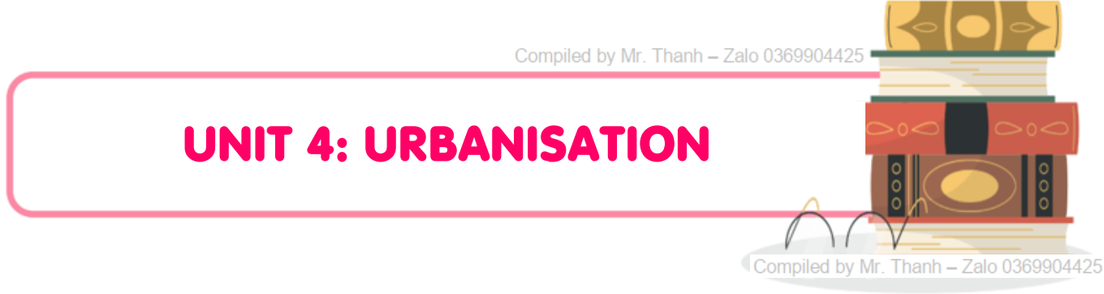

**PART I. VOCABULARY**

**a. Vocabulary**

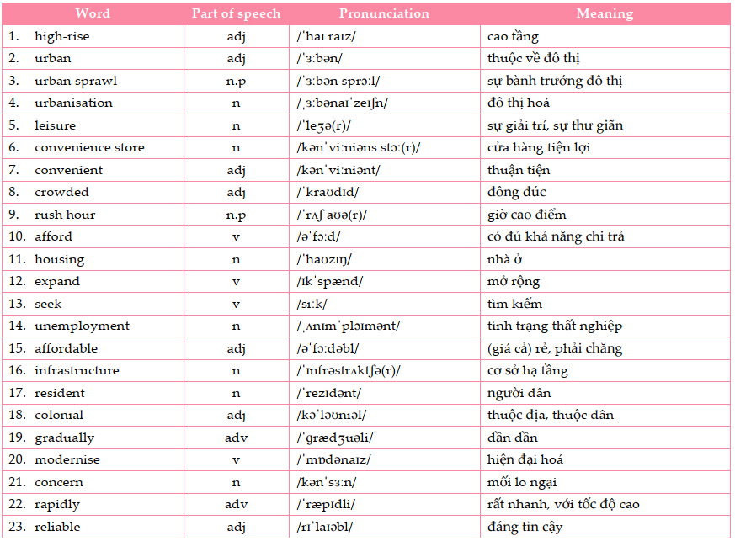

**PART II. GRAMMAR**

**a. Present perfect**

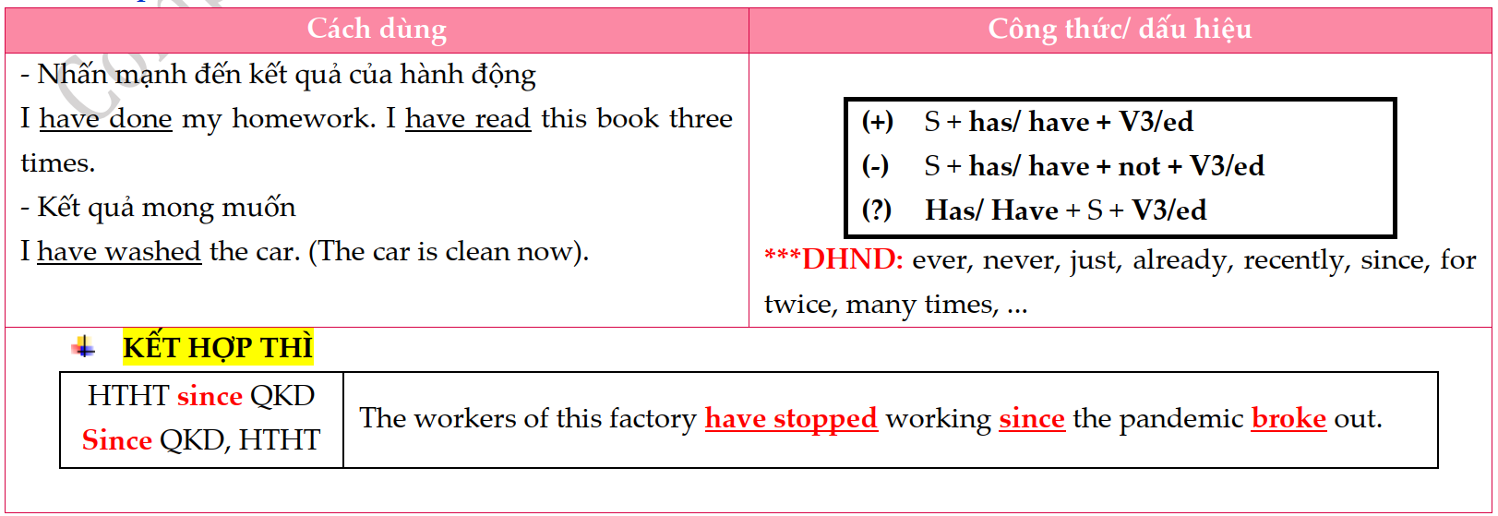

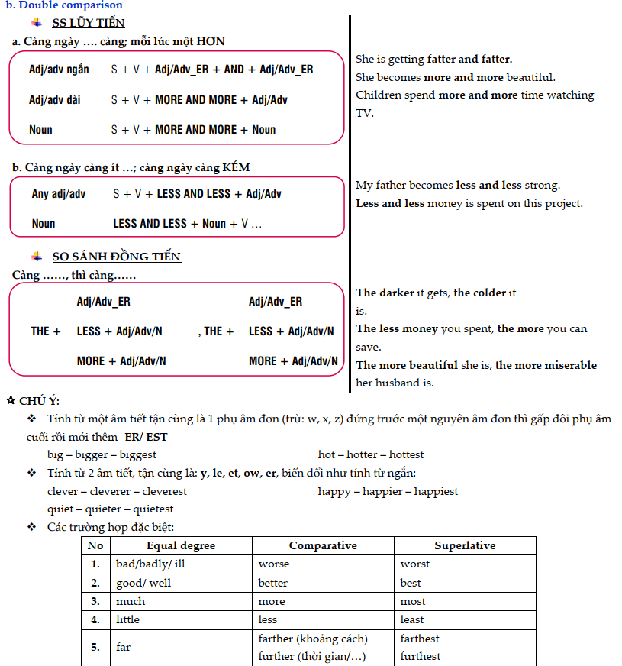

**PART III. PRACTICE**

**Exercise 1: Mark the letter A, B, C, or D to indicate the word whose underlined part differs from the other three in pronunciation in each of the following questions.**

1. A. illustrate B. identify C. inaccurate D. agricultural
2. A. prestige B. connect C. harvest  D. congestion
3. A. housing B. crisis  C. cost  D. custom
4. A. navigate B. necessitate C. inadequate D. debate
5. A. concern B. affordable C. convenience D. colonial

**Exercise 2: Mark the letter A, B, C, or D to indicate the word that differs from the other three in the position of primary stress in each of the following questions.**

1. A. confide B. comfort C. inflate D. severe
2. A. biology B. environment C. geography D. scientific
3. A. estimate B. prestigious C. proportion D. urbanity
4. A. transformation B. urbanization C. revolution D. population
5. A. agricultural B. unemployed C. sustainable D. economic

**Exercise 3: Mark the letter A, B, C, or D to indicate the correct answer to each of the following questions.**

1. The city's _________ struggled to keep up with the growing population.

A. leisure B. convenience C. infrastructure D. unemployment

1. Urbanization is occurring so _________ that it's hard for public services to maintain pace.

A. reliably B. affordably C. conveniently D. rapidly

1. Environmental _________ are increasing as urban areas continue to expand.

A. concerns B. residents C. unemployment D. Infrastructure

1. The urban _________ has led to the loss of green spaces in many cities.

A. unemployment B. housing C. leisure D. sprawl

1. Urbanization often attracts _________ looking for better employment opportunities and improved living conditions.

A. housings B. displays C. stores D. residents

1. The rapid growth of cities can lead to _________, with wealthier areas receiving more resources than poorer ones.

A. migrant B. sanitation C. inequality D. slum

1. Environmental _________ is growing as urban areas struggle to manage waste and pollution effectively.

A. unemployment B. concern C. trend D. grid

1. Living in the city is often more _________, with easy access to shops, services, and entertainment.

A. high-rise B. sharp C. steady D. convenient

1. A _________ is essential in urban areas, where the cost of living is typically higher than in rural regions.

A. population density B. living wage C. convenience store D. urban sprawl

1. Despite the prosperity of cities, _________ remains a significant challenge, affecting millions of urban dwellers.

A. fine B. poverty C. density D. leisure

1. Many _________ move to cities in search of a better life, but they can face challenges such as discrimination and social isolation.

A. migrants B. slums C. stores D. concerns

1. _________ rates can soar in cities when there is a mismatch between the skills of workers and the jobs available.

A. Infrastructure B. Resident C. Unemployment D. Sanitation

1. The city's _________ of public transportation systems has made commuting much easier for its growing population.

A. fluctuate B. upgrade C. seek D. afford

1. As urbanization continues, the skyline is increasingly dominated by _________ apartment buildings to accommodate more residents.

A. urban B. convenient C. high-rise D. colonial

1. One of the challenges of urbanization is ensuring that housing remains _________ for all income levels.

A. gradual B. affordable C. crowded D. sharp

1. A_________ network of services, including electricity and water supply, is essential for the functioning of densely populated urban areas.

A. colonial B. crowded C. urban D. reliable

1. He has gone to the UK for further education since he ______ upper secondary school.

A. finished B. is finishing C. will finish D. finish

1. Peter has played football ________ he was a child.

A. for B. so  C. since D. because

1. She _________ two miles and a half, and now she feels exhausted.

A. has run B. was running C. will have run D. has been running

1. I can’t find my eraser. Have you seen it ________?

A. never B. before C. recently D. just

1. My father ____.

A. has never smoked B. will never smoke C. did never smoke D. have never smoked

1. We ____ Lisa recently.

A. won’t see B. haven't seen C. didn’t see D. are going to see

1. I ____ fifteen phone calls this morning.

A. am being made B. have been made C. was making D. have made

1. ____ anything so strange in your life?

A. Did you ever hear B. Was you ever hearing C. Have you ever heard D. Do you ever heard

1. My job gets ____ every year.

A. harder and harder B. harder and more harder C. more harder and harder D. more and more harder

1. She's getting over her operation. She feels ____.

A. gooder and gooder B. better and better C. more better and better D. more and more better

1. The market for tablets is becoming ____ all the time.

A. competitiver and competitiver B. more and more competitive

C. more competitiver and competitiver D. more competitive and competitive

1. My dad's eyesight is getting ____. He can hardly see anything these days.

A. more worser and worser B. more and more worse

C. worse and worse D. worser and worser

1. Thanks to the progress of science and technology, our lives have become ____.

A. more and more good B. better and better

C. the more and more good D. gooder and gooder

1. Unfortunately, her illness was ____ than we thought at first.

A. serious B. serious and serious C. more and more serious D. the most serious

1. It gets ____ when the winter is coming.

A. cold and cold B. the coldest and coldest C. colder and colder D. more and more cold

1. There were a lot of people on the bus. It was ____ than usual.

A. crowded B. more and more crowed C. a bit crowded D. the most crowded

1. The more tasks I need to finish, ______ stressed I become.

A. the most B. more than C. the more than D. the more

1. It’s believed that ______ young people choose not to attend college.

A. more and more B. more and most C. the more and more D. the most and the most

1. The more expensive a product is, ______ high-quality it seems.

A. the most B. the more C. more than D. most of

**Exercise 4: Complete each of the following sentences, using the structure comparative + and + comparative with the word in brackets.**

1. It is becoming __________________ to find a job. (hard)

2. His visit to New York seemed to get __________________ because he was very busy at work. (short)

3. Eating and travelling in this city is getting __________________. (expensive)

4. As the day went to the weather got __________________. (bad)

5. We had to shop the discussion because the question we becoming __________________. (complicated)

6. Your English is Ok now, your pronunciation has got __________________. (good)

7. Little John is becoming __________________. (active)

**Exercise 5: Combine the sentences, using DOUBLE COMPARATIVE**

1. She studies hard, she will get good grades.

🡲

2. You rest much, you will feel better.

🡲

3. The weather is warmer, I feel better.

🡲

4. We leave early, we will arrive soon.

🡲

5. We have much knowledge, we become wise.

🡲

6. You are young, you learn easily.

🡲

7. The hotel is expensive, the services are good.

🡲

8. You use much electricity, your bill will be high.

🡲

9. I thought about the plan, I like it little.

🡲

10. He is old, he learns slowly.

🡲

11. She eats much, she will become fat.

🡲

12. She is older, she becomes more beautiful.

🡲

13. You have much, you want more.

🡲

14. I waited long. I got angry.

🡲

15. I live far. I feel homesick.

🡲

**Exercise 6: Read the following advertisement / announcement and mark the letter A, B, C or D to indicate the correct option that best fits each of the numbered blanks**

**➀**

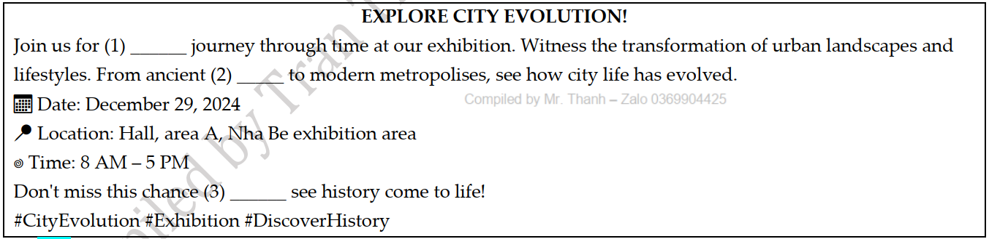

1. A. a B. an C. the D. no article
2. A. leisures B. concerns C. settlements D. unemployments
3. A. for B. with C. to D. in

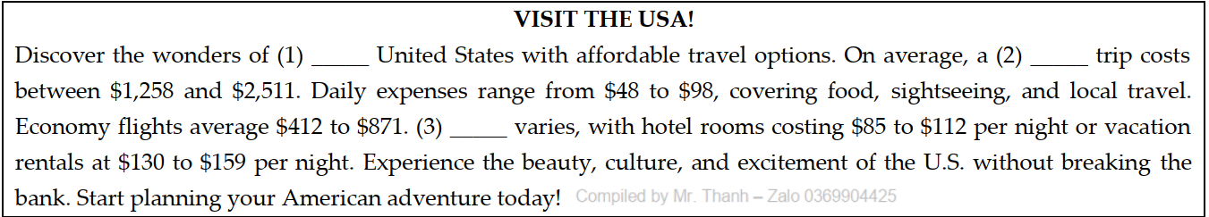**➁**

1. A. no article B. an C. a D. the
2. A. one-week trip B. week one trip C. trip one week D. one-weeks trip
3. A. Convenience B. Infrastructure C. Accommodation D. Urbanisation

**Exercise 7: Mark the letter A, B, C or D to indicate the correct arrangement of the sentences to make a meaningful paragraph/letter in each of the following questions.**

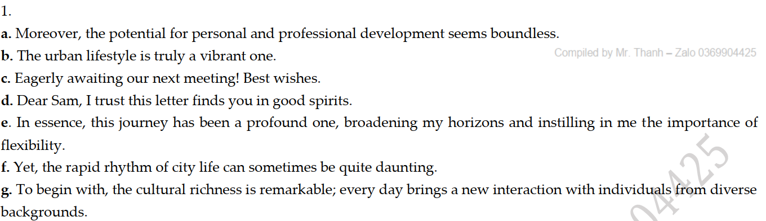

A. d – b – a – g – f – e – c B. d – a – b – g – f – e – c

C. d – b – g – a – f – e – c D. d – b – g – f – a – e – c

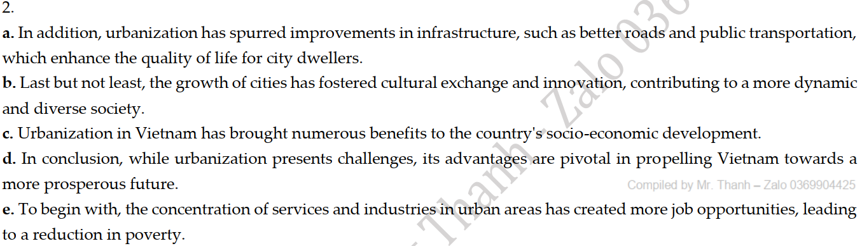

A. c – e – a – b – d B. c – e – a – b – d C. c – e – a – b – d D. c – a – e – b – d

**Exercise 8: Read the following passage and mark the letter A, B, C, or D to choose the word or phrase that best fits each of the numbered blanks from 1 to 5.**

**➀**

Rapid urbanization can hold long-term economic, social and environmental promise for developing if investments made now in infrastructure, housing and public services are efficient and sustainable, the World Bank says in a new report. In the next two decades, cities are (1) __________ to expand by another two billion residents, as people move in unprecedented numbers from rural areas to pursue hopes and aspirations in cities. More than 90 per cent of this urban population growth is expected to occur in the developing world, (2) __________ many cities are already struggling to provide basic (3) ___________ such as water, electricity, transport, health services and education. Report authors note that (4) ___________ new urban growth will not take place in the “megacities” of the world e.g. Rio de Janeiro, Jakarta or New Delhi (5) __________ rather in less commonly recognized “secondary” cities - places like Fushun in China, and Surat in India. To help policymakers prepare for and manage growth, the report distills lessons learned from 12 countries across all geographic regions and stages of urbanization. It then translates these global lessons into practical policy advice.

1. A. predictable B. predicted C. predicting D. predictions

2. A. where B. what C. which D. why

3. A. demands B. orders C. needs D. uses

4. A. almost B. most C. mostly D. nearly

5. A. but B. nor C. or D. yet

**➁**

**SUSTAINABLE CITIES: A CLEANER FUTURE**

For the past few decades, there has been an urbanization trend around the world, where more and more people are moving to cities. Since 2009, the UN Habitat (1) ______ that over 3 million people are moving into cities every week. Urban areas have been an (2) ______ destination for migrants in anticipation of finding a better job and a higher standard of living.

While migrants contribute immensely to the economies of cities, ever-increasing populations raise issues of congestion, distribution of resources, and increased pressure on waste management infrastructure, healthcare, and education. By 2050, it is estimated that 70% of the world's population will live in cities (3) ______ makes the concept of Sustainable Cities an efficient resolution to the growing population.

(4) ______, Sustainable Cities have an essential role in the urbanization trend to improve residents lives by focusing on environmental initiatives and projects such as limiting CO2 gas emissions in the air, using renewable energy sources, or bringing awareness to environmental issues. With outdoor pollution killing over 3 million lives yearly, (5) _______ in cities, it is evident that urbanization can increase the environmental effect upon cities. Many cities around the world have redesigned their city planning strategies and commenced initiatives to target these issues directly.

1. A. estimates B. expects  C. claims  D. counts

2. A. attraction B. attracts C. attractive D. attractively

3. A. whom B. when C. who D. which

4. A. Moreover B. Therefore C. As regards D. However

5. A. the most B. almost C. equally  D. mostly

**Exercise 9: Mark the letter A, B, C, or D on your answer sheet to indicate the correct option that best fits each of the numbered blanks from 1 to 5.**

**➀**

**AN URBANISING WORLD**

More than two thirds of the world's urban population is now in Africa, Asia and Latin America. Since 1950, (1) _______. Rapid urban growth has also brought a huge increase in the number of large cities, including many that have reached sizes that are historically unprecedented. Just two centuries ago, there were only two "million cities" worldwide (that is, cities with one million or more inhabitants) - London and Beijing (Peking). (2) ______ Most of these million cities are in Africa, Asia, and Latin America, and many have populations that have grown more than tenfold since 1950. Brasilia, the federal capital of Brazil, did not exist in 1950 and now has more than 2 million inhabitants.

"Mega-cities," with ten or more million inhabitants are a new phenomenon. The first city (3) ______ was New York in around 1940. There were 12 mega-cities by 1990 (the latest year for which there are relatively accurate statistics as data for 2000 censuses are not available or censuses are scheduled for 2001); seven were in Asia, three in Latin America, and two in the United States. In 1800, the (4) ______ was fewer than 200 000 inhabitants but now it is over 5 million. These statistics give the impression of rapid urbanization that is primarily (5) ______ large cities. But this is not the case.

1. the urban population of these regions has grown more than fivefold.

B. the urban population of these regions has decreased more than fivefold.

C. the urban population of these regions has grown most than fivefold.

D. the urban population of these regions has decreased less than fivefold.

1. A. By 1950, there were 80; today there were over 300. B. By 1950, there is 80; today there are over 300.

C. By 1950, there were 80; today there are over 300. D. By 1950, there were 80; today there are an over 300.

1. A. reach this revenue B. to reach this size

C. reaching this size D. to be reached this revenue

1. high-rise size of the world's 100 tallest cities

B. crowded size of the world's 100 largest cities

C. affordable size of the world's 100 most comfortable cities

D. average size of the world's 100 largest cities

1. A. focused on B. amazed at C. independent of D. impressive on

**➁**

Urbanisation is the rapid expansion of cities, characterised by urban sprawl and a large number of migrants (1) ______. As cities expand, so does (2) ______ to support growing populations. Many migrants move to urban areas to make a living, contributing to the urbanisation trend.

However, with this expansion comes concern about the strain on resources and services. Urbanisation transforms landscapes and societies, reshaping (3) ______. While it offers economic prospects, urbanisation also poses challenges in managing resources and (4) ______. Thus, urbanisation's impacts on communities and environments (5) ______.

1. A. who seeks better opportunities B. seeking better opportunities

C. that seeking better opportunities D. where they are seeking better opportunities

1. A. the infrastructure for demand B. demanding infrastructure

C. infrastructure demanding D. the demand for infrastructure

1. A. the way people live and work B. people live and work

C. when people live and work D. to live and work

1. A. ensuring fair access to opportunities B. to ensure fair access to opportunities

C. that ensures fair access to opportunities D. ensured fair access to opportunities

1. A. remain a concern pressing worldwide B. remain a worldwide concern pressing

C. remain a pressing concern worldwide D. remains a pressing concern worldwide

**Exercise 9: Read the following passage and mark the letter A, B, C, or D to indicate the correct answer to each of the questions from 1 to 5.**

**➀**

Where the significance of migration to cities is recognised, it is widely seen as a problem. In 2013, a UN study of all 193 UN member states found that 80 per cent had policies to reduce rural to urban migration. This figure has risen substantially in recent decades, up from only 38 per cent in 1996. It is also more **pronounced** in poorer countries: 88 per cent of the least developed countries reported policies to reduce migration to urban areas.

But this negative attitude towards migration to cities may well be mistaken. The WMR argues that problems of access to services – such as housing, sanitation, education or employment – that result from rural to urban migration, are not inevitable. Rather, they are caused by poor planning. Although all socio- economic classes are reflected in migration to cities, migrants from rural areas are disproportionately poor, and inadequate planning is often a result of a weak political will to support **them**.

In this way, migrants who come to cities can help diversify the networks that the city can draw upon – for instance, by linking cities to broader global networks. Perhaps the most famous example of this is Eastleigh in Nairobi. Known as “Little Mogadishu”, this neighbourhood has become a vibrant, global commercial hub, powered by enterprising members of the Somali, Ethiopian and Kenyan diasporas.

(Adapted from *citymetric.com*)

1. What could be the passage mainly about?

A. Migrants coming to urban areas from rural areas

B. Migrants coming to urban areas to find jobs

C. The effects of rising migrant numbers in urban areas

D. The analysis on why rural migrants migrate to urban areas

2. The word “**pronounced**” in the first paragraph is closet in meaning to____________.

A. ambiguous B. stable C. evident D. vague

3. Which of the following is NOT mentioned as a consequence of increasing number of rural residents moving to cities?

A. Poor access to services such as housing B. Problems with sanitation

C. Difficulties to find employment D. Overcrowding in the cities

4. The word “**them**” in paragraph 2 refers to ____________.

A. politicians B. migrants C. citizens D. poor people

5. Which of the following is TRUE, according to the passage?

A. 80 UN members states had policies aimed at reducing rural to urban migration.

B. Problems resulting from rural to urban migration linked to access to services are unavoidable.

C. Migrants who come to cities will help diversify the networks from which the city can depend on.

D. Eastleigh in Nairobi is considered the poorest city in the world.

**➁** The increase in urbanization causes different problems. Air and water pollution are amongst the major issue we have to **tackle**.

In the first place, cars, factories and burning waste emit dangerous gases that change the air quality in our cities and pose threats to our health. Dangerous gases such as carbon dioxide and nitrogen oxides cause respiratory diseases, for instant, bronchitis and asthma **those** are also proved to have long-term effects on the environment.

Furthermore, with the increased population, it becomes difficult to manage the waste generated in cities. Most of the waste is discharged or dumped into rivers or onto streets. The waste pollutes water and makes it unfit for human consumption. Subsequently, it becomes more and more difficult for city dwellers to get clean water. Some cities in Africa are unable to provide adequate water supply because most of the water is lost in pipe leakages. In fact, most city dwellers in developing countries are forced to boil their water or to buy bottled water, which is very expensive.

There are several actions that could be taken to eradicate the problems described above. Firstly, a simple solution would be joining community efforts to address problems affecting your city. Ask your parents, friends and relatives to join in as well. These efforts might include clean-up campaigns, recycling projects and a signature campaign to ask the government to do something about the situation. A second measure would be encouraging your teacher to talk about these problems and to discuss how young people can help to solve them. Finally, writing to local organizations working on these issues for ideas on how you can contribute to solve them.

1. The word **tackle** in paragraph 1 is closest in meaning to ______.

A. deal with B. make up C. try on D. turn down

2. The word **those** in paragraph 2 refers to ______.

A. bronchitis and asthma B. carbon dioxide and nitrogen oxides

C. dangerous gases D. respiratory diseases

3. According to the passage, in some cities in Africa ______.

A. people are allowed to dump waste into rivers and on streets

B. people aren't provided enough water due to leaking pipes

C. people have found some solutions to the problems

D. people would rather use boiling water and bottled water

4. Which of the following is NOT true according to the passage?

A. City problems should be taught and be topic for students to discuss at school.

B. Children must ask for their parent's permission before joining community efforts.

C. Participators might take part in different kinds of projects and campaigns.

D. People can contribute in solving the problems by writing to local organizations working on these issues.

5. Which of the following would serve as the best title for the passage?

A. Environment degradation: Air and water pollution

B. Environmental pollution: Problems and actions

C. Increasing urbanization: Causes and effects

D. Increasing urbanization: Effects and solutions

**Exercise 11: Read the following passage and mark the letter A, B, C, or D to indicate the correct answer to each of the questions from 1 to 7.**

**➀** Tokyo, with a population of 33 million people, is by far the largest city in world. It’s also the most technologically advanced, and the city runs like digital clockwork. The automated subway, for example, is so efficient that it is able to transport almost eight million commuters every day and on the rare occasions that **it** goes wrong, nobody believes it. If you are late for work in Tokyo and, as an excuse, you say that your train was late, you need to provide written proof from the train company. The idea of late trains is almost unthinkable. There is very little crime, violence, or vandalism in Tokyo and the streets are safe to walk by day or night. There is also relatively low unemployment compared to other big cities in the world.

But such a huge population creates serious problems of space, and as Marr flew over Tokyo in a helicopter he saw football pitches, playgrounds, even driving schools constructed on top of buildings. Streets, parks, and subways are extremely **crammed**. Property prices are so high and space is so short that a family of six people may live in a tiny flat of only 25 square metres.

There are other problems too, of alienation and loneliness. The Hikikomori are inhabitants of Tokyo who cannot cope with ‘the mechanical coldness and robotic uniformity’ of a megacity and have become **recluses**, rarely or never leaving their homes. There is also a new business that has grown up in Tokyo which allows friendless people to ‘rent a friend’ to accompany them to a wedding or just to sit and chat to them in a bar after work.

Another strange group of people are the Hashiriya, Tokyo’s street racers who risk their lives driving at ridiculous speeds along the city streets. During the week these men have ordinary jobs and they’re model citizens. But on Saturday nights they spend the evening driving though the city as fast as they possibly can. It’s a deadly game, but it’s just one way of escaping the daily pressures of life in the metropolis.

(Adapted from *New English File* by Clive Oxenden and Christina Latham-Koenig)

1. What best serves as the title for the passage?

A. Tokyo: A city of alienation and loneliness B. Tokyo: A prime example of a megacity

C. Tokyo: How to avoid missing trains? D. Tokyo: The most developed city in the world

2. The word “**it**” in the first paragraph refers to ____________.

A. automated subway B. Tokyo C. digital clockwork D. train company

3. According to paragraph 1, why does the idea of late trains seem implausible in Tokyo?

A. because the trains are automated

B. because it is capable of transporting nearly eight million commuters every day

C. because it is sponspored by train companies

D. because it is so effective that it just goes wrong on rare occasions

4. The word “**crammed**” in the second paragraph is closet in meaning to____________.

A. spacious B. occupied C. packed D. busy

5. The word “**recluses**” in paragraph 3 mostly means____________.

A. hermits B. introverts C. monks D. ascetics

6. Which of the following is NOT mentioned about Tokyo in the passage?

A. Due to the severe space shortage, property prices are so high.

B. In Tokyo, a new business has been growing, allowing single people to rent a boyfriend or a girlfriend.

C. Some individuals tend to avoid going outside due to isolation and loneliness.

D. During the week, the Hashiriya are model cirizens and Tokyo’s street races on Saturday nights.

7. Which of the following can be inferred from the passage?

A. Japanese government is planning to invest more in constructing schools on top of buildings.

B. People in Tokyo are too busy to even make friends.

C. Tokyo is a wealthy city, but it may be difficult to live there because of overcrowding and busy lifestyles.

D. Living in Tokyo would make you solitary and stressed because of the busy environment.

**➁** Buying a house is the single largest financial investment an individual makes. Yet, in India this act is fraught with risk and individuals depend on weak laws for justice. Occasionally, deviant promoters are called to account as was the case in the detention of Unitech's promoters. This incident shows up the fallout of an absence of proper regulation to cover contracts between buyers and real estate promoters. A real estate bill, which is presently pending in Rajya Sabha, seeks to fill this gap. It has been debated for over two years and should be passed by Parliament in the budget session.

India is in the midst of rapid urbanization and urban population is expected to more than double to about 900 million over the next three decades. Unfortunately, even the current population does not have adequate housing. A government estimate in 2012 put the shortage at nearly 19 million units. If this shortage is to be **alleviated** quickly, India's messy real estate sector needs reforms.

The real estate bill seeks to set standards for contracts between buyers and sellers. Transparency, a rare commodity in real estate, is enforced as promoters have to upload project details on the regulators' website. Importantly, standard definitions of terms mean that buyers will not feel cheated after taking **possession** of a house. In order to protect buyers who pay upfront, a part of the money collected for a real estate project is ring-fenced in a separate bank account. Also, given the uncertainty, which exists in India on land titles, the real estate bill provides title insurance. This bill has been scrutinized by two parliamentary committees and its passage now brooks no delay.

This bill is an important step in cleaning up the real estate market, but the journey should not end with it. State governments play a significant role in real estate and they are often the source of problems. Some estimates suggest that real estate developers have to seek approvals of as many as 40 central and state departments, which lead to delays and an **escalation** in the cost of houses. Sensibly, NDA government's project to provide universal urban housing forces states to institute reforms to access central funding. Without real estate reforms at the level of states, it will not be possible to

1. According to the passage, which of the following is the pending in Rajya Sabha?

A. NDA government's new scheme B. Universal rural housing programme

C. Real estate bill D. Universal urban housing programme

2. Which of the following is NOT true according to the passage?

A. Current population does not have adequate housing in India.

B. India's real estate sector needs reforms.

C. Real state bill has been scrutinized by two parliamentary committees.

D. Urban population is expected to more than double to about 850 million over the next three decades.

3. According to the passage, what is the source of problem in real estate?

A. Buyers and sellers B. Central governments

C. Market money makers D. State governments

4. The word **alleviated** in the second paragraph is **OPPOSITE** in meaning to ________.

A. aggravated B. deaden C. diminished D. relieved

5. The word **possession** in the third paragraph refers to _________.

A. lease B. need C. proprietary rights D. renting

6.The word **escalation** in the forth paragraph refers to _________.

A. decrease B. growth C. reduction D. Sustainability

7.It is impossible to meet the ambition of making housing accessible for urban dwellers _________.

A. with real estate reforms at state level B. without support of central government

C. without passing the bill in Rajya Sabha D. without real estate reforms at the level of state

--- THE END ---

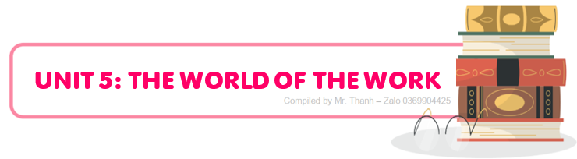

**C:\Users\ADMIN\Pictures\Screenshots\THANH.png**

**PART I. VOCABULARY**

**a. Vocabulary**

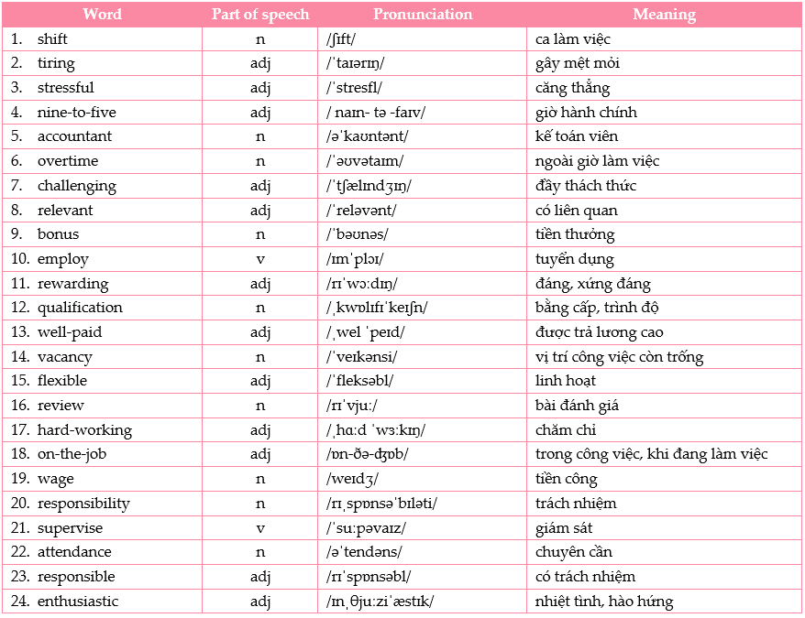

**b. Collocations/ phrases**

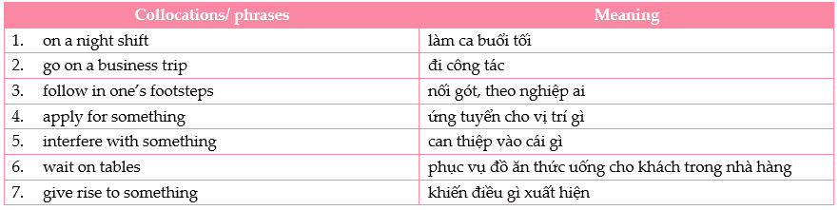

**PART II. GRAMMAR**

**a.** **Simple sentences**

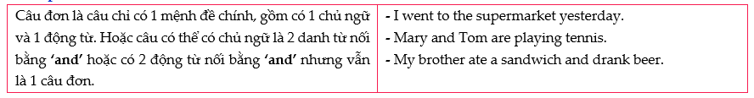

**b. Compound sentences**

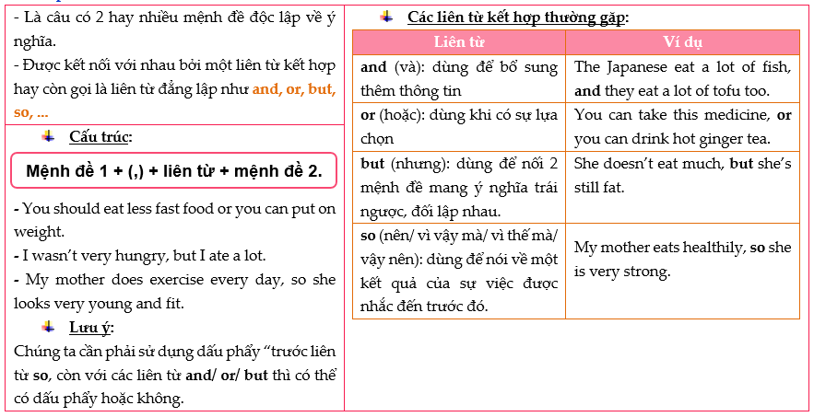

**c. Complex sentences**

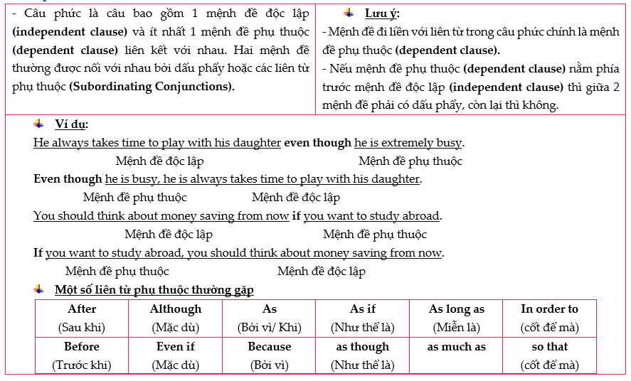

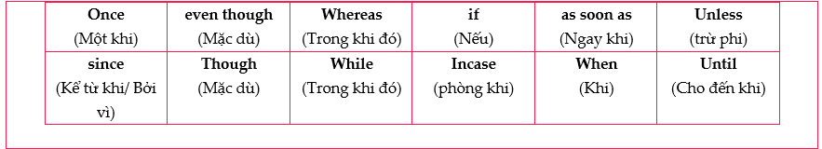

**PART III. PRACTICE**

**Exercise 1: Mark the letter A, B, C, or D to indicate the word whose underlined part differs from the other three in pronunciation in each of the following questions.**

1. A. organized B. prioritize C. important D. opportunity
2. A. challenging B. energetic C. management D. organized
3. A. relevant B. review C. academic D. potential
4. A. enthusiastic B. qualification C. shift D. overtime
5. A. rewarding B. relevant C. stressful D. flexible

**Exercise 2: Mark the letter A, B, C, or D to indicate the word that differs from the other three in the position of primary stress in each of the following questions.**

1. A. bonus B. employ C. attend D. review
2. A. accountant B. attendance C. hard-working D. supervise
3. A. explore B. destination C. magnificence D. accessible
4. A. organization B. enthusiastic C. compassionate D. qualification
5. A. prioritise B. energetic C. communicate D. responsible

**Exercise 3: Mark the letter A, B, C, or D to indicate the correct answer to each of the following questions.**

1. Helping others through social work can be incredibly _______, despite the emotional challenges it may present.

A. stressful B. challenging C. responsible D. rewarding

1. A fair _______ is crucial for workers to support themselves and their families, reflecting the value of their labor.

A. fare B. pension C. wage D. fine

1. _______ a team requires not only leadership skills but also empathy and the ability to motivate others.

A. Attending B. Shifting C. Employing D. Supervising

1. Nurses often work in shifts, with some covering the day _______ and others working through the night.

A. overtime B. shift C. bonus D. qualification

1. Due to increased demand, the factory has many _______ for skilled workers ready to start immediately.

A. responsibilities B. reviews C. wages D. vacancies

1. During the holiday season, many retail workers put in _______ to manage the surge in customers.

A. qualification B. vacancy C. overtime D. shift

1. The introduction of automation in manufacturing can _______ new job opportunities in technology and maintenance.

A. give rise to B. wait on C. interfere with D. apply for

1. Volunteers often contribute _______ work, which is invaluable to non-profit organizations and community projects.

A. adaptable B. patient C. unpaid D. well-paid

1. A _______ employee is a valuable asset to any company, often entrusted with greater responsibilities.

A. reliable B. demanding C. repetitive D. stressful

1. _______ dress codes are becoming more common in workplaces that prioritize comfort and personal expression.

A. Tiring B. Repetitive C. Organised D. Casual

1. Being _______ in today's fast-paced work environment is essential for career growth and success.

A. unpaid B. organised C. confident D. adaptable

1. Learning to _______ effectively can increase productivity, but it's also important to focus on quality.

A. interfere B. multitask C. endure D. demand

1. The house was destroyed in the fire, _________ fortunately, the whole family was saved.

A. and B. however C. but D. so

1. Our family love Thai food, _________ we order it once a week.

A. so B. and C. for D. because

1. Jill should show up on time, __________, he can’t enter.

A. however B. otherwise C. even though D. nevertheless

1. We should be careful not to break anything during Tet holiday _________ it is believed to bring bad luck.

A. because B. yet C. so D. nonetheless

1. I have to be on time, ________ my boss will be annoyed if I’m late.

A. and B. nor C. but D. for

1. I’m afraid of heights, _________ I appreciate the view from the top of this building.

A. and B. nor C. yet D. for

1. Linh wanted to make some pies but didn’t have apples; _________, she decided to bake a cake.

A. therefore B. in contrast C. namely D.so

1. Auther is a weak leader; _________, he has a lot of supporters.

A. otherwise B. moreover C. additionally D. nevertheless

1. We were working hard __________ Jack and Jerry were enjoying the sunshine on the beach now.

A. while B. instead C. but D. therefore

1. __________ hard the teacher tried to explain, I couldn’t understand a word of it.

A. While B. However C. Otherwise D. If

1. The extended family arranged marriage, ______ individuals were consulted on the choice of their mate.

A. so B. and C. yet D. otherwise

1. ______ the first footer has a good reputation and success, the family believes that they will receive luck and good fortune throughout the year.

A. If B. When C. Because D. Moreover

1. Parents usually buy new clothes and shoes for their children a month before the New Year; ______ children cannot wear their new clothes until the first day of the Year and onward .

A. moreover B. although C. otherwise D. however

1. The left hand is customarily used for cleaning, ______ Indian people never eat with their left hands.

A. so B. but C. however D. therefore

1. The yellow apricot blossoms are often seen in Southern Viet Nam, ______, the pink peach blossoms are known as the primary flower in every home in the North.

A. moreover B. however C. therefore D. yet

1. The Vietnamese are influenced by Buddhist theology and Confucian philosophy, ______ they believe in fate in marriage.

A. and B. but C. so D. yet

1. Always take your shoes off before you enter a temple in India, ______ you will be considered impolite.

A. otherwise B. therefore C. however D. moreover

1. "GiaoThua" is the most sacred time of the year; ______, the first houseguest to offer the first greeting is very important.

A. moreover B. nevertheless C.so D. therefore

**Exercise 4: Read the following advertisement / announcement and mark the letter A, B, C or D to indicate the correct option that best fits each of the numbered blanks**

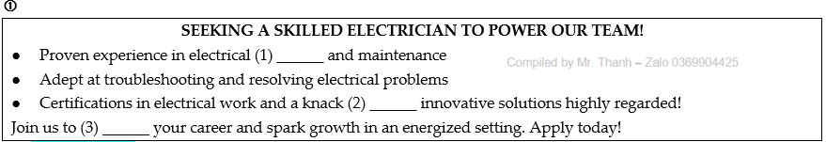

1. A. installations B. shifts C. bonuses D. reviews
2. A. to B. for C. at D. of
3. A. electrician B. electricity C. electrical D. electrify

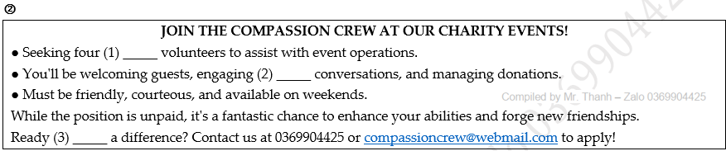

1. A. on-the-job B. flexible C. challenging D. enthusiastic
2. A. in B. to C. for D. about
3. A. making B. to make C. made D. to be made

**Exercise 5: Mark the letter A, B, C or D to indicate the correct arrangement of the sentences to make a meaningful paragraph/letter in each of the following questions.**

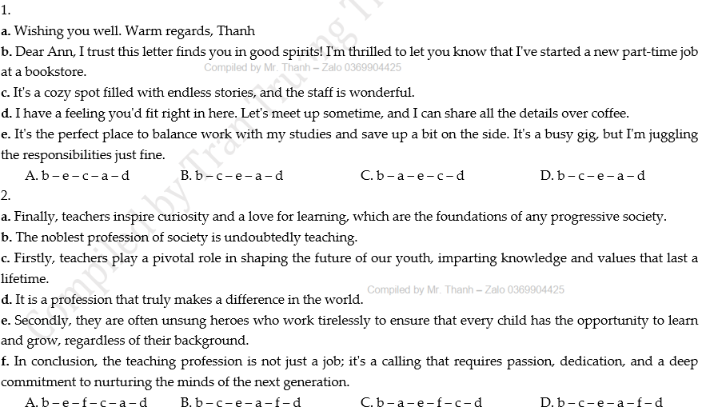

**Exercise 6: Read the following passage and mark the letter A, B, C, or D to choose the word or phrase that best fits each of the numbered blanks from 1 to 5.**

**➀**

**SECRETARIES**

What’s in a name? In the case of the secretary, or Personal Assistant (PA), it can be something rather surprising. The dictionary calls a secretary “anyone (1) _____ handles correspondence, keeps record and does clerical work for others. But while this particular job definition looks a bit (2) _______, the word’s original meaning is a hundred times more exotic and perhaps more appropriate. The word itself has been with us since the 14th century and comes from the medieval Latin word secretarius meaning “something hidden”. Secretaries started out as those members of staff with knowledge hidden from (3) _______, the silent ones mysteriously operating the secret machine of organizations.

Some years ago, “something hidden” probably meant kept out of sight, tucked away with all the other secretaries and typists. A good secretary was an unremarkable one, efficiently (4) ______ orders, and then returning mouse-like to his or her station behind the typewriter, (5) _____, with the advent of new office technology, the job effectively upgraded itself and the role has changed to one closer to the original meaning.

(Adapted from *Certificate in Advanced English*)

1. A. whom B. which C. who D. where
2. A. outdated B. elderly C. unfashionable D. aged
3. A. other B. such C. others D. much
4. A. satisfying B. minding C. conforming D. obeying
5. A. either B. but C. nor D. so

**➁**

**TIPS FOR BODY LANGUAGE DURING INTERVIEWS**

There are several crucial points about body language to be aware of when you are in a job interview. In general, men have an advantage when it comes to revealing nervousness through body language. They tend to sit (1) _______, whereas women often flap their hands or cross their legs and swing the top leg, or clutch at their handbags. These actions should be minimized during a job interview. Keeping control of facial expressions is the most difficult art to master. Try to nod occasionally while questions are being asked, (2) _______ avoid doing a "nodding dog" impression. Keep your chin up and try to look either at the desk or at the interviewer. Never look at the point just above the interviewer's head - it will make him or her nervous.

(3) _______ piece of advice is to develop a (4) _______ handshake - limp handshakes never impress. But wait to have your hand shaken by the interviewer rather than making the first move. If you are carrying a bag when you enter the room, it is very important that you keep it in your left hand, (5) _______ makes handshaking easier (it is simply unfortunate if the interviewer happens to be left- handed).

(Adapted from *"Matrix", Connybeare A. & Betterton S. 2013. Oxford*)

1. A. still B. till C. stock-still D. until
2. A. nor B. but C. although D. and
3. A. The other B. Other C. Another D. Others
4. A. steady B. firm C. hard D. solid
5. A. who B. that C. what D. which

**Exercise 7: Mark the letter A, B, C, or D on your answer sheet to indicate the correct option that best fits each of the numbered blanks from 1 to 5.**

**➀** Having a part-time job while studying offers numerous advantages. Firstly, (1) _______ while studying, enabling them to apply theoretical knowledge in real-world scenarios. Secondly, working part-time helps students develop time management skills, (2) _______ balance work and academic commitments effectively. Moreover, part-time jobs provide students with financial independence, allowing them to support (3) _______ and alleviate financial burdens. Additionally, part-time employment enhances interpersonal skills by (4) _______. Overall, having a part-time job while studying is beneficial because it enables students to gain experience, manage time efficiently, (5) _______, and enhance interpersonal skills.

1. A. that allows students gain practical experience B. it allows students to gain practical experience

C. what allows students to gain practical experience D. this allows students gaining practical experience

1. A. if they learn to B. because they learn C. though they learn to D. as they learn to
2. A. ourselves B. itself C. myself D. themselves
3. A. promoting interaction with colleagues and customers

B. promote interaction with colleagues and customers

C. promoting colleagues and customers with interaction

D. promote colleagues and customers with interaction

1. A. we attain financial independence B. financial independence is attained

C. attain financial independence D. attaining financial independence

**➁** Doing an apprenticeship is challenging, but incredibly rewarding. When they serve their apprenticeship, individuals gain hands-on experience in their chosen field (1) ______. They work under supervised conditions, (2) ______ and skill development.

(3) ______, apprenticeships offer a direct pathway to a full-time position within the industry. So, apprentices not only learn the theoretical aspects of their trade but also apply (4) ______in real-world settings. This combination of practical experience and theoretical knowledge equips apprentices with valuable skills and prepares them for (5) ______.

1. A. if they earn qualifications B. while earning qualifications

C. though earned qualifications D. when they earned qualifications

1. A. allowing for practical learning B. allow for practical learning

C. to allow for practical learning D. allow practical learning

1. A. In spite of traditional education routes B. Because of traditional education routes

C. Unlike traditional education routes D. Not only traditional education routes

1. A. it B. that C. them D. theirs
2. A. successful careers in their chosen fields B. succeeding in their chosen careers of fields

C. their success of their chosen careers of fields D. successfully chosen fields of careers

**Exercise 8: Read the following passage and mark the letter A, B, C, or D to indicate the correct answer to each of the questions from 1 to 5.**

**➀** Jake, a high school graduate, chose not to pursue a degree. Instead, he joined the workforce. He started as an apprentice waiter at a local restaurant. On a night shift, he learned the ropes, multitasking between taking orders, serving customers, and clearing tables. Though the work was **repetitive** and stressful, Jake remained determined.

Over time, Jake absorbed the restaurant's rhythm and atmosphere. He observed chefs preparing dishes and managers operating the restaurant.

Years passed, and Jake's dedication paid off. He worked diligently and successfully learned about restaurant management. With determination, he opened his own restaurant. Today, **it** is crowded with diners enjoying delicious meals. From apprentice waiter to restaurant owner, Jake's journey is a testament to hard work and determination. He looks back on his time as an apprentice, where he laid the foundation for his culinary dreams.

1. Which best serves as the title for the passage?

A. From an Apprentice to a Chef B. Gaining Success without a University Degree

C. Problems Faced by High School Leavers D. An Inspiring Story of a University Graduate

1. According to paragraph 1, which of the following is NOT mentioned as one task Jack had to do during a night shift?

A. collecting bills B. serving customers C. clearing tables D. taking orders

1. The word **repetitive** in paragraph 1 is opposite in meaning to _______.

A. demanding B. boring C. interesting D. patient

1. The word **it** in paragraph 3 refers to _______.

A. management B. Jack’s restaurant C. dedication D. determination

1. Which of the following is NOT true according to the passage?

A. Jake decided not to pursue higher education and join the labour force.

B. Jake’s restaurant is bustling with customers who come to enjoy tasty meals.

C. Jake learned about restaurant management during his apprenticeship as a waiter.

D. It was hard work that laid the foundation for Jake’s cooking dreams.

**➁** When you first start a new position, people commonly advise you to spend time learning the office, department and institutional culture. Taking the opportunity to learn the historical precedence of decisionmaking or the professional **status quo** can give you a better understanding of the "why" and how to best either adapt as a new member of the team or develop convincing arguments for proposed changes.

Starting a new position, whether mid-year or during the traditional hiring period, often requires patience with processes. Anything from human resources checklists to having the IT department establish your computer system to even getting an identification card to enter your office building often takes time.

Before starting a new job, people often have an idea or dream of how their position and the professional environment will be. But flexibility and grace are almost always required in order to strive toward **this vision**. While you shouldn't completely change who you are or want to be in your professional role, some ability to adapt is required. In times of upheaval, the capability to deftly change tasks or priorities to best serve the students or the campus community at large will showcase you as a successful employee.

Throughout the job search and hiring process, communication is vital. From first establishing interview times to booking travel for the campus visit to even negotiating and accepting an offer, clear communication is needed from both you and your employer.

*(Adapted from insidehighered.com)*

1. What is the passage mainly about?   
 A. The things you should know before you start a new job  
 B. The problems you’ll encounter in your new working environment  
 C. The methods on how to navigate a new job  
 D. How to succeed in getting promotion?  
2. The phrase “**status quo**” in the first paragraph mostly means ______  
 A. current situation B. higher position

C. potential employers D. company procedures  
3. Which of the following is NOT mentioned as a process which can take time when you are offered a new job, according to the passage?  
 A. Establishing your computer system by the IT department  
 B. Having an ID card to access the office building  
 C. Processing the checklists for human resources  
 D. Producing documents required by the company  
4. The phrase “**this vision**” in paragraph 3 refers to _________  
 A. getting the position of your dream job  
 B. the idea or dream of people about their new job  
 C. the professional role  
 D. being flexible and graceful in your new position  
5. Which of the following is TRUE, according to the passage?  
 A. Communication is crucial in the job search and recruiting process.  
 B. Starting a new job requires no patience with procedures.  
 C. If you wish to be in a professional setting, you can fully alter who you are.  
 D. You will be seen as a successful employee if you have the ability to support your

**Exercise 9: Read the following passage and mark the letter A, B, C, or D to indicate the correct answer to each of the questions from 1 to 7.**

**➀**

Becoming a teacher demands not only knowledge in an academic field but also a personal commitment to lifelong learning, and enthusiasm for sharing knowledge with other people. To become one of those noble educators in the USA, one has to satisfy several basic requirements.

First and foremost, it is a prerequisite to have bachelor's degree in education. In the event that a candidate already has a bachelor's degree in another field, a teacher preparation program is needed. But that is not all. Almost every school in the USA understands that real classroom teaching experience is a **vital** part of a teacher's training. Before taking over a class, a person typically needs to complete a training program, including working as a supervised student teacher.

People who want to become university teachers need master's degrees. Getting a master's degree is a necessity, but if it is gained too early, there may be concerns that the candidate lacks the real-world experience to go with it. In fact, very few schools want to hire novices with little or no classroom experience and even if **they** are accepted, they are usually ill-paid. One wise solution to the issue is for future post graduates to start working as teachers before going on to gain their master's degree.

Besides knowledge and experience, certain personal qualities are also required. A teacher should be positive, prepared, focused, and most importantly, patient. Being a teacher involves being aware of the fact that learning sometimes be hard work, even for the most motivated students. Also, teaching can at times be tiring and frustrating, so teaching candidates have to practice being patient with themselves. In short, as in other careers, teaching requires a combination of qualifications, experience, and personal qualities. Teaching candidates meeting mandatory requirements are always in demand in the USA.

1. The text is mainly about _______.

A. the importance of teachers.

B. the advantages and disadvantages of being a teacher in the USA.

C. the difference of teaching career.

D. the basic requirements of being a teacher in the USA.

1. According to the text, future post graduates should start working as teachers _______.

A. after gaining their master's degree.

B. before studying for their master's degree.

C. during the time they are studying for their master's degree.

D. before studying for their bachelor's degree.

1. The word “**vital**” in paragraph 2 is closest in meaning to _______.

A. very useless B. very easy C. very important D. very interesting

1. According to the text, teaching requires a combination of many things EXCEPT _______.

A. qualifications B. personal qualities C. experience D. appearance

1. According to the text, the most important quality of a teacher is _______.

A. being patient B. being to work hard C. being prepared D. being a role model

1. The word “**they**” in paragraph 3 refers to _______.

A. postgraduates B. novices C. schools D. teachers

1. According to the text, all of the following sentences are true EXCEPT _______.

A. Those who want to become university teachers need master's degrees.

B. A teachers needs to be aware of the fact that learning can sometimes be hard work.

C. A great number of schools in the USA want to hire novices with little or no classroom experience.

D. In the USA, before one takes over a class, a training program is typically necessary to be completed.

**➁**

**TRAVELING TO WORK**

If you were going to choose a job that involves travel, what would be your first choice? There are many jobs available today that give people opportunities to travel. Although may traveling careers sound fantastic, **they** also have disadvantages.

Being an au pair is an excellent way to not only go to different countries, but to live in different places around the world and really get a feel for the culture. Au pairs lives with the families they are placed with and take of children. Many parents include au pairs in family events and vacations, so they experience many aspects of the new culture while on the job. However, many of the activities are centered around the children, so they may not get to experience many things that interest adults.

For people who want a bit more freedom working abroad, being an English teacher maybe a good choice. There are English teaching jobs in almost countries in the world. People teaching English in other countries often have a chance to travel on the weekends around the country. One drawback is that many teachers often wind up hanging out with other English teachers, and they don’t have time to learn the country’s language.

The nickname “roadie” implies that this job involves life on the road. Roadies are people who work and travel with bands and provide technical support. Roadies can be lighting and stage crew who set up the stage and break it down before and after events. They can also be technicians helping band members with their instruments. International tours take a band’s crew to cities around the world, often requiring air travel. However, the crew doesn’t get much time off, so they may travel to several countries without seeing much besides concert venues and hotels.

Similarly, flight attendants often travel to cities around the world, but they don’t see much besides the inside of airplanes and hotels. However, when they do have time off, they can often fly at no cost, and family member can sometimes fly free as well. Its is widely thought that a flight attendant job is **glamorous**, but flight attendants must deal with travel hassles, as well as security issues.

All jobs gave advantages and disadvantages whether or not you travel for work, so if you have the travel bug, keep these jobs in mind for the future.

1. Which of the following is a disadvantage of the job as an au pair?

A. experience many interesting things. B. live in different places around the world.

C. experience many aspects of the new culture. D. most activities are centered around children.

1. What does the passage mainly discuss?

A. Jobs with opportunities to travel. B. Disadvantages of traveling jobs.

C. Traveling to and from work. D. Jobs involving traveling by planes.

1. The word “**glamorous**” in paragraph 5 is closet in meaning to ______.

A. skilled B. attractive C. permanent D. challenging

1. How is a flight attendant’s job similar to a roadie’s?

A. Family members may not have to pay for flights.

B. They must deal with travel hassles.

C. A lot of time is spent indoors.

D. They provide technical support.

1. The word “**they**” in paragraph 1 refers to ______?

A. people B. opportunities C. careers D. disadvantages

1. Which of the following is something a roadie might do?

A. set up the lights for a performance. B. play the guitar in front of a large audience.

C. clean hotel rooms after the ban and crew have left. D. work on the road.

1. It can be inferred from the passage that ______.

A. traveling careers have more disadvantages than many other.

B. English teachers abroad don’t know the language of the country where they work.

C. it’s essential that the job you choose have more benefits than drawbacks.

D. people who want to travel are more likely to get a job.

--- THE END ---