TRƯỜNG THCS-THPT HAI BÀ TRƯNG  ĐỀ CHÍNH THỨC | ĐỀ KIỂM TRA CUỐI KỲ 2  NĂM HỌC 2021 - 2022  MÔN : ANH VĂN – LỚP : 9  Thời gian: 60 phút  (Không kể thời gian phát đề)
- PRONUNCIATION: ( 1.0 PT)

1/ A. disaster B. fixture C. tidal D. discover
2/ A. appliance B. imagination C. scientist D. highway
3/ A. occur B. underwater C. result D. erupt
4/ A. destroy B. predict C. expect D. separate

- Choose the word / phrase (A, B, C or D) that best fits the blank space in each sentence: (4.0 PTS)

5/. ………….. can lift cars, mobile homes and animals into the air.
A. Droughts B. Landslides C. Pollutants D. Tornadoes
6/. Don’t forget to bring …………………. your umbrella.
A. up B. along C. about D. together
7/. Four forest fires in 10 days ………………….. 300 hectares of trees in Karnataka.
A. dissolved B. destroyed C. caused D. sucked up
8/. Your furniture will shake and start to move across the floor during …………………...
A. an earthquake B. a snowstorm C. a tidal wave D. a volcano
9/. Two schools ………………….. in Mexico City due to Tuesday's 7.1 magnitude earthquake.
A. reduced B. collapsed C. destroyed D. prohibited
10/. In about 20 minutes, a tsunami will ………………….. the Japanese coastline.
A. float B. burn C. strike D. occur
11/. The Federal Reserve Bank ………………….. that the economy will grow by 2% this year.
A. checks B. reaches C. forecasts D. prepares
12/. In the future, it may be possible to ………………….. earthquakes.
A. feel B. predict C. fix D. mean
13/. I ………………….. you’re right.
A. expect B. explain C. fine D. share
14/. The nurse measured my temperature.
A. made B. got C. looked up D. took
15/. Many areas of Africa have ………………….. severe drought this year.
A. enjoyed B. made C. found D. suffered
16/ …………. are the result of an abrupt shift in the underwater movement of the earth.
A. Tidal waves B. Earthquakes C. Volcanoes D. Snowstorms
17/. Forest fires start easily during …………………..
A. floods B. thunderstorms C. hurricanes D. droughts
18/. …………. can suck up anything that is in their path.
A. Tsunamis B. Tornadoes C. Deforestations D. Typhoons
19/. I think we should fill all buckets …………………. water.
A. in B. from C. with D. by

20/. - “I think we should buy some canned food.” - “………………….”
A. Yes, I’d love to. B. Yes, thanks.
C. Great! Let’s do that. D. How about checking all the window latches?

III. Caution signs – warnings: (1.0 PT)
What is the sign about?

21/. A. Volcano  B. Snowstorm  C. Thunderstorm  D. Tornado | 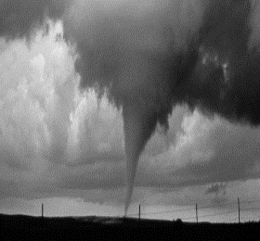 | 22/. A. Soil pollution  B. Earthquake  C. Thunderstorm  D. Sandstorm | 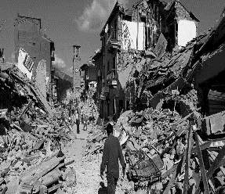
23/. A. Volcano  B. Earthquake  C. Typhoon  D. Tornado | 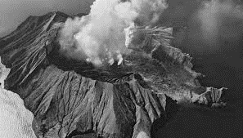 | 24/. A. Soil pollution  B. Drought  C. Desertification  D. Deforestation | 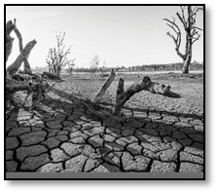

IV. WORD FORM (1.0 pt)
25/.The bridge collapsed without any ….………….….………….. (warn)
26/. The sky was dark and ….………….….………….. (storm)
27/. Access to this information is ….………….….…………. restricted. (severe)
28/. The scheme has been set up to help ….………….….…………. people. (home)

V. REARRANGEMENT(1.0 pt)
29/. walked on/ lived in /Neil Armstrong / the moon/ the USA/ who first
Neil Armstrong …………………………………………………………
30/. met yesterday / The man / for dinner/ to my house/ whom you/ is coming
The man …………………………………………………………………

VI. TRANSFORMATION: (2.0 pts)
31/. John met a girl. I used to employ her. (WHOM)
John …………………………………………………………………………
32/. Do you know the man? He is coming towards us.(WHO)
Do you know ………………………………………………………………..
33/. Johns forgot his umbrella, so he got wet.(BECAUSE)
Because ……………………………………………………………………...
34/. I felt tired, so I went to bed early. (BECAUSE)
I went ………………………………………………………………………..

GOOD LUCK !
**************
THE END

