|  |  |
| --- | --- |
| *Họ và tên: ....................................................*  *Lớp: .............................................................* | PHIẾU GHI BÀI HÓA HỌC 11 CÁNH DIỀU  **Bài 17: PHENOL** |

**MỞ ĐẦU**

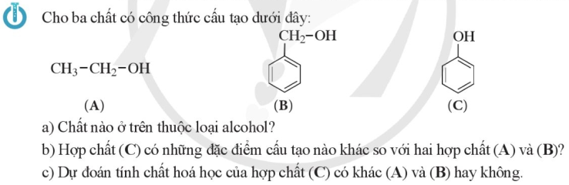

..........................................................................................................................................................................

..........................................................................................................................................................................

**I. KHÁI NIỆM**

**1) Khái niệm**

..........................................................................................................................................................................

..........................................................................................................................................................................

..........................................................................................................................................................................

|  |  |
| --- | --- |
|  |  |

**2) Phân loại**

..........................................................................................................................................................................

..........................................................................................................................................................................

..........................................................................................................................................................................

..........................................................................................................................................................................

..........................................................................................................................................................................

..........................................................................................................................................................................

..........................................................................................................................................................................

..........................................................................................................................................................................

**II. TÍNH CHẤT VẬT LÍ**

Trạng thái: .................. Màu sắc: ..................... tnc: .............. Tính bền: .........................................................

Tính tan: ..........................................................................................................................................................

Tính độc: ..........................................................................................................................................................

|  |  |
| --- | --- |
|  |  |
|  | ..................................................................................................................  ..................................................................................................................  ..................................................................................................................  ..................................................................................................................  ..................................................................................................................  .................................................................................................................. |

**III. TÍNH CHẤT HÓA HỌC**

Nhận xét đặc điểm cấu tạo của phân tử phenol?

..........................................................................................................................................................................

..........................................................................................................................................................................

..........................................................................................................................................................................

..........................................................................................................................................................................

Nhận xét về khả năng phản ứng của phenol?

..........................................................................................................................................................................

..........................................................................................................................................................................

|  |  |
| --- | --- |
|  | ..................................................................................................................  ..................................................................................................................  ..................................................................................................................  ..................................................................................................................  ..................................................................................................................  .................................................................................................................. |

**1) Tính acid của phenol**

Nhận xét về độ mạnh tính acid của phenol? ...................................................................................................

..........................................................................................................................................................................

***a) Phản ứng với dung dịch NaOH***

|  |  |
| --- | --- |
|  | ................................................................  ................................................................  ................................................................  ................................................................  ................................................................  ................................................................  ................................................................ |

..........................................................................................................................................................................

..........................................................................................................................................................................

***b) Phản ứng với sodium carbonate***

|  |  |  |
| --- | --- | --- |
| ...............................................................................................................  ...............................................................................................................  ...............................................................................................................  ...............................................................................................................  ...............................................................................................................  ...............................................................................................................  ...............................................................................................................  ...............................................................................................................  ...............................................................................................................  ...............................................................................................................  ............................................................................................................... | |  |
|  | ..................................................................................................................  ..................................................................................................................  ..................................................................................................................  .................................................................................................................. | |

..........................................................................................................................................................................

..........................................................................................................................................................................

..........................................................................................................................................................................

..........................................................................................................................................................................

**2) Phản ứng thế nguyên tử H của vòng benzene**

***a) Phản ứng với nước bromine***

|  |  |
| --- | --- |
|  | ................................................................  ................................................................  ................................................................  ................................................................  ................................................................  ................................................................  ................................................................ |

..........................................................................................................................................................................

..........................................................................................................................................................................

..........................................................................................................................................................................

..........................................................................................................................................................................

|  |  |
| --- | --- |
|  | ..................................................................................................................  ..................................................................................................................  ..................................................................................................................  ..................................................................................................................  .................................................................................................................. |
|  | ..................................................................................................................  ..................................................................................................................  ..................................................................................................................  ..................................................................................................................  .................................................................................................................. |

***b) Phản ứng với dung dịch HNO3 đặc***

|  |  |
| --- | --- |
|  | ..................................................................................................................  ..................................................................................................................  ..................................................................................................................  ..................................................................................................................  ..................................................................................................................  ..................................................................................................................  ..................................................................................................................  ..................................................................................................................  ..................................................................................................................  ..................................................................................................................  ..................................................................................................................  ..................................................................................................................  ..................................................................................................................  ..................................................................................................................  ..................................................................................................................  ..................................................................................................................  .................................................................................................................. |

**IV. ỨNG DỤNG VÀ ĐIỀU CHẾ**

**1) Ứng dụng**

..........................................................................................................................................................................

..........................................................................................................................................................................

..........................................................................................................................................................................

..........................................................................................................................................................................

|  |  |
| --- | --- |
|  | ..................................................................................................................  ..................................................................................................................  ..................................................................................................................  ..................................................................................................................  .................................................................................................................. |

**2) Điều chế**

..........................................................................................................................................................................

..........................................................................................................................................................................

..........................................................................................................................................................................

..........................................................................................................................................................................