REVIEW 2 (UNITS 4 - 5 - 6)

Lesson 1: Language

I. Objectives
By the end of this lesson, students will be able to:

1. Knowledge
Revise the language they have learnt and the skills they have practised in Units 4 - 5 - 6

2. Core competence
- Develop communication skills and creativity
- Be collaborative and supportive in pair work and teamwork
- Actively join in class activities

3. Personal qualities
Develop self-study skills

II. Materials
- Grade 6 textbook, Review 2, Language
- Pictures, printed chart
- hoclieu.vn

Anticipated difficulties | Solutions
1. Students may find the lesson boring due to a large number of language exercises. | - Encourage students to work in pairs, in groups so that they can help each other.  - Design as many exercises as games as possible.  - Provide feedback and help if necessary.
2. Some students will excessively talk in the class. | - Define expectation in explicit detail.  - Have excessively talkative students practise.  - Continue to define expectations in small chunks (before every activity).
  - Board Plan

Date of teaching

Review 2

Lesson 1: Language

* Warm-up
Memory game
I. Practice
II. Pronunciation
Task 1: Listen and circle the word with the different underlined sound.
III. Vocabulary
Task 2: Write the words in the box (a-h) next to their opposites (1-8).
Task 3: Choose the correct word/ phrase for each definition.
IV. Grammar
Task 4: Complete the sentences with the correct answer A, B, or C.
Task 5: Complete the sentences with should or shouldn’t.
* Homework

Procedure

Stage |  | Stage aim |  | Procedure |  | Interaction |  | Time
 | Warm-up |  | To remind students the knowledge that they have learnt in Units 4 - 5 - 6. |  | * Memory game:  - Teacher divides the class into 4 big groups.  - Teacher gives each group an unfinished chart which summarises the language that  students have learnt in Units 4, 5, 6 and asks them to complete the chart.  - The group which finishes correctly and more quickly is the winner.  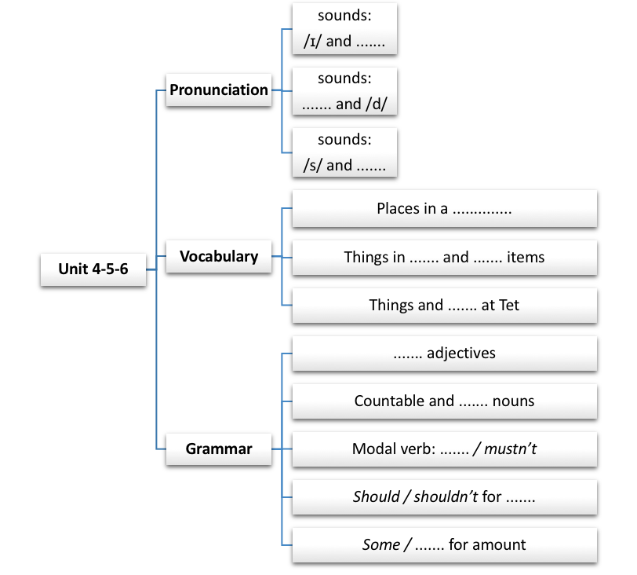  Answer key:  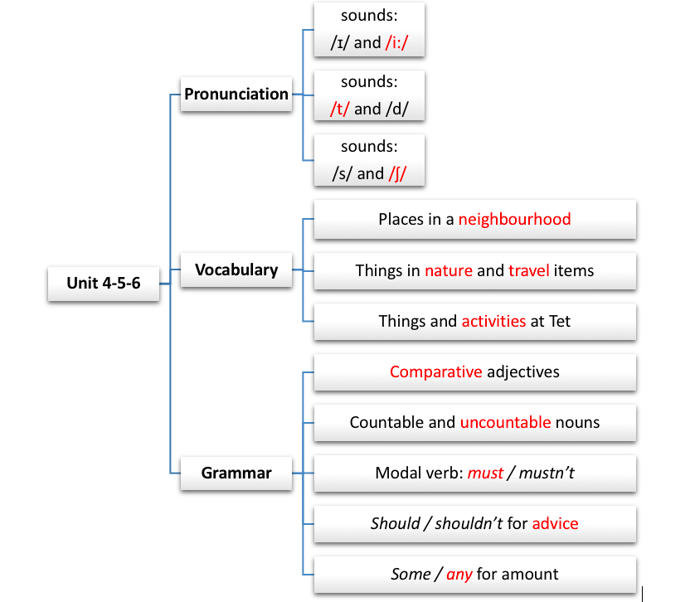 |  | Group work |  | 5 mins
 | Practice |  | To help students review the  pronunciation of the sounds learnt in Units 4 - 5 - 6:  - /ɪ/ and /i:/  - /t/ and /d/  - /s/ and /∫/  To help students review the adjectives  describing the neighbourhood, the wonders of Viet Nam, and Tet holiday.  To help students identify the words through their  definitions.  To help students review grammar elements taught in Units 4 - 5 - 6: must/ mustn’t, some/ any, and comparative  adjectives.  To help students review the use of should/ shouldn’t. |  | * PRONUNCIATION:  Task 1: Listen and circle the word with the  different underlined sound.  - Students do this exercise individually then share their answers with their partners.  - Teacher gives feedback and confirms the answers.  Answer key:  1. A 2. C 3. B  4. C 5. C  * VOCABULARY:  Task 2: Write the words in the box (a-h) next to their opposite (1-8).  - Teacher prepares sets of words and organises this task as a game.  - Teacher divides the class into 2 teams, gives each team 2 sets of words. One set includes the adjectives in the box and the other includes their opposites.  - Teacher lets students come to match on the board.  - The team matching faster and correctly is the winner.  Answer key:  1. d 2. g 3. f 4. b 5. a 6. h 7. c 8. e  Task 3: Choose the correct word/ phrase for each definition.  - Teacher has students do this task individually and then share their answers with their partners.  - Teacher calls one or two students to write their answers on the board.  - Teacher checks and confirms the correct ones.  Answer key:  - waterfall  - compass  - museum  - wish  - lucky money  * GRAMMAR:  Task 4: Complete the sentences with the  correct answer A, B, or C.  - Teacher has students do the exercise individually.  - Teacher asks students to exchange their answers and discuss if there is any difference in their answers then checks students’ answers as a class, and explains if needed.  Answer key:  1. B 2. C 3. C  4. A 5. A  Task 5: Complete the sentences with should or shouldn’t.  - Teacher has a brief revision of should/ shouldn’t by giving a phrase showing an activity. Students speak aloud if they should/ shouldn’t do it.  - Teacher lets students do this exercise independently.  - Teacher checks their answers as a class.  Answer key:  - should  - shouldn’t  - shouldn’t  - should  - should |  | S  T-Ss  Teamwork  T-Ss  S  T-Ss  S  Pair work  S  T-Ss |  | 35 mins
 | Consolidation |  | To consolidate what students have practised in the lesson. |  | Teacher asks students to talk about what they have practised in the lesson. |  | T-Ss |  | 4 mins
 | Homework |  | To prepare for the next lesson. |  | Prepare for Lesson 2: Skills. |  | T-Ss |  | 1 min

REVIEW 2 (UNITS 4 - 5 - 6)

Lesson 2: Skills

I. Objectives
By the end of this lesson, students will be able to:

1. Knowledge
Revise the language they have learnt and the skills they have practised in Units 4 - 5 - 6

2. Core competence
- Develop communication skills and creativity
- Be collaborative and supportive in pair work and teamwork
- Actively join in class activities

3. Personal qualities
Develop self-study skills

II. Materials
- Grade 6 textbook, Review 2, Skills
- CD player
- hoclieu.vn

Anticipated difficulties | Solutions
1. Students may find the lesson boring due to a large number of language exercises. | - Encourage students to work in pairs, in groups so that they can help each other.  - Design as many exercises as games as possible.  - Provide feedback and help if necessary.
2. Some students will excessively talk in the class. | - Define expectation in explicit detail.  - Have excessively talkative students practise.  - Continue to define expectations in small chunks (before every activity).

  - Board Plan

Date of teaching

Review 2

Lesson 2: Skills

*Warm-up

Chatting
I. Practice

II. Reading
Task 1: Read the passage and match the headings (A, B, C) with the paragraphs.
Task 2: Read the passage again and choose the correct answer A, B or C.
III. Speaking
Task 3: Work in pairs. Read the passage Visit Singapore again and make a list of the places. Take turns to ask and find out which place your partner wants to visit and why.
IV. Listening
Task 4: Listen and tick (✔) T (True) or F (False).
V. Writing
Task 5: Complete this paragraph to describe the place you live.
* Homework

Procedure

Stage | Stage aim | Procedure | Interaction | Time
Warm-up | To increase students’ interest and lead them into the lesson. | * Chatting:  - Teacher asks students some questions to lead them into the lesson:  - Do you want to visit Singapore?  - Do you know what is Singapore famous for?  - Teacher leads in the reading part of the lesson. | T-Ss | 3 mins
Practice | To help students practise reading for general information.  To help students practise reading for specific information.  To help students practise asking and answering about a place they want to visit and explain why.  To help students review listening for specific  information (T/F questions).  To help students complete a guided paragraph of about 50 words to describe their neighbourhood. | * READING  Task 1: Read the passage and match the headings (A, B, C) with the paragraphs.  - Teacher has students read the headings and the paragraphs carefully before matching.  - Teacher asks students to underline the words/ phrases in the paragraphs which help them do the matching and goes through the underlined words and phrases students have done, then guides them how to look for clues. This will help students do Activity 2 more easily.  - Teacher checks the answers as a class.  Answer key:  1. B  2. C  3. A  Task 2: Read the passage again and choose the correct answer A, B or C.  - Teacher has students read each sentence and look for the key word(s) in it.  - Teacher decides where to look for the information (paragraph 1, 2, or 3). This will make it quicker and easier for students to find the correct answers.  E.g. Sentence 1 has ‘plants and flowers’ → go to paragraph 1: Nature.  - Teacher checks students’ answers as a class.  Answer key:  1. A  2. A  3. B  4. C  * SPEAKING  Task 3: Work in pairs. Read the passage Visit Singapore again and make a list of the places. Take turns to ask and find out which place your partner wants to visit and why.  - Teacher asks students to refer to the passage about Singapore (Reading 1) and make a list of the places mentioned.  - Teacher lets students have some time to form their own ideas of where to go and why they want to go there, then work in pairs, asking and  answering to find out where their partners want to go and why.  - Teacher goes round and supports students if it’s needed.  - Teacher calls some students/ pairs to present their ideas to the class.  * LISTENING  Task 4: Mai’s family is talking to a travel agent about their trip to Singapore. Listen and tick (✔) T (True) or F (False).  - Teacher allows students some time to read the  statements carefully to have some ideas what the listening is about.  - Teacher guides students to look for key words which can help them focus while listening. For example: four days (1), won’t go (2), a full day (3)...  - Teacher plays the recording twice or three times (as needed). Students listen and tick the answers.  - Teacher allows students to swap their answers.  - Teacher checks their answers as a class, encourages students to correct the false  statement(s).  - If there is still time, teacher may give students some  information about the Light and Sound Show and Sentosa.  - The Light and Sound Show: a form of nighttime  entertainment that is usually presented outdoor, using light and sound to tell a story of  history.  - Sentosa: a sunny island in Singapore, a big centre of entertainment, which offers activities for people of different age groups. There are Sea Aquarium, Butterfly Park, Insect Kingdom, Skyline Luge, Cove Waterpark, Universal  Studio, and the famous Light and Sound Show.  Answer key:  1. T  2. F  3. T  4. T  5. F  Audio script:  Travel agent: Here we have a four-day programme for you... Mai’s mother: Do we visit  somewhere natural?  Travel agent: Oh yes. We have two days for nature: one day at the National Park and one day at the zoo.  Mai’s mother: How about Sentosa?  Travel agent: Sentosa is a ‘must’ for families. We spend one day there.  Mai’s mother: Is it enough?  Travel agent: We start early and return late. There we visit the Sea Aquarium...  Mai’s mother: What is it?  Travel agent: It’s a zoo for fish.  Mai’s mother: Great.  Travel agent: In the evening we will watch the Light and Sound Show. And the last day is for ...  *WRITING  Task 5: Complete this paragraph to describe the place you live.  - Teacher has students read the guided paragraph first and decide which information is needed for each blank.  - Teacher allows them some time to think about the information they need to complete the frame.  - Teacher allows them some time to do the task.  - Teacher goes round and check if they are doing the job correctly and offers help if needed.  - Teacher calls on one or two volunteers to read aloud their answers then calls for other students’ comments.  - Teacher collects some writings to correct at home. | S  T-Ss  T-Ss  T-Ss  Pair work  T-Ss  S  Pair work  T-Ss  T-Ss | 38 mins
Consolidation | To consolidate what students have practise in the lesson. | Teacher asks students to talk about what they have practise in the lesson. | T-Ss | 3 mins
Homework | To prepare for the next lesson. | Prepare for Unit 7 – Lesson 1. | T-Ss | 1 min

