|  |  |  |
| --- | --- | --- |
| Phòng GD&ĐT TP Hà Tiên  Trường Tiểu học Thuận Yên  Lớp:..................................................................  Họ và tên:……………………………………. | | Bài kiểm tra cuối học kỳ I  Năm học: 2021 – 2022  Môn: Tiếng Anh  Khối: 3- Thời gian: 40 phút  Ngày kiểm tra:…………………… |
| Điểm | Nhận xét của giáo viên | Chữ ký giám thị:……………………  Chữ ký giám khảo: ………….…….. |

**Part 1: Questions 1 – 4: Read and circle *(Đọc và khoanh tròn đáp án đúng)*. (2.0 marks)**

1. Class: Good morning, Miss Hien.  
    Miss Hien: Sit down, please.

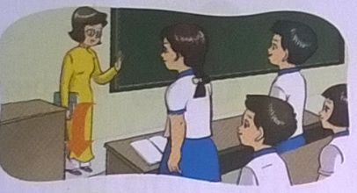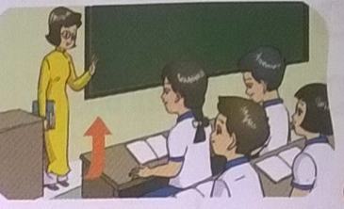

a.

b.

2. Linda: Is your school big?  
    Nam: Yes, it is.

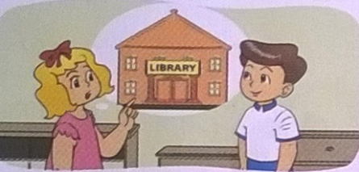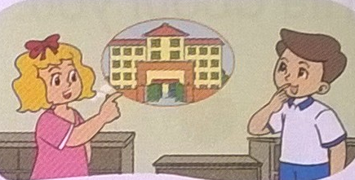

a.

b.

3. Mai: What colour are your pencils, Nam?  
    Nam: They are brown.

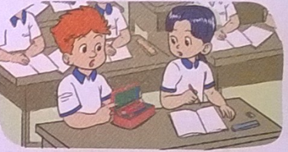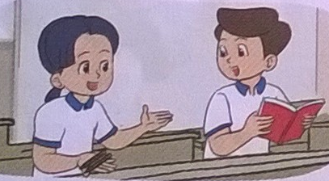

a..

b.

4. Linda: What do you do at break time?  
    Nam: I play football.  
    Linda: Great!

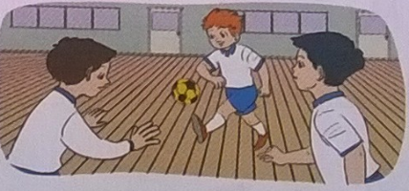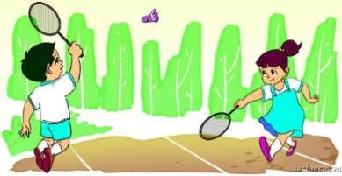

a..

b.

**Part 2: read and number. *(Em hãy đọc những hội thoại sau và đánh số tương ứng với từng hình)* (2.0 marks)**

1. Nam: May I come in?  
    Miss Hien: Yes, you can.

2. Tom: Is that the classroom?  
    Mai: No, it isn't. It's the computer room.

3. Tom: Is that your pencil case?  
    Mai: What colour is it?  
    Tom: It's pink.  
    Mai: Yes. It's my pencil case.

4. Mary: What do you do at break time?  
    Mai: I play hide-and-seek.

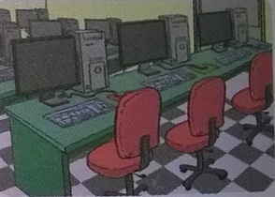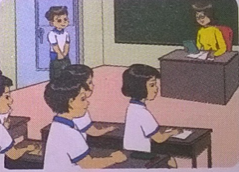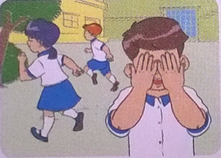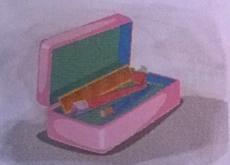

**a/**  **b/ c/ d/**

***Part 3:*** ***Read and circle:*** (Đọc và khoanh tròn đáp án đúng) **(1.0 marks)**

1.Is the English room new?

a. Yes, it isn’t .

b. No, it is.

c. No, it isn’t.

2. How old are you?

a. I eight years old.

b. I’m eight years old.

c. I’m eight year old.

3. This is my pen.

a. It is blue.

b. Yes, it is.

c. they are blue.

4. Do you like skipping?

a. yes, you can.

b. yes, I like.

c. yes, I do.

***Part 4: Read and tick: (*√*) (True or False)*** (Đọc và đánh dấu **√** vào cột T nếu câu đúng thông tin, sai thông tin đánh vào cột F) **(1.0 marks)**

I am Phong. I’m nine years old. Mai and Nam are my friends. We are in class 3A . This is my classroom. It is small. That is my school bag. It is yellow. Those are my pens. They are blue. At break time, I and Nam play chess in classroom. Mai does not like chess. She likes skipping.

|  |  |  |
| --- | --- | --- |
| ***Sentences:*** | ***True ( T )*** | ***False ( F )*** |
| ***0). Phong and Nam are in class 3A.*** | **√** |  |
| 1) I’m nine years old. |  |  |
| 2) It is small. |  |  |
| 3) His school bag is green. |  |  |
| 4) She likes skipping. |  |  |

**Part 5:** **Arrange the following words to make meaningful sentences and circle**: (Sắp xếp những từ sau thành câu có nghĩa và chọn đáp án đúng.) **(1.0 marks)**

1. those/ Are/ your/notebooks?
2. Are your those notebooks?
3. Are notebooks those your?
4. Are those your notebooks?
5. computer/ room/ The/ is/ new.
6. The room computer is new.
7. The computer room is new.
8. The is new computer room.
9. May/ out?/ I /go/
10. May I go out?
11. May go I out?
12. I May go out?
13. book/ My/ red./ is
14. My book is red.
15. My is book red.
16. is My book red.

Part 6: ***Write about colour and break time***; (Viết màu sắc và hoạt động khi ra chơi) **(1.0 marks)**

1. ***What’s your name? My name is Dat.***
2. What colour is your pen? 🖛 It’s ________________
3. What do you do at break time? 🖛 I play ___________________

**-The end-**

**ĐÁP ÁN MÔN TIẾNG ANH KHỐI 3 HKI**

**Part 1: Questions 1 – 4: Read and circle** *(Đọc và khoanh tròn* *)*.

1.a 2.b 3.a 4.a

**Part 2: Read and number.***(Đọc và đánh số)*

a.2 b.4 c.3 d.1

Part 3: ***Read and cricle:*** *(Đọc và khoanh tròn)*

1.c 2.b 3.a 4.c

Part 4: ***Read and tick: (*✓*) (True or False)***

1.T 2. T 3.F 4. T

Part 5: ***Arrange the following words to make meaningful sentences and circle***: (Sắp xếp những từ sau thành câu có nghĩa và khoanh tròn đáp án đúng)

1. c. Are those your notebooks?

2. b. The computer room is new.

3. a. May I go out?

4. a. My book is red.

Part 6: ***Write about colour and break time***; (Viết màu sắc và hoạt động khi ra chơi)

1. It’s *blue/ white/…*

2. I play *chess/ badminton/ football/…..*

**MA TRẬN ĐỀ KHỐI 3 - HKI**

**Liệt kê các chủ đề, cấu trúc và từ vựng cần kiểm tra**

|  |  |  |
| --- | --- | --- |
| **Topics** | **Sentences patterns** | **Vocabulary** |
| * One’s/someone’s age * Permission * School facilities/ school things * Break time activities | Hello/hi. I’m+name  How are you?  What’s your name?  How do you spell your name?  How old are you?  Stand up!  May I sit down?  Yes, you may.  No, you may not.  That’s the + school facility/school thing  What colour is it?  It’s + colour.  what colour are they?  They’re + colour  What do you do at break time?  I play + game/ sport.  Do you like + game/sport? | Hello, hi, fine, I’m fine, thank you. Nice to meet you. Spell, name, how, old  Stand up, sit down, come, here, open, close, may, go out, come in  School, library, classroom, computer room, playground, gym, big, small, old, new, large, rubber, pencil case, school bag, notebook, pencil, ruler, pencil sharpener, blue, red, black, yellow, brown, green, orange  Break time, badminton, football, chess, basketball, table tennis, play, like, skating, hide-and-seek, skipping, blind man’s bluff |

**Lựa chọn các nhiệm vụ đánh giá, phân chia kiến thức ngôn ngữ vào các nhiệm vụ đánh giá, số câu, tỉ lệ mức độ nhận thức, số điểm.**

|  |  |  |  |  |  |
| --- | --- | --- | --- | --- | --- |
| **Kĩ năng** | **Nhiệm vụ đánh giá/ kiến thức cần đánh giá** | **Mức/ Điểm** | | | **Tổng số câu, số điểm, tỉ lệ %** |
| **M1** | **M2** | **M3** |  |
| Reading | **Listen and tick**  Name, sit down, break time | 1  0.5đ | 2  1đ | 1  0,5đ | 8 câu  4đ  40% |
| **Listen and number**  Come in, colour, school facilities, break time |  | 2  1đ | 2  1đ |
| **Read and circle**  Old, colour, school things, break time |  | 3  0.75đ | 1  0.25đ | 8 câu  2đ  20% |
| **Read and tick**  Name, old, school things, colour. | 1  0.25 đ | 2  0. 5 đ | 1  0.25đ |
| Writing | **Arrange the following words to make meaningful sentences.**  School things, come in, colour | 1  0.25  đ | 2  0.5 đ | 1  0.25  đ | 6 câu  2đ  20% |
| **Write about break time and colour in progress** |  | 1  0.5 đ | 1  0.5 đ |
| Speaking | **Getting to know each other** | 2  0.5 đ |  |  | 8 câu  2đ  20% |
|  | **Talking about your school** | 1  0.25đ | 1  0.25đ | 1  0.25đ |
|  | **Describing picture** | 1  0.25đ | 1  0.25đ | 1  0.25đ |