Date of preparing: ………………………………….
Date of teaching: ………………………………….

Period …
UNIT 4: FESTIVALS and FREE TIME
Lesson 3 - Part 1 (Page 36) - Vocabulary and Listening
Social Studies

I. OBJECTIVES
By the end of the lesson, Ss will be able to…
1. Knowledge
- talk about different festivals.
- know more useful information about many festivals in the world.
2. Ability
- improve the use of English, speaking and listening skills.
3. Quality
- have positive attitude in English language learning so that they actively participate in all classroom activities.
- keep traditional cultures.

II. TEACHING AIDS AND LEARNING MATERIALS
Lesson plan, PPT slides, student’s book, workbook, notebook, personal computer (if any), projector/TV, speakers, DCR & DHA on Eduhome, handouts…
III. PROCEDURES
A. Warm up: (5’)
a) Objective: to introduce the new lesson and set the scene for Ss to acquire new language; to get students' attention at the beginning of the class by means of enjoyable and short activities as well as to engage them in the steps that follow
b) Content: introducing some festivals in the world
c) Product: Ss get to know some festivals they are going to study in the lesson.
d) Competence: collaboration, critical thinking skill.
e) Organization of the activity:
Teacher’s Activities | Students’ Activities
- Give greetings  - Check attendance  - Option 1: MATCHING  - Introduce some festivals, using pictures  - Have Ss look at the pictures and match each picture with its right name  - Have Ss give answers, give feedback  Lead to the new lesson  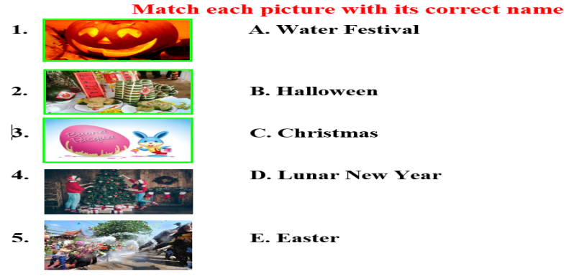  - Option 2: Game: Guessing the festival  - Give Ss 3-4 questions, for each question – Ss have 4 cues to guess which festival is being mentioned.  - Explain rules: If Ss can give correct answers from the first cue, they will get 40 points. The match will be reduced to 30, 20 and 10 until the last cue is given. (T can think of any way to carry out this game, it depends).  - Illustration:  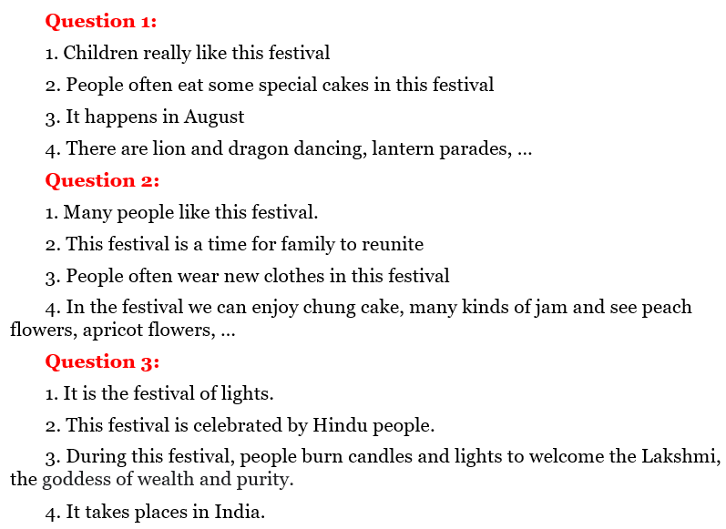  Lead to the new lesson | - Greet T  - Look and match  Answers keys  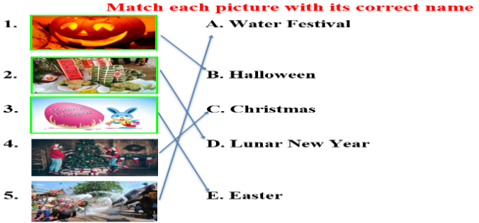  - Find out the festival (whole class)  - Listen  Answers keys  Question 1: The Mid-Autumn Festival  Question 2: The Lunar New Year  Question 3: The Diwali Festival

B. New lesson (35’)
- Activities 1: Vocabulary (15’)
a) Objective: Ss know more festival activities.
b) Content:
- numbering the picture.
- discussing things people do during holidays.
c) Products: Ss know how to pronounce the new words correctly and use them in appropriate situations.
d) Competence: communication, collaboration, presentation, creativity.
e) Organization of the activity:
Teacher’s Activities | Students’ Activities
a. Number the pictures. Listen and repeat.  - Have Ss look and the pictures and read the activities in the book  - Demonstrate the activity, using the example  - Have Ss number the pictures  - Ask Ss to work in pairs to check their answers with their partners  - Call Ss to give answers  - Check answers as a whole class.  - Play audio (CD1 – Track 50). Have Ss listen and repeat  - Call some Ss to read the phrase again  - Correct Ss’ pronunciation if necessary  b. Discuss the things you think people do during these holidays.  - Option 1:  - Have Ss discuss the things you think people do during these holidays  - Go round and give help if necessary  - Have Ss share their ideas with the class  - Give feedback and evaluation  - Option 2:  - Design the task: Put the given activities into the right column  - Have Ss work in pairs and put the activities in the right column  - Encourage Ss to add more activities  - Call Ss to give answers  - Give feedback  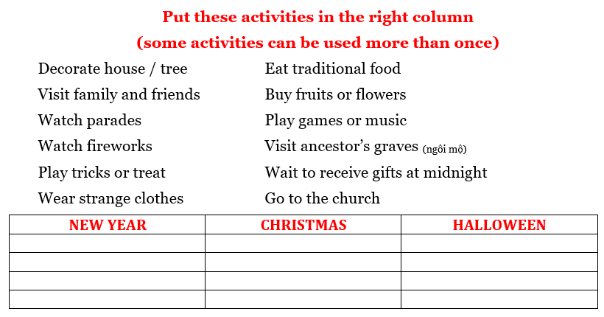 | - Look and read  - Work in pairs  - Give answer  - Listen and repeat  - Read the phrase again  Answers keys  B.5 C. 3 D. 8 E. 4 F. 2 G. 6 H. 7  - Work in pairs  - Give answers  Expected answers  - People eat traditional food at Christmas / New Year  - People decorate a house or tree at Tet (New Year) / Christmas  - People get lucky money, candy of gifts at New Year  - People play games or music at Halloween / Christmas / New Year  - Work in pairs  - Give answers  Answer keys  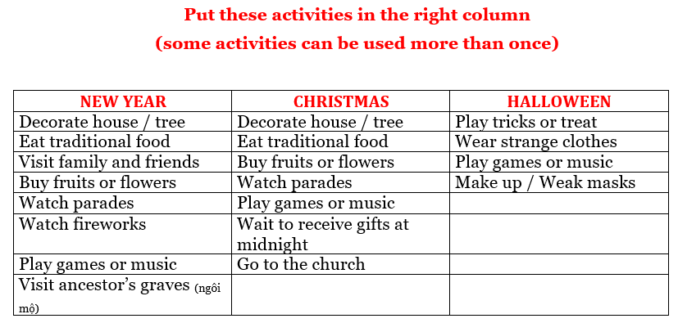
- Activity 2: Listening (10’)
a) Objective: Ss can develop their listening comprehension skills.
b) Content: Ss listen to some people talking about traditional festivals.
c) Products: Ss can listen for main ideas and specific information, then they can talk about festivals.
d) Competence: collaboration, communication, analytical and synthesizing skills.
e) Organization of the activity:

Teacher’s Activities | Students’ Activities
*Conversation Skill: Getting time to think  - Focus on the Conversation Skill box  - Explain to the Ss that they are going to learn how to use hesitation devices  - Give more words / phrase to express hesitation:  Well …  Umm …  Let me see …  I see …  Well, you know …  - Play audio. (CD 1 – Track 52). Have Ss listen and repeat  - Have some Ss practice the conversation skill in front of the class  - Give feedback  a. Listen to some people talking about traditional festivals. Are all the festivals celebrated in the same country?  - Have Ss look at the request of the task  - Play audio (CD1 – Track 51)  - Have Ss listen and answer the question by circling Yes / No  - Check answers as a whole class  b. Listen and draw lines  - Have Ss read the festivals and activities in the task  - Demonstrate the activity  - Play audio (CD1 – Track 51) again  - Have Ss listen and draw lines  - Call Ss to read their answers  - Check answers as a whole class | - Look and read  - Listen and take notes  - Listen and repeat  - Practice in pairs  - Read  - Listen and give answer  Answer keys  No.  - Read  - Listen and draw lines  - Read answers  Answer keys  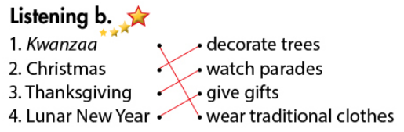
- Activity 3: Grammar – Useful language (10’)
a) Objective: Ss can use some useful languages in their speaking.
b) Content: Structures to ask and answer about festival activities
c) Products: Ss can apply the structure in everyday communication.
d) Competence: collaboration, communication, presentation.
e) Organization of the activity:
Teacher’s Activities | Students’ Activities
Listen then practice  - Option 1:  - Have Ss look at the Useful Language box  - Explain more about the structures used to ask about festival activities  How do people prepare for…?  What do they do during …?  - Play audio (CD1 – Track 53)  - Have Ss practice the useful language  - Have Ss practice the conversation, using other activities from “New words” and Listening”, and their own ideas  - Call some pairs to present, give feedback and evaluation  - Option 2:  - Follow the same steps as option 1  - Call some Ss to ask and answer about a festival activity (Ss can choose which one to talk about)  - Have Ss act out the conversation as naturally as they can (without using the textbook)  - Give feedback and evaluation | - Look  - Listen and take notes  - Listen  - Practice in pairs  - Present  - Work in pairs  - Present

C. Consolidation (3’)
* Names of some festivals: Christmas, New Year, Easter, Thanksgiving, Kwanzaa, Water Festival, …
* Conversation skill: Getting time to think
Well …
Umm …
Let me see …
I see …
Well, you know …
* Asking about festival activities:
How do people prepare for…?
What do they do during …?

D. Homework (2’)
- Find more information about some famous festivals in the world.
- Ask and answer about festival activities.
- Do exercises in Workbook: Lesson 3 - New words – Listening (page 24).
- Prepare: Lesson 3 – Reading, Speaking and Writing (page 37 – SB).

