**ĐỀ VIP 9+ - ĐỀ SỐ 7**

## Read the following school announcement and mark the letter A, B, C, or D to indicate the correct option that best fits each of the numbered blanks from 1 to 6.

Attention students! Our school is thrilled to announce the upcoming **(1)** dedicated to promoting sustainable green initiatives. This contest aims to encourage innovative ideas that could make a real difference in our community, inspiring everyone to **(2)** more eco-friendly practices.

Participants will be judged on creativity, effectiveness, and the potential impact of their initiatives, with a great **(3)** of emphasis on sustainability. We encourage students to submit projects that focus **(4)** areas such as recycling, energy conservation, and reducing waste, each of which contributes to a healthier environment.

Those **(5)** will have the chance to present their projects to a panel of judges, showing how they **(6)** environmental issues seriously.

If you're keen on making a difference, join us and help lead the way towards a greener future. Sign up by Friday in the main office!

|  |  |  |  |  |
| --- | --- | --- | --- | --- |
| **Question 1.** | **A.** environmental project contest | | **B.** project environmental contest | |
|  | **C.** contest environmental project | | **D.** environment contest project | |
| **Question 2.** | **A.** adjust | **B.** adapt | **C.** adopt | **D.** adore |
| **Question 3.** | **A.** variety | **B.** number | **C.** deal | **D.** minority |
| **Question 4.** | **A.** with | **B.** for | **C.** at | **D.** on |
| **Question 5.** | **A.** selected | **B.** are selected | **C.** who select | **D.** selecting |
| **Question 6.** | **A.** put | **B.** take | **C.** bring | **D.** get |

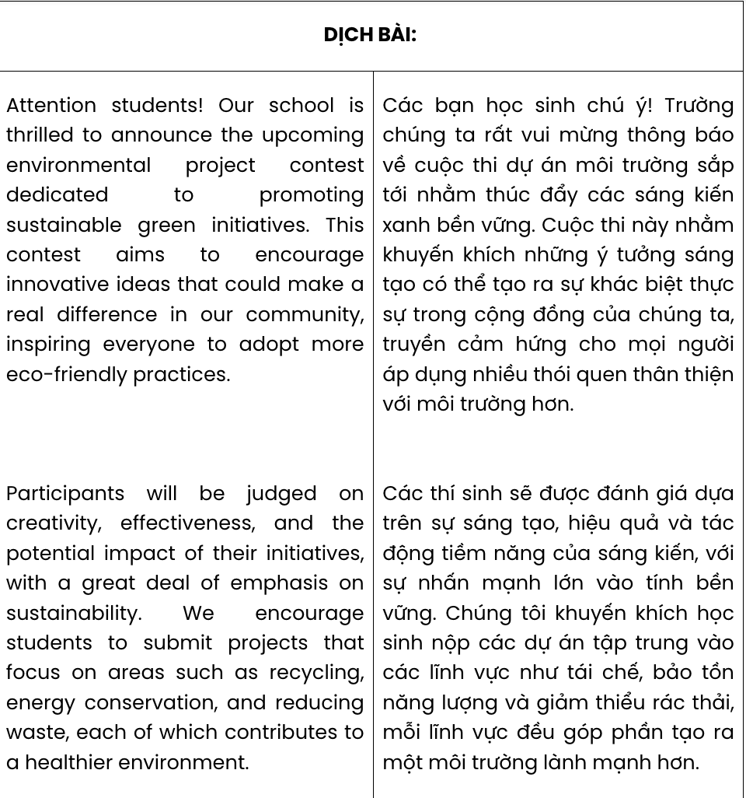

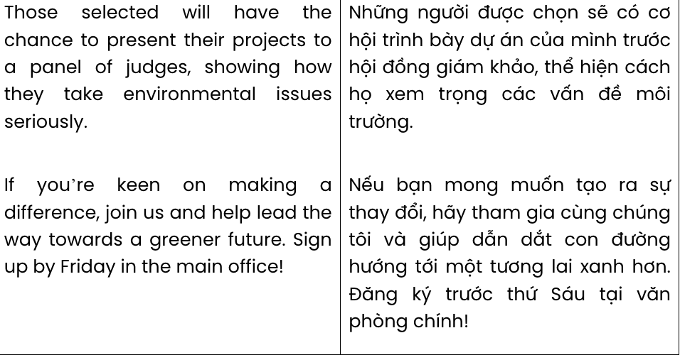

**GIẢI CÂU 1:**

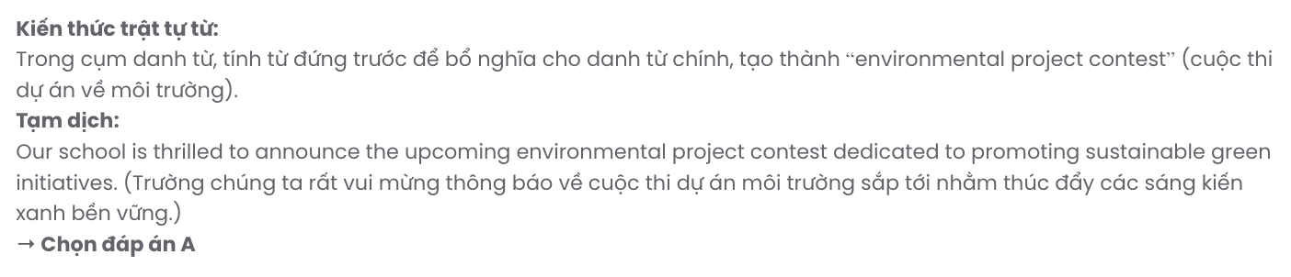

**GIẢI CÂU 2:**

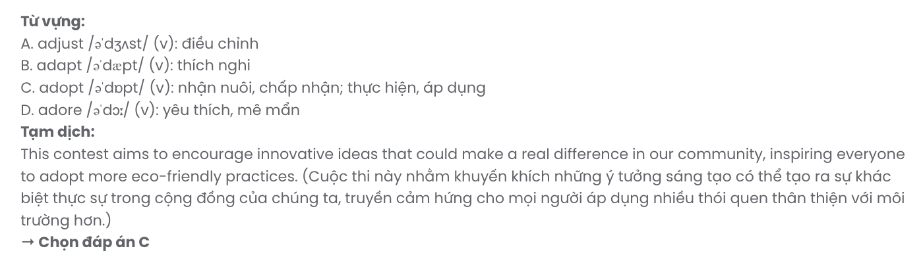

**GIẢI CÂU 3:**

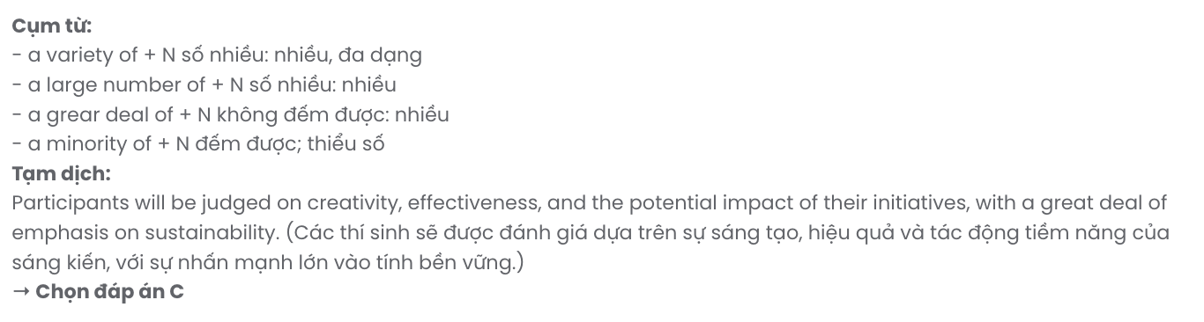

**GIẢI CÂU 4:**

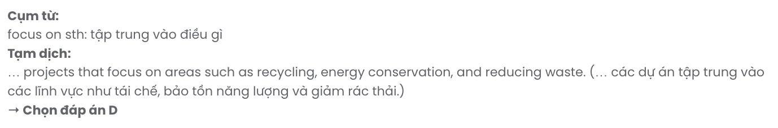

**GIẢI CÂU 5:**

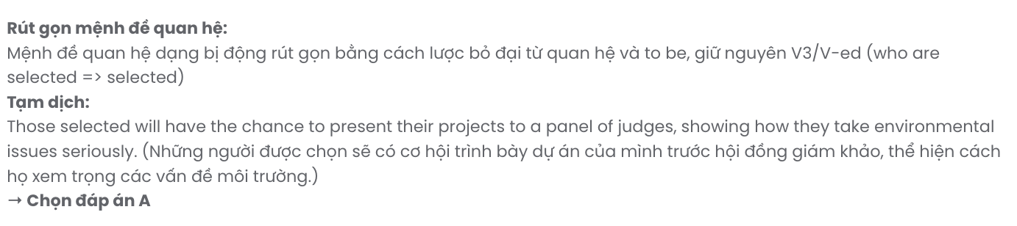

**GIẢI CÂU 6:**

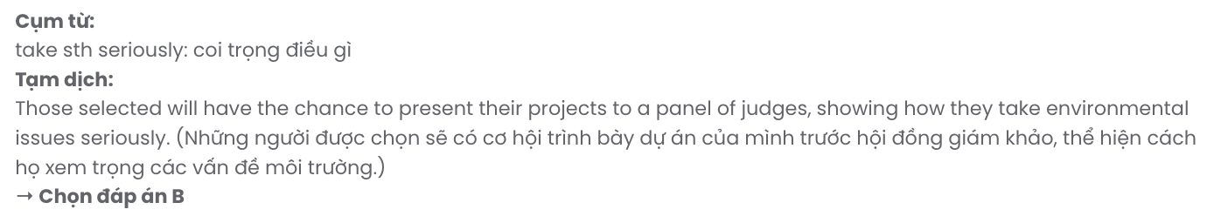

***Read the following advertisement and mark the letter A, B, C, or D to indicate the correct option that best fits each of the numbered blanks from 7 to 12.***

# Explore Nature Responsibly with Eco-Tours

**Why Choose Eco-Tours?**

Eco-tours have quickly **(7)** as a preferred travel choice, allowing travellers to enjoy nature responsibly. **(8)** the growing need to protect our environment, eco-tours strive to minimise ecological impact. These tours help travellers avoid **(9)** delicate ecosystems and contribute to conservation efforts.

# What Eco-Tours Offer

Eco-tours offer **(10)** unique experiences, from guided forest treks to wildlife observation, all planned with sustainability in mind. Travellers can expect eco-friendly accommodations and **(11)**

designed to preserve local habitats. You'll be **(12)** to know that these tours emphasise sustainability, ensuring that natural wonders are protected for future generations.

Choose eco-tours for a rewarding experience that benefits both you and the environment!

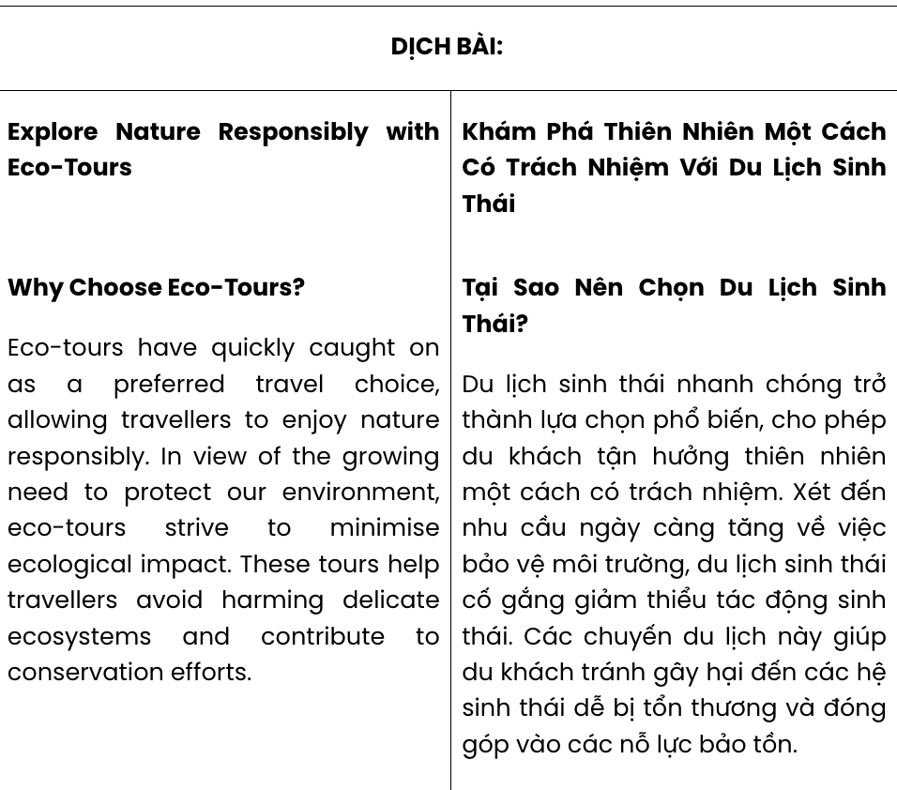

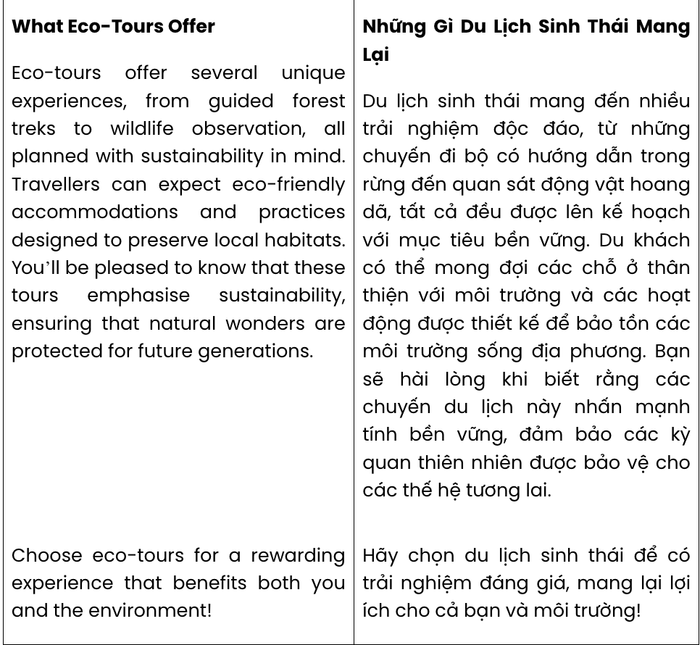

**GIẢI CÂU 7:**

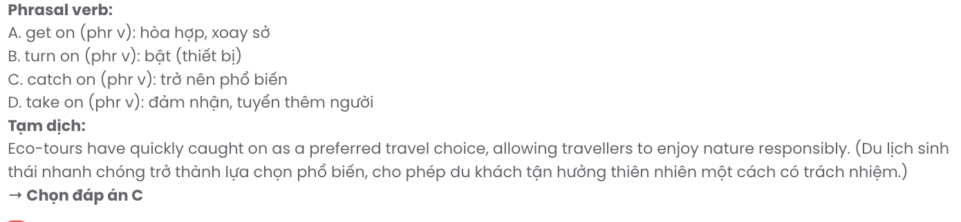

**GIẢI CÂU 8:**

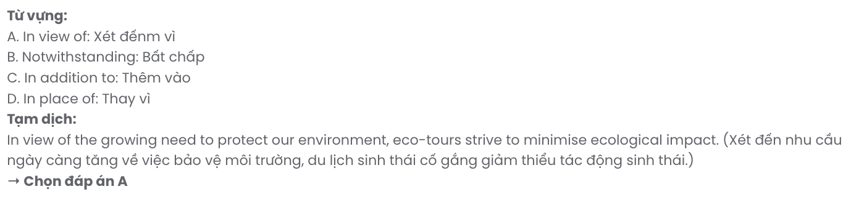

**GIẢI CÂU 9:**

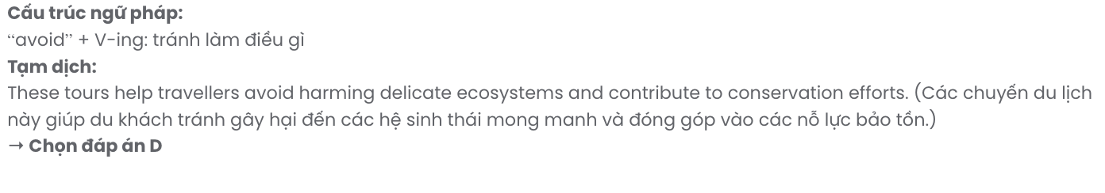

**GIẢI CÂU 10:**

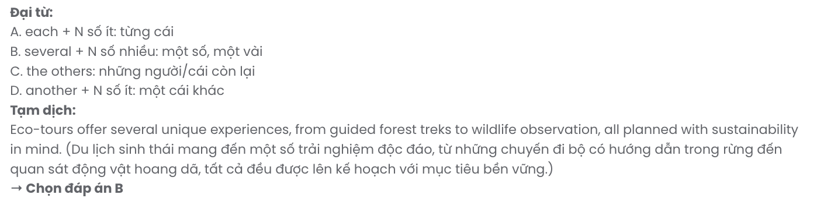

**GIẢI CÂU 11:**

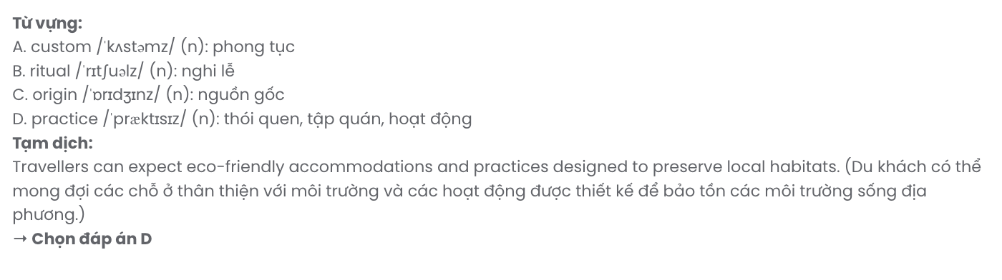

**GIẢI CÂU 12:**

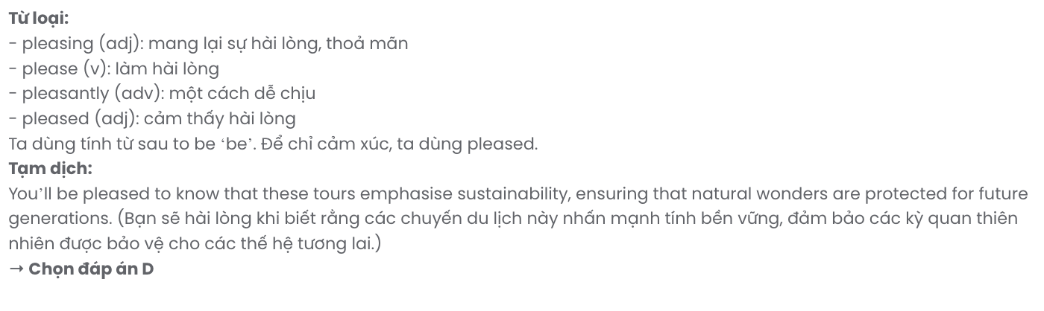

|  |  |  |  |  |
| --- | --- | --- | --- | --- |
| **Question 7.** | **A.** got on | **B.** turned on | **C.** caught on | **D.** taken on |
| **Question 8.** | **A.** In view of | **B.** Notwithstanding | **C.** In addition to | **D.** In place of |
| **Question 9.** | **A.** harm | **B.** to harming | **C.** to harm | **D.** harming |
| **Question 10.** | **A.** each | **B.** several | **C.** the others | **D.** another |
| **Question 11.** | **A.** customs | **B.** rituals | **C.** origins | **D.** practices |
| **Question 12.** | **A.** pleasing | **B.** please | **C.** pleasantly | **D.** pleased |

***Mark the letter A, B, C or D on your answer sheet to indicate the best arrangement of utterances or sentences to make a meaningful exchange or text in each of the following questions from 13 to 17.***

# Question 13.

1. Jake: Do you listen to music while studying?
2. Jake: I actually focus better with music - it keeps me energised and on track!
3. Emma: I find it distracting. I prefer studying in complete silence.

**A.** b – c – a **B.** b – a – c **C.** c – a – b **D.** a – c – b

# Question 14.

Hi Alex,

1. I’m slowly adjusting to this chaotic flow, but it’s so different from back home.
2. Another surprise was the food; the flavours are much bolder and spicier than I expected.
3. Moving to Vietnam has been a real adventure, but I’ve had some surprises along the way.
4. Despite the challenges, I’m enjoying discovering this culture and everything it has to offer.
5. The biggest shock was the traffic - motorbikes fill every street, moving in ways I’m not used to. Write back soon,

Sam

**A.** c – e – a – b – d **B.** e – b – a – d – c **C.** c – b – a – e – d **D.** a – e – c – b – d

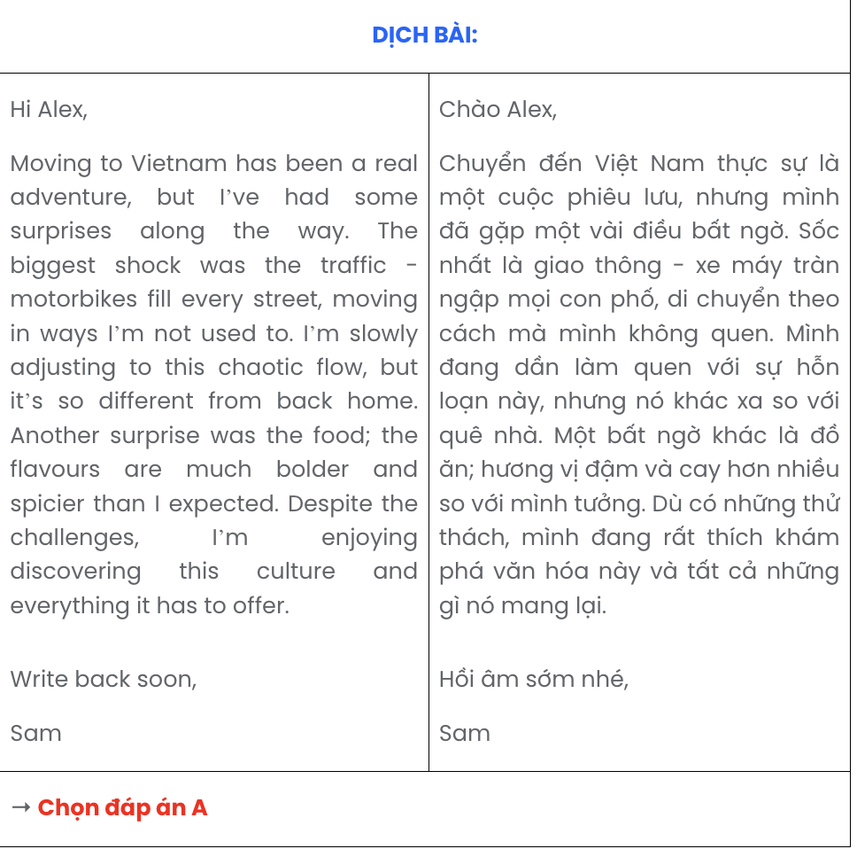

# Question 15.

1. Tom: How do you find the time for it?
2. Emma: I’ve started going to the gym regularly. It’s been great for my energy levels.
3. Tom: That sounds good, but I’m not sure I’d be able to stick with a schedule.
4. Emma: They have flexible hours, so I can go whenever I’m free.
5. Tom: What are you doing to stay active these days?

**A.** b – a – d – c – e **B.** b – c – d – a – e **C.** e – b – a – d – c **D.** e – d – c – b – a

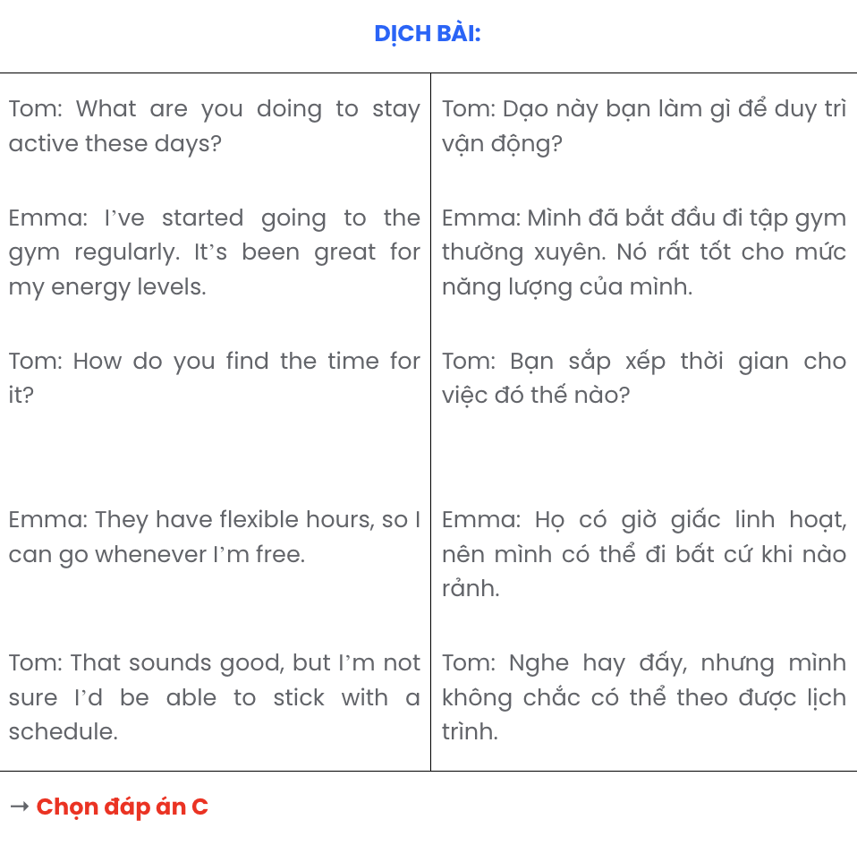

# Question 16.

1. Many voluntary groups have emerged, focusing on local needs like park restoration, after-school programs, and community clean-ups.
2. The increased participation has encouraged local authorities to support these groups, offering grants and resources to expand their efforts.
3. Masonfield has seen a remarkable rise in community involvement over the past few years.
4. These initiatives have also brought together residents from different backgrounds, fostering a sense of unity and pride within the town.
5. The rise in volunteer efforts has also sparked discussions about creating a community centre in Masonfield to support future projects and gatherings.

**A.** c – b – e – d – a **B.** c – d – b – a – e **C.** c – e – a – b – d **D.** c – a – d – b – e

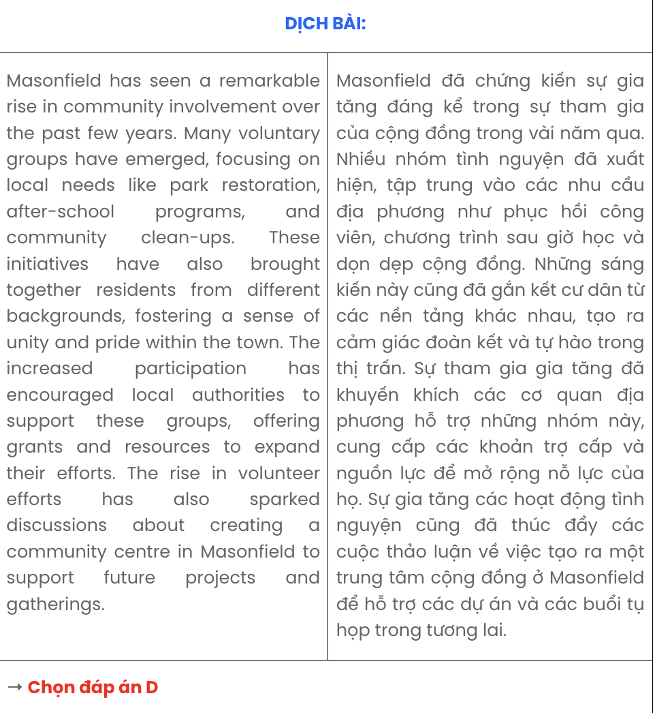

# Question 17.

1. For people, the constant glow can interfere with sleep and overall well-being.
2. The bright lights from buildings, street lamps, and billboards create an artificial glow that blocks out natural starlight.
3. This excess light disrupts local wildlife, as animals rely on natural darkness for their daily cycles.
4. Many cities are now considering ways to reduce light pollution, using shielded lighting and dimming systems to restore balance.
5. Light pollution has become a serious concern in many big cities worldwide.

**A.** d – c – b – a – e **B.** e – c – a – b – d **C.** e – b – c – a – d **D.** d – a – c – b – e

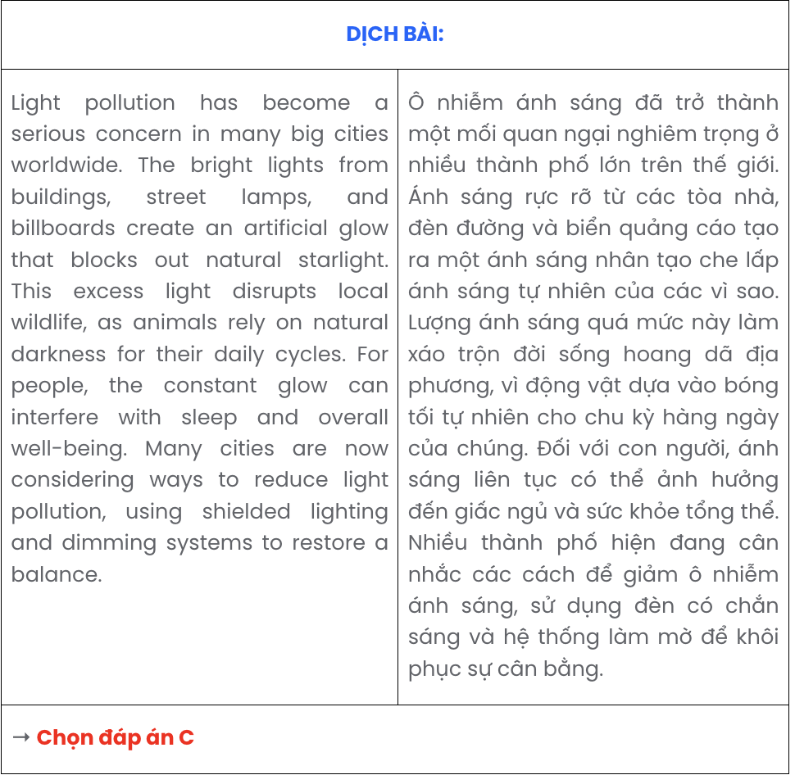

## Read the following passage about AI assistance for disabled students and mark the letter A, B, C, or D to indicate the correct option that best fits each of the numbered blanks from 18 to 22.

AI-powered technologies, once concepts in futuristic predictions, are now assisting disabled students in real-world applications. For instance, Emma, an AI-enabled educational assistant, **(18)**  . Within just a few months, Emma demonstrated significant improvements in accessibility for students with disabilities, providing personalised learning support and engaging students across various subjects.

Emma was developed by a California-based tech company **(19)**  . Without a doubt, Emma and similar AI-powered tools represent the rapid progress in assistive technology, particularly in supporting disabled students. **(20)**  .

Emma’s design is inspired by a diverse range of needs, catering to students with visual, auditory, and physical disabilities. Equipped with voice recognition and visual tracking, **(21)**  . Additionally, adaptive text-to-speech technology allows her to read material out loud, helping students overcome learning barriers with ease.

Emma’s true strength lies in her ability to provide individualised support. She adjusts to each student’s learning style and needs, offering a personalised educational experience that evolves over time. **(22)**

.

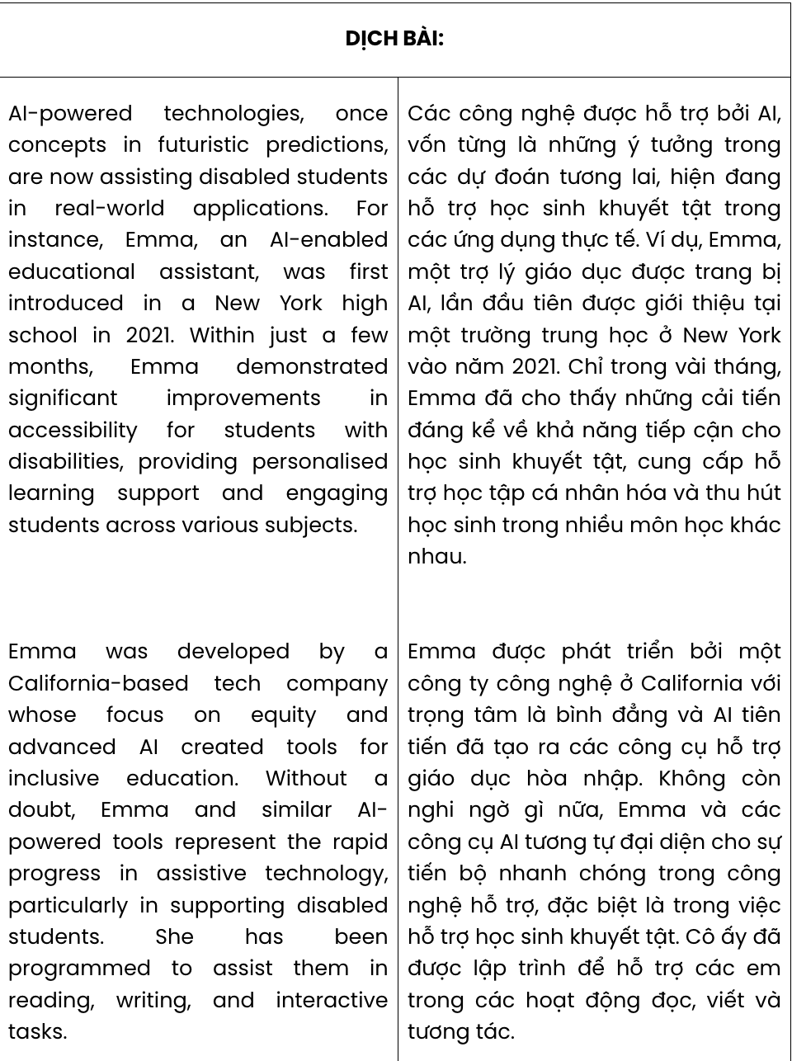

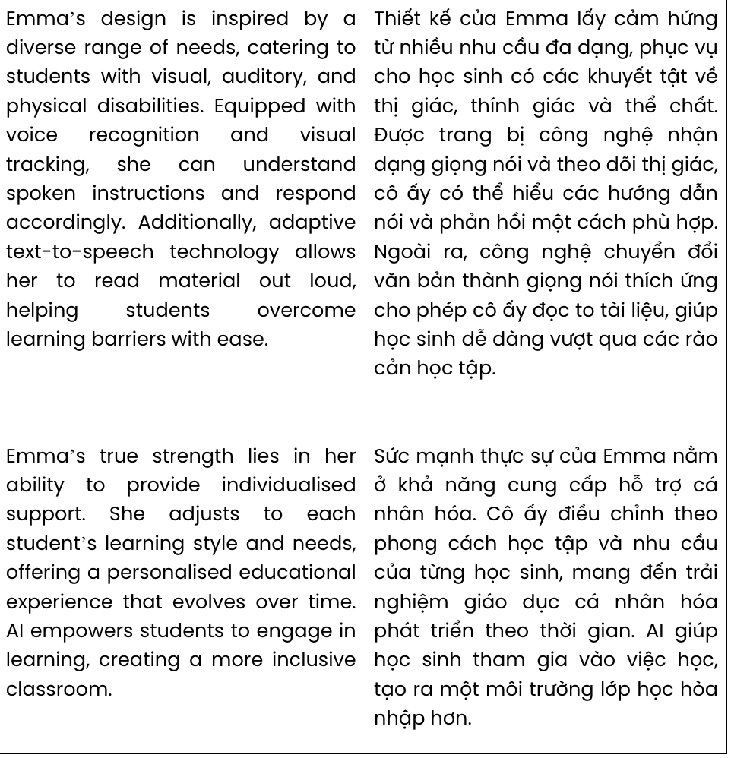

# Question 18.

* 1. which was initially implemented in a New York high school in 2021
  2. was first introduced in a New York high school in 2021
  3. having made its debut in a New York high school in 2021
  4. whose launch was announced in a New York high school in 2021

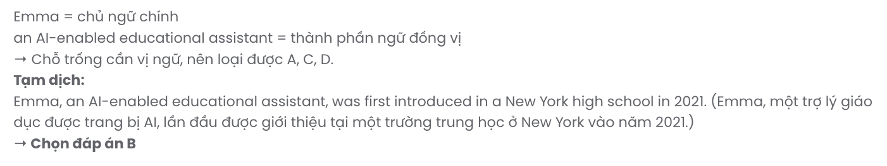

# Question 19.

1. of which emphasis on equity and advanced AI to create tools for inclusive education
2. prioritised equity and advanced AI to produce tools for inclusive education
3. attached importance to equity and advanced AI for tools to support inclusive learning
4. whose focus on equity and advanced AI created tools for inclusive education

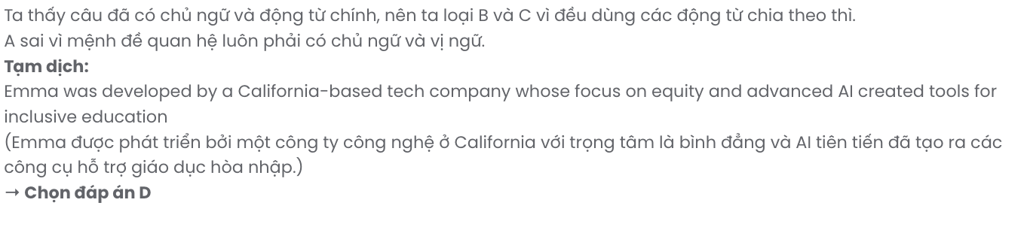

# Question 20.

1. Wanting to assist them in reading, writing, and interactive tasks, she has been designed
2. Their assistance in reading, writing, and interactive tasks gave birth to her
3. She has been programmed to assist them in reading, writing, and interactive tasks
4. Programmed reading, writing, and interactive tasks assist in developing her

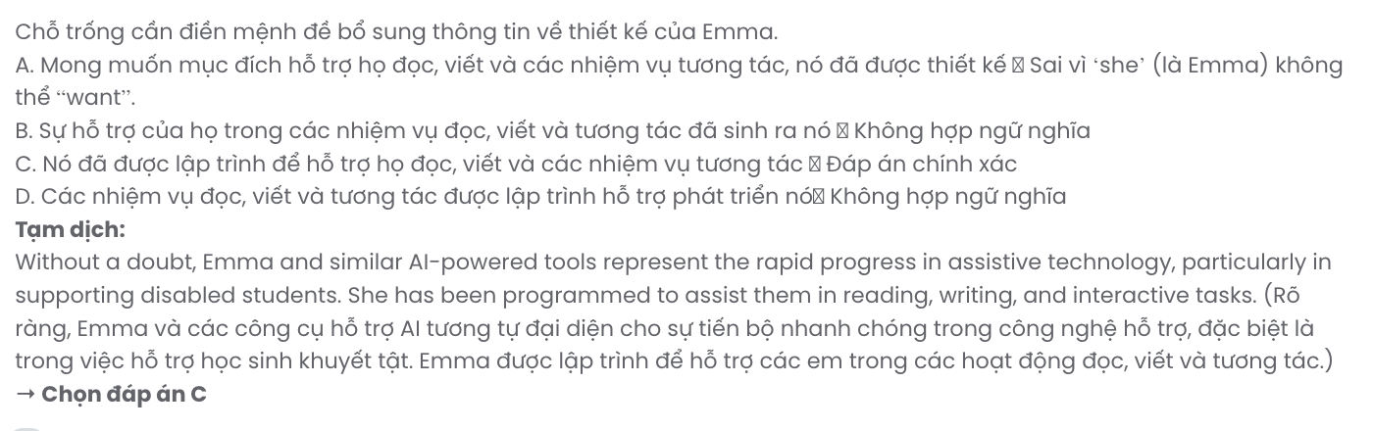

# Question 21.

1. understanding spoken instructions and responding accordingly is easier for her
2. spoken instructions help her understand and respond accordingly
3. she can understand spoken instructions and respond accordingly
4. they help her respond accordingly by understanding spoken instructions

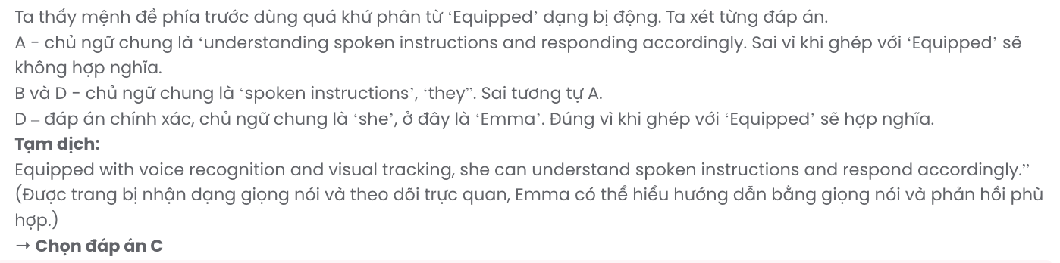

# Question 22.

1. AI empowers students to engage in learning, creating a more inclusive classroom
2. Empowered to engage in learning by AI, students create a more inclusive classroom
3. Students engaging in learning empower AI to create a more inclusive classroom
4. AI creates a more inclusive classroom so that it empowers students to engage in learning

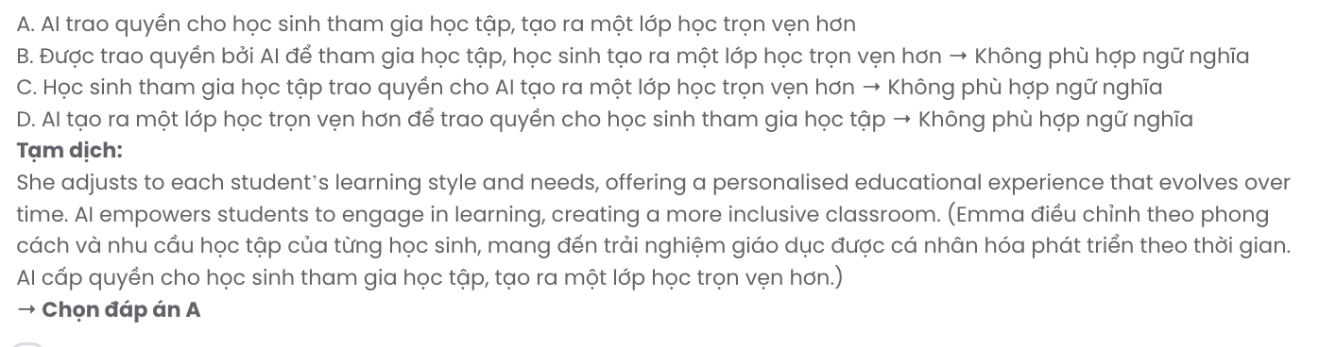

## Read the following passage and mark the letter A, B, C, or D to indicate the correct answer to each of the questions from 23 to 30.

It wasn't my usual holiday experience: standing on the beach, getting ready to release a baby sea turtle no bigger than my hand. But that was how I spent my final night in Puerto Vallarta, Mexico. During my week there, I had seen other tourists releasing the turtles in the early evening, and as my stay came to an end, I decided to join in.

Oscar, the organiser, runs Sociedad Ecológica de Occidente - a conservation project that brings tourists and residents together to save the sea turtles of Puerta Vallarta. These turtles are under **threat** from poachers who want their meat and eggs. But Oscar and his volunteers collect the eggs and take them to protected areas where they are allowed to hatch in safety.

We listened to Oscar's instructions. He told us that the turtles were released as the sun goes down so the bright lights of the hotels and nightclubs don't stop **them** finding their way back to the sea. We stood a few metres from the sea's edge holding our one-day-old turtles carefully in both hands. At a signal from Oscar, we gently placed them on the sand, stepped back and watched as they crawled slowly into the sea. **Back home, I still think of the tiny baby turtle and wonder where it is now**. Did it make it to the open sea? Is it safe? Oscar Aranda has **dedicated** his life to saving the sea turtles; I only gave a few

minutes of my time, but those minutes will stay with me for a lifetime.

(Adapted from *On Screen*)

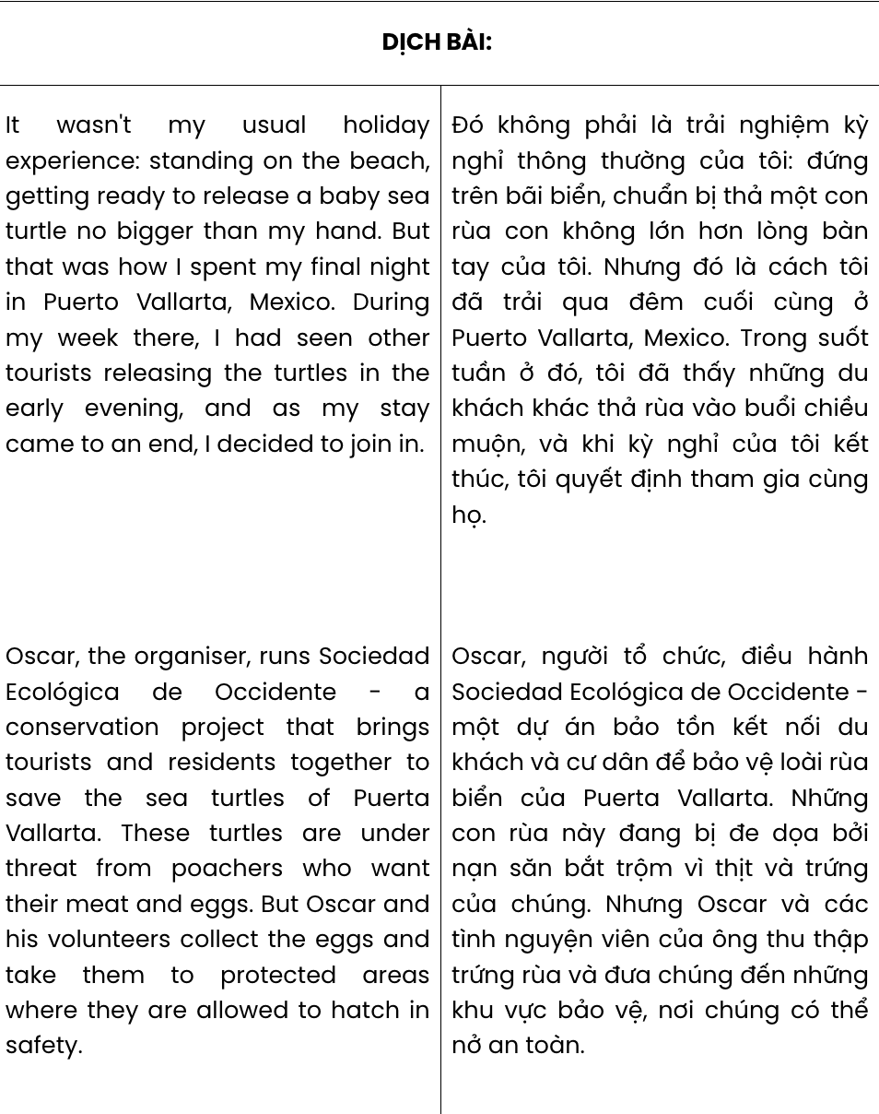

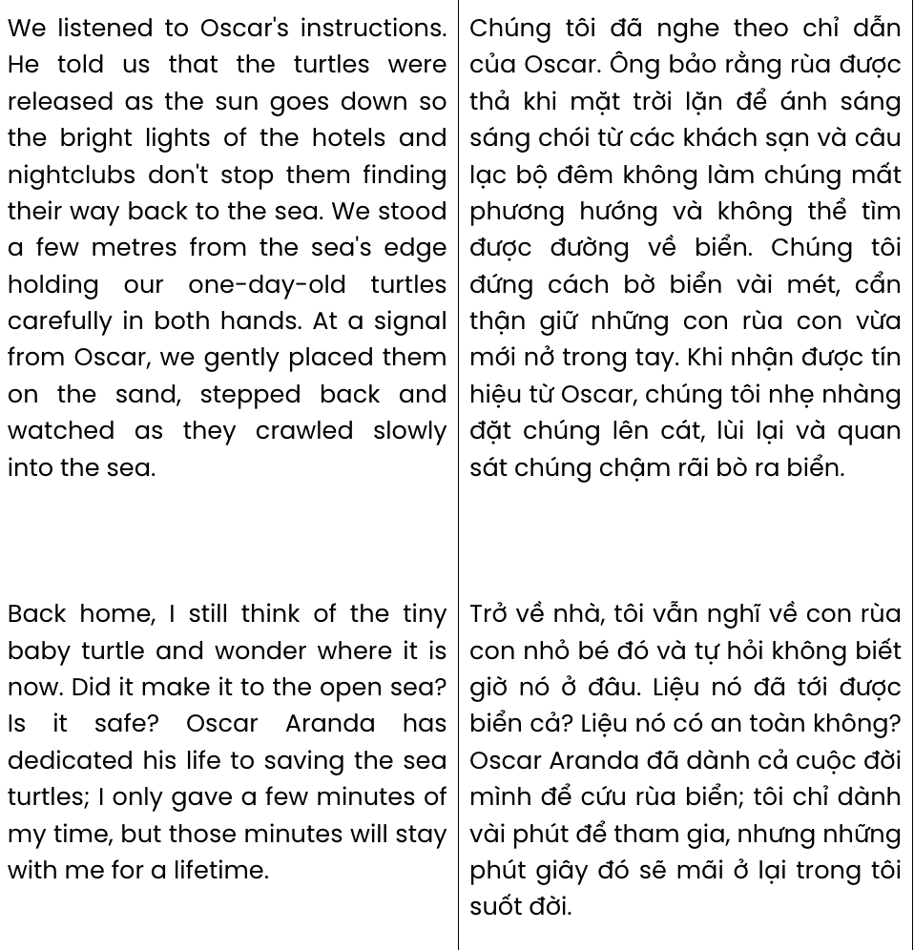

**Question 23.** According to the passage, the author decided to help with the project possibly because

.

1. he was interested in protecting wildlife and their habitats
2. he wanted to do something different before his holiday ended
3. he aimed to inspire other tourists to join the conservation effort
4. he accepted Oscar’s offer to join other tourists to save sea turtles

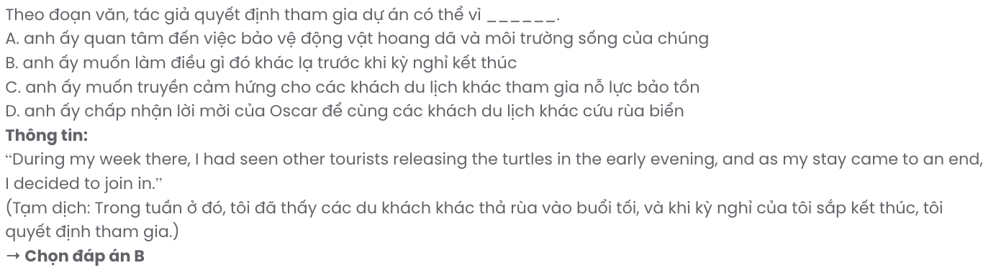

**Question 24.** The word **threat** in paragraph 2 is OPPOSITE in meaning to .

**A.** danger **B.** confusion **C.** clarity **D.** support

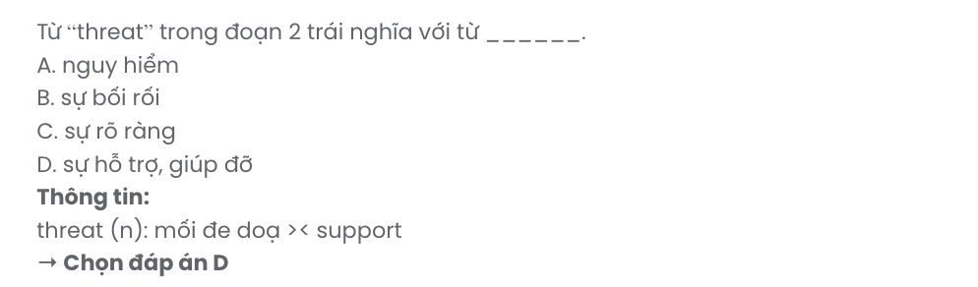

**Question 25.** The word **them** in paragraph 3 refers to .

**A.** lights **B.** instructions **C.** eggs **D.** turtles

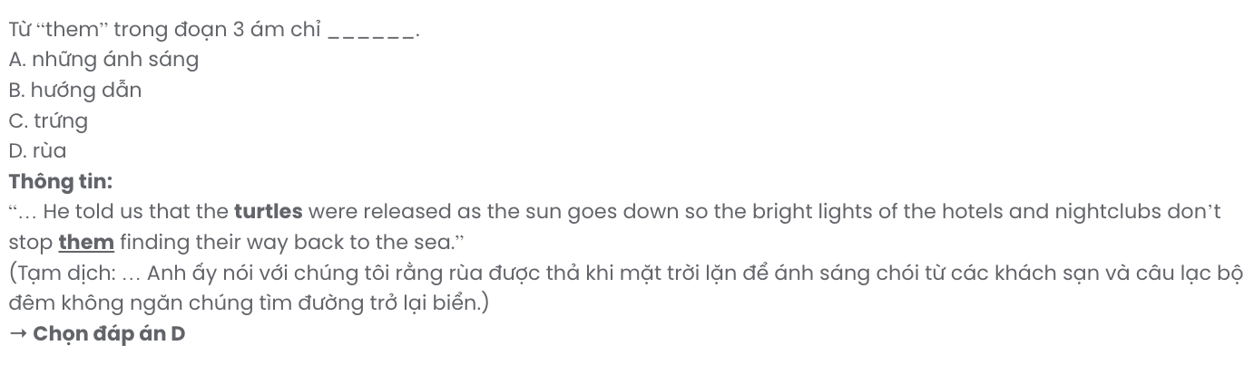

**Question 26.** Which of the following best paraphrases the underlined sentence in paragraph 4?

# Back home, I still think of the tiny baby turtle and wonder where it is now.

1. Back home, I remember releasing many baby turtles and hope they are all doing well.
2. Even after returning home, I still find myself thinking about the tiny baby turtle’s whereabouts.
3. Once I returned, I thought about those baby turtles and wondered if they’d survived.
4. I often think of turtles when I’m home, wondering about their chances in the wild.

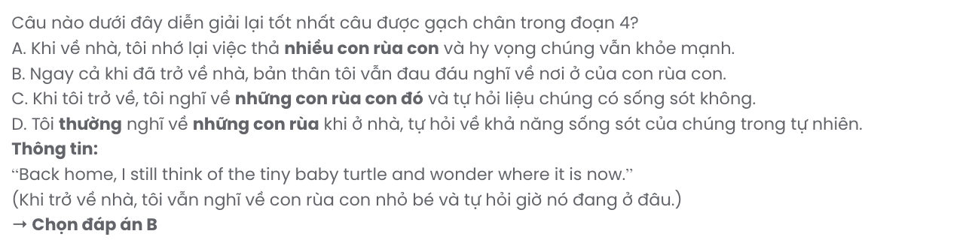

**Question 27.** The word **dedicated** in paragraph 4 can be best replaced by .

**A.** transformed **B.** devoted **C.** conveyed **D.** illustrated

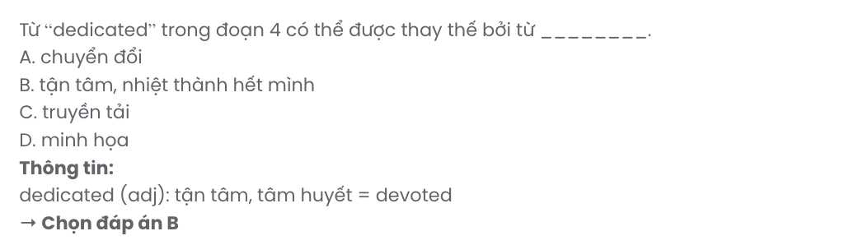

**Question 28.** Which of the following is NOT mentioned in the passage?

1. Oscar and other volunteers take the turtles’ eggs to safe places.
2. The residents of Puerta Vallarta also join Sociedad Ecológica de Occidente.
3. The experience in Mexico made the author more interested in wildlife.
4. The author didn’t leave right away after he placed sea turtles on the sand.

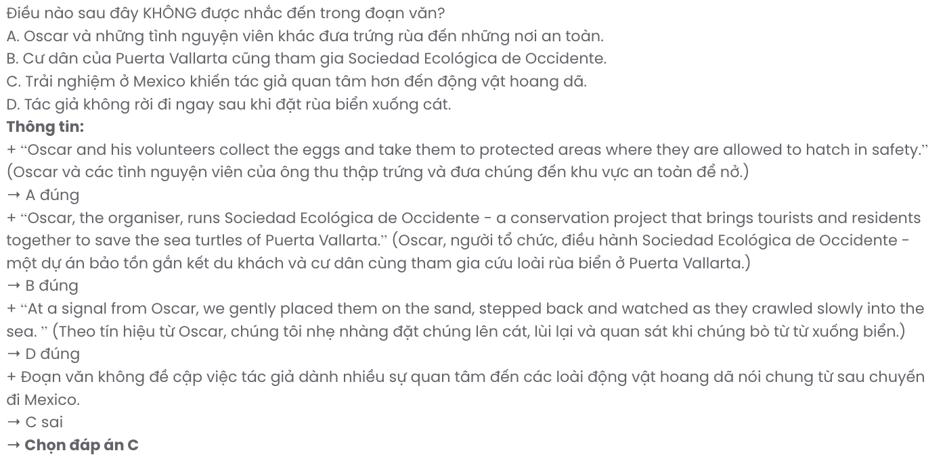

**Question 29.** In which paragraph does the author narrate the experience of the turtle release event?

**A.** Paragraph 1 **B.** Paragraph 2 **C.** Paragraph 3 **D.** Paragraph 4

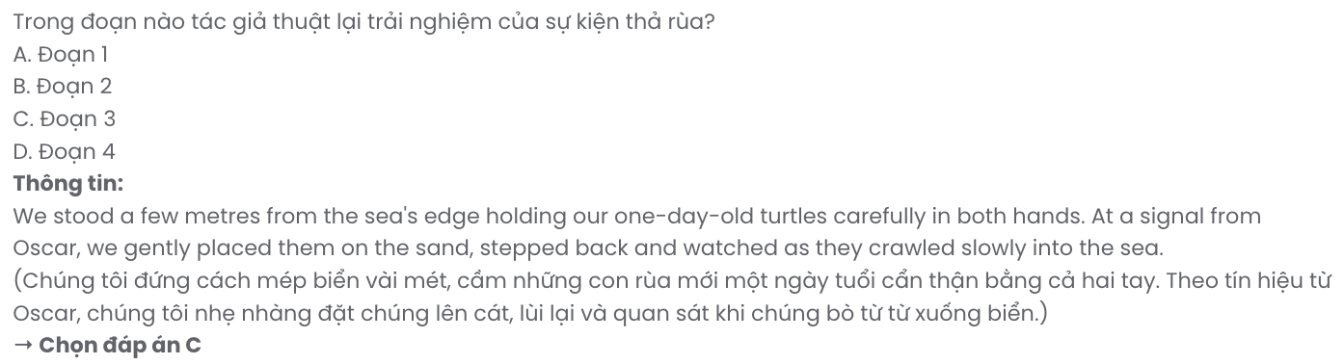

**Question 30.** In which paragraph does the author discuss a joint effort to save sea turtles?

**A.** Paragraph 1 **B.** Paragraph 2 **C.** Paragraph 3 **D.** Paragraph 4

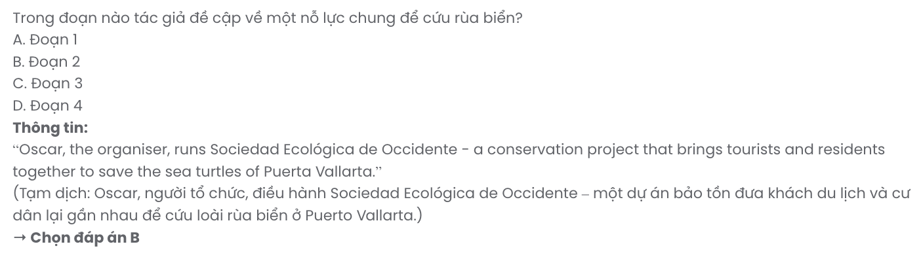

## Read the following passage and mark the letter A, B, C, or D to indicate the correct answer to each of the questions from 31 to 40.

According to the latest figures, the average number of friends people have on social media is somewhere between 200 and 300. Research suggests that this figure is actually higher for teenagers. But is this a realistic amount? Is it **feasible** to maintain meaningful relationships with so many people, in particular those you may never actually meet in person?

Nowadays, we are just one click away from making new friends on social media. This has led some people to question just how sincere the friendship is. We're living in a time where we expect things to happen instantly, so is it really all that surprising that the way we form friendships has adapted to this trend? Perhaps it shows how social media has made friendships less sincere, reducing **them** to a series of meaningless 'adds' and 'likes'.

**[I]** My most important relationships haven't grown out of a few trivial online exchanges. **[II]** It's taken years of shared experiences to develop strong and lasting bonds. **[III]** And these for me - and I believe for most other people too - are much more valuable and meaningful. **[IV]** It's something that cannot be replicated on social media, no matter how many times you have 'liked' a person's posts.

It has been suggested that technology is **ruining** our relationships with other people. However, it seems undeniable that it has now altered people's priorities, and transformed the way that we manage our friendships in the most fundamental ways. **Ultimately, though, it's up to us to decide how real and meaningful those friendships truly are**.

(Adapted from *Open World*)

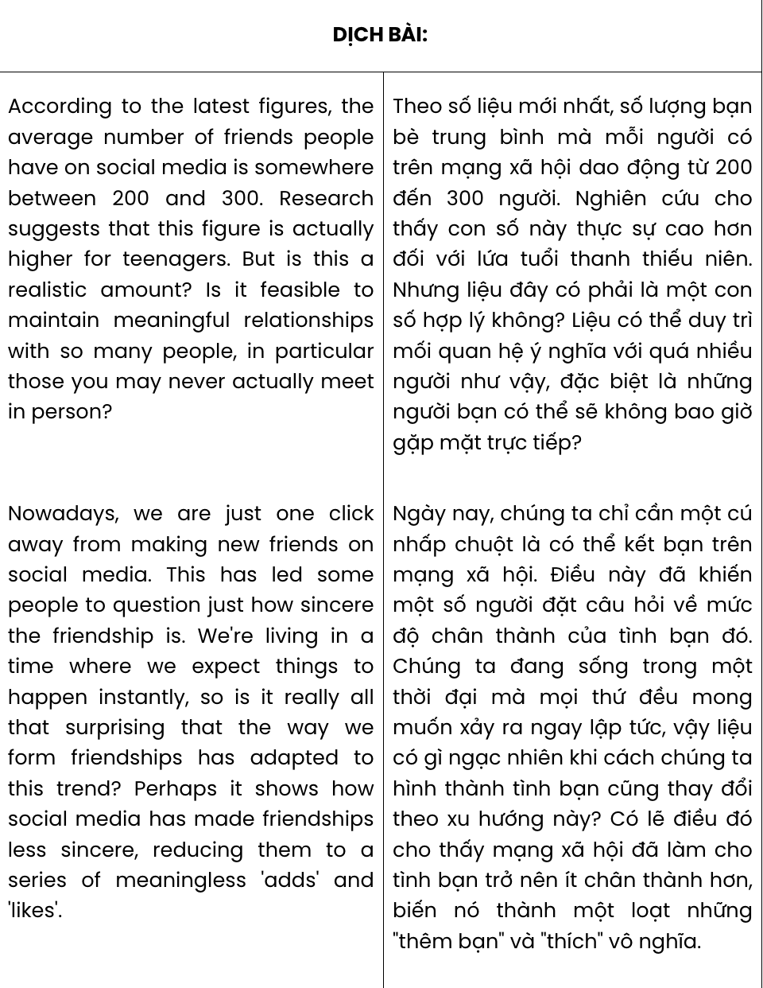

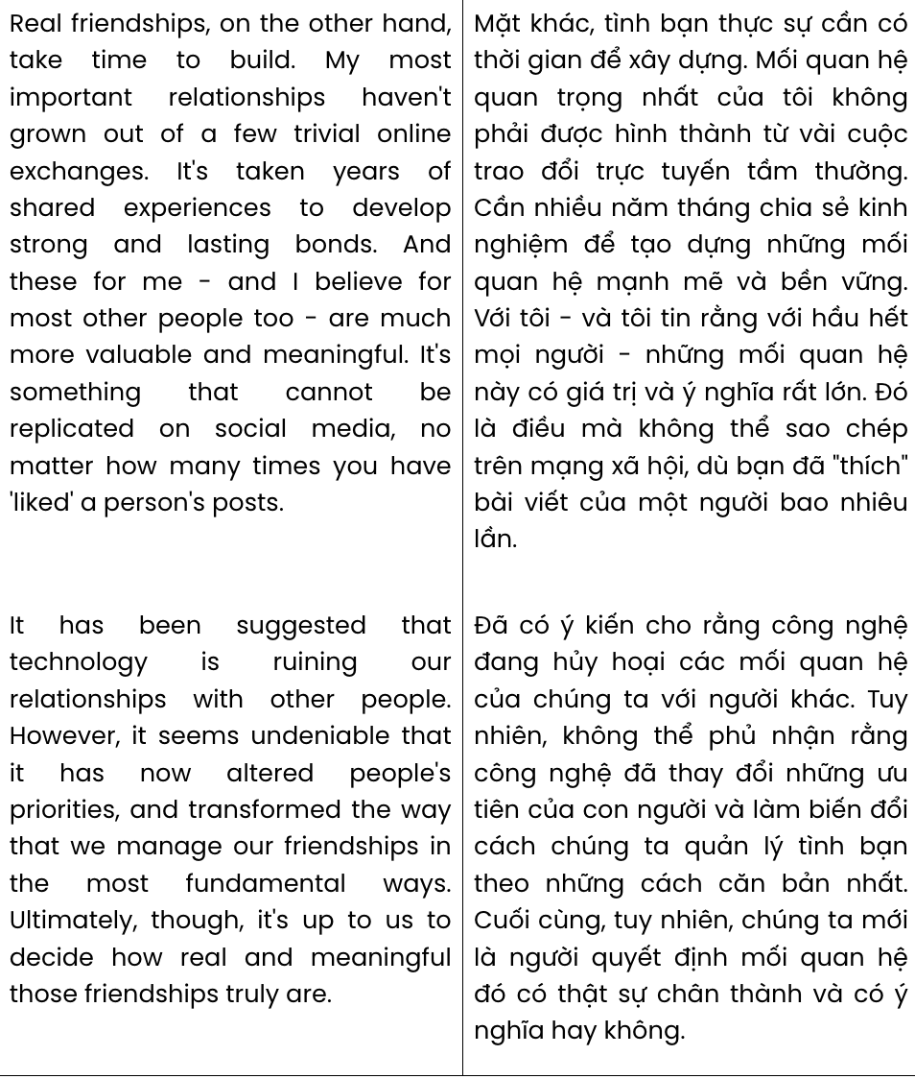

**Question 31.** The word **feasible** in paragraph 1 is closest in meaning to .

**A.** practical **B.** unlikely **C.** normal **D.** important

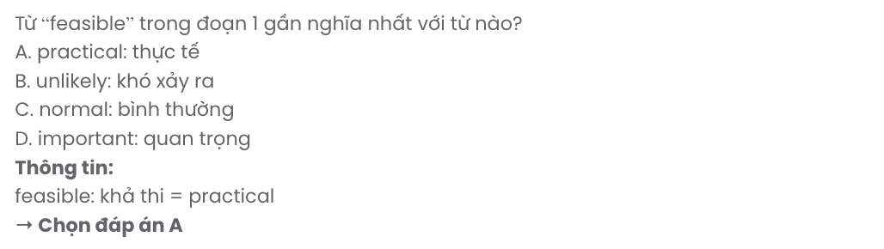

**Question 32.** According to paragraph 2, making new friends quite easily on social media has led to some doubt about .

**A.** the influence of online friends **B.** the honesty of real friends

**C.** the quality of friendships **D.** the authenticity of social media

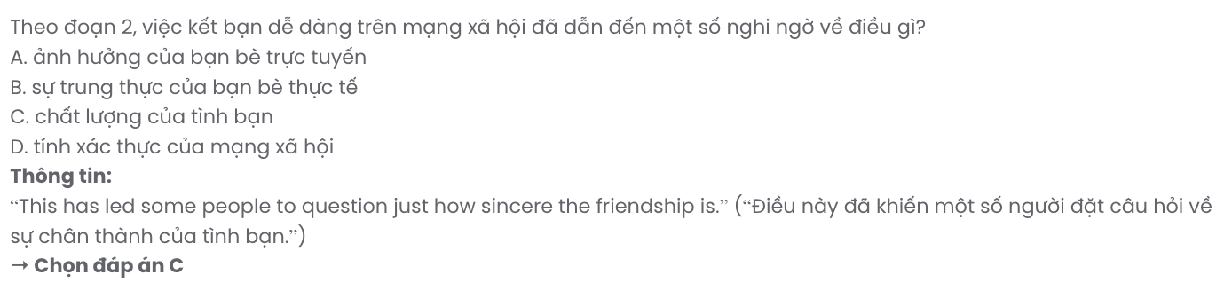

**Question 33.** The word **them** in paragraph 2 refers to .

**A.** people **B.** friendships **C.** things **D.** friends

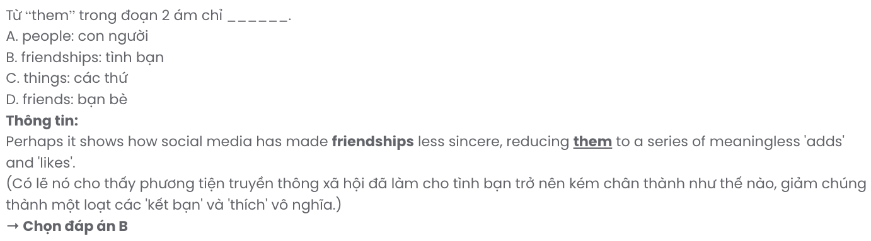

**Question 34.** Which of the following best summarises paragraph 2?

**A.** Social media may simplify friendships, turning them into superficial bonds built through ‘adds’ and ‘likes.’

**B.** Social media might make friendships more genuine, creating connections based primarily on ‘adds’ and ‘likes.’

**C.** Social media may reduce friendships to insincere connections, with friendships formed through ‘adds’ and ‘likes.

**D.** Social media has reduced friendships to shallow interactions, often built only through ‘adds’ and ‘likes.’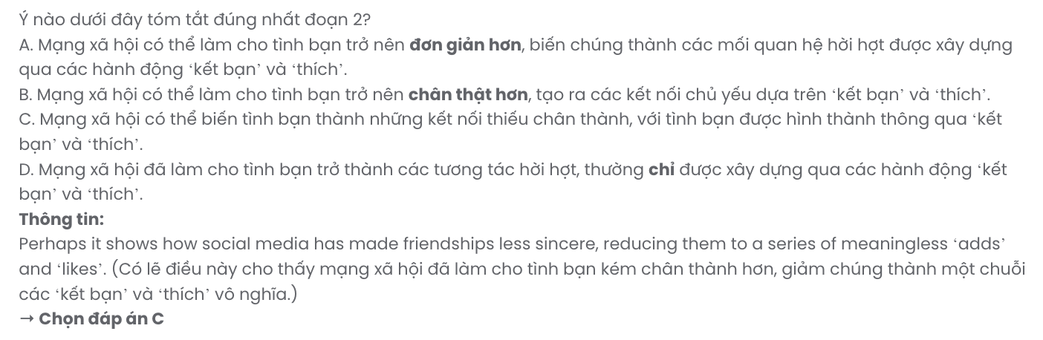

**Question 35.** Where in paragraph 3 does the following sentence best fit?

# Real friendships, on the other hand, take time to build.

**A.** [I] **B.** [II] **C.** [III] **D.** [IV]

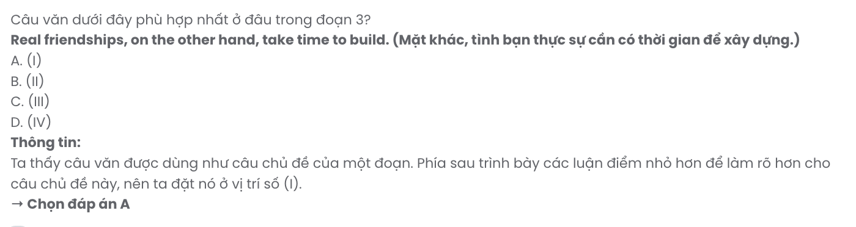

**Question 36.** The word **ruining** in paragraph 4 is OPPOSITE in meaning to .

**A.** safeguarding **B.** recognising **C.** retaining **D.** damaging

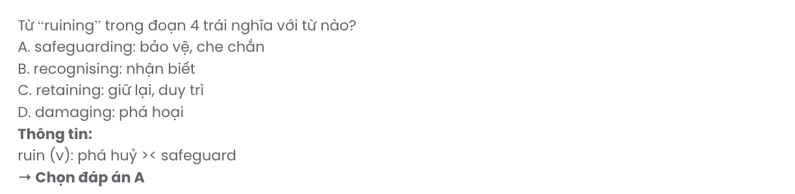

**Question 37.** Which of the following best paraphrases the underlined sentence in paragraph 4?

# Ultimately, though, it's up to us to decide how real and meaningful those friendships truly are.

**A.** In the end, it’s our choice to determine how genuine and valuable those friendships are.

**B.** Ultimately, we can only hope that those friendships are as genuine and meaningful as possible.

**C.** At last, friendships would become meaningful and real if we put effort into making them so.

**D.** In the end, it’s up to our friends to prove how meaningful our connections truly are.

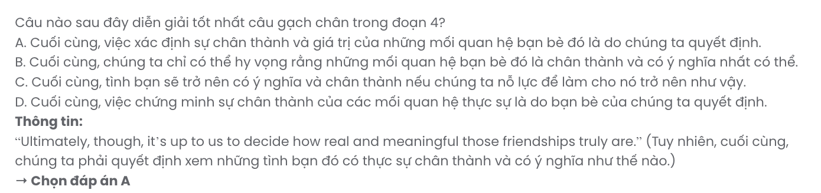

**Question 38.** Which of the following is TRUE according to the passage?

**A.** The number of online friends individuals accumulate is surprisingly high compared to in-person friendships.

**B.** Social media reinforces friendships through actions like ‘adds’ and ‘likes,’ helping people stay connected.

**C.** Building a close, real-life friendship generally takes a significant amount of time and effort.

**D.** New technology has altered how we establish and maintain real-life friendships, impacting social interactions.

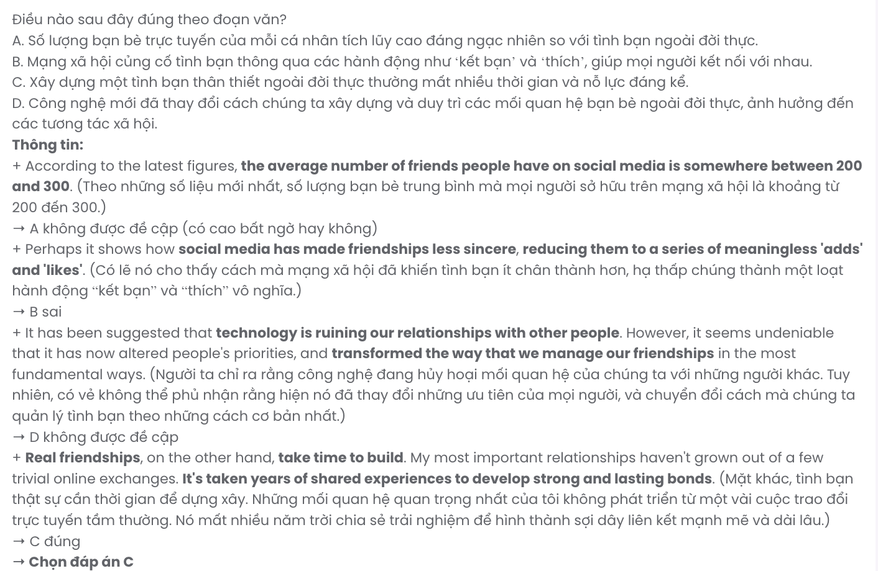

**Question 39.** Which of the following can be inferred from the passage?

**A.** Each individual is responsible for managing the impact that online friendships have on their personal lives.

**B.** The author places a high value on friendships that are deep, meaningful, and developed gradually over time.

**C.** The authenticity of friendships formed online is completely influenced by advancements in technology.

**D.** The way we establish friendships today accurately reflects the significant influence of social media.

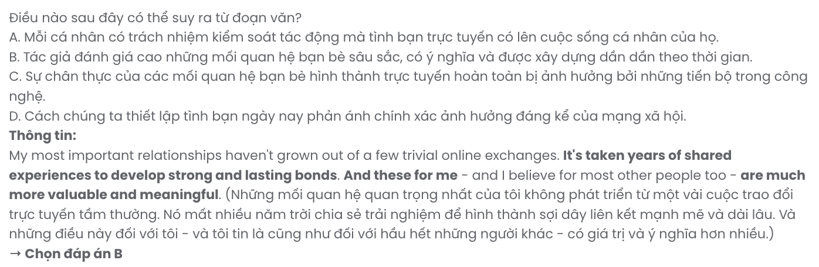

**Question 40.** Which of the following best summarises the passage?

**A.** Technology has deepened friendships by helping people connect instantly and making it easier to maintain close relationships despite distance.

**B.** Real friendships are now easier to form through social media, where meaningful connections don’t require much time or effort to develop.

**C.** Friendships today remain unaffected by technology, as social media has not completely altered how we build or value our relationships.

**D.** Social media has made friendships more superficial, while meaningful relationships require time and shared experiences to develop.

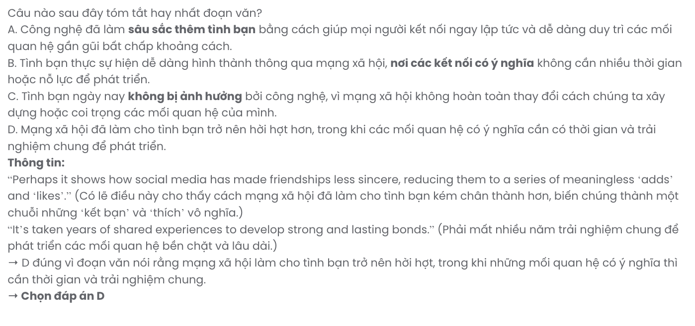

|  |  |  |  |  |
| --- | --- | --- | --- | --- |
| **BẢNG TỪ VỰNG** | | | | |
| **STT** | **Từ vựng** | **Từ loại** | **Phiên âm** | **Nghĩa** |
| **1** | thrilled | adj | /θrɪld/ | vui mừng, phấn khích |
| **2** | upcoming | adj | /ˈʌpkʌmɪŋ/ | sắp tới |
| **3** | innovative | adj | /ˈɪnəveɪtɪv/ | sáng tạo |
| **4** | initiative | n | /ɪˈnɪʃətɪv/ | sáng kiến |
| **5** | participant | n | /pɑːˈtɪsɪpənt/ | thành viên tham gia |
| **6** | potential | adj | /pəˈtenʃəl/ | tiềm năng |
| **7** | emphasis | n | /ˈemfəsɪs/ | nhấn mạnh, sự chú trọng |
| **8** | judge | n | /ʤʌʤ/ | thẩm phán |
| **9** | adjust | v | /əˈʤʌst/ | điều chỉnh |
| **10** | adopt | v | /əˈdɒpt/ | áp dụng, làm theo |
| **11** | adore | v | /əˈdɔː/ | yêu thích |
| **12** | eco-tour | n | /ˈiːkəʊ-tʊər/ | du lịch sinh thái |
| **13** | strive | v | /straɪv/ | phấn đấu |
| **14** | minimise/  minimize | v | /ˈmɪnɪmaɪz/ | giảm thiểu tới mức tối đa |
| **15** | delicate | adj | /ˈdelɪkɪt/ | mỏng manh, tinh tế, nhẹ nhàng |
| **16** | imagination | n | /ɪˌmæʤɪˈneɪʃən/ | trí tưởng tượng |
| **17** | conservation | n | /kɒnsəˈveɪʃən/ | sự bảo tồn |
| **18** | trek | n | /trek/ | cuộc hành trình |
| **19** | accommodation | n | /əˌkɒməˈdeɪʃən/ | chỗ ở |
| **20** | ritual | n | /ˈrɪʧʊəl/ | nghi lễ |
| **21** | practice | n | /ˈpræktɪs/ | thực hành; phong tục, thói quen |
| **22** | chaotic | adj | /keɪˈɒtɪk/ | hỗn loạn |
| **23** | emerge | v | /ɪˈmɜːʤ/ | nổi lên |
| **24** | grant | v | /ɡrɑːnt/ | cấp tiền |
| **25** | unity | n | /ˈjuːnɪti/ | đoàn kết |
| **26** | dim | adj | /ˈdɪm/ | mờ dần |
| **27** | futuristic | adj | /ˌfjuːtʃəˈrɪstɪk/ | hướng tới tương lai |
| **28** | disabled | adj | /dɪˈseɪbld/ | khuyết tật |
| **29** | demonstrate | v | /ˈdemənˌstreɪt/ | trình bày |
| **30** | personalised/  personalized | adj | /ˈpɜːsənəlaɪzd/ | cá nhân hóa |
| **31** | represent | v | /ˌreprɪˈzent/ | đại diện |
| **32** | assistive | adj | /əˈsɪstɪv/ | hỗ trợ |
| **33** | diverse | adj | /daɪˈvɜːs/ | đa dạng |
| **34** | auditory | adj | /ˈɔːdɪtəri/ | liên quan tới thính giác |
| **35** | voice recognition | np | /vɔɪs rekəɡˈnɪʃn/ | nhận dạng giọng nói |
| **36** | visual tracking | np | /ˈvɪʒʊəl ˈtrækɪŋ/ | theo dõi hình ảnh |
| **37** | adaptive | adj | /əˈdæptɪv/ | thích ứng |
| **38** | text-to-speech | adj | /tekst tuː spiːʧ/ | chuyển đổi văn bản thành lời nói |
| **39** | evolve | v | /ɪˈvɒlv/ | phát triển, tiến hoá |
| **40** | initially | adv | /ɪˈnɪʃəli/ | ban đầu |

|  |  |  |  |  |
| --- | --- | --- | --- | --- |
| **41** | implement | v | /ˈɪmplɪˌment/ | thực hiện |
| **42** | empower | v | /ɪmˈpaʊə/ | trao quyền |
| **43** | poacher | n | /ˈpəʊʧə/ | kẻ săn trộm |
| **44** | gently | adv | /ˈʤentli/ | nhẹ nhàng |
| **45** | crawl | v | /krɔːl/ | bò |
| **46** | dedicated | adj | /ˈdedɪkeɪtɪd/ | cống hiến |
| **47** | convey | v | /kənˈveɪ/ | truyền đạt |
| **48** | average | adj | /ˈævərɪʤ/ | trung bình |
| **49** | figure | n | /ˈfɪɡjʊə/ | nhân vật, số liệu |
| **50** | realistic | adj | /rɪəˈlɪstɪk/ | thực tế |
| **51** | feasible | adj | /ˈfiːzəbl/ | khả thi |
| **52** | sincere | adj | /sɪnˈsɪə/ | chân thành |
| **53** | instantly | adv | /ˈɪnstəntli/ | ngay lập tức |
| **54** | trivial | adj | /ˈtrɪviəl/ | tầm thường |
| **55** | replicate | v | /ˈreplɪˌkeɪt/ | lặp lại |
| **56** | ruin | v | /ruːɪn/ | phá hủy |
| **57** | undeniable | adj | /ˌʌndɪˈnaɪəbl/ | không thể phủ nhận |
| **58** | alter | v | /ˈɔːltə/ | thay đổi |
| **59** | fundamental | adj | /ˌfʌndəˈmentl/ | cơ bản |
| **60** | practical | adj | /ˈpræktɪkl/ | thực tiễn |
| **61** | safeguard | v | /ˈseɪfɡɑːd/ | bảo vệ |
| **62** | retain | v | /rɪˈteɪn/ | duy trì |
| **63** | reinforce | v | /ˌriːɪnˈfɔːs/ | tăng cường |

|  |  |  |
| --- | --- | --- |
| **BẢNG CẤU TRÚC** | | |
| **STT** | **Cấu trúc** | **Nghĩa** |
| **1** | be dedicated to something or doing something | tận tâm, tâm huyết với cái gì |
| **2** | aim to do something | hướng tới mục tiêu làm gì |
| **3** | a great deal of | nhiều |
| **4** | adapt to something | thích nghi với cái gì |
| **5** | cater to somebody | phục vụ, đáp ứng nhu cầu của ai |
| **6** | give birth to | sản sinh ra |
| **7** | be under threat | bị đe doạ |
| **8** | put effort into | nỗ lực làm gì |