Họ và tên: ....................................................  Lớp: ............................................................. | PHIẾU GHI BÀI HÓA HỌC 11 CÁNH DIỀU  Bài 6: SULFUR VÀ SULFUR DIOXIDE
MỞ ĐẦU
..........................................................................................................................................................................
..........................................................................................................................................................................
I. SULFUR
1) Trạng thái tự nhiên
Kí hiệu hóa học: .......... Số hiệu nguyên tử: ........... Độ âm điện: ...............
Dạng tồn tại trong tự nhiên: ..................................................................................................................... gồm
..........................................................................................................................................................................
..........................................................................................................................................................................
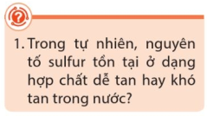 | ..................................................................................................................  ..................................................................................................................  ..................................................................................................................  ..................................................................................................................
2) Tính chất
a) Tính chất vật lí
Trạng thái: ............. Màu sắc: ............ Tính tan: ........................................................ t_{nc}: ......... t_{hóa hơi}: .........
b) Tính chất hóa học
■ Tính oxi hóa: Sulfur phản ứng với ........................................................... tạo ra .........................................
Phản ứng với Fe: ..............................................................................................................................................
Phản ứng với Hg: .............................................................................................................................................
► Nhận xét số oxi hóa của sulfur trong các phản ứng trên?
..........................................................................................................................................................................
■ Tính khử: Sulfur phản ứng với .....................................................................................................................
Phản ứng với O₂: .............................................................................................................................................
► Nhận xét số oxi hóa của sulfur trong các phản ứng trên?
..........................................................................................................................................................................
3) Ứng dụng
..........................................................................................................................................................................
..........................................................................................................................................................................
..........................................................................................................................................................................
..........................................................................................................................................................................
II. SULFUR DIOXIDE
1) Một số tính chất
■ Tính chất vật lí
Trạng thái: ........... Màu sắc: .................. Mùi: ............. Tính độc: .................. Tính tan: ...............................
■ Tính chất hóa học
(1) Sulfur dioxide là một ................................. có các phản ứng với: ..............................................................
..........................................................................................................................................................................
..........................................................................................................................................................................
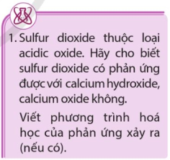 | ..................................................................................................................  ..................................................................................................................  ..................................................................................................................  ..................................................................................................................  ..................................................................................................................  ..................................................................................................................
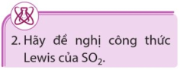 | ..................................................................................................................  ..................................................................................................................  ..................................................................................................................  ..................................................................................................................
(2) Sulfur dioxide còn có .................................................................................................................................
Ví dụ: Tính oxi hóa: .........................................................................................................................................
..........................................................................................................................................................................
Ví dụ: Tính khử: ...............................................................................................................................................
..........................................................................................................................................................................
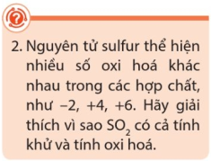 | ..................................................................................................................  ..................................................................................................................  ..................................................................................................................  ..................................................................................................................  ..................................................................................................................  ..................................................................................................................
2) Ứng dụng
..........................................................................................................................................................................
..........................................................................................................................................................................
..........................................................................................................................................................................
..........................................................................................................................................................................
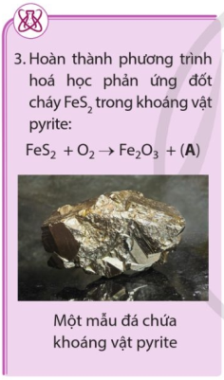 | ..................................................................................................................  ..................................................................................................................  ..................................................................................................................  ..................................................................................................................  ..................................................................................................................  ..................................................................................................................  .................................................................................................................  .................................................................................................................  .................................................................................................................  .................................................................................................................  .................................................................................................................
3) Một số biện pháp giảm thải sulfur dioxide vào khí quyển
..........................................................................................................................................................................
..........................................................................................................................................................................
..........................................................................................................................................................................
..........................................................................................................................................................................
..........................................................................................................................................................................
..........................................................................................................................................................................
..........................................................................................................................................................................
..........................................................................................................................................................................
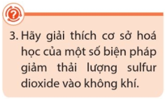 | ..................................................................................................................  ..................................................................................................................  ..................................................................................................................  ..................................................................................................................
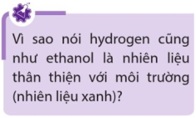 | ..................................................................................................................  ..................................................................................................................  ..................................................................................................................  ..................................................................................................................

Tài liệu được chia sẻ bởi
https://www.vnteach.com
https://www.facebook.com/groups/thuvienvnteach/

