LỚP 6 HK1 FORM 2026 TEST 5

Mark the letter A, B, C or D on your answer sheet to indicate the word whose underlined part differs from the other three in pronunciation in each of the following questions.
Question 1. A. duck B. individual C. during D. dance
Question 2. A. picked B. promised C. delivered D. clicked

Mark the letter A, B, C or D on your answer sheet to indicate the word that differs from the other three in the position of primary stress in each of the following questions.
Question 3. A. island B. forest C. canteen D. wonder
Question 4. A. attractive B. necessary C. forgettable D. traditional

Mark the letter A, B, C or D on your answer sheet to indicate the correct answer to each of the following questions.
Question 5. I’m afraid you enter this area. It is dangerous.
A. Must B. mustn’t C. must to D. to must
Question 6. Linh must home by 10 p.m. every day.
- Is B. be C. are D. am
Question 7. I’m going shopping. I need to buy for my birthday party.
A. Much B. a few C. few D. a little
Question 8. “Let’s go to Cuc Phuong National Park this Sunday.” _ “ ”
A. That’s a good idea C. I know it
B. I usually go there D. What can I do
Question 9. You should put on sunscream when you go out in summer.
A. many B. a few C. some D. few
Question 10. Tet is coming. We clean and decorate our house.
A. Should B. shouldn’t C. mustn’t D. are
Question 11. I always my grandparents a long life and good health.
A. Celebrate B. wish C. make D. bring
Question 12. The is the first person to enter your house in the New Year.
A. Relative B. first cousin C. first footer D. rooster

Read the following announcement and mark the letter A, B, C or D on your answer sheet to indicate the correct option that best fits each of the numbered blanks from 13 to 16.

SERVICES IN MY AREA
There are many services in my neighbourhood. We have a bakery, a hair salon, and a (13) . The post office is (14) the bank. I often go to the bakery to buy bread. My sister (15) her hair at the salon every month. People here (16) friendly and welcoming.
Question 13: A. school | B. bank | C. garden | D. yard
Question 14: A. next | B. near | C. between | D. behind
Question 15: A. cuts | B. cut | C. cutting | D. cutted
Question 16: A. is | B. are | C. be | D. am
Question 17: Put the sentences (a-c) in the correct order, then fill in the blank to make a logical text.
My experience at the mall was a bit frustrating yesterday. Here’s what happened. _________
a. When I tried to pay, the payment system was down, and I couldn’t complete my purchase.
b. I went to buy a few items, but the store was very crowded and hard to navigate.
c. I had to wait for a long time until the system was back online to finish buying what I needed.
A. b-a-c
B. a-b-c
C. c-a-b
D. b-c-a
Question 18: Choose the sentence that you can end the text (in Question 17) most appropriately.
A. The staff were very helpful and kept me updated about the situation.
B. I decided to leave the mall and come back another day.
C. After a while, I managed to pay and leave the store satisfied.
D. The store offered a discount for the inconvenience caused.

Read the following passage and mark the letter A, B, C or D on your answer sheet to indicate option that best fits each numbered blank from 19 to 24.
Newquay is small town (19) the Atlantic coast in the south of England. It has got great beaches and is the (20) place to surf in the UK. In Newquay, there are lots of other things to do as (21) as surfing. If you like water sports, you can go kayaking, water-skiing or coasteering. Coasteering is different because it is rock climbing, jumping into the sea and swimming in the same activity, but you (22) always go with a special instructor. If you like animals you can also visit the Blue Reef Aquarium and (23)
a lot of different fish and even sharks. You can also go (24) on the beach or visit Newquay Zoo. Come and see for yourself.
Question 19. A. in B. on C. at D. to Question 20. A. good B. better C. best D. goodest Question 21. A. well B. much C. soon D. far Question 22. A. shall B. may C. could D. should Question 23. A. see B. like C. get D. look Question 24. A. horse ride B. horse riding C. riding horse D. ride horse

Mark the letter A, B, C or D on your answer sheet to indicate the sentence that closest in meaning to the original sentence in each of the following questions.
Question 25: National roads are usually wider than city streets.
- City streets are narrower than national roads.
- National roads are as wide as city streets.
- City streets are more narrow than national roads.
- National roads are usually less wide than city streets.
Question 26: Going shopping in that supermarket is more expensive than in this open-air market.
- Shopping in this open-air market is more expensive than in that supermarket.
- Shopping in that supermarket is not as cheap as in this open-air market.
- Shopping in this open-air market is cheaper than this in that supermarket.
- Going shopping in this open-air market is more expensive than in that supermarket.

Mark the letter A, B, C or D on your answer sheet to indicate the sentence that is made from the given cues in each of the following questions.
Question 27: A lake/ small/ a sea.
  - A lake is not smaller than a sea.
  - A lake is much smaller than a sea.
  - A lake is more small than a sea.
  - A lake is smaller a sea.
Question 28. French food/ good/ English food.
- French food are better than English food.
- French food is gooder than English food.
- French food is more good than English food.
- French food is better than English food.

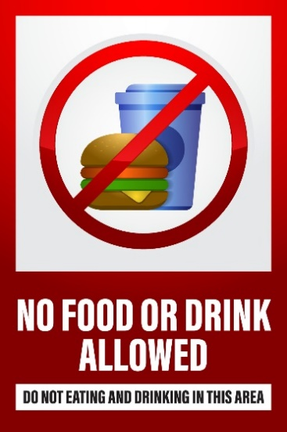 | Question 29: What does the sign means?  A. You are free to eat or drink anything you like in this area whenever you want.  B. Eating and drinking are permitted only in this specific area and not outside of it.  C. Do not bring any food or drinks into this area at any time, as it is not allowed.  D. Food and drink can only be consumed in this area during certain hours of the day.

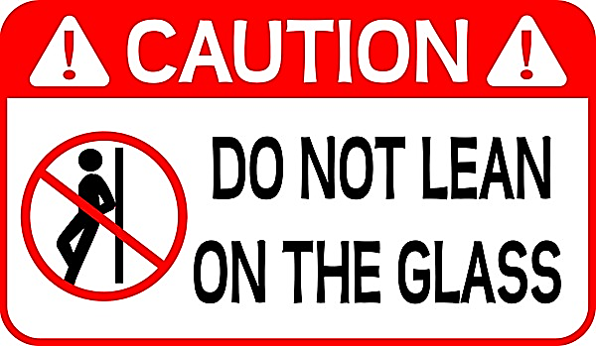 | Question 30: What does the sign suggest?  A. Leaning on the railing is dangerous because it is not safe.  B. Do not stand near the railing.  C. Do not touch the railing to stay safe.  D. Only lean on the railing when you are tired.

Read the following passage and mark the letter A, B, C or D on your answer sheet to indicate the correct answer to each of the following questions from 31 to 36.
Many people work in London prefer to live outside it, and to go into their offices, factories or schools everyday by train, car or bus, even though this means they have to get up earlier in the morning and reach home later in the evening.
One advantage of living outside London is that houses are cheaper. Even small flat in London without a garden costs quite a lot to rent. With the same money one can get a little house in the country with a garden of one's own. Then in the country one can rest from the noise and hurry of the town. Even though one has to get up earlier and spend more time in trains or buses, one can sleep well at night; during weekends and summer evenings one can enjoy the fresh, clean air of the country. If one likes gardens, one can spend his free time digging planting, watering and doing the other things that are needed in a garden. Then, when the flowers and the vegetables come up, one has the reward of one who has shared the secrets of nature.

Question 31. Where do most people who work in London prefer to live?
A. London B. London's suburbs C. London's town D. London's urban areas
Question 32. Why do they have to get up early in the morning?
- Because they have to catch the early train or bus.
- Because they want to avoid traffic jam.
- Because life far from train or bus station.
- Because it takes them a lot of time to get to their offices, factories or schools.
Question 33. What are the advantages of living outside London?
A. Houses are cheap B. There's peace and quiet C. Air is fresh D. All are correct
Question 34. The phrase verb "come up" means
A. rise B. happen C. appear D. reach
Question 35. Which of the following is not true?
  - People in the country can sleep well
  - People in the country usually spend their free time gardening.
  - People in the country get fresh air
  - People in the country get peace and quiet.

Question 36. The word “cheaper” is OPPOSITE in meaning to .
A. Larger B. more expensive C. smaller D. less attractive Four phrases/ sentences have been removed from the text below. For each question, mark the letter A, B, C or D on your answer sheet to indicate the correct option that best fits each of the numbered blanks from 37 to 40.
I live in Newquay. It's a small town on the Atlantic coast in the south of England. (37) . There are lots of surf schools where (38) . I go surfing with my friends every weekend. My favourite place is Fistral Beach. I love Newquay because (39) . If you like water sports, you can go kayaking or water-skiing. If you like animals, you can visit the Blue Reef Aquarium and see lots of different fish and even sharks. You can also go horse riding on the beach or visit Newquay Zoo. There are lots of other attractions too like mini golf and bowling. (40)
- you can learn how to surf
- It has got great beaches and it is the best place to surf in the UK
- Come and see for yourself!
- there are lots of other things to do as well as surfing
Question 37 Question 38 Question 39 Question 40

