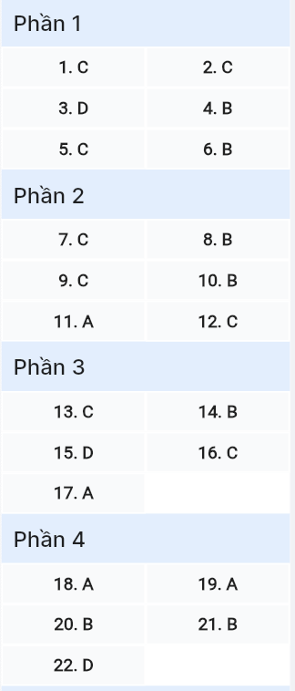
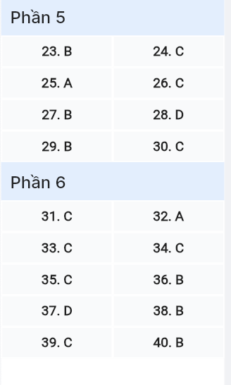
ĐỀ MINH HỌA SỐ 16
KỲ THI TỐT NGHIỆP TRUNG HỌC PHỔ THÔNG NĂM 2025
(Đề thi có 08 trang)
Môn thi: TIẾNG ANH
Thời gian làm bài: 50 phút, không kể thời gian phát đề

Read the following advertisement and mark the letter A, B, C or D on your answer sheet to indicate the option that best fits each of the numbered blanks from 1 to 6.

Explore a Rich Cultural Journey!
Are you interested in exploring diverse traditions from around the world? Our (1) _______ offers an (2) _______ journey, bringing you closer to local heritage and authentic experiences. (3) _______ part in this enriching adventure will deepen your understanding of global cultures!
Led by experienced local guides, our tours offer you the chance (4) _______ with communities, participating in traditional festivals and learning ancient customs. With memorable activities, you’ll visit iconic cultural landmarks, taste traditional cuisine, and discover the beauty of regional arts, (5) _______ you a deeper connection to the local culture.
Ready to take your curiosity to new heights? Join us today to begin your cultural adventure, and let the world’s wonders unfold before you. Whether you’re passionate (6) _______ history, art, or folklore, our tour will leave you inspired and enriched.
Question 1 (697457): A. unique cultural program tour B. program unique cultural tour
C. unique cultural tour program D. tour programs cultural unique
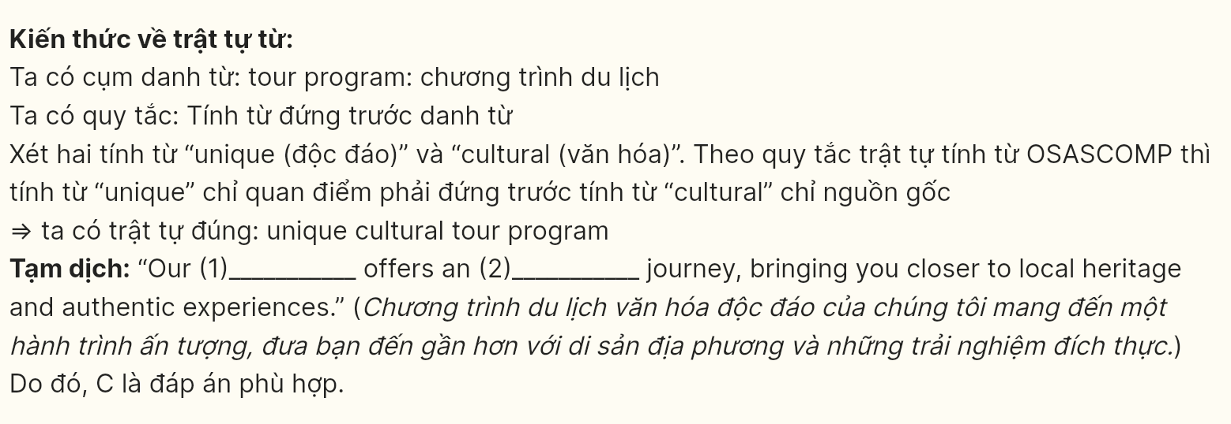
Question 2 (697458): A. impressively B. impression C. impressive D. impress
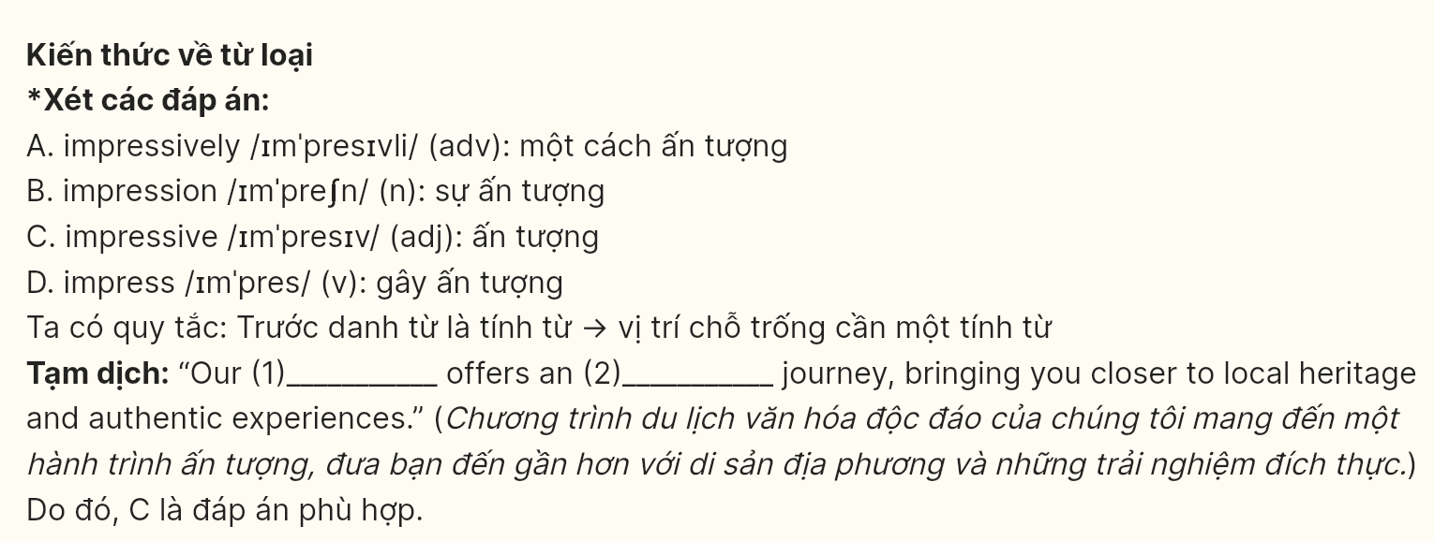
Question 3 (697459): A. Making B. Doing C. Paying D. Taking
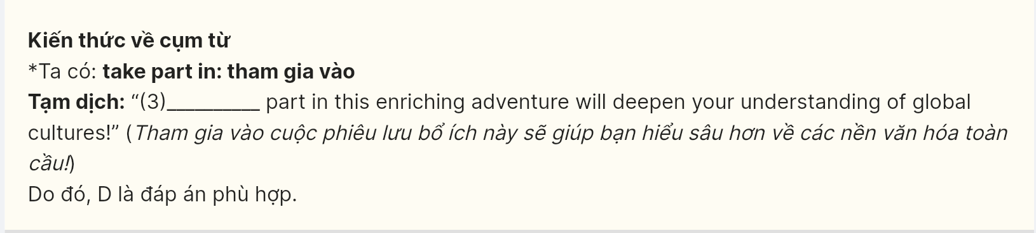
Question 4 (697460): A. to engaging B. to engage C. engaging D. engage
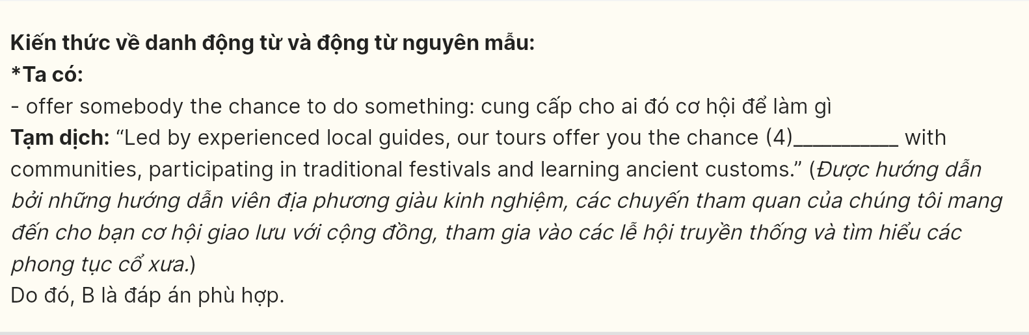
Question 5 (697461): A. that give B. which giving C. giving D. gave
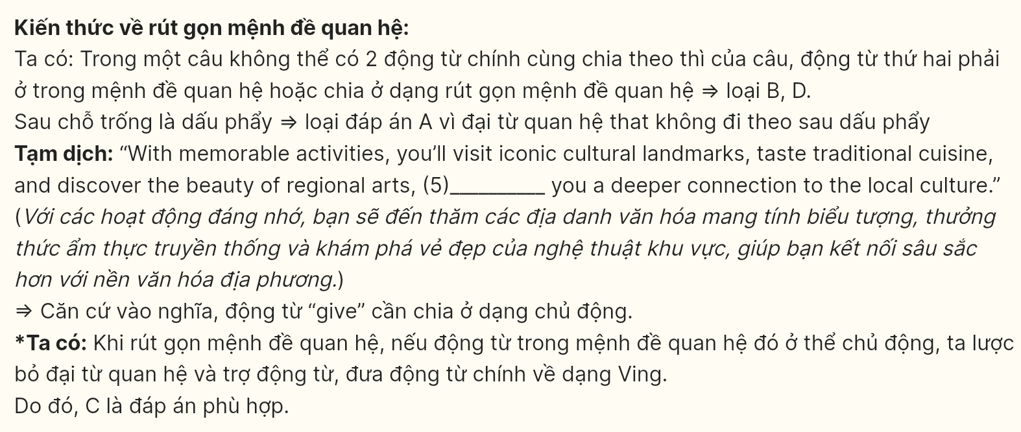
Question 6 (697462): A. in B. about C. on D. by
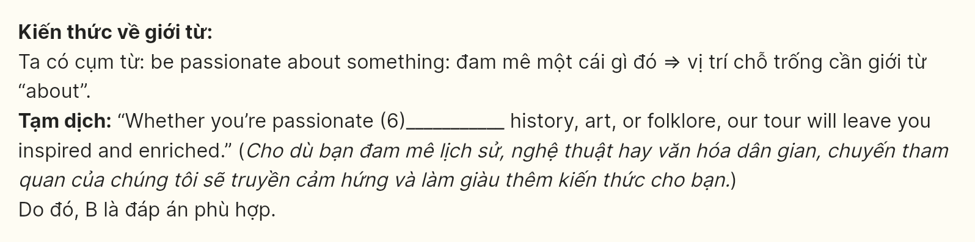
Read the following leaflet and mark the letter A, B, C, or D on your answer sheet to indicate the correct option that best fits each of the numbered blanks from 7 to 12.
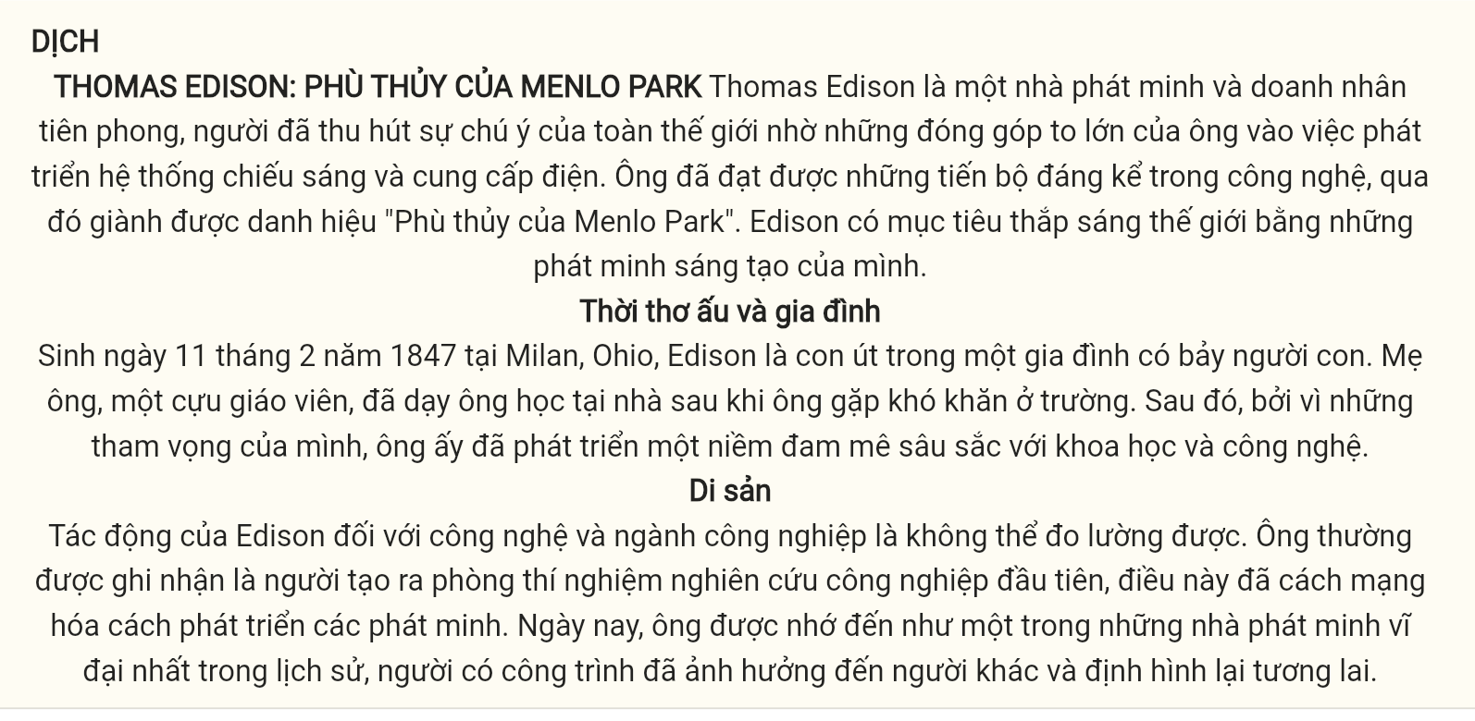
THOMAS EDISON: THE WIZARD OF MENLO PARK
Thomas Edison was a pioneering inventor and businessman who grabbed the (7) _______ for his contributions to the development of electric light and power systems. He made significant advancements in technology, earning the title of “The Wizard of Menlo Park.” Edison aimed to (8) _______ the world with his innovative inventions.
Early Life & Family
Born on February 11, 1847, in Milan, Ohio, Edison was the youngest of seven children. His mother, a former school teacher, educated him at home after he struggled in school. After that, (9) _______ his ambitions, he developed a keen (10) _______ in science and technology.
Legacy
Edison’s impact on technology and industry is (11) _______. He is often credited with creating the first industrial research laboratory, which revolutionized how inventions are developed. Today, he is remembered as one of history’s greatest inventors, whose work influences (12) _______ and reshapes the future.
(Adapted from Asian Scientist)
Question 7 (697463): A. labels B. titles C. headlines D. captions
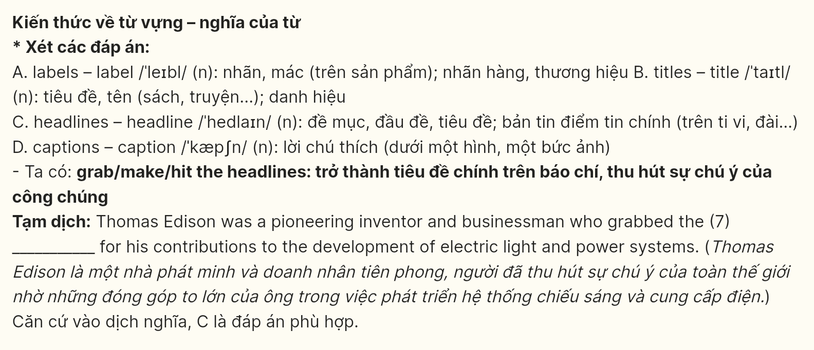
Question 8 (697464): A. catch up with B. light up C. carry out D. calm down
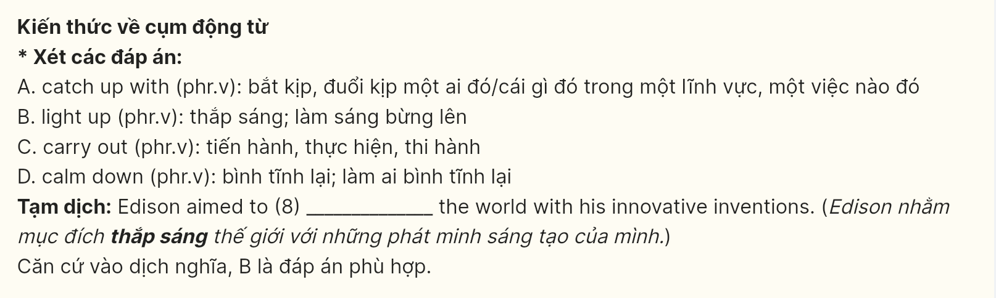
Question 9 (697465): A. On behalf of B. Instead of C. Because of D. In case of
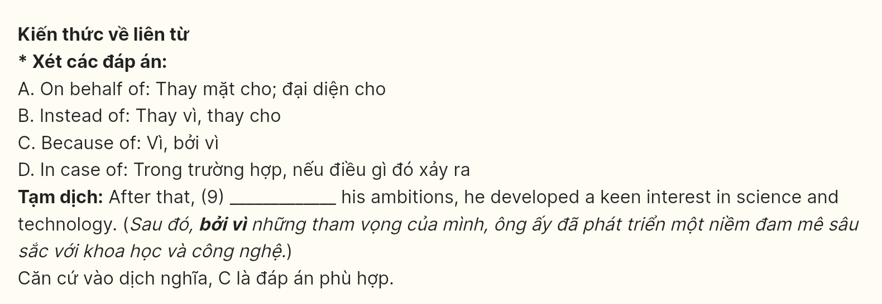
Question 10 (697466):A. comfort B. interest C. ease D. leisure
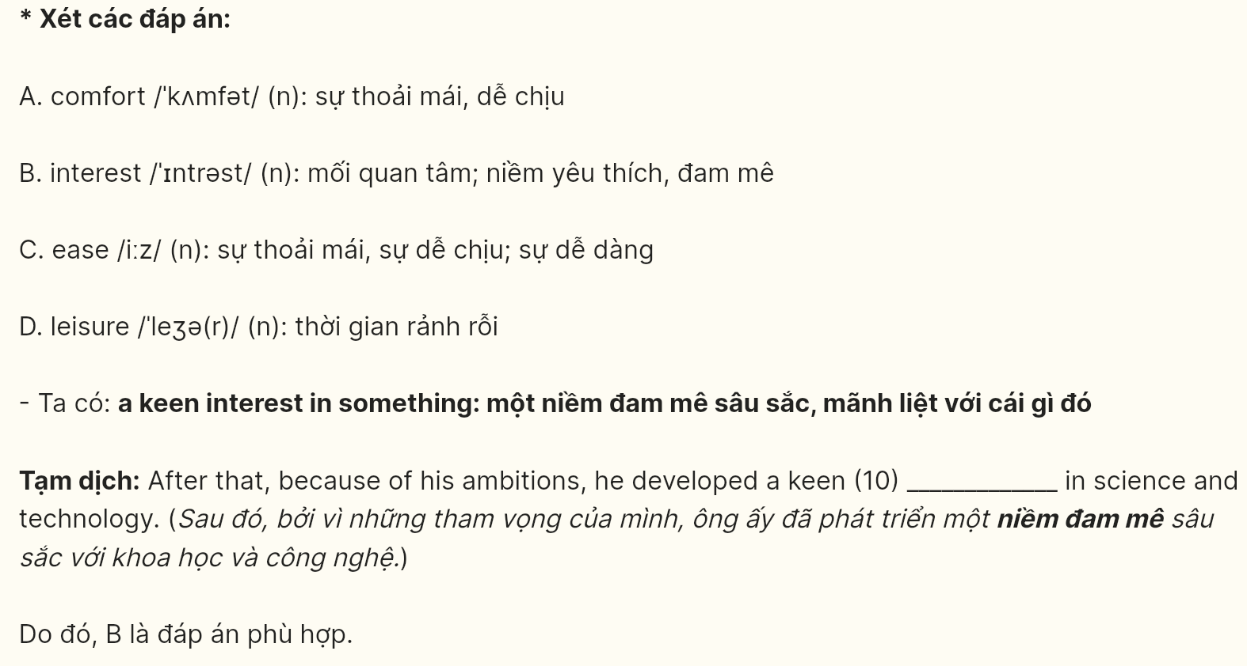
Question 11 (697467): A. immeasurable B. trivial C. insignificant D. glamorous
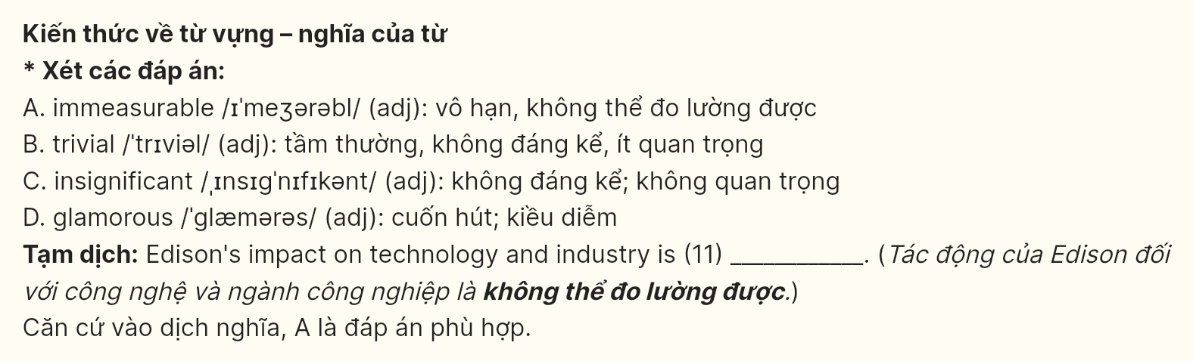
Question 12 (697468): A. other B. another C. others D. the others
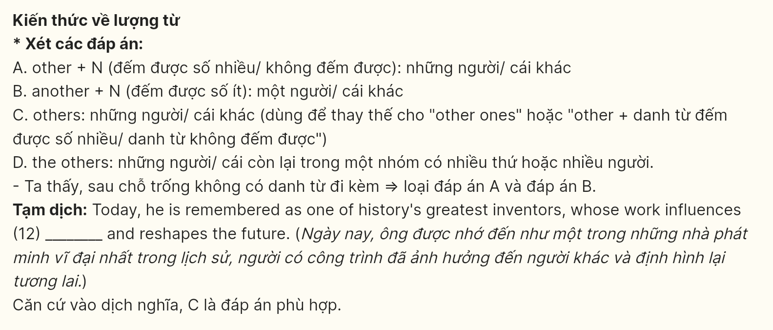
Mark the letter A, B, C, or D on your answer sheet to indicate the best arrangement of utterances or sentences to make a meaningful exchange or text in each of the following questions from 13 to 17.
Question 13 (697469):
a. Alex: Been there, done that! Tell you what - I picked up some awesome time management hacks that are total game-changers.
b. Maya: Ugh, I’m just swamped with this work-life balance thing. Feels like I’m running on empty.
c. Alex: Hey, what’s eating you? You’ve been super stressed out lately.
A. b-a-c B. b-c-a C. c-b-a D. a-c-b

Question 14 (697470):
a. Jake: Right? And get this - they’ve got these AI systems running the whole show.
b. Rachel: No way! I’m so over-sitting in traffic. This sounds like a total dream.
c. Jake: Yo, check this out! They’re building this crazy smart city with self-driving everything!
d. Rachel: For real? But doesn’t that freak you out a bit? Like, what if the system crashes?
e. Jake: Nah, that’s the beauty of it – they’ve got all these fail-safes. It’s pretty mind-blowing stuff.
A. c-a-b-d-e B. c-b-a-d-e C. c-d-a-b-e D. c-b-e-a-d
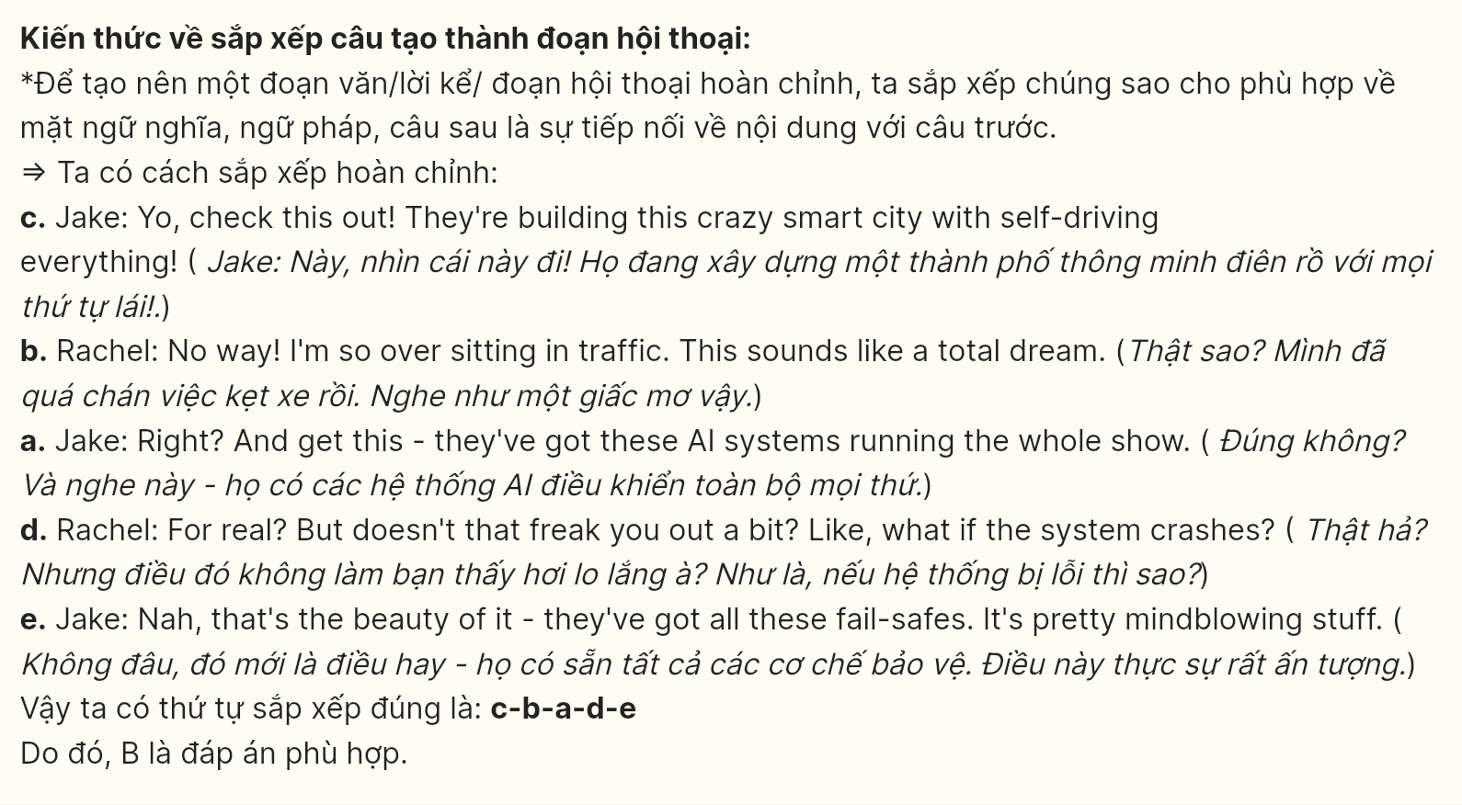
Question 15 (697471):
Dear Jamie,
a. You wouldn’t believe how locals have adapted their traditional businesses to cater to this new crowd.
b. Every corner has these cool co-working spaces packed with people from all over the globe.
c. It’s fascinating to see ancient culture and modern technology existing in perfect harmony.
d. The whole digital nomad scene here in Bali has completely transformed how people experience travel.
e. You should definitely check it out – it might change your perspective on remote work altogether.
Best wishes,
Sam
A. d-a-c-b-e B. d-b-c-a-e C. d-a-c-d-e D. d-b-a-c-e
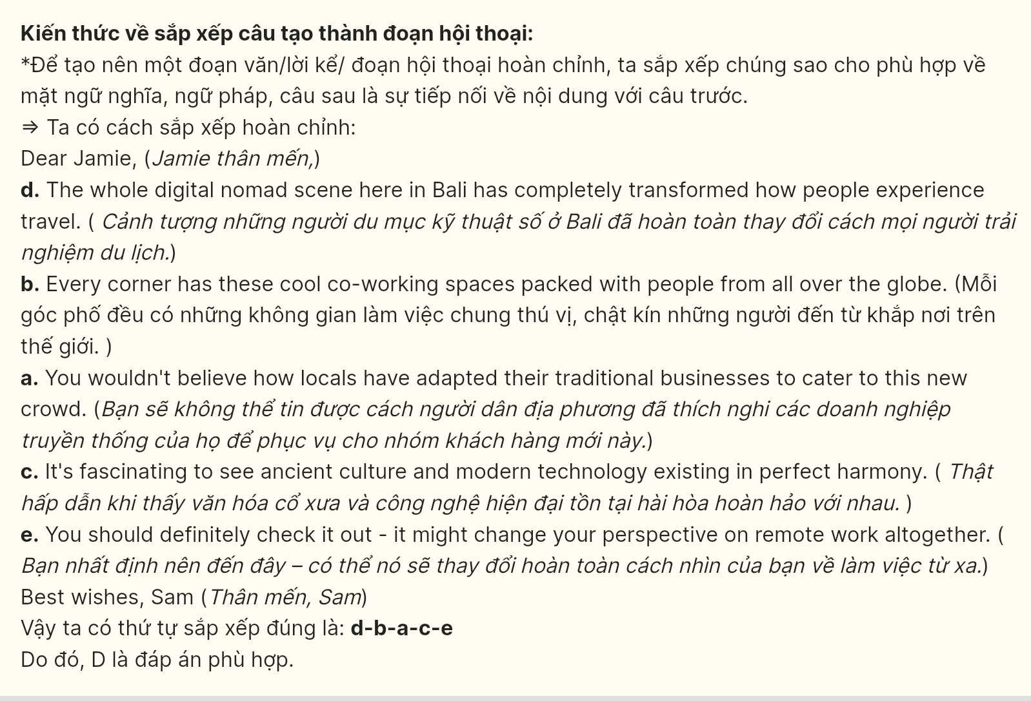
Question 16 (697472):
a. Unlike my previous corporate job, there were no traditional hierarchies or fixed departments here.
b. Instead, I found myself collaborating with different teams based on project needs and expertise.
c. During my first week at a modern startup, I was amazed by their unique approach to team structure.
d. Looking back, I realize this experience completely changed my view of organizational management.
e. This flexible system not only boosted our creativity but also made work more engaging and meaningful.
A. c-a-b-d-e B. b-c-a-e-d C. c-a-e-b-d D. c-d-e-b-a
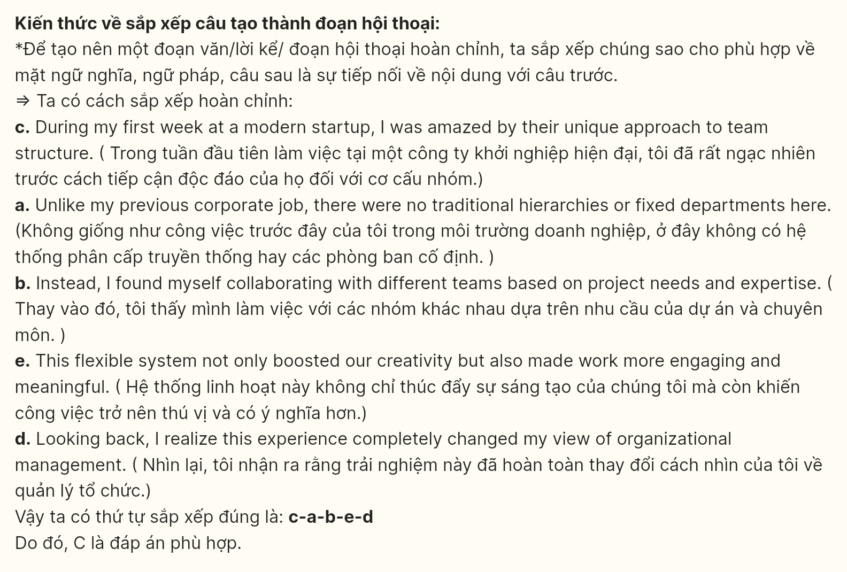
Question 17 (697473):
a. The invention quickly transformed cities, extending human activity well into the night hours.
b. When Thomas Edison first unveiled his electric light bulb in 1879, few could imagine its impact.
c. Factories could now operate around the clock, revolutionizing industrial production worldwide.
d. This simple innovation sparked numerous related inventions in power distribution and electronics.
e. Today, we’re witnessing similar revolutionary changes with artificial intelligence and quantum computing.
A. b-a-c-d-e B. b-a-d-c-e C. c-b-a-e-d D. c-d-e-b-a
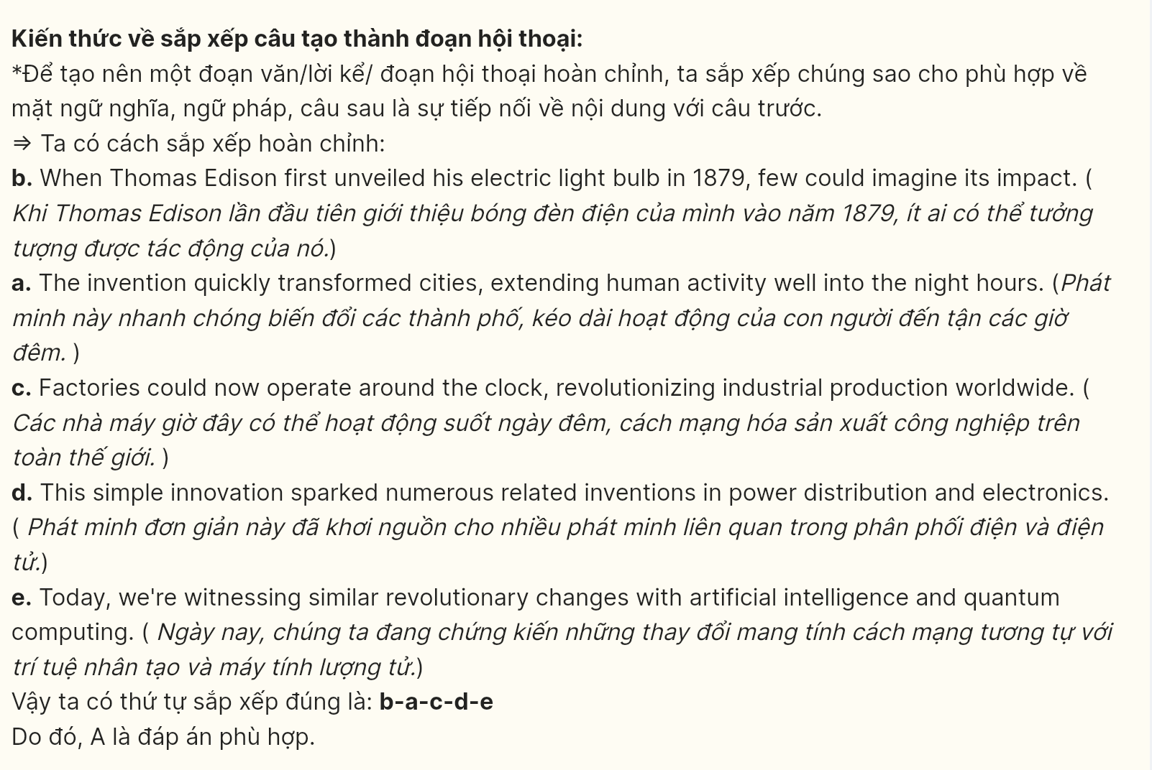
Read the following passage about family life and mark the letter A, B, C, or D on your answer sheet to indicate the option that best fits each of the numbered blanks from 18 to 22.

Family life has always been a cornerstone of society, providing support, love, and stability. Modern families come in various shapes and sizes, but they all share one thing in common: the need for connection and mutual care. Eating together regularly, (18) _______, In fact, families that engage in shared activities such as cooking meals, going on trips, or playing games, tend to have healthier relationships. (19) _______.
Family structures have evolved over the years. While the traditional nuclear family remains common, single-parent, extended, and blended families are becoming more frequent. Each member brings unique perspectives, and despite varying parenting styles, love and respect are universally valued. (20) _______.
However, with busy schedules and the demands of modern life, many families struggle to spend quality time together. Technology plays a major role in both bringing them closer and distancing them. Many families, (21) _______, often find themselves isolated despite being in the same room.
It is impossible to overestimate the influence of family life on personal development and happiness. Children, in particular, (22) _______. Children who don’t have close family ties may experience mental health problems.
Question 18 (697474):
A. families experience stronger relationships and better emotional well-being
B. better emotional well-being is experienced by families who eat together
C. they find it easier to communicate when they eat together
D. regular meals lead to improved emotional well-being for children
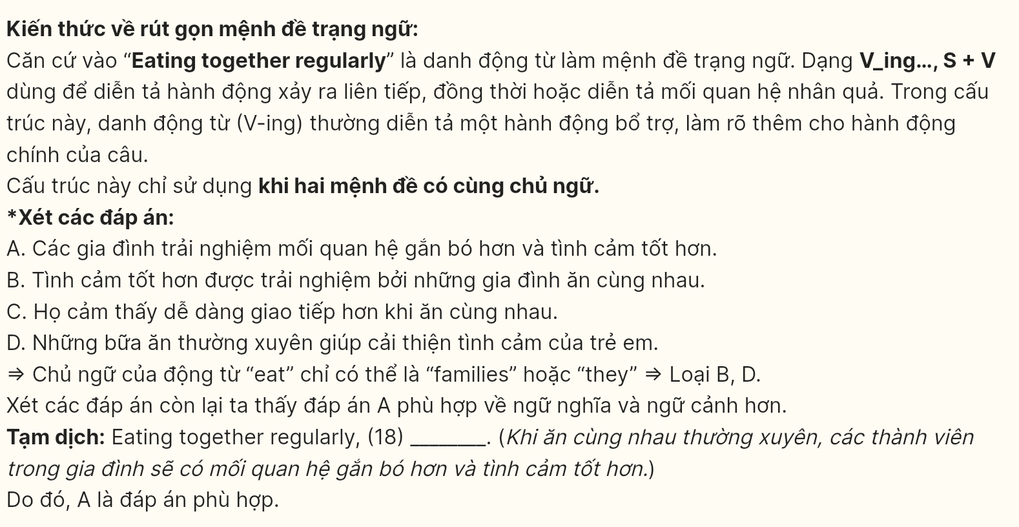
Question 19 (697475):
A. Spending time together can lead to deeper understanding and stronger connections
B. Designed to improve relationships, spending quality time is essential for families
C. People in the family who engage in shared activities often find themselves with less personal time
D. Families that spend time together are more likely to face conflicts and misunderstandings
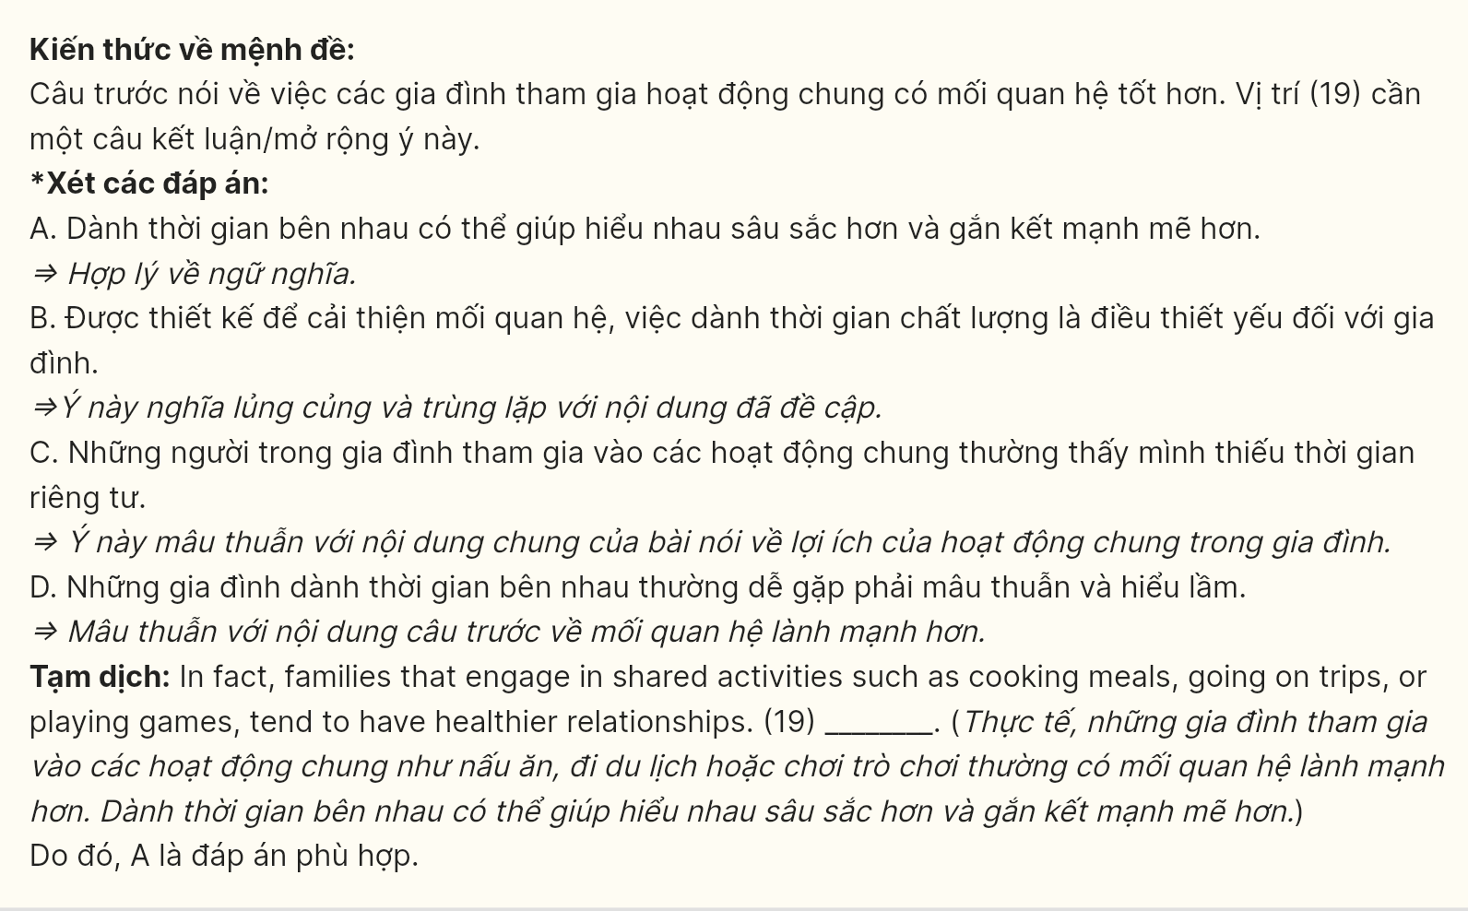
Question 20 (697476):
A. Not only the nuclear family is common, but also single-parent families are rare
B. When a family shows kindness and support, they are better able to solve conflicts
C. Family values remain important, so they can be difficult to maintain
D. Spending time together, families often find themselves with less personal space and freedom
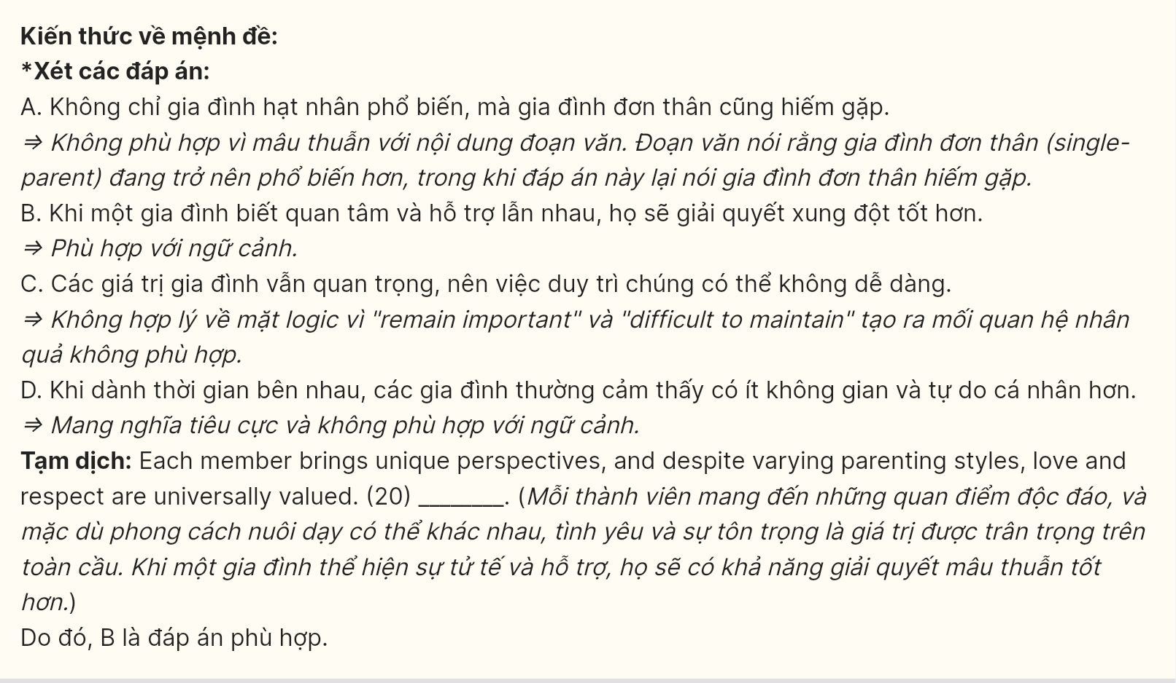
Question 21 [697477]:
A. brings families together using digital devices
B. which are now more connected through digital devices
C. succeeded in connecting families through digital devices
D. many of whose are now more connected by digital devices
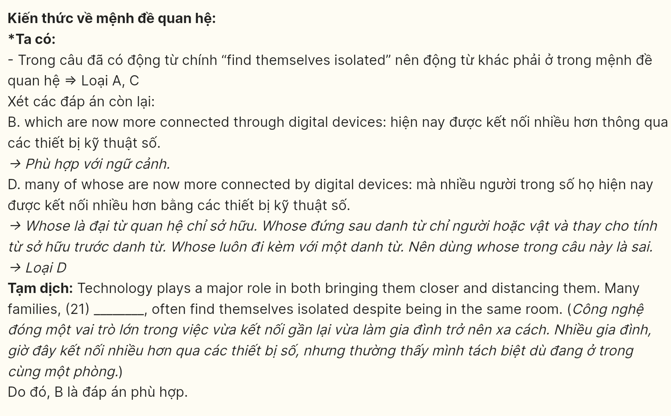
Question 22 [697478]:
A. having thrived in a nurturing environment where they feel cared for and valued
B. that thrived in a supportive family environment where they felt valued and loved
C. in which families feel cared for and appreciated, thriving in a supportive environment
D. thrive in a supportive family environment where they feel loved and valued
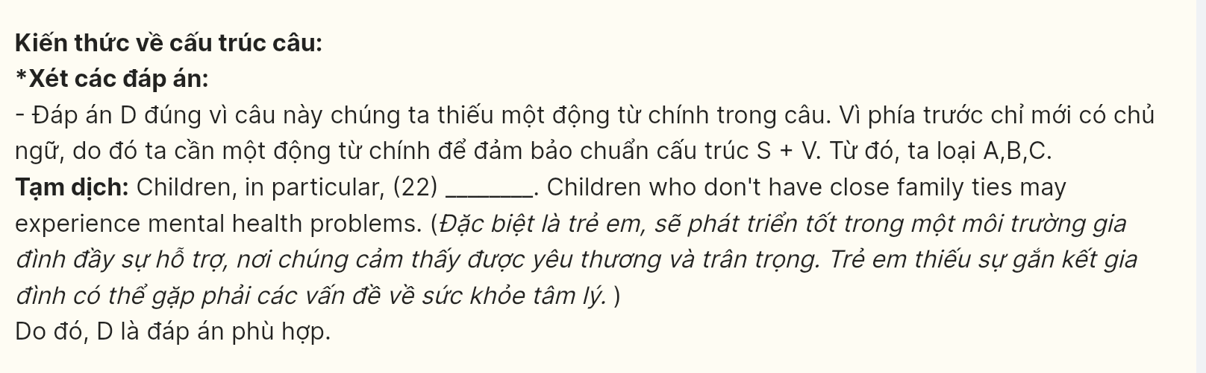
Read the following passage about multi-tasking drawbacks and mark the letters A, B, C, D on your answer sheet to indicate the best answer to each of the following questions from 23 to 30.
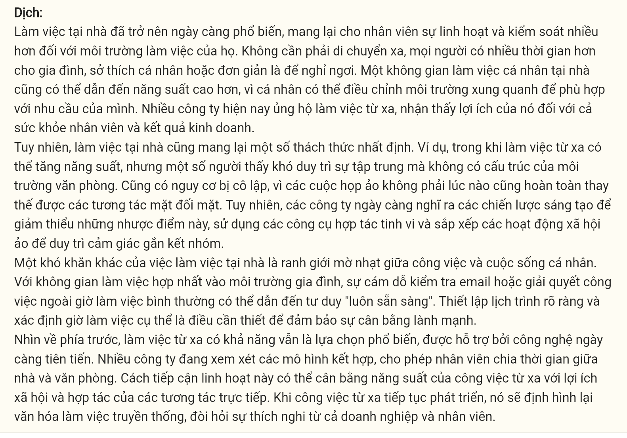
Working from home has become increasingly common, providing employees with greater flexibility and control over their work environments. Without the need for long commutes, people have more time for family, personal interests, or simply to rest. A personalized workspace at home can also lead to higher productivity, as individuals can adjust their surroundings to suit their needs. Many companies now support remote work, recognizing its benefits for both employee well-being and business outcomes.
However, working from home does bring certain challenges. For example, while remote work can boost productivity, some people find it hard to stay focused without the structure of an office setting. There’s also a risk of isolation, as virtual meetings don’t always fully replace face-to-face interactions. However, companies are increasingly devising creative strategies to mitigate these drawbacks, using sophisticated collaboration tools and arranging virtual social activities to preserve a sense of team cohesion.
Another difficulty with working from home is the blurred line between work and personal life. With workspaces merged into the home environment, the temptation to check emails or tackle tasks outside of regular hours can lead to an “always-on” mentality. Setting clear schedules and defining specific working hours is essential to ensure a healthy balance.
Looking forward, remote work is likely to remain a popular choice, supported by ever-advancing technology. Many companies are considering hybrid models, allowing employees to split their time between home and office. This flexible approach can balance the productivity of remote work with the social and collaborative benefits of in-person interactions. As remote work continues to evolve, it will reshape traditional work culture, requiring adaptation from both businesses and employees.
(Adapted from BreakingNewEnglish)
Question 23 [697479]: According to the passage, which of the following is NOT mentioned as a challenge of working from home?
A. Difficulty focusing without office structure
B. Lack of technological support for remote work
C. Risk of isolation from lack of face-to-face contact
D. Temptation to work outside regular hours
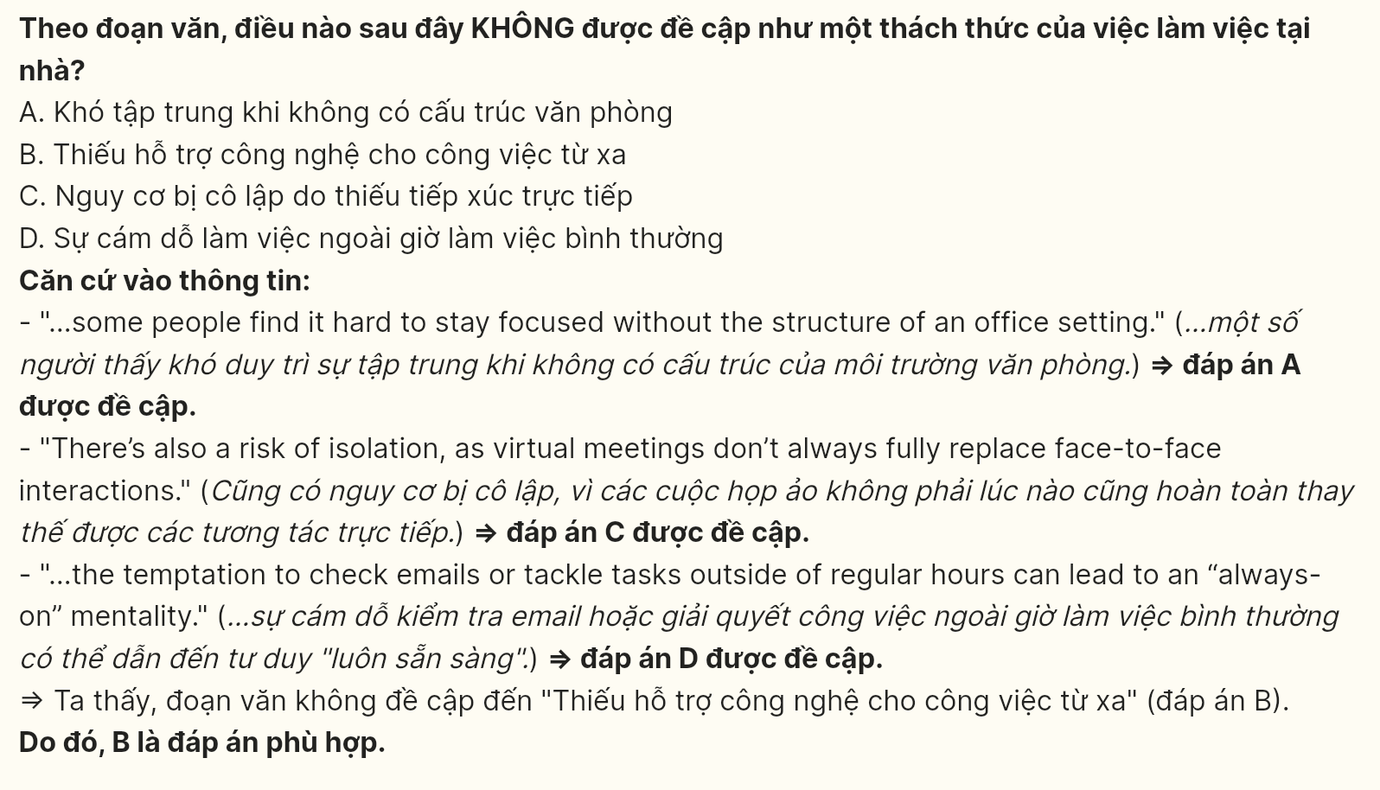
Question 24 [697480]: The word “blurred” in paragraph 3 is OPPOSITE in meaning to _______
A. shrouded B. obscured C. defined D. concealed
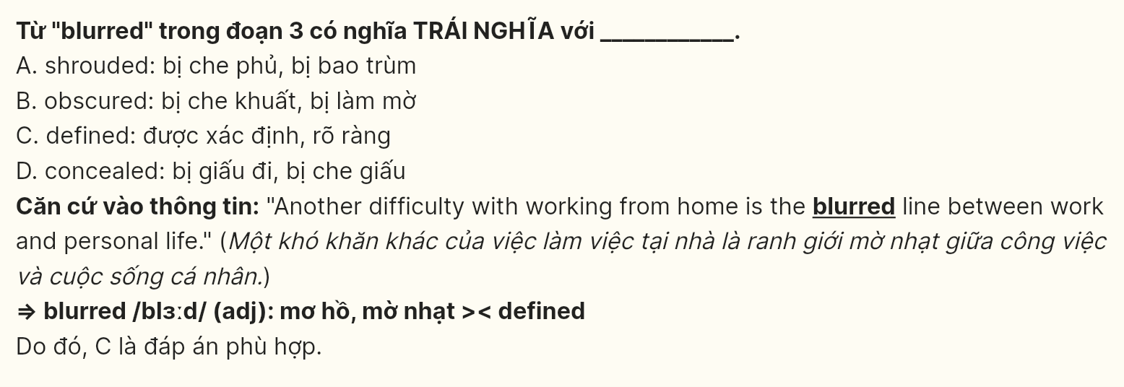
Question 25 [697481]: The word “it” in paragraph 4 refers to _______
A. remote work B. approach C. productivity D. work culture
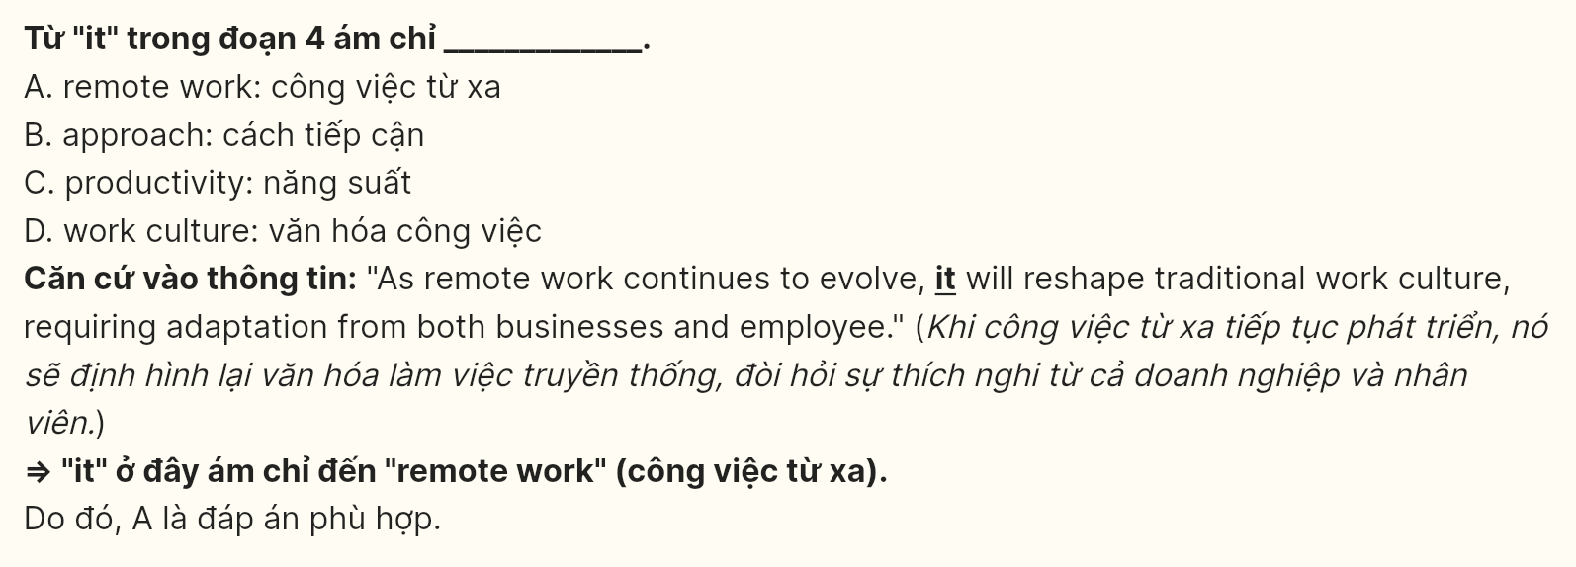
Question 26 [697482]: The word “cohesion” in paragraph 2 could be best replaced by
A. detachment B. fracture C. unity D. discord
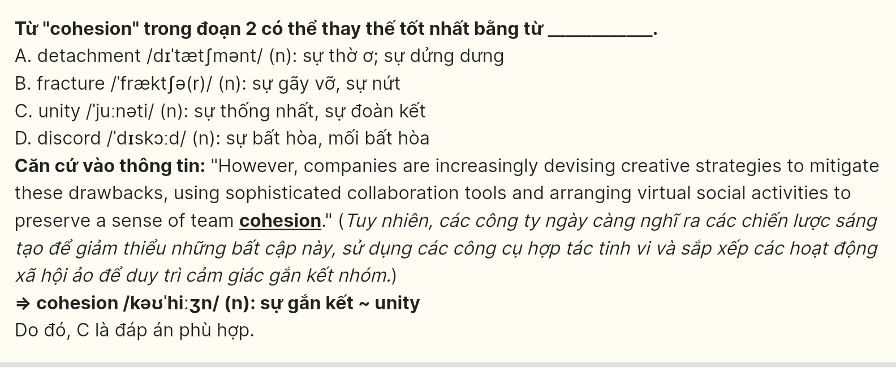
Question 27 [697483]: Which of the following best paraphrases the underlined sentence in paragraph 3?
A. Since workspaces have become more distinct from home environments, people find it easy to disconnect from work and avoid tasks after hours.
B. The integration of workspaces into home environments increases the likelihood that people will work beyond regular hours, fostering a mindset of constant availability.
C. Separating workspaces from home environments helps employees maintain a work-life balance and discourages the habit of working outside standard hours.
D. The division between work and home environments encourages employees to check emails only during regular hours, minimizing the need to be constantly available.
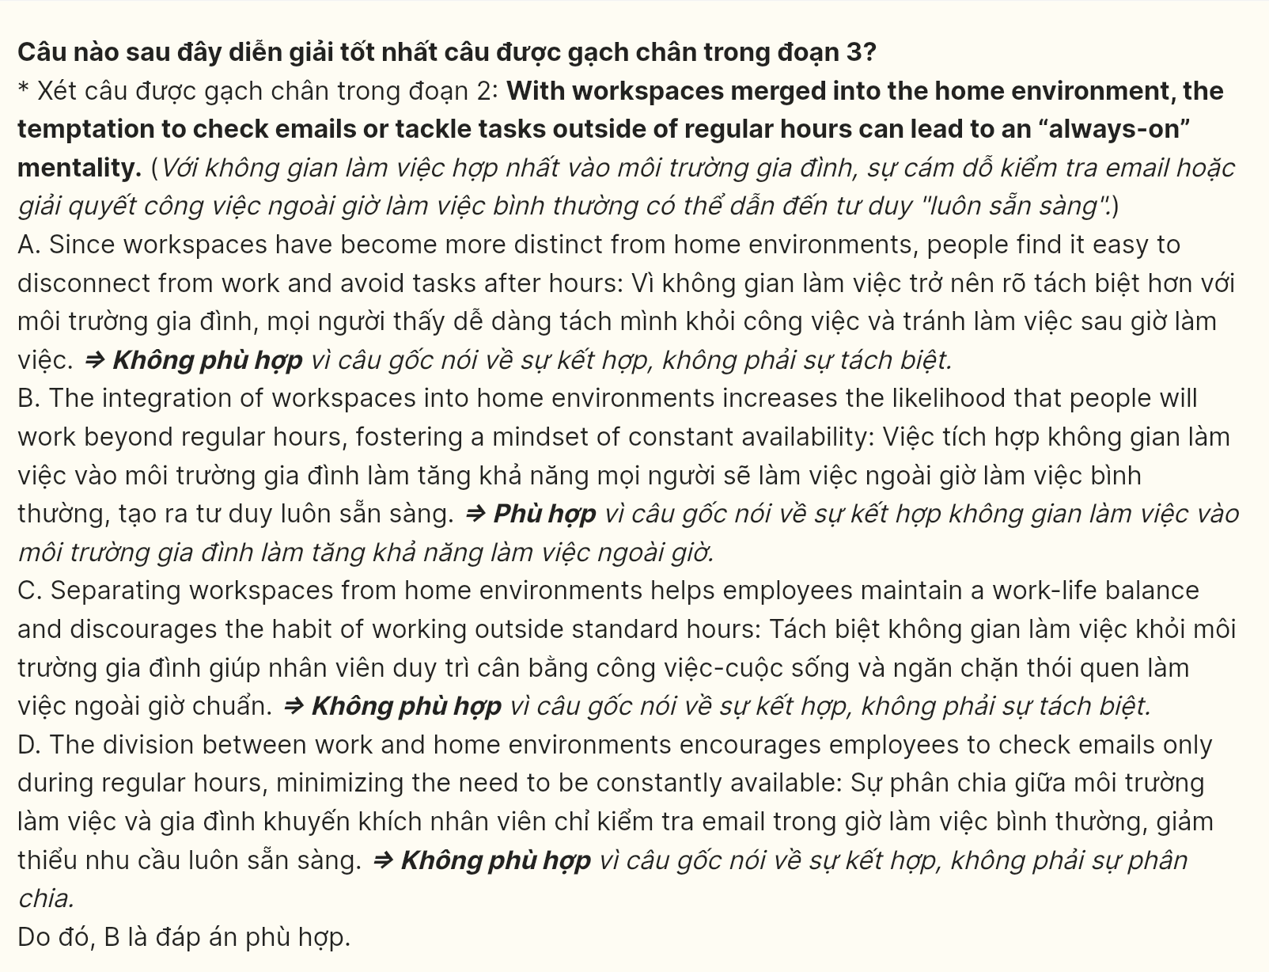
Question 28 [697484]: Which of the following is TRUE according to the passage?
A. The shift to remote work has resulted in a universal decrease in employee productivity across all sectors.
B. Companies are finding that virtual meetings are a complete substitute for in-person interactions.
C. Working from home is universally beneficial and eliminates all challenges associated with traditional office settings.
D. Employees who work remotely may experience a lack of focus due to the absence of an office structure.
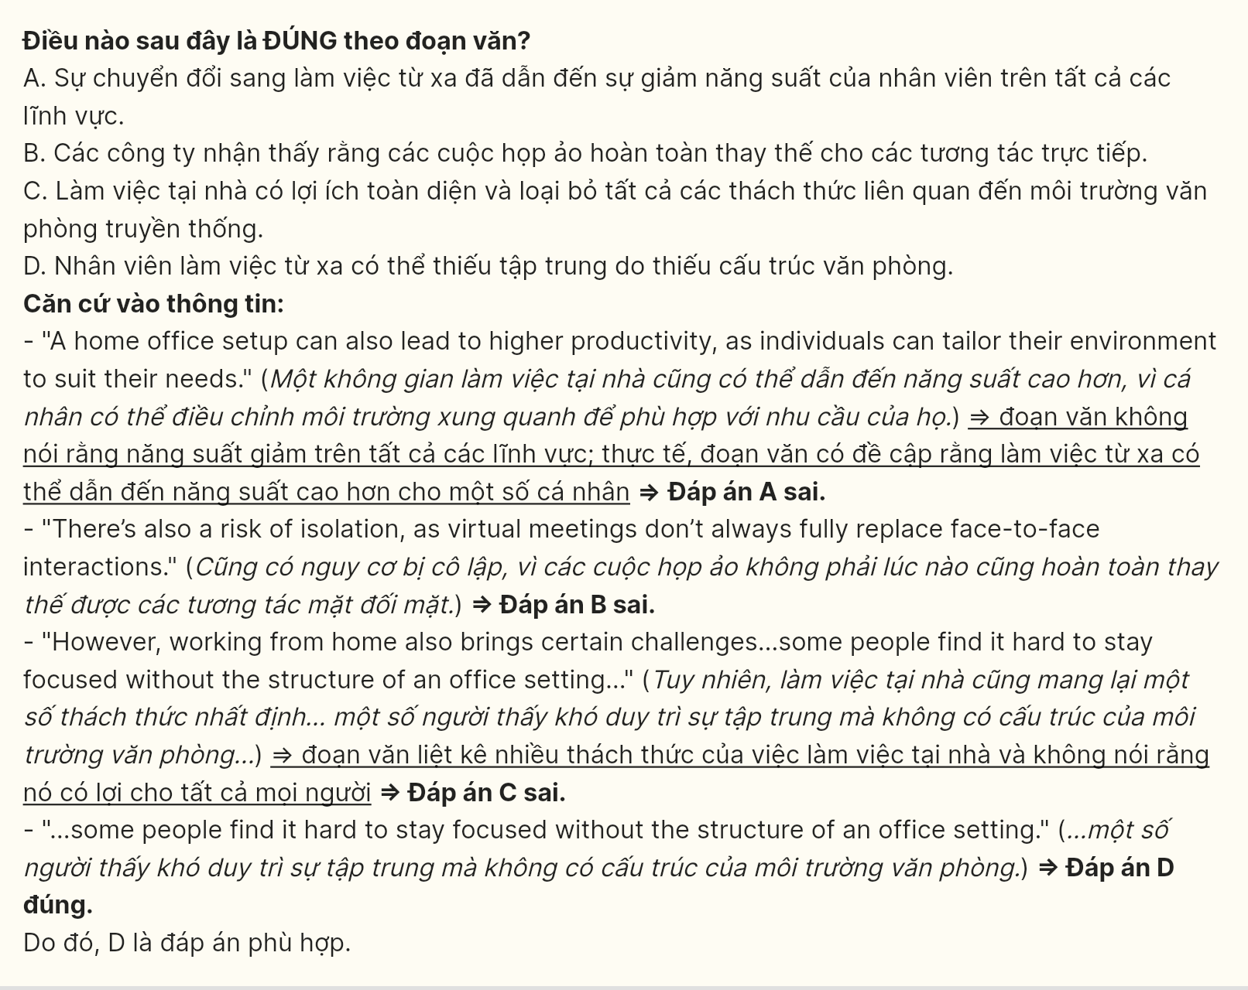
Question 29 [697485]: In which paragraph does the writer mention a present concession relationship?
A. Paragraph 1 B. Paragraph 2 C. Paragraph 3 D. Paragraph 4
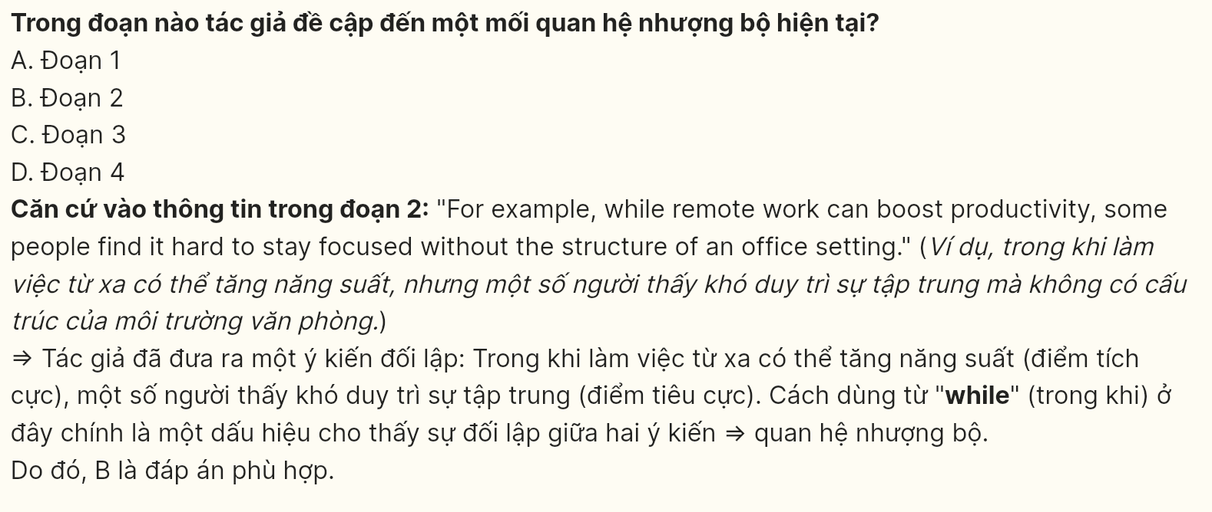
Question 30 [697486]: In which paragraph does the writer discuss another challenge associated with the lack of separation between work and personal life?
A. Paragraph 1 B. Paragraph 2 C. Paragraph 3 D. Paragraph 4
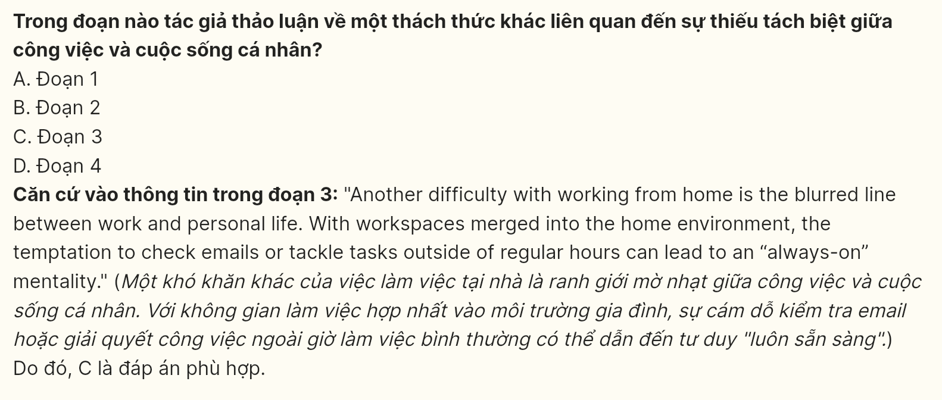
Read the following passage and mark the letters A, B, C, or D on your answer sheet to indicate the correct answer to each question from 31 to 40.
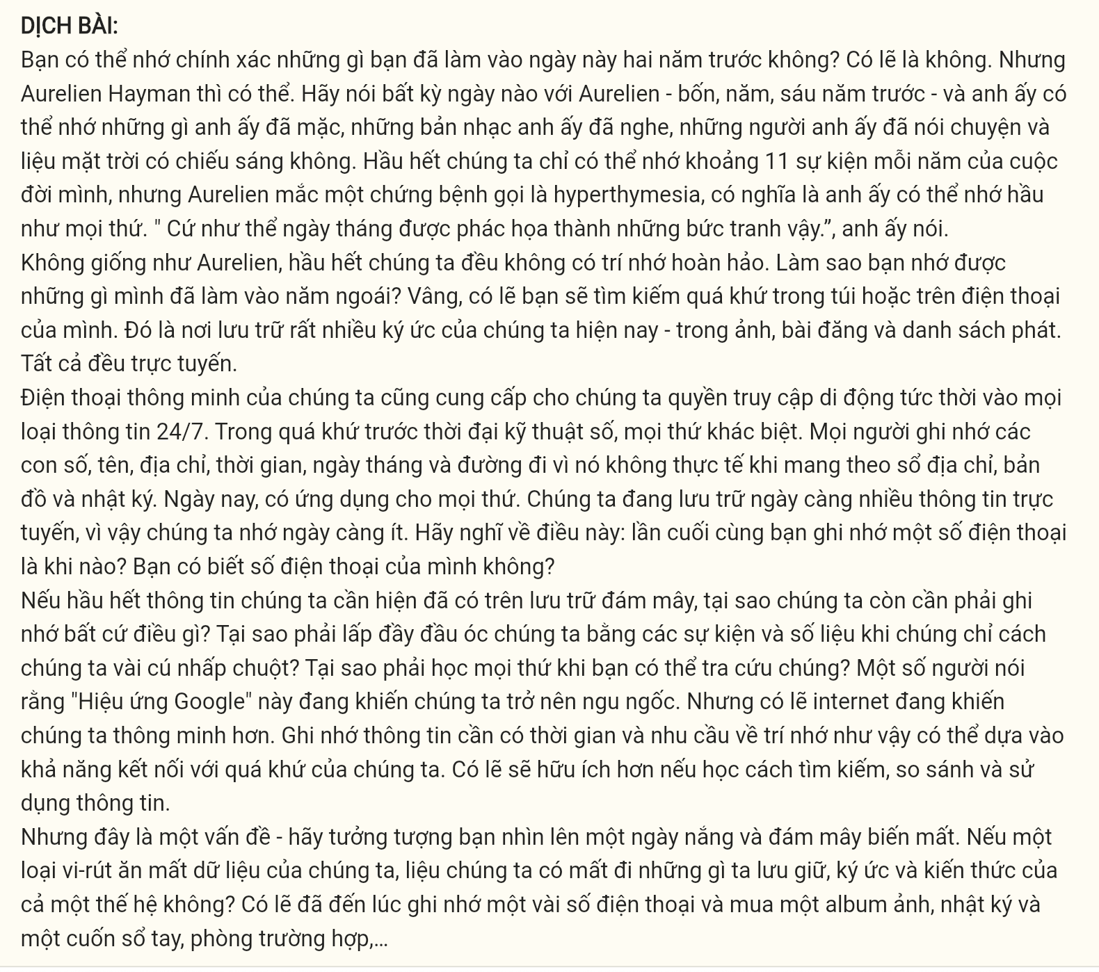
Can you remember exactly what you were doing on this day two years ago? Probably not. But Aurelien Hayman can. Say any date to Aurelien – four, five, six years ago – and he can remember what he was wearing, what music he listened to, who he talked to, and if the sun was shining. Most of us can only remember about 11 events from each year of our lives, but Aurelien has a condition called hyperthymesia, which means he can remember almost everything. “It’s like the dates have pictures,” he says.
Unlike Aurelien, most of us don’t have a perfect memory. How do you remember what you did last year? Well, you probably look for the past in your pocket, on your phone. That’s where a lot of our memories are now – in photos, posts, and playlists. It’s all online.
Our smartphones also give us instant mobile access to all kinds of information 24/7. In the pre-digital past, things were different. People memorized numbers, names, addresses, times, dates, and directions because it wasn’t practical to carry around address books, maps, and diaries. Nowadays, there’s an app for everything. We are storing more and more information online, so we remember less and less. Think about it: when did you last memorize a telephone number? Do you know your own number?
[I] If most information that we need is now online in the cloud, why do we need to remember anything? [II] Some people say that this “Google Effect” is making us stupid. But maybe the internet is making us smarter. [III] Memorizing information takes time, and the need for such memory may be rooted in our ability to connect with our past. Maybe it’s more useful to learn how to find, compare, and use information. [IV]
Here’s a problem though – imagine you look up one sunny day and the cloud disappears. If a virus eats our data, do we lose the records, memories, and knowledge of a whole generation? Perhaps it’s time to remember a few phone numbers and buy a photo album, diary, and notebook, just in case...
(Adapted from Oxford Discover Futures by Ben Wetz and Jane Hudson)
Question 31 [697487]: According to the passage, where do most of our memories reside now?
A. In our minds B. In physical photo albums
C. In digital forms like photos and posts D. In written diaries
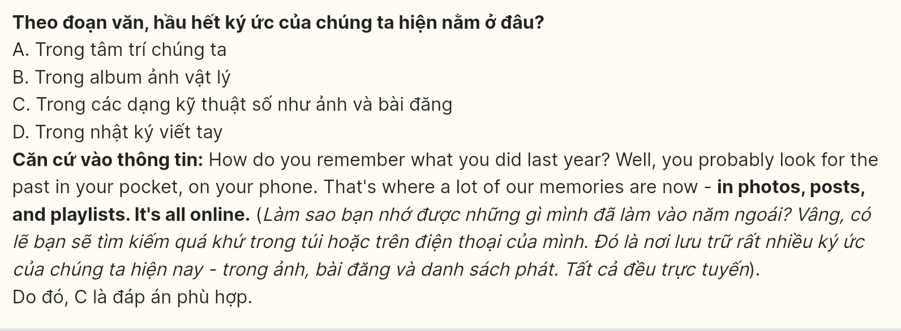
Question 32 [697488]: The word “practical” in paragraph 3 is OPPOSITE in meaning to ______
A. theoretical B. likely C. realistic D. rational
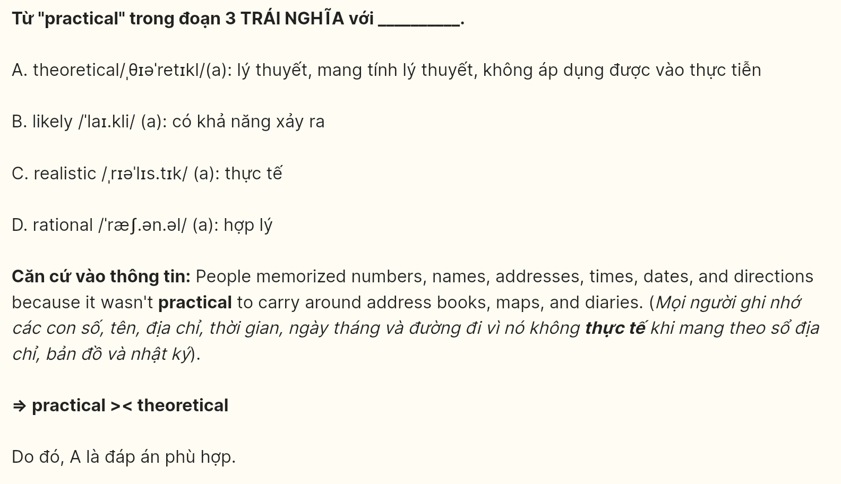
Question 33 [697489]: The word “it” in paragraph 3 refers to ______
A. your own number
B. a telephone number
C. the act of memorizing a telephone number
D. the act of storing information
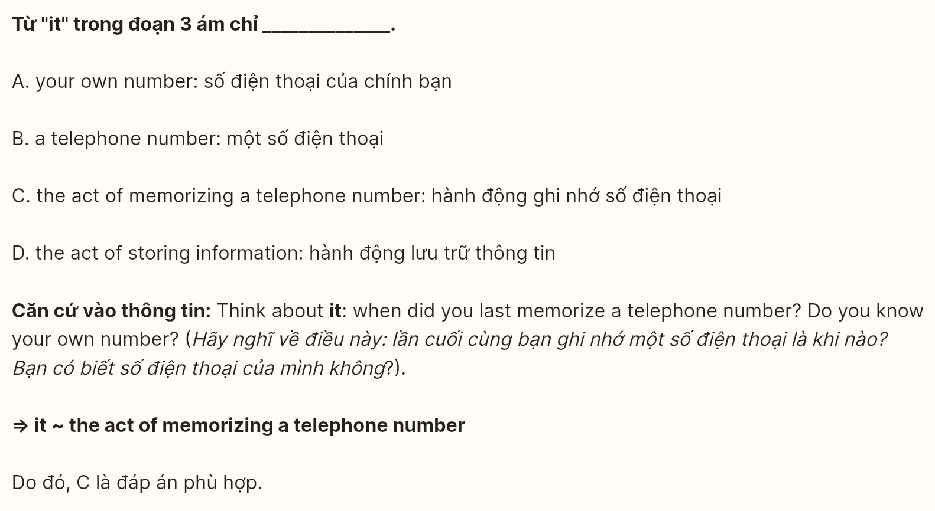
Question 34 [697490]: Which of the following best paraphrases the underlined sentence in paragraph 3?
A. Storing vast amounts of information online leads to a development in our memory capacity.
B. We tend to memorize more details now that we have digital storage options.
C. As we increasingly save information on the internet, our ability to remember it diminishes.
D. The less we rely on online storage for information, the better we need to remember things ourselves.
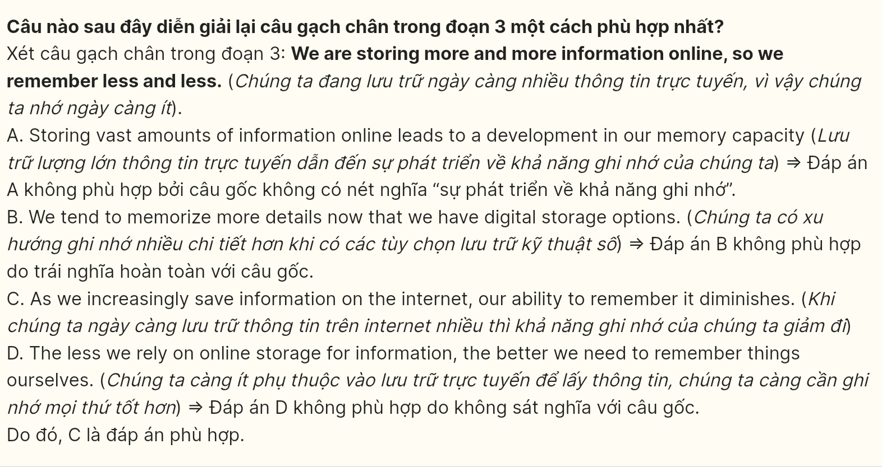
Question 35 [697491]: Which of the following best summarizes paragraph 3?
A. People used to memorize important information because they did not have smartphones or digital tools.
B. The invention of smartphones has eliminated the need for memorization, leading to a decline in our memory skills.
C. Smartphones have replaced the need to memorize a lot of details, as we now store everything online and rely less on memory.
D. Modern technology has made it easier to store information online, but it may have negative effects on our memory.
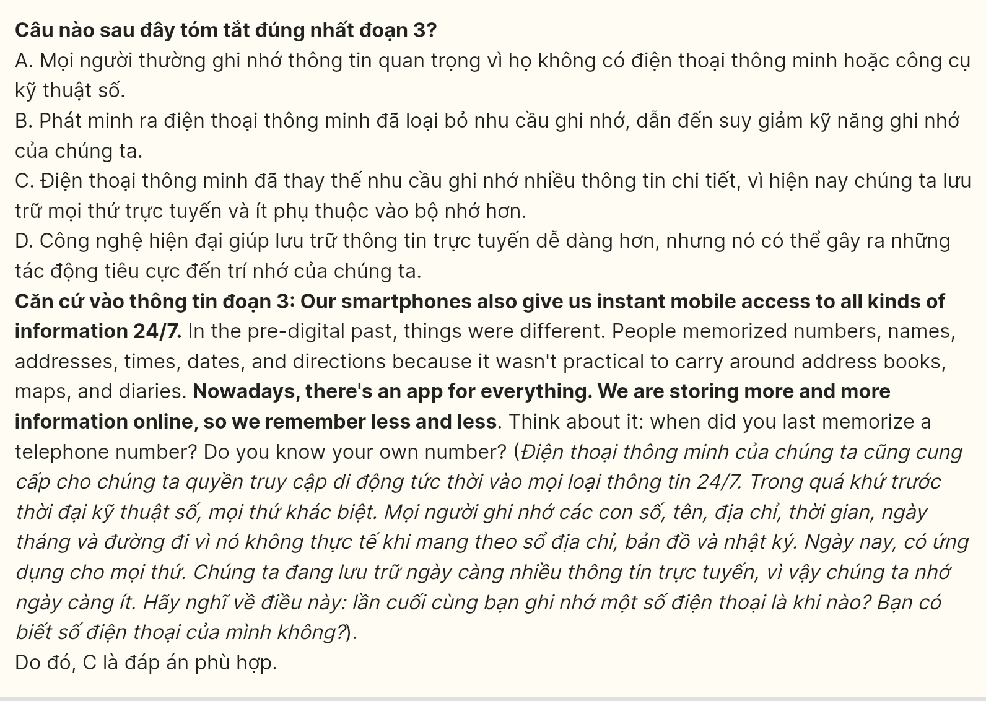
Question 36 [697492]: Where in paragraph 4 does the following sentence best fit?
Why fill our heads with facts and figures when they are a couple of clicks away? Why learn things when you can look them up?
A. [I] B. [II] C. [III] D. [IV]
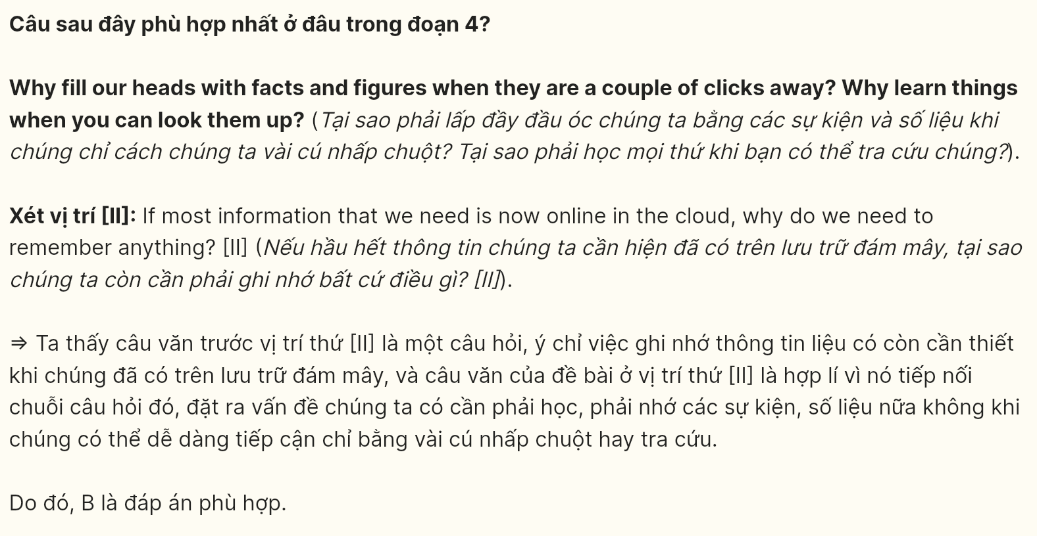
Question 37 [697493]: The phrase “rooted in” in paragraph 4 could be best replaced by ______
A. eliminated by B. separated from C. connected with D. based on
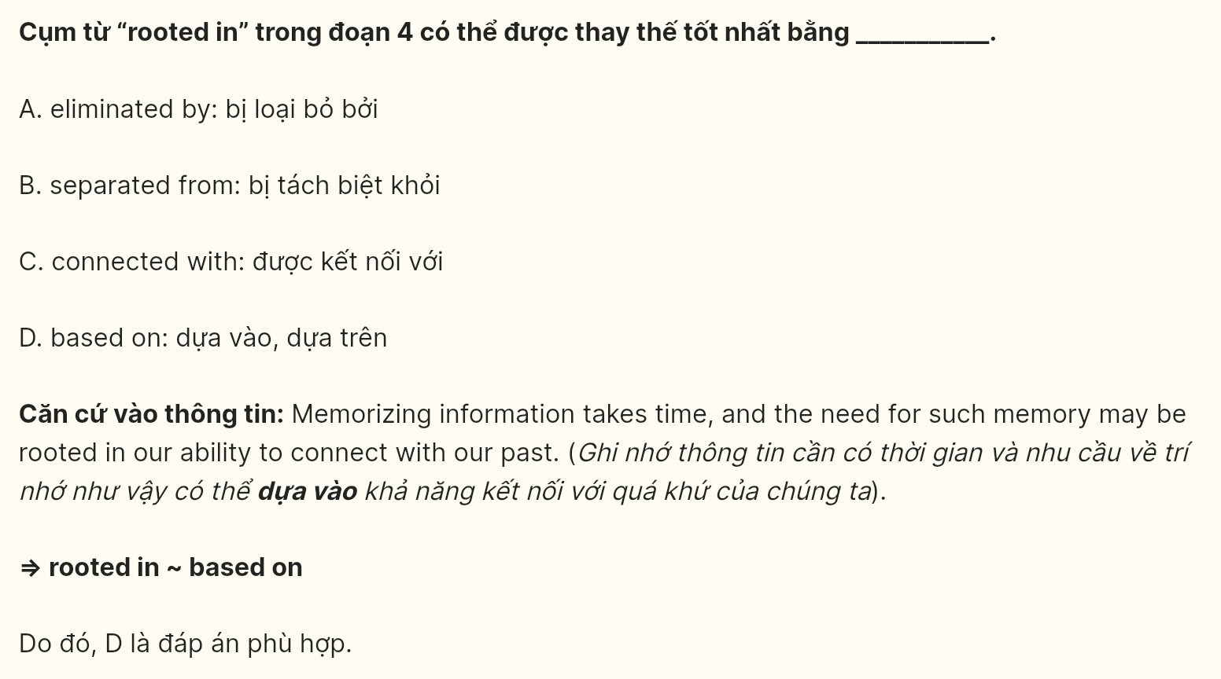
Question 38 [697494]: Which of the following is NOT TRUE, according to the passage?
A. The “Google Effect” raises concerns about our reliance on technology.
B. It is unnecessary to memorize any information because everything is available online.
C. In the past, people memorized important information because it was inconvenient to carry around address books and maps.
D. Aurelien Hayman can recall specific details from any given date in the past several years.
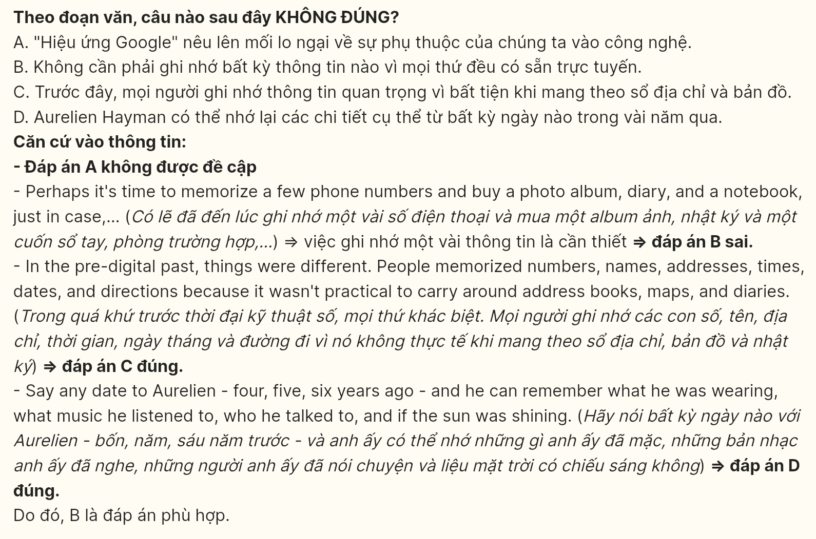
Question 39 [697495]: Which of the following can most likely be inferred from the passage?
A. Aurelien Hayman's memory is considered a typical human ability.
B. Relying on technology guarantees the preservation of memories.
C. Memorizing information is becoming less valued in the digital age.
D. Keeping a diary is an outdated practice in the modern world.
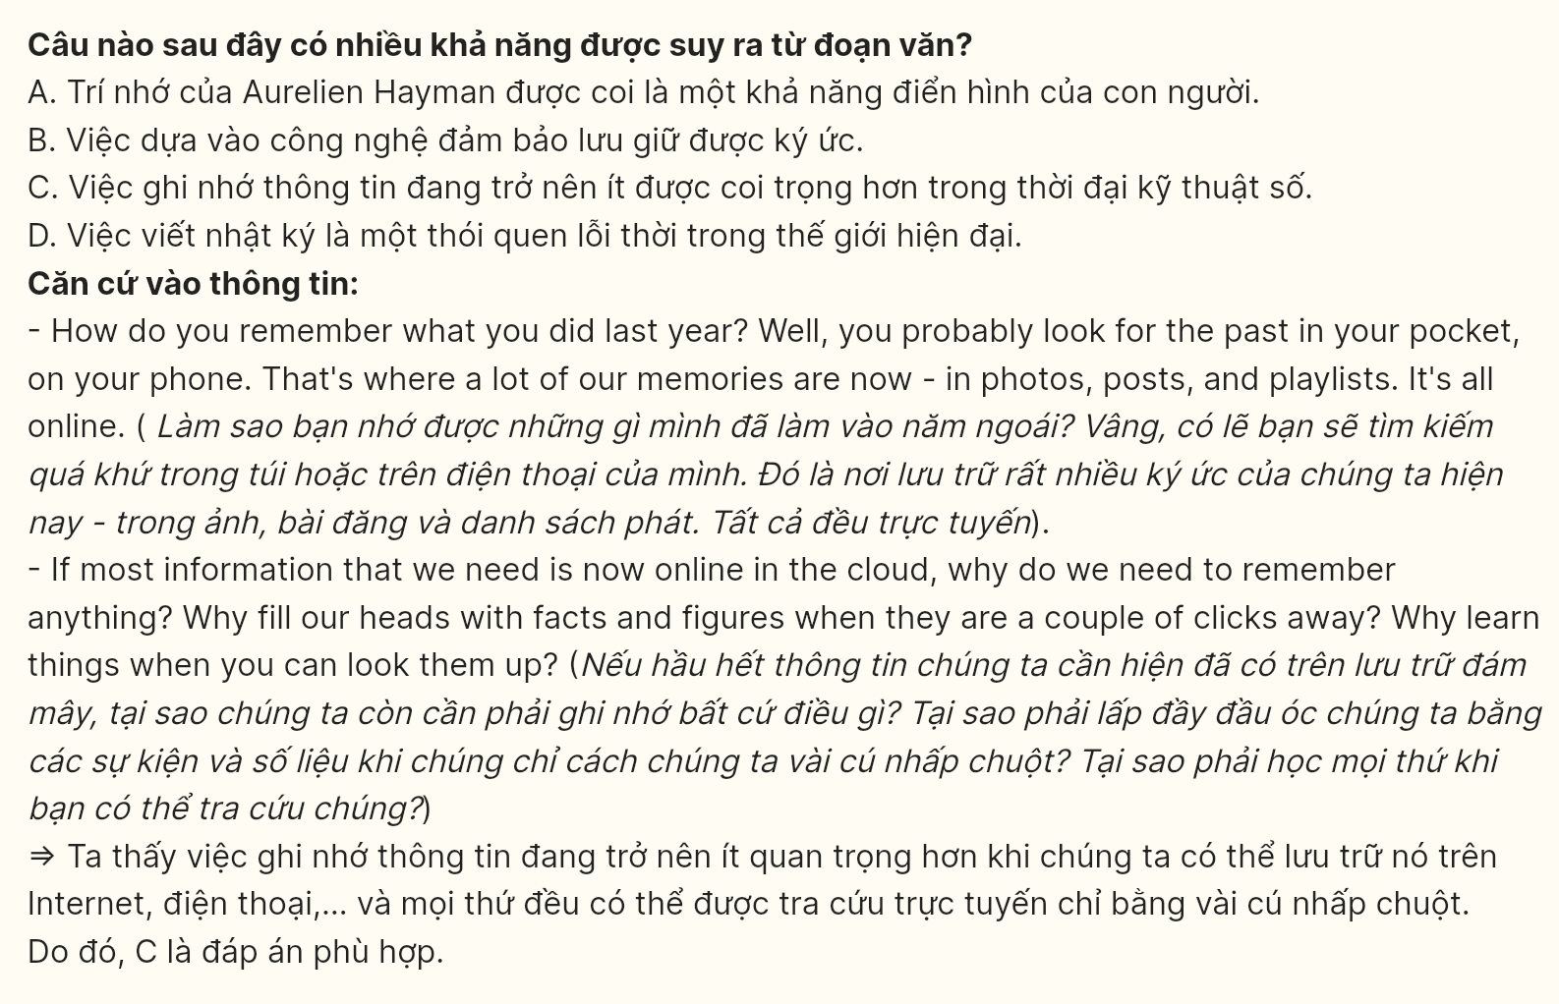
Question 40 [697496]: Which of the following best summarizes the passage?
A. Aurelien Hayman’s unique memory condition illustrates how people used to remember information before smartphones existed.
B. The reliance on digital devices for information storage has changed our relationship with memory, raising concerns about the potential loss of knowledge.
C. Hyperthymesia is an extraordinary ability that highlights the importance of memorization in today’s digital age.
D. The internet makes it unnecessary to memorize facts and figures, which could lead to a decline in cognitive skills.
