**ĐỀ MINH HỌA SỐ 11**  
**KỲ THI TỐT NGHIỆP TRUNG HỌC PHỔ THÔNG NĂM 2025**  
(Đề thi có 08 trang)  
**Môn thi: TIẾNG ANH**  
**Thời gian làm bài: 50 phút, không kể thời gian phát đề**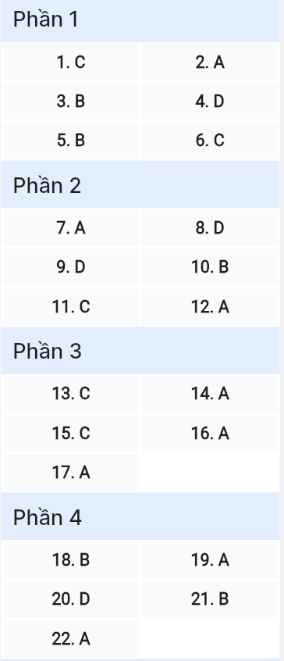

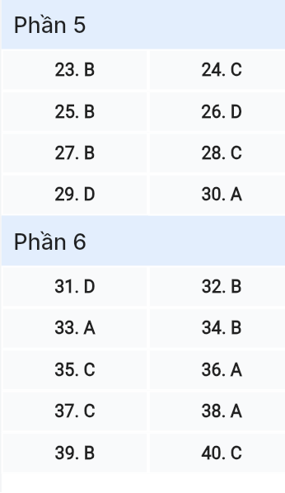

***Read the following advertisement and mark the letter A, B, C or D on your answer sheet to indicate the option that best fits each of the numbered blanks from 1 to 6.***

**DISCOVER NEW TRAVEL BUDDIES WITH TRAVELMATE**

"Who will you explore your next destination with? Will they share the same (1) ____ for adventure, or will they prefer a more relaxing trip?" If you often wonder (2) ____, your travel companions before your next vacation, we have exciting news for you! TravelMate, a (3) ____ platform, allows you to select your future travel buddies before your trip. This service is designed to give you a more enjoyable and personalized experience.

All you need to do is share your travel preferences with the platform, and you'll be matched with others (4) ____ similar tastes. Whether you're looking to make new friends or reconnect with previous ones, TravelMate (5) ____ it easy. If you're seeking adventure or simply want (6) ____ a relaxing getaway, there's a perfect match waiting for you!

*(Adapted from Global Travel)*

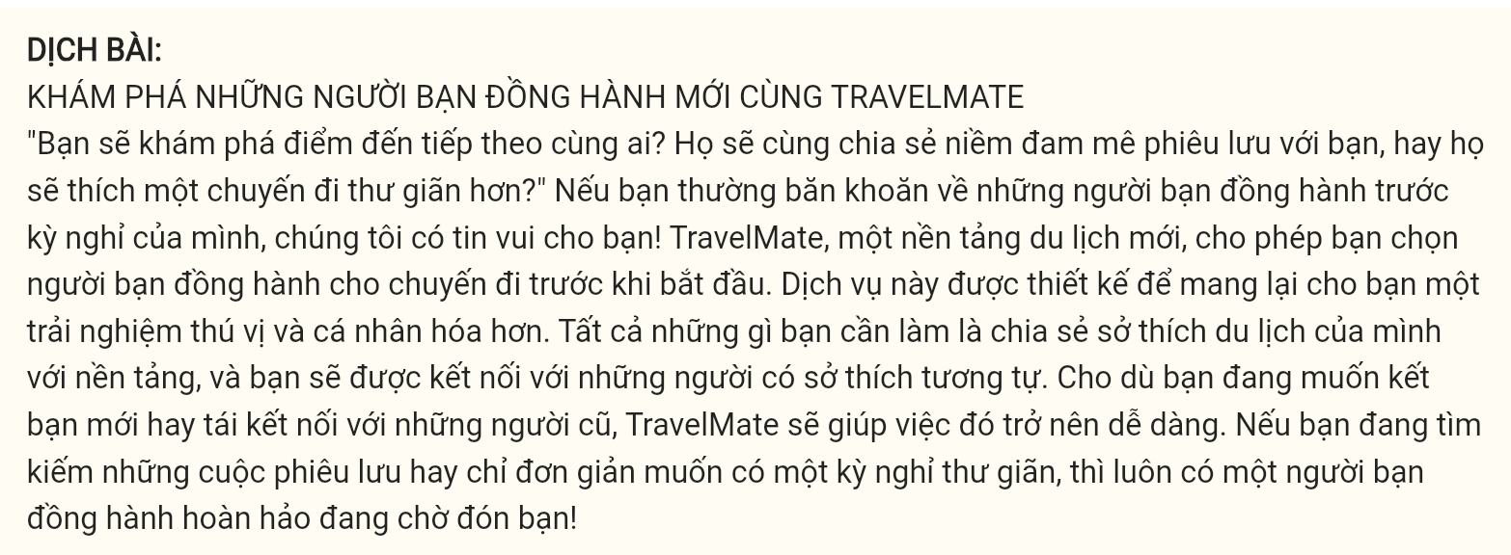

**Question** 1 [696544]: A. enthusiastically B. enthusiast C. enthusiasm D. enthusiastic

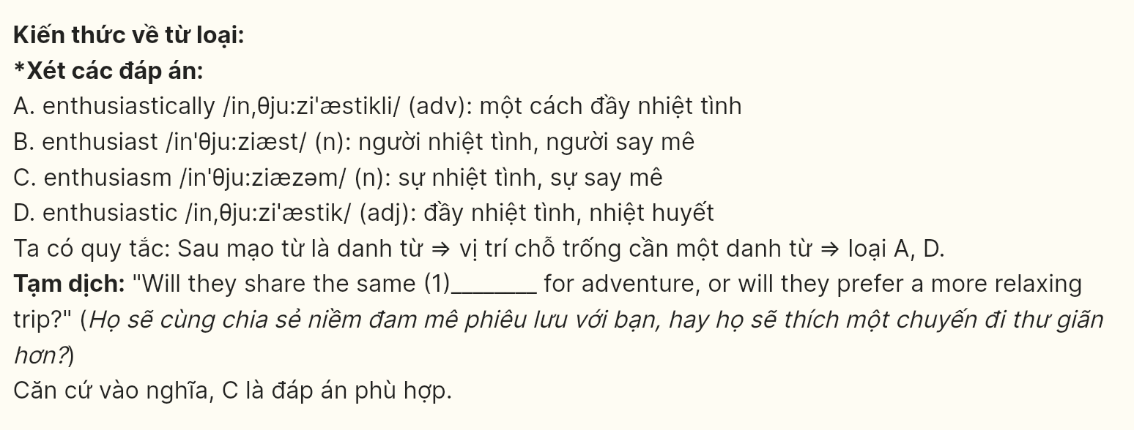

**Question** 2 [696545]: A. about B. for C. over D. with

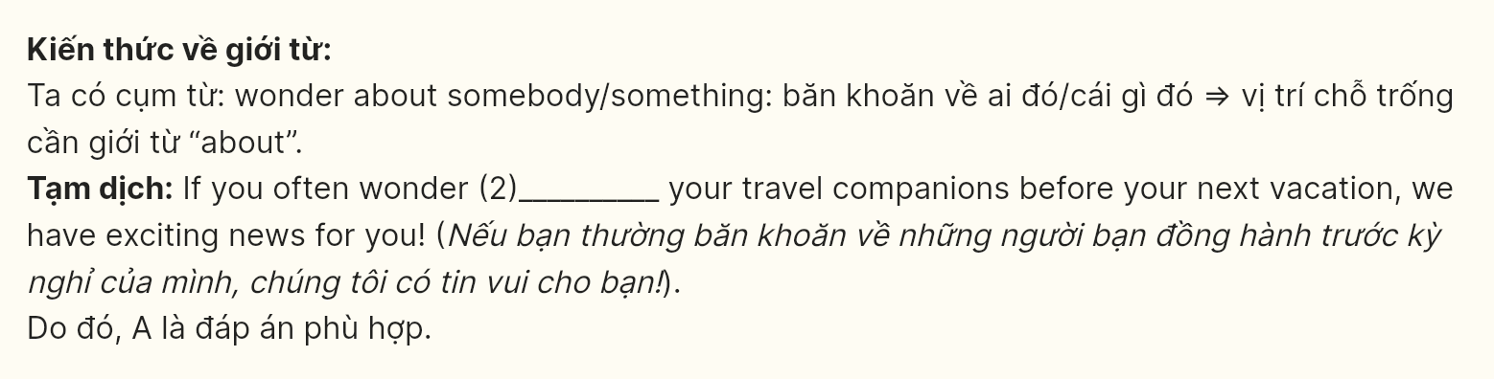

**Question** 3 [696546]: A. travel platform new B. new travel platform

C. travel new platform D. new platform travel

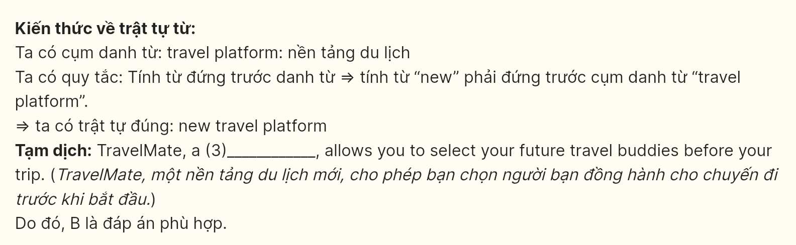

**Question** 4 [696547]: A. who has B. had C. to have D. having

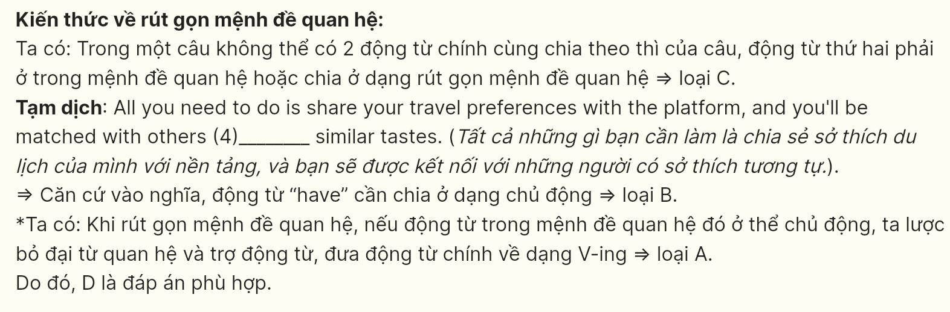

**Question** 5 [696548]: A. takes B. makes C. gives D. does

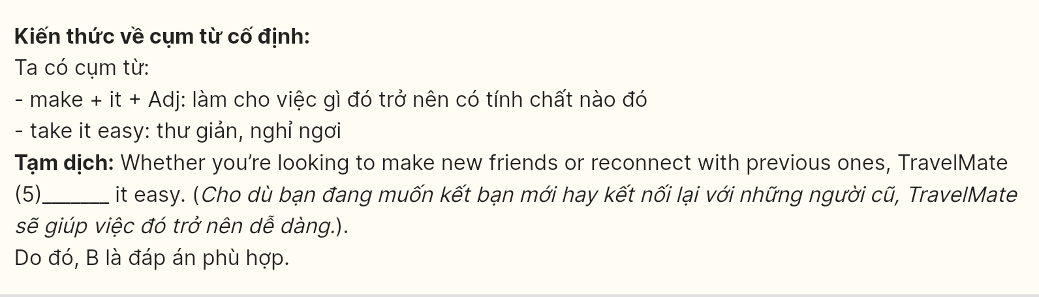

**Question** 6 [696549]: A. have B. to having C. to have D. having



***Read the following leaflet and mark the letter A, B, C, or D on your answer sheet to indicate the option that best fits each of the numbered blanks from 7 to 12.***

**EXPLORE CULTURAL DIVERSITY**

Culture is the heart of every society, reflecting traditions, values, and creativity. By understanding different cultures, we enrich our perspectives and build connections with (7) ____. Whether through art, language, or celebrations, culture (8) ____ our identities and offers a window into the lives of others.

**Why Embrace Cultural Diversity?**

**Celebrate Differences:** Every culture has unique traditions, from festivals and dances to foods and clothing. By (9) ____ experiencing these, we gain a deeper appreciation of our global community. Language As a Key: Learning even a few words in another language can open (10) ____ to new friendships and understanding.  
**Art & Music:** Cultural (11) ____ and performances are windows into a community's history and values.

**Get Involved!**

Attend local cultural festivals.  
Try traditional cuisines from around the world.  
(12) ____ art and films from different countries.

*Celebrating culture brings us closer together.*

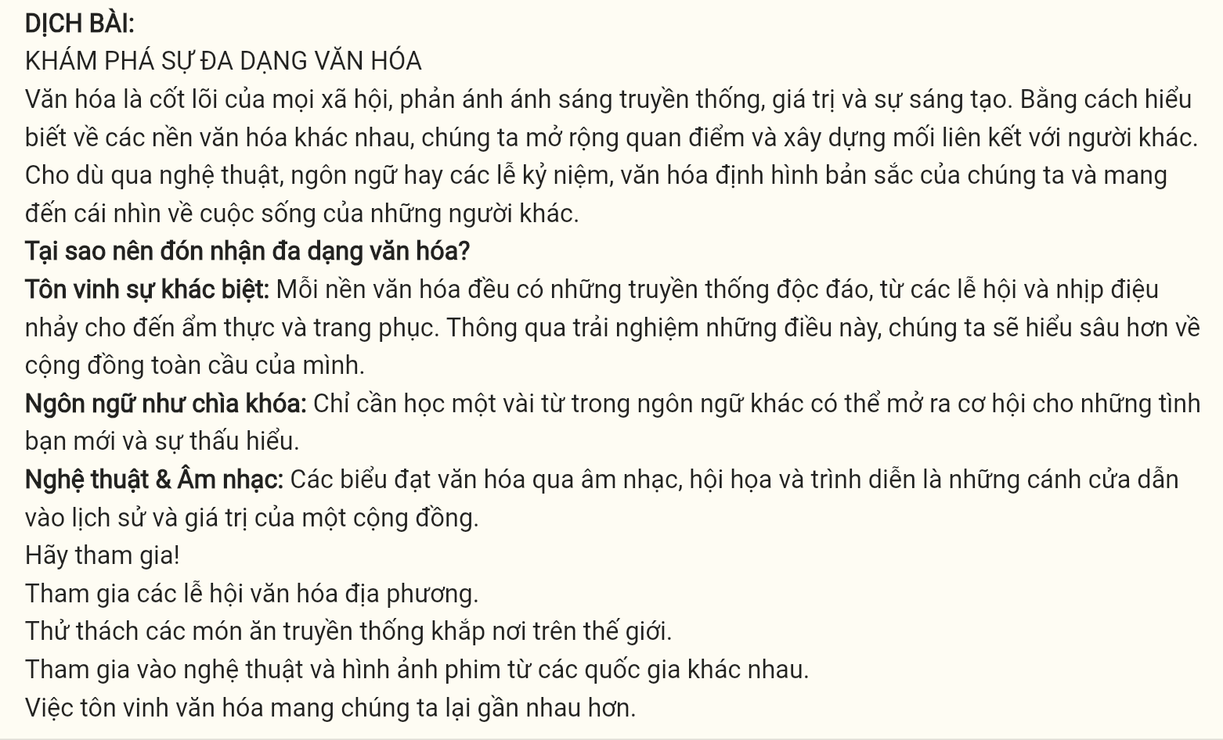

**Question** 7 [696550]: A. others B. another C. other D. the other

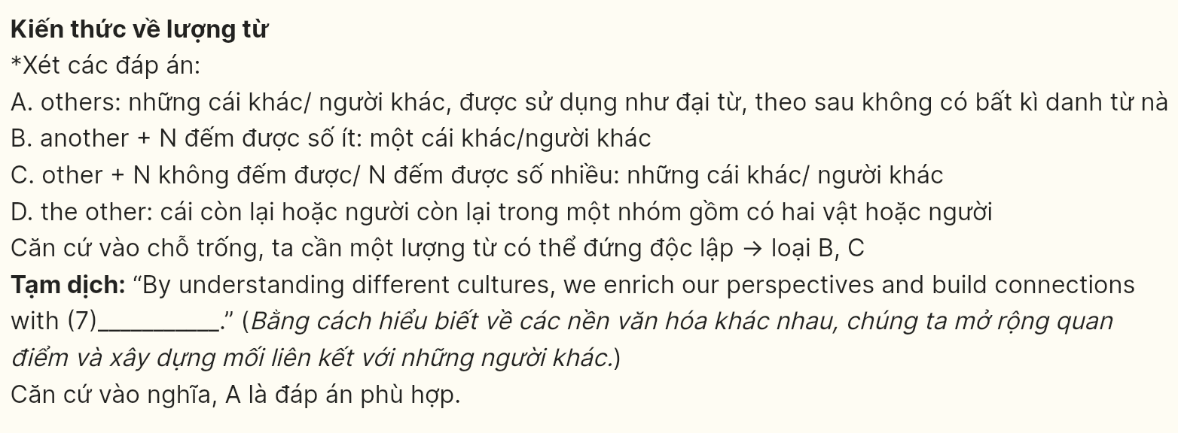

**Question** 8 [696551]: A. creates B. forms C. establishes D. shapes

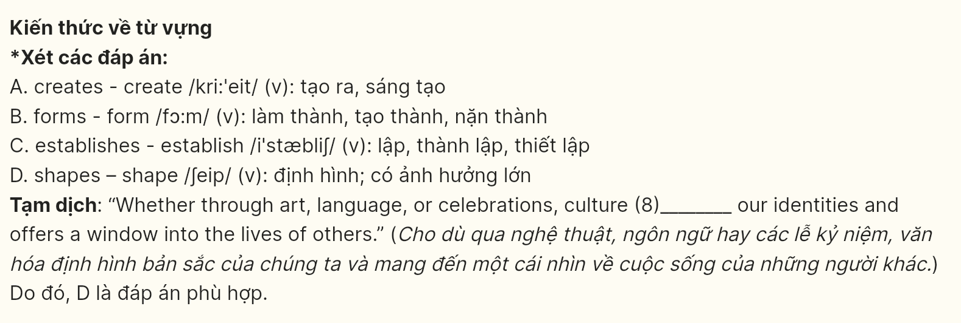

**Question** 9 [696552]: A. in view of B. on behalf of C. in case of D. by means of

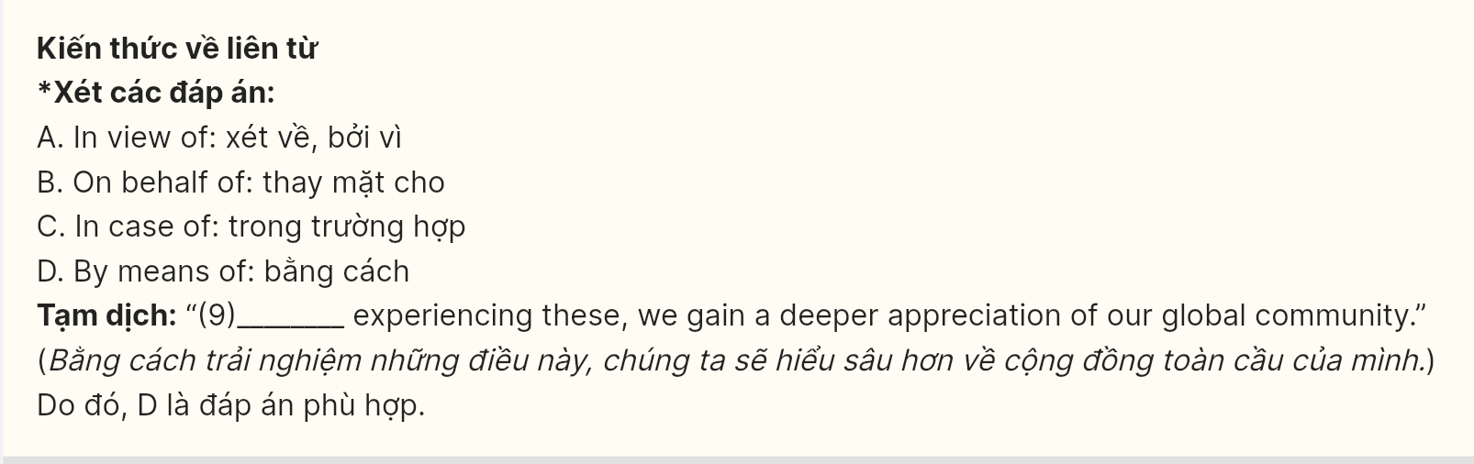

**Question** 10 [696553]: A. gates B. doors C. windows D. curtains

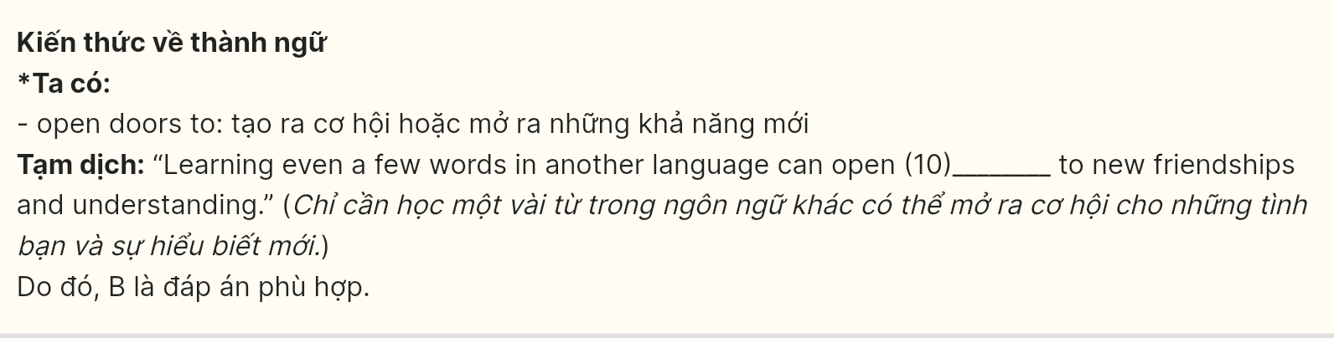

**Question** 11 [696554]: A. compression B. depression C. expressions D. impressions

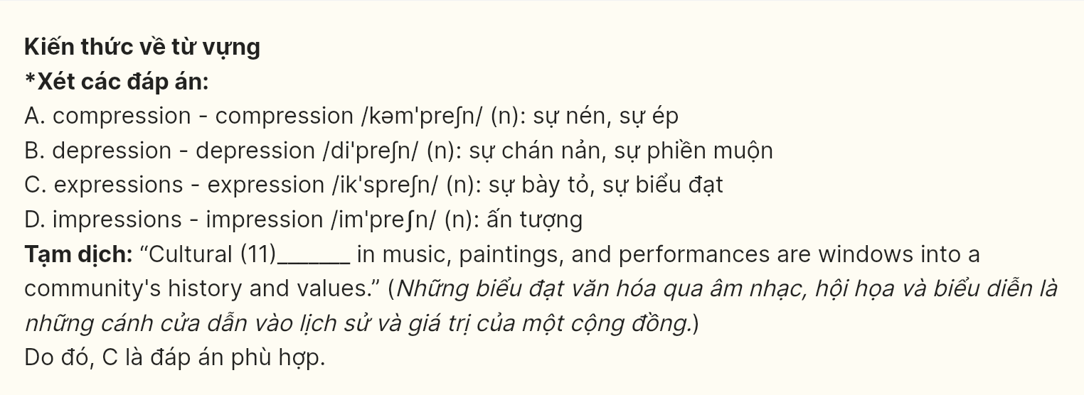

**Question** 12 [696555]: A. Engage with B. Share with C. Commit to D. Contribute to

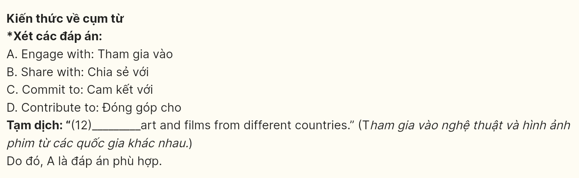

***Mark the letter A, B, C, or D on your answer sheet to indicate the best arrangement of utterances or sentences to make a meaningful exchange or text in each of the following questions from 13 to 17.***

**Question 13 [696556]:**

a. Peter: Ok. Let’s have a look. What do you want to study?  
b. Jennifer: I can’t decide which university to study at. I really like both Weston and Eastdale.  
c. Jennifer: I want to study marketing or economics.

A. a-c-b B. b-c-a C. b-a-c D. c-b-a



**Question 14 [696557]:**

a. John: I’m planning to visit Japan next summer.  
b. Mary: Why Japan?  
c. Mary: Have you already decided on the places you want to visit?  
d. John: I’ve always been fascinated by Japanese culture and history.  
e. Mary: That sounds amazing! I hope you enjoy the trip.

A. c-a-b-d-e B. a-b-d-c-e C. b-a-e-d-c D. c-a-d-b-e



**Question 15 [696558]:**

Hi John,

a. It’s fantastic that you’ve taken the time to recommend those cultural podcasts to me.  
b. I listened to the first one on ancient civilizations, and it was truly insightful.  
c. You know, maybe we could start a discussion group about these topics, what do you think?  
d. Thanks also for introducing me to those documentaries - they’ve been an amazing supplement to the podcasts!  
e. While I’m busy at the moment preparing for my exam, I’m eager to dive deeper into the content afterward.

Write back soon,

Emily

A. b-d-a-c-e B. a-b-d-c-e C. a-d-b-e-c D. b-e-a-d-c

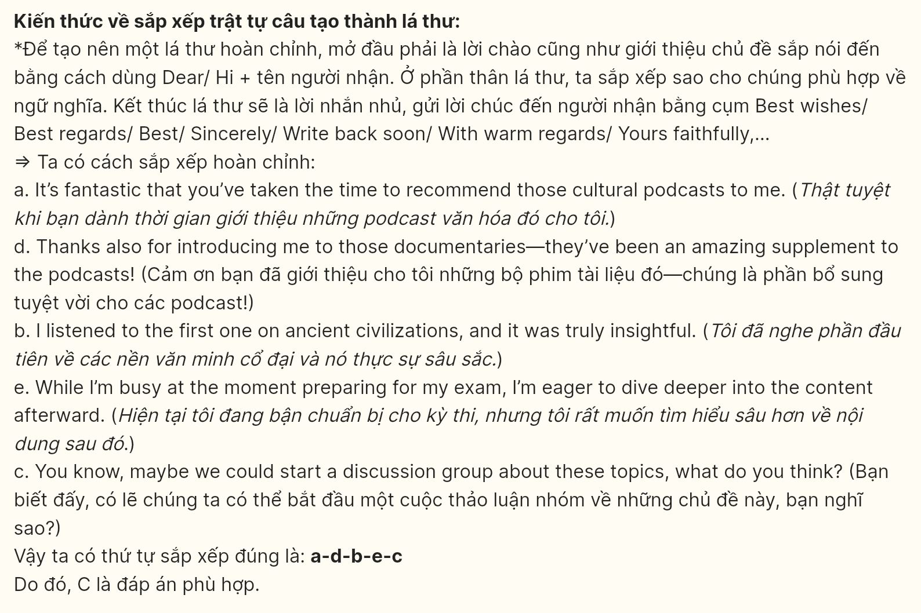

**Question 16 [696559]:**

a. While managing large teams and coordinating multiple tasks can be challenging, the sense of accomplishment when a project is completed successfully is truly rewarding.  
b. I started my journey in project management five years ago, where I quickly developed a passion for overseeing complex projects.  
c. My ability to communicate clearly with clients and colleagues is one of my greatest strengths in this role.  
d. I have honed my skills through various leadership training programs and by handling diverse projects across industries.  
e. In conclusion, my experience in leading teams and delivering results under tight deadlines has shaped me into a well-rounded project manager.

A. b-d-c-a-e B. c-a-d-b-e C. d-b-a-c-e D. b-c-a-d-e

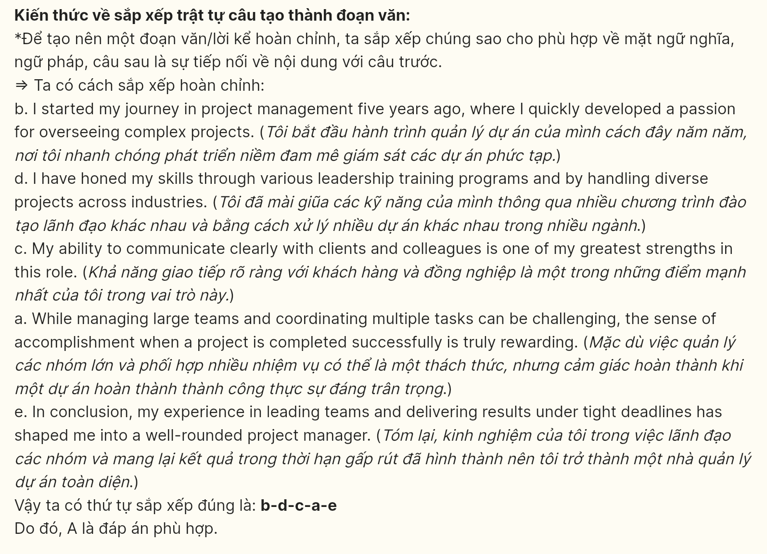

**Question 17 [696560]:**

a. However, despite these advancements, the region still struggles with infrastructure challenges, as public transportation remains underdeveloped.  
b. Over the past decade, Greystone has undergone a remarkable transformation, shifting from a quiet suburban town to a vibrant hub of commercial activity.  
c. The influx of new residents has increased demand for housing, resulting in a rapid expansion of residential developments across the city.  
d. This economic growth has attracted businesses from tech startups to retail giants, significantly enhancing employment opportunities and boosting the local economy.  
e. The surge in population, along with the expansion of commercial sectors, has led to a noticeable strain on public services and transportation networks.

A. b-d-c-e-a B. b-c-d-a-e C. b-c-e-d-a D. b-e-d-c-a

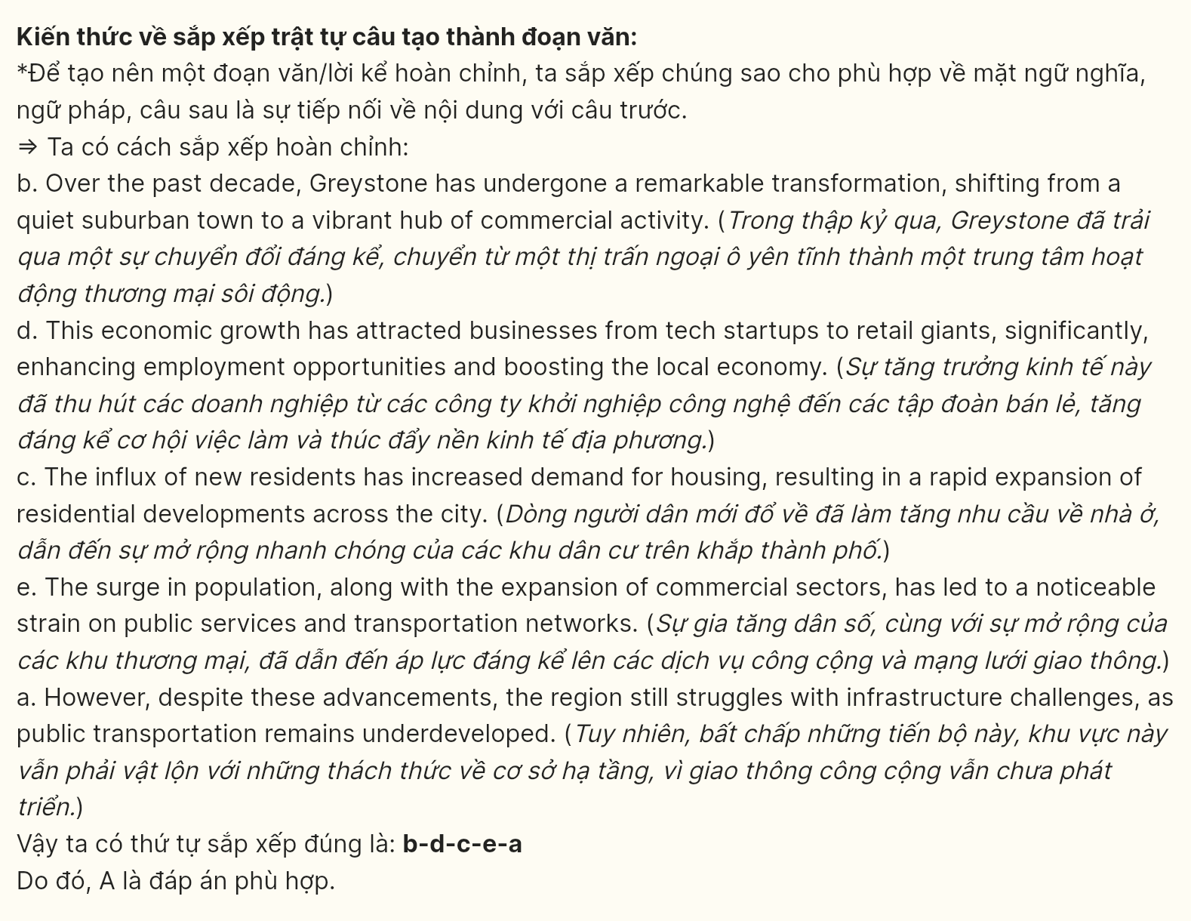

***Read the following passage about humanoid robots and mark the letter A, B, C or D on your answer sheet to indicate the option that best fits each of the numbered blanks from 18 to 22.***

The future of electric vehicles (EVs) is promising, as technological advancements and environmental concerns (18) ______. As governments worldwide implement stricter emissions regulations and offer incentives for EV adoption, manufacturers are investing heavily in research and development. (19) ______, resulting in longer ranges and faster charging times. For instance, new solid-state batteries have the potential to enhance energy density and safety, making EVs more practical for everyday use.

Additionally, the rise of autonomous driving technology is set to revolutionize the way we interact with vehicles. Many electric models are now equipped with advanced driver-assistance systems (20) ______. Furthermore, the integration of smart technology allows for seamless connectivity, enabling drivers to monitor their vehicle's performance and locate charging stations through mobile apps.

As charging infrastructure continues to expand, (21) ______, the convenience of owning an EV is increasing. This transition to electric vehicles not only promises a reduction in carbon emissions but also fosters a cleaner, healthier environment. Overall, (22) ______ and sustainable transportation.

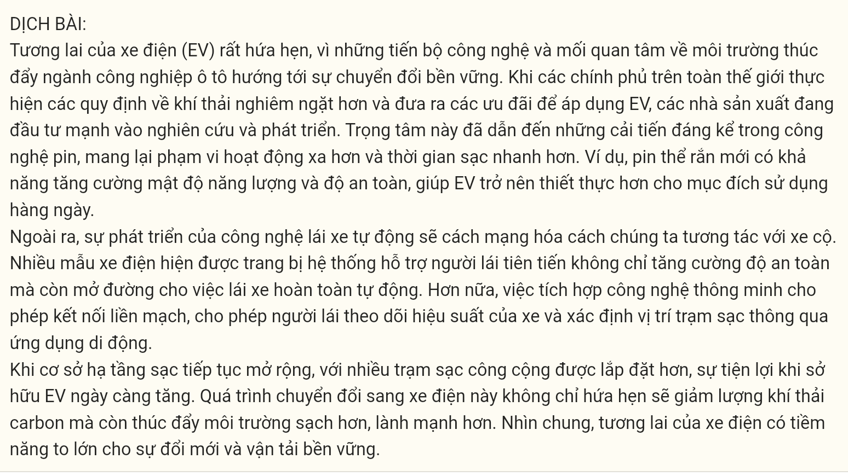

**Question 18 [696561]:**

A. driving the automotive industry toward a sustainable transformation  
B. drive the automotive industry toward a sustainable transformation  
C. that drive the automotive industry toward a sustainable transformation  
D. from which drive the automotive industry toward a sustainable transformation

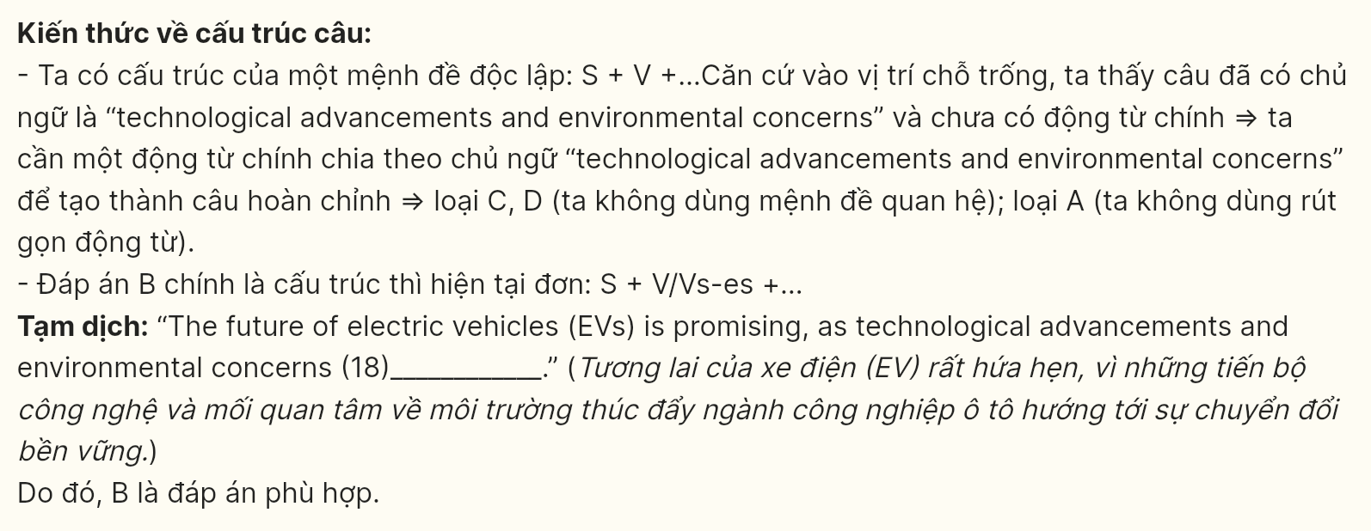

**Question 19 [696562]:**

A. This focus has led to significant improvements in battery technology  
B. Having led to significant improvements in battery technology  
C. This focus of significant improvements in battery technology  
D. Significant improvements have led to this focus on battery technology

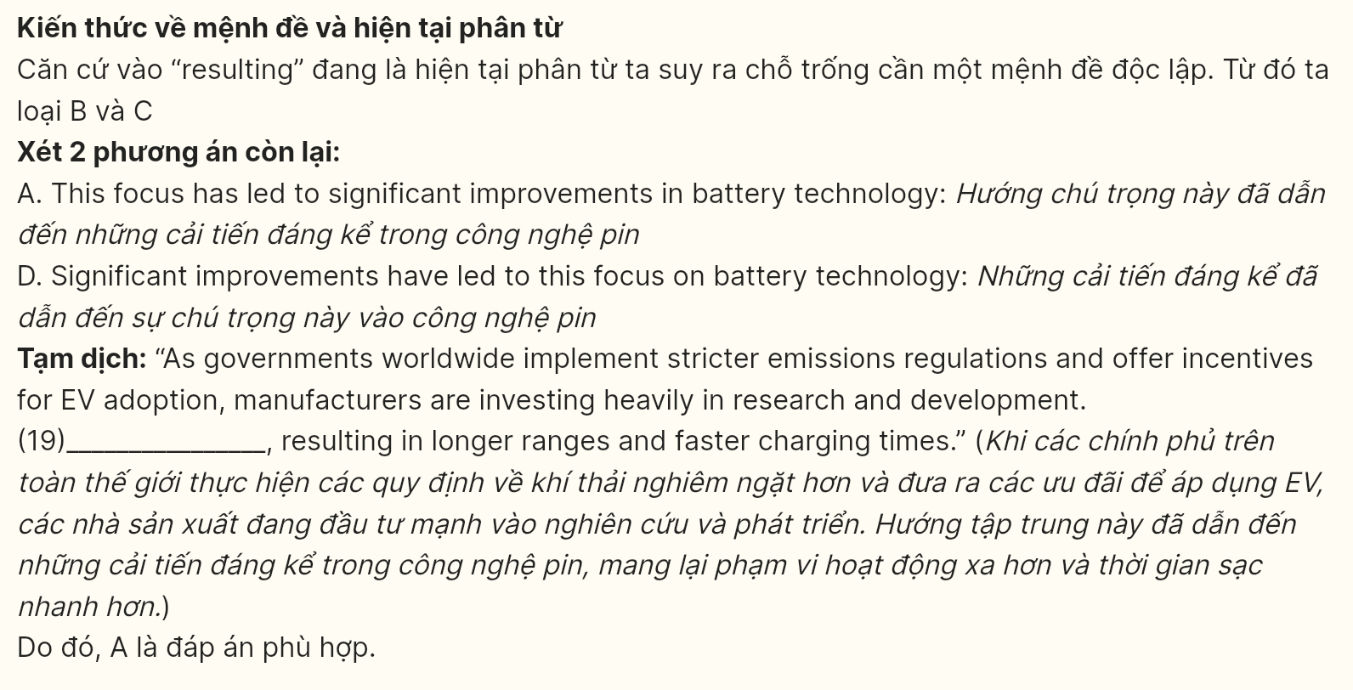

**Question 20 [696563]:**

A. whose not only enhance safety but also pave the way for fully autonomous driving  
B. not only enhance safety but also pave the way for fully autonomous driving  
C. not only enhancing safety but also pave the way for fully autonomous driving  
D. that not only enhance safety but also pave the way for fully autonomous driving

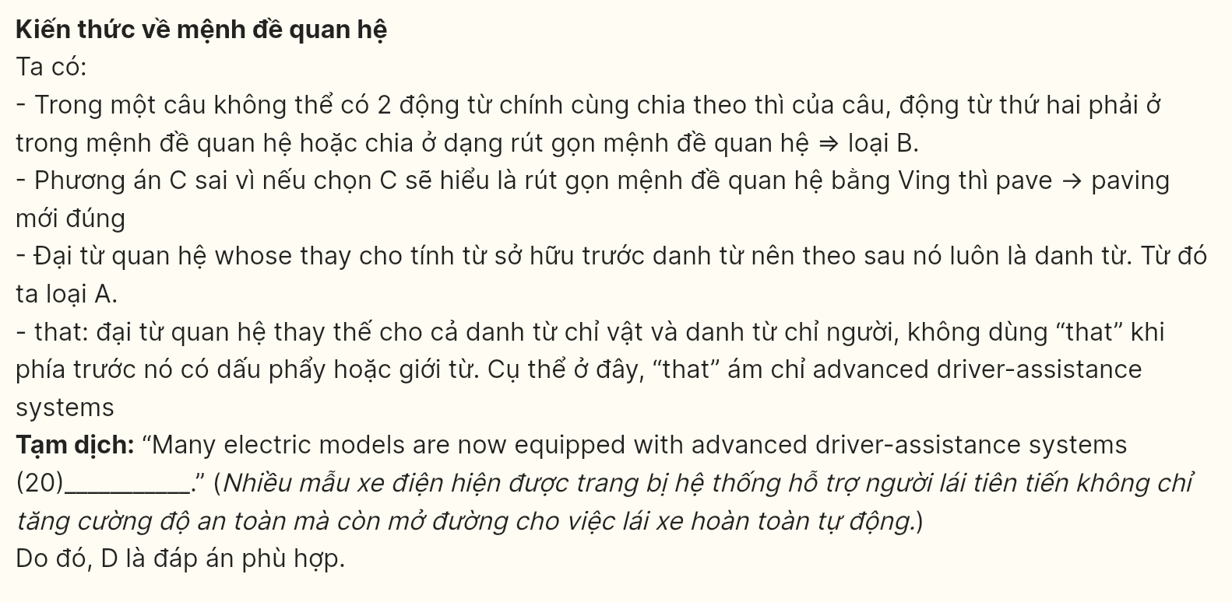

**Question 21 [696564]:**

A. more public charging stations are being installed  
B. with more public charging stations being installed  
C. more public charging stations being installed  
D. with more public charging stations installing

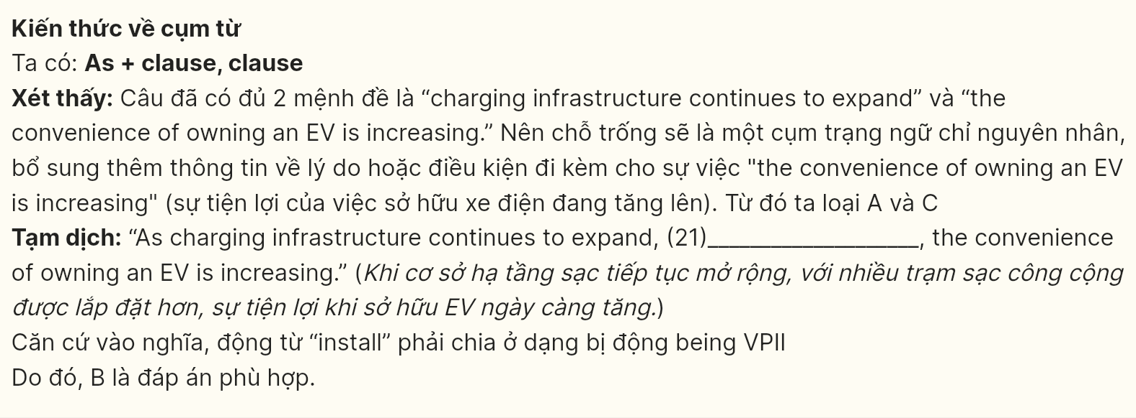

**Question 22 [696565]:**

A. the future of electric vehicles holds immense potential for innovation  
B. immense potential for innovation holds the future of electric vehicles  
C. electric vehicles for innovation hold immense potential for the future  
D. the future for innovation holds immense potential of electric vehicles

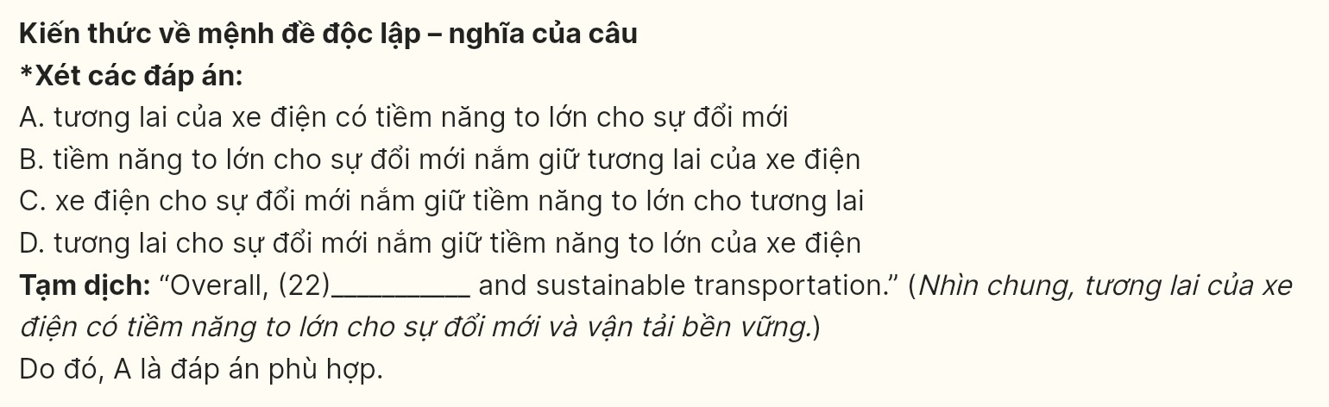

***Read the following passage about endangered languages and mark the letter A, B, C or D on your answer sheet to indicate the best answer to each of the following questions from 23 to 30.***

Vietnamese cultural identity is a rich and intricate tapestry that reflects the nation’s long and storied history. Rooted in over a thousand years of civilization, Vietnam's cultural identity is a fusion of **indigenous** traditions and external influences, shaped by its geographical location and historical interactions.

First and foremost, at the heart of Vietnamese culture is a deep **reverence** for family and community. Confucian values emphasizing respect for elders, filial piety, and social harmony have played a pivotal role in shaping Vietnamese society. These values are reflected in the close-knit family structures, hierarchical relationships, and communal rituals that are integral to daily life.

Secondly, Vietnamese cuisine is celebrated worldwide for its exquisite flavors and diversity. With its emphasis on fresh ingredients, fragrant herbs, and balanced flavors, Vietnamese food tells a story of the country’s agricultural heritage and regional variations. Iconic dishes like pho, banh mi, and spring rolls have become global favorites, representing the culinary artistry deeply ingrained in Vietnamese culture. Also, Vietnam’s artistic expressions are equally captivating. Traditional art forms like water puppetry, silk painting, and folk music continue to thrive alongside contemporary artistic movements. **Ao dai, a graceful traditional dress, exemplifies the fusion of elegance and modesty in Vietnamese fashion, symbolizing cultural pride and identity.**

Today, in the face of modernization and globalization, Vietnamese cultural identity remains resilient. While adapting to the challenges of the 21st century, the Vietnamese people continue to honor their traditions, celebrate **their** unique cultural expressions, and pass on their heritage to future generations, ensuring that their cultural identity remains vibrant and enduring.

*(Adapted from Saigoneer)*

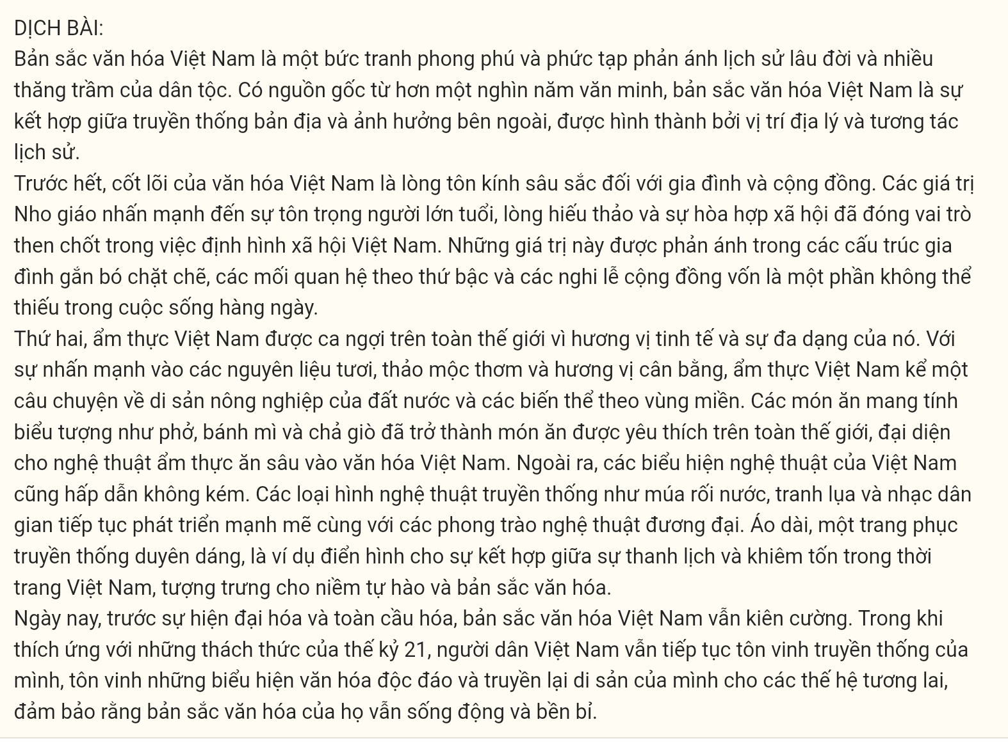

**Question 23 [696566]:** The word **indigenous** in paragraph 1 is **OPPOSITE** in meaning to ______:  
A. local B. foreign C. native D. traditional

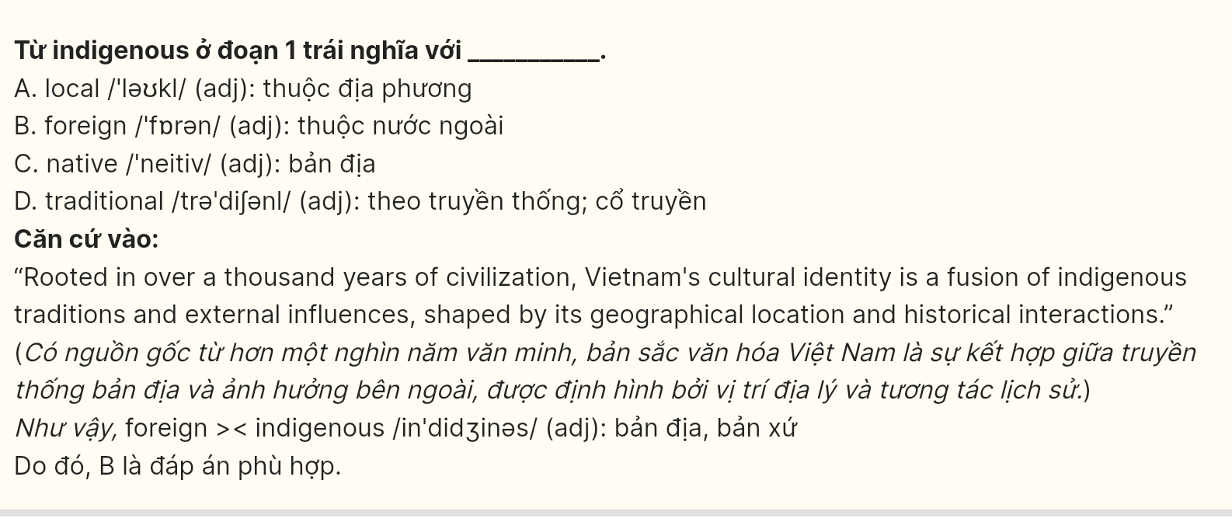

**Question 24 [696567]:** Which of the following is **NOT** mentioned as Confucian values emphasizing respect for?  
A. filial piety B. social harmony C. individualism D. elders

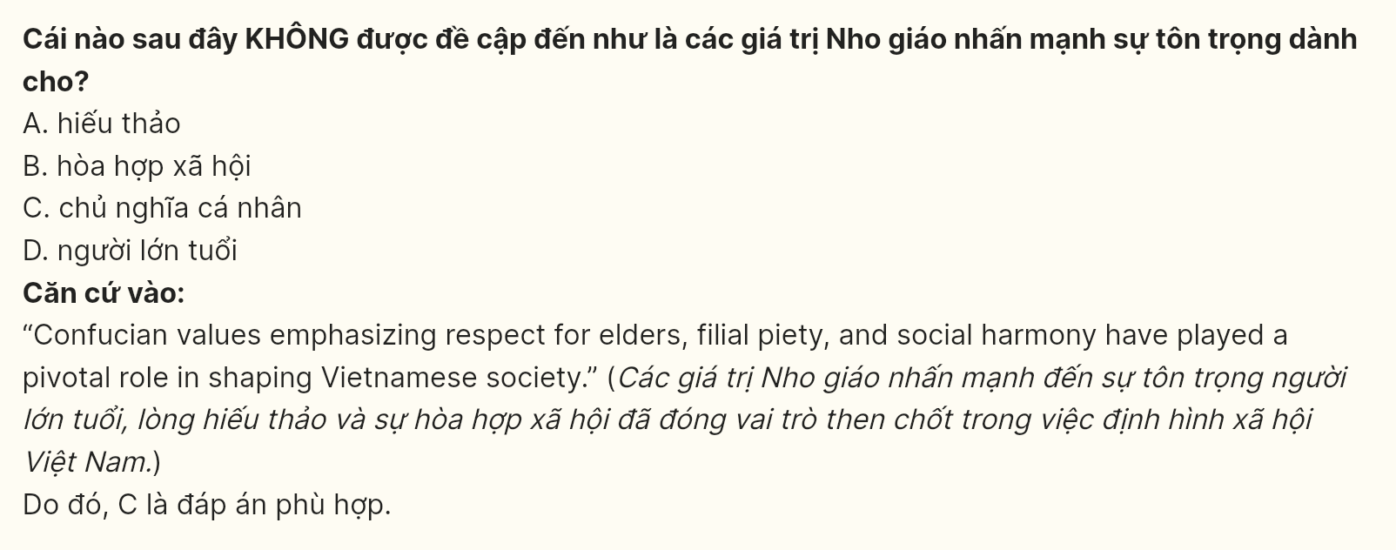

**Question 25 [696568]:** The word **reverence** in paragraph 2 could be best replaced by ______:  
A. disrespect B. admiration C. indifference D. criticism

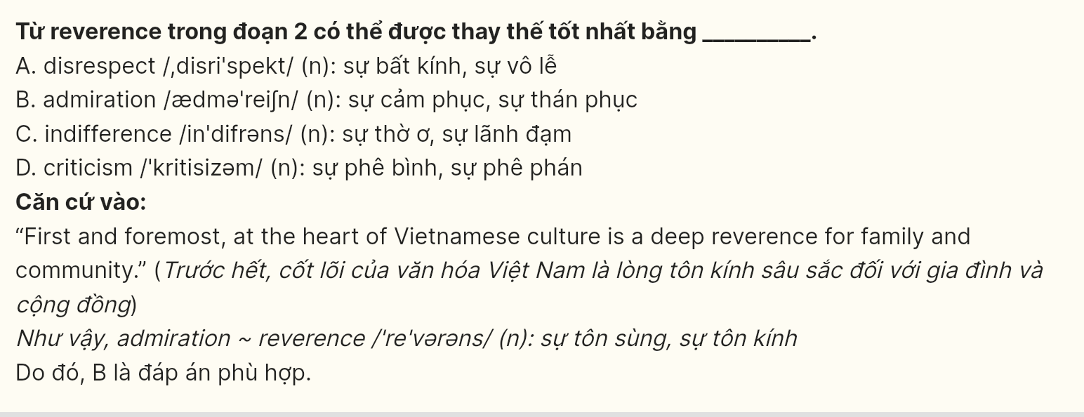

**Question 26 [696569]:** Which of the following best paraphrases the underlined sentence in paragraph 3?  
A. The ao dai, known for its elegance and modesty, represents a blend of Vietnamese fashion that embodies cultural identity and pride.  
B. As a traditional dress, the ao dai reflects the combination of sophistication and simplicity in Vietnamese fashion, representing the nation’s cultural values.  
C. The graceful ao dai, a traditional Vietnamese attire, signifies the blend of elegance and restraint, illustrating the pride and identity of Vietnamese culture.  
D. Known as a traditional dress, the ao dai beautifully combines elegance with modesty, serving as a symbol of Vietnam’s cultural identity and pride.

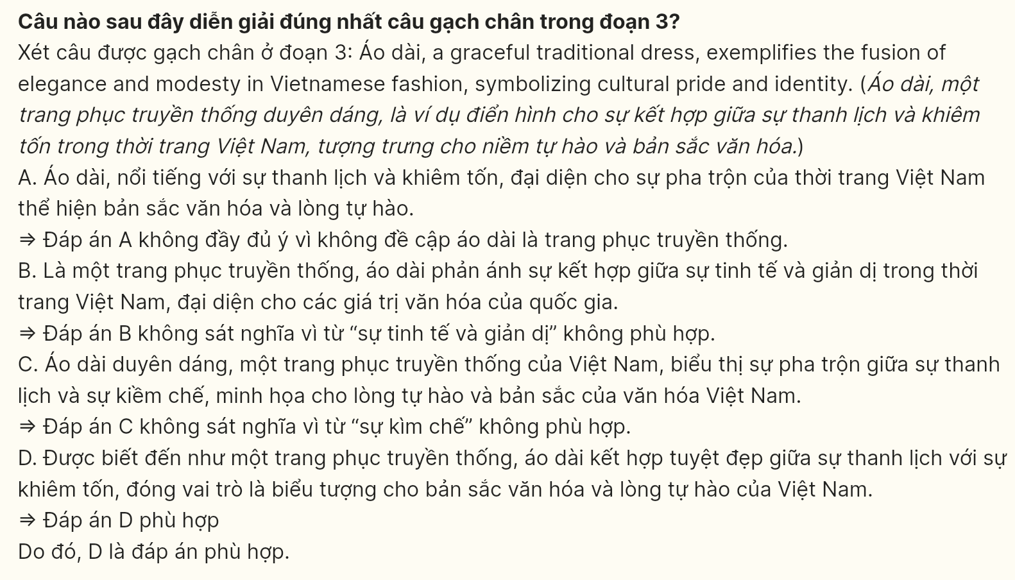

**Question 27 [696570]:** The word **their** in paragraph 4 refers to ________:  
A. Vietnamese cuisine B. Traditional art forms

C. Agricultural heritage D. Artistic movements

**Quest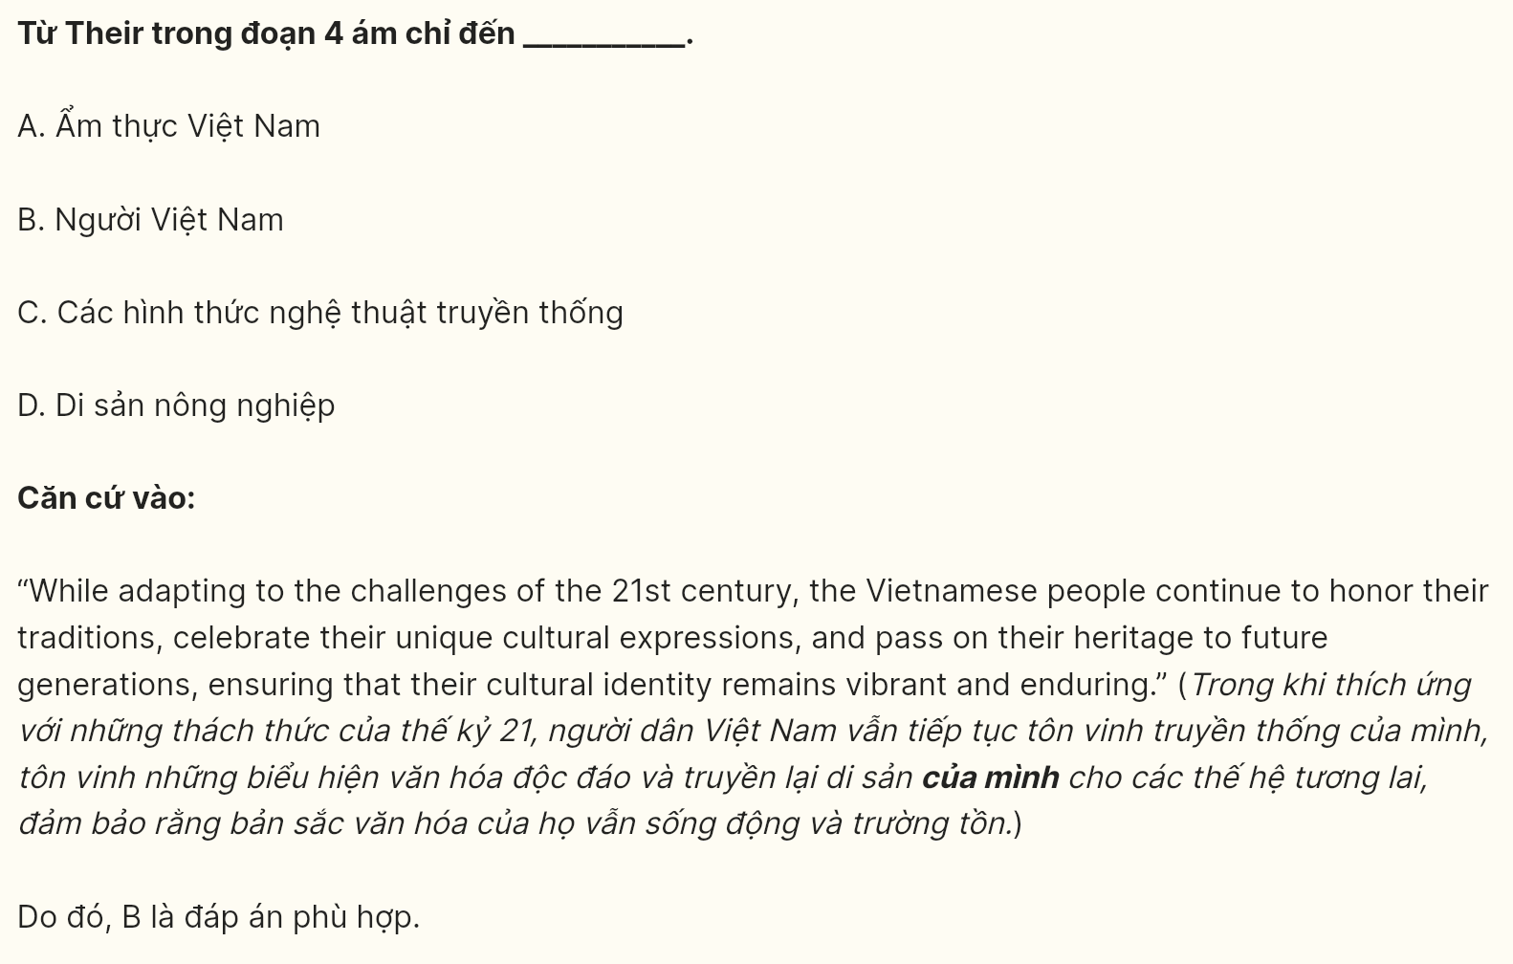ion 28 [696571]:** Which of the following is **TRUE** according to the passage?  
A. Vietnamese cultural identity is static and unchanging.  
B. Modernization has completely erased Vietnamese traditions.  
C. Vietnamese cuisine has gained international recognition.  
D. Water puppetry is no longer practiced in Vietnam.

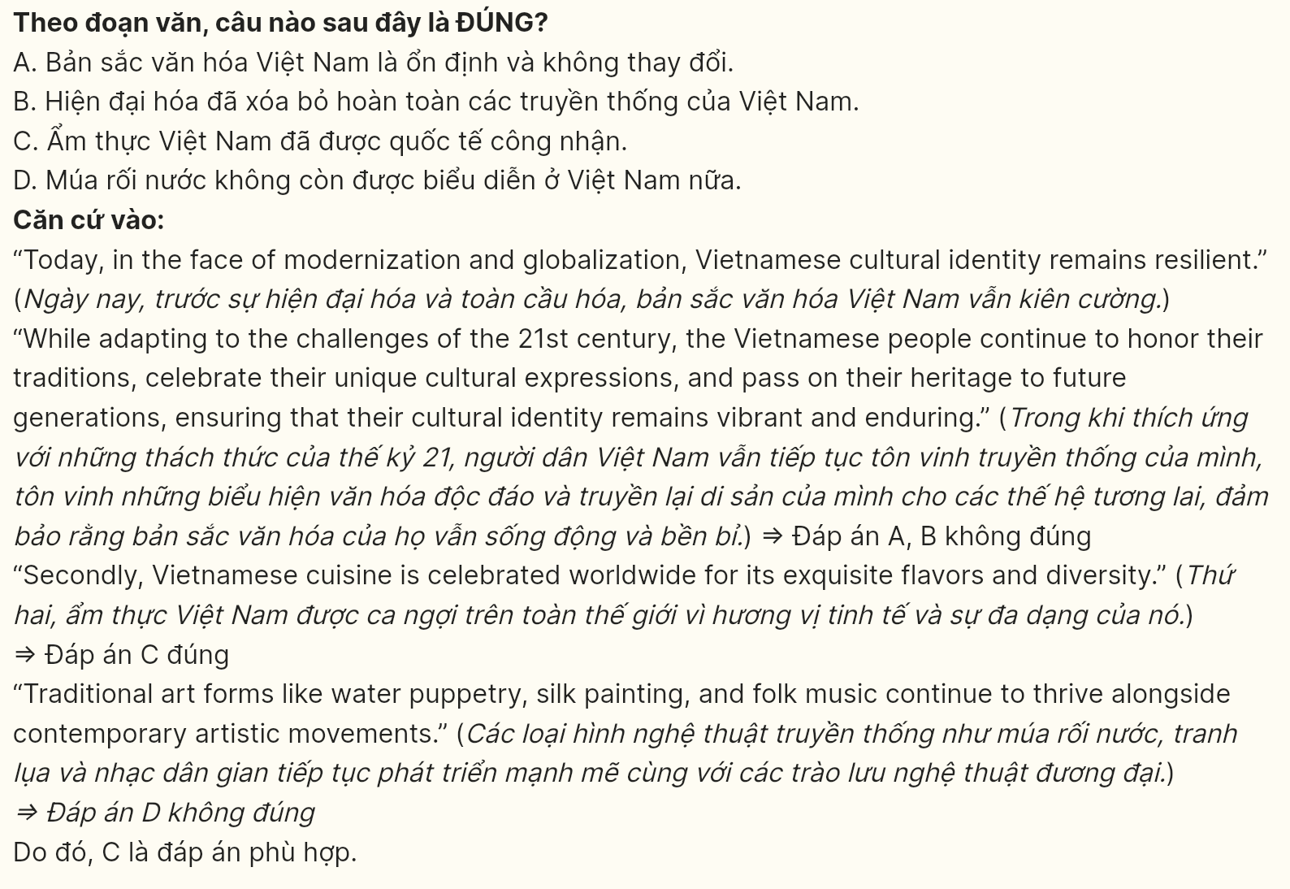

**Question 29 [696572]:** In which paragraph does the writer mention a **concession relationship?**  
A. Paragraph 1 B. Paragraph 2 C. Paragraph 3 D. Paragraph 4

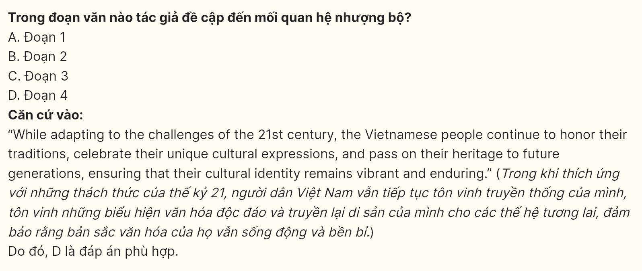

**Question 30 [696573]:** In which paragraph does the writer state that Vietnamese cultural identity is influenced by both internal and external factors?

A. Paragraph 1 B. Paragraph 2 C. Paragraph 3 D. Paragraph 4

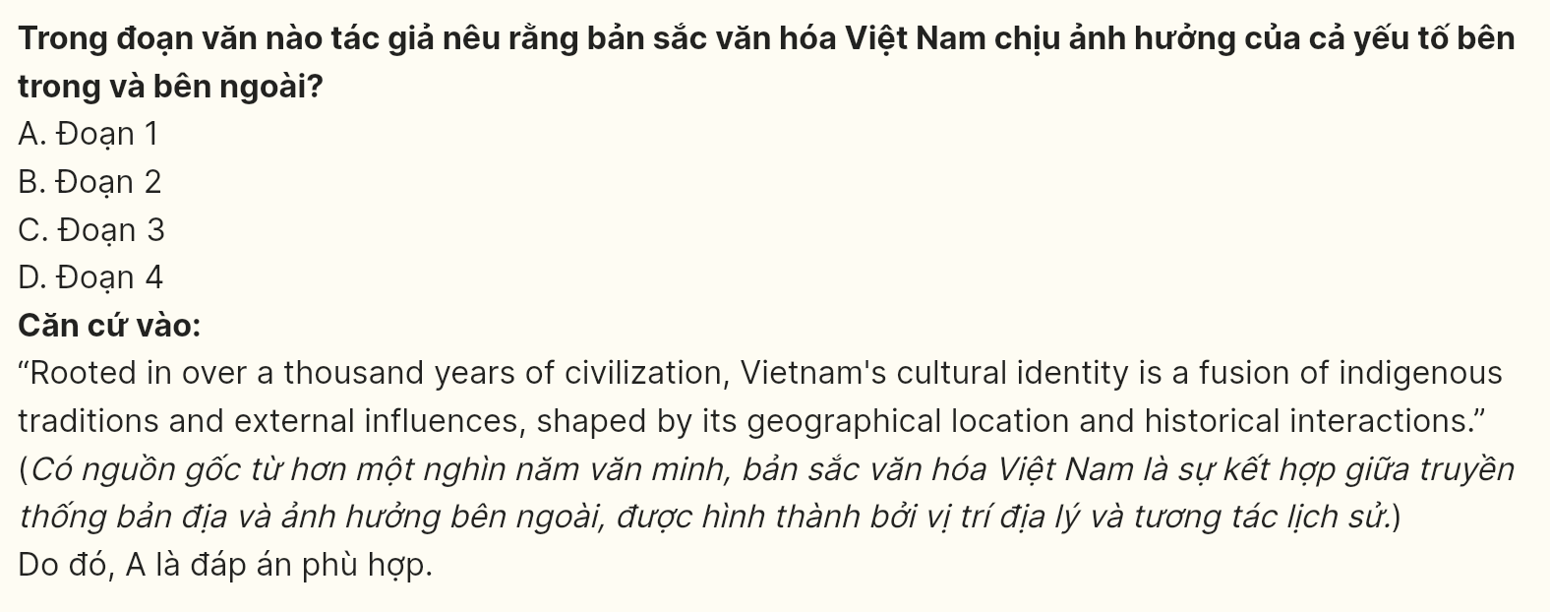

***Read the following passage about the urban shift and mark the letter A, B, C or D on your answer sheet to indicate the best answer to each of the following questions from 31 to 40.***

[I] Landslides are a significant environmental challenge in the northern mountainous provinces of Vietnam, particularly during the rainy season. The region, characterized by steep slopes and heavy rainfall, is **prone** to this natural disaster, which poses serious threats to both the local population and infrastructure. [II] In recent years, numerous landslides have occurred, often triggered by prolonged periods of heavy rain, resulting in devastating impacts on communities and livelihoods.

[III] The mountainous terrain, combined with deforestation and improper land use, exacerbates the risk of landslides. As farmers clear forests for agriculture, the natural vegetation that stabilizes the soil is lost, making slopes more **susceptible to** erosion. When heavy rains saturate the soil, **it** can quickly become unstable, leading to sudden and destructive landslides. [IV]

In response to this growing threat, local authorities and environmental organizations are taking proactive measures to mitigate the risks associated with landslides. Efforts include reforestation projects, improving drainage systems, and raising public awareness about safe practices during the rainy season. Additionally, advanced monitoring systems are being implemented to provide early warnings, allowing communities to evacuate before a disaster strikes.

**Despite these efforts, the challenges remain significant**, and ongoing education and support for sustainable land management practices are crucial for reducing the incidence and impact of landslides in northern Vietnam.

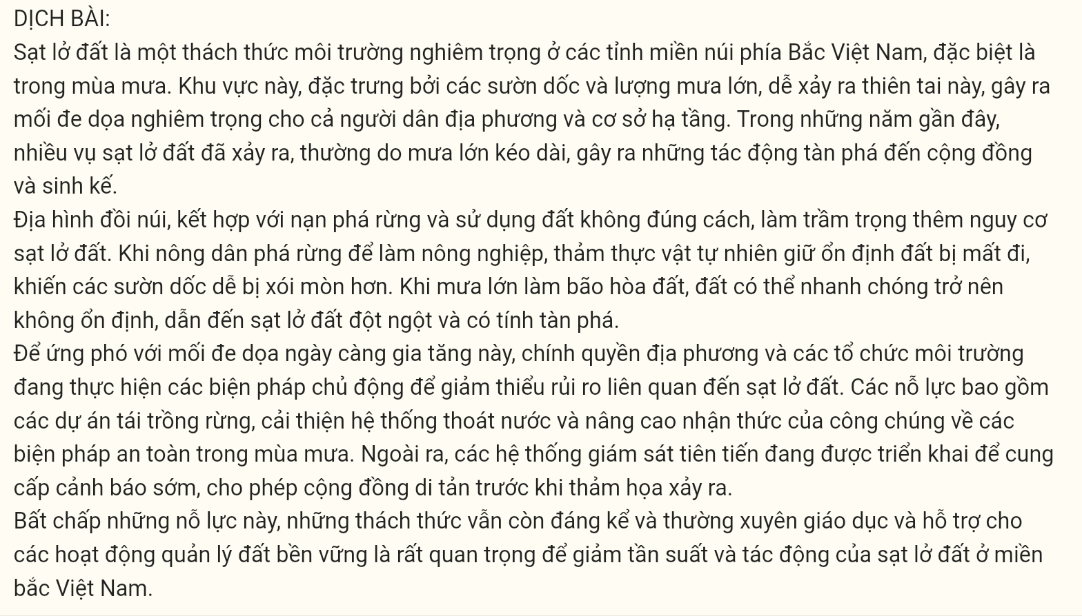

**Question 31 [696574]:** Where in this passage does the following sentence best fit?  
***These events not only destroy homes and roads but also disrupt essential services such as education and healthcare.***A. [I] B. [II] C. [III] D. [IV]

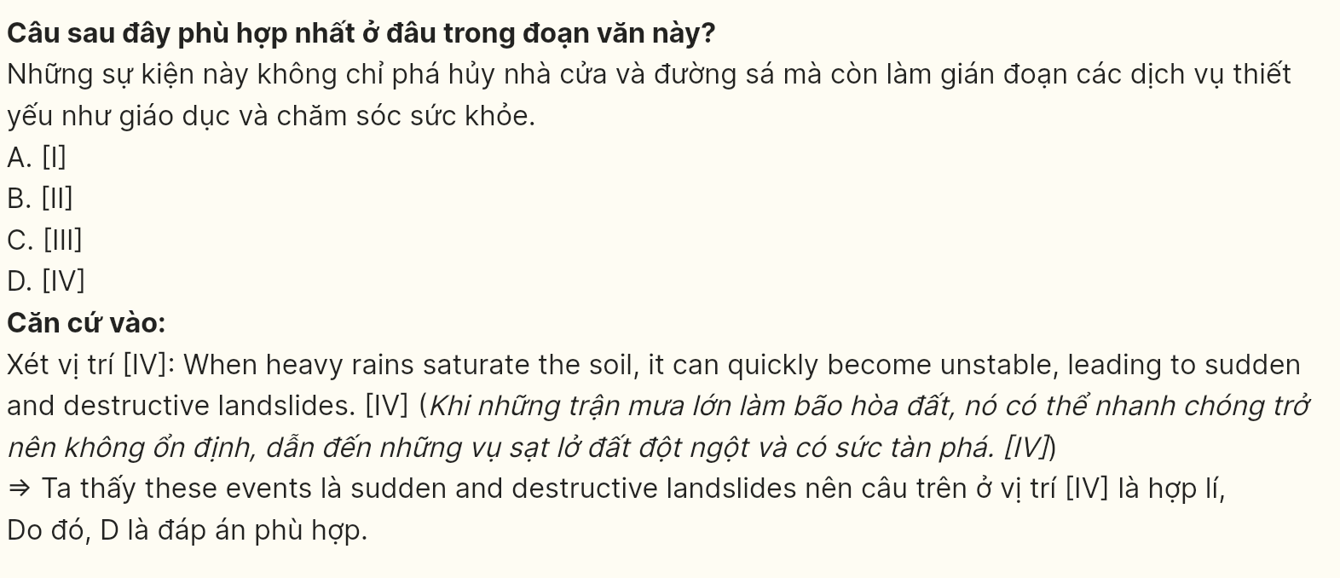

**Question 32 [696575]:** The word ***prone*** in paragraph 1 could be best replaced by ______.  
A. resistant B. vulnerable C. indifferent D. immune

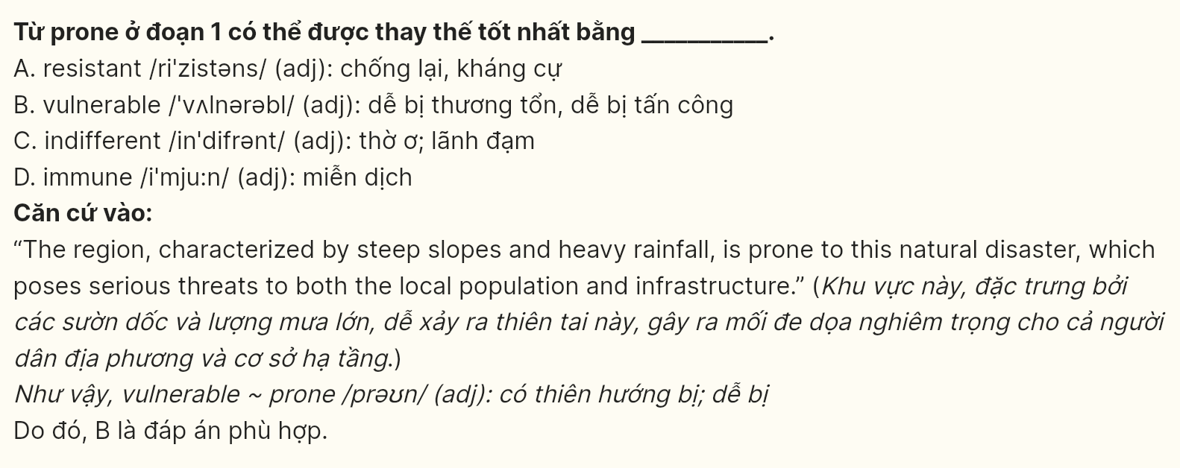

**Question 33 [696576]:** The word ***it*** in paragraph 2 refers to ______.  
A. the soil B. the rainy season C. the local population D. the infrastructure

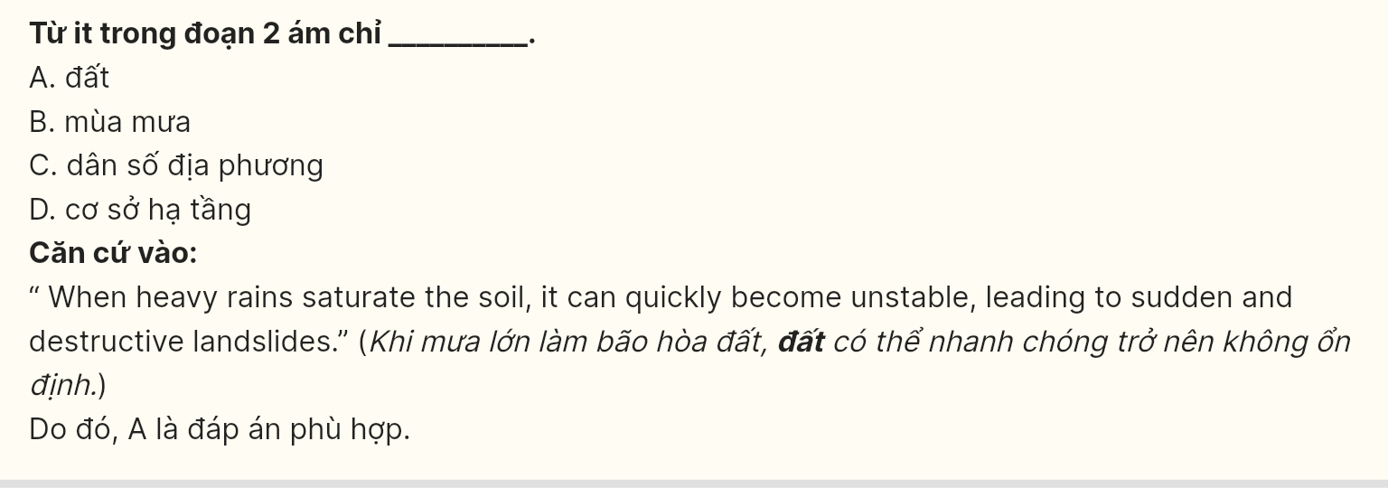

**Question 34 [696577]:** The phrase ***susceptible to*** in paragraph 3 is **OPPOSITE** in meaning to ______.  
A. open to B. immune to C. prone to D. favorable for

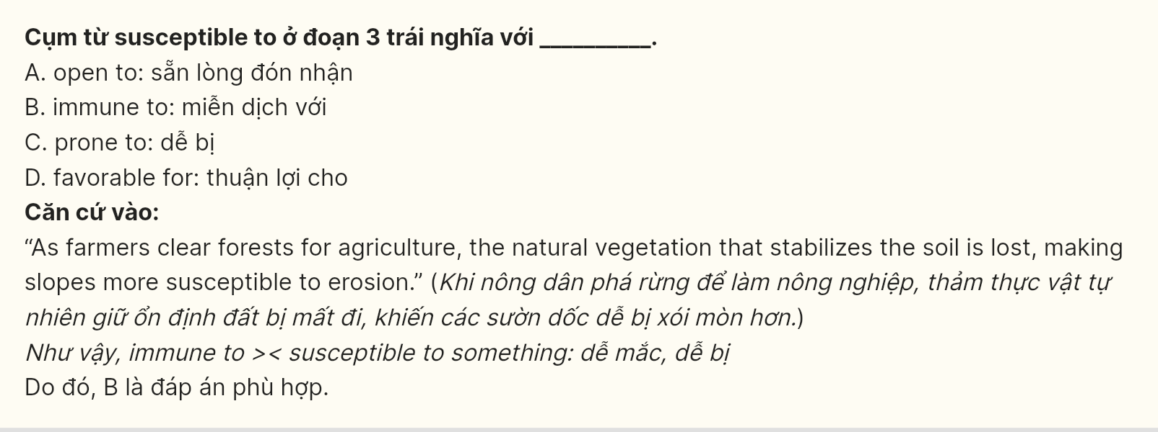

**Question 35 [696578]:** According to paragraph 3, which of the following is **NOT** a proactive measure to mitigate the risks associated with landslides?  
A. Reforestation projects B. Improving drainage systems  
C. Increasing logging activities D. Raising public awareness

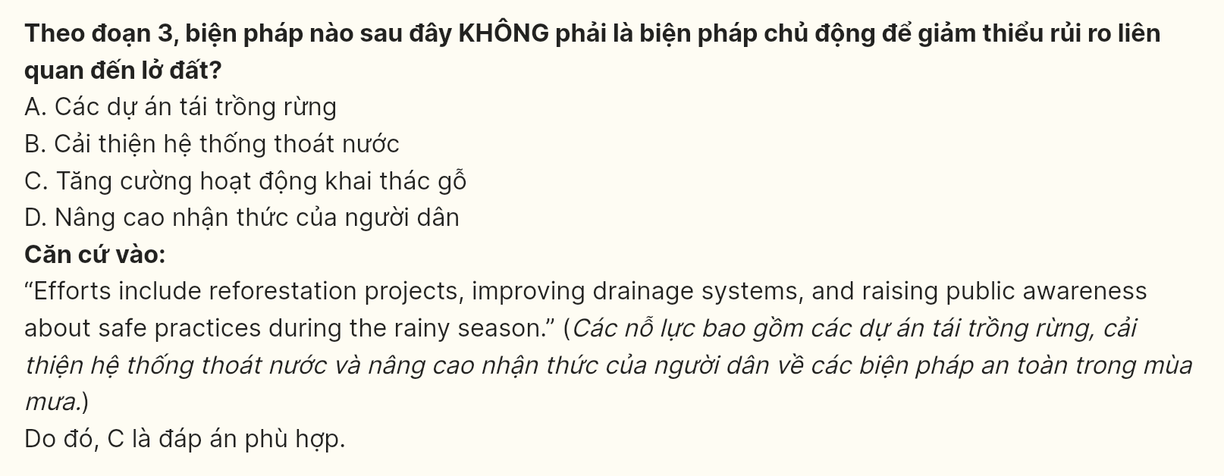

**Question 36 [696579]:** Which of the following best summarises paragraph 3?  
A. Local authorities and organizations are actively working to reduce the risks of landslides through various projects and public education initiatives.  
B. The government is focusing on implementing advanced technologies to predict landslides and ensure the safety of local communities.  
C. Reforestation and improved drainage systems are essential for enhancing the environment and preventing landslides in northern Vietnam.  
D. Communities are encouraged to participate in disaster preparedness training to minimize the impact of landslides during the rainy season.

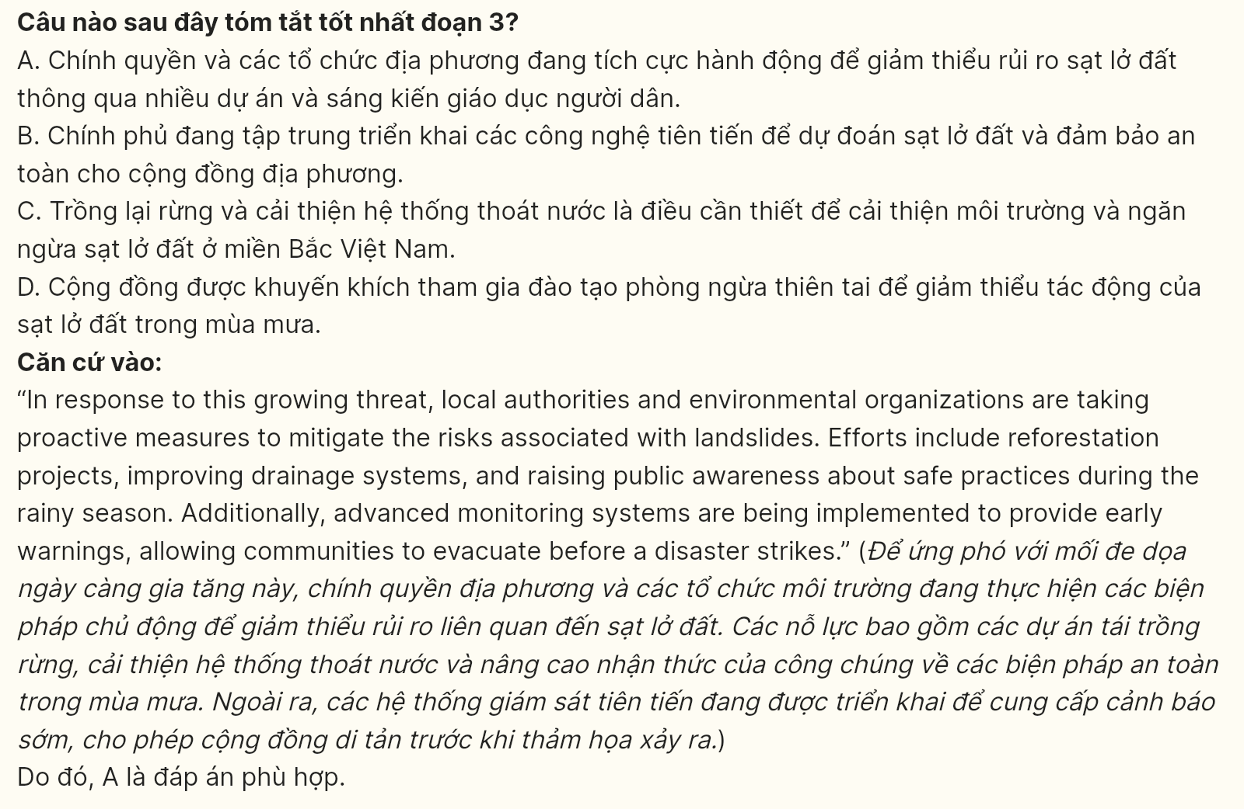

**Question 37 [696580]:** Which of the following is **TRUE** according to the passage?  
A. Landslides only occur in the rainy season.  
B. The local population is unaffected by landslides.  
C. Deforestation contributes to landslide risks.  
D. Monitoring systems are unnecessary for landslide management.

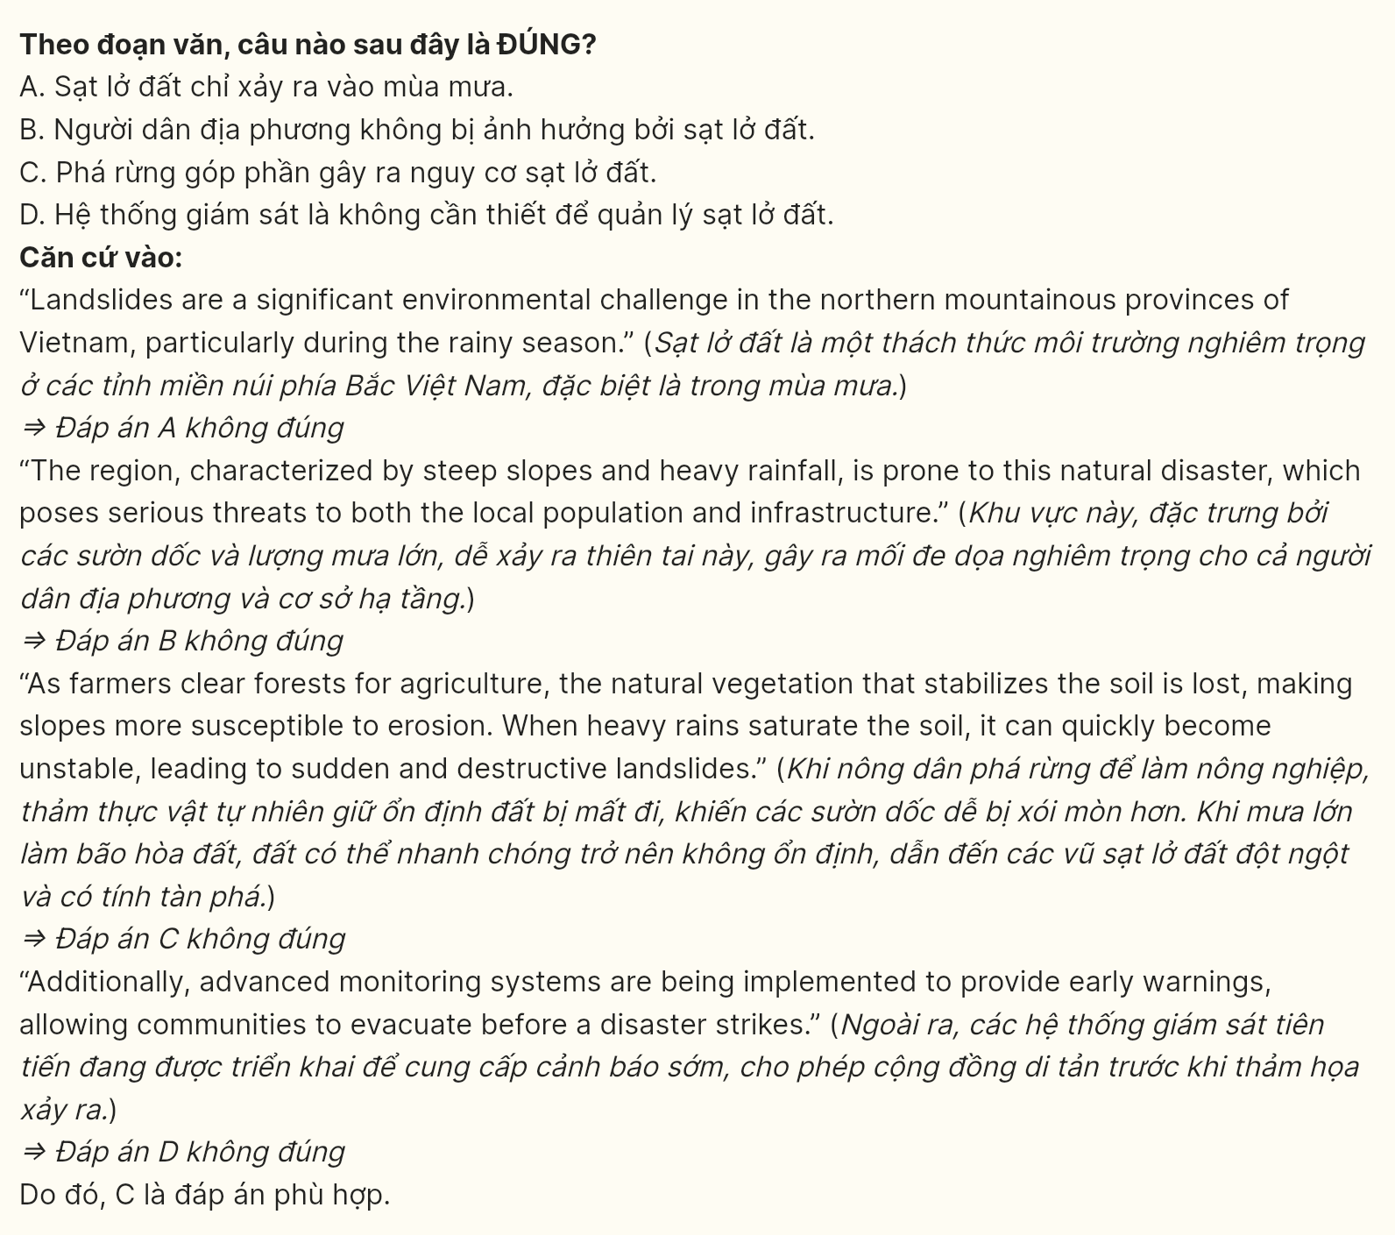

**Question 38 [696581]:** Which of the following best paraphrases the underlined part in paragraph 4?  
A. Even with these initiatives, the difficulties continue to be considerable.  
B. Although these measures have been taken, the challenges are still manageable.  
C. In spite of these actions, the effects still appear to be minor.  
D. Regardless of these efforts, the challenges are becoming less significant.

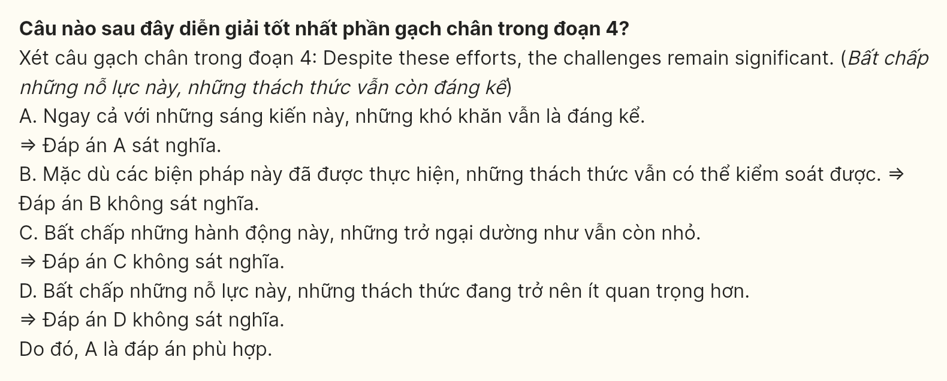

**Question 39 [696582]:** Which of the following can be inferred from the passage?  
A. Ongoing reforestation and improved land management practices are essential for minimizing future landslide risks in northern Vietnam.  
B. The frequency of landslides in northern Vietnam will likely decrease in the coming years due to effective government interventions.  
C. Local communities are fully aware of the risks of landslides and are actively participating in mitigation efforts.  
D. Climate change is the sole cause of the increasing landslide occurrences in the northern mountainous provinces of Vietnam.

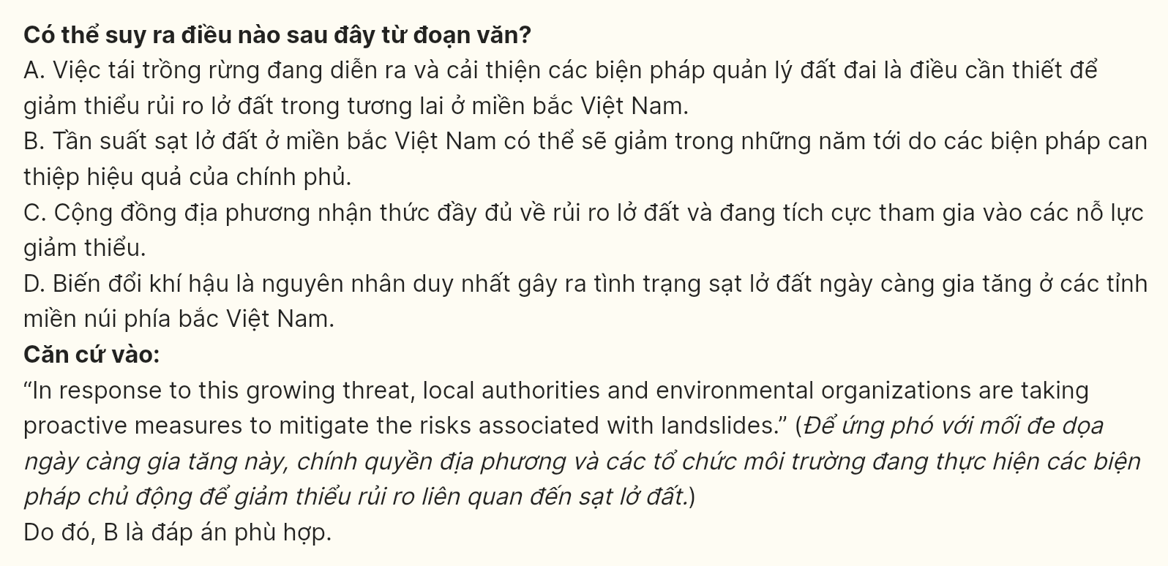

**Question 40 [696583]:** Which of the following best summarises the passage?  
A. Landslides are a minor issue in northern Vietnam.  
B. The effects of landslides are temporary and easily managed.  
C. Landslides pose a significant threat, but measures are being taken to reduce their impact.  
D. Local authorities have completely eliminated the risk of landslides.

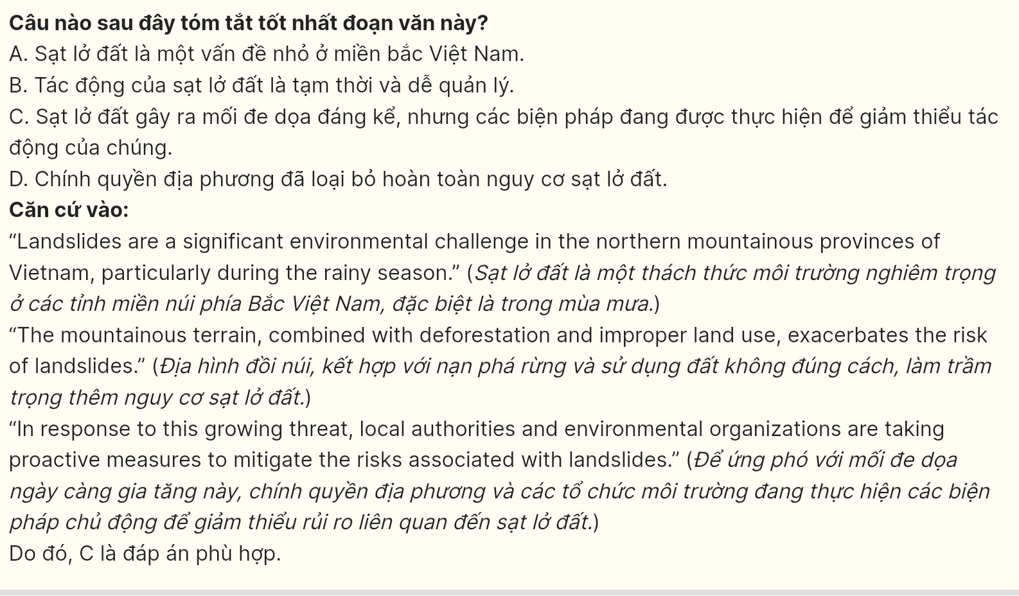

**----- THE END -----**