**TIẾNG ANH 8 – FRIENDS PLUS**

**UNIT 2 – TEST 2**

**I. PRONUNCIATION**

**Câu 1.** Which word has the underlined part pronounced differently from that of the others?

**A.** nose **B.** cover **C.** tone **D.** odor

**Đáp án đúng:** B

A. nose /nəʊz/

B. cover /ˈkʌvə(r)/

C. tone /təʊn/

D. odor /ˈəʊdə(r)/

**Câu 2.** Which word has the underlined part pronounced differently from that of the others?

**A.** archive **B.** touch **C.** orchard **D.** lunch

**Đáp án đúng:** B

A. archive /ˈɑːkaɪv/

B. touch /tʌtʃ/

C. orchard /ˈɔːtʃəd/

D. lunch /lʌntʃ/

**Câu 3.** Which word has a different stress pattern from that of the others?

**A.** fascinate **B.** wonderful **C.** delicious **D.** alpaca

**Đáp án đúng:** C

A. fascinate /ˈfæsɪneɪt/

B. wonderful /ˈwʌndəfl/

C. delicious /dɪˈlɪʃəs/

D. alpaca /ælˈpækə/

**Câu 4.** Which word has a different stress pattern from that of the others?

**A.** identify **B.** incredible **C.** artificial **D.** anosmia

**Đáp án đúng:** C

A. identify /aɪˈdentɪfaɪ/

B. incredible /ɪnˈkredəbl/

C. artificial /ˌɑːtɪˈfɪʃl/

D. anosmia /ænˈɒz.mi.ə/

**II. Choose the answer (A, B, C or D) that best fits the space in each question.**

**Câu 5.** The album reminds me ______ pleasant memories when I was at primary school.

**A.** of **B.** with **C.** for **D.** about

**Đáp án đúng:** A

**Câu 6.** In order to become a pilot, you must have ______-perfect sight.

**A.** close **B.** short **C.** kin **D.** near

**Đáp án đúng:** D

**Câu 7.** Yellow and purple are directly opposite on the colour wheel so they are ______.

**A.** complementary **B.** harmonious **C.** primary **D.** secondary

**Đáp án đúng:** A

**Câu 8.** Trang An Scenic Landscape Complex is certainly worth ______.

**A.** to visit **B.** visiting **C.** visit **D.** for a visit

**Đáp án đúng:** B

**Câu 9.** Sarah prefers the feel of a warm bed ______ a winter’s night.

**A.** on **B.** at **C.** in **D.** towards

**Đáp án đúng:** A

**Câu 10.** I haven’t signed up for the new bowling club yet because I have heard it is ______ boring.

**A.** a lot **B.** a few **C.** a bit **D.** a much

**Đáp án đúng:** C

**Câu 11.** Some people who are anosmic lose their senses of ______.

**A.** smell and touch **B.** smell and taste **C.** hearing and taste **D.** sight and hearing

**Đáp án đúng:** B

**Câu 12.** Robert: “Why not ______ riding a horse, Dan?” - “Well, I ______ it on my last trip to Da Lat.”

**A.** try – have ridden **B.** trying - ride **C.** try - rode **D.** trying – are riding

**Đáp án đúng:** C

**Câu 13.** Have you found a place to live ______, Peter?

**A.** already **B.** recently **C.** then **D.** yet

**Đáp án đúng:** D

**Câu 14.** Mike: “Let’s go fishing next weekend!” - Clover: “______”

**A.** I think you will enjoy it. **B.** I sometimes go to the mall on my own.

**C.** It is very kind of you to say so. **D.** It doesn’t sound much fun to me.

**Đáp án đúng:** D

**III. Look at each sign or notice. Choose the best answer (A, B, C or D) that matches its meaning.**

**Câu 15.** What does the sign say?

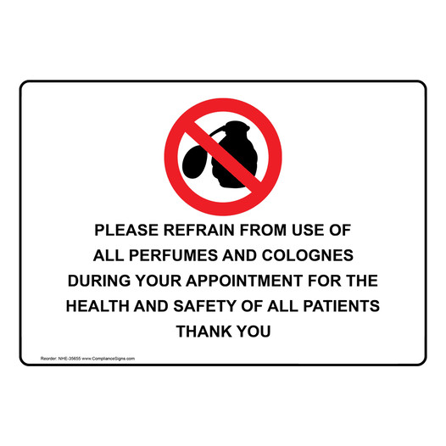

**A.** Fragrances can be used within four metres of an entrance to any hospital.

**B.** The government wants to create a smoke-free area in hospitals.

**C.** Perfumes are banned for the health and safety of participants.

**D.** Artificial scents mustn’t be added to healthcare products.

**Đáp án đúng:** C

**Câu 16.** What does the notice say?

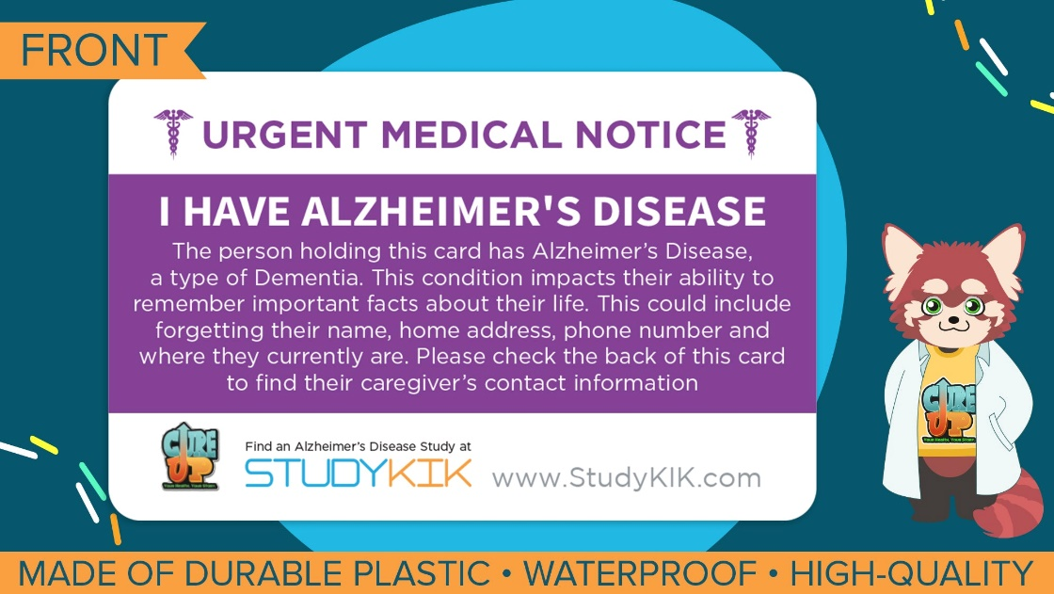

**A.** You should remember your name, address and phone number.

**B.** You can use this card to enter a fitness center.

**C.** You can borrow books on Alzheimer’s to know about important facts.

**D.** You can help this Alzheimer’s patient by contacting his caregiver.

**Đáp án đúng:** D

**IV. Read the following and do as directed.**

Although there is convincing evidence that pleasant fragrances can improve our mood and sense of well-being, some of these findings should be viewed with caution. Recent studies have shown that our expectations about an odour, rather than any direct effects of exposure to it, may sometimes be responsible for the mood and health benefits reported. In one experiment, researchers found that just telling subjects that a pleasant or unpleasant odour was being administered, which they might not be able to smell, altered their self-reports of mood and well-being. The mere mention of a positive odour reduced reports of symptoms related to poor health and increased reports of positive mood!

More reliable results have been obtained, however, from experiments using placebos (odourless sprays). Although the subjects do respond to some extent to odourless placebos which they think are fragrances, the effect of the real thing is significantly greater. The thought of pleasant fragrances can be enough to make us a bit more cheerful, but the actual smell can have dramatic effects in improving our mood and sense of well-being.

The positive emotional effects of pleasant scents also affect our perceptions of other people. Those who are exposed to pleasant fragrances tend to give higher “attractiveness ratings” to people in photographs, although these effects are only significant where there is some ambiguity in the pictures. If a person is clearly outstandingly beautiful, or extremely ugly, fragrance does not affect our judgement. But if the person is just ‘average’, a pleasant fragrance will tip the balance of our evaluation in his or her favour. So, the beautiful models used to advertise perfume probably have no need of it, but the rest of us ordinary mortals might well benefit from a spray or two of something pleasant. Beauty is in the “nose” of the beholder.

**True/False Questions:**

**Câu 17.** Those who were told about the odour in advance did not give correct reports on their feelings.

**A.** True **B.** False

**Đáp án đúng:** A

**Câu 18.** Real scents slightly improve our mood and sense of well-being.

**A.** True **B.** False

**Đáp án đúng:** B

**Câu 19.** Sweet smell has a significant effect on attractiveness ratings in all cases.

**A.** True **B.** False

**Đáp án đúng:** B

**Câu 20.** Sweet-scented sprays may be beneficial to ordinary people.

**A.** True **B.** False

**Đáp án đúng:** A

**Choose the correct answer to each question:**

**Câu 21.** What is NOT affected by pleasant fragrances?

**A.** mood **B.** well-being **C.** poverty **D.** perception

**Đáp án đúng:** C

**Câu 22.** What can be concluded from the passage?

**A.** Some discoveries of smell are subjective because of the participant bias.

**B.** The more people are exposed to pleasant scents, the healthier they are.

**C.** Pleasant fragrances help get rid of negative feelings.

**D.** Being sweet-scented gives us more chances to become a professional model.

**Đáp án đúng:** A

**V. Choose the word (A, B, C or D) that best fits each blank space in the following passage.**

Hearing is a mechanical sense which turns physical movement into the electrical signals that make (23) _____ the language of the brain, translating these vibrations into what we experience as the world of sound. Language highlights the vital importance of hearing in brain development. There is (24) ______ evidence that infants who hear more words from their parents learn to read (25) ______ and do better in school than their peers.

Another form of hearing perception is music. Humans are often (26) ______ affected as melody, harmony and rhythm engage widespread brain areas. When the brain is stimulated by melodic tunes, a variety of memory regions seem to be activated. Recent studies have (27) ______ the positive effects of music on people with brain disorders. Specifically, in the final stage of Alzheimer’s, a person suffering from severe memory (28) ______ may be able to tap a beat or sing lyrics to a song from childhood.

**Câu 23.** Choose the correct answer.

**A.** up **B.** for **C.** with **D.** from

**Đáp án đúng:** A

**Câu 24.** Choose the correct answer.

**A.** bright **B.** good **C.** light **D.** small

**Đáp án đúng:** B

**Câu 25.** Choose the correct answer.

**A.** slower **B.** earlier **C.** later **D.** higher

**Đáp án đúng:** B

**Câu 26.** Choose the correct answer.

**A.** richly **B.** likely **C.** deeply **D.** slightly

**Đáp án đúng:** C

**Câu 27.** Choose the correct answer.

**A.** opposed **B.** reminded **C.** created **D.** confirmed

**Đáp án đúng:** D

**Câu 28.** Choose the correct answer.

**A.** lose **B.** lost **C.** loose **D.** loss

**Đáp án đúng:** D

**VI. Supply the correct form of the word given in each sentence.**

**Câu 29.** Keep in mind that whole bean coffees will be fresher and more ______ for a longer period of time. **(FLAVOUR)**

**Đáp án đúng:** flavorful / flavourful

**Câu 30.** ______ markets in Viet Nam are where you can purchase the freshest produce as well as other intricate handmade products. **(FLOAT)**

**Đáp án đúng:** Floating

**Câu 31.** The world was ______ by the events of September 11th happened in New York. **(HORRIBLE)**

**Đáp án đúng:** horrified

**Câu 32.** The Mood and Feelings ______ is a written list of questions that measures depressive symptoms in children and young adults. **(QUESTION)**

**Đáp án đúng**: Questionnaire

**Câu 33.** It's one of those films in which even the smaller roles are as beautifully and as ______ done as the larger ones. **(MEMORY)**

**Đáp án đúng**: memorably

**Câu 34.** You can ______ perfume notes based on the time passed after the application of the perfume. **(IDENTIFICATION)**

**Đáp án đúng**: identify

**VII. Rearrange the groups of words in a correct order to make complete sentences.**

**Câu 35.** I have visited / and tried / As a water-slide tester, / a lot of cities / a lot of great water slides.

**Đáp án đúng:** As a water-slide tester, I have visited a lot of cities and tried a lot of great water slides.

**Câu 36.** eaten? / the two most disgusting / What are / you’ve ever / things that

**Đáp án đúng:** What are the two most disgusting things that you’ve ever eaten?

**VIII. Rewrite each of the following sentences in another way so that it means almost the same as the sentence printed before it.**

**Câu 37.** Mandy expects to win the singing contest. **(TO)**

🡪Mandy is

**Đáp án đúng:** Mandy is looking forward to winning the singing contest.

**Câu 38.** It’s 2 years since I last visited this church. **(FOR)**

🡪I

**Đáp án đúng:** I haven’t visited this church for 2 years.

**Câu 39.** He has known Betty for a long time. **(AGO)**

🡪 He

**Đáp án đúng:** He knew Betty a long time ago.

**Câu 40.** What has been done by Tom this weekend? ***(Change into active voice)***

🡪 What

**Đáp án đúng:** What has Tom done this weekend?

**------ HẾT ------**