ĐỀ VIP 9+ - ĐỀ SỐ 5
Read the following leaflet and mark the letter A, B, C, or D to indicate the correct option that best fits each of the numbered blanks from 1 to 6.

Stay Safe on Social Media!
Follow these tips to protect yourself online and enjoy social media safely

Facts and figures:
Over 70% of teens use social media daily, but many face risks like cyberbullying and privacy breaches. Meanwhile, about 59% of teens share personal information online, increasing their (1) to online threats.

Positive action!
- Keep personal information private. Avoid (2) your address, school name, or phone number. (3)
posting personal details, only share them selectively with trusted people.
- Think before you post. Photos and messages can be saved and shared, even if you delete them. Always consider the impact before posting anything online.
- Adjust your privacy settings. (4) social media platforms allow you to control who can view your posts and profile. Limiting the (5) of people who see your content helps keep it safe.
- Report and block (6) users. Don’t engage with anyone who makes you uncomfortable online, and tell an adult if necessary.
By following these steps, you can stay safe and make the most of your online experience!
Question 1. | A. interference | B. vulnerability | C. interaction | D. analysis
Question 2. | A. sharing | B. to sharing | C. to share | D. share
Question 3. | A. Regardless of | B. Except for | C. In place of | D. In contrast to
Question 4. | A. Each | B. Another | C. Others | D. Most
Question 5. | A. degree | B. number | C. amount | D. volume
Question 6. | A. credible | B. accessible | C. suspicious | D. instant
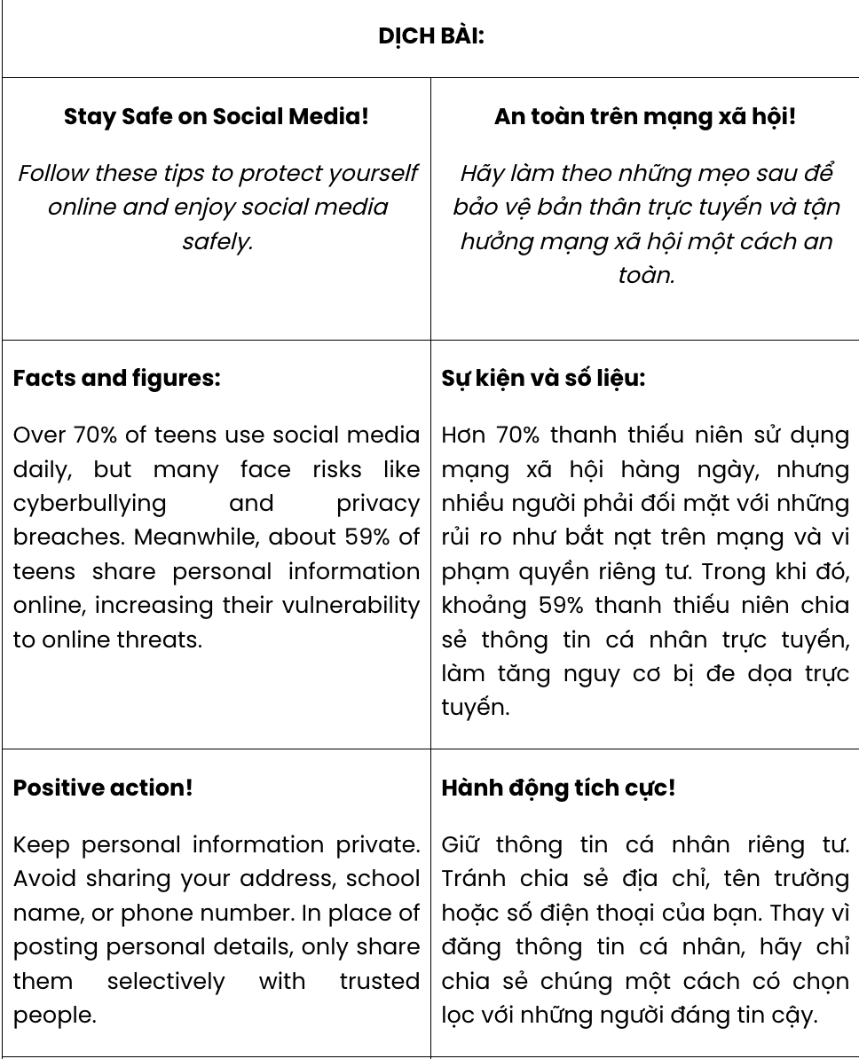
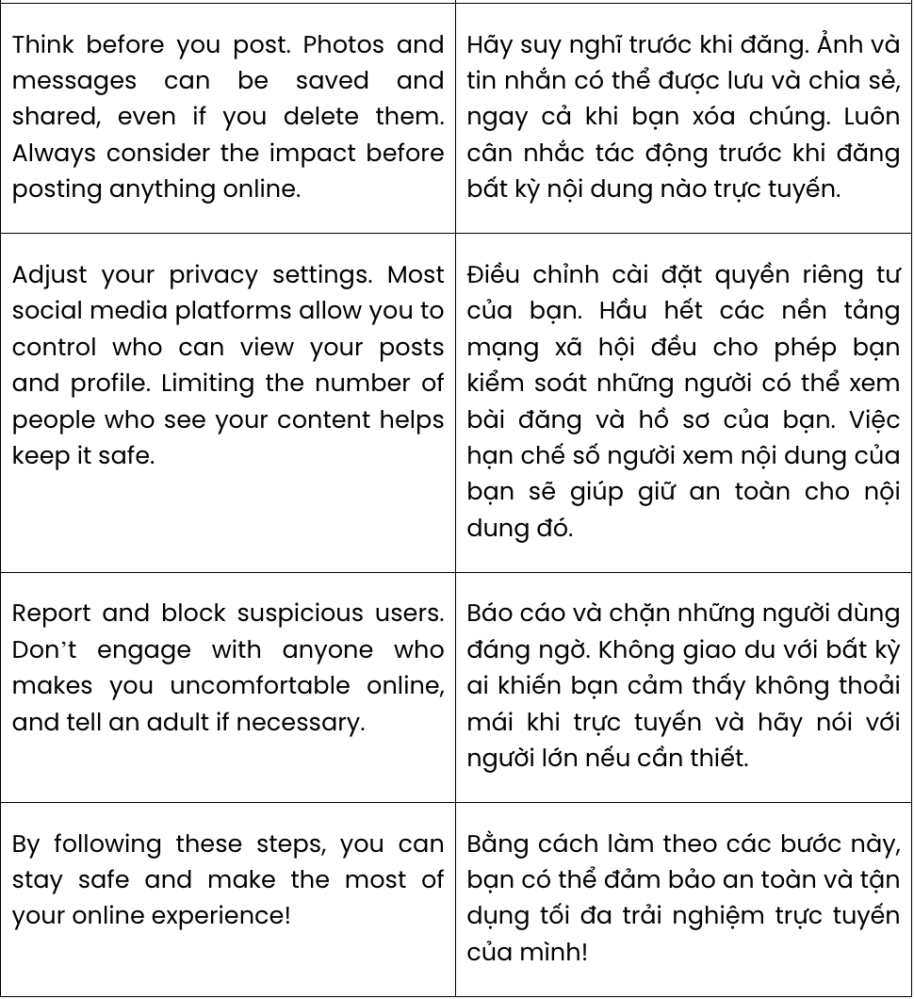
GIẢI CÂU 1:
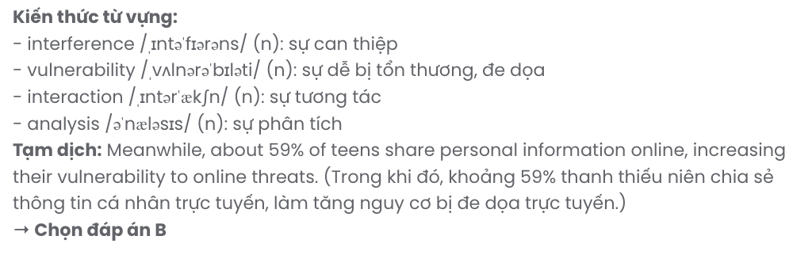
GIẢI CÂU 2:
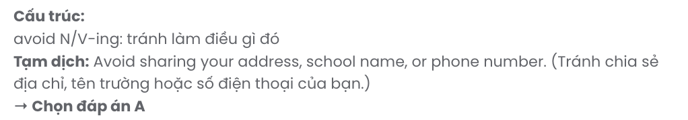
GIẢI CÂU 3:
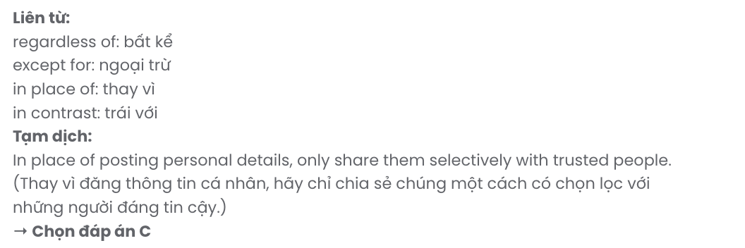
GIẢI CÂU 4:
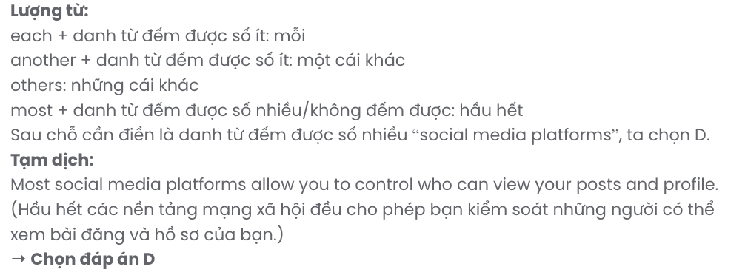
GIẢI CÂU 5:
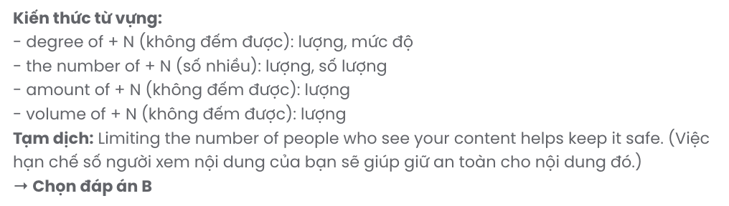
GIẢI CÂU 6:
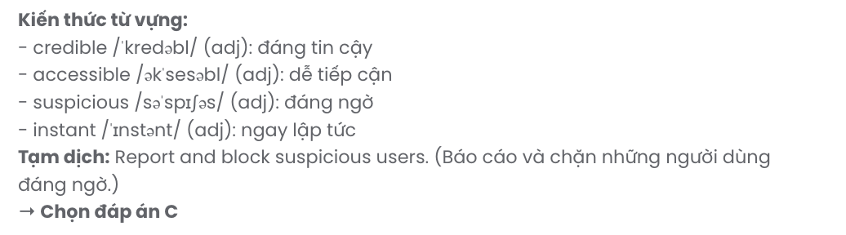
Read the following advertisement and mark the letter A, B, C, or D to indicate the correct option that best fits each of the numbered blanks from 7 to 12.

Discover New Cultures with Cultural Connect
Are you curious about who you'll meet and the (7) stories they'll share about their customs and traditions? If you’re considering joining a (8) , Cultural Connect is here to make it an unforgettable journey!
With our new Global Match system, (9) to help you choose your exchange partner, you can now make meaningful connections! After signing up, you’ll have the chance to share your profile with other participants worldwide. (10) a look at their profiles to find the perfect match for your interests.

What You Can Expect:
- Expand your knowledge by connecting with people passionate (11) art, history, and education.
- Make new friends who love sharing stories about travel, food, and everyday life.
Take this chance to (12) a journey of learning, sharing, and cultural discovery. Sign up today and start building unforgettable connections!
Question 7. | A. excited | B. excitement | C. excitingly | D. exciting
Question 8. | A. cultural exchange programme |  | B. cultural programme exchange
 | C. programme cultural exchange |  | D. exchange cultural programme
Question 9. | A. which created | B. created | C. creating | D. was created
Question 10. | A. Put | B. Make | C. Take | D. Raise
Question 11. | A. with | B. for | C. at | D. about
Question 12. | A. take up | B. put off | C. get on | D. go up
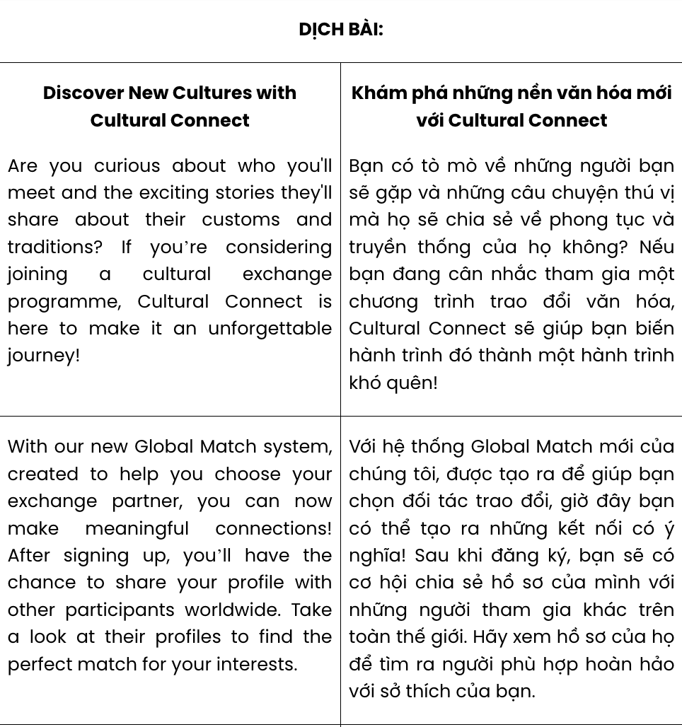
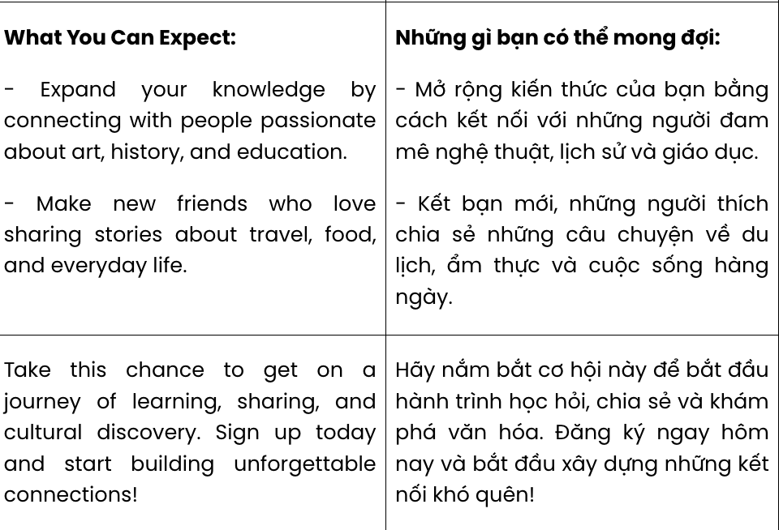
GIẢI CÂU 7:
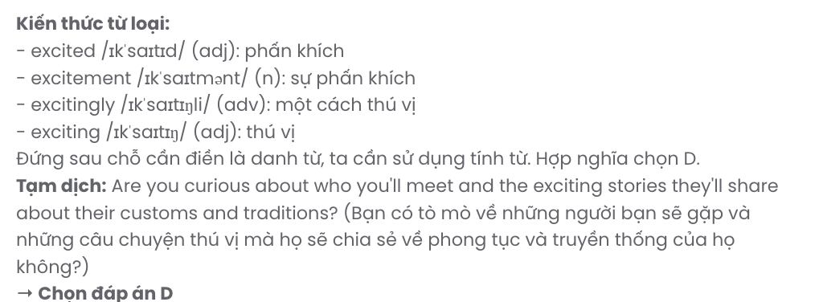
GIẢI CÂU 8:
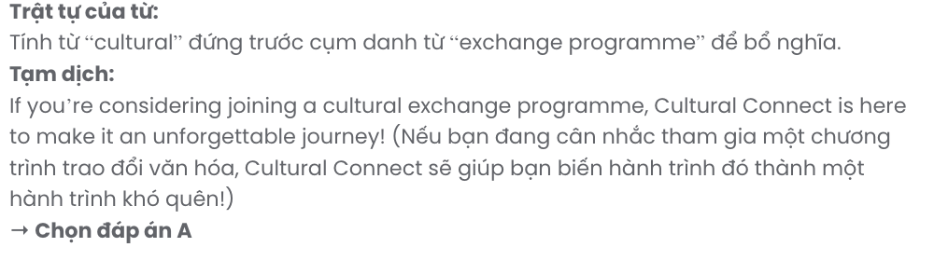
GIẢI CÂU 9: 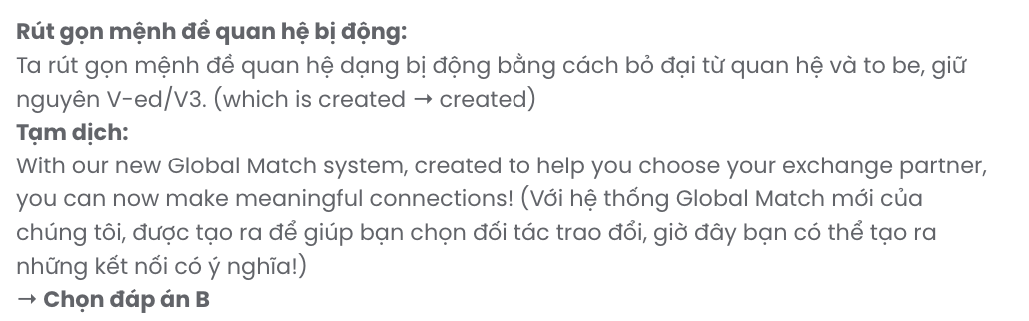
GIẢI CÂU 10:
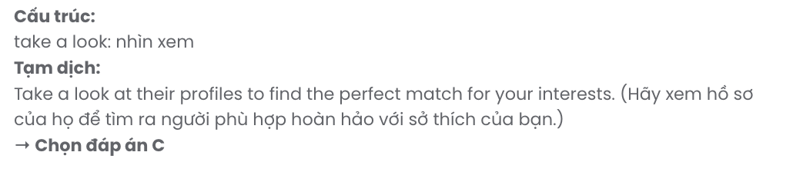
GIẢI CÂU 11:
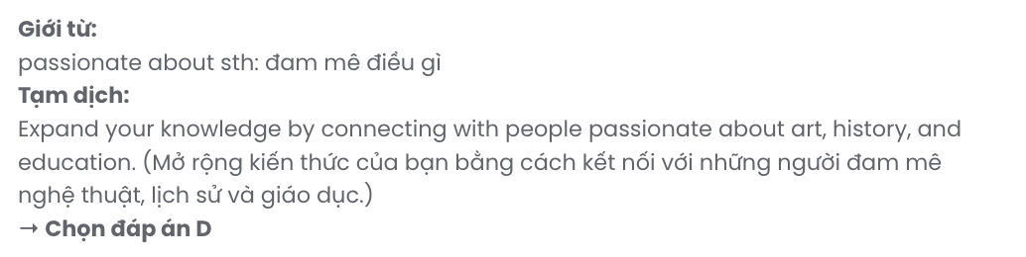
GIẢI CÂU 12:
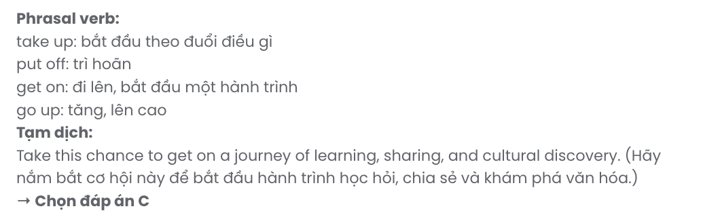
Mark the letter A, B, C or D on your answer sheet to indicate the best arrangement of utterances or sentences to make a meaningful exchange or text in each of the following questions from 13 to 17.

Question 13.
- Grandma: Mark, can you help me increase the font size of this text on my laptop? It's too small for me to read.
- Grandma: It works! Everything's so easy to read now. Thanks, dear.
- Mark: Let me show you ... You need to press these two keys together... See? It's easy, isn't it?
A. a – b – c B. a – c – b C. c – b – a D. b – c – a
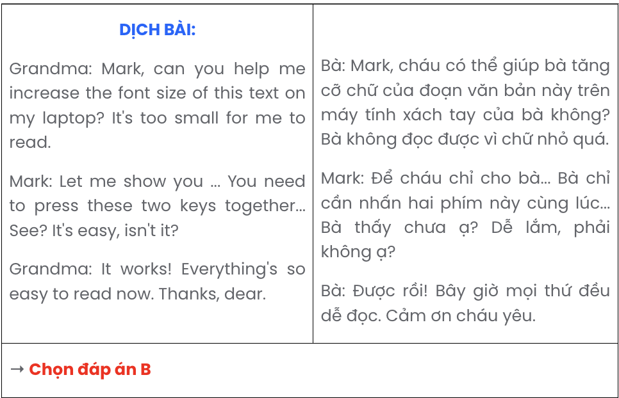

Question 14.
- Jane: I’m planning to volunteer with a wildlife organisation.
- Max: How are you going to help protect wildlife?
- Max: Why do you want to volunteer?
- Jane: It offers flexible schedules, and I’ll be able to learn about conservation efforts.
- Max: I think it’s too time-consuming. I don’t think I’ll volunteer.
A. b – a – c – d – e B. c – d – e – a – b C. c – a – e – d – b D. b – d – e – c – a
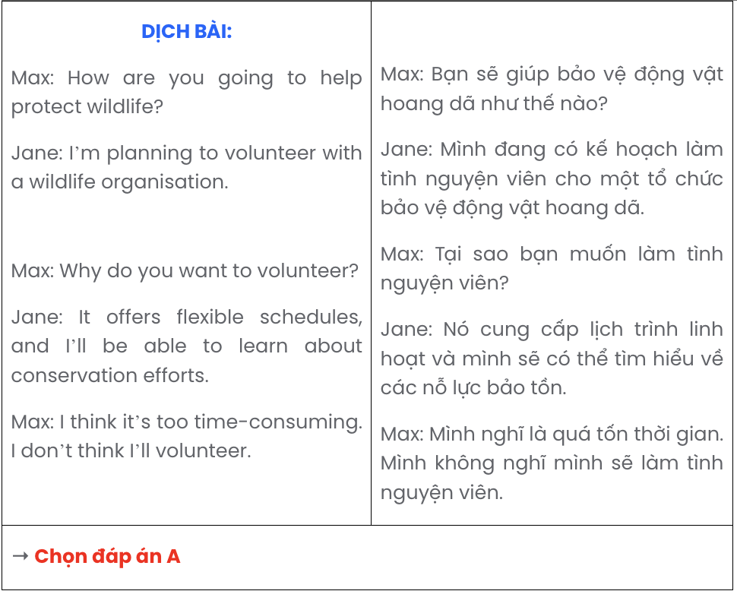

Question 15.
Hi Leo,
- But the idea of a fully automated home is quite exciting to think about.
- Thanks so much for the videos on smart cities you shared last week.
- You know, we should check out one of these cities together sometime. What do you think?
- Thanks also for recommending the virtual tours of smart cities - they’re far better than the ones I’ve seen before.
- It’s amazing to see how technology can improve urban life, but I’m not sure I’m ready to live in a place like that just yet.
Talk soon.
Sam
A. d – e – b – a – c B. e – a – d – b – c C. c – e – a – b – d D. b – e – a – d – c

Question 16.
- This adaptation to Japan’s way of life became easier over time, and I found joy in exploring traditional tea houses, historic temples, and cherry blossom parks.
- Arriving in Japan was exhilarating, but navigating Tokyo’s busy train stations for the first time was overwhelming as I tried to make sense of the signs and schedules.
- In the end, my first experience in Japan was deeply rewarding, teaching me resilience and a genuine appreciation for stepping out of my comfort zone.
- Since it was my first time visiting Japan, the culture, language, and even daily routines felt completely unfamiliar and incredibly fascinating.
- Embracing these challenges, I focused on learning the basics, like mastering simple phrases and understanding Japanese customs to feel more connected.
A. b – a – d – e – c B. a – b – e – d – c C. d – b – e – a – c D. e – b – a – d – c

Question 17.
- Once known for its small class sizes and close-knit community, Redmond University has expanded with new buildings dedicated to science, technology, and student services.
- This expansion has attracted more students and faculty from around the world, making the campus more culturally diverse and academically vibrant.
- This increased diversity has led to a greater demand for multicultural events and language support services, enriching the student experience.
- To meet these needs, the university has established a new cultural centre and additional language programmes, creating a welcoming environment for all students.
- Sunflower University has undergone a remarkable transformation over the past decade.
A. e – b – c – a – d B. e – d – a – b – c C. e – c – d – a – b D. e – a – b – c – d
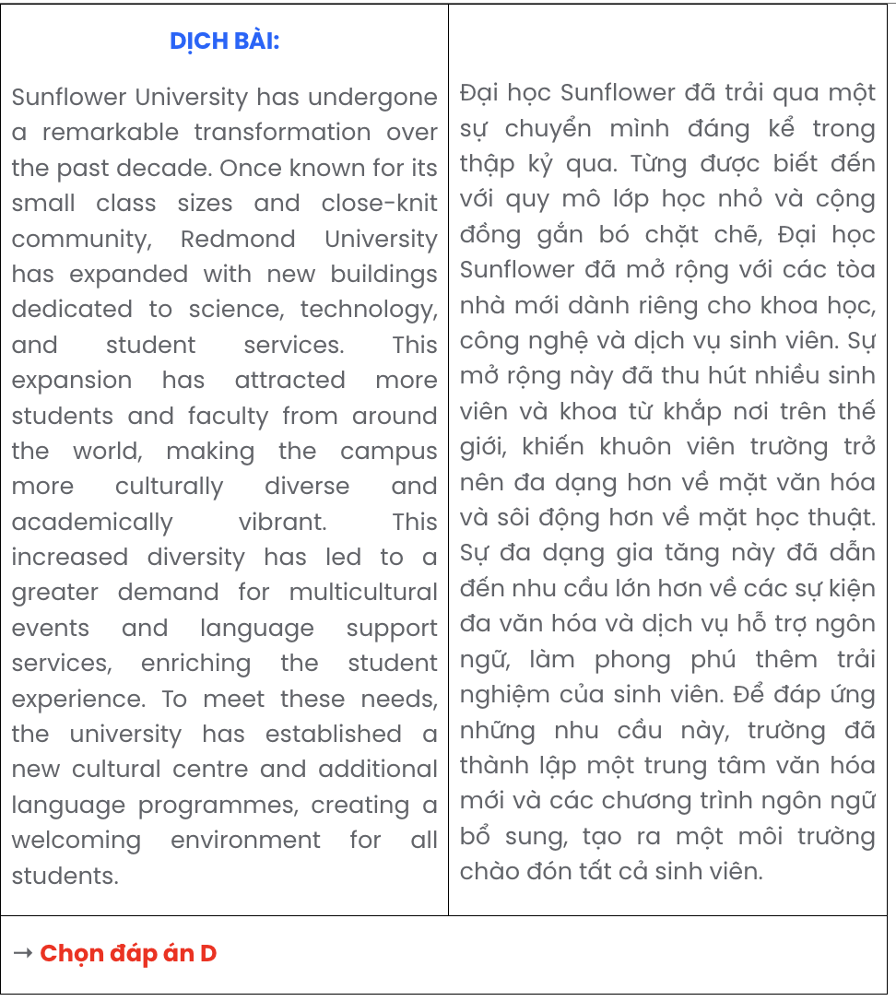
Read the following passage about endangered species and mark the letter A, B, C, or D to indicate the correct option that best fits each of the numbered blanks from 18 to 22.
Endangered species, long subjects of conservation efforts and environmental campaigns, face an uncertain future. The giant panda, for example, (18) . Decades of conservation work in China have led to a rise in their numbers, and in 2016, the species’ status was reclassified from "endangered" to "vulnerable." Other species, however, remain critically threatened. In recent years, the Sumatran tiger has drawn global attention, with fewer than 400 individuals estimated to remain in the wild. To address this crisis, countries like Indonesia have established protected areas and anti-poaching units.
The Sumatran tiger population is monitored by international wildlife organisations (19) .
These organisations work to sustain biodiversity and prevent extinction. (20) .
The tiger's natural habitat includes dense forests and wetlands that support a complex ecosystem. (21)
. However, illegal logging and land conversion continue to endanger their environment, and these pressures require ongoing conservation efforts.
Efforts to save endangered species have shown promising results. Having raised awareness and mobilised resources, (22) .

Question 18.
A. having been declared endangered due to habitat loss and poaching
B. which became totally extinct due to habitat loss and poaching
C. that was in danger of extinction due to habitat loss and poaching
D. was once listed as endangered due to habitat loss and poaching

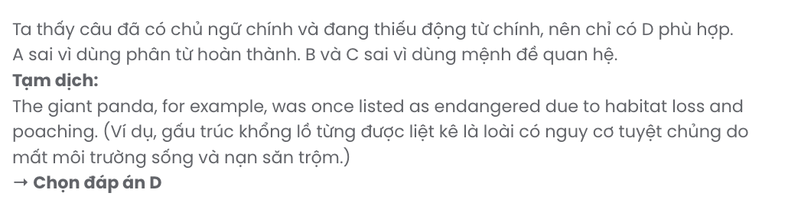

Question 19.
A. tried to bring it back to life thanks to tracking, research, and habitat restoration efforts
B. of which important efforts in tracking, research, and habitat restoration for survival
C. whose efforts in tracking, research, and habitat restoration are crucial for survival
D. managed to bring it back to life by efforts in tracking, research, and habitat restoration
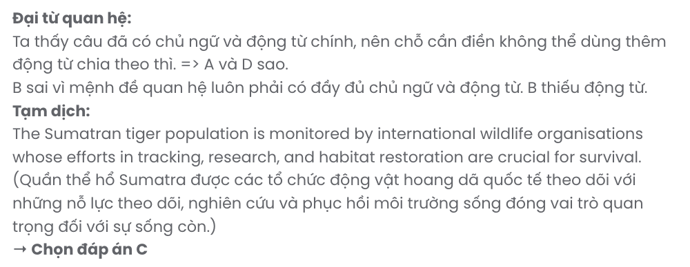

Question 20.
A. Adapting to changing environments and threats, species assist in their establishment
B. They aim to assist species in adapting to changing environments and threats
C. The assistance in changing environment and threats adapts their aim to species
D. Adapting to changing environment and threats assists species with their aim
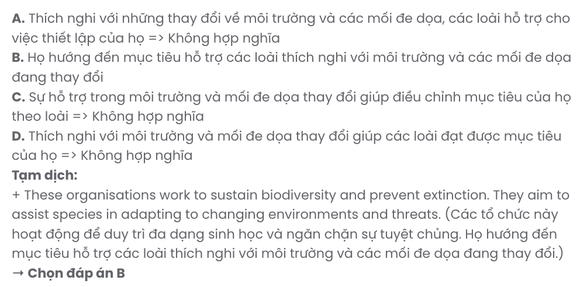

Question 21.
A. Relying on sharp vision and a powerful sense of smell, the tiger struggles for survival
B. Sharp vision and a powerful sense of smell are reliant skills for the tiger to survive
C. The tiger uses skills for survival, relying on sharp vision and a powerful sense of smell
D. With sharp vision and a powerful sense of smell, the tiger relies on these skills for survival
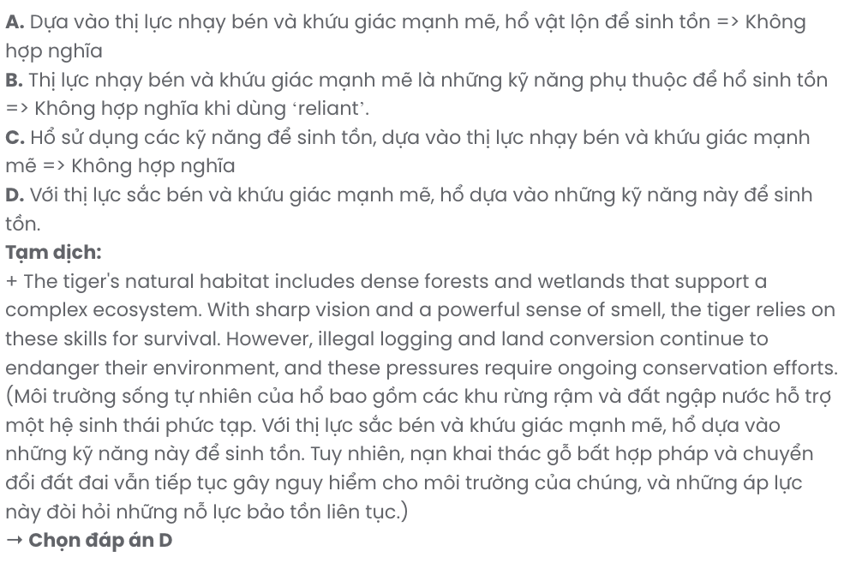

Question 22.
A. conservationists hope to ensure a sustainable future for endangered species
B. ensuring a sustainable future for endangered species is conservationists’ hope
C. a hope for a sustainable future for endangered species reassures conservationists
D. it brings a hope for conservationists about a sustainable future for endangered species
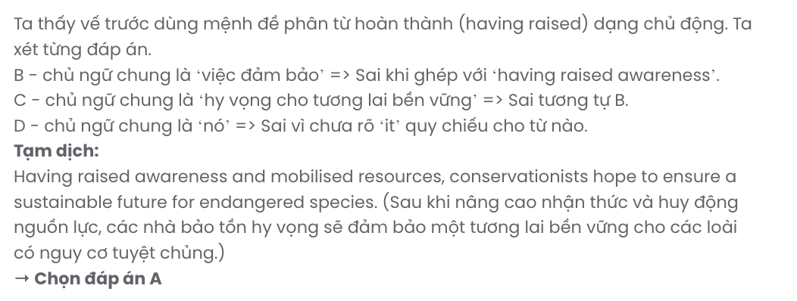
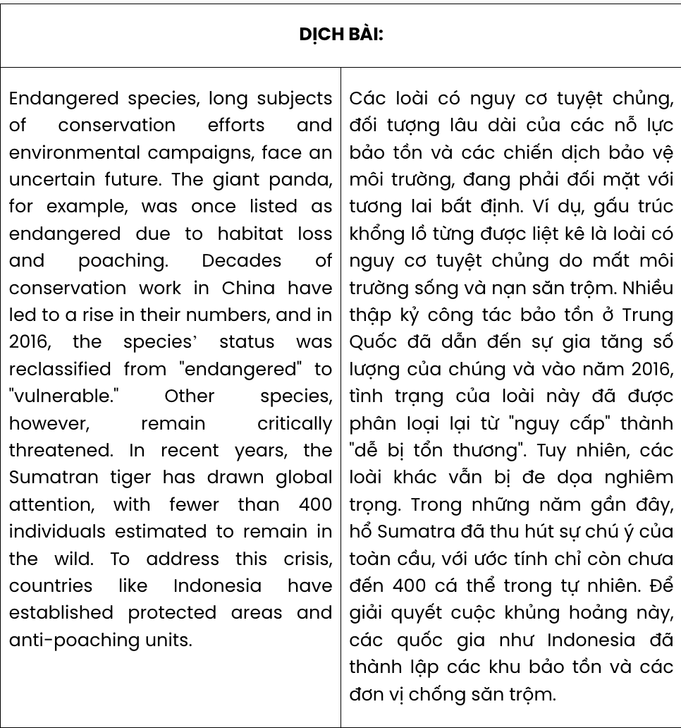
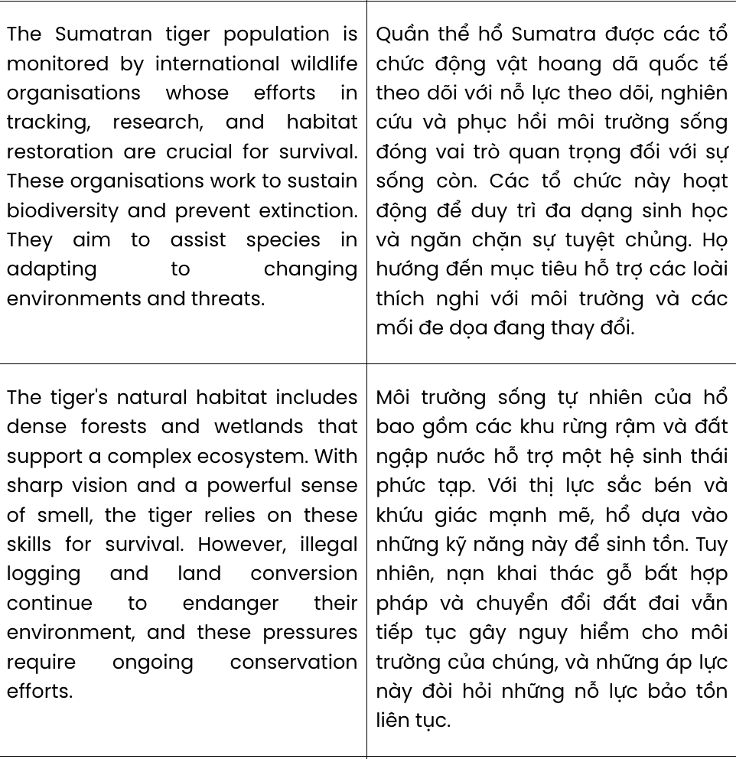
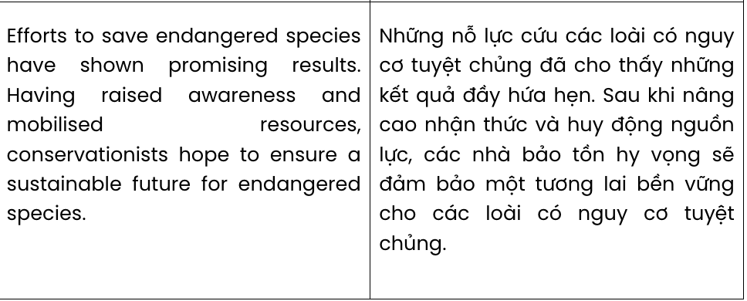
Read the following passage about Tatyana McFadde and mark the letter A, B, C, or D to indicate the correct answer to each of the questions from 23 to 30.
Tatyana grew up in Baltimore, Maryland, and later became one of the best Paralympic athletes in US history. However, she had to surmount significant challenges before she achieved great success.
Tatyana was born with spina bifida, a spinal condition that made her suffer from a severe walking disability. In addition, she spent her early childhood in a home for children without families and didn't have a wheelchair to help her get around. However, Tatyana was determined to play with other children her age and soon learned to walk using her hands.
At the age of 6, Tatyana was adopted by a family and she began her new life in Baltimore. She developed a keen interest in sports and took up wheelchair racing at just eight years old. She quickly showed promise in sport, and by the age of 15, she had already competed in her first Summer Paralympics, taking home a silver and a bronze medal. Since then, she has achieved huge success, winning 7 Paralympic golds and becoming the first person ever to complete a Grand Slam of marathons by winning the Chicago, Boston, New York, and London marathons in the same year in 2013. She was also named the 'Female Athlete of the Year' International Paralympic Committee in 2013 and 2014.
In spite of the challenges she has faced, Tatyana has achieved incredible success in sports and has become a role model for aspiring athletes all over the world. Her story shows us that any obstacles can be conquered with enough dedication and determination.
(Adapted from Bright)
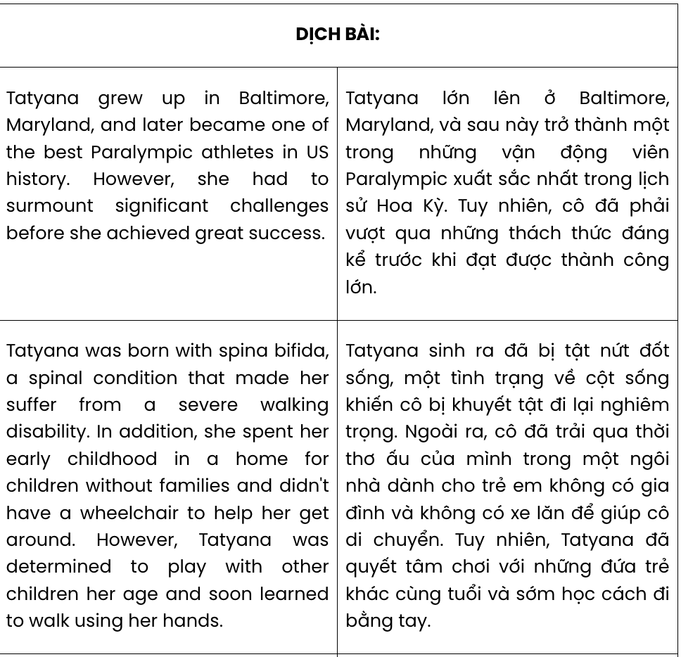
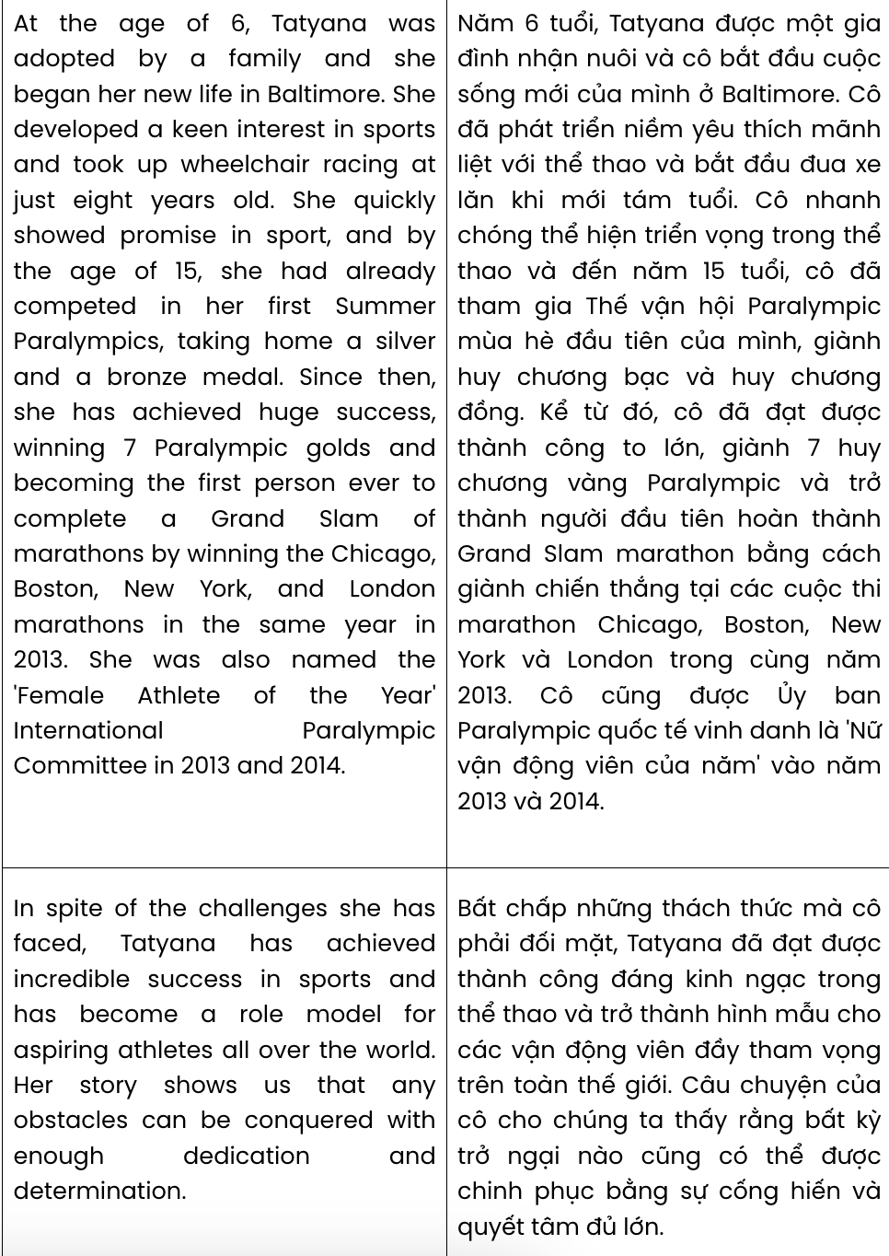

Question 23. The word surmount in paragraph 1 can be best replaced by .
A. experience B. overcome C. control D. comprehend
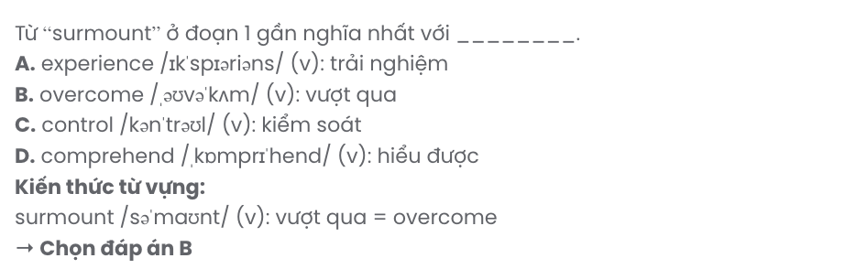

Question 24. The word that in paragraph 2 refers to .
A. her early childhood B. spina bifida
C. a severe walking disability D. a wheelchair

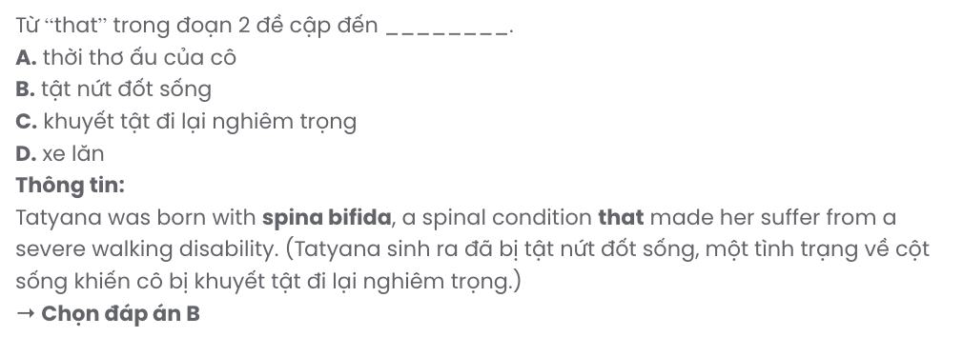
Question 25. Which of the following NOT mentioned as a challenge faced by Tatyana?
A. She suffered from a serious disease. B. She didn’t have access to a wheelchair.
C. She was brought up in an orphanage. D. Her adoptive parents were very cruel.
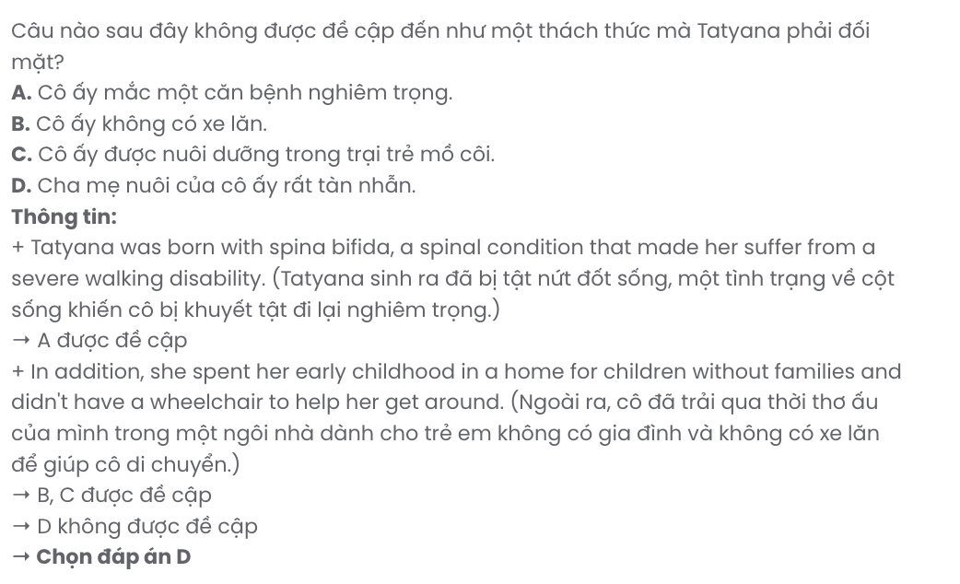
Question 26. Which of the following best paraphrases the underlined sentence in paragraph 3?
A. At the age of eight, she began exploring different sports and eventually chose wheelchair racing.
B. She grew passionate about sports and started wheelchair racing when she was only eight.
C. When she was eight, she showed a mild curiosity in sports and joined a local racing club.
D. Her interest in racing began at age eight, after she was encouraged to try various sports.
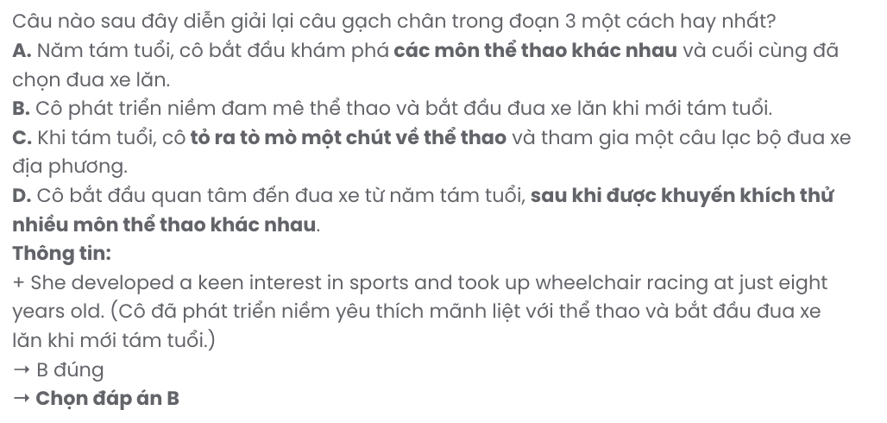
Question 27. The word incredible in paragraph 4 is OPPOSITE in meaning to .
A. complicated B. understandable C. satisfying D. ordinary
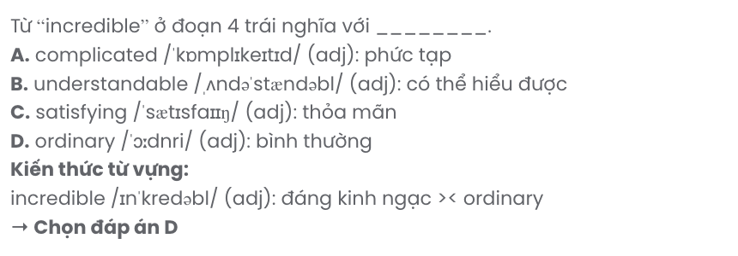

Question 28. Which of the following is TRUE according to the passage?
A. A person can only gain notable attainments through hard work and commitment.
B. Tatyana won two medals for her first time competing at the Summer Paralympics.
C. Tatyana was named the 'Female Athlete of the Year' despite her humble background.
D. Tatyana taught herself walking by using hands as she was hesitant to play with other kids.
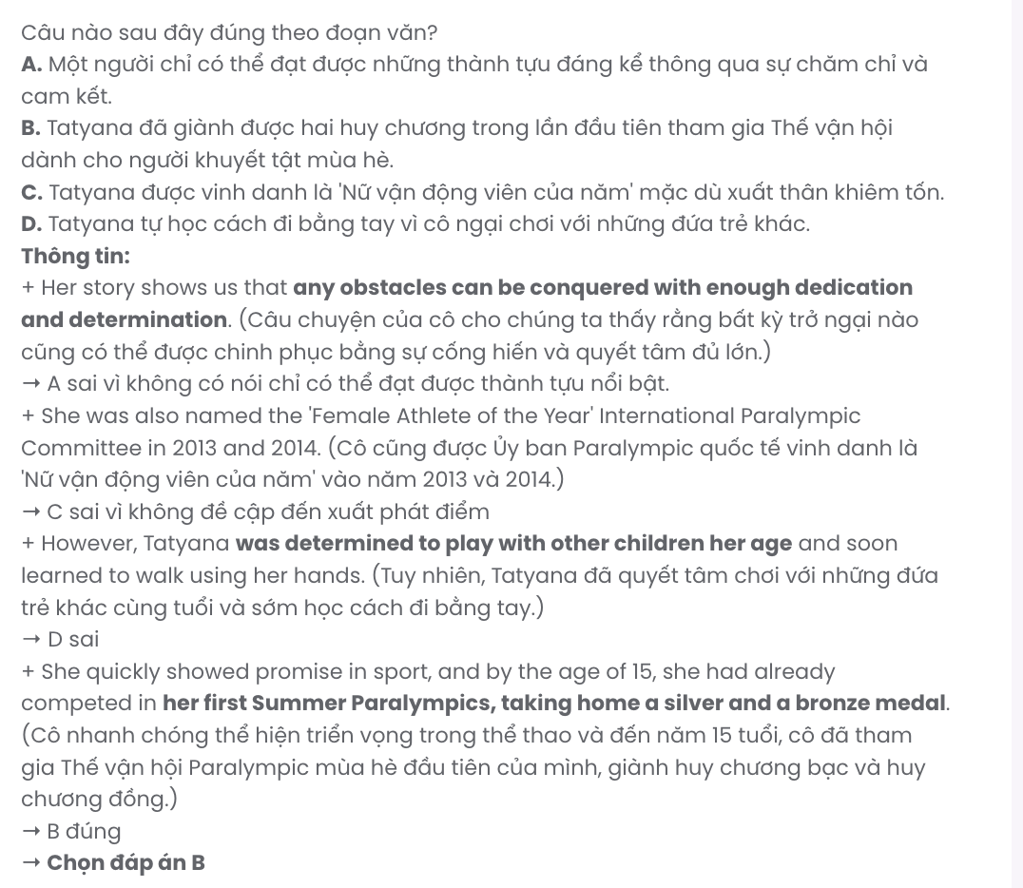
Question 29. In which paragraph does the author narrate the achievements of Tatyana?
A. Paragraph 1 B. Paragraph 2 C. Paragraph 3 D. Paragraph 4
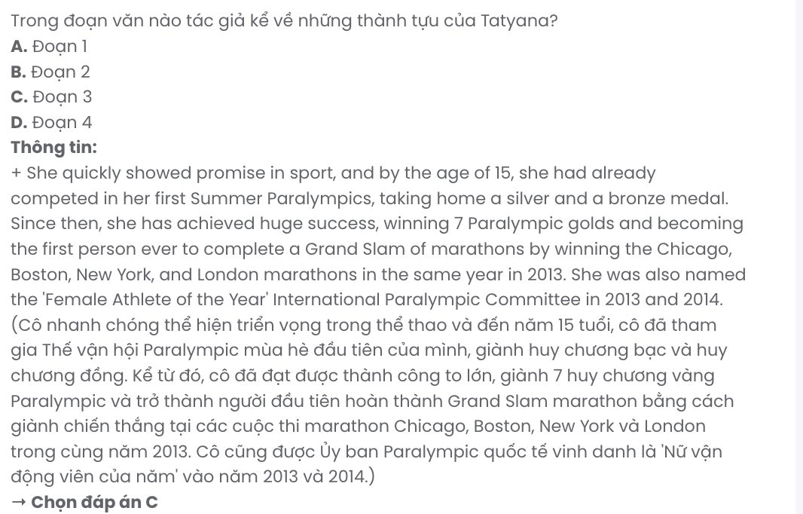
Question 30. In which paragraph does the author bring up a valuable life lesson?
A. Paragraph 1 B. Paragraph 2 C. Paragraph 3 D. Paragraph 4
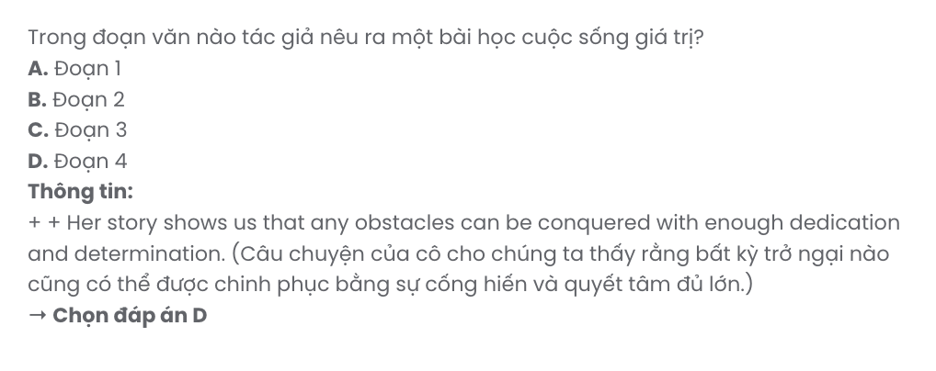
Read the following passage about community initiatives to tackle ocean pollution and mark the letter A, B, C, or D on your answer sheet to indicate the correct answer to each of the questions from 31 to 40.
A recent storm in the southwest of England brought an unexpected problem - large amounts of plastic rubbish on the beaches. The oceans are full of plastic, and when a storm moves the water more than usual, it can also lift this rubbish from the bottom of the sea and move it to the shore. It is clearly a big problem, but some people are now taking action themselves.
[I] In one town, a group of local people have decided to clean up their beach themselves. [II] Although they are all volunteers, so they aren't paid, they spend every weekend down on the shore, collecting as much rubbish as they can. They put it into different bags, depending on the type. [III] They also encourage tourists who use the beach to pick up five pieces of rubbish before they leave. [IV]
One family is using art to make people think about the problem of plastic in the oceans. Sara and John Bailey, together with their two children, regularly collect rubbish from the beach near their home and use it to create works of art. Sara says they have great fun together choosing which things to use and thinking of clever ways to use them. The works of art go into local shops, and the money they make from them pays for any materials that they need.
A bigger project is using plastic from the oceans to create useful products for local people. The project, which receives financial help from the government, collects plastic from the beach. It sends it to a local factory, where it is recycled and made into kayaks, or small boats. These kayaks go back to local people at no cost, and people can then use them to spend time on the sea collecting more plastic.
Although governments clearly need to take action to deal with the problem of plastic in the oceans, it seems that individuals and local groups can also be a big part of the solution.
(Adapted from Open World)

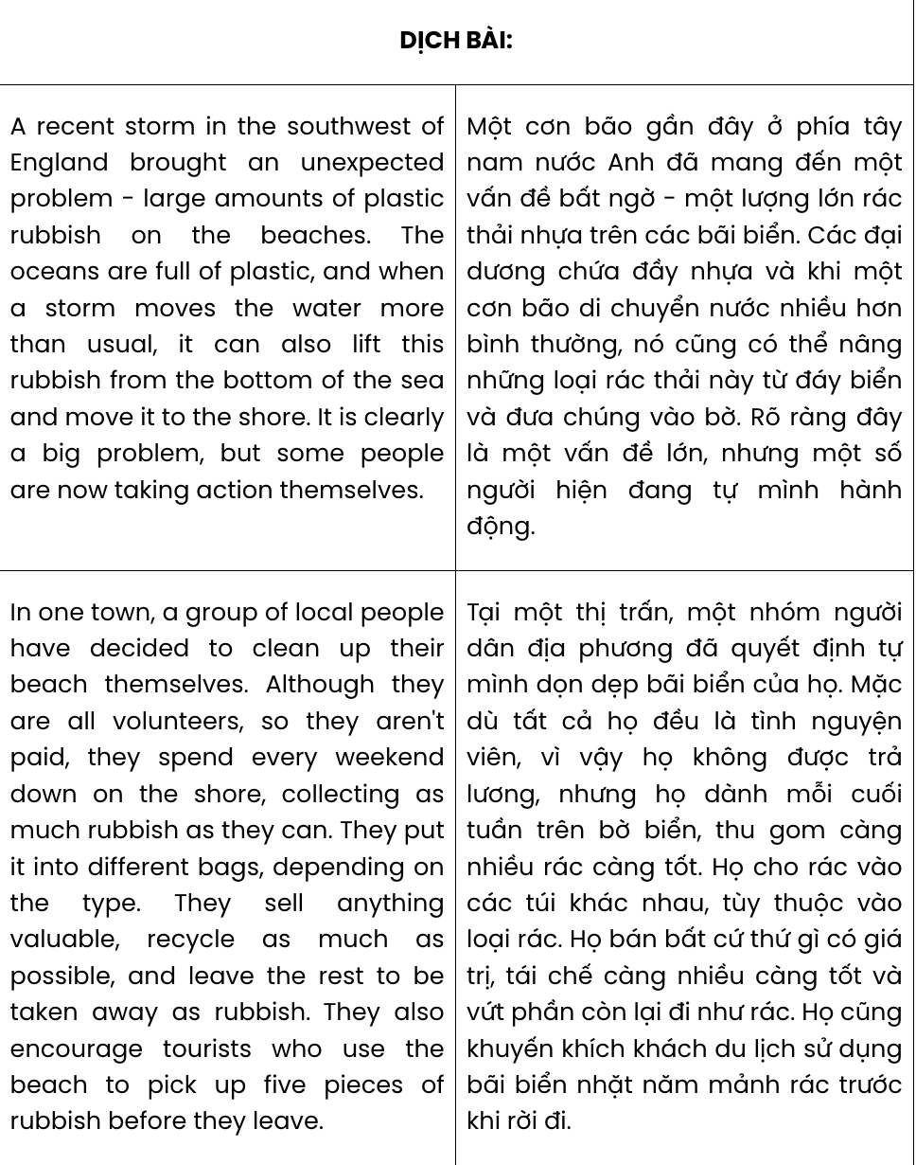

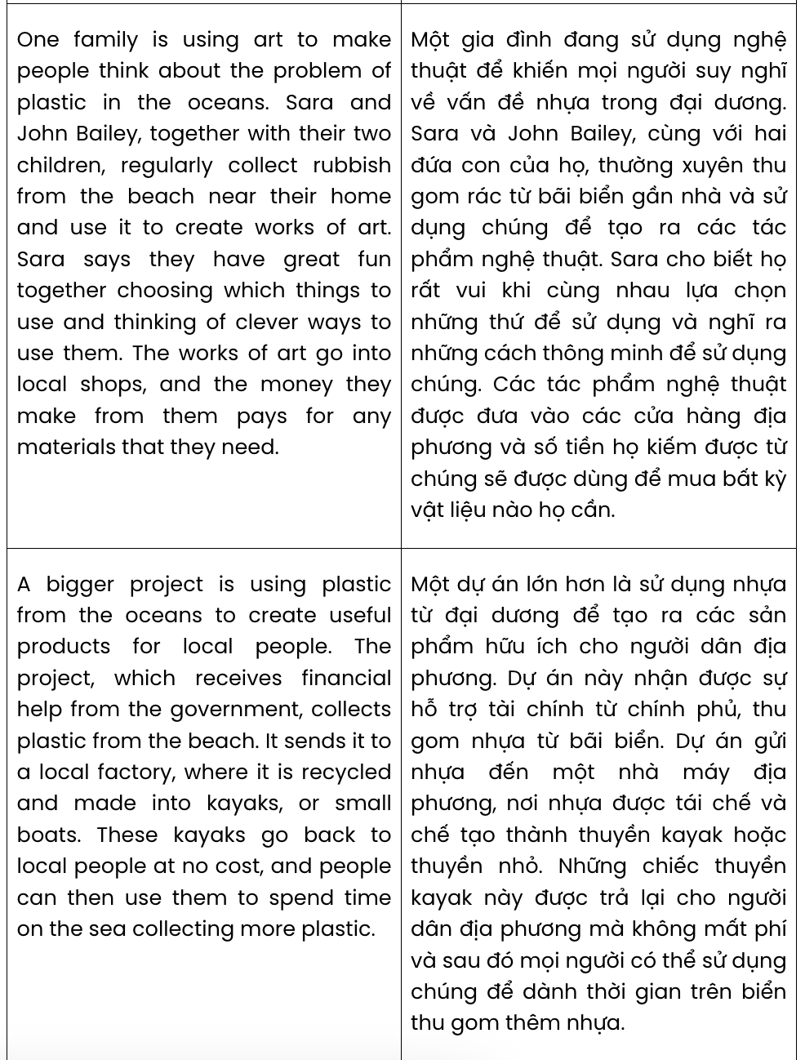

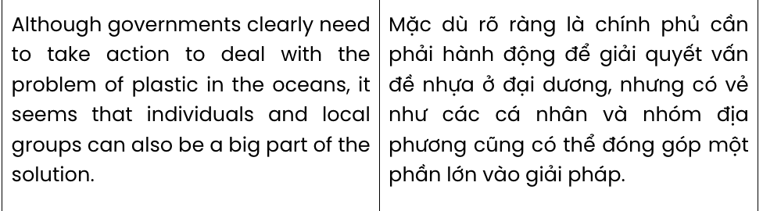
Question 31. According to paragraph 1, after a recent storm in the south west of England, people found
.
A. large amounts of valuable plastic rubbish B. historic objects dating back 100 years
C. lots of plastic trash washed up on the beaches D. long lost items at the bottom of the ocean
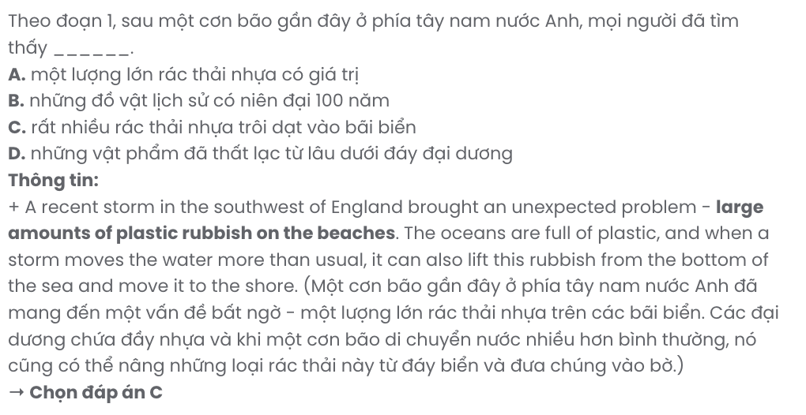
Question 32. The word it in paragraph 1 refers to .
A. storm B. water C. sea D. rubbish
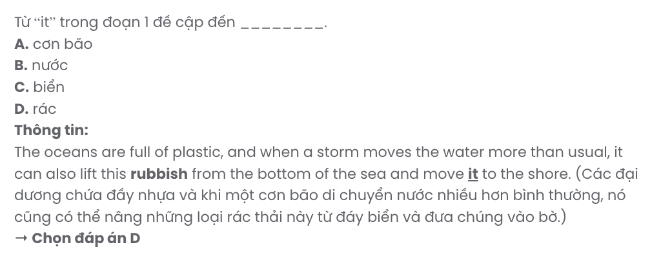
Question 33. Which of the following best paraphrases the underlined sentence in paragraph 1?
A. It remains an issue, yet some people have started acting by teaming up with others.
B. Some people think it’s a problem, though others continue to ignore it.
C. While the problem is significant, there are now individuals taking matters into their own hands.
D. This is still a major issue, with only a few people now starting to take responsibility.
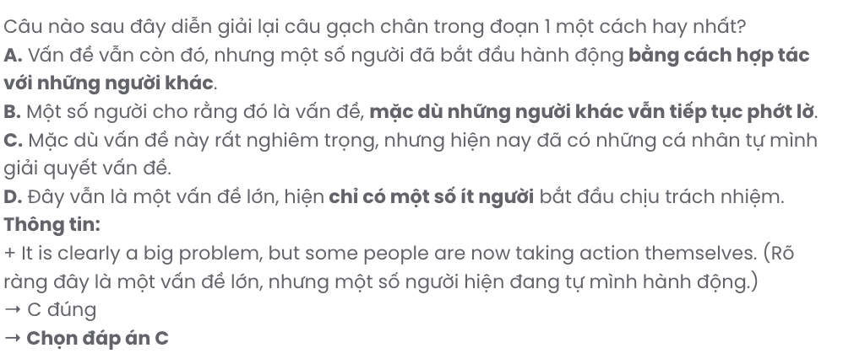
Question 34. Where in paragraph 2 does the following sentence best fit?

They sell anything valuable, recycle as much as possible, and leave the rest to be taken away as rubbish.
A. [I] B. [II] C. [III] D. [IV]
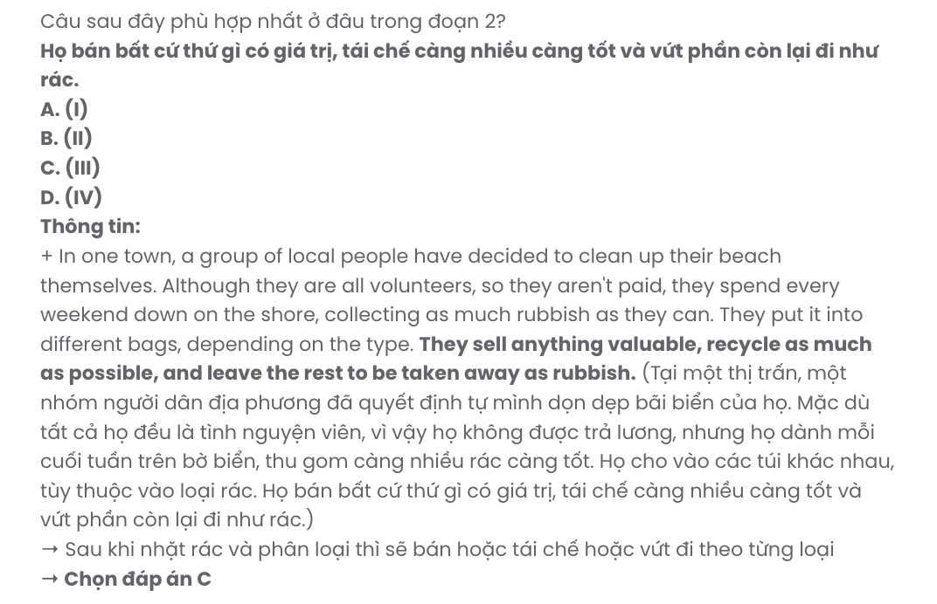
Question 35. The word encourage in paragraph 2 is OPPOSITE in meaning to .
A. admit B. accept C. prevent D. persuade
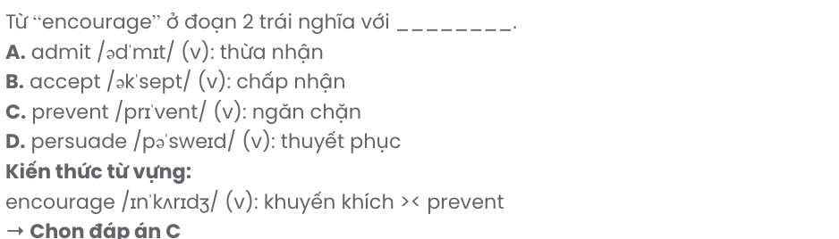
Question 36. The word clever in paragraph 3 is closest in meaning to .
A. creative B. expensive C. similar D. common
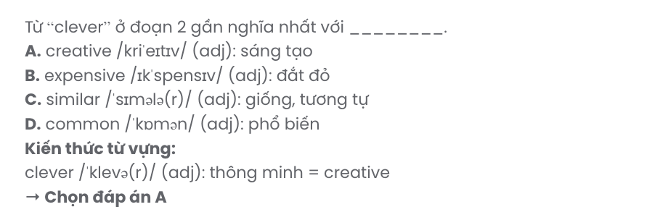
Question 37. Which of the following best summarises paragraph 4?
A. Ocean plastic is recycled into kayaks, allowing locals to enjoy time on the sea freely.
B. Collected plastic is recycled into kayaks for locals to help in cleaning the ocean.
C. Government funds enable the recycling of ocean plastic into free boats, benefiting the local economy.
D. Local people gather beach plastic, which is sold after being recycled into useful items.
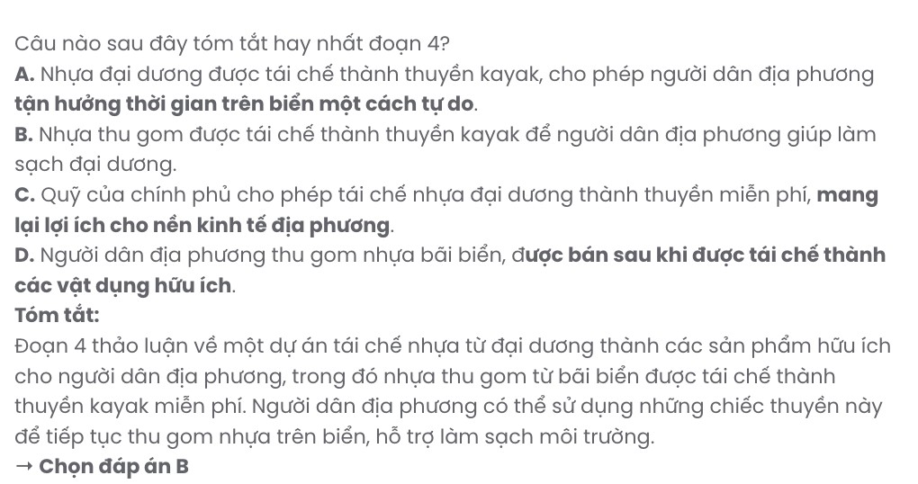
Question 38. Which of the following is NOT true according to the passage?
A. The project that collects plastic from the beach receives money to pay for the work.
B. Sara and John Bailey with their children use plastic rubbish to create works of art.
C. Volunteer plastic pickers sort the rubbish they collect, depending on the type.
D. The kayak project charges local people a small fee to get a small boat or a kayak.
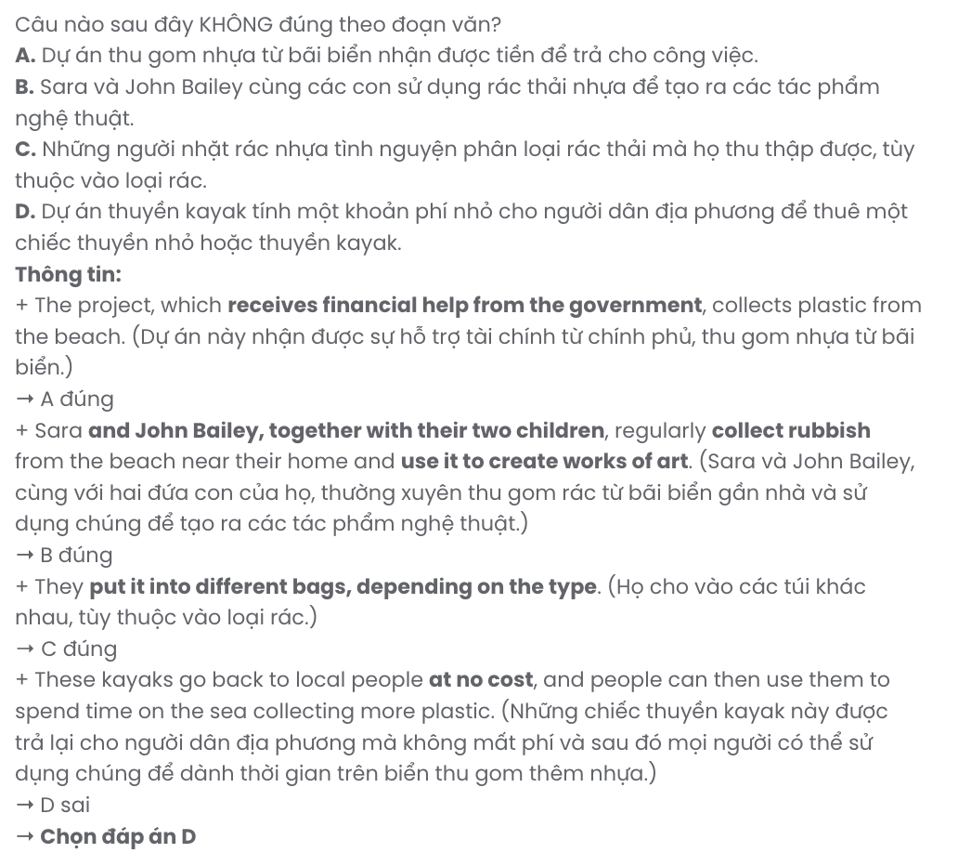
Question 39. Which of the following can be inferred from the passage?
A. Governments are quite sluggish in dealing with plastic pollution in the oceans.
B. The problem of plastic rubbish on the beaches requires collective efforts.
C. Using art to make people aware of plastic pollution in the oceans is the best idea.
D. Collecting plastics on the beaches should be a paid job to keep them clean.
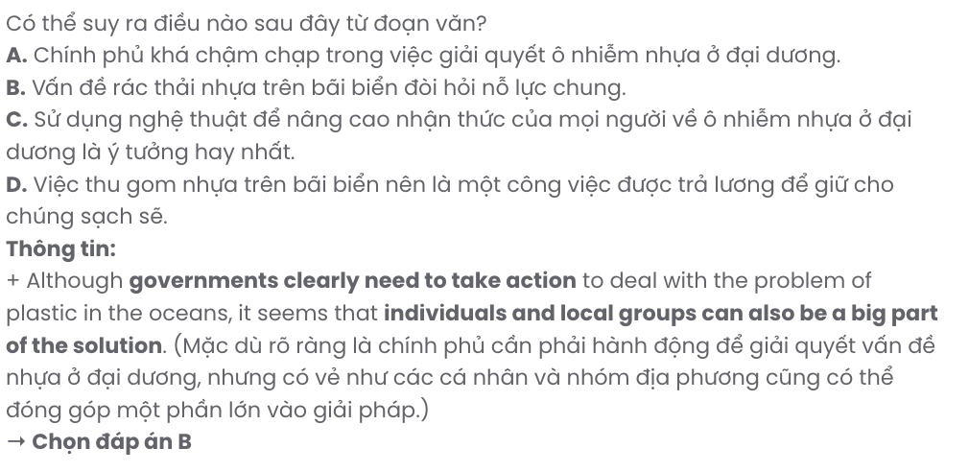
Question 40. Which of the following best summarises the passage?
A. A storm brought plastic ashore, leading locals to create art and products to address the issue, with government-funded projects producing recycled kayaks for cleanup efforts.
B. After a storm, locals began recycling plastic from the sea, supported by government projects to raise awareness and create environmentally friendly art, while encouraging visitors to participate.
C. People in England are cleaning plastic after a storm, with some creating art, others relying on tourists, and the government funding new products from ocean waste.
D. Locals are tackling plastic pollution by taking part in picking up rubbish, creating art and using government-funded projects to recycle plastic into kayaks for beach cleanup activities.

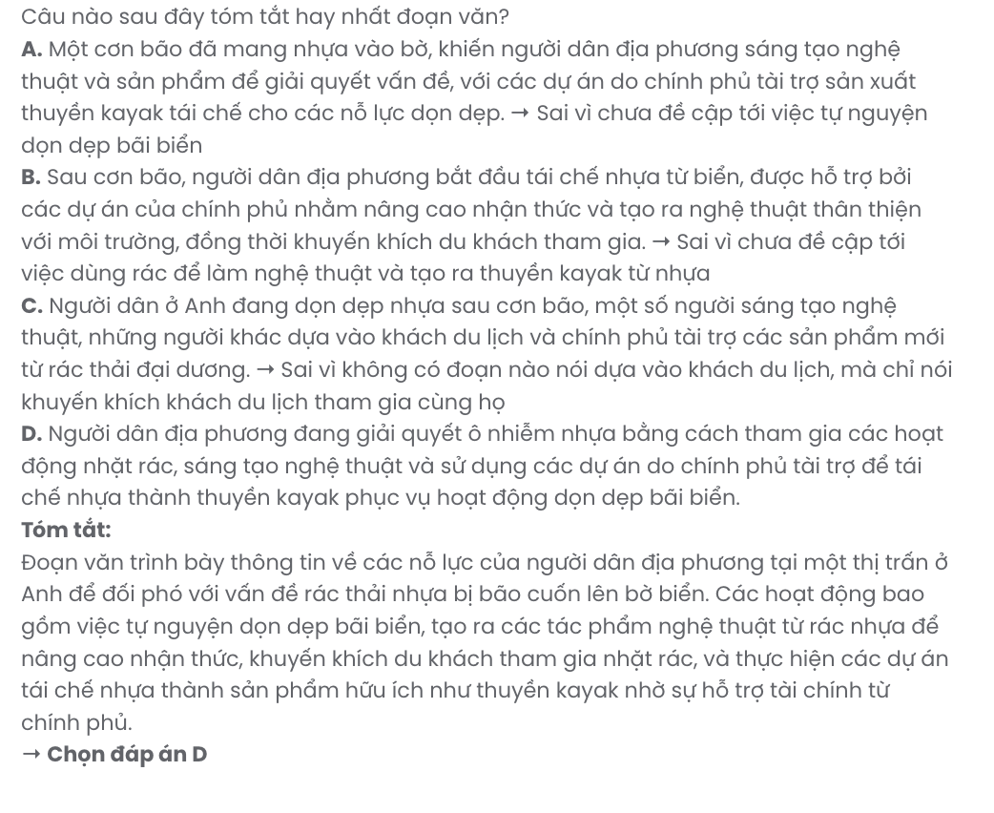
BẢNG TỪ VỰNG
STT | Từ vựng | Từ loại | Phiên âm | Nghĩa
1. | social media | np | /ˌsəʊʃl ˈmiːdiə/ | mạng xã hội
2. | fact | n | /fækt/ | sự thật
3. | figure | n | /ˈfɪɡə/ | số liệu
4. | cyberbullying | n | /ˈsaɪbəˌbʊliɪŋ/ | nạn bắt nạt trên mạng
5. | privacy | n | /ˈprɪvəsi/ | quyền riêng tư
6. | breach | n | /briːʧ/ | sự vi phạm
7. | personal | adj | /ˈpɜːsənl/ | cá nhân
8. | interference | n | /ˌɪntəˈfɪərəns/ | sự can thiệp
9. | vulnerability | n | /ˌvʌlnərəˈbɪləti/ | sự dễ bị tổn thương, đe dọa
10. | interaction | n | /ˌɪntərˈækʃn/ | sự tương tác
11. | analysis | n | /əˈnæləsɪs/ | sự phân tích
12. | threat | n | /θret/ | mối đe dọa
13. | address | n | /əˈdres/ | địa chỉ
14. | selectively | adv | /sɪˈlektɪvli/ | có chọn lọc
15. | impact | n | /ˈɪmpækt/ | tác động
16. | adjust | v | /əˈʤʌst/ | điều chỉnh
17. | setting | n | /ˈsetɪŋ/ | cài đặt
18. | platform | n | /ˈplætfɔːm/ | nền tảng
19. | profile | n | /ˈprəʊfaɪl/ | hồ sơ
20. | limit | v | /ˈlɪmɪt/ | giới hạn
21. | content | n | /ˈkɒntent/ | nội dung
22. | report | v | /rɪˈpɔːt/ | báo cáo
23. | block | v | /blɒk/ | chặn
24. | credible | adj | /ˈkredəbl/ | đáng tin cậy
25. | accessible | adj | /əkˈsesəbl/ | dễ tiếp cận
26. | suspicious | adj | /səˈspɪʃəs/ | đáng ngờ
27. | instant | adj | /ˈɪnstənt/ | ngay lập tức
28. | uncomfortable | adj | /ʌnˈkʌmftəbl/ | khó chịu
29. | necessary | adj | /ˈnesəsəri/ | cần thiết
30. | culture | n | /ˈkʌlʧə/ | nền văn hóa
31. | curious | adj | /ˈkjʊəriəs/ | tò mò
32. | exciting | adj | /ɪkˈsaɪtɪŋ/ | thú vị
33. | custom | n | /ˈkʌstəm/ | phong tục
34. | tradition | n | /trəˈdɪʃn/ | truyền thống
35. | exchange | n | /ɪksˈʧeɪnʤ/ | trao đổi
36. | unforgettable | adj | /ˌʌnfəˈɡetəbl/ | khó quên

37. | journey | n | /ˈʤɜːni/ | hành trình
38. | system | n | /ˈsɪstəm/ | hệ thống
39. | meaningful | adj | /ˈmiːnɪŋfl/ | có ý nghĩa
40. | connection | n | /kəˈnekʃn/ | kết nối
41. | participant | n | /pɑːˈtɪsɪpənt/ | người tham gia
42. | worldwide | n | /ˌwɜːldˈwaɪd/ | toàn cầu
43. | knowledge | n | /ˈnɒlɪʤ/ | kiến thức
44. | passionate | adj | /ˈpæʃnət/ | đam mê
45. | discovery | n | /dɪˈskʌvəri/ | sự khám phá
46. | wildlife | n | /ˈwaɪldlaɪf/ | động vật hoang dã
47. | volunteer | v | /ˌvɒlənˈtɪə/ | tình nguyện
48. | organisation/  organization | n | /ˌɔːɡənaɪˈzeɪʃn/ | tổ chức
49. | flexible | adj | /ˈfleksəbᵊl/ | linh hoạt
50. | schedule | n | /ˈʃedjuːl/ | lịch trình
51. | conservation | n | /ˌkɒnsəˈveɪʃn/ | bảo tồn
52. | effort | n | /ˈefət/ | nỗ lực
53. | time-consuming | adj | /ˈtaɪmkənˈsjuːmɪŋ/ | tốn thời gian
54. | technology | n | /tekˈnɒləʤi/ | công nghệ
55. | urban | n | /ˈɜːbən/ | đô thị
56. | automated | adj | /ˈɔːtəmeɪtɪd/ | tự động
57. | virtual | adj | /ˈvɜːʧuəl/ | ảo
58. | routine | n | /ruːˈtiːn/ | thói quen
59. | unfamiliar | adj | /ʌnfəˈmɪliə/ | xa lạ
60. | fascinating | adj | /ˈfæsɪneɪtɪŋ/ | hấp dẫn
61. | exhilarating | adj | /ɪɡˈzɪləreɪtɪŋ/ | phấn khích
62. | navigate | v | /ˈnævɪɡeɪt/ | điều hướng
63. | overwhelming | adj | /ˌəʊvəˈwelmɪŋ/ | choáng ngợp
64. | embrace | v | /ɪmˈbreɪs/ | tiếp nhận, đón nhận
65. | master | v | /ˈmɑːstə/ | thành thạo
66. | historic | adj | /hɪˈstɒrɪk/ | thuộc lịch sử
67. | temple | n | /ˈtempl/ | ngôi đền
68. | cherry blossom | n | /ˈʧeri blɒsəm/ | hoa anh đào
69. | rewarding | adj | /rɪˈwɔːdɪŋ/ | bổ ích, đáng làm
70. | resilience | n | /rɪˈzɪliəns/ | sự bền bỉ, kiên cường
71. | genuine | adj | /ˈʤenjuɪn/ | chân thành
72. | appreciation | n | /əˌpriːʃiˈeɪʃn/ | sự chân trọng
73. | comfort zone | np | /ˈkʌmfət zəʊn/ | vùng an toàn

74. | undergo | v | /ˌʌndəˈɡəʊ/ | trải qua
75. | remarkable | adj | /rɪˈmɑːkəbl/ | đáng kể
76. | transformation | n | /ˌtrænsfəˈmeɪʃn/ | sự chuyển đổi
77. | decade | n | /ˈdekeɪd/ | thập kỷ
78. | close-knit | adj | /ˌkləʊs ˈnɪt/ | gắn bó mạnh mẽ
79. | community | n | /kəˈmjuːnəti/ | cộng đồng
80. | expand | v | /ɪkˈspænd/ | mở rộng
81. | faculty | n | /ˈfæklti/ | khoa
82. | campus | n | /ˈkæmpəs/ | khuôn viên trường
83. | diverse | adj | /daɪˈvɜːs/ | đa dạng
84. | academically | adv | /ˌækəˈdemɪkli/ | về mặt học thuật
85. | vibrant | adj | /ˈvaɪbrənt/ | sôi động
86. | demand | n | /dɪˈmɑːnd/ | nhu cầu
87. | multicultural | adj | /ˌmʌltiˈkʌltʃərəl/ | đa văn hóa
88. | enrich | v | /ɪnˈrɪʧ/ | làm giàu, làm phong phú thêm
89. | welcoming | adj | /ˈwelkəmɪŋ/ | chào đón
90. | endangered | adj | /ɪnˈdeɪnʤəd/ | nguy cấp
91. | species | n | /ˈspiːʃiːz/ | loài
92. | uncertain | adj | /ʌnˈsɜːtn/ | bất định
93. | habitat | n | /ˈhæbɪtæt/ | môi trường sống
94. | poaching | n | /ˈpəʊʧɪŋ/ | nạn săn trộm
95. | reclassify | v | /ˌriːˈklæsɪfaɪ/ | phân loại lại
96. | individual | n | /ˌɪndɪˈvɪʤuəl/ | cá thể
97. | crisis | n | /ˈkraɪsɪs/ | cuộc khủng hoảng
98. | monitor | v | /ˈmɒnɪtə/ | theo dõi
99. | sustain | v | /səˈsteɪn/ | duy trì
100. | biodiversity | n | /ˌbaɪəʊdaɪˈvɜːsəti/ | sự đa dạng sinh học
101. | extinction | n | /ɪkˈstɪŋkʃn/ | sự tuyệt chủng
102. | dense | adj | /dens/ | dày đặc
103. | wetland | n | /ˈwetlənd/ | đất ngập nước
104. | complex | adj | /ˈkɒmpleks/ | phức tạp
105. | ecosystem | n | /ˈiːkəʊˌsɪstəm/ | hệ sinh thái
106. | vision | n | /ˈvɪʒn/ | thị lực
107. | logging | n | /ˈlɒɡɪŋ/ | khai thác gỗ
108. | conversion | n | /kənˈvɜːʃn/ | sự chuyển đổi
109. | ongoing | adj | /ˌɒŋˈɡəʊɪŋ/ | liên tục
110. | promising | adj | /ˈprɒmɪsɪŋ/ | hứa hẹn
111. | mobilise/ | v | /ˈməʊbɪlaɪz/ | huy động

 | mobilize
112. | sustainable | adj | /səˈsteɪnəbl/ | bền vững
113. | athlete | n | /ˈæθliːt/ | vận động viên
114. | surmount  = overcome | v | /səˈmaʊnt/  /ˌəʊvəˈkʌm/ | vượt qua
115. | comprehend | v | /ˌkɒmprɪˈhend/ | hiểu được
116. | spinal | adj | /ˈspaɪnl/ | thuộc cột sống
117. | condition | n | /kənˈdɪʃᵊn/ | tình trạng
118. | severe | adj | /sɪˈvɪə/ | nghiêm trọng
119. | disability | n | /ˌdɪsəˈbɪləti/ | khiếm khuyết
120. | wheelchair | n | /ˈwiːlʧeə/ | xe lăn
121. | promise | n | /ˈprɒmɪs/ | triển vọng
122. | medal | n | /ˈmedl/ | huy chương
123. | committee | n | /kəˈmɪti/ | ủy ban
124. | incredible | adj | /ɪnˈkredəbl/ | đáng kinh ngạc
125. | complicated | adj | /ˈkɒmplɪkeɪtɪd/ | phức tạp
126. | understandable | adj | /ˌʌndəˈstændəbl/ | có thể hiểu được
127. | satisfying | adj | /ˈsætɪsfaɪɪŋ/ | thỏa mãn
128. | ordinary | adj | /ˈɔːdnri/ | bình thường
129. | role model | n | /ˈrəʊl mɒdl/ | hình mẫu
130. | aspiring | adj | /əˈspaɪərɪŋ/ | đầy tham vọng
131. | obstacle | n | /ˈɒbstəkl/ | trở ngại
132. | conquer | v | /ˈkɒŋkə/ | chinh phục
133. | dedication | n | /ˌdedɪˈkeɪʃn/ | sự cống hiến
134. | determination | n | /dɪˌtɜːmɪˈneɪʃn/ | sự quyết tâm
135. | plastic | n | /ˈplæstɪk/ | nhựa
136. | rubbish | n | /ˈrʌbɪʃ/ | rác thải
137. | shore | n | /ʃɔː/ | bở biển
138. | valuable | adj | /ˈvæljəbl/ | có giá trị
139. | recycle | v | /ˌriːˈsaɪkl/ | tái chế
140. | encourage | v | /ɪnˈkʌrɪʤ/ | khuyến khích
141. | clever | adj | /ˈklevə/ | thông minh
142. | material | n | /məˈtɪəriəl/ | vật liệu
143. | financial | adj | /faɪˈnænʃl/ | thuộc tài chính
144. | solution | n | /səˈluːʃn/ | giải pháp

STT | Cấu trúc | Nghĩa
1 | stay safe | giữ an toàn
2 | face risks | đối mặt với rủi ro
3 | make the most of something | tận dụng tối đa điều gì
4 | sign up | đăng ký
5 | have the chance to do something | có cơ hội làm gì
6 | take a look at something | nhìn xem gì
7 | take up | bắt đầu theo đổi thứ gì
8 | put off | trì hoãn
9 | get on | bắt đầu một hành trình, lên tàu xe …
10 | go up | tăng
11 | check out | xem qua
12 | make sense of | hiểu được
13 | find joy in doing something | thấy vui khi làm gì
14 | step out of one’s comfort zone | bước ra khỏi vùng an toàn
15 | meet the needs | đáp ứng nhu cầu
16 | draw attention | thu hút sự chú ý
17 | aim to do something | có mục tiêu làm gì
18 | rely on somebody/something | dựa vào ai/gì
19 | raise awareness | nâng cao nhận thức
20 | interest in something | yêu thích điều gì
21 | take action | hành động

