School: ……………………………………….. | Date:……………………………………..
Class: ……………………………..................... | Period: 23

UNIT 2: FIT FOR LIFE
Grammar 2b (Page 33)

1. Objectives
By the end of this lesson, students will be able to…
1.1. Language knowledge/ skills
- review: the Past Simple.
- learn and practise regular and irregular verbs.
- practise doing grammar exercises.
- use the tenses reviewed to ask and answer about what they did last week.
1.2. Competences
- improve Ss’ analytical, critical thinking skills.
1.3. Attributes
- develop their patriotism, kindness, honesty and accountability.
2. Teaching aids and materials
- Teacher’s aids: Student’s book and Teacher’s book, class CDs, IWB – Phần mềm tương tác trực quan, projector/interactive whiteboard /TV (if any), PowerPoint slides.
- Students’ aids: Student’s book, Workbook, Notebook.
3. Assessment Evidence
Performance Tasks | Performance Products | Assessment Tools
- Use the words in brackets to write questions.  - Put the verbs in the brackets into the Past Simple and decide the verbs are regular or irregular.  - Form complete questions and use the blog in Exercise 5 to answer them.  - Ask and answer questions to find out what your partner did last weekend. | - Ss’ answers.  - Ss’ answers.  - Ss’ answers.  - Ss’ answers/ presentation. | - Observation.  - Observation.  - Observation.  - Observation/ peer correction.

4. Procedures
A. Warm up: 5 minutes
a. Objectives: to review the Past Simple (question).
b. Content: task 4.
c. Expected outcomes: Ss can recall the tense learnt earlier.
d. Organization
Teacher’s activities | Students’ activities
Task 4. Use the words in brackets to write questions in your notebook as in the example. Read them aloud.  1 She played football yesterday. (What?)  What did she do yesterday?  2 They did yoga in the gym last Friday. (Where?)  3 He went to the stadium on foot last Saturday. (How?)  4 We had basketball practice yesterday afternoon. (When?)  5 Sally went jogging with Mary yesterday morning. (Who?)  - Explain the task and read out the example.  - Give Ss time to complete the task.  - Ask various Ss to read out the questions and check their answers. | - Use the words in brackets to write questions in your notebook as in the example.  - Read them aloud.  Answer Keys:  2. Where did they do yoga last Friday?  3. How did they go to the stadium last  Saturday?  4. When did you have basketball practise?  5. Who did Sally go jogging with yesterday morning?

B. Presentation: 10 minutes
a. Objectives: to help Ss review the Past Simple.
b. Content: Language Box.
c. Expected outcomes: Ss can recall the theory of the Past Simple.
d. Organization
Teacher’s activities | Students’ activities
Theory Box:  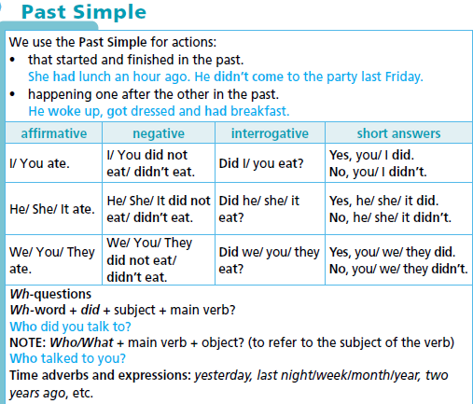  - Ask the Ss to study the theory box and read the examples.  - Elicit further examples from Ss around the class. | - Read the Theory box.  - Listen to the teacher and take notes.
C. Practice: 15 minutes
a. Objectives: to help Ss practise the Past Simple, regular and irregular verbs.
b. Content: tasks 5, 6.
c. Expected outcomes: Ss can remember and practise the Past Simple, regular verbs and irregular verbs.
d. Organization:
Teacher’s activities | Students’ activities
Task 5. Put the verbs in the brackets into the Past Simple. Which verbs are regular? Which are irregular?  - Explain the task using IWB and give Ss time to complete it.  - Check Ss’ answers and elicit which verbs are regular and which are irregular (using the IWB). | - Put the verbs in the brackets into the Past Simple.  - Decide the verbs are regular or irregular?  Answer keys:  1) visited (R)  2) left (I)  3) arrived (R)  4) rushed (R)  5) went (I)  6) watched (R)  7) ate (I)  8) was (I)
Task 6. Form complete questions. Then use the blog in Exercise 5 to answer them.  1. Tom & his family / go / London / last summer  A: Did Tom and his family go to London last summer?  B: No, they didn’t. They went to Orlando.  2. they / visit / Universal Studios  3. Tom’s sister / go / on all the rides at the park  4. they / have / dinner / at their hotel  - Explain the task and ask two Ss to read out the example.  - Give Ss time to complete the task and monitor the activity around the class.  - Check Ss’ answers. | - Form complete questions.  - Use the blog in Exercise 5 to answer them.  - Complete the task individually and practise with their friend.  Answer keys:  2 A: Did they visit Universal Studios?  B: No, they didn’t. They visited Universal  Orlando Resort.  3 A: Did Tom’s sister go on all the rides at the park?  B: No, she didn’t. She watched a show.  4 A: Did they have dinner at their hotel?  B: No, they didn’t. They ate at the Three  Broomsticks restaurant.

D. Production: 10 minutes
a. Objectives: to help Ss practise the Past Simple, Wh- questions, regular and irregular verbs.
b. Content: Task 7.
c. Expected outcomes: Ss can ask and answer about their activities last weekend.
d. Organization

Teacher’s activities | Students’ activities
Task 7. Ask and answer questions to find out what your partner did last weekend. Use the phrases in the list and your own ideas.  • play football • watch TV • meet your friends • visit your aunt • see a film • read a book • go swimming • go to the cinema  A: Did you play football last Saturday?  B: No, I didn’t. I stayed home and did my homework. What about you?  A: I went to the mall to buy some new trainers. Did you visit your aunt on Sunday?  B: Yes, we did. We had lunch together. What did you do?  A: I went to the cinema with my parents.  - Explain the task and ask two Ss to read out the example.  - Ask Ss to use the phrases from the list to complete the task.  - Check Ss’ answers. | - Ask and answer questions to find out what your partner did last weekend.  - Use the phrases in the list and their own ideas.  Suggested Answer  A: Did you watch TV last Saturday?  B: No, I didn’t. I met my friends at the mall.  What about you?  A: I went to the cinema with my brother. Did you go jogging on Sunday?  B: Yes, I did. I also did some yoga. What did you do?  A: I went swimming at the beach with my parents. etc.  Background Information  Universal Orlando Resort is a theme park and entertainment resort complex in Florida, USA.  Harry Potter is a book character  created by British author  J. K. Rowling.
E. Consolidation and homework assignments: 5 minutes
- Grammar point: the Past simple, regular verbs and irregular verbs.
- Do the exercises in workbook on page 17.
- Prepare the next lesson: Vocabulary 2c (page 34).
5. Reflection
a. What I liked most about this lesson today:
…………………………………………………………………………………………
b. What I learned from this lesson today:
…………………………………………………………………………………………
c. What I should improve for this lesson next time:
…………………………………………………………………………………………

