Họ tên thí sinh: .................................................................
Số báo danh: ......................................................................
Mã Đề: 029.
Câu 1. What will be available at the end-of-year celebration on December 15 at the Downtown Club?
Please join us for our end-of-year celebration on December 15 at 8 pm at the Downtown Club. We'll have a live DJ, drinks, and appetizers as we celebrate the end of another great year. We hope to see you there!
A. A silent auction and live music B. A movie screening and popcorn
C. A live DJ, drinks, and appetizers D. A fashion show and cocktails
Câu 2. Who can participate in this cycle ride?
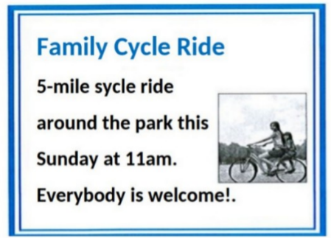
A. Anyone who wants to join B. Only park members
C. Only families with children D. Only experienced cyclists
Câu 3. Look at the signs. Choose the best answer for the question.
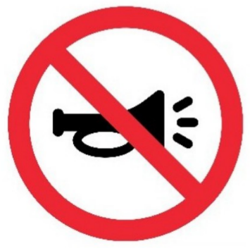
A. There aren’t any horns in this area. B. You should use the horn only in an emergency.
C. You don’t have to use the horn in this area. D. You mustn’t use the horn in this area.
Câu 4. What are students asked to do after using the kitchen?
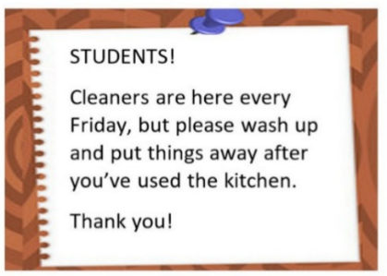
A. Deep clean the entire kitchen B. Call the cleaners
C. Wash up and put things away D. Leave everything as it is
Câu 5. What is true about the announcement from the library?
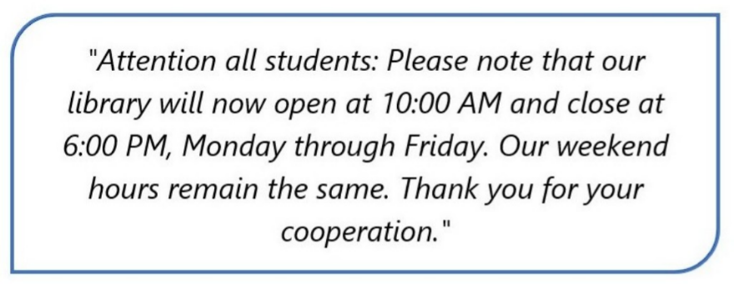
A. Change in the library's phone number.
B. Change in the library's hours on weekends.
C. Change in the library's opening and closing times on weekdays.
D. Change in the library's location.
Câu 6. What is true about this notice?
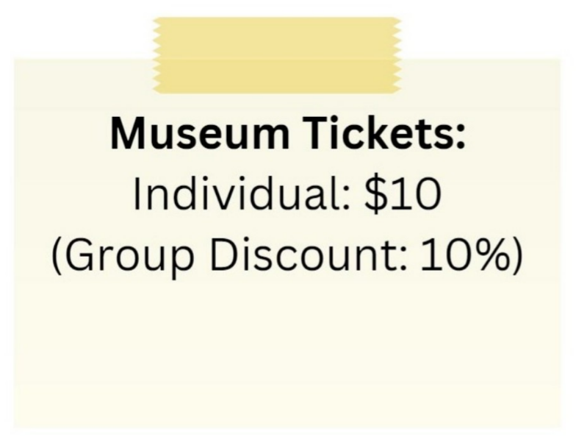
A. The individual ticket price is $10 and there is a 10% group discount.
B. The group discount is 20%.
C. There is no group discount available.
D. The individual ticket price is $5.
Câu 7. Why is the Chess club changing its meeting location?
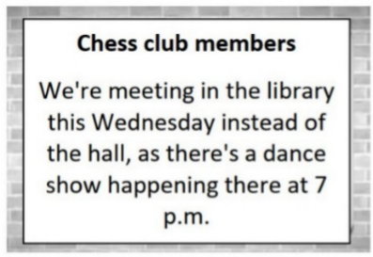
A. The hall is being renovated B. The chess tables are in the library
C. There's a dance show in the hall D. The library is more spacious
Câu 8. Look at the signs. Choose the best answer for the question.
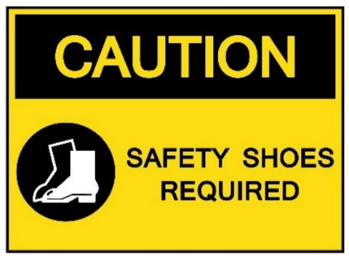
A. You have to keep your shoes safe in this area.
B. You are allowed to wear shoes in this area.
C. You should wear shoes in this area because of safety.
D. You have to wear shoes that can provide protection in this area.
Câu 9. Look at the signs. Choose the best answer for the question.
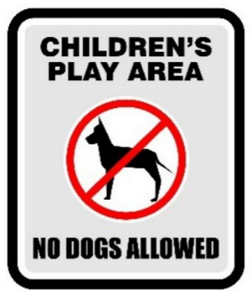
A. Dogs cannot be taken into this place as it is a children’s play area.
B. Dogs are not safe for children in this play area.
C. Dogs are not allowed to play with children in this area.
D. Don’t let your children play here because of the dogs.
Câu 10. Why will Jim be late?
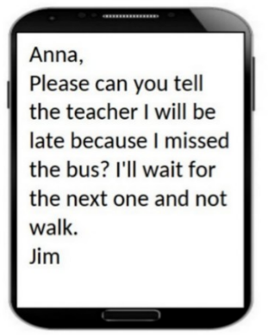
A. There was a traffic jam B. His car broke down
C. He missed the bus D. He overslept
----HẾT---

