SPEAKING ( 10’)
1. Introduction:
Introduce yourself with basic information (name, class, age, hobby, family, etc.)(0.5 point)
2. Each of you will now receive a card. On the card there is a picture and clues for five questions. You should use the words to make questions and ask your friend. Your friend will answer the questions based on the picture he/she has (0.5 point)

Topic 1: Talk about main features and attractions of the city
Example.
City life  1. Which city is it ?  2. Where is it located ?  3. What is the main features of this city?  4. What are its attractions ? | 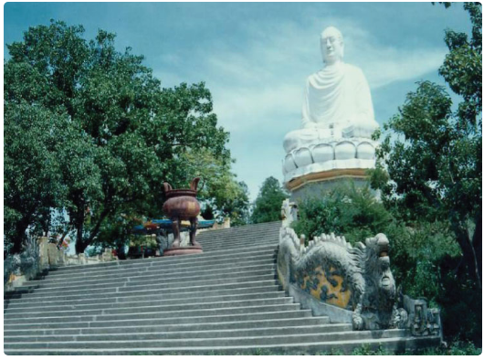
1. Which city is it ?  2. Where is it located ?  3. What is the main features of this city?  4. What are its attractions ? | 

Topic 2: Talk about one of the famous wonder of Viet Nam.
Topic 3: Talk bout your stress or pressure at school/ at home.
Topic 4 : Talk bout the changes of your country / neighborhood : then and now.
3. Answer further questions (1 point)
- Answer teacher’s extra questions

