|  |  |
| --- | --- |
| **PHÒNG GIÁO DỤC VÀ ĐÀO TẠO**  **HUYỆN NINH GIANG** | **ĐỀ KHẢO SÁT HỌC SINH GIỎI**  **NĂM HỌC 2024 - 2025**  **MÔN: TIẾNG ANH 6**  **Thời gian làm bài: 120 phút**  **Đề gồm: 06 trang** |

**SECTION A. LISTENING. (2 pts)**

***Part 1: Listen to five short recordings and for each recording you have to choose the best of three pictures (A, B or C). (0.5 pt)***

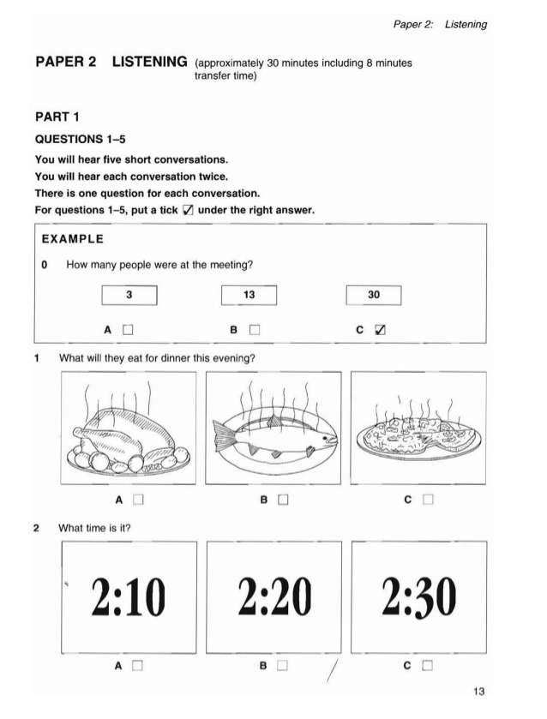

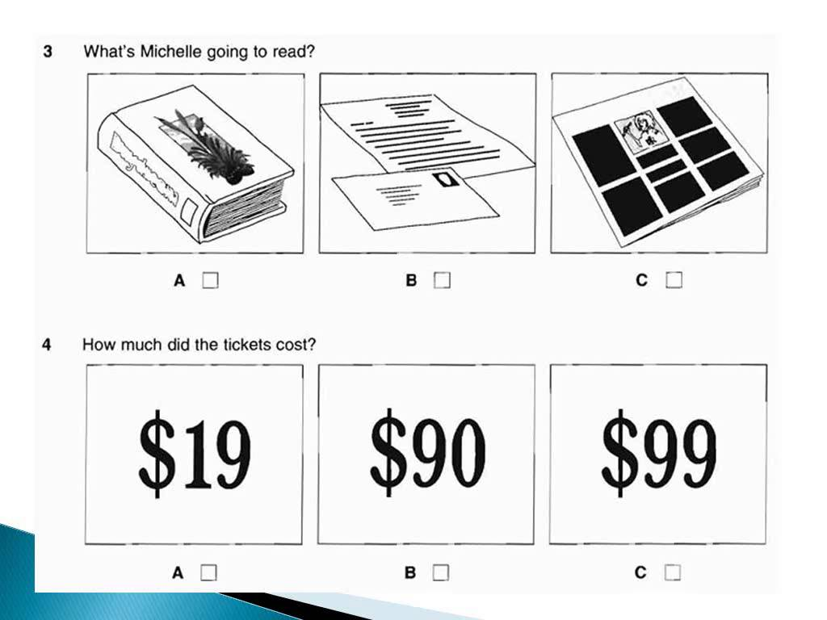

5. Where is the chemist’s?

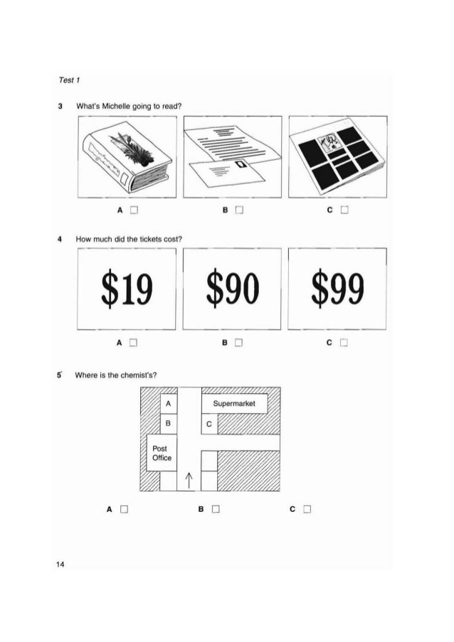

**A B C**

***Part II. Liz is telling her father about the things she bought. Listen and choose the right answer (A, B or C). (0.5 pt)***

1. When did Liz go to the shopping center?

A. today B. yesterday C. on Tuesday D. on Sunday

2. What did Liz buy for the baby?

A. a book B. a ball C. a toy animal D. a hat

3. What sort of CD did Liz choose?

A. pop music B. dance music C. Classical music D. rock music

4. What clothes did Liz get?

A. some jeans B. a sweater C. a dress D. a T-shirt

5. Liz bought Dad’s magazine……….

A. in the department store B. at a newsagent’s

C. In a bookshop D. at a stationer

***Part III. You will hear Judy asking about music lesson. Listen and complete the questions. (0.5 pt)***

|  |
| --- |
| **GUITAR LESSONS FOR JUDY**  **Class: Beginners**  **Day: (1)** .................................................  **Starting time: (2)** ....................................  **Price of each lesson: (3)** £.........................  **Teacher’s name: (4)** ..............................  **Room number: (5)** ......................on the 3rd floor. |

***Part IV.******Listen to*** ***the conversation*** TWICE ***then decide whether the statements are True (T) or False (F). (0.5 pt)***

|  |  |
| --- | --- |
| **Statements** | **T/F** |
| 1. Betty Barratt is 10 years old. |  |
| 1. She lives at 15 Randall Street. |  |
| 1. Her phone number is 810 334. |  |
| 1. She has played tennis for 4 years. |  |
| 1. She prefers to play every morning. |  |

**SECTION B. VOCABULARY AND GRAMMAR. (2.5 pts)**

***Part I. Circle best option A, B, C or D to complete the following sentences. (0.9 pt)***

1. You can watch Harry Potter on TV …………….. you can read it.

A. so B. and C. but D. or

2. There aren’t ………….. good films on TV at the moment.

A. some B. any C. much D. a lot

3. If we cut down more trees, there ……… more floods.

A. are B. were C. was D. will be

4. That dog isn’t ………………..it looks.

A. more dangerous than B. as dangerous as

C. dangerous than D. dangerouser than

5. I’ve never seen a …………… bridge than this one.

A. longest B. longer C. most longest D. more longer

5. What about collecting rubbish on the beach?

A. No, thanks. B. Yes, I can.

C. Good idea! D. I’d love to.

6. We should use ………………. pens and pencils to reduce rubbish.

A. reliable B. reusable C. refillable D. sociable

7. In the future, we will have………… to do housework.

A. robots B. wireless TV C. smart phone D. hi-tech fridge

8. We should use ……………. to save natural resources.

A. oil B. solar energy C. coal D. gas

9.__.................means creating new products from used materials.

A. Reduce B. Reuse C. Recycle D. Rebuild

***Part II. Read the following advertisement and mark the letter A, B, C or D on your answer sheet to indicate the correct option that best fits each of the numbered blanks. (0.6 pt)***

**ADVERTISEMENT**

Heart-to-Heart Organization is looking (1) four people to help at charity events. You will be greeting and talking to guests, and sorting donations. You need to be friendly, polite, and (2) to work at weekends. This is an unpaid role, but a great opportunity to develop new skills and (3) friends.

To apply, please call 0905384199 or email us at [hearttoheart@webmail.com](mailto:hearttoheart@webmail.com)

|  |  |  |  |
| --- | --- | --- | --- |
| **1. A.** up | **B.** forward to | **C.** for | **D.** after |
| **2. A.** willing | **B.** reluctant | **C.** asking | **D.** running |
| **3. A.** bring | **B.** make | **C.** adopt | **D**. chat |

**ANNOUNCEMENT**

**We will be closing early on New Year's Eve and closed all day on New Year's Day**

We're looking forward to another year of serving you! We want (4)______ you for your patronage this year and to let you know we'll be closing early on New year’s Eve and closed all day on New Year's Day (5) _______ give our awesome employee a chance to celebrate. We thank you for your understanding! (6)______ you a happy and safe New Year!

|  |  |  |  |
| --- | --- | --- | --- |
| 4. A. know | B. knows | C. to know | D. knowing |
| 5. A. in order to | B. to | C. in order that | D. so as that |
| 6. A. Having | B. Wishing | C. Taking | D. Being |

***Part III. There are 5 mistakes in thịs passage. Find out and correct them. (0.5 pt)***

My name is Minh. I’m in grade 6B at Nguyen Trai secondary school. I live in Ho Chi Minh city. There are four people in my family: my parent, my sister and me. I am an energetic and strong boy. So, I like climbing and camping on the mountain. My favorite subject is Geography. I want to exploring different countries. I hope that I can climb all of the mountains in the world. I love the feeling of climbing the top in a mountain. That is very great to me. In the future, I would like to become a tour guide to discover beautiful places all over a world.

1. …………->…………. 2. …………->………….. 3. ………->……………..

4. …………->………… 5. …………->…………….

***Part IV. Use the words given in brackets to form a word that fits in the space. (0.5 pt)***

1. Don't make a fire here. It is very ............................... **DANGER**

2. Is The Underground in London ....................... than Metro in Paris? **GOOD**

3. That .......................... can play the guitar very well**. MUSIC**

4. Is Thanh Son a .................................. district? **MOUNTAIN**

5. He would like to be a ................................... one day. **MILLION**

**SECTION C. READING. (2.5 pts)**

***Part 1. Choose the best phrase to complete each blank in the dialogue. (0.5 pt)***

|  |
| --- |
| **A. Is it near**  **B. Where are you going now?**  **C. Where do you live**  **D. How are you**  **E. See you later** |

Minh: Hi, Hoang. ______(1)________?

**Hoang**: Hi, Minh. I’m fine. And you?

Minh: Fine, thanks.________(2)_________________ ?

**Hoang**: I live at 16 Nguyen Van Cu Street.

Minh:______(3)________ your school?

**Hoang**: Yes, it is. So I often walk to school. How about you? Where do you live?

-Minh: At 35 Tran Phu Street.

**Hoang**: ______(4)________ now?

Minh: I’m going to the market to buy some food.

**Hoang** : Oh, it’s 1.45. My class usually starts at 2. I must go to school now.

___(5)___________. Bye!

Minh: Bye.

***Part II. Read and choose A, B, C or D to complete the passage. (1 pt)***

Mr. Thanh is (1)________ engineer in a big factory. He lives in a small apartment (2) _____ the fifth floor of a building in Ho Chi Minh City. The factory is not near (3) _______ so he goes to work by bus. He (4) ________ home at 7 o’clock to arrive to work at 7.45. (5) ________ is Saturday morning now, and Mr. Thanh is (6)________ home, in bed. On Saturdays he (7)_______ at a quarter to seven. Then he sits in the living room and (8)_______ breakfast. On Saturday afternoons he (9)_______ tennis or goes swimming. On Saturday evenings he (10)_______ at home, he usually goes out.

1. A. a B. an C. the D. any

2. A. at B. in C. on D. of

3. A. house B. he’s house C. him house D. his house

4. A. leaves B. is leave C. leaving D. leave

5. A. It B. It’s C. Their D. They

6. A. in B. at C. on D. with

7. A. get up B. to get up C. getting up D. gets up

8. A. have B. having C. has D. to have

9. A. plays B. is play C. play D. is playing

10. A. not stay B. doesn’t stay C. isn’t stay D. no staying

***Part III. Read the passage and choose the correct answers A, B, C or D for each question. (1 pt)***

I’m interested in sports, especially athletics, and I run seven or eight kilometers every day. I **particularly** enjoy cross country running, where you have to run across fields, jump over streams and so on. While I’m running, I think about all sorts of things, and at the end of a run I’m sometimes surprised to find that I’ve managed to solve a problem that was on my mind.

Next year, I’m going to try the London Marathon. It’s **hard** race of 26 miles, or 42 kilometers, and you have to be tough to finish, but I very much want to do it. I worry a bit about getting too old, and I’d like to prove to myself that I’m still almost as fit as I was twenty years old.

I’m interested in mountaineering as well as running. I’ll never become an expert climber, but I know what I’m doing in the mountains. I successfully completed a course in snow and ice climbing when I was younger; and I’ve done a series of easy climbs in the Alps during the last few years. My wife doesn’t share my interest in mountains. She agreed to go climbing with me once, but she found that she felt ill as soon as she got above 1,000 meters.

1. What sport is the writer fond of?

A. sport B. athletics C. mountaineering D. B& C are correct

2. How often does the writer run every day?

A. 7- 8 kilometers B. 26 miles C. 42 kilometers D. above 1,000 meters

3. The word **“particularly”** in line 2 can be best replaced by………….

A. normally B. suddenly C. partly D. especially

4. At the end of a run the writer sometimes finds that………….

A. he gets the answer to a problem B. he grows bigger

C. he feels better D. he gets a surprising problem

5. What is the writer going to take part in next year?

A. the London athletics B. the London Marathon

C. climbing the mountain in London D. climbing in the Alps

6. The writer wants to take part in the London Marathon because …………….

A. He wants to prove that he is still healthy B. he wants to do it before getting old

C. the reward is great D. it helps him solve his problems

7. The word **“hard”** in the first line of the second paragraph can be best replaced by …….

A. easy B. difficult C. long D. short

8. The writer’s wife is not interested in mountaineering because…………….

A. it doesn’t bring her any benefit

B. she feels ill at the height of above 1,000 meters

C. she doesn’t want to climb together with her husband

D. the weather in the mountains is too cold for her

9. According to the passage, which of the following statements is TRUE?

A. The writer doesn’t practice any sports.

B. The London Marathon is not an easy race.

C. Becoming an expert climber has always been the writer’s dream.

D. The writer knows very little about mountaineering.

10. What is the main idea of the passage?

A. the writer’s hobby. B. the writer’s family.

C. the writer’s favorite subject. D. the writer’s favorite food.

**PART D. WRITING. (3 pts)**

***Part I. Rewrite sentences so that they have the same meaning with the first ones. (0.5 pt)***

1. No cities in Viet Nam are noisier than Ho Chi Minh City.

=> Ho Chi Minh City ………………………………………………………….

2. She likes to live in the countryside.

=> She enjoys ………………………………………………………………

3. How many teachers are there in your school?

=> How many teachers ……………………………………………………

4. Do you and your friends walk to school every day?

=> Do you and your friends go…………………………………

5. We have English class at 7.15.

=> Our English class………………………………………………………

***Part II. Write an Email. (1 pt)***

Imagine your foreign friend wants to know something about Vietnam. In 70 to 80 English words, write an email to tell him/her about your neighborhood. In your email you should write about:

- Place where you live

- The climate

- The people

- Facilities in your neighborhood

- What you like/dislike about your neighborhood

|  |
| --- |
|  |
|  |
|  |

**Part III. Write about your house in the future (90 – 100 words). (1 pt).**

|  |
| --- |
|  |

**HƯỚNG DẪN CHẤM ĐỀ HSG 6**

**NĂM HỌC: 2024 – 2025**

**MÔN: TIẾNG ANH**

**SECTION A. LISTENING. (2 pts)**

***Part I. Listen 5 short conversations and choose the correct pictures. (0.5 pt)***

1 - B 2 - C 3 - B 4 - B 5 – C

***Part II. Listen and complete sentences. (0.5 pt)***

1.A 2.B 3.B 4.D 5.C

***Part III. Listen and choose A, B or C answer for each question. (0.5 pt)***

1. Wednesday 2- 7.30 3- 5.50 4-Caplle 5- 328

***Part IV.*** ***Listen to*** ***the conversation*** twice ***then decide whether the statements are True* (T) *or False (F). (0.5 pt)***

1.T 2.F 3.T 4.T 5.F

**SECTION B. VOCABULARY AND GRAMMAR. (2.5 pts)**

***Part I. Circle best option A, B, C or D to complete the following sentences. (0.9 pt)***

1-D 2-B 3-D 4-B 5-C 6-B 7-A 8-B 9-C

***Part II. Read the following advertisement and mark the letter A, B, C or D on your answer sheet to indicate the correct option that best fits each of the numbered blanks. (0.6 pt)***

1. C 2. A 3. B 4.C 5.A 6.B

***Part III. There are 5 mistakes in thịs passage. Find out and correct them. (0.5 pt)***

1. grade -> class. 2. Parent -> parents. 3. exploring -> explore

4. in -> of 5. a -> the

***Part IV. Use the words given in brackets to form a word that fits in the space. ( 0.5 pt)***

1. dangerous 2. better 3. Musician 4. Mountainous 5. millionaire

**SECTION C. READING (2.5 pts)**

***Part 1. Choose the best phrase to complete each blank in the dialogue. (0.5 pt)***

1. D 2. C 3. A 4. C 5. E

***Part II- Read and choose A, B, C or D to complete the passage. (1 pt)***

|  |  |  |  |  |
| --- | --- | --- | --- | --- |
| 1. B | 2. C | 3. D | 4. A | 5. A |
| 6. B | 7. D | 8. C | 9. A | 10. B |

***Part III- Read the passage and choose the correct answers A, B, C or D for each question. (1 pt)***

1- D 2- A 3- D 4-A 5- A 6-A 7-B 8-B 9-B 10- A

**SECTION D. WRITING (3 pts)**

***Part I. Rewrite sentences so that they have the same meaning with the first ones. (0.5 pt)***

1. Ho Chi Minh City is the noisiest city in VN

2. She enjoys living in the countryside.

3. How many teachers does your school have?

4. Do you and your friends go to school on foot every day?

5. Our English class starts at 7.15.

***Part II. Write an Email. (1 pt)***

|  |  |  |
| --- | --- | --- |
| Tiêu chí | Yêu cầu | Điểm |
| Form | Đúng form email | 0.3 |
| Từ vựng | Đảm bảo chính xác, phù hợp nội dung, không trùng lặp. | 0.3 |
| Ngữ pháp | Đảm bảo chính xác, thể hiện đúng ý tưởng, đúng lô-gic. | 0.4 |

***Part III. Write about about your house in the future (90 – 100 words). (1.5 pts).***

|  |  |  |
| --- | --- | --- |
| Tiêu chí | Yêu cầu | Điểm |
| Từ vựng | Đảm bảo chính xác, phù hợp nội dung, không trùng lặp. | 0.5 |
| Ngữ pháp | Đảm bảo chính xác, thể hiện đúng ý tưởng, đúng lô-gic. | 0.5 |
| Nội dung | Viết về ngôi nhà tương lai | 0.5 |