**Remembering the past**

**Task 1. Complete the crossword puzzle about culture and find the mystery word.**

Across

1. Because they did not have a ______ , people cooked over a fire.

2. People used candlelight before they had ______ .

3. People had to talk in person before they had a ______ .

4. People used to play records on a ______ .

5. Before people had ______ they used wooden tubs.

Down

1. Before we had a ______ , people used to chew up leaves and put them on the wound.

2. Now, cars run on ______ .

3. Before ______ was invented, all the books were hand written.

4. The Chinese invented paper ______ .

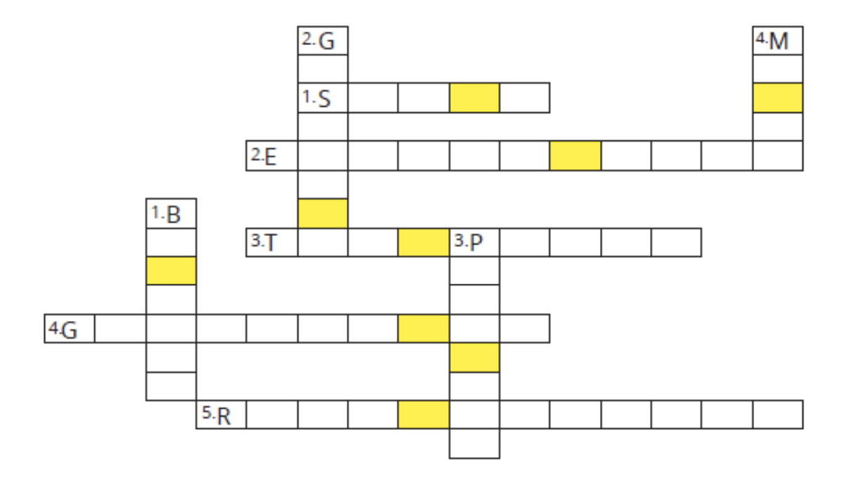

What do the letters in the coloured squares spell? _________________

**Task 2. Complete the definitions with the words in the box.**

| author | interview | ban | brush | instrument |
| --- | --- | --- | --- | --- |
| museum | novel | sculpture | frame | stage |

1 ______ – something you play to make music, such as a guitar or a piano

2 ______ – to ask someone questions about himself or herself for an article, television show, etc.

3 ______ – a person who writes books, articles, etc.

4 ______ – an object that is used to paint a picture

5 ______ – a work of art that is made from wood, stone, etc.

6 ______ – a building where objects to do with art, history, or science are shown

7 ______ – a book that tells a story about people and events that are not real

8 ______ – a structure that goes around the edge of a picture

9 ______ – to officially say something is not allowed and must not be done

10 ______ – the raised area in a theatre where actors or singers perform

**ANSWER KEY**

**Task 1**

***Across***

1. stove 2. electricity

3. telephone 4. gramophone 5. running water

***Down***

1. bandage 2. gasoline

3. printing 4. money

What do the letters in the coloured squares spell? **INVENTION**

**Task 2**

1. instrument 2. interview 3. author

4. brush 5. sculpture 6. museum

7. novel 8. frame 9. ban 10. stage

**WORDLIST**

| **Word** | **Pronunciation** | **Meaning** |
| --- | --- | --- |
| bandage (n) | /ˈbændɪdʒ/ | Băng vết thương |
| gasoline (n) | /ˈɡæsəliːn/ | Xăng dầu |
| gramophone (n) | /ˈɡræməfəʊn/ | Máy hát đĩa |
| sculpture (adj) | /ˈskʌlptʃə(r)/ | Tượng điêu khắc |