HỘI CÁC TRƯỜNG CHUYÊN
VÙNG DUYÊN HẢI VÀ ĐỒNG BẰNG BẮC BỘ


HỘI THẢO KHOA HỌC LẦN THỨ XVII
NĂM 2025
MÔN TIẾNG ANH

Tháng 7, năm 2025
Chuyên đề:

USING AI APPS TO ASSIST TEACHERS IN DESIGNING LISTERNING TASKS FOR GIFTED STUDENTS

Tháng 7, năm 2025
ABSTRACT
Using artificial intelligence (AI) tools has emerged as a promising approach to support teachers in designing listening tasks tailored for gifted students. These learners often require more challenging and stimulating materials, yet teachers may lack the time or resources to meet their advanced needs. This study aims to explore how AI applications can be effectively used to create high-quality, differentiated listening activities. Through descriptive analysis, the research examines the key features of AI-assisted task design, including content adaptation and automated question generation. Several practical tools and platforms are reviewed, with suggested strategies such as customizing reading levels, integrating authentic audio, and incorporating comprehension games. The study also presents three sets of sample tasks generated with AI tools and offers guidelines for evaluating task effectiveness. This research is intended to serve as a practical resource for teachers seeking to enhance
the learning experience of gifted students through technology.
KEYWORDS: AI apps, gifted students, listening tasks, task design

TABLE OF CONTENTS
PART A: INTRODUCTION 1
1. Rationale of the study 1
2. Aim and objectives of the study 2
3. Scope of the study 3
4. Significance of the study 3
PART B: LITERATURE REVIEW 5
1. Listening as a language skill 5
1.1. Listening skills in English Language Teaching (ELT) 5
1.2. Teaching listening skills for gifted learners 5
1.3. Teachers’ common challenges in designing effective listening activities 6
2. Artificial Intelligence (AI) and listening activities 7
2.1. Introduction to Artificial Intelligence (AI) and its role in education 7
2.2. Appyling AI in designing listening tasks 8
2.3. AI-Powered tools for designing English listening tasks 9
PART C: PRACTICAL IMPLICATIONS 10
1. Suggested workflow using AI Tools 10
1.1. Designing new questions from an existing transcript 10
1.2. Designing a new task format from an existing transcript 13
1.3. Designing fully AI-generated transcript and tasks based on an existing format 18
2. Challenges and considerations in implementing AI-assisted workflows 25
PART D: CONCLUSION 27
1. Summary of the study 27
2. Limitations of the study 28
3. Suggestions for further research 28
REFERENCES 29
APPENDIX

PART A: INTRODUCTION
This section provides a general overview of the study, outlining its rationale, aim, objectives as well as its scope and significance.

Rationale of the study
Listening, the very basic language skill is consistently interrelated and intervened with the other language skills - speaking, reading and writing. (D. Renukadevi, 2014). Rost (2011) emphasizes that listening provides input that forms the basis for language development and enables learners to acquire pronunciation, vocabulary, and grammar structures in context. According to Brown (2001), listening is a "receptive skill" that not only supports comprehension but also facilitates the development of speaking, reading, and writing. Moreover, Vandergrift (1999) emphasizes that listening provides authentic input that is crucial for internalizing linguistic structures and vocabulary. In both academic and everyday contexts, effective listening improves understanding, reduces miscommunication, and enhances interaction. It is also key in educational settings, where much of the content is delivered orally. Rost (2002) further argues that listening is an active process of constructing meaning, which requires attention, memory, and cognitive engagement.
For gifted students, listening skills play a crucial role in the language development, supporting their need for accelerated and enriched learning experiences. Gifted learners often demonstrate advanced cognitive abilities, including strong memory, analytical thinking, and rapid information processing. To fully engage these abilities, high-quality listening input is essential. As Lin (2011) points out, listening comprehension is foundational for gifted students to build higher-order thinking skills, such as inference, synthesis, and evaluation. Authentic and intellectually stimulating listening tasks allow them to access complex content, improve linguistic sensitivity, and make cross-disciplinary connections. Moreover, listening activities designed with appropriate cognitive challenge can foster autonomy and motivation in language learning (VanTassel-Baska & Brown, 2007).
Despite these benefits, listening instruction is often generalized, lacking differentiation for high-ability learners. Therefore, tailored listening activities that incorporate depth, complexity, and real-world relevance are vital for maximizing the potential of gifted students. Moreover, gifted learners often possess superior language abilities, process information quickly, and require intellectually challenging materials. However, teachers may face difficulties in independently creating listening tasks that are appropriately complex, content-rich, and engaging. As a result, the application of artificial intelligence (AI) in designing listening tasks for gifted students is essential to meet their advanced content and skill development needs. AI can generate diverse listening content, adjust difficulty levels based on student ability, and incorporate elements such as accurate pronunciation, natural speech speed, and real-world contexts (Chou, 2021). Additionally, AI supports automated question generation, learner response analysis, and task refinement suggestions, helping teachers save time while maintaining quality (Luckin et al., 2016). Therefore, AI is not merely a technical tool but also acts as a collaborative partner in personalizing and enhancing listening instruction for high-ability students.
This study seeks to explore how AI can be applied meaningfully in the design of listening tasks that align with the cognitive and linguistic profiles of gifted learners. By addressing this gap, the research aims to contribute practical solutions to help teachers save time, boost lesson effectiveness, and better meet the advanced learning needs of their students.

Aim and objectives of the study
This study aims to explore the application of Artificial Intelligence (AI) in the design of English listening tasks to enhance the learning experience of gifted students at the high school level, specifically tailored to ensure their outstanding accomplishments in NEC and other regional English competitions. By integrating AI tools, the research seeks to improve task quality, learner engagement, and the development of higher-order listening skills designed for the specific needs of talented language learners. To achieve this aim, the study sets out the following objectives:
- Identifying the specific listening needs of gifted high school students preparing for the National English Competition (NEC) and other regional contests.
- Examining how AI tools (such as automatic question generators, speech recognition, and adaptive audio platforms) can be utilized to design differentiated and challenging listening tasks.
- Evaluating the effectiveness of AI-assisted listening activities in fostering engagement, critical thinking, and higher-order listening skills among gifted learners.
- Developing sample AI-generated listening tasks aligned with NEC-style question formats and analyzing their pedagogical value.
- Proposing practical guidelines for teachers to integrate AI tools into listening task design effectively, enhancing both the quality of instruction and student performance.

3. Scope of the study
Listening comprehension is one of the core components in both language acquisition and high-stakes English assessments. In this study, the researchers focus on the application of Artificial Intelligence (AI) in the design of listening tasks tailored to the cognitive and linguistic demands of gifted high school students. Specifically, the study highlights how AI tools can support the creation of differentiated, challenging, and pedagogically sound listening exercises that align with the question types and difficulty levels found in the listening section of Vietnam’s National English Competition (NEC) for the academic year 2024–2025.
This study aims to introduce AI-driven solutions that enhance both the quality and complexity of listening materials, ultimately contributing to the development of higher-order listening skills such as inference, prediction, and synthesis. In addition, the study presents sample listening tasks generated with AI platforms that mirror the structure of NEC listening questions, thereby increasing the authenticity and practical value of the proposed methods.
To provide measurable and applicable outcomes, the research further proposes a set of evaluation criteria that teachers and exam designers can use to assess the effectiveness of AI-assisted listening tasks. These criteria serve not only as assessment tools but also as a foundation for building a more specialized and competitive listening curriculum for high-performing learners.
To maximize the study's practical applicability, the NEC 2024 - 2025 listening exam format is used as the primary reference point, ensuring all sample tasks and strategies are grounded in current national standards for academic excellence in English language learning.
- Significance of the study
This study focuses on the design of advanced English listening tasks using Artificial Intelligence (AI), with an emphasis on task types and cognitive demands aligned with the National English Competition (NEC) for the academic year 2024 - 2025. By investigating how AI tools can assist in generating listening materials that reflect the structure and rigor of NEC listening sections, the research aims to contribute both theoretically and practically to the improvement of listening instruction for gifted high school students.
Through a combination of existing literature, classroom-based observations, and practical experience in preparing students for high-stakes English exams, the authors hope to offer valuable insights into how AI can support teachers in crafting more efficient, challenging, and personalized listening tasks. These contributions are expected to not only enhance learners’ test performance but also foster the development of critical listening sub-skills such as inference, note-taking, and processing authentic audio input.
The study provides sample student-style responses and AI-generated tasks modeled on the NEC format, enabling educators to better identify common comprehension issues and typical error patterns in high-level listening performance. In addition to sample tasks, the authors propose detailed suggestions for integrating AI tools into lesson planning and listening instruction, as well as an evaluation checklist to assess task quality and learner outcomes.
With these practical and pedagogical contributions, the study aims to serve as a foundational reference for educators and curriculum designers seeking to incorporate AI in designing listening tasks for high-achieving learners, thereby raising the overall quality of listening instruction in gifted education programs.

PART B: LITERATURE REVIEW
This section provides a comprehensive overview of the theoretical and empirical literature relevant to the study. It establishes a solid foundation for the application of strategies discussed in the following sections. Key concepts related to English listening instruction, gifted education, and the integration of Artificial Intelligence (AI) in language learning are defined and examined.

1. Listening as a language skill

1.1. Listening skills in English Language Teaching (ELT)
Listening is widely recognized as a fundamental component of language acquisition and communication. As one of the four core language skills (listening, speaking, reading, and writing), it serves as the primary channel through which learners receive spoken input and develop linguistic competence. In traditional language classrooms, listening has often been treated as a passive skill. However, according to Vandergrift (2007), listening is an active process that involves predicting, inferring, and verifying meaning from spoken input. In the context of ELT, listening tasks must be well-structured to support learners in developing both bottom-up (e.g., decoding sounds) and top-down (e.g., using context and background knowledge) processing strategies (Field, 2008). Research has shown that effective listening instruction requires explicit teaching of strategies such as predicting, monitoring, and inferring (Field, 2008). Bottom-up processes (e.g., recognizing sounds, words, and syntax) and top-down processes (e.g., using background knowledge, context, and expectations) must work together to achieve successful comprehension.
For gifted students, who often possess higher levels of cognitive ability and language awareness, listening tasks should go beyond comprehension questions and encourage critical thinking, interpretation, and synthesis (Sternberg & Davidson, 2005). However, most traditional listening materials are designed for average learners, which can lead to under-stimulation for talented students. As noted by Rost (2016), advanced learners benefit from materials that encourage analysis, interpretation, and evaluation. This may involve exposure to authentic spoken texts, challenging vocabulary, and tasks that require critical engagement, such as inferring speakers’ intentions or evaluating arguments.

1.2. Teaching listening skills for gifted learners
Teaching listening skills to gifted learners requires both differentiated instruction and cognitively challenging materials. While these students often show advanced verbal intelligence, they may still struggle with certain aspects of listening, such as processing rapid speech, interpreting tone, or understanding varied accents (Anderson & Lynch, 2003). According to Vandergrift and Goh (2012), effective listening instruction must combine bottom-up (sound recognition) and top-down (meaning-making) processes. For gifted learners, this means going beyond simple comprehension tasks to include critical listening activities like evaluating the speaker’s argument or detecting bias. Authentic resources such as academic podcasts, expert interviews, and TED Talks allow students to engage with real-world input and develop inferential skills. Moreover, incorporating metacognitive strategies - such as prediction and self-monitoring - not only improves listening proficiency but also supports the autonomy that gifted learners often crave (Goh & Taib, 2006). Thus, successful listening instruction for this group should emphasize depth, complexity, and reflection.

1.3. Teachers’ common challenges in designing effective listening activities
Designing effective listening activities remains a complex task for many language teachers, particularly in diverse and exam-oriented educational settings. One of the most common challenges is the selection of appropriate input materials. Many teachers rely on scripted or artificial recordings from textbooks that fail to represent natural spoken language. These materials often lack the features of authentic speech—such as hesitations, reductions, accents, or discourse markers—which are crucial for developing real-world listening skills (Field, 2008). As a result, learners may perform well in classroom exercises but struggle to comprehend unscripted speech outside the classroom.
Another major obstacle is catering to learners with varying proficiency levels in the same classroom. Creating listening activities that are challenging yet accessible requires a nuanced understanding of students' cognitive load and language competence. Vandergrift and Goh (2012) argue that teachers must design tasks that scaffold listening through metacognitive strategies, such as predicting content, monitoring comprehension, and evaluating outcomes. However, many educators lack formal training in teaching listening strategically, leading them to rely on traditional methods like comprehension questions, which focus more on testing than on skill development.
Time constraints and institutional pressures also hinder the creation of effective listening tasks. In many educational systems, listening is often treated as a passive skill, and instructional time is allocated disproportionately to grammar or writing. Teachers may feel they do not have the time to train students in active listening strategies or to integrate reflection and discussion phases after listening tasks (Renandya & Farrell, 2011). Moreover, technological limitations can pose further difficulties. In resource-poor environments, access to quality audio equipment or internet-based tools may be restricted, reducing the teacher's ability to incorporate diverse, authentic materials into the classroom.
Finally, assessment-oriented environments contribute to the overemphasis on listening for correct answers rather than listening for understanding or interpretation. This focus reduces listening practice to a test-taking skill rather than communicative competency. Teachers, especially those preparing students for high-stakes exams, often feel pressured to “teach to the test,” which may limit creativity and variation in listening task design.
In sum, to address these challenges, professional development should emphasize the pedagogy of listening, provide training in metacognitive strategy instruction, and promote access to flexible, authentic listening resources.

2. Artificial Intelligence (AI) and listening activities
Artificial Intelligence (AI) has become an increasingly powerful tool in language education. AI-powered platforms offer personalized learning, real-time feedback, and task generation capabilities. AI tools can assist teachers in creating listening materials by generating transcripts, summarizing audio content, or even simulating spoken dialogues (Godwin-Jones, 2021).

2.1. Introduction to Artificial Intelligence (AI) and its role in education
Artificial Intelligence (AI) refers to the simulation of human intelligence in machines that are capable of performing tasks such as reasoning, learning, decision-making, and problem-solving (Russell & Norvig, 2021). Over the last decade, AI has rapidly evolved and found widespread applications across sectors, particularly in education, where it holds transformative potential.
The application of AI in education is reshaping traditional teaching and learning processes. Intelligent Tutoring Systems (ITS), automated assessment tools, adaptive learning platforms, and virtual assistants are just a few examples of how AI is personalizing instruction and supporting both students and educators (Luckin et al., 2016). By analyzing student data and learning patterns, AI can deliver customized content, identify learning gaps, and provide real-time feedback, thus enhancing learner engagement and outcomes (Chen et al., 2020).
Moreover, AI supports teachers in administrative tasks such as grading, monitoring progress, and curriculum planning, allowing them to focus more on pedagogical strategies and student interaction (Holmes et al., 2019). In this way, AI serves as both a learning facilitator and a teaching assistant, augmenting human capabilities rather than replacing them.
Importantly, AI also plays a critical role in fostering educational equity. It can offer tailored learning experiences to students with diverse needs, including those with disabilities or those who require remedial support, thus contributing to more inclusive education (Zawacki-Richter et al., 2019). However, the integration of AI in education also raises ethical concerns such as data privacy, algorithmic bias, and the digital divide. These issues must be addressed thoughtfully to ensure that AI contributes positively and equitably to the future of education.
In summary, AI is not just a technological trend but a powerful educational tool that, when applied responsibly, can revolutionize learning and teaching. This paper will further explore how AI is being implemented in educational contexts, its benefits, challenges, and future implications.

2.2. Appyling AI in designing listening tasks
Applying artificial intelligence (AI) in designing listening tasks marks a significant advancement in language education, offering personalized, efficient, and data-driven approaches to skill development. Traditional methods of creating listening materials often require extensive time, manual effort, and technical knowledge, which can be burdensome for teachers, especially in large or mixed-ability classrooms. AI-powered tools now enable educators to generate listening transcripts, convert text to natural-sounding audio, and adapt content to learners’ proficiency levels within minutes (Mellati & Khademi, 2020). For example, platforms like Google's Text-to-Speech and OpenAI’s Whisper can support the rapid development of customized materials that simulate real-life listening contexts with diverse accents and speech rates.
Moreover, AI applications can support adaptive learning by analyzing learners’ responses and adjusting task difficulty accordingly. This is particularly useful for listening, where real-time feedback and scaffolding are crucial. According to Jalilifar et al. (2021), AI systems can track learner behavior—such as pause frequency, replay rates, or incorrect answers—and provide targeted feedback that enhances comprehension and retention. In addition, AI-powered language learning platforms like ELSA and Duolingo incorporate speech recognition and listening analytics to help users practice specific phonemes, sentence structures, or listening patterns.
Beyond personalization, AI also enhances task variety. Teachers can create tasks such as multiple-choice, gap-fill, matching, or even open-ended discussion prompts based on audio input, saving valuable preparation time. As Nguyen & Khuat (2023) point out, AI-driven tools not only optimize content creation but also empower teachers to focus more on pedagogy rather than materials development.
In short, the integration of AI in designing listening tasks offers a transformative solution to many long-standing challenges in listening instruction. When used thoughtfully, it can foster learner autonomy, engagement, and meaningful listening practice tailored to individual needs.

2.3. AI-Powered tools for designing English listening tasks
AI-powered tools have transformed the creation of English listening tasks by offering innovative solutions for educators to design engaging, tailored, and effective materials. Tools like ChatGPT, Gemini, Grok, DeepSeek, and Text-to-Speech (TTS) systems provide unique functionalities to streamline the process, catering to diverse learner needs.
ChatGPT, developed by OpenAI, excels in generating contextualized listening prompts, dialogues, and comprehension questions. It can create realistic conversational scripts tailored to specific proficiency levels or topics, such as business English or casual dialogues, with customizable vocabulary and accents (OpenAI, 2023). Gemini, Google’s AI model, offers similar capabilities but emphasizes integration with multimedia platforms, enabling educators to pair listening tasks with interactive Google Workspace tools for seamless classroom use (Google, 2024). Grok, created by xAI, stands out for its ability to generate concise, culturally nuanced audio scripts and comprehension exercises, leveraging its DeepSearch mode to pull real-time linguistic data for authenticity (xAI, 2025). DeepSeek, known for its open-source approach, provides cost-effective solutions for generating listening content and analyzing learner performance through AI-driven feedback, making it ideal for large-scale educational platforms (DeepSeek, 2024). Finally, Text-to-Speech technologies, such as those from Amazon Polly or Google Cloud TTS, enable the creation of high-quality audio with natural-sounding voices in various accents, enhancing listening task realism (Amazon, 2024; Google, 2024).
These tools collectively empower educators to design dynamic, accessible, and inclusive English listening tasks, addressing diverse learning styles and proficiency levels while saving time and resources.

PART C: PRACTICAL IMPLICATIONS
This chapter provides detailed descriptions of how to implement various AI-driven tools to
support the design of listening tasks specifically tailored for gifted students.

1. Suggested workflow using AI Tools
AI-assisted tools offer flexible and scalable approaches to designing high-quality listening tasks. Depending on pedagogical goals and resource availability, teachers can adopt one of the following three approaches to integrate AI into their task design process, especially for gifted learners who require intellectually stimulating and varied input. Each strategy is described below with clear objectives, implementation steps, pedagogical benefits, and examples inspired by the National English Competition for Gifted Students 2024 –2025.

1.1. Designing new questions from an existing transcript
1.1.1. Objectives of the approach
To develop a new set of questions based on an existing listening transcript, maintaining the
original question format (e.g., multiple-choice), while shifting the cognitive focus toward different skills (e.g., inference, paraphrasing, cause-effect).
1.1.2. AI-Integrated design process
This design process includes four main steps, enabling teachers to replicate question structure and difficulty using existing transcripts.
Step 1: Input the original transcript
Select a high-quality transcript from a reliable source, such as the Listening Section of the National English Competition for Gifted Students 2024 –2025. Input this transcript into an AI platform (e.g., ChatGPT or DeepSeek) without any accompanying questions.
Step 2: Input the original questions for analysis
Provide the original set of questions to the AI and prompt it to analyze the question design.
Example prompt: Analyze the defining features, structure, cognitive focus, and format of these questions and what listening skills they assess (e.g., factual detail, inference, vocabulary in context)
Step 3: Generate new questions with the same format and cognitive features
Ask AI to design a new set of questions in the same format but covering different content from the same transcript.
Example prompt: Based on the transcript above and the prior analysis of the original task format, generate a new set of questions that:
- Follows the same question format (e.g., multiple-choice, gap-fill, true/false, matching).
- Maintains the same level of difficulty and cognitive features (e.g., inference, paraphrasing, detail recognition, overall understanding).
- Focuses on different segments or content from the same transcript (i.e., do not reuse ideas or phrases already tested in the original task).
Step 4: Review and revise the output
Examine the AI-generated questions for clarity, alignment with the transcript, cognitive challenge, and linguistic accuracy. Edit if necessary to meet the desired instructional goals for gifted students.
1.1.3. Benefits of the approach
This approach offers multiple pedagogical and practical benefits for educators working with gifted learners. Firstly, it encourages the efficient reuse of high-quality listening materials while maintaining content freshness by generating entirely new questions for each task cycle. This not only extends the life and utility of valuable transcripts but also reduces the need for constant sourcing of new input texts. Moreover, by focusing on targeted question design—such as those assessing inference, paraphrasing, or implied meaning - it promotes higher-order thinking skills that are essential for cognitively advanced students. In addition, the use of AI significantly saves time for teachers during the task creation process, while still allowing them to retain full control over task quality and cognitive alignment. Finally, this approach makes it possible to produce multiple task versions from a single transcript, making it ideal for differentiated instruction and for learners who benefit from engaging with varied question types across multiple practice sessions.
1.1.4. A suggested sample task
To demonstrate the practical implementation of this approach, a transcript and task format from Part 1 (Listening Section) of the 2024 –2025 National English Competition for Gifted Students is used as a model.
Step 1: Input the original transcript
Select the transcript of Part 1 from Listening Section of the National English Competition for Gifted Students 2024–2025. Input this transcript into ChatGPT.
Step 2: Input the original questions for analysis
Provide the original set of questions to ChatGPT and prompt it to analyze the question design.
Prompt: Analyze the structure, cognitive focus, and format of these questions, and what listening skills they assess (factual detail, inference, vocabulary in context).
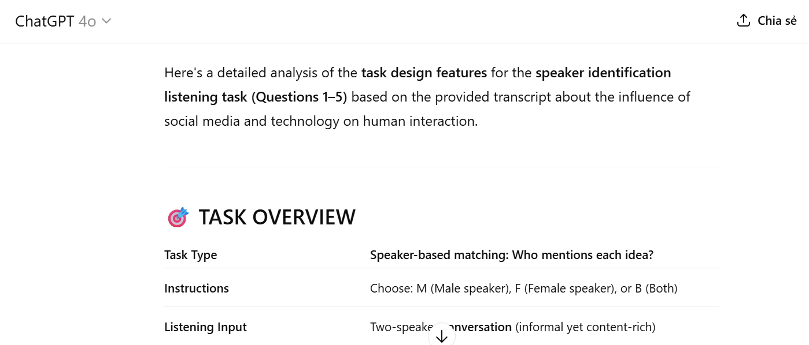
Step 3: Generate new questions with the same format and cognitive features
Ask AI to design a new set of questions in the same format but covering different content from the same transcript.
Prompt: Based on the transcript above and the detailed task analysis, generate a new set of 5 questions using the format Male / Female / Both (M/F/B). Your task is to:
- Design statement-based questions where students must attribute each idea to the correct speaker.
- Maintain the same cognitive demands as the original task.
- Ensure thematic balance, covering key ideas.
- Use different content segments from the same transcript (do not repeat ideas from the original task).
- Each question should have only one correct answer: Male / Female / Both.
Result:
Here's a set of questions following the same design principles as your example:
Speaker Attribution Task (M=Male, F=Female, B=Both):
1. The overuse of technology is turning people into socially isolated individuals.
2. Social media provides a practical solution for maintaining relationships across long distances.
3. The decline in meaningful personal relationships is a consequence of prioritizing online connections.
4. Technology’s benefits and drawbacks must be accepted as part of its inevitable presence in society.
5. Advancements in communication technology are undeniable, but they come at the cost of reduced social skills.
Suggested answer:
- Male 2. Female 3. Male 4. Female 5. Both
Step 4: Review and revise the output
Carefully review the AI-generated questions for accuracy, clarity, and alignment with the transcript. Ensure that each item reflects the intended speaker and maintains the same cognitive level as the original task. Check for clear language, balanced answer distribution (M/F/B), and coverage of different content segments. Revise any questions that are vague, misleading, or redundant. This step ensures the task is appropriate, engaging, and effective for gifted learners before classroom use.


1.2. Designing a new task format from an existing transcript
1.2.1. Objectives of the approach
To maintain the transcript but design a new task format that targets a different sub-skill (e.g., sequencing, summarizing, or identifying speaker attitudes), allowing for skill variation and deeper cognitive processing.
1.2.2. AI-Integrated design process
This design process includes four main steps, enabling teachers to create entirely new question formats from existing transcripts while ensuring an appropriate level of challenge.
Step 1: Analyze the existing transcript
Select a high-quality transcript from a reliable source, such as the Listening Section of the National English Competition for Gifted Students 2024 –2025. Input this transcript into an AI platform (e.g., ChatGPT or DeepSeek) without any accompanying questions.
Example prompt: Read and analyze the full transcript. Identify key content points, themes, vocabulary, and potential focus areas (e.g., facts, opinions, tone, sequence).
Step 2: Determine and analyze the new task format
Choose a task type different from the original (e.g., if the original was multiple choice, switch to gap-fill, matching, sentence completion, note-taking, etc.) and ensure the new format matches the target skills (e.g., inference, detail, gist, vocabulary).
Example prompt: Analyze the defining features, structure, cognitive focus, and format of these questions and what listening skills they assess (e.g., factual detail, inference, vocabulary in context)
Step 3: Design the new task
Example prompt: Based on the characteristics of the transcript provided and the format of the original listening task, generate a new set of questions that:
- Uses the same task format and response structure (e.g., M/F/B multiple-choice, gap-fill, summary completion, true/false).
- Maintains the same level of difficulty and targets equivalent listening comprehension skills, such as:
- Focuses on different content areas or sections of the same transcript, ensuring no overlap with the ideas tested in the original task.
- Preserves thematic relevance and includes a balance of question types requiring both direct recall and interpretive comprehension.
Step 4: Review and adjust
Check alignment between the transcript and the new task as well as ensure clarity, fairness, and no ambiguity in instructions or question stems.
1.2.3. Benefits of the approach
This approach offers several practical and pedagogical benefits. First, it maximizes the reusability of authentic materials by allowing teachers to develop new tasks without the need to search for or create entirely new transcripts. This saves time while maintaining exposure to meaningful input. Second, designing a new task format enables educators to target different listening sub-skills – such as identifying main ideas, interpreting speaker attitudes, or inferring meaning – thereby promoting a more comprehensive development of listening competence. Finally, this method supports differentiation and cognitive challenge, especially for gifted or advanced learners. By keeping the same content but changing the format, teachers can adapt the task to suit various learner profiles and maintain engagement through novelty and increased complexity.
1.2.4. A suggested sample task
For illustration purposes, this study employs a transcript from Part 2 and adapts a task format from Part 3 (Listening section) of the 2024 – 2025 National English Competition for Gifted Students, serving as a representative model for task redesign.
Step 1: Analyze the existing transcript
Input the transcript of part 2 (Listening Section) into Grok (an AI platform) and ask Grok to analyze its features.
Prompt: Read and analyze the full transcript. Identify key content points, themes, vocabulary, and potential focus areas (e.g., facts, opinions, tone, sequence)
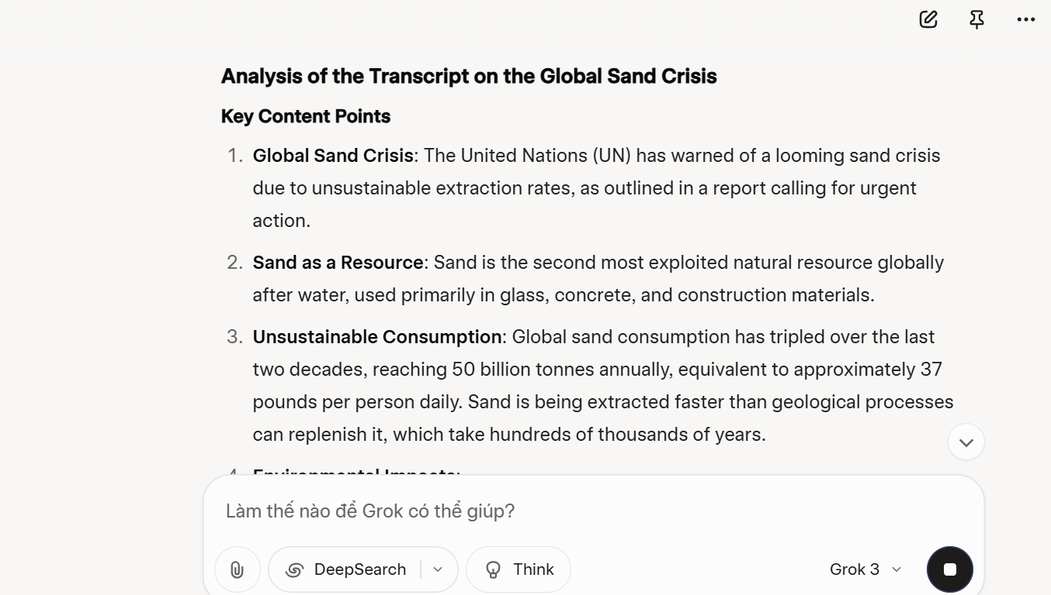
Step 2: Determine and analyze the new task format
Choose the task type from Part 3 (Listening Section) and ask Grok to analyze its features.
Prompt: Analyze the defining features, structure, cognitive focus, and format of these questions and what listening skills they assess (e.g., factual detail, inference, vocabulary in context)
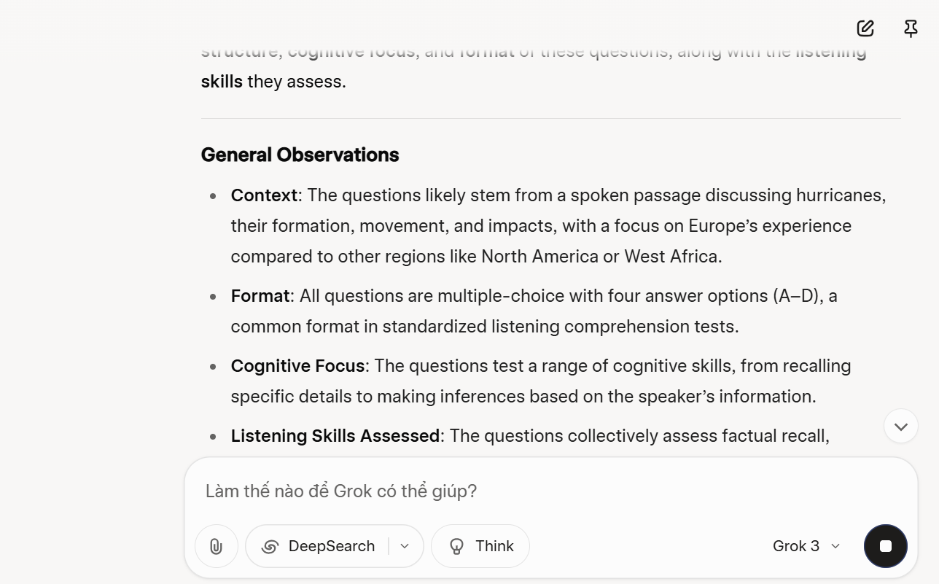
Step 3: Design the new task
Based on the characteristics of the transcript on the global sand crisis and the design of the original listening task, generate a new set of 5 multiple choice questions that meet the following criteria:
- Format consistency
+ Use the same question format as the original task
+ Follow the same response structure (four-option MCQs).
- Cognitive features
+ Maintain the same level of difficulty and focus on equivalent listening skills
+ Paraphrase recognition (statements should not repeat transcript language verbatim).
- Content scope
+ Focus on different segments or content areas of the same transcript that were not covered by the original questions.
+ Avoid repeating any previously tested ideas or phrases.
- Thematic alignment: preserve thematic relevance by ensuring that the new questions reflect key transcript themes.
Result:
1. Which of the following is true about sand as a global resource?
A. It is the most exploited natural resource in the world, surpassing water.
B. Its global consumption has doubled over the past two decades to 50 billion tonnes annually.
C. Sand is primarily used in agriculture and water purification processes.
D. Geological processes replenish sand at a rate that matches current extraction levels.
2. According to the speaker, sand extraction________________
A. is a highly regulated process globally, ensuring sustainable use.
B. causes environmental damage by altering river flows and erasing small islands.
C. occurs mainly in developed nations to support industrial manufacturing.
D. has no significant impact on coastlines or biodiversity.
3. Which of the following is an immediate result of excessive sand removal in the Mekong Delta?
A. The delta is sinking due to sand extraction and water withdrawal.
B. African villages are increasingly relying on Mekong sand for urban construction.
C. The Mekong River’s flow has reversed, allowing saltwater crocodiles to move inland.
D. Global sand consumption has decreased due to alternative materials.
4. All of the following contribute to the sand crisis EXCEPT________________
A. ungoverned extraction practices.
B. recycling of concrete materials.
C. rising demand for construction in Africa.
D. sea level rise exacerbating coastal vulnerability.
5. Which of the following can be inferred from the talk?
A. The sand crisis will have no impact on global food security in the next decade.
B. Without intervention, coastal communities in Africa may face increased risks from climate change.
C. By 2050, Sri Lanka’s rivers will no longer support sand extraction due to regulatory bans.
D. Recycling concrete will completely eliminate the need for sand extraction globally.
Suggested answer: 1. A 2. B 3. A 4. B 5. B
Step 4: Review and adjust
Review the new questions to ensure they align with the transcript and match the cognitive level of the original task. Check that each item targets different content areas, uses effective paraphrasing, and avoids ambiguity. Verify that the correct answers are supported by the transcript and that distractors are plausible. Ensure clarity in wording, fairness in content, and consistency in format. Make adjustments as needed to improve accuracy, difficulty balance, and thematic relevance before classroom use.


1.3. Designing fully AI-generated transcript and tasks based on an existing format
1.3.1. Objectives of the approach.
To use AI to create both a new transcript and corresponding task set based on a model (e.g., from the national exam), allowing for greater flexibility and topic expansion while preserving task consistency.
1.3.2. AI-Integrated design process
This approach involves leveraging AI tools to automatically generate both the transcript and corresponding listening tasks, while strictly adhering to the structure, style, and cognitive features of a pre-existing task format (e.g., from national or standardized exams). It enables educators to create fresh, coherent, and level-appropriate listening materials with minimal manual input. The process typically includes the following steps:
Step 1. Analyze the original transcript
Carefully examine an existing transcript from a trusted listening task (e.g., from a national exam). Example prompt: Identify key features of an existing transcript such as topic, length, speaker roles, tone, sentence complexity, vocabulary range, and content structure.
Step 2. Generate a similar transcript using AI
Prompt an AI tool (e.g., ChatGPT, Gemini, or DeepSeek) to create a new transcript that mimics the original in terms of topic, structure, and difficulty level. Use a Text-to-Speech (TTS) platform (e.g., ElevenLabs, Narakeet, or NaturalReader) to convert the new transcript into audio for use in actual listening tasks.
Example prompt: Based on the original transcript, create a new transcript that closely mirrors it in terms of:
- Topic domain: Address a closely related issue (e.g., if the original discusses environmental crises caused by resource exploitation, the new transcript might explore water scarcity, deforestation, or air pollution).
- Structure: Maintain a similar organizational pattern (e.g., introduction → examples → expert opinion → proposed solutions).
- Length and complexity: Match the difficulty level, sentence length, and lexical density (approximately ___ words; include technical and abstract vocabulary suitable for B2+/C1 learners).
- Tone and purpose: Preserve the same informative and cautionary tone, incorporating credible sources (e.g., experts, organizations like the UN or WHO) to enhance authority.
Step 3. Analyze the question format and features
Study the question format of the original task (e.g., multiple choice, gap-fill, sentence completion). Pay attention to question types, number of items, cognitive skills tested (e.g., inference, gist, detail), and instructions.
Example prompt: Analyze the defining features, structure, cognitive focus, and format of these questions and what listening skills they assess (e.g., factual detail, inference, vocabulary in context)
Step 4. Design new questions using AI based on the new transcript and original features
Ask the AI to generate a new set of questions that follows the same format and structural features of the original task, aligns with the content and focus of the newly generated transcript and maintains a comparable level of difficulty and cognitive demand
Example prompt: Based on the newly generated transcript below and using the same format and question features as in the original task (e.g., [insert format: multiple choice / gap-fill / note completion]), design a new set of questions. The questions should:
– Match the same number of items (e.g., 5 questions)
– Reflect the same listening skill focus (e.g., inference/detail/gist)
– Maintain the same level of difficulty
– Follow the same layout and instructions as the original format
Transcript:
[Insert your AI-generated transcript here]
Original Format Features:
– Task type: [e.g., Sentence Completion]
– Number of blanks: [e.g., 5]
– Max words per answer: [e.g., No more than three words]
– Skills tested: [e.g., detailed understanding, vocabulary recognition]
Step 5. Review and refine the AI-generated task.
Evaluate the quality and alignment of the new task. Check for clarity, answerability, skill coverage, and language accuracy. Make manual adjustments if needed to ensure the task meets pedagogical and assessment goals.
    - Benefits of the approach.
This approach offers several notable benefits for educators and curriculum designers, particularly in contexts that demand high levels of customization, such as gifted education or specialized exam preparation. By prompting AI tools to generate entirely new transcripts while adhering to the structure, topic domain, and cognitive demands of an existing task format, teachers can rapidly expand their bank of listening materials without sacrificing quality or alignment with instructional goals. This method enhances content freshness and thematic diversity, making listening practice more engaging for learners. Moreover, it allows educators to target specific listening skills—such as inference, paraphrasing, and speaker attribution—by embedding them into custom-designed scenarios. Another advantage is the seamless integration with Text-to-Speech (TTS) platforms, enabling quick transformation of scripts into high-quality audio files for classroom or testing use. Ultimately, this approach supports both pedagogical efficiency and innovation, empowering teachers to generate original, level-appropriate content while maintaining rigorous assessment standards.
1.3.4. A suggested sample task
To demonstrate the feasibility and pedagogical value of fully AI-generated listening materials, this study employs the transcript and task format from Part 4 of the 2024 – 2025 National English Competition for Gifted Students as a representative model. By using this part of the exam as a template, the AI-generated transcript and question set maintain a comparable level of difficulty, thematic depth, and cognitive demand. This illustrates how generative tools can produce listening materials that align with national standards while offering flexibility in topic selection and reusability for classroom or assessment contexts.
Step 1. Analyze the original transcript
Carefully examine the existing transcript of Part 4 (the 2024 – 2025 National English Competition for Gifted Students) using DeepSeek.
Prompt: Identify key features of an existing transcript such as topic, length, speaker roles, tone, sentence complexity, vocabulary range, and content structure.
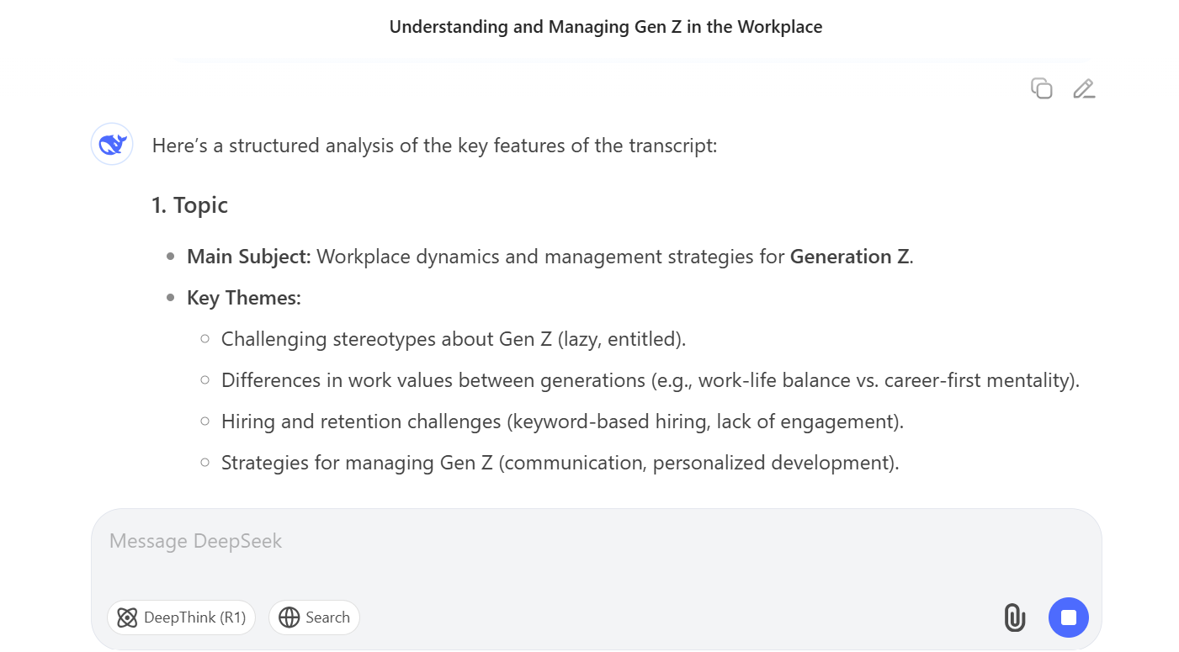
Step 2. Generate a similar transcript using AI
Prompt ChatGPT to create a new transcript that mimics the original in terms of topic, structure, and difficulty level.
Prompt: Based on the original transcript, create a new transcript that closely mirrors it in terms of:
- Topic: the ongoing tensions between Israel and Iran
- Structure: Maintain a similar organizational pattern (introduction → examples → expert opinion → proposed solutions).
- Length and complexity: Match the difficulty level, sentence length, and lexical density (approximately 650 words; include technical and abstract vocabulary suitable for C1 learners).
- Tone and purpose: Preserve the same informative and cautionary tone, incorporating credible sources to enhance authority.
Use a Text-to-Speech (TTS) platform (aistudio) to convert the new transcript into audio for use in actual listening tasks.
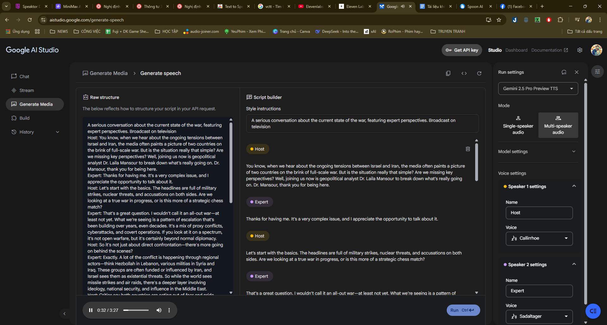
Step 3. Analyze the question format and features
Study the question format of the original task (Part 4, Summary Completion) using Gemini. Pay attention to question types, number of items, cognitive skills tested (e.g., inference, gist, detail), and instructions.
Prompt: Analyze the defining features, structure, cognitive focus, and format of these questions and what listening skills they assess (e.g., factual detail, inference, vocabulary in context)
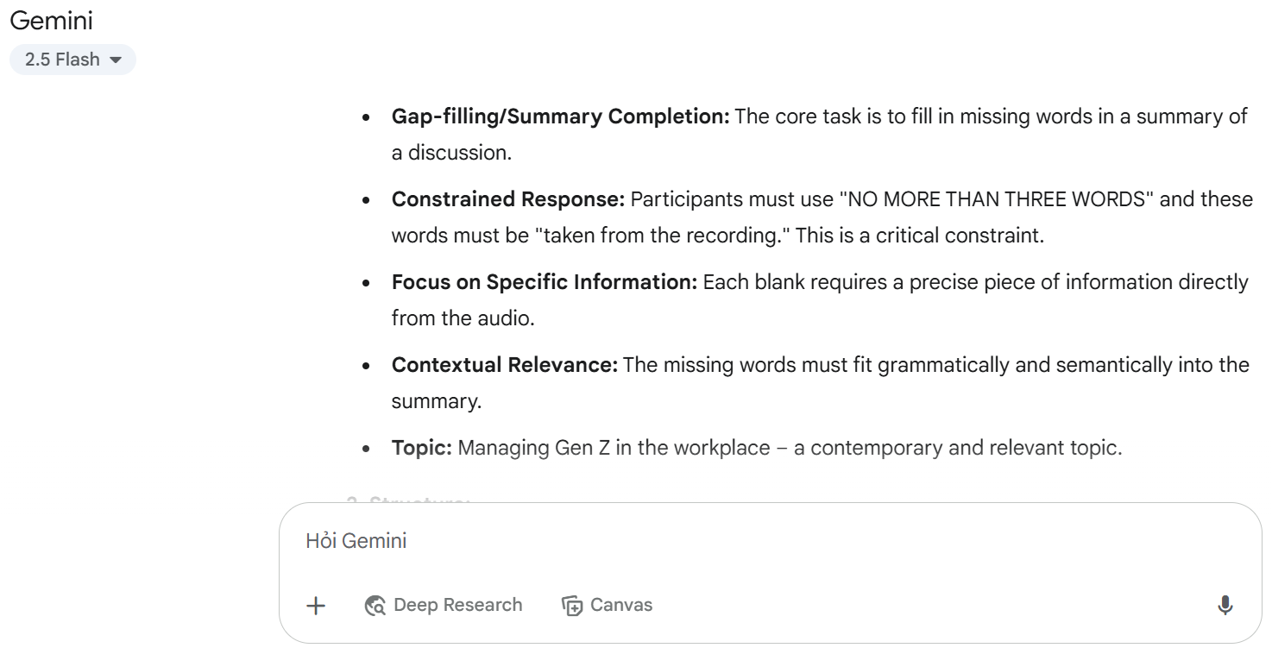
Step 4. Design new questions using AI based on the new transcript and original features
Ask ChatGPT to generate a new set of questions that follows the same format and structural features of the original task, aligns with the content and focus of the newly generated transcript and maintains a comparable level of difficulty and cognitive demand
Prompt: Based on the newly generated transcript below and using the same format and question features as in the original task (summary completion), design a new set of questions. The questions should:
– Match the same number of items (10 blanks)
– Reflect the same listening skill focus (detail/gist)
– Maintain the same level of difficulty
– Follow the same layout and instructions as the original format
Transcript:
[Insert the AI-generated transcript here]
Original Format Features:
– Task type: [Summary Completion]
– Number of blanks: [10]
– Max words per answer: [No more than three words]
– Skills tested: [detailed understanding, vocabulary recognition]
Result: In a recent interview, geopolitical analyst Dr. Laila Mansour explains that the conflict between Israel and Iran is not a full-scale war but rather a (1) ____________ involving covert operations and indirect confrontations. While much of the violence appears military, there are significant (2) ____________ through regional groups like Hezbollah.
These groups, according to Dr. Mansour, are often supported by Iran and perceived by Israel as (3)____________. The discussion reveals that much of the tension stems from a (4)____________ between both sides, with Iran seeking deterrence through nuclear capability, and Israel refusing to accept any such potential.
Despite the escalation, the expert notes that (5) ____________ has occurred even in moments of crisis, although building (6) ____________ remains difficult in this part of the world. The role of (7)____________ like the US and the EU has further influenced the direction of the conflict through sanctions and military support.
Dr. Mansour warns that a direct war could impact issues far beyond the Middle East, including global (8) ____________, cybersecurity, and population movement. She emphasizes that people should care about the conflict because it could become a major (9) ____________ with widespread consequences.
She concludes by saying that the only viable way forward is to increase efforts in (10) ____________, rather than relying solely on force.
Suggested answer:
1. proxy conflict 6. mutual trust
2. political dimensions 7. external powers
3. threats 8. security
4. strategic standoff 9. geopolitical crisis
5. diplomatic engagement 10. diplomacy
Step 5. Review and refine the AI-generated task.
After generating the transcript and corresponding listening task using AI, it is crucial to conduct a comprehensive review to ensure the output meets the desired pedagogical and assessment standards. This step involves checking for content accuracy, clarity, and consistency with the original task format. Questions must align with the cognitive demands of the source task—such as inference, paraphrasing, or identifying speaker viewpoints - and should present a balanced mix of explicit and interpretive items. Language should be natural, grammatically correct, and accessible to the target proficiency level. Additionally, distractors in multiple-choice questions must be plausible yet clearly distinguishable from the correct answers. Finally, the answer key should be verified for accuracy, with brief justifications provided if needed. Through this review process, educators can refine the task to ensure it maintains both the integrity and effectiveness of the listening assessment.



2. Challenges and considerations in implementing AI-assisted workflows

While the proposed workflows demonstrate the practical value of using AI tools in designing listening tasks for gifted students, their implementation in real educational contexts presents several challenges that require careful consideration.

Firstly, the quality and effectiveness of each workflow depend heavily on teachers’ ability to formulate clear, precise, and pedagogically sound prompts. For example, in Workflow 1.1 and 1.2, where new questions or formats are generated from an existing transcript, the outcome is highly influenced by how well the teacher communicates the intended question type, level of difficulty, or cognitive focus to the AI tool. Teachers unfamiliar with prompt engineering may struggle to produce reliable outputs, leading to inconsistent task quality. Therefore, successful implementation requires not only access to AI tools but also training in AI literacy and task design principles.

Secondly, although AI tools can automate and accelerate the task design process, they are not immune to content limitations. AI-generated transcripts (Workflow 1.3), for instance, may sometimes include unnatural phrasing, lack contextual coherence, or fail to reflect the cultural or linguistic depth expected in materials for gifted learners. Moreover, question items derived from these transcripts might not always meet the standards of validity and reliability required for advanced learners. As a result, every workflow must include a human-in-the-loop step, where the teacher reviews, edits, and adapts AI outputs to ensure alignment with learning objectives and student profiles.

Thirdly, issues of technological access and teacher readiness also come into play. Not all schools or educators have equal exposure to advanced AI platforms or the time to experiment with multiple prompt iterations. While the workflows are theoretically sound and practically useful, their success in classroom application may vary depending on institutional support, teacher digital competence, and the availability of AI-integrated resources.

Finally, from an ethical and pedagogical standpoint, educators must be aware of potential biases and unintended consequences in AI-generated content. Listening materials created without careful oversight could misrepresent accents, reinforce stereotypes, or include inappropriate content for younger gifted learners. Additionally, overreliance on AI tools without pedagogical reflection may lead to task standardization rather than differentiation — the very opposite of what gifted education requires.

In sum, while the AI-assisted workflows offer a structured, innovative, and time-saving approach to listening task design, their implementation must be accompanied by teacher training, quality assurance protocols, and ethical awareness. By proactively addressing these challenges, educators can make the most of AI’s potential while maintaining the pedagogical integrity essential for educating gifted students.

PART D: CONCLUSION
In this part, the primary findings of the study on using AI to design English listening tasks are summarized along with the overall outcomes. The study shows that AI can effectively generate transcripts and questions aligned with standard task formats and cognitive demands. Furthermore, the researchers offer recommendations for future studies, highlighting the need for human review to ensure accuracy and quality. Future research should explore integrating AI with text-to-speech tools and adaptive task generation to enhance listening task development.

1. Summary of the study
The findings of the study confirm that artificial intelligence (AI) holds significant potential in supporting the design of high-quality English listening tasks for gifted high school students. Through the integration of AI tools such as ChatGPT, DeepSeek, Grok and Gemini, educators can generate listening transcripts and question sets that mirror the cognitive complexity, structure, and format of standardized assessments, particularly the National English Competition (NEC) for the academic year 2024 –2025. The study demonstrates that AI is capable of producing not only content-rich and thematically appropriate transcripts but also differentiated task types that assess a range of listening sub-skills, including inference, paraphrasing, and detailed comprehension.
One of the key findings is that AI-assisted task design significantly reduces the time and effort traditionally required for listening material development while allowing for greater flexibility in topic selection and cognitive targeting. The ability to replicate national exam formats with comparable linguistic difficulty and question structure ensures that AI-generated tasks maintain pedagogical relevance and assessment validity. Moreover, the use of Text-to-Speech (TTS) technologies enables educators to convert AI-generated scripts into high-quality audio materials with natural pacing, pronunciation, and accent diversity, thereby enhancing the authenticity of listening input.
The study also highlights that while AI is highly effective in generating initial drafts of listening tasks, human oversight remains essential. Teachers must review and refine AI-generated content to ensure alignment with specific learning goals, remove ambiguities, and adjust for cultural or contextual appropriateness. Nonetheless, the combination of AI generation and teacher moderation creates an efficient workflow that fosters both instructional innovation and learner engagement. Overall, the findings suggest that AI offers a promising, scalable, and customizable solution for designing advanced listening tasks that support the linguistic and cognitive development of gifted learners in high-stakes academic environments.

2. Limitations of the study
This study on the application of AI in designing English listening tasks for gifted high school students, while insightful, has several limitations. It focuses on a limited set of AI tools (e.g., ChatGPT, Gemini, Grok, DeepSeek), potentially overlooking other emerging technologies, and its emphasis on the National English Competition (NEC) 2024 –2025 format restricts generalizability to other contexts or learner groups. The reliance on descriptive analysis and sample task generation, without empirical classroom testing, leaves the effectiveness of AI-generated tasks unverified. Additionally, the study assumes teacher familiarity with AI tools, which may not hold in resource-constrained settings, and it does not fully address ethical concerns like data privacy or the digital divide. The dependence on high-quality input transcripts, lack of student feedback, and unexamined time demands for reviewing AI outputs further limit practical applicability. Future research should empirically test these tasks, explore a broader range of tools, and address ethical and accessibility barriers to ensure equitable implementation.

3. Suggestions for further research
To build on the current study’s exploration of Artificial Intelligence (AI) in designing English listening tasks for gifted high school students, further research is recommended to address its limitations and broaden its impact. First, empirical studies should test AI-generated tasks in real classroom settings with gifted students preparing for the National English Competition (NEC), measuring outcomes like listening comprehension, engagement, and higher-order skills such as inference and synthesis, while comparing these tasks to traditional ones. Second, investigating a wider array of AI tools, including advanced speech synthesis, real-time analytics, or virtual reality platforms, could uncover additional functionalities and cost-effective solutions for task design. Third, expanding the study’s scope to diverse contexts, such as international exams (e.g., IELTS, TOEFL), non-gifted learners, or varied age groups, would enhance the generalizability of AI-assisted methods across curricula and cultures. Finally, research should focus on teacher training programs to address technological and pedagogical barriers, ensuring educators can effectively integrate AI tools, while also exploring ethical considerations like data privacy and equitable access to technology to promote inclusive implementation.

REFERENCES
AI. (2025). Grok: Designing Educational Content. Retrieved from https://x.ai/grok
Amazon. (2024). Amazon Polly: Text-to-Speech. Retrieved from https://aws.amazon.com/polly/
Anderson, A., & Lynch, T. (2003). Listening. Oxford University Press.
Brown, H. D. (2001). Teaching by Principles: An Interactive Approach to Language Pedagogy (2nd ed.). Longman.
Chou, C. C. (2021). The Potential of Artificial Intelligence in Language Learning: A Review of Recent Applications. Journal of Educational Technology & Society, 24(2), 35–47.
DeepSeek. (2024). DeepSeek: AI for Education. Retrieved from https://www.deepseek.com/
D. Renukadevi, International Journal of Education and Information Studies. ISSN 2277-3169 Volume 4, Number 1 (2014), pp. 59-63 © Research India Publications http://www.ripublication.com
Field, J. (2008). Listening in the Language Classroom. Cambridge University Press.
Godwin-Jones, R. (2021). "AI tools for language learning: Promises and perils." Language Learning & Technology, 25(3), 1–14.
Goh, C. C. M., & Taib, Y. (2006). Metacognitive instruction in listening for young learners. ELT Journal, 60(3), 222–232.
Google. (2024). Gemini and Google Cloud TTS. Retrieved from https://cloud.google.com/text-to-speech
Jalilifar, A., et al. (2021). Smart Learning Systems: AI Tools in Enhancing EFL Listening Comprehension. International Journal of Emerging Technologies in Learning (iJET), 16(23), 145–152.
Lin, Y. (2011). Fostering listening comprehension in gifted language learners: Challenges and strategies. Gifted Education International, 27(3), 249–261.
Luckin, R., Holmes, W., Griffiths, M., & Forcier, L. B. (2016). Intelligence Unleashed: An Argument for AI in Education. Pearson Education.
Luckin, R. et al. (2016). Intelligence Unleashed: An Argument for AI in Education. Pearson.
Mellati, M., & Khademi, M. (2020). Artificial Intelligence in Language Learning: Enhancing Nguyen, T. M., & Khuat, T. H. (2023). Using AI to Assist English Language Teachers in Material Design. Vietnam Journal of Educational Technology, 19(1), 34–41.
OpenAI. (2023). ChatGPT for Education. Retrieved from https://openai.com/

Pham, T. T., & Nguyen, H. N. (2022). “AI in Vietnamese Education: Benefits and Barriers.” Vietnam Journal of Education Studies, 43(2), 57–64.
Renandya, W. A., & Farrell, T. S. C. (2011). ‘Teacher, the tape is too fast!’: Extensive listening in ELT. ELT Journal, 65(1), 52–59.
Rost, M. (2002). Teaching and Researching Listening. Pearson Education.
Rost, M. (2011). Teaching and Researching Listening (2nd ed.). Pearson Education.
Rost, M. (2016). Teaching and Researching Listening (2nd ed.). Routledge.
Sternberg, R. J., & Davidson, J. E. (2005). Conceptions of Giftedness. Cambridge University Press.
Settles, B., & Meeder, B. (2016). A Trainable Spaced Repetition Model for Language Learning. Proceedings of the Association for Computational Linguistics.
Students’ Listening Skills. Theory and Practice in Language Studies, 10(5), 567–574.
Tomlinson, C. A. (2014). The Differentiated Classroom: Responding to the Needs of All Learners. ASCD.
Vandergrift, L. (1999). Facilitating second language listening comprehension: Acquiring successful strategies. ELT Journal, 53(3), 168–176.
Vandergrift, L. (2007). “Recent developments in second and foreign language listening comprehension research.” Language Teaching, 40(3), 191–210.
VanTassel-Baska, J., & Brown, E. (2007). Curriculum for gifted and talented students. Prufrock Press.
Vandergrift, L., & Goh, C. M. (2012). Teaching and Learning Second Language Listening: Metacognition in Action. Routledge.
Zawacki-Richter, O. et al. (2019). Systematic Review of Research on AI Applications in Higher Education. IJETHE, 16(1), 1–27.

APPENDIX
THE LISTENING SECTION OF VIETNAM’S NATIONAL ENGLISH COMPETITION (NEC) FOR THE ACADEMIC YEAR 2024–2025
LISTENING (5.0 points)
• The listening section is in FOUR parts. You will hear each part TWICE. At the beginning of each part, you will hear a sound.
• There will be a piece of music at the beginning and at the end of the listening section. You will have TWO minutes to check your answers at the end of the listening section.
• Al/ the other instructions are included in the recording.
Part 1. For questions 1 — 5, listen to two friends discussing the influence of technology and social media on human interaction, and decide whether the following are mentioned by only one of the speakers, or by both of them. In the corresponding numbered boxes provided,
write M for the Male speaker;
F for the Female speaker;
B for Both of the speakers.
1. A personal shortcoming that can be addressed
2. An improvement made to an existing system
3. A leisure activity that has been made unnecessary
4. An existing phenomenon that has been irreversible
5. A natural ability that is being hindered
Your answers:
1. | 2. | 3. | 4. | 5.
Part 2. For questions 6 — 10, listen to a news report on sand crisis and match each number (6 — 10) in Column I with one letter (A — J) in Column Il to make a correct statement according to what Is stated or implied by the speaker(s). Write your answers in the corresponding numbered boxes provided.
Column I | Column Il
- Africa  - Sri Lanka  - The Mekong delta  - The United Nations  - The world | - is having geographical features damaged and removed due to sand extraction.  - is imposing a strict prohibition on the extraction of sand from beaches and rivers.  - is facing risks from wild animals as a result of sand removal.  - is consuming sand at the rate of more than 37 pounds per person per day.  - is having rare reptiles swept away together with sand from the rivers.  - is being faced with agricultural problems due to excessive exploitation of sand.  - is facing threats from extreme weather phenomena, especially in its coastal areas.  - is exploiting and using sand 'in a more unregulated manner than water.  - is proposing reducing demand for mining sand by means of reusing and recycling.  - is facing the problem of fresh water getting undrinkable due to salinisation.

Your answers:
6. | 7. | 8. | 9. | 10.
Part 3. For questions 11 — 15, listen to a talk about hurricanes and write the letter A, B, C, orD in the numbered boxes provided to indicate the correct answer to each of the following questions according to what you hear.
11. Which of the following is true about Europe?
A. The continent receives hefty doses of wind and rain over the years.
B. The continent has not been struck by any hurricane for over a century.
C. Europe has fewer hurricanes yet more wind and rain than North America during the hurricane season.
D. In terms of protection against hurricanes, Europe has a geographical advantage over North America.
12. According to the speaker, a hurricane
A. is a tropical storm formed off the coast of West Africa which travels across the Atlantic
B. necessitates a combination of warm water and humidity that picks up enough rotating air
C. is a column of rapidly rising rotating air that has picked up a great deal of warm, moist air
D. travels across the Atlantic from the coast of West Africa after collecting enough warm and wet air
13. Which of the following is the immediate result of the trade winds?
A. The hurricanes are driven to the far North over a long distance to reach Europe.
B. Europe has been affected by a smaller number of hurricane remnants than Florida.
C. Both Europe and the West Coast of the U.S. rarely experience direct hits from full-blown hurricanes.
D. The force of a hurricane is reduced to that of a tropical storm or even weaker when it makes a landfall.
14. All of the following cause a hurricane to waver by the time it reaches Europe EXCEPT __
A. Europe's location
B. the water fronts
C. the colder currents
D. subtropical jet streams
15. Which of the following can be inferred from the talk?
A. Given the increasingly serious global warming, Europe will no longer be safe from hurricane force storms.
B. By the end of the 21 st century, Northern Russia will suffer from hurricane remnants even more than Ireland.
C. Remnants of hurricanes when landing on the Europe's shore would cause extensive damage but no casualties.
D. Ireland will not be stricken by any storm more powerful than Hurricane Ophelia remnants in the next 50 years.
Your answers:
11. | 12. | 13. | 14. | 15.
Part 4. For questions 16 — 25, listen to part of a discussion about managing Gen Z in the workplace and complete the following summary. Write NO MORE THAN THREE WORDS taken from the recording for each space. Write your answers in the corresponding numbered boxes provided.
The portrayal of Gen Z as (16) _________and uncooperative is a perception that is being questioned and the guest also believes it would be unfair to look at (17) _______such as age to make an overgeneralisation for the whole generation. The negative cases are likened to the front and back of a (18) _______while the majority of Gen Z are described as clever, motivated, curious, and creative. In the previous generations, the term (19) _______ " was used to label individuals that could achieve (20) _______ together with a successful career and a happy family. However, Gen Z would rather try something new when seeing many of their predecessors fail to obtain these. The ideal of working hard and getting promoted at work does not seem to belong to the mindset of Gen Z, which accounts for the cases of (21)______ or the lack of loyalty to the company reported on social media. However, according to the guest, there exist certain (22) _______in common recruitment practices that disregard the interpersonal skills as well as (23) _______essential for workplace achievement. This causes a significant proportion of Gen Z newcomers to fail to thrive in sales roles within their first year due to the lack of competitiveness and (24) _______ required of a salesperson. The guest concludes that it is impossible to implement uniform strategies to motivate Gen Z employees, so the first thing to do is to (25) _______them and find ways to make them feel like part of the company.
Your answers:
16. | 17.
18. | 19.
20. | 21.
22. | 23.
24. | 25.

TRANSCRIPTS OF THE LISTENING SECTION
PART 1.
Man: Did you see that documentary last night about the rise in social media, and how some experts are linking that rise to a breakdown in society?
Woman: No, I didn't see it. Was it good?
Man: Actually, it was quite disturbing. They were explaining how people have lost the art of talking, and we're all becoming a race of recluses glued to our monitors, constantly checking people's status and updates instead of meeting people in person. I never really thought about it before, but now it seems obvious. I mean, we've all been there. You're out with your friends, and instead of talking to each other, everyone is on their smartphone or tablet. Makes you think why you bother meeting up in the first place.
Woman: Okay, I get your point, but I'm sure the situation's not as terrible as all that. Social media is just another communication tool. And while I'll grant you some people take it to the extreme, I think your average user is quite sensible, and it is a great way to keep in touch with friends and family that live further afield. Before, we only had landlines and snail mail, which had their uses, but with instant messaging and video calling, it's so much better.
Man: Well, yeah, technology has advanced long-distance communication, there's no doubt about that, but our ability to form close relationships and maintain the ones we already have is suffering. The type of relationships that people use to invest their time and energy into cultivating are falling by the wayside in favor of multiple contacts online.
Woman: I think you're exaggerating the problem.
Man: Am I? It's affecting people's ability to hold one-to-one conversations in everyday settings. The documentary said that new hires in a lot of companies lack the social skills to succeed in face-to-face interactions, and that can be directly attributed to the increase in the use of technology.
Woman: I don't know that we can blame technology for that. Society itself seems to be moving away from the close-knit community in favor of global interactions. Besides, for a lot of people, the inability to conduct intimate relationships is hardwired. They're just shy or feel awkward in certain social settings. In fact, technology may actually be helping those people by providing them a means by which they can grow their social circle that they otherwise wouldn't have. So when you're talking about recluses.
Man: well, one might see that as an advantage. But do you really think it's helping them to stay cooped up all day with no outside contact? Surely it would be better to encourage them to overcome their shyness and meet new people the old-fashioned way. Otherwise, they might become more introverted and secluded from society, which can't be good for anyone.
Woman: Maybe, but I don't think it's all doom and gloom. As with anything, there's good and bad points, and you have to take the rough with the smooth, because there's one thing that's for sure. Technology isn't going anywhere. It's here to stay, and there's no getting around that.
PART 2.
The world faces a looming sand crisis, the UN has warned. It issued a report calling for urgent action to avert it, including a ban on beach mining.
It's renewing at a geological rate and we are extracting at such a fast rate.
Let's take a look at what's causing the damage and where. Sand is the most exploited natural resource in the world after water. It's used in glass, concrete and construction materials.
But its use is largely ungoverned, meaning we are consuming it faster than it can be replaced by geological processes that take hundreds of thousands of years. Global consumption has tripled over two decades to reach 50 billion tonnes a year. That's the equivalent of about 37 pounds per person each day.
Sand extraction is harming rivers and coastlines and even wiping out small islands. One example is a Sri Lankan river where sand removal reversed the water flow. That means ocean water is heading inland and bringing saltwater crocodiles with it.
Removal like this is happening around the world to feed construction. Meanwhile, the longest river in Southeast Asia, the Mekong, is sinking. Pascal Puzzi is the UN Environment Programme Director.
In the Mekong River, for example, there's so much sand taken out of the Mekong Delta that the delta is sinking also because of water withdrawing. And on top of that, you have sea level rise, so you're losing ground, you're getting more salinisation of this fertile soil. So we're going to see a lot of impact that is the crisis that is looming and that we want to avert.
Demand is now seen as shifting to Africa, where villages often remove sand from lakes or beaches to build growing cities. This puts coastlines more at risk to the impact of climate change, such as powerful storms. So what are the solutions? The UN recommends a ban on beach extraction and a creation for an international standard for marine dredging that harms ocean biodiversity.
It is also calling for reducing demand by reusing sand from recycled materials like concrete left over from mining. Now listen to part two again. The world faces a looming sand crisis, the UN has warned.
It issued a report calling for urgent action to avert it, including a ban on beach mining. It's renewing at a geological rate and we are extracting at such a fast rate. Let's take a look at what's causing the damage and where.
Sand is the most exploited natural resource in the world after water. It's used in glass, concrete and construction materials. But its use is largely ungoverned, meaning we are consuming it faster than it can be replaced by geological processes that take hundreds of thousands of years.
Global consumption has tripled over two decades to reach 50 billion tons a year. That's the equivalent of about 37 pounds per person each day. Sand extraction is harming rivers and coastlines and even wiping out small islands.
One example is a Sri Lankan river where sand removal reversed the water flow. That means ocean water is heading inland and bringing saltwater crocodiles with it. Removal like this is happening around the world to feed construction.
Meanwhile, the longest river in Southeast Asia, the Mekong, is sinking. Pascal Puzzi is the UN Environment Programme Director. In the Mekong river, for example, there's so much sand taken out of the Mekong delta that the delta is sinking, also because of water withdrawing.
And on top of that, you have sea level rise, so you're losing ground, you're getting more salinisation of this fertile soil. So we're going to see a lot of impact that is the crisis that is looming and that we want to avert. Demand is now seen as shifting to Africa, where villages often remove sand from lakes or beaches to build growing cities.
This puts coastlines more at risk to the impact of climate change, such as powerful storms. So what are the solutions? The UN recommends a ban on beach extraction and a creation for an international standard for marine dredging that harms ocean biodiversity. It is also calling for reducing demand by reusing sand from recycled materials, like concrete left over from mining.
PART 3.
Its shore in over 50 years. Now, don't get the wrong idea. Hurricane season still brings a hefty dose of wind and rain. But Europe has something that North America doesn't when it comes to protection against hurricanes. Location. Hurricanes usually form off the coast of West Africa, where warm water near the equator and high humidity create columns of rapidly rising rotating air. It's the perfect recipe for a storm. Now, the more warm, moist air that the system picks up, the stronger it becomes. That's why tropical storms can quickly grow into a full on hurricane as it marches across the Atlantic. Now, normally, hurricanes are propelled on a westward track by the trade winds caused by the earth's rotation. That's why Europe, as well as the west coast of the US Rarely experience full on hurricanes. But that's not the whole story. After all, since the year 2000, remnants of around 30 hurricanes have reached Europe. For comparison, Florida has seen 79 real hurricanes over the same time frame. By the time these remnants make landfall, they've went from a hurricane force to a tropical storm or weaker. That's where Europe's location comes into play. In order for a hurricane to head towards Europe, something crucial has to happen.
It has to travel really far north by about 200 miles. Once a storm system reaches 30 degrees north, it encounters the subtropical jet stream, which moves in the opposite direction of the trade winds and therefore blows the storm east. But because the storm is now farther north, the waters underneath are colder by up to about 5 to 10 degrees Celsius, which means less energy available to feed the storm. And as a result, it starts to die down by the time it's headed for Europe. Even though it's no longer a hurricane, it still packs a punch when it hits shore. In fact, most of these hurricane remnants will combine with other nearby cyclones and weather fronts that create high winds and rain that mainly hit Ireland and Great Britain, but have been known to reach as far as Greece or even farther. In northern Russia, typical damages include power outages, flooding, and occasionally casualties. Most recently, the remnants of hurricane Ophelia made landfall in Ireland and Scotland. In 2017, about 50,000 households in Northern Ireland lost power. Three deaths were reported and downed trees closed many of the public roads and highways. This was the worst storm that Ireland had seen in 50 years.
And it may be a sign of what's to come. As global surface temperatures rising rise, it will also increase the sea surface temperatures in the northern Atlantic, which researchers estimate could contribute to an increase in the number of hurricane force storms that reach Europe. Some experts predict that by the end of the 21st century, Europe could experience on average 13 powerful storms each year during hurricane season compared to the 2 per year it sees now.
PART 4
You know, they've been labeled as lazy, entitled, and difficult to work with, but could it be that Gen Z is actually just misunderstood? Well, Kat Walsh joins us now to showcase how to best manage Gen Z in the workplace. Kat, thanks for being here. Thank you for having me. So you're saying, hey, they are not difficult. They are not lazy. Well, I'm not saying they aren't difficult. There are some things that we need to work out. I find it very difficult to classify a whole population of people by a demographic like age. So I think of it as a bell curve. And if you slice off the front and the back, what you have in that middle section, they're really smart. They're really motivated. They're curious. They're really, really innovative. And they just think a little differently than we did. When I started my career, career was at the center of everything. You aligned your work and where you worked, when you had babies with your career. And remember back in the 80s, they used to use the term having it all. And very few people did. They weren't getting financial stability and great robust careers and managing their family well. Very few people did. And women and people of color, even fewer of them made it. So Gen Z is saying, you know, they didn't do a very good job, let's try something new. Yeah, we hear a lot on social media a lot about quiet quitting, and that there's just no loyalty to the organizations. When we were coming up, you know, work your hardest for your company because you want your company to see that you're doing great and that you can be advancing in that company. And it doesn't feel like that that's part of that generation's ethos. Yeah, there's a couple of things to that. First of all, there's some quirks with our hiring. We hire using software that maps keywords on a resume to a job description. And they're not soft skills and they're not personal attributes. And so I'll give you an example. In 2024, 50% of Gen Z, 50% of the Outcoming graduates will no matter what their degree is they're gonna go into sales and of those 60% of those will fail in the first year So and you know, we know the skills that are required for a good sales job you you it's good to be competitive It's good to have resilience, but those aren't necessarily the same skills that a humanities major has or a sociology major has so there's a problem in the way that we're hiring and also they leave because they're not engaged and 84% of Gen Z believes that learning and development is as important or more important than a title or a promotion. So they really want to be engaged. And if you do engage them, they will be loyal. They will be loyal and they'll be committed to really doing a very, very good job for you. So if you have somebody who's watching that says work works with a 25 year old, let's say, and just they're not, they don't take it seriously. They're not doing the hard work. I, when I was young, I did, I went to work every day at this time.
I didn't go home till now. Well, they're looking for more work life balance. So you're saying just engage them there. I say, first of all, communicate with them more. Because what one person means when they say, I want to be engaged and I want to have career development is completely different than somebody else. What isn't going to work in the future is just blanketing the whole entire workforce with the same programming across. So it begins with communication. It seems like the generations, you know, Gen X….

ANALYSIS OF THE TASK DESIGN (PART 1)
Here’s an analysis of the task design based on the transcript provided and questions:
Task Design Features:
- Listening Comprehension Focus
  - The task requires students to carefully listen to a conversation between two speakers discussing the impact of technology and social media on human interaction.
  - Students must identify which speaker (Male, Female, or Both) makes each specific point.
- Multiple-Choice Format (M/F/B)
  - Instead of filling in blanks, students must categorize statements based on who mentions them.
  - This tests detailed comprehension and speaker attribution skills.
- Paraphrasing & Inference Required
  - The statements in the questions are not direct quotes but rather paraphrased or summarized ideas from the conversation.
  - Students must interpret the speakers' arguments to match them correctly.
- Balanced Difficulty
  - Some answers are explicit (e.g., "Technology isn't going anywhere" → Female speaker).
  - Others require inference (e.g., "A leisure activity that has been made unnecessary" → Male speaker implies meeting friends is less meaningful due to phone use).
- Thematic Coverage
  - The questions cover key themes from the discussion:
    - Personal shortcomings (shyness, social skills)
    - Technological improvements (long-distance communication)
    - Negative consequences (lost conversational skills, irreversible societal changes)
- Lexical & Conceptual Challenge
  - Includes synonym recognition (e.g., "hardwired" → "personal shortcoming").
  - Tests understanding of abstract concepts (e.g., "irreversible phenomenon" → technology’s permanence).

A NEW SET OF TASK QUESTIONS, ANSWER AND EXPLANATIONS (PART 1)
Instructions: Listen carefully to the conversation between a male and a female speaker discussing the impact of technology and social media on human interaction. For each question, choose who makes the point: Male (M), Female (F), or Both (B). The statements are paraphrased, so you must interpret the speakers' arguments to match them correctly.
- The overuse of technology is turning people into socially isolated individuals.
a) Male
b) Female
c) Both
Answer: Male
Explanation: The male speaker describes people as becoming "a race of recluses glued to our monitors" and expresses concern about introversion and seclusion from society.
- Social media provides a practical solution for maintaining relationships across long distances.
a) Male
b) Female
c) Both
Answer: Female
Explanation: The female speaker highlights that social media is "a great way to keep in touch with friends and family that live further afield," citing instant messaging and video calling.
- The decline in meaningful personal relationships is a consequence of prioritizing online connections.
a) Male
b) Female
c) Both
Answer: Male
Explanation: The male speaker argues that "our ability to form close relationships and maintain the ones we already have is suffering" due to favoring "multiple contacts online."
- Technology’s benefits and drawbacks must be accepted as part of its inevitable presence in society.
a) Male
b) Female
c) Both
Answer: Female
Explanation: The female speaker concludes that "there's good and bad points" and "technology isn't going anywhere. It's here to stay."
- Advancements in communication technology are undeniable, but they come at the cost of reduced social skills.
a) Male
b) Female
c) Both
Answer: Both
Explanation: The male speaker acknowledges that "technology has advanced long-distance communication" but emphasizes its negative impact on social skills. The female speaker agrees on the benefits for long-distance communication but does not dispute the potential for reduced social skills, implying partial alignment.

ANALYSIS OF THE TRANSCRIPT (PART 2)

Here is a detailed analysis of the features of the transcript on the global sand crisis:
1. Topic and Thematic Focus
Main Topic: The looming global sand crisis, with emphasis on environmental degradation and unsustainable resource use.
Subtopics/Themes:
Overexploitation of sand and its role as a critical resource.
Environmental impacts (river erosion, delta sinking, coastal vulnerability).
Geopolitical shifts in sand demand (e.g., from Asia to Africa).
Proposed solutions (bans, international regulations, recycling).
2. Structure and Organization
The transcript follows a clear logical sequence often used in academic or report-based spoken texts:
Introduction: Highlights the urgency and scope of the crisis (UN warning, fast extraction rate).
Context and Scale: Sand as the second most exploited natural resource; global consumption data.
Environmental Consequences: Specific case studies (Sri Lanka, Mekong Delta, Africa).
Expert Commentary: Pascal Puzzi from UNEP adds authority and technical explanation.
Solutions: UN recommendations for policy and recycling practices.
Repetition: The transcript is partially repeated, suggesting a broadcast or training context to reinforce understanding.
3. Cognitive and Linguistic Features
Listening Skills Required:
Inference: Understanding indirect effects (e.g., “coastlines more at risk” from climate change due to sand removal).
Detail recognition: Facts like “50 billion tonnes per year” or “37 pounds per person each day”.
Paraphrase processing: Some ideas are repeated using slightly different vocabulary.
Vocabulary Range:
Technical terms: geological rate, marine dredging, salinisation, biodiversity, extraction.
Abstract and policy terms: looming crisis, ungoverned consumption, international standard.
Sentence Complexity: Generally B2+/C1 level, with compound/complex structures and embedded clauses.
Tone: Informative, cautionary, and formal – consistent with UN-style environmental reporting.
4. Speaker Roles and Voice
Impersonal narration: Uses passive voice and institutional language (“the UN has warned”).
Named expert: Pascal Puzzi is introduced to explain complex phenomena, giving the transcript credibility and authenticity.
Objective perspective: There’s no overt bias; the information is presented factually with supporting examples.
5. Pedagogical Suitability
Proficiency Level: Upper-intermediate to advanced learners (B2–C1).
Use in Listening Tasks:
Suitable for summary completion, multiple-choice, or note-taking formats.
Supports assessment of higher-order comprehension skills: synthesis, evaluation, and application.
Cross-disciplinary relevance: Connects to geography, environmental science, and global studies.

ANALYSIS OF THE QUESTIONS (PART 3)
The provided questions (11–15) appear to be related to a listening comprehension exercise based on a talk about hurricanes, their characteristics, and their impact on Europe compared to other regions. Below is an analysis of the defining features, structure, cognitive focus, and format of these questions, along with the listening skills they assess.
General Observations
- Context: The questions likely stem from a spoken passage discussing hurricanes, their formation, movement, and impacts, with a focus on Europe’s experience compared to other regions like North America or West Africa.
- Format: All questions are multiple-choice with four answer options (A–D), a common format in standardized listening comprehension tests.
- Cognitive Focus: The questions test a range of cognitive skills, from recalling specific details to making inferences based on the speaker’s information.
- Listening Skills Assessed: The questions collectively assess factual recall, understanding of processes, inference, and contextual interpretation of information.

ANALYSIS OF THE TRANSCRIPT (PART 4)
Here’s a structured analysis of the key features of the transcript:
1. Topic
- Main Subject:Workplace dynamics and management strategies for **Generation Z**.
- Key Themes:
- Challenging stereotypes about Gen Z (lazy, entitled).
- Differences in work values between generations (e.g., work-life balance vs. career-first mentality).
- Hiring and retention challenges (keyword-based hiring, lack of engagement).
- Strategies for managing Gen Z (communication, personalized development).
2. Length
- Approx. Word Count: ~500 words.
- Duration (Estimated): ~3-4 minutes (assuming conversational pace).
- Structure:
- Introduction (host sets up the topic).
- Discussion (guest provides insights, examples, and counterarguments).
- Conclusion (implied shift to generational comparisons).
3. Speaker Roles
- Host:
- Facilitates the discussion.
- Asks questions, summarizes points, and occasionally contrasts Gen Z with older generations.
- Guest (Kat Walsh):
- Expert voice providing analysis.
- Uses anecdotes, statistics, and structured arguments (e.g., bell curve analogy, hiring flaws).
- Balances defense of Gen Z with practical management advice.
4. Tone
- Conversational & Engaging:
- Informal phrasing ("you know," "well," "so").
- Friendly and approachable, but with authoritative insights from the guest.
- Balanced Perspective:
- Neither overly critical nor blindly praising of Gen Z.
- Acknowledges challenges ("they’re not all easy to work with") but reframes them as systemic issues.
5. Sentence Complexity
- Mix of Simple and Compound Sentences:
- Simple: "They're really smart. They're really motivated."
- Compound/Complex: "We hire using software that maps keywords on a resume to a job description, and they're not soft skills."
- Fragments for Emphasis: "So and you know, we know the skills required for a good sales job..."
- Natural Speech Patterns:
- Repetition ("really, really innovative").

ANALYSIS OF THE QUESTION (PART 4)

Task Type:
Summary Completion (Gap-Fill)
Format: Fill in the blanks using NO MORE THAN THREE WORDS taken directly from the recording.
Number of items: 10 questions (16–25)
Answer type: Verbatim from audio, not paraphrased
Target skills: Detail recognition, inference, lexical understanding, summarizing
Transcript-Based Content Focus:
The summary is based on a discussion about managing Generation Z in the workplace and explores:
Common misconceptions about Gen Z (e.g., being lazy or entitled)
Generational differences in values and expectations
The evolution of work ideals and career paths
Challenges in recruitment and retention of Gen Z workers
The importance of personalization in management strategies
Listening Skills Assessed:
Detailed listening: Learners must extract specific phrases directly from the recording.
Recognition of paraphrasing and reference: The summary rephrases ideas from the recording, requiring learners to identify synonymous expressions or indirect references.
Understanding logical relationships: Many blanks require understanding of cause-effect (e.g., lack of loyalty → job hopping).
Comprehending abstract ideas: Concepts like work ethic, interpersonal skills, motivation are central and demand conceptual understanding.
Lexical accuracy: Learners must spell responses correctly and stay within the word limit.
Cognitive Demand:
Level: B2+/C1
Requires more than literal word-matching—students must track speaker argumentation, understand nuance, and distinguish between main points and examples.
Many answers occur in less emphasized parts of speech (e.g., noun phrases buried in explanation), which increases difficulty.
Strengths of the Question Design:
Tests higher-order listening skills, not just basic comprehension.
Covers a diverse range of ideas from the recording (generalization, cultural shifts, recruitment errors, workplace traits).
Reflects real-world contexts (workplace dynamics, generational change), which adds authenticity and relevance.

NEW TRANSCRIPT BASED ON PART 4

Host: You know, when we hear about the ongoing tensions between Israel and Iran, the media often paints a picture of two countries on the brink of full-scale war. But is the situation really that simple? Are we missing key perspectives? Well, joining us now is geopolitical analyst Dr. Laila Mansour to break down what’s really going on. Dr. Mansour, thank you for being here.
Expert: Thanks for having me. It’s a very complex issue, and I appreciate the opportunity to talk about it.
Host: Let’s start with the basics. The headlines are full of military strikes, nuclear threats, and accusations on both sides. Are we looking at a true war in progress, or is this more of a strategic chess match?
Expert: That’s a great question. I wouldn’t call it an all-out war—at least not yet. What we’re seeing is a pattern of escalation that’s been building over years, even decades. It’s a mix of proxy conflicts, cyberattacks, and covert operations. If you look at it on a spectrum, it’s not open warfare, but it's certainly beyond normal diplomacy.
Host: So it's not just about direct confrontation—there's more going on behind the scenes?
Expert: Exactly. A lot of the conflict is happening through regional actors—think Hezbollah in Lebanon, various militias in Syria and Iraq. These groups are often funded or influenced by Iran, and Israel sees them as existential threats. So while the world sees missile strikes and air raids, there's a deeper layer involving ideology, national security, and influence in the Middle East.
Host: Critics say both countries are acting out of fear and pride. Iran is accused of pursuing nuclear weapons, and Israel has responded with aggressive military action. Is there any room for de-escalation?
Expert: There is, but it requires a shift in how we approach diplomacy. Iran views its nuclear program as a form of protection—some would say deterrence. Israel, on the other hand, sees any Iranian nuclear capability as unacceptable. That creates a zero-sum dynamic. But interestingly, backdoor diplomacy has occurred—even in times of heightened tension. The challenge is building trust in a region where mistrust is the default.
Host: And what about the role of international actors—like the US, the EU, or even Russia?
Expert: They play a huge role. The U.S. has long been Israel’s staunch ally, but it also negotiated the original nuclear deal with Iran. Now, with shifting global alliances and internal divisions, the pressure is mounting on all sides. Sanctions, diplomacy, military aid—all of it shapes the narrative and the options available to both nations.
Host: So if someone’s watching this and thinking, “Why does this matter to me?”, what would you say?
Expert: I’d say it matters because it affects global energy markets, refugee movements, cybersecurity, and even global peace. A direct war between Israel and Iran could draw in multiple nations, destabilize the region, and create ripple effects worldwide. So this isn’t just a local feud—it’s a potential global flashpoint.
Host: Dr. Mansour, thank you so much for giving us clarity on such a complicated issue.
Expert: You're welcome. And let’s hope cooler heads prevail.

