 | Date: Feb 2nd, 2023
Class: 10/1, 10/11 | Period: 60
UNIT 6: COMMUNITY LIFE
Lesson 2.3 – Pronunciation & Speaking, (page 53)

1. Objectives
By the end of this lesson, students will be able to…
  - Language knowledge & skills
- practice final /ts/ sound.
- talk about rules.
- improve speaking skill.
1.2. Competences
- improve Ss’ communication, collaboration, analytical and critical thinking skills.
1.3. Attributes
- develop patriotism.
2. Teaching aids and materials
- Teacher’s aids: Student’s book and Teacher’s book, class CDs, Digital Book, (DCR phần mềm tương tác SB, DHA (từ vựng/ cấu trúc) phần mềm trò chơi tương tác) projector / interactive whiteboard /TV (if any), PowerPoint slides.
- Students’ aids: Student’s book, Workbook, Notebook.
3. Assessment Evidence
Performance Tasks | Performance Products | Assessment Tools
- Respond to pictures.  - Recognize and practice pronouncing the sound.  - Practice saying the rules.  - Practice making rules. | - Ss’ reaction to pictures and their performance.  - Ss’ reaction to tasks.  - Ss’ answers/ presentation.  - Ss’ answers/ presentation. | - T’s feedback.  - T’s feedback/ DCR.  - T’s feedback.  - T’s feedback/Peers’ feedback.

4. Procedures
A. Warm up: 5 minutes
a. Objectives: to raise the Ss’ awareness of the final /ts/ sound and get them ready for the lesson.
b. Content: Picture prompts
c. Expected outcomes: Ss can have a general view of the final /ts/ sound.
d. Organization

Teacher’s activities | Students’ activities
Picture prompts  - Show/write some pictures.  Picture 1  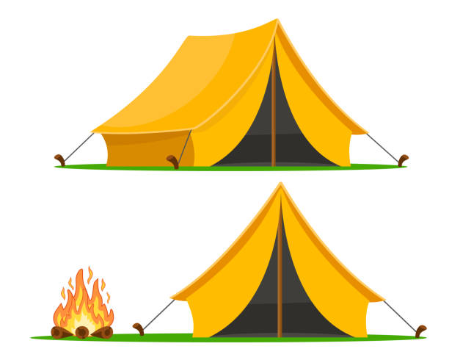  Picture 2    Picture 2    - Get the answers from Ss.  - Check the answers, focus on the final /ts/ sound and lead to new lesson. | - Present their answers.  Ss’ own answers

B. Pre-speaking: 10 minutes
a. Objectives: to prepare Ss for the speaking activity by introducing the final /ts/ sound.
b. Content: Pronunciation, task b, c, d.
Task b. Listen to the words and focus on the underlined letters.
Task c. Listen and cross out the word with the wrong sound.
Task d. Take turns saying the words in c. while your partner points to them.
c. Expected outcomes: Ss can make the final /ts/ sound correctly and naturally.
d. Organization
Teacher’s activities | Students’ activities
Task b.  - Ask Ss look at the words provided.  - Play the audio file (using DCR) and ask Ss to listen and repeat chorally and individually.  - Ask Ss to notice the final /ts/ sound.  - Call some Ss to pronounce the words.  - Give help if necessary. | - Listen to the audio file and repeat.  - Notice the final /ts/ sound.  - Do as told.  Answer Keys (Use the DCR)
Task c.  - Ask Ss to look at the words before listening to them.  - Play the audio file (using DCR).  - Elicit the answers from Ss.  - Check the answers. | - Study the words individually.  - Listen and cross out the one with the wrong pronunciation.  - Give their answer.  Answer Keys (Use the DCR)
Task d.  - Get Ss to work in pairs to pronounce the words.  - Set the time for the activity.  - Move around to give help.  - Call some Ss to do in front of the whole class. | - Work in pairs.  - Do as told.  Ss’ own answers

C. While-speaking: 15 minutes
a. Objectives: to help Ss pronounce the final /ts/ sound correctly, and improve Ss’ speaking skill.
b. Content: Practice, task a, b and Speaking, task a.
Practice, task a: Match the rules to the pictures and take turns saying the rules for each place.
Practice, task b: Think of one more rule for each place.
Speaking, task a. You are going to make some new rules for your school. In pairs: Choose one of the following places: gym, library, and schoolyard. Discuss and write six rules for that place.
c. Expected outcomes: Ss can make meaningful rules, and develop their speaking skill.
d. Organization:
Teacher’s activities | Students’ activities
Practice, task a.  - Get Ss to match the rules to the pictures.  - Ask Ss to practice saying the rules in pairs.  - Set the time for the activity.  - Call some Ss to act out.  - Check Ss’ answers and give feedback if needed. | - Practice saying the riles in pairs.  - present their answers.  Answer Keys (Use the DCR)
Practice, task b.  - Ask Ss to add one more rule for each place.  - Set the time for the activity.  - Call some to write their answers on the board.  - Give comment. | - Add one more rule for each place.  - Give their answers.  Ss’ own answers
Speaking, task a.  - Divide the class into pairs.  - Give them time to complete the rules for the place they have chosen.  - Call some to talk to the whole class.  - Check their answers. | - Work in pairs to ask and answer.  - Complete the rules.  - Talk to the whole class.  Ss’ own answers

D. Post- speaking: 10 minutes
a. Objectives: to help Ss to use the language and information in the real situation.
b. Content: Speaking, Task b
Task b: Listen to another pair's rules. Do you agree that they are good rules? How would you change them?
c. Expected outcomes: Ss can express their agreement and disagreement and suggest the way to change.
d. Organization

Teacher’s activities | Students’ activities
Task b:  - Introduce the task to Ss (using DCR).  - Ask Ss to work in pairs.  - Set the time for Ss to do.  - Get around to give help and take notes of some mistakes.  - Call some to talk to the whole class.  - Check and give comment. | - Work in pairs.  - Listen to other pair’s rules.  - Express their agreement and disagreement and suggest the way to change.  - Present their answers.  Ss’ own answers

E. Consolidation and homework assignments: 5 minutes
- Make a clip about rules for a place in your school.
- Prepare the next lesson: Lesson 3.1 – Listening & Reading, (page 54).
5. Reflection

a. What I liked most about this lesson today:
…………………………………………………………………………………………
- What I learned from this lesson today:
…………………………………………………………………………………………
c. What I should improve for this lesson next time:
…………………………………………………………………………………………

