**TIẾNG ANH 7 – i-LEARN SMART WORLD**

# **UNIT 1 TEST**

***Note:*** *Each correct answer earns 0.2 points.*

**I. PRONUNCIATION** **(0.8 points)**

***A. Choose the word whose underlined part is pronounced differently.***

1. A. safe B. bake C. alley D. make

2. A. story B. bowling C. zorbing D. sports

***B.*** ***Choose the word that has a different stressed syllable from the rest.***

3. A. collect B. tonight C. behind D. comic

4. A. equipment B. badminton C. opposite D. teenager

**II. VOCABULARY AND GRAMMAR (2.4 points)**

***Choose the best option (A, B, C or D) to complete each of the following*** ***questions.***

5. My brother __________ sports. He watches TV or plays computer games all day.

A. often plays B. never plays

C. rarely play D. is sometimes playing

6. My friends and I go skating at the __________ on Saturdays.

A. water park B. fair C. alley D. ice rink

7. My sister __________ with her friends on school nights. She __________ lots of homework.

A. doesn’t hang out/ has B. hangs out/ has

C. isn’t hanging out/ is having D. isn’t hanging out/ has

8. Our family loves going to the __________ every summer. There are many amazing water slides and a lazy river.

A. fun fair B. sports center C. water park D. park

9. I often __________ with my camera or smartphone.

A. build models B. make vlogs C. write blogs D. read stories

10. Student A: “Why did you buy eggs and flour?”

Student B: “I __________ a cake for my mum. It’s her birthday tomorrow.”

A. am baking B. will have C. am cooking D. make

11. There’s a park ______ my house. But my dad has to take us there because crossing the road is dangerous.

A. in front B. next to C. opposite D. behind of

12. My mother likes buying vegetables at the __________because they are fresh and cheap.

A. fun fair B. market C. park D. mall

13. We __________ at Hòa Bình theater tomorrow. My dad bought the tickets yesterday.

A. going to watch a play B. watch a play

C. will watch a play D. are watching a play

14. Student A: “How often do you play online games? ”

Student B: “_________”

A. Yes, I’m playing it now. B. Yes, I do.

C. Every weekend. D. I always love online games.

15. Read the poster and choose the correct statement.

|  |  |
| --- | --- |
|  | A. You don’t have to buy tickets.  B. It opens daily from 3 to 7p.m.  C. It costs $2.5 to rent a pair of skates.  D. It’s closed early on Saturdays. |

16. What does the sign mean?

|  |  |
| --- | --- |
|  | A. Children can enter this place alone.  B. Children can’t play in this area.  C. Only children can enter this place.  D. Children can’t enter this area without their parents. |

**III. WORD FORMATION (1.2 points)**

***Write the correct form of the words in the brackets.***

17. Scuba diving looks ____________. I think I will try it. **(EXCITE)**

18. The first time I went rock climbing, I was really _______________. **(SCARY)**

19. It costs 10 dollars to rent the ____________ equipment. **(SAFE)**

20. Andy has a ____________ of stamps and postcards from different countries. **(COLLECT)**

21. Kate is having a birthday party next Sunday. She sent me an ____________ yesterday. **(INVITE)**

22. My brother is really into extreme sports like rock climbing or zorbing, but my mum thinks they’re too ____________. **(DANGER)**

**IV. LISTENING (2 points)**

***A. Becky is calling Toby to make plans to meet. Listen and write short answers to the questions.***

23. Where is Becky meeting Joe tonight?

→

24. What is Toby doing tonight?

→

25. When is Toby going bowling?

→

26. Whose birthday is on Saturday?

→

27. Where are Becky and Toby meeting on Saturday afternoon?

→

***B. You will hear a talk about an extreme sport. Listen and decide whether the statements are True (T) or False (F).***

28. The speaker started skydiving two years ago.

29. His friend taught him how to skydive.

30. They fell for 13 seconds before opening the parachute.

31. The speaker felt excited.

32. The speaker thought he would never go skydiving again.

**V. READING (2 points)**

***A. Read the following passage and complete the summary with suitable information. For each blank, write*** ***NO MORE THAN THREE WORDS AND/ OR A NUMBER.***

My name is Dylan and my favorite hobby is making vlogs. I started this hobby when I was in grade 6th. On my 12th birthday, my dad gave me a camera. I love it so much and I always use it to take photos and make vlogs about people and places. I really enjoy meeting new people. I think it’s great to make new friends and see their way of life. My dad is a journalist, so he often takes me to different places. He also created a Facebook account for me, so I can post my vlogs there. The account has more than 1,000 followers. I don’t have a lot of free time during the week because I have so much homework to do. Therefore, I only edit vlogs on the weekends. And it often takes me one day to finish one vlog. I also like video games but I’m not really a big fan. Sometimes I make vlogs about new video games, too.

**DYLAN’S FAVORITE HOBBY**

Dylan began making vlogs at the age of (33) ________________. He uses a (34) ________________ to make them. This hobby helps him make (35) ________________ and know more about their lifestyles. He posts his videos on (36) ________________ and attracts many followers. He does the editing on (37) ________________ and it takes him one day to make a vlog.

***B. Read the following passage and fill in each blank with a suitable word or phrase from the box. There are two words/ phrases that you don’t need.***

next to free zorbing models takes swimming spends

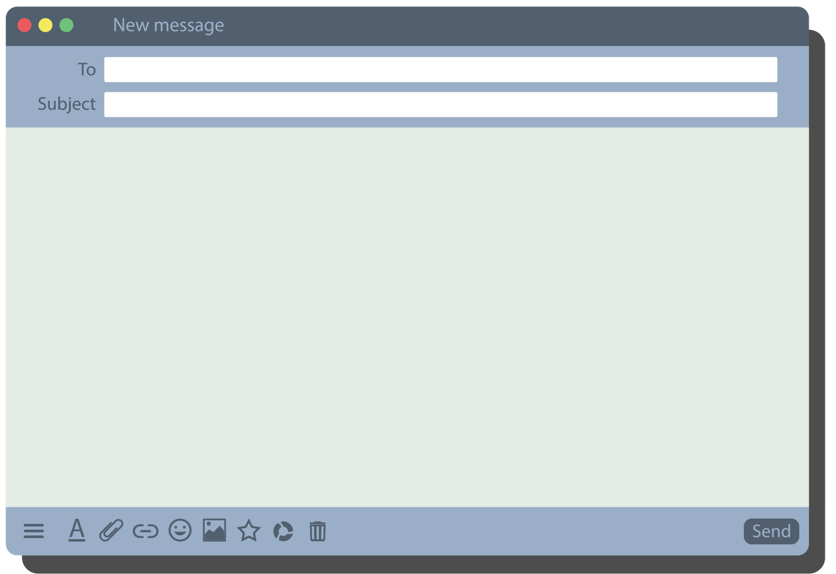

Hi Michael,

Are you (38) ____________ next Sunday? My dad is taking me and my brother to the new theme park. It’s (39) ____________ the sports center. Do you want to come?

My dad can pick you up at 8a.m. It (40) ____________ one hour to get there. Tickets cost 30 dollars. There are many amazing water slides and especially, there is aqua (41) ____________. It will be incredibly fun and thrilling when you roll on water inside a huge ball. And don’t worry, it’s not dangerous at all. There’s also a souvenir shop where you can buy beautiful wooden boat (42) ____________ for your collection.

Let me know if you can come by Thursday.

I hope you can come!

See you soon.

Jackson

Water park next Sunday?

Michael@gmail.com

**VI. WRITING (1.6 points)**

***A. Rewrite the following sentences without changing their meaning. Use the given word(s) if any*.**

43. Ben likes making vlogs about his plants and flowers.

→ Ben’s hobby .

44. It often takes Ben two hours to make a vlog.

→ Ben often spends .

45. The café is in front of the sports center.

→ The sports center .

46. I’m interested in cycling in the park.

→ I think cycling .

***B. Use the given words or phrases to make complete sentences.***

47. My dad/ go/ sports center/ weekends/.

→ .

48. Molly/ enjoy/ read/ collect/ comics/.

→ .

49. Ann/ meet/ us/ in front/ the bowling alley/ 7 o’clock/ this evening.

→ .

50. What/ your sister/ do/ free time/?

→ ?

*\*\*\*****End – Of – Test****\*\*\**