Week: Date of planning: ……
Period: Date of teaching: ……
UNIT 5: OUR CUSTOMS AND TRADITIONS
Lesson 4: Communication
I. OBJECTIVES
By the end of this lesson, Ss will be able to achieve the follwing:
1. Knowledge
- Give advice
- Read about a local festival
- Compare two local festivals.
2. Competences
- Develop creativity and communication skills
- Be collaborative and supportive in pair work and team work
- Actively join in class activities
3. Personal qualities
- Be ready to give advice
- Be interested more about local festivals.
II. MATERIALS
- Grade 8 textbook, Unit 5, Communication.
- Computer connected to the Internet
- Projector/ TV
III. PROCEDURES
1. WARM-UP (5 mins)
a. Objectives:
- To create an active atmosphere in the class before the lesson
- To lead into the new unit.
b. Content:
- To introduce table manners.
c. Expected outcomes:
- Ss have general ideas about table manners.
d. Organisation

TEACHER’S AND STUDENTS’ ACTIVITIES | CONTENTS
- T shows a picture of a child having dinner with family. Ask Ss what the child is doing and whether she is behaving well at the table.  - Tell Ss that “table manners” means the polite ways of behaving when eating. These behaviours differ from one culture to another.  - Ask Ss to give some examples of table manners that they know. Lead in to the lesson. | 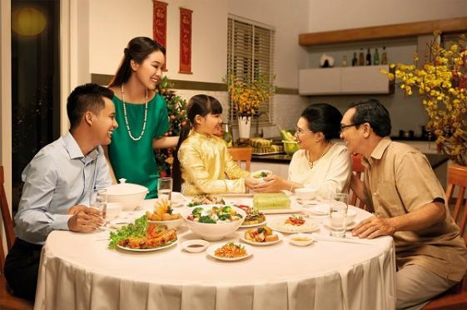  Suggested answers:  - Wait for the table arrangement before sitting down  - Wait for the oldest people to start first  - Pass your bowl with two hands  - Do not stick the chopstick against the bowl  - Do not flip the fish on the plate  - Do not point the chopsticks to anyone  - Do not dig into the dish  - Do not eat directly from shared dishes  - Stay until other people finish  - Say Thanks to the host after the meal

2. ACTIVITY 1: PRESENTATION (14 mins)
a. Objectives:
- To introduce ways of giving advice.
- To help Ss practise giving advice.
b. Content:
- Task 1: Listen and practise the conversation.
- Task 2: Work in pairs. Make similar conversations with the following situations.
c. Expected outcomes:
- Ss understand how to give advice.
- Students can make dialogue by giving advice.
d. Organisation

TEACHER’S AND STUDENTS’ ACTIVITIES | CONTENTS
Task 1: Listen and read the conversation below. Pay attention to the highlighted parts. (6 mins)
- Teacher plays the recording for Ss to listen and read the dialogue between Tom and Mai.  - T asks Ss to pay attention to the highlighted language.  - T elicits from Ss that the first two highlighted phrases are ways to advise what one should do, and the last highlighted word is for saying what one should NOT do.  - Teacher has Ss practise the dialogues in pairs. Call on some pairs to practise the dialogues in front of the class.  -> Structure: to give advice  - Perhaps you should + V₀  - It’s a good idea to + V₀  - Don’t + V₀ | 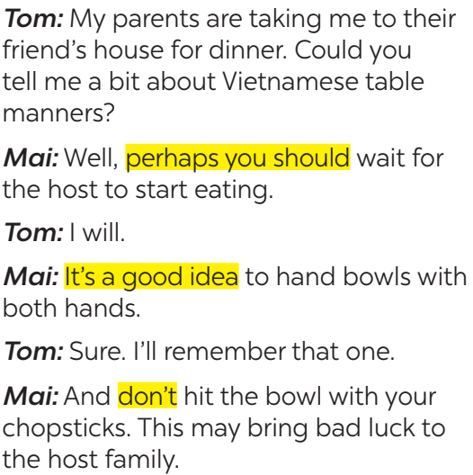
Task 2: Work in pairs. Make similar conversations with the following situations. (9 mins)
- Teacher asks Ss to work in pairs (5 minutes) to make similar dialogues with the given situations, using the expressions they have learnt.  - Teacher moves around to observe and provide help. T calls on some pairs to practise in front of the class.  - T comments on their performance. | Suggested answers:  1. Perhaps you should bring warm clothes, a scarf, coat, jacket,…  2. It’s a good idea to bring a gift such as a birthday cake, pen, pencil, clothes…

3. ACTIVITY 2: PRACTICE (12 mins)
a. Objectives:
- To provide Ss with information about lion dance in Japan.
b. Content:
- Task 3: Read the text about the lion dance in Japan and complete the table with the information from the text.
c. Expected outcomes:
- Ss can understand the text and fill in the blank with right information.
d. Organisation

TEACHER’S AND STUDENTS’ ACTIVITIES | CONTENTS
Task 3: Read the text about the lion dance in Japan and complete the table with the information from the text. (10 mins)
- Teacher writes “Lion Dance” on the board or shows a picture of a lion dance. T tells Ss that this is called the lion dance and it is popular in many Asian countries. T elicits from Ss the occasion(s) when they may see a lion dance performance.  - Teacher tells Ss that they are going to read about lion dance in Japan.  - Teacher has Ss look at the table of information and think of the type of information they need for each blank.  - Teacher asks Ss to work in pairs to do this activity. They can draw this table on a sheet of paper. After pairs finish their work, T asks them to share their table with the whole class.  - Teacher comments on their answers.  - If time allows, have some pairs use the information in the table to talk about the Japanese lion dance without looking again at the text. | Answer key:  1. shishi-mai  2. New Year celebrations  3. acrobatics  4. flutes  5. bad spirits
4. ACTIVITY 3: PRODUCTION (9 mins)
a. Objectives:
- To help Ss compare the Vietnamese unicorn dance with the Japanese lion dance.
b. Content:
- Task 4: Work in groups. Read Mai’s notes on the Vietnamese unicorn dance. Compare the Vietnamese unicorn dance with the Japanese lion dance.
c. Expected outcomes:
- Students can compare the Vietnamese unicorn dance with the Japanese lion dance.
d. Organisation
Task 4: Work in groups. Read Mai’s notes on the Vietnamese unicorn dance. Compare the Vietnamese unicorn dance with the Japanese lion dance. (10 mins)
- Teacher shows two pictures, one of the Vietnamese unicorn dance and one of the Japanese lion dance next to each other.  - Teacher has Ss look at the pictures and point out some similarities and differences between the two pictures. T encourages Ss to use the structures “Both…. and …..” and “…. but….”.  - Teacher tells Ss to look at Mai’s notes on Vietnamese unicorn dance. T asks them if there is any information they didn’t know.  - Teacher has Ss work in groups to compare the Vietnamese unicorn dance and the Japanese lion dance, using the tables in 3 and 4. Tell the groups that they need to write at least 5 sentences using 5 pieces of information from the tables.  - Teacher asks some Ss to report their group’s answers to the class. | Suggested answers:  - There are one or more performers in both Vietnamese Unicorn dance and Japanese Lion dance.  - Both Vietnamese Unicorn dance and Japanese Lion dance perform in the New Year Festival.  - Vietnamese Unicorn dance needs Ong Dia but Japanese Lion dance doesn’t need it.  …

5. CONSOLIDATION (5 mins)
a. Wrap-up
- T asks Ss to summarize what they have learnt in the lesson.
- T has Ss look at the objectives written on the board at the beginning of the lesson and tick the objectives they have learnt.
b. Homework
- Do exercise in workbook: Exercise C1 p39; Exercise C2 p40
- Compare Vietnamese Tet Holiday and Chinese Tet Holiday.

