ĐỀ SỐ 14
Thời gian làm bài: 120 phút

PART A: LISTENING (10 pts)
Part I. You will hear five short conversations. You will hear each conversation twice. There is one question for each conversation. For question 1-5, put a tick ()
1. How does the man travel to Liverpool?
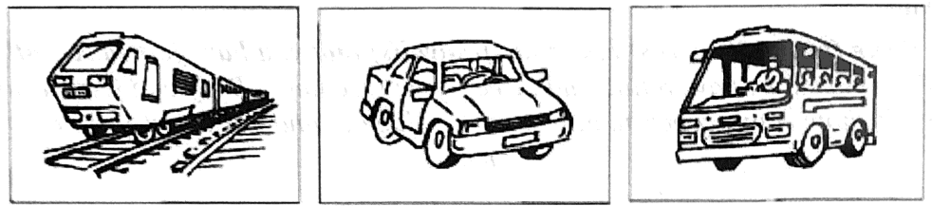
A | B | C
2. Which bill has just arrived?

A | B | C
3. How did the man hear about the fire?
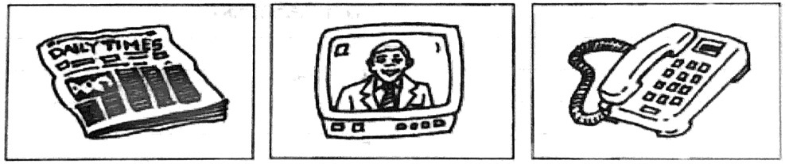
A | B | C
4. What time will the writer arrive at the bookshop?
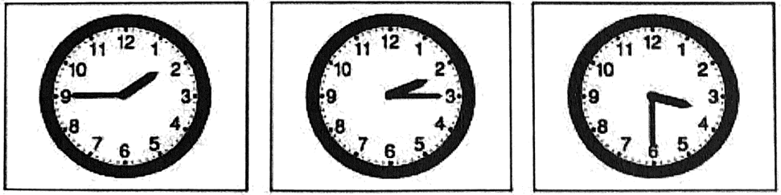
A | B | C
5. What did the woman leave in the restaurant?
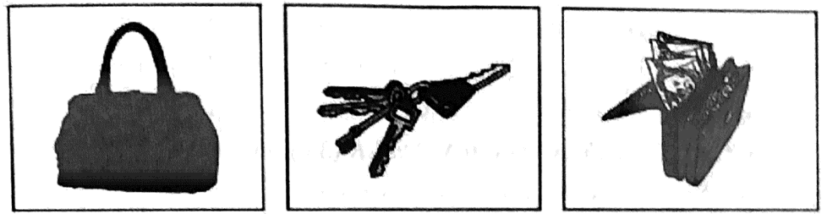
A | B | C
Part II. You will hear a man asking some information about a language school. Listen and complete questions.
School for Italian Studies
Length: | 6 or 9 months
Next courses begin on: | (6) ____________________
Number of students in each class: | (7) ____________________
Extra pay only for: | (8) ____________________ book
School hours:  Saturday | (9) ____________________ to 1.p.m.
Nearest underground station: | (10) ____________________
PART B: PHONETICS (7 pts)
I. Choose the word A, B, C or D whose underlined part is pronounced differently from the others.
1. A. northern | B. sunbathing | C. breath | D. thunder
2. A. island | B. rescue | C. institute | D. limestone
3. A. jungle | B. gist | C. grind | D. emigrate
4. A. stretcher | B. chemistry | C. Christmas | D. character
5. A. heritage | B. shortage | C. teenage | D. luggage
II. Choose the word A, B, C or D whose main stress is different from the others in the group.
1. A. reserved | B. invent | C. beneath | D. wardrobe
2. A. character | B. transmit | C. opposite | D. dangerous
3. A. festival | B. heritage | C. resident | D. selection
4. A. expensive | B. sensitive | C. negative | D. sociable
5. A. morning | B. college | C. arrive | D. famous
PART C: VOCABULARY AND GRAMMAR (33 pts)
I. Complete the sentence with suitable prepositions.
1. Jane doesn’t spend much money _______ clothes.
2. In Da Lat it is usually cold _______ night, but it’s warm _______ the day.
3. She always takes good care _______ her children.
4. _______ the rice-cooking festival, fire is made _______ the traditional way.
5. He congratulated me _______ winning the competition.
6. Suddenly, the canoe overturned and everyone fell _______ the deep and dangerous water.
7. She got _______ late this morning because her alarm clock didn’t go _______.
II. Put the correct form of the words in brackets.
1. Phuong Linh arranged flowers the most ____________________ (attract) in the contest.
2. It is a contest in which ____________________ (participate) have to read two poems in English.
3. ____________________ (environment) are concerned about the use of dynamite to catch fish.
4. The police are interested in the sudden __________________ (appear) of the valuable painting.
5. Nam put ____________________ (press) on that towel to stop the bleeding.
6. After many years of ___________________ (fail), Edison finally succeeded in inventing the light bulb.
7. We use first-aid in order to ease the victim’s pain and ____________________ (anxious).
8. She felt ____________________ (relief) after she passed the exam.
9. You’ll meet the tour guide on your ____________________ (arrive) at the hotel.
10. Sapa is considered the most beautiful ____________________ (mountain) resort in the north of Viet Nam.

III. Find and correct a mistake in each sentence.
1. If he would speak more slowly, I could understand him.
________________________________________________________________________________________________
2. The boys hurt himself when they jumped down from the tree.
________________________________________________________________________________________________
3. After living in London for two months, my brother got used to drive on the left.
________________________________________________________________________________________________
4. Linh wishes that she is given a teddy bear at Christmas.
________________________________________________________________________________________________
5. The returned ticket is more expensive than the single one.
________________________________________________________________________________________________
6. I suggested that you writing to them to accept their offer.
________________________________________________________________________________________________
7. They asked me where was I going to spend my vocation that summer.
________________________________________________________________________________________________
8. Everybody I know like to eat chocolates and ice-cream.
________________________________________________________________________________________________
9. My brother enjoys to read detective stories in his free time.
________________________________________________________________________________________________
10. Your brother hardly goes to work by bus, doesn’t he?
________________________________________________________________________________________________

IV. Supply the correct form of the verbs in brackets.
1. He (watch) ________________ a film on TV when I (come) ________________ to see him last night.
2. ________________ (you / buy) a new school bag by your father two years ago?
3. I (not see) ________________ my cousin for a month. He (not go) ________________ out since he (buy) ________________ a new color TV.
4. Leave me alone. I (do) ________________ my homework.
5. On July 20th, 1969, Neil Armstrong (step) ________________ down onto the Moon.
6. I am used (get) ________________ up early now. Last year, I used (get) ________________ up late.
PART D. READING COMPREHENSION (20 pts)
I. Choose the best word in the box to fill in each blank in the following passage.
has to is teaching cover
teacher more and high decided

FOREIGN ENGLISH LANGUAGE TEACHERS FOR SCHOOLS IN VIETNAM
Vietnam (1) _____________ well on its way to integrate with the world and for that reason emphasis on English language skills (2) _____________ become very essential. Recently, the City Department of Education and Training (3) _____________ to recruit foreign native English speakers to teach in elementary, middle and (4) _____________ schools in Vietnam.
The policy calls for social contributions to improve English language (5) _____________ from primary schools to senior high schools by employing only foreign native English teachers. Each student will chip in VND120,000 ($5.8) a month to (6) _____________ the $35 an hour salary of the foreign (7) _____________.
Compared (8) _____________ traditional English teaching methodology, it is better that thousands of students in the City have a chance of practicing listening (9) _____________ speaking skills with native English speakers, who create a (10) _____________ exciting atmosphere in classrooms for students.
II. Read and fill a suitable word in each blanket.
Christmas is always held (1) _____________ December the twenty fifth every year. Every family in England decorates a Christmas tree and puts (2) _____________ in the middle of the living room. And Santa Claus plays an important (3) _____________ in this festival. There is a poem to relate him. In 1823, the patron saint of children, Saint Nicholas appeared in a poem (4) _____________ A Visit Saint Nicholas. The character in the poem (5) _____________ a fat jolly man who wore a (6) _____________ suit and gave children (7) _____________ on Christmas Eve. The poem, which was (8) by Clement Clarke Moore, an American professor, became popular (9) _____________ the USA. Santa Claus is based (10) _____________ the description of Saint Nicholas in this poem.
PART E: WRITING (30 pts)

I. Complete the second sentence so that it has a similar meaning to the first sentence.
1. Couldn’t you find a better hotel?
Is this
2. haven’t seen that man here before.
This is
3. Old car tires are recycled to make shoes and sandals.
People
4. The coffee is so hot that I can’t drink it.
The coffee is too
5. Somebody repaired his car yesterday.
He had
6. It was thought that the painting had been destroyed.
The painting
7. That’s the strangest film I’ve ever seen.
I have never
8. I can’t buy the tickets. They are too expensive.
The tickets are so
9. Peter spent three hours repainting his house.
It
10. Leave now or you will miss the train.
Unless
II. Complete the following sentences, use the words given.
1. I/ play table tennis/ Nam/ when/ my friends/ come.
________________________________________________________________________________________________
2. We ought/ use/ cloth bags/ instead/ reuse/ plastic bags.
________________________________________________________________________________________________
3. Could/ give me/ information?
________________________________________________________________________________________________
4. I/ used/ look after/ younger/ brother/ sister/ when/ parents/ at/ work.
________________________________________________________________________________________________
5. Why/ we/ have/ put/ dangerous things/ out/ children’s reach?
________________________________________________________________________________________________
6. How long/ it/ take you/ get/ school?
________________________________________________________________________________________________
7. He/ not interested/ buy/ new/ house.
________________________________________________________________________________________________
8. We/ have/ wonderful/ time/ moment/ SaPa.
________________________________________________________________________________________________
9. I/ bored/ doing/ same thing/ day after day.
________________________________________________________________________________________________
10. Marie Curie/ born/ Poland/ 1867.
________________________________________________________________________________________________

III. Write an essay (over 200 words) about advantages and disadvantages of living in the countryside. (10 pts)
(The essay must have a title and three parts: Opening - Body and Conclusion. Don’t show your proper names/ school/ village...)
________________________________________________________________________________________________
________________________________________________________________________________________________
________________________________________________________________________________________________
________________________________________________________________________________________________
________________________________________________________________________________________________
________________________________________________________________________________________________
________________________________________________________________________________________________
________________________________________________________________________________________________
________________________________________________________________________________________________
________________________________________________________________________________________________
________________________________________________________________________________________________
________________________________________________________________________________________________
________________________________________________________________________________________________
________________________________________________________________________________________________
________________________________________________________________________________________________
________________________________________________________________________________________________
________________________________________________________________________________________________
________________________________________________________________________________________________
________________________________________________________________________________________________
________________________________________________________________________________________________
________________________________________________________________________________________________
________________________________________________________________________________________________
________________________________________________________________________________________________
________________________________________________________________________________________________
________________________________________________________________________________________________
________________________________________________________________________________________________
________________________________________________________________________________________________
________________________________________________________________________________________________
________________________________________________________________________________________________
________________________________________________________________________________________________
________________________________________________________________________________________________
________________________________________________________________________________________________
________________________________________________________________________________________________
________________________________________________________________________________________________
________________________________________________________________________________________________
________________________________________________________________________________________________
________________________________________________________________________________________________
________________________________________________________________________________________________
________________________________________________________________________________________________
________________________________________________________________________________________________
________________________________________________________________________________________________
________________________________________________________________________________________________
________________________________________________________________________________________________
________________________________________________________________________________________________
________________________________________________________________________________________________
________________________________________________________________________________________________
________________________________________________________________________________________________
________________________________________________________________________________________________
________________________________________________________________________________________________

