Week:……………..  Period:……………. | Date of planning : …/… / 2023  Date of teaching : …/… / 2023

UNIT 4: ETHNIC GROUPS OF VIET NAM
Lesson 7: Looking back & Project

I. OBJECTIVES
By the end of this lesson, students will be able to:
1. Knowledge:
- Revise more vocabulary items they have learnt in the unit in different contexts.
- Revise Yes/ No questions and Wh-questions.
- Revise the use of countable and uncountable nouns.
- Have an opportunity to research more deeply into an ethnic group they are interested in.
2. Competence:
- Develop communication skills and creativity.
- Be collaborative and supportive in pair work.
- Actively join in class activities
3. Personal qualities
- Respect ethnic groups of Viet Nam and their culture
- Develop self-study skills
II. MATERIALS
- Grade 8 textbook, Unit 4: Looking back & Project
- Computer connected to the Internet
- Projector / TV
III. PROCEDURES
1. WARM-UP (5 mins)
a. Objectives:
- To create an active atmosphere in the class before the lesson.
- To lead into the new lesson.
b. Content:
- Mind map
c. Expected outcomes:
- Ss can tell the teacher what they have learnt in unit 4.
d. Organisation
TEACHER AND STUDENTS’ ACTIVITIES | CONTENTS
Mind map  - Teacher writes on the board “Unit 4” and asks students to think of what they have learnt already in this unit.  - Students work in groups to do the task.  - Teacher calls some students to retell.  - Teacher confirms and leads them to do all the exercises in books. | Suggested answer:  - Vocabulary: about the lifestyle of ethnic groups  - Pronunciation: /k/ and /g/  - Grammar: Yes / No and Wh-questions, countable and uncountable nouns
2. ACTIVITY 1: PRESENTATION (10 mins)
a. Objectives:
- To help Ss revise the vocabulary they have learnt in the unit through pictures.
- To help Ss revise more vocabulary items they have learnt in the unit in different contexts.
b. Content:
- Task 1: Match the words and phrases with the pictures.
- Task 2: Complete the sentences with the word and phrases from the box.
c. Expected outcomes:
- Ss can use the words they have learnt in different contexts.
d. Organisation
TEACHER’S AND STUDENTS’ ACTIVITIES | CONTENTS
Task 1: Match the words and phrases with the pictures. (5 mins)
- Teacher asks Ss to work individually and read the words/ phrases carefully.  - Ss match the phrases with suitable pictures.  - Teacher calls some Ss to share their answers.  - Teacher confirms the correct answers as a class. |  | Answer key:  1. c  2. a  3. e  4. b  5. d
Task 2: Complete the sentences with the word and phrases from the box. (5 mins)
- Teacher asks Ss to read the word and phrases in the box and see if they still remember their meanings.  - Ss read each sentence and choose the correct answer from the box to complete it.  - Teacher asks Ss to double-check their answers with their partners.  - Teacher confirms the correct answers as a class. |  | Answer key:  1. musical instruments  2. sticky rice  3. communal house  4. folk songs  5. staircase
3. ACTIVITY 2: PRACTICE (10 mins)
a. Objectives:
- To help Ss revise Yes / No questions and Wh-questions.
- To help Ss revise the use of countable and uncountable nouns.
b. Content:
- Task 3: Write questions from the clues.
- Task 4: There is one incorrect underlined word in each sentence. Circle and correct it.
c. Expected outcomes:
- Students can make Yes / No and Wh-questions using the clues.
- Students can identify mistakes when using countable and uncountable noun and correct them.
d. Organisation
TEACHER’S AND STUDENTS’ ACTIVITIES | CONTENTS
Task 3: Write questions from the clues. (5 mins)
- Teacher asks Ss to work individually and read the clues carefully.  - Ss use the clues given to make Yes / No and Wh-questions.  - Teacher asks them to compare their answers with a partner.  - Teacher confirms the correct answers as a class. |  | Answer key:  1. Did you attend the Khmer’s Moon Worship Festival last year?  2. How many ethnic minority groups are there in Viet Nam?  3. Where do the Hmong live?  4. What did you do at the Ede’s Harvest Festival last October?  5. How old are the minority children when they start helping the family?
Task 4: There is one incorrect underlined word in each sentence. Circle and correct it. (5 mins)
- Teacher asks Ss to read each sentence and decide which underlined word is incorrect.  - Teacher asks Ss to do this exercise individually.  - Teacher calls on 2-3 Ss to give their answers and asks them to explain their answers.  - Teacher confirms the correct answers as a class. |  | Answer key:  1. houses → house  2. leave → leaves  3. Much → Many  4. houseworks → housework  5. many → much
4. ACTIVITY 3: PRODUCTION (15 mins)
a. Objectives:
- To provide Ss with an opportunity to research more deeply into an ethnic group they are interested in.
b. Content:
- Present the poster to the class.
c. Expected outcomes:
- Ss can research more deeply and talk about an ethnic group they are interested in.
d. Organisation
TEACHER’S AND STUDENTS’ ACTIVITIES | CONTENTS
Our ethnic groups  - Ask Ss to read the instructions again (T has already assigned the project since the first lesson of the Unit and checked their progress after each lesson).  - Let students have some time to check their posters for the final time and make any adjustments if necessary.  - T has groups show their posters and present them to the class. | 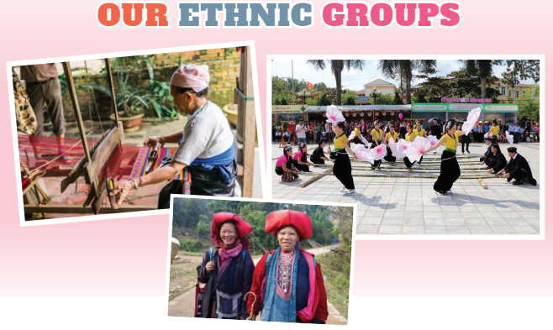
5. CONSOLIDATION (5 mins)
a. Wrap-up
- Teacher asks Ss to summarise the main points of the lesson.
b. Homework
- Do exercises in the workbook.
- Prepare for Unit 5: Getting started.

